CHAROTAR UNIVERSITY OF SCIENCE & TECHNOLOGY
Faculty of Technology & Engineering
Devang Patel Institute of Advance Technology and Research (DEPSTAR)

CSUE301 – : Big Data Analytics
Practical File – ODD Semester 2026-27

StudentID: 24DIT022
Student Name: Pankti Halatwala

Practical 9
1. Problem Definition

TrendPulse Social Media Analytics monitors social media activity across platforms such as Twitter/X, Instagram, Facebook, and LinkedIn. Large volumes of posts contain hashtags related to technology, sports, entertainment and other topics.
The objective of this practical is to use PySpark to process hashtag data and identify popular and trending topics.
The practical performs hashtag grouping, frequency counting, popularity ranking, daily trend analysis, regional analysis, category analysis and visualization.
Note: The dataset used in this practical is a generated/sample dataset for educational analysis.

PART A — Practical Execution

Step 1: Creating Folder and files

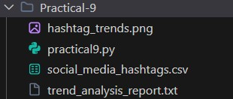

Step 2: Creating Spark Session

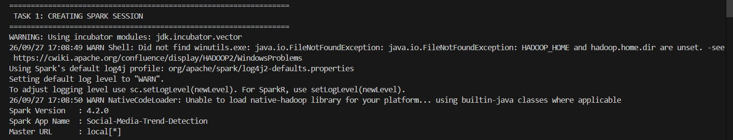

Step 3: Loading Social Media Hashtag Dataset
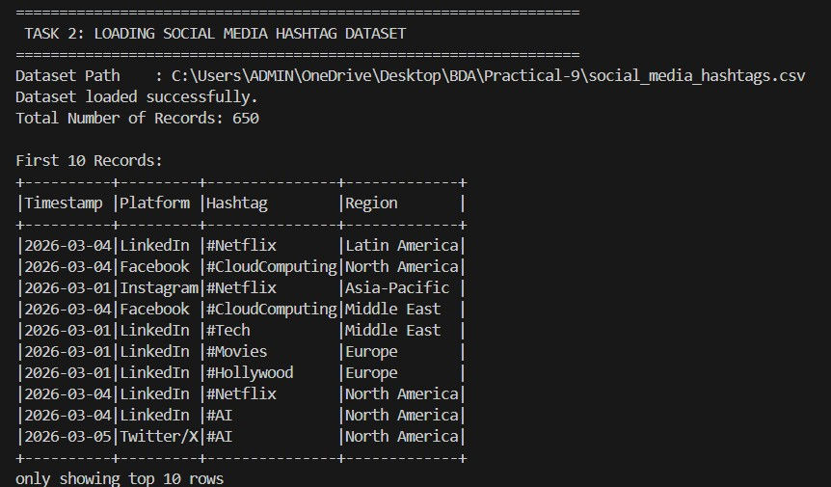

Step 4: Displaying Hashtag Records
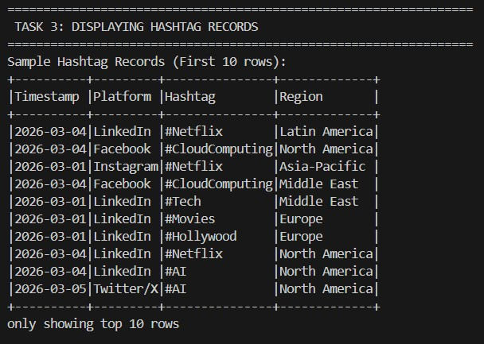

Step 5: Validating Dataset Structure
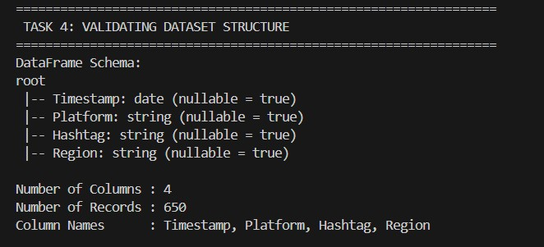

Step 6: Grouping Hashtags
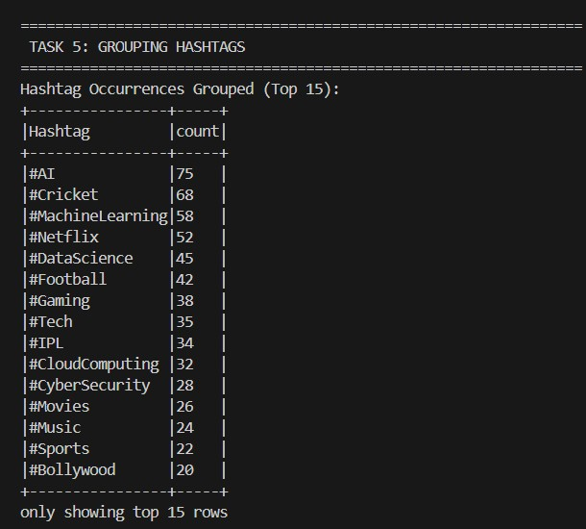

Step 7: Counting Hashtag Occurrences
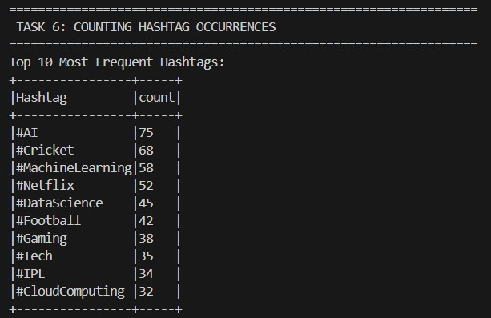

Step 8: Sorting Hashtags by Popularity
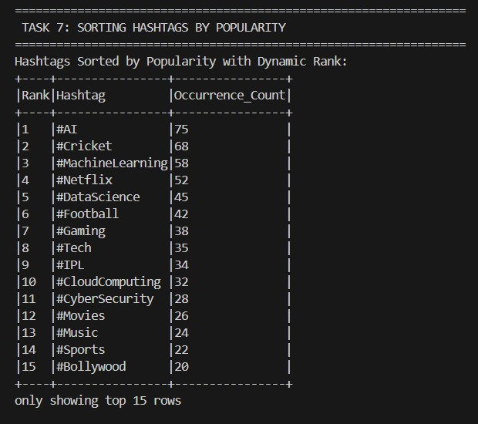

Step 9: Identifying Top Trending Hashtags
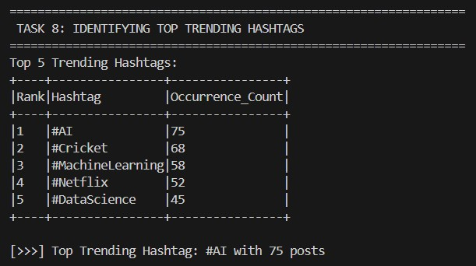

Step 10: Supplementary 1 — Top 3 Trending Hashtags
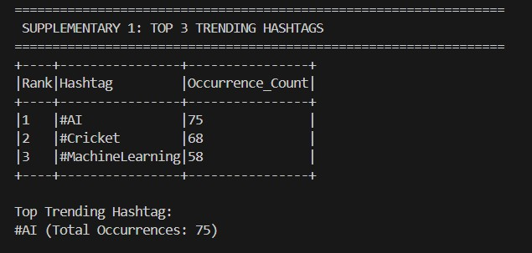

Step 11: Supplementary 2 Daily Trend Comparison

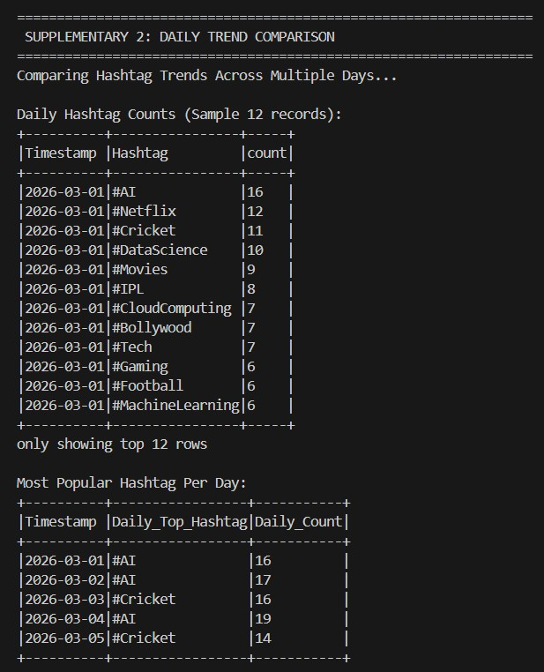

Step 12: Supplementary 3 Regional Hashtag Analysis
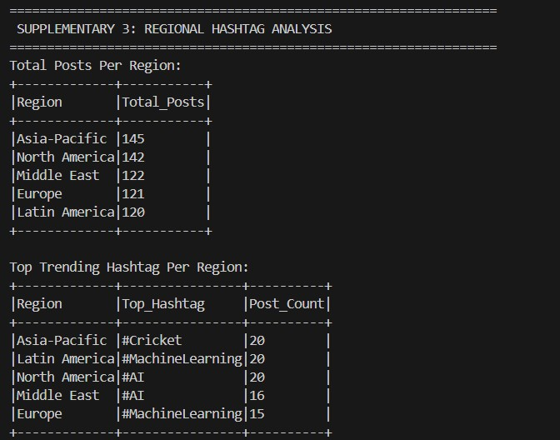

Step 13: Task 10 / Supplementary 4 — User Interest and Hashtag Categories
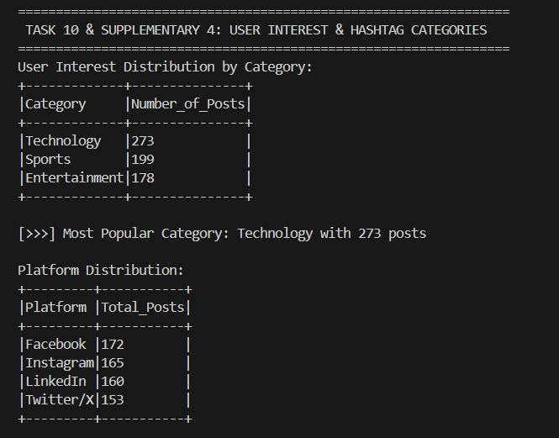

Key Questions / Analysis
Q1. Why is Apache Spark suitable for social media analytics?
Answer:
Apache Spark is suitable for social media analytics because it can process large amounts of data efficiently using distributed computing. Spark DataFrames provide fast operations such as filtering, grouping, aggregation and sorting, which are useful for analysing large social media datasets.

Q2. What is the significance of hashtag frequency?
Answer:
Hashtag frequency represents how many times a particular hashtag appears in the dataset. A higher frequency indicates that the topic is receiving more attention in the analyzed sample.

Q3. How can trend analysis support digital marketing campaigns?
Answer:
Trend analysis helps marketers identify popular topics and changing user interests. Businesses can use this information to create relevant content, plan campaigns and monitor emerging topics.

Q4. Why do businesses monitor social media trends?
Answer:
Businesses monitor social media trends to understand customer interests, identify emerging topics, observe discussions about products or services and improve their marketing strategies.

Q5. How can real-time analytics improve decision making?
Answer:
Real-time analytics allows organizations to detect changes in trends quickly. This can help businesses respond faster to emerging topics, customer interests and market changes.

Result
The Social Media Trend Detection practical was successfully implemented using PySpark.
The dataset contained 650 social media records and 18 distinct hashtags. Hashtag frequency, popularity ranking, top trends, daily trends, regional trends and category-based user interests were successfully analyzed.
The most frequently occurring hashtag in the sample dataset was #AI with 75 occurrences.
The Technology category had the highest number of posts with 273 posts. A visualization of the top 10 hashtags was also successfully generated using Matplotlib.

Conclusion
The practical demonstrated how PySpark DataFrame operations and aggregation techniques can be used for social media trend detection. Hashtags were grouped, counted and ranked according to their frequency.
Daily and regional analysis provided additional information about changing user interests. Category analysis showed the distribution of Technology, Sports and Entertainment topics.
The practical demonstrates that PySpark can be used to process and analyze large-scale social media datasets efficiently and extract useful trends for business analysis.

5. Github Link
Github Link:

