CHAROTAR UNIVERSITY OF SCIENCE & TECHNOLOGY

Faculty of Technology & Engineering
Devang Patel Institute of Advance Technology and Research (DEPSTAR)

CSUE301 – : Big Data Analytics
Practical File – ODD Semester 2026-27

StudentID: 24DIT022
Student Name: Pankti Halatwala

Practical 10
1. Problem Definition

RetailEdge Analytics wants to segment a large number of customers according to their purchasing behaviour. Traditional single-node K-Means algorithms may face memory and scalability limitations when processing very large datasets.
In this practical, Apache Spark MLlib is used to implement Parallel K-Means clustering for customer segmentation.
Customer transaction data is processed to extract meaningful behavioural features such as:
- Total Spend
- Purchase Frequency
- Average Basket Size
- Recency
These features are normalized using StandardScaler and clustered using Spark MLlib K-Means with k = 5 clusters.
The clustering quality is evaluated using WSSSE, and the Elbow Method is used to compare different values of k. Customer segments are then interpreted based on their purchasing behaviour.

PART A - Practical Execution

Step 1: Creating Folder and files

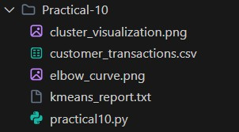

Step 2: Creating Spark Session

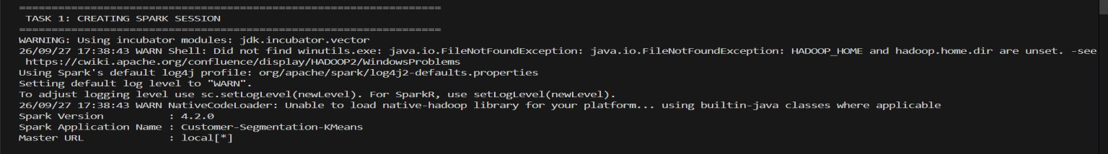

Step 3: DATASET DESCRIPTION
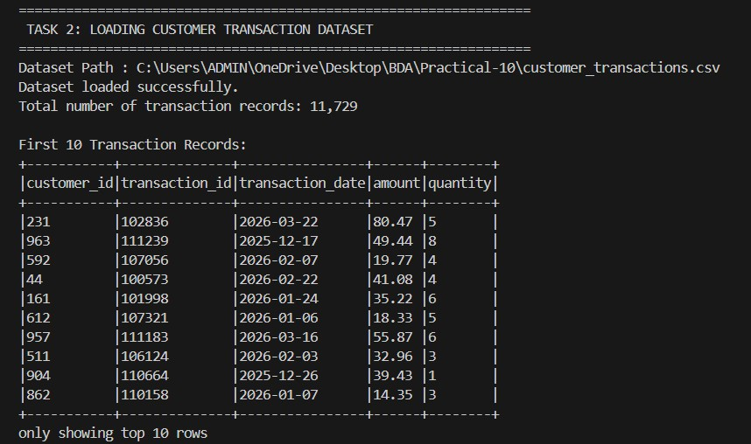

Step 4: Dataset Schema and Structure
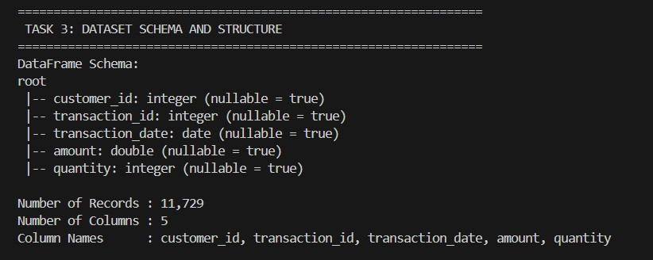

Step 5: DATA PREPROCESSING

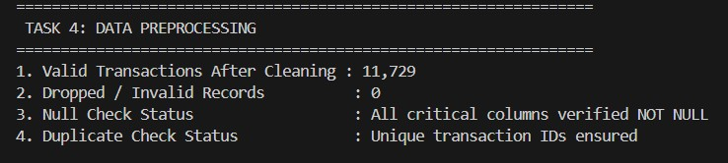

Step 6: CUSTOMER FEATURE EXTRACTION
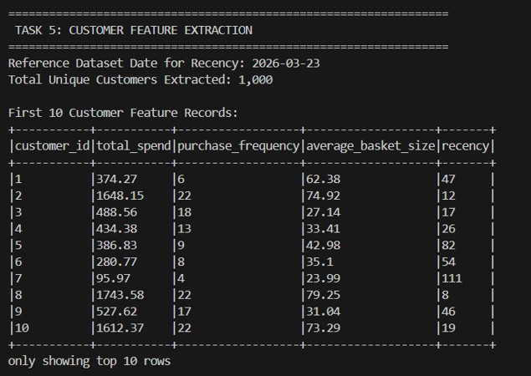

Step 7: FEATURE VECTOR ASSEMBLY
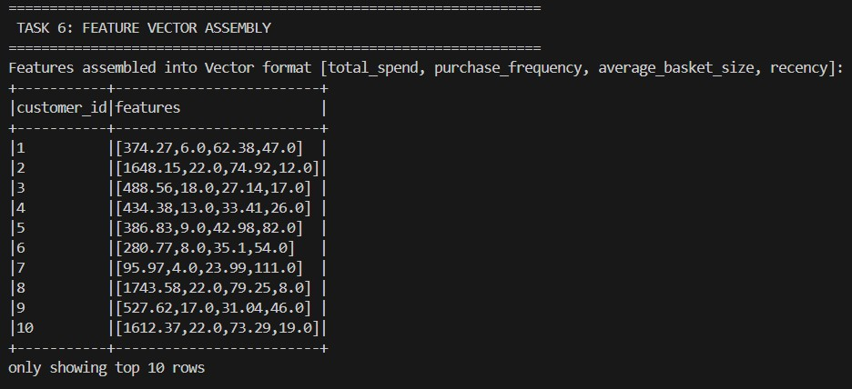

Step 8: FEATURE SCALING
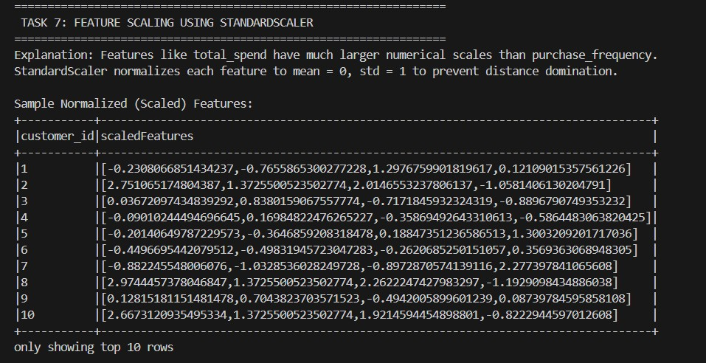

Step 9: PARALLEL K-MEANS
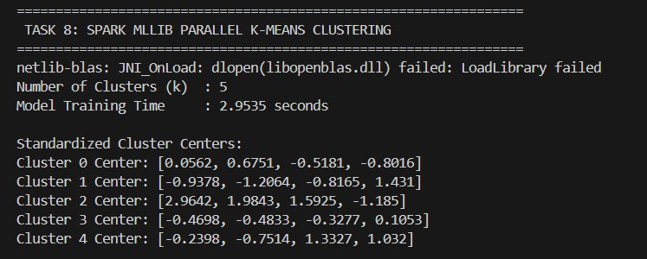x

Step 10: WSSSE
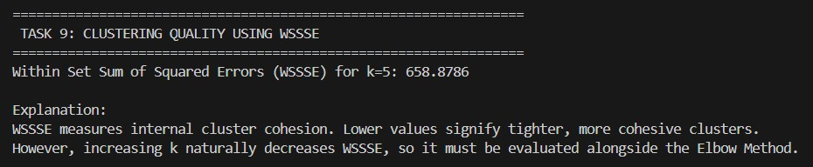

Step 11: CUSTOMER CLUSTER ASSIGNMENT
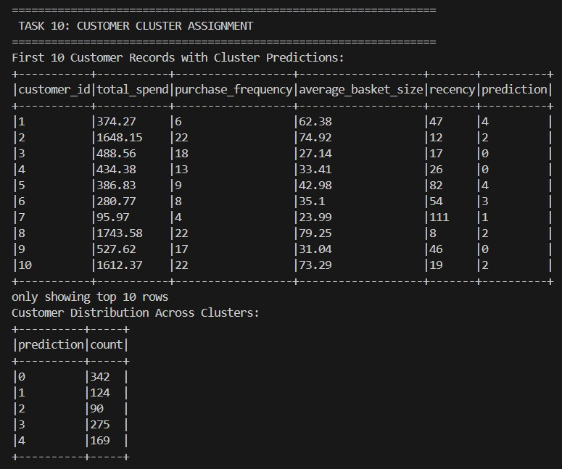

Step 12: CLUSTER CENTERS & SEGMENT SUMMARY
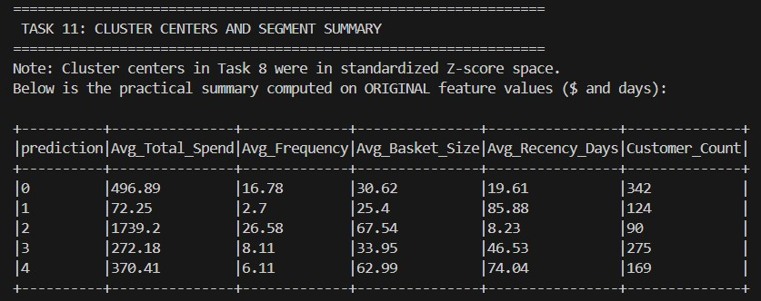

Step 13: CUSTOMER SEGMENT INTERPRETATION
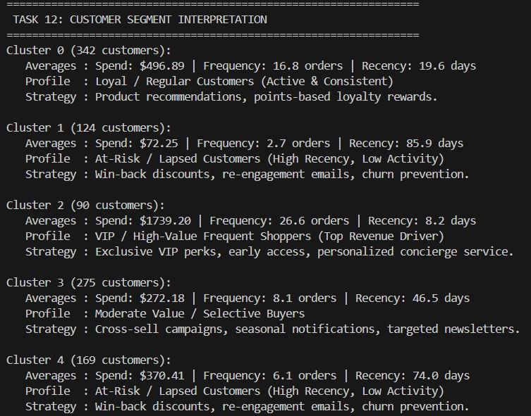

Step 14: ELBOW METHOD
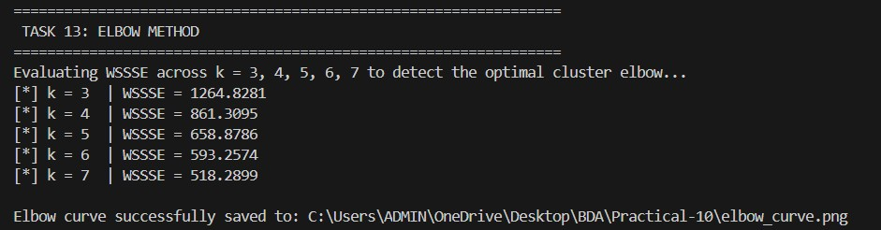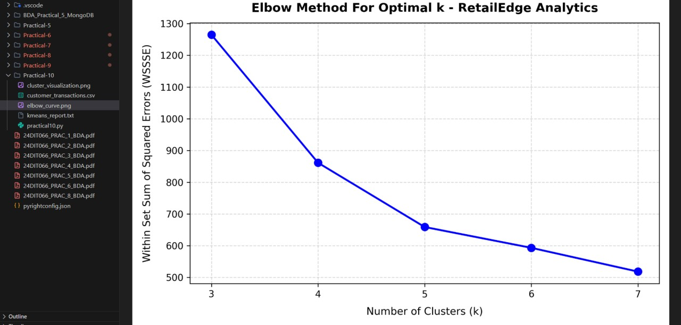

Step 15: K=3 VS K=5 VS K=7
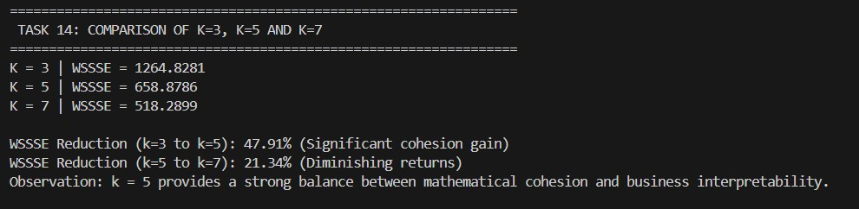

STEP 16: BISECTING K-MEANS
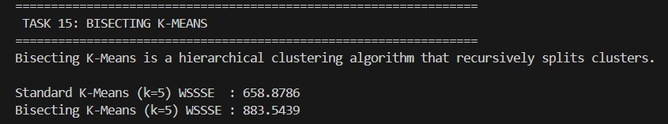

Step 17: SINGLE NODE VS SPARK
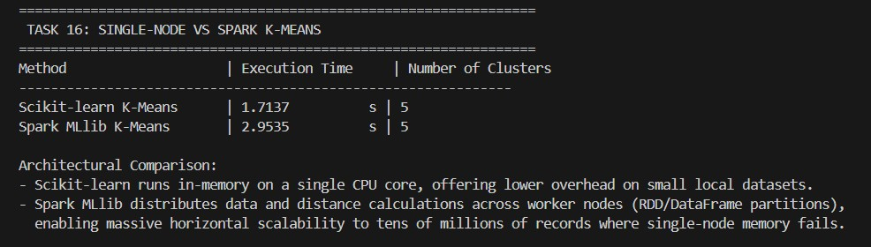

Step 18: CLUSTER VISUALIZATION
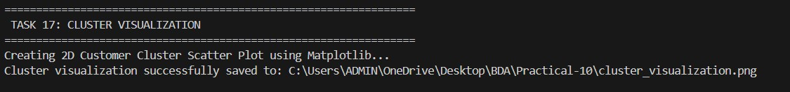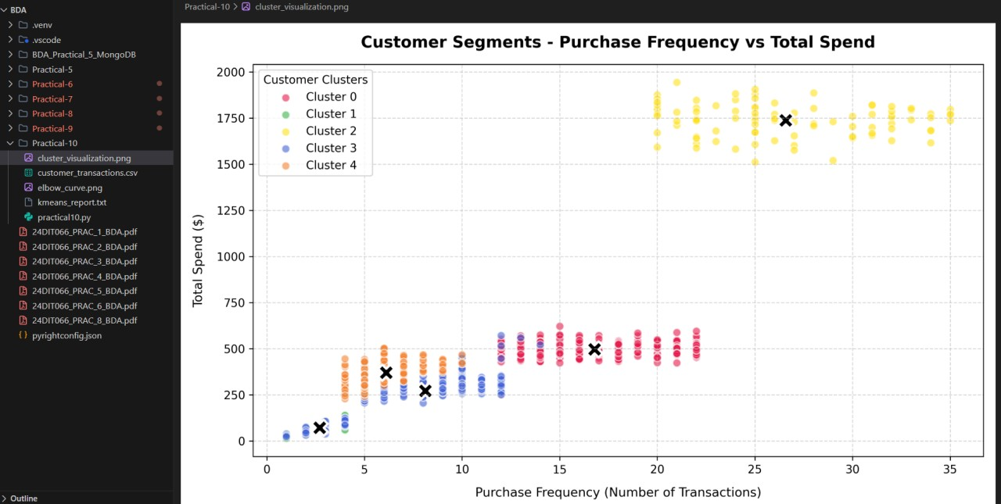

KEY QUESTIONS / ANALYSIS
Q1. Why does traditional K-Means fail at large scale, and how does Spark's parallel K-Means overcome this?
Traditional K-Means running on a single machine can face memory and processing limitations when the dataset becomes very large.
Spark MLlib distributes data processing across partitions and can execute computations in parallel. This allows large datasets to be processed across multiple machines or CPU cores.

Q2. What is the significance of the WSSSE metric? How do you use the Elbow Method to select optimal k?
WSSSE measures the sum of squared distances between data points and their assigned cluster centers.
A lower WSSSE generally indicates more compact clusters.
However, WSSSE normally decreases when more clusters are added. Therefore, the Elbow Method plots WSSSE against different values of k and looks for a point where further increases in k provide smaller improvements.
In this practical:
• k = 3 → 1264.8281
• k = 4 → 861.3095 • k = 5 → 658.8786 • k = 6 → 593.2574 • k = 7 → 518.2899
The practical selected k = 5 as a balance between cohesion and interpretability.

Q3. How does data partitioning in Spark affect convergence speed of K-Means?
Spark partitions data into smaller parts that can be processed in parallel. Appropriate partitioning can improve CPU utilization and allow distance calculations to be performed concurrently.
Poor partitioning can create processing imbalance or additional overhead, which can affect execution performance.

Q4. What customer behaviour pattern does each cluster represent? How can marketing strategies differ per segment?
The five clusters represent different purchasing behaviours:
Cluster Behaviour
Loyal / Regular
At-Risk / Lapsed
VIP / High-Value Frequent
Moderate Value / Selective
At-Risk / Lapsed
Marketing strategies can therefore be customized according to customer behaviour.
For example, VIP customers can receive exclusive benefits, while at-risk customers can receive re-engagement campaigns.

Q5. How does feature scaling impact the clustering result? What happens if features are not normalized?
Feature scaling ensures that features with larger numerical ranges do not dominate the distance calculations used by K-Means.
In this practical, StandardScaler was used to normalize:
• Total Spend
• Purchase Frequency
• Average Basket Size
• Recency
Without scaling, Total Spend could have a much stronger influence on the clustering result because of its larger numerical values.

RESULT
The customer segmentation practical was successfully implemented using Apache Spark MLlib.
A total of 11,729 transactions from 1,000 customers were processed.
Four customer behavioural features were extracted:

• Total Spend
• Purchase Frequency
• Average Basket Size
• Recency
StandardScaler was applied before clustering.
Spark MLlib K-Means successfully generated 5 customer clusters with a WSSSE of 658.8786.
The Elbow Method was evaluated for k = 3 to 7, and k = 5 was selected as a practical balance between clustering cohesion and interpretability. The cluster analysis identified different customer groups including regular customers, high-value frequent customers, moderate-value customers and atrisk/lapsed customers.

CONCLUSION
Apache Spark MLlib successfully implemented scalable K-Means clustering for customer segmentation.
The practical demonstrated the complete machine-learning workflow, including transaction preprocessing, feature extraction, feature scaling, parallel K-Means clustering, WSSSE evaluation, Elbow Method analysis and customer segment interpretation.
The results show how transactional data can be transformed into meaningful customer segments that can support targeted marketing strategies. Spark MLlib also provides a scalable architecture for processing much larger datasets than would normally fit comfortably into a single-node machine.

Github Link:

