CHAROTAR UNIVERSITY OF SCIENCE & TECHNOLOGY
Faculty of Technology & Engineering
Devang Patel Institute of Advance Technology and Research (DEPSTAR)

CSUE301 – : Big Data Analytics
Practical File – ODD Semester 2026-27

StudentID: 24DIT022
Student Name: Pankti Halatwala

Practical 7

1. Problem Definition
You are a Big Data Engineer at MovieFlix Technologies, a movie recommendation company serving millions of users worldwide. The recommendation engine repeatedly processes movie ratings data to generate personalized suggestions. Due to the increasing volume of user interactions, query execution time has become a major concern. Management wants to optimize the Spark application using Caching and Partitioning techniques to reduce execution time and improve scalability.

PART A — Practical Execution

Step 1: Creating Folder and files

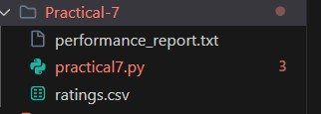

Step 2: Creating Spark Session

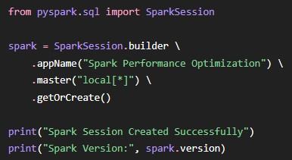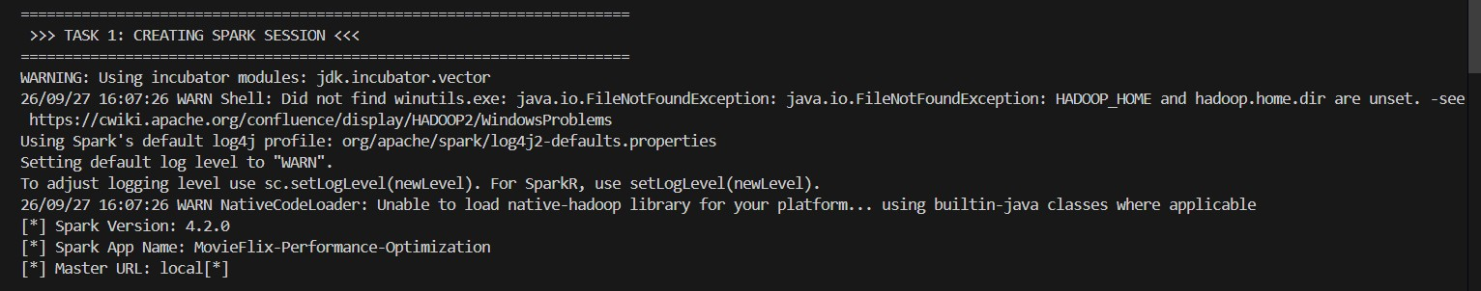

Step 3: Loading Ratings Dataset
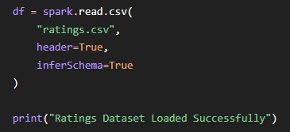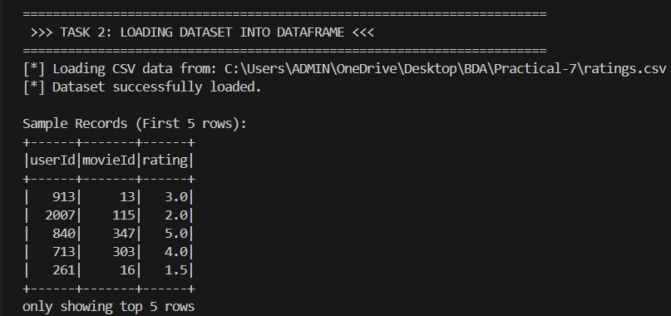

Step 4: Display Dataset Schema
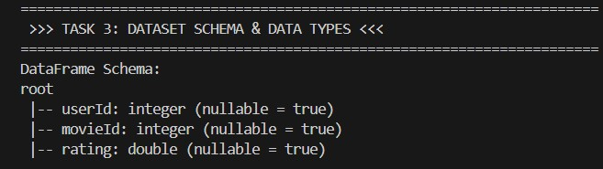

Step 5: Display Record Count and Initial Partitions
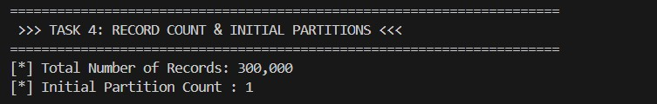

Step 6: Calculate Average Movie Rating
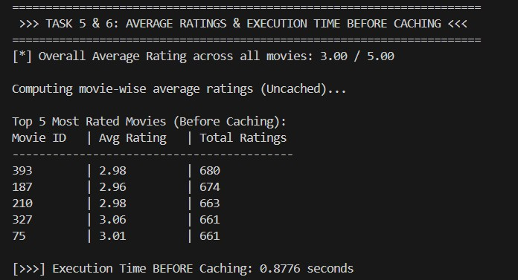

Step 7: Measure Execution Time Before Caching

Step 8: Apply cache() and Trigger Caching
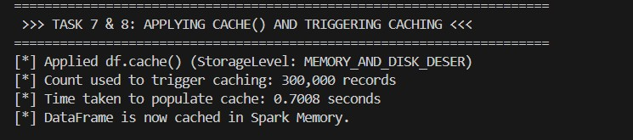

Step 9: Recalculate Average Ratings After Caching
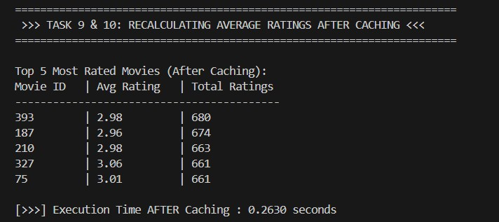

Step 10: Measure Execution Time After Caching
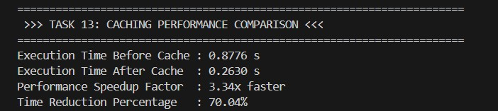

Step 11: Repartition Dataset into 2, 4 and 8 Partitions

The dataset was repartitioned into 2, 4 and 8 partitions to compare execution performance. Results:

Number of Partitions Actual Partition Count Execution Time
2 2 0.7512 s
4 4 0.4433 s
8 8 0.4900 s
The 4-partition configuration recorded the lowest execution time among these three measured repartitioning runs.
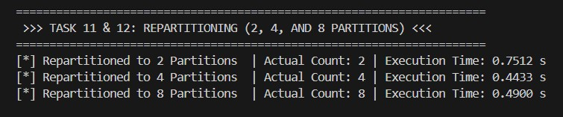

Step 12: Compare coalesce() and repartition()

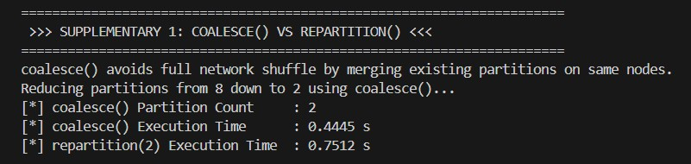

Step 13: Compare cache() and persist(DISK_ONLY)
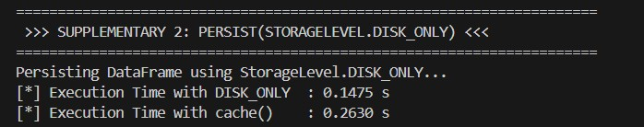

Step 14: Measure Multiple Spark Actions

Spark Action Result Execution Time count() 300,000 rows 0.1262 s take(10) 10 rows 0.0426 s filter(rating >= 4.0) 99,945 rows 0.2983 s
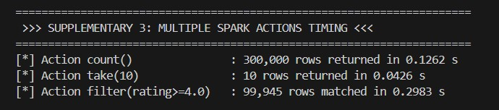

Step 15: Final Performance Summary

Dataset Details
File Name : ratings.csv
Total Records : 300,000


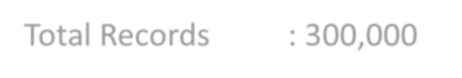
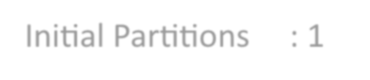





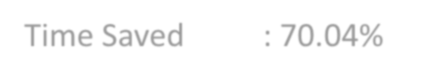



Schema : userId (int), movieId (int), rating (double)
Initial Partitions : 1
Overall Average Rating : 3.00 / 5.00
Caching Benchmark
Before Caching Time : 0.8776 seconds
After Caching Time : 0.2630 seconds
Performance Speedup : 3.34x faster
Time Saved : 70.04%
Partitioning Benchmark
2 Partitions : 0.7512 seconds
4 Partitions : 0.4433 seconds
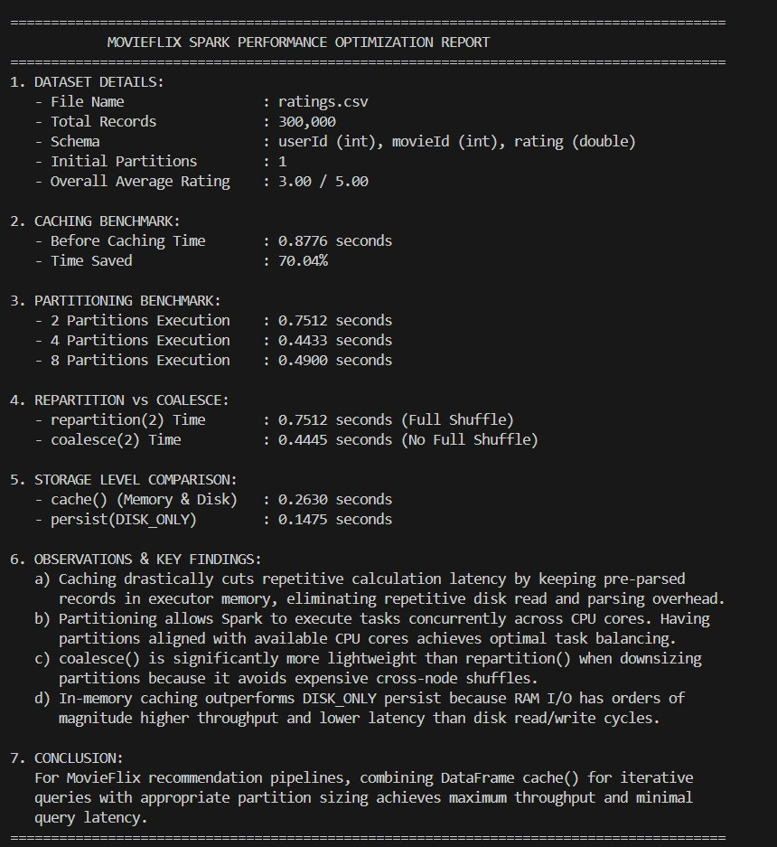
8
Partitions : 0.4900 seconds

Repartition vs Coalesce

repartition(2) : 0.7512 seconds

coalesce(2) : 0.4445 seconds

Storage Level Comparison

cache() : 0.2630 seconds

persist(DISK_ONLY) : 0.1475 seconds

Step 16: Performance Report
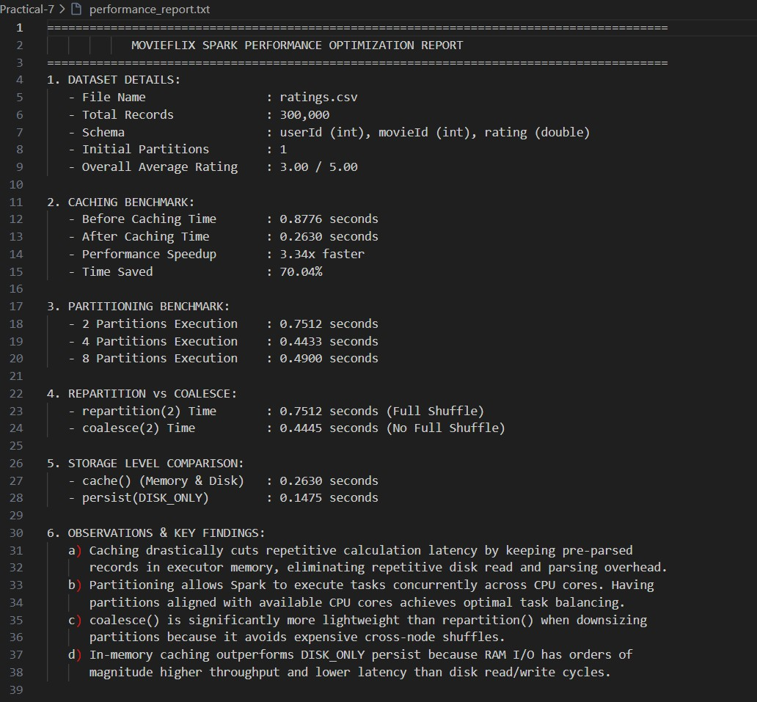

3. Key Questions / Analysis
Q1. What is caching in Apache Spark and why does it improve performance?
Caching is an optimization technique in Apache Spark in which a DataFrame or RDD is stored for reuse after it has been computed. When the same data is required again, Spark can reuse the cached data instead of recomputing it. This can reduce execution time for repeated operations.

Q2. What is the difference between cache() and persist()?
cache() is a convenient method for caching a DataFrame or RDD using Spark's default caching storage level. persist() provides more control because a specific storage level can be selected. For example: df.cache() uses the default caching storage level, whereas:
df.persist(StorageLevel.DISK_ONLY) stores the persisted data on disk.

Therefore: cache() → Simple/default caching persist() → Allows selection of storage level

Q3. How does Spark partition data internally?
Spark divides a dataset into smaller units called partitions. Spark can process these partitions through separate tasks, allowing data processing to be performed in parallel.
In this practical, the initial dataset contained 1 partition and was later repartitioned into 2, 4 and 8 partitions.

Q4. Why does repartition() improve scalability? repartition() changes the number of partitions by redistributing data. It can increase parallelism when the existing number of partitions is not suitable for the workload.
For example: df.repartition(8) creates 8 partitions.
However, repartitioning involves data redistribution and therefore can introduce shuffle overhead.

Q5. How does lazy evaluation affect Spark performance?
Spark uses lazy evaluation for transformations. Operations such as select(), filter() and withColumn() do not immediately execute the computation.
Spark builds an execution plan and executes the required operations when an action such as count(), show() or collect() is called.
Therefore:

Transformation → Defines the operation Action → Triggers execution

4. Conclusion
The practical successfully demonstrated Spark performance optimization using Caching and
Partitioning techniques. The movie ratings dataset containing 300,000 records was loaded into a Spark DataFrame, its schema and partition count were examined, and the average movie rating was calculated.
The execution time before caching was 0.8776 seconds, while the measured execution time after caching was 0.2630 seconds. This resulted in a measured 3.34× speedup and 70.04% time reduction for the tested operation.
The dataset was also repartitioned into 2, 4 and 8 partitions to study the effect of partitioning on execution time. The practical further compared coalesce() with repartition() and cache() with persist(StorageLevel.DISK_ONLY).
The experiment demonstrated how caching can reduce repeated computation and how partitioning techniques can be used to control parallel data processing in Spark.

5. Github Link
Github Link: _ https://github.com/panktihalatwala/24DID022_BDA

