v11 演示稿：表型框架（相容性 → 区别性 → 临床相关性）；按 JAAD 规则图表合计 2 项（单面板图 1 + 表 I）；首段研究空白按 FASCE 修正。已有数字沿用 v2 模拟参数（FICTIONAL）；黄色高亮为占位符。Key Message + 正文 = 470 words；5 条文献。
Is Persistent Acne at the Upper Lip, Chin, and Jawline a Distinct Regional Phenotype? A Cross-Sectional Study
Key Message: Persistent acne activity at the upper lip, chin, and jawline behaved as a coherent region with clinical correlates distinct from the rest of the face and was often patients' main concern.
Mandibular-predominant acne affects about 20% of adult women; separate mandibular scoring has been proposed¹ and reported in a spironolactone trial.² The chin is the most frequently involved facial site,³ yet chin involvement was not associated with biochemical hyperandrogenemia in a recent study.⁴ Whether persistent activity at the upper lip, chin, and jawline forms a coherent regional phenotype, sharing clinical correlates that differ from the rest of the face and matching what patients most want treated, has not been tested.
Adults with acne and no acne medication for 6 months reported, for each of 7 sites, whether active lesions were present in at least 3 of the past 6 months (activity) and the highest lesion type recalled (Chinese grades I–IV);⁵ physicians recorded current global grade and site morphology. Beard-associated sites (upper lip, chin, jawline) is an anatomical term for both sexes. Four clinical correlates were prespecified: age >25 years, premenstrual aggravation (women), body mass index ≥24 kg/m², and listed high-glycemic foods ≥3 times weekly. The phenotype was examined in 3 steps: coherence (direction of each correlate at each component site), distinction (factor-by-region interaction in long-format logistic regression with site intercepts and participant-clustered errors, adjusted for age, sex, body mass index, and current global grade, expressed as a ratio of odds ratios [ROR]), and clinical relevance (most bothersome site versus expectation from each participant's involved sites).
Of 600 respondents (92.3%), 580 had complete site data (430 women). Beard-associated activity occurred in 300 (51.7%). Each correlate pointed in the same direction at the upper lip, chin, and jawline (Table I), and contrasts persisted when the chin was excluded. All 4 correlates were more strongly associated with beard-associated than other sites (Fig 1): age >25 years (ROR, 2.14; 95% CI, 1.51–3.05), premenstrual aggravation (2.02; 1.29–3.17), body mass index (1.72; 1.19–2.50), and high-glycemic foods (1.44; 1.01–2.05). Recalled pustules or nodules/cysts were reported at 56.0%–60.0% of involved beard-associated sites versus 20.0%–30.0% elsewhere. Of 170 participants with both regions involved, 112 (65.9%) were most bothered by a beard-associated site (expected, __; P = __). Contrasts were similar for grade III–IV activity and after adjustment for site-level oiliness.
Persistent acne activity at the upper lip, chin, and jawline behaved as a coherent region with clinical correlates distinct from the rest of the face and was often patients' main concern. These cross-sectional associations held after adjustment for current global grade but do not establish mechanism, and site does not identify androgen excess.⁴ Persistent activity in this region may prompt targeted questions about menstrual pattern, weight, and diet, with treatment guided by established indications. Recall-based activity and exclusion of recently treated patients limit inference; prospective, site-resolved studies are needed.
Declarations
Authors: names, degrees, affiliations
Funding sources: to complete
Conflicts of interest: to complete
IRB approval status: committee and approval number; written informed consent obtained
Supplementary material: Mendeley Data DOI
Key words: acne vulgaris; beard-associated sites; chin; jawline; upper lip; facial distribution; premenstrual acne; phenotype; cross-sectional study
References
1. Carmina E, Dreno B, Lucky WA, et al. Female adult acne and androgen excess: a report from the Multidisciplinary Androgen Excess and PCOS Committee. J Endocr Soc. 2022;6(3):bvac003. doi:10.1210/jendso/bvac003
2. Dréno B, Nguyen JM, Hainaut E, et al. Efficacy of spironolactone compared with doxycycline in moderate acne in adult females: results of the multicentre, controlled, randomized, double-blind prospective and parallel Female Acne Spironolactone vs doxyCycline Efficacy (FASCE) study. Acta Derm Venereol. 2024;104:adv26002. doi:10.2340/actadv.v104.26002
3. Telkkälä A, Jokelainen J, Piltonen T, Huilaja L, Sinikumpu SP. The prevalence and characteristics of adult female acne: a cross-sectional population-based study. Acta Derm Venereol. 2025;105:adv44151. doi:10.2340/actadv.v105.44151
4. Altunel CT, Tatlıcan S. The clinical predictors of biochemical hyperandrogenemia and its relation to treatment resistance in women with acne. Postepy Dermatol Alergol. 2025;42(1):54-61. doi:10.5114/ada.2024.144480
5. Chinese Acne Treatment Guidelines Expert Group. Guideline for diagnosis and treatment of acne (the 2019 revised edition). J Clin Dermatol. 2019;48(9):583-588. doi:10.16761/j.cnki.1000-4963.2019.09.020 [In Chinese]

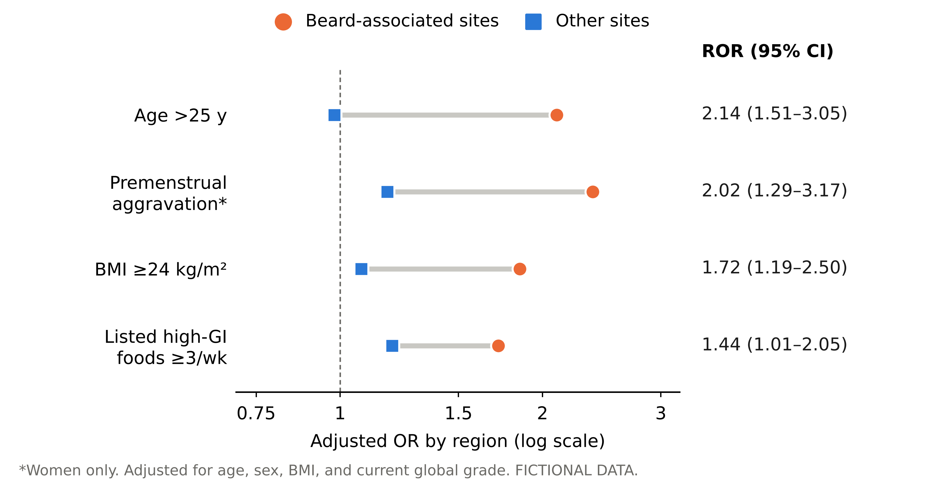
Fig 1. Region-level adjusted odds ratios (ORs) for the 4 prespecified clinical correlates at beard-associated sites (upper lip, chin, jawline; circles) and other facial sites (forehead, cheeks, nose; squares). The ratio of ORs (ROR) is the factor-by-region interaction from long-format logistic regression with site intercepts and participant-clustered standard errors, adjusted for age, sex, body mass index (BMI), and current global grade. GI, glycemic index. Fictional data.
Table I. Activity and adjusted ORs for the 4 clinical correlates at each facial site
FICTIONAL PARAMETERS; highlighted cells to be filled with real data. Cells show OR (95% CI).
Site | Activity,  % | Recalled  III–IV, %† | Age  >25 y | Premenstrual  aggravation* | BMI  ≥24 kg/m² | Listed high-GI  foods ≥3/wk
Beard-associated
Upper lip | 25.9 | 56.0 | 2.00  (1.27–3.14) | 2.25  (1.27–3.97) | 1.75  (1.07–2.86) | 1.65  (1.05–2.59)
Chin | 39.7 | 60.0 | 2.20  (1.46–3.32) | 2.50  (1.47–4.24) | 1.95  (1.24–3.06) | 1.80  (1.19–2.72)
Jawline | 32.8 | 56.8 | 2.10  (1.36–3.23) | 2.35  (1.36–4.07) | 1.85  (1.16–2.96) | 1.70  (1.10–2.62)
Other
Forehead | 37.9 | 25.9 | 0.95  (0.64–1.41) | 1.20  (0.71–2.04) | 1.10  (0.71–1.69) | 1.18  (0.80–1.75)
Right cheek | 39.7 | 27.8 | 1.00  (0.64–1.57) | 1.15  (0.64–2.07) | 1.05  (0.64–1.71) | 1.20  (0.75–1.92)
Left cheek | 41.4 | 30.0 | 1.10  (0.76–1.60) | 1.25  (0.75–2.08) | 1.15  (0.76–1.74) | 1.25  (0.86–1.81)
Nose | 22.4 | 20.0 | 0.85  (0.55–1.31) | 1.10  (0.62–1.94) | 1.00  (0.62–1.60) | 1.15  (0.73–1.80)
ROR excluding chin‡ |  |  | __ | __ | __ | __
Activity, active lesions at the site in at least 3 of the past 6 months (N = 580); it is a threshold for persistent or recurrent involvement, not a measure of flare frequency. †Highest lesion type recalled at involved sites: grade III, pustules; IV, nodules/cysts. *400 women with applicable menstrual responses. Each factor and site was modeled separately, adjusted for age group, sex, BMI, and current global grade (omitting the factor itself). ‡Region contrast with the upper lip and jawline as the beard-associated region, testing whether the result depends on the chin. BMI, body mass index; GI, glycemic index; OR, odds ratio; ROR, ratio of ORs.

