Supplementary Material — v11（表型框架）。已有数字沿用 v2 模拟参数（FICTIONAL）；黄色高亮为占位符，只能由真实数据填写。
Supplementary Material
Is Persistent Acne at the Upper Lip, Chin, and Jawline a Distinct Regional Phenotype? A Cross-Sectional Study
Supplementary Methods
Study question and design rationale
The study tests a clinical regional hypothesis: that persistent activity at the upper lip, chin, and jawline forms a coherent phenotype. Three properties were required, each prespecified with its own criterion (Supplementary Table S1): coherence (the 3 component sites share the direction of association with each clinical correlate, and the result does not depend on the chin alone); distinction (the correlates are more strongly associated with these sites than with the forehead, cheeks, and nose within the same participants); and clinical relevance (these sites are the main concern of patients more often than expected from their involvement). A positive pooled result alone was not considered sufficient.
Lower-face involvement has been described as characteristic of adult female acne,[S1] although most adult women in a large international study had acne distributed as in adolescents[S2] and cheeks predominated in an Indian adult series.[S3] Facial sebaceous glands show higher type 1 5α-reductase activity than non-acne-prone skin,[S4] and beard follicles are androgen dependent.[S5] Premenstrual flares are common, yet one survey found no difference in facial distribution between women with and without them.[S6] BMI correlates with acne severity in women,[S7] and a low-glycemic-load diet improves acne;[S8] neither has been examined by site. A mandibular score has been proposed for adult female acne[S9] and reported in a spironolactone trial (main text reference 2), whereas a larger spironolactone trial did not report site-specific outcomes.[S10] The present study therefore does not claim that regional scoring is new; it tests whether this specific 3-site combination is coherent, distinct, and clinically relevant.
The 4 correlates are clinical markers, not measurements of hormones or metabolism: age is a population characteristic; premenstrual aggravation is a reproductive-endocrine clinical clue; BMI ≥24 kg/m² reflects body size and possible metabolic risk, not established metabolic disease; and listed high-glycemic foods are a dietary exposure frequency, not a measured glycemic index, insulin, or IGF-1.
Participants and measures
Setting: institution(s); recruitment period: dates. Consecutive adults (≥18 years) with clinician-supported acne and no acne medication during the preceding 6 months were invited. The study was approved by committee, approval number; written informed consent was obtained.
Seven sites were assessed with a standard diagram: forehead, right and left cheeks, nose, upper lip (philtral region), chin, and jawline (mandibular border, excluding the neck). "Beard-associated" is an anatomical term applied to both sexes. Activity (N1): active lesions at that site in at least 3 different months of the past 6 months (yes/no/uncertain); marks and scars do not count. This is a threshold for persistent or recurrent involvement within a recall window, not a measure of flare frequency. For each active site, participants recorded the highest lesion type recalled (Q10-R; Chinese grade I, comedones; II, papules; III, pustules; IV, nodules/cysts); this is the most severe type that occurred, not the most common type.
At the visit, a physician recorded current global grade (C1) and current highest lesion type at each site (C1-L), and flagged possible alternative diagnoses (C2). C1-L describes current morphology and supports differential diagnosis; it is not used to validate 6-month recall. Participants also rated perceived oiliness at each site (N2); women with premenstrual aggravation indicated which sites were affected (N4); participants with any burden named the most bothersome site (Q41-R), the lesion types or sequelae that bothered them at each site (Q43-R), and their most important treatment goal and its location (N7).
Statistical analysis
Step 1, coherence. Site-specific ORs for each correlate were estimated at all 7 sites (main Table I). A 2-df Wald test of correlate-by-component interaction within beard-associated rows is reported descriptively; non-significance is not interpreted as equivalence. Region contrasts were repeated with each component removed in turn, in particular without the chin, to test whether the region result depends on a single site (Supplementary Table S2).
Step 2, distinction (primary). Data were arranged with one row per participant-site (580 × 7 = 4060 rows; 2800 for the menstrual analysis). For each correlate separately, logit Pr(activity) = site intercept + β·factor + γ·(factor × beard-associated site) + covariates, with participant-clustered standard errors. The ratio of ORs (ROR) is exp(γ). Covariates were age group, sex, BMI, and current global grade (clear, I, II, III, IV), omitting the factor itself and sex in the female-only model. Benjamini–Hochberg correction was applied across the 4 contrasts. The interaction compares regions within the same participants and is unaffected by confounders whose effect on the log-odds is the same at every site; confounders acting differently by region, and residual confounding by acne burden over the recall window, are not removed. Current global grade is a single-visit measure and does not capture 6-month burden.
Validation and sensitivity analyses. (a) Grade III–IV activity (activity with recalled grade III or IV at that site) as the outcome, judged by direction; (b) the primary model without current global grade; (c) additional adjustment for site-level perceived oiliness; (d) additional adjustment for daily mask wearing ≥4 hours; (e) for the 3 non-age correlates, restriction to participants aged 18–25 years. A difference in the 18–25-year subgroup indicates effect modification by age within this sample; it cannot identify adult-onset acne. Attenuation after adjustment for site-level oiliness indicates overlap between the correlate and local oiliness; it cannot establish sebum as a mediator. Sex-specific RORs are reported for correlates applicable to both sexes (Supplementary Tables S3 and S4).
Step 3, clinical relevance. Among participants with both regions involved and a single most bothersome site among their involved sites, the expected number of beard-associated choices was Σ(beard-associated involved sites / all involved sites); observed and expected counts were compared with an exact Poisson-binomial test. Participants whose most bothersome site did not meet the activity threshold (for example, because scars or marks were the main concern) were retained and described, not excluded. At the most bothersome site, the type of bother (active lesions, marks, scars) was summarized from Q43-R, and treatment goals and their locations from N7. Current nodules or cysts at examination (C1-L) and site-specific premenstrual aggravation (N4) were summarized by region; both are descriptive, and N4 shares the self-report source of the premenstrual correlate (Supplementary Table S5).
Auxiliary and exploratory analyses. Self-reported oily skin and heavy sweating were analyzed in the same model and reported descriptively (Supplementary Table S6). Resting sweat secretion is highest on the forehead and eccrine gland density lowest on the upper lip;[S11] sebum output is higher on the forehead and nose than on the cheeks, but the chin is also sebum-rich,[S12] and lesion counts have correlated with cheek rather than forehead–nose–chin sebum.[S13] Exploratory factors carry nominal P values (Supplementary Table S7). Clinical considerations in the main text remain within current guidelines.[S14] Software: name, version.
Supplementary references
S1. Dréno B, Layton A, Zouboulis CC, et al. Adult female acne: a new paradigm. J Eur Acad Dermatol Venereol. 2013;27(9):1063-1070. doi:10.1111/jdv.12061
S2. Dréno B, Thiboutot D, Layton AM, Berson D, Perez M, Kang S. Large-scale international study enhances understanding of an emerging acne population: adult females. J Eur Acad Dermatol Venereol. 2015;29(6):1096-1106. doi:10.1111/jdv.12757
S3. Khunger N, Kumar C. A clinico-epidemiological study of adult acne: is it different from adolescent acne? Indian J Dermatol Venereol Leprol. 2012;78(3):335-341. doi:10.4103/0378-6323.95450
S4. Thiboutot D, Harris G, Iles V, Cimis G, Gilliland K, Hagari S. Activity of the type 1 5α-reductase exhibits regional differences in isolated sebaceous glands and whole skin. J Invest Dermatol. 1995;105(2):209-214. doi:10.1111/1523-1747.ep12317162
S5. Randall VA. Androgen-dependent human hair growth: a biological paradox. Endocr Abstr. 2004;7:S24. consider replacing with Randall VA, Androgens and hair growth, Dermatol Ther 2008, after verification
S6. Geller L, Rosen J, Frankel A, Goldenberg G. Perimenstrual flare of adult acne. J Clin Aesthet Dermatol. 2014;7(8):30-34.
S7. Alan S, Cenesizoglu E. Effects of hyperandrogenism and high body mass index on acne severity in women. Saudi Med J. 2014;35(8):886-889.
S8. Smith RN, Mann NJ, Braue A, Mäkeläinen H, Varigos GA. A low-glycemic-load diet improves symptoms in acne vulgaris patients: a randomized controlled trial. Am J Clin Nutr. 2007;86(1):107-115. verify page range
S9. Auffret N, Claudel JP, Leccia MT, et al. AFAST – Adult Female Acne Scoring Tool: an easy-to-use tool for scoring acne in adult females. J Eur Acad Dermatol Venereol. 2016;30(5):824-828. doi:10.1111/jdv.13518 verify volume and pages
S10. Santer M, Lawrence M, Renz S, et al. Effectiveness of spironolactone for women with acne vulgaris (SAFA) in England and Wales: pragmatic, multicentre, phase 3, double blind, randomised controlled trial. BMJ. 2023;381:e074349. doi:10.1136/bmj-2022-074349
S11. Taylor NAS, Machado-Moreira CA. Regional variations in transepidermal water loss, eccrine sweat gland density, sweat secretion rates and electrolyte composition in resting and exercising humans. Extrem Physiol Med. 2013;2:4. doi:10.1186/2046-7648-2-4
S12. Youn SW, Na JI, Choi SY, Huh CH, Park KC. Regional and seasonal variations in facial sebum secretions: a proposal for the definition of combination skin type. Skin Res Technol. 2005;11(3):189-195. doi:10.1111/j.1600-0846.2005.00119.x
S13. Jung IS, Yun SJ, Lee JB. The difference in sebum secretion affecting development of acne. Ann Dermatol. 2019;31(4):426-433. doi:10.5021/ad.2019.31.4.426
S14. Reynolds RV, Yeung H, Cheng CE, et al. Guidelines of care for the management of acne vulgaris. J Am Acad Dermatol. 2024;90(5):1006.e1-1006.e30. doi:10.1016/j.jaad.2023.12.017

Supplementary Fig S1. Proportion of participants with qualifying activity at each site (shading) and, among involved sites, the proportion with recalled grade III–IV lesions. Beard-associated sites are outlined; the jawline is 1 site shown bilaterally. Fictional data.
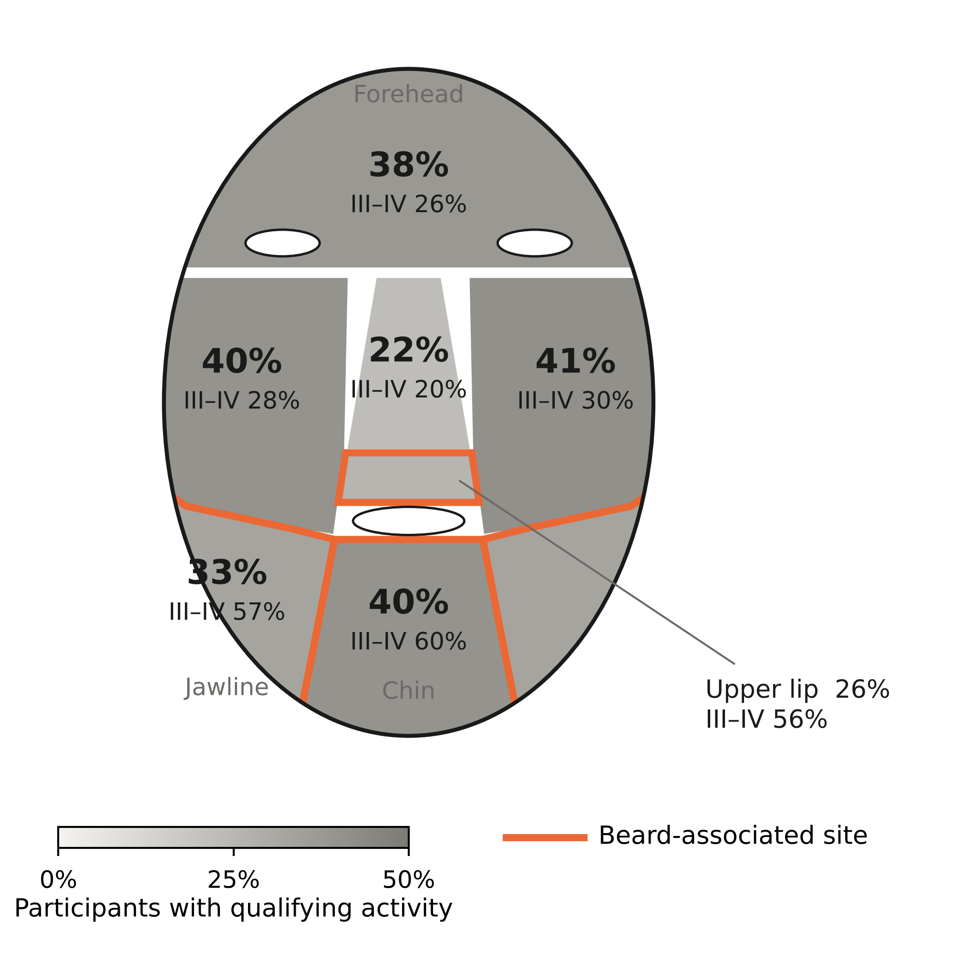

Supplementary Table S1. Prespecified criteria for each step
Step | Criterion for support | If not met
Coherence | For ≥3 of 4 correlates, the OR point estimate is >1 at each of the upper lip, chin, and jawline, and the ROR excluding the chin is >1 | Report component sites separately; the region claim is limited to the components that meet the criterion
Distinction (primary) | ≥3 of 4 RORs >1 with Benjamini–Hochberg-adjusted P <.05, with the same direction for grade III–IV activity | Report as a descriptive distribution study; no regional phenotype claim
Clinical relevance | Observed beard-associated choices of most bothersome site exceed expectation (exact P <.05) | Retain the association findings; remove the patient-priority statement from the Key Message
Overall | Regional phenotype language is used only if all 3 steps are supported | With 2 of 3 supported, describe as "partial support" and name the unmet step

Supplementary Table S2. Coherence checks
TO BE FILLED WITH REAL DATA.
Correlate | Component heterogeneity P | ROR without chin | ROR without upper lip | ROR without jawline
Age >25 y | __ | __ (__–__) | __ (__–__) | __ (__–__)
Premenstrual aggravation | __ | __ (__–__) | __ (__–__) | __ (__–__)
BMI ≥24 kg/m² | __ | __ (__–__) | __ (__–__) | __ (__–__)
Listed high-GI foods ≥3/wk | __ | __ (__–__) | __ (__–__) | __ (__–__)

Supplementary Table S3. Validation and sensitivity analyses, ROR (95% CI)
Primary column repeats fictional parameters; other columns TO BE FILLED.
Correlate | Primary | Grade III–IV activity | Without global grade | + Site-level oiliness | + Mask wearing | Aged 18–25 y
Age >25 y | 2.14 (1.51–3.05) | __ (__–__) | __ (__–__) | __ (__–__) | __ (__–__) | Not applicable
Premenstrual aggravation | 2.02 (1.29–3.17) | __ (__–__) | __ (__–__) | __ (__–__) | __ (__–__) | __ (__–__)
BMI ≥24 kg/m² | 1.72 (1.19–2.50) | __ (__–__) | __ (__–__) | __ (__–__) | __ (__–__) | __ (__–__)
Listed high-GI foods ≥3/wk | 1.44 (1.01–2.05) | __ (__–__) | __ (__–__) | __ (__–__) | __ (__–__) | __ (__–__)

Supplementary Table S4. Contrasts by sex, ROR (95% CI)
TO BE FILLED WITH REAL DATA (fictional sample: 150 men, 430 women).
Correlate | Men | Women | Sex interaction P
Age >25 y | __ (__–__) | __ (__–__) | __
BMI ≥24 kg/m² | __ (__–__) | __ (__–__) | __
Listed high-GI foods ≥3/wk | __ (__–__) | __ (__–__) | __

Supplementary Table S5. Clinical relevance
Fictional values where shown; other cells TO BE FILLED.
Measure | Beard-associated sites | Other sites | Note
Most bothersome site among participants with both regions involved, n/N | 112/170 (65.9%) | 58/170 (34.1%) | Expected beard-associated choices __; exact P __
Most bothersome site did not meet the activity threshold, n | __ | __ | Retained; main bother at that site (Q43-R) described below
Main bother at the most bothersome site: active lesions / marks / scars, % | __ / __ / __ | __ / __ / __ | Q43-R
Most important goal "persistent or recurrent lesions", located at site region, n | 84/126 | 42/126 | N7; fictional
Current nodules or cysts at examination, % of participants | __ | __ | C1-L; descriptive
Site-specific premenstrual aggravation among women with premenstrual aggravation, % | __ | __ | N4; same self-report source as the correlate

Supplementary Table S6. Auxiliary sebum and sweat factors
Reported descriptively; not part of the phenotype criteria.
Factor | Region OR,  beard-associated | Region OR,  other | ROR (95% CI)
Self-reported oily skin | 1.67 | 2.52 | 0.66 (0.50–0.87)
Heavy sweating | __ | __ | __ (__–__)
Oily skin values are fictional; heavy sweating to be filled. Sebum production is itself androgen dependent, so oiliness is not independent of the hormonal axis.

Supplementary Table S7. Exploratory factors
No prespecified direction; nominal P values. Fictional values where shown.
Factor | Outcome | Estimate (95% CI) | P
Smoking ≥1/day for ≥1 y | Activity, ROR | 1.86 (1.05–3.28) | .032
Smoking ≥1/day for ≥1 y | Jawline grade III–IV activity, OR | __ (__–__) | __
Irregular sleep schedule | Activity, ROR | 1.68 (1.18–2.40) | .004
PHQ-4, per point | Activity, ROR | 1.10 (1.04–1.16) | .001
Menstrual irregularity (women) | Activity, ROR | __ (__–__) | __
Self-reported physician-diagnosed PCOS (women) | Activity, ROR | __ (__–__) | __
The smoking–jawline analysis tests a clinical observation of pustular jawline acne in long-term smokers; it is adjusted for age group, sex, and BMI. Shaving was not recorded, so in men smoking may be partly confounded by shaving-related lesions. PCOS, polycystic ovary syndrome; PHQ-4, Patient Health Questionnaire-4.

