Early functional mitral and tricuspid regurgitation response patterns after ablation in paroxysmal and persistent atrial fibrillation
Ying Cao;¹ Aobo Gong;¹ Chen Jun;¹ Zexi Li;¹ Fanghui Li;¹ Xianjin Hu;¹ Bangjiaxin Ren;¹ Wenjie Li;¹ Zhou Yifan;¹ Rui Zeng;¹
¹Department of Cardiology, West China Hospital, Sichuan University, Chengdu, China
Rui Zeng, MD, PhD, ¹Department of Cardiology, West China Hospital, Sichuan University, 37 Guoxue Road, Chengdu 610041, Sichuan, China.
Tel: +86-028-85423248, Fax: +86-028-85582944, Email: zengrui_0524@126.com
Short title: Valve response patterns across AF types
Word count: 4,782 main text; 250 abstract (excluding references, tables, and figure legends)

Abstract
Background and Aims
Functional mitral (MR) and tricuspid regurgitation (TR) may improve after atrial fibrillation (AF) ablation, but their within-patient concordance remains unclear. We examined joint and discordant responses in parallel in paroxysmal and persistent AF.
Methods
Among 3,551 AF ablation patients with an in-hospital baseline echocardiogram, baseline phenotypes were characterized in 3,045 and 1-month responses in 844 procedures (837 patients; 343 paroxysmal, 501 persistent AF) with baseline MR or TR. Improvement was a ≥1-analysis-grade reduction. Twelve prespecified baseline factors were mutually adjusted and, post hoc, related to joint improvement.
Results
Baseline MR and/or TR was present in 51.6%; combined disease was more frequent in persistent than paroxysmal AF (37.4% vs 11.6%). At 1 month, MR improved in 47.2% and TR in 52.7% of valve series; among moderate-or-greater series, 43.3% of MR and 48.9% of TR regressed to mild or less. In combined disease, both valves improved in 34.4%, exceeding independent expectation in both AF types (observed/expected ratio, 1.36); blinded re-reading supported the association (odds ratio [OR], 4.01; 95% CI, 2.10–7.63). Joint improvement was more likely with higher body mass index (OR, 1.79; 1.33–2.40) and less likely with larger left atrium (OR, 0.62; 0.43–0.89). Joint improvement at 1 year was present in 83% after early joint improvement versus 19% after none.
Conclusion
About half of AF ablation candidates had functional MR or TR; one-fifth had both. After ablation, both valves tended to improve together, more often with higher body mass index and smaller atria, and early joint improvement usually persisted, supporting valve-by-valve reassessment at 1 month.
Key Words: atrial fibrillation; catheter ablation; echocardiography; mitral valve insufficiency; tricuspid valve insufficiency
What’s new?
• About half of patients undergoing AF ablation had functional MR or TR, and one in five had both; combined disease was three times as frequent in persistent as in paroxysmal AF.
• Within 1 month after ablation, MR and TR tended to improve together beyond chance in both AF types, and nearly half of moderate-or-greater regurgitation regressed to mild or less.
• Joint improvement was more likely with higher body mass index and smaller atria; with a larger left atrium, improvement was more often confined to one valve.
• Joint improvement at 1 month usually persisted at 1 year (83% vs 19% when neither valve improved), supporting valve-by-valve echocardiographic reassessment at 1 month.

Introduction
Atrial fibrillation (AF) promotes atrial and annular remodeling that can cause functional mitral regurgitation (MR) and tricuspid regurgitation (TR),^{1,2} both associated with heart failure, hospitalization, and mortality.^{3,4} Catheter ablation may reduce regurgitation through rhythm restoration and subsequent changes in cardiac structure and loading.^{5,6} Understanding the valve response is therefore relevant when evaluating patients with AF and functional regurgitation.
MR and TR often coexist as a high-risk combined phenotype.^{7,8} A prospective persistent AF cohort assessed before cardioversion found combined moderate or severe MR/TR in 22.4%.⁹ Improvement of individual valves after rhythm control has been reported,^{6,10,11} but aggregate rates do not reveal whether both valves improve in the same patient. A shared response may coexist with valve-specific variation, leaving relevant regurgitation in one valve despite improvement of the other. Paroxysmal and persistent AF offer clinically defined settings in which to examine this pattern, alongside differences in baseline regurgitation burden and rhythm outcomes.
We therefore addressed four questions in patients undergoing AF ablation, in parallel in paroxysmal and persistent AF: how common isolated and combined MR/TR are before ablation; whether both valves improve together within patients beyond chance; which baseline characteristics distinguish patients whose improvement extends to both valves; and whether the joint state at 1 month indicates the later course. Blinded re-reading and an aortic regurgitation (AR) negative control assessed robustness.

Methods

Study population and analysis sets
This single-center retrospective study at West China Hospital, Sichuan University, included adults (age ≥18 years) undergoing AF ablation between January 2020 and September 2024 with an in-hospital baseline transthoracic echocardiography (TTE) report (n=3,682). After uniform exclusion of prior or concurrent valve surgery (n=74), organic valve disease (n=30), congenital heart disease (n=19), and obstructive hypertrophic cardiomyopathy (n=8), the study population comprised 3,551 patients (Figure 1). Two analysis sets addressed complementary questions: a baseline phenotype set of 3,045 patients characterized regurgitation burden and coexistence, and a paired response set of 844 procedures in 837 patients assessed 1-month improvement; 372 patients belonged to both sets. Paroxysmal and persistent AF were analyzed separately within each set using common definitions.
The baseline phenotype set included one admission per patient, the first ablation admission in the study period; MR and TR grades were extracted from its TTE report (weighted κ against manual abstraction, 0.96–0.97), and patients were classified as having neither valve, MR only, TR only, or both affected (analysis grade ≥1; Supplementary Table S1A). Registry grades were recorded only for patients with regurgitation and were not used to estimate prevalence.
For the paired response set, the study registry identified 1,445 admissions in 1,419 patients of the study population with MR or TR of analysis grade ≥1 (very mild or worse) on the in-hospital baseline TTE. Admissions without a 1-month TTE (n=601) were excluded and compared with included procedures (Supplementary Table S1B). The set comprised 844 procedures in 837 patients: isolated MR (n=132), isolated TR (n=325), and combined MR/TR (n=387). Seven patients underwent two ablations, with each procedure analyzed separately. When the baseline-set admission was itself a paired procedure (366 of the 372 patients in both sets), paired-analysis baseline grades were used in both sets.
Paroxysmal and persistent AF contributed 343 and 501 procedures, respectively, with common endpoints and model contrasts for isolated MR, isolated TR, and combined disease; one patient contributed a procedure to each. Baseline phenotypes were also analyzed by AF type. The parallel framework was added after the initial overall analyses. Stratified baseline-factor models omitted AF type and retained whole-cohort interquartile ranges; log-scale OR heterogeneity was assessed between groups (Supplementary Table S11).
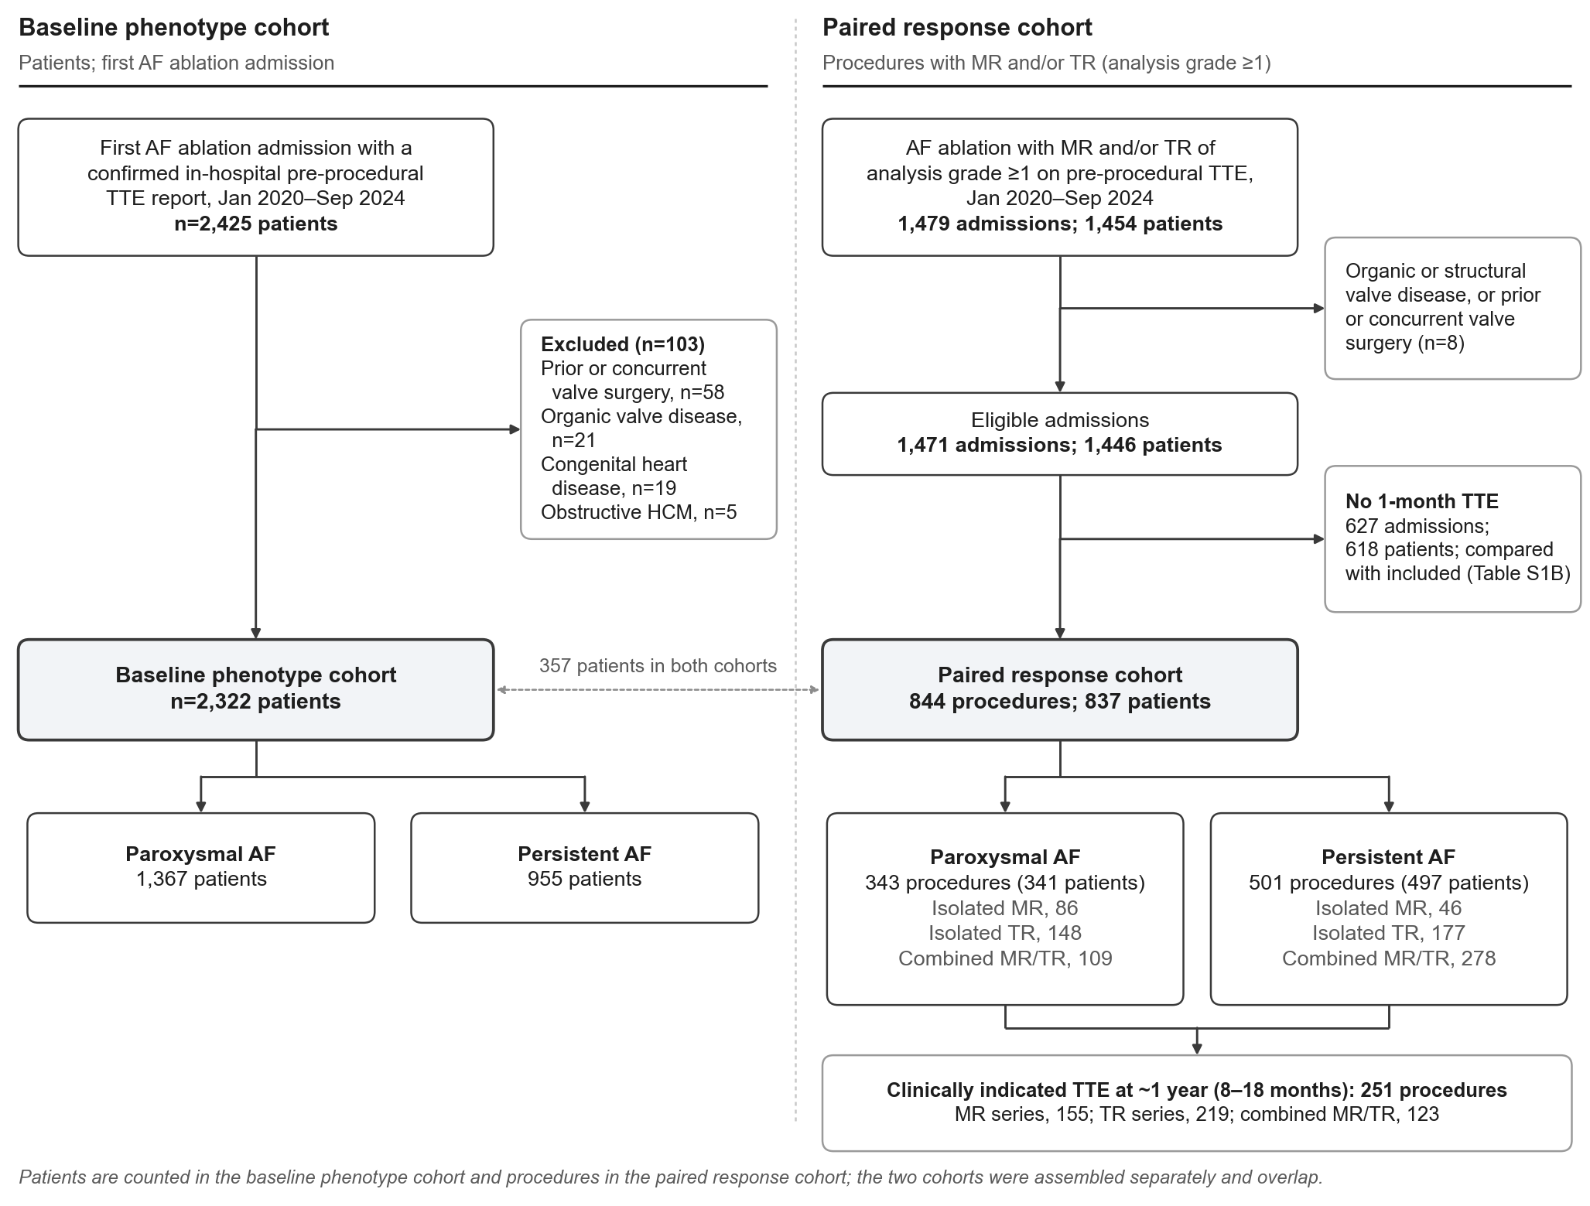
Figure 1. Study population and analysis sets.

Echocardiographic Assessment and Study Endpoints
Standardized TTE was performed before and 1 month after ablation. Anonymized examinations were re-read in random order on the eight-level scale, blinded to time point, rhythm, and report grades. A Level III echocardiographer also blinded to phenotype read 100 randomly sampled procedures; a second echocardiographer read 126 further combined-disease procedures and 20 first-sample examinations. Joint-response analysis in all 172 combined-disease procedures and its criterion (lower 95% confidence limit of the MR–TR improvement OR >1) were specified before the second reading (Supplementary Table S2).
MR and TR severity was graded by integrating color Doppler jet characteristics, vena contracta width, and supportive semi-quantitative parameters according to contemporary recommendations.^{12–14} Reports used an institutional eight-level scale: none/trace, very mild, mild, mild-to-moderate, moderate, moderate-to-severe, severe, and very severe. Analysis grades were 0, none/trace; 1, very mild or mild; 2, moderate (including report-labelled mild-to-moderate and moderate); 3, moderate-to-severe or worse (MR) or moderate-to-severe or severe (TR); and 4, very severe TR. Grade 4 represented the combined beyond-severe category encompassing massive and torrential TR, consistent with expanded grading and published use of very severe TR.^{15,16} Analysis grade ≥2 was termed study-defined moderate or greater. For MR, mild-to-moderate (Grade 2/2+) is a subclass of moderate in the EACVI/ESC convention.¹⁴ For TR, this collapsed category was an operational study definition. Individual examinations were not independently reclassified against guideline quantitative thresholds.
The primary end point was a ≥1-analysis-grade reduction in MR or TR from baseline to 1 month. Sensitivity endpoints included improvement among series with study-defined moderate-or-greater baseline regurgitation (analysis grade ≥2), a ≥2-grade reduction, and regression to grade ≤1 (mild or less), with alternative mappings and the original eight-level scale. In combined MR/TR, four states were distinguished: both valves improved, TR only, MR only, and neither. A common 1-month assessment identifies joint improvement, not temporal synchrony. Persistence was assessed at approximately 1 year using clinically indicated TTEs obtained within an 8–18-month window (median, 12.0 months; interquartile range, 11.4–12.7). AR was a negative control in procedures with baseline AR and AR documented at 1 month.

Ablation Procedure and Rhythm Assessment
All patients underwent bilateral pulmonary vein isolation (PVI) using radiofrequency (RF), cryoballoon (CBA), or pulsed field ablation (PFA). Posterior wall isolation, roof line ablation, and mitral isthmus (MI) and tricuspid isthmus (TI) line ablation were added at the operator's discretion, electrical cardioversion was performed if AF persisted, and transcatheter left atrial appendage occlusion (LAAO) was performed during the same procedure in eligible patients. Rhythm was classified on 24-hour Holter monitoring performed at approximately the time of the 1-month TTE.

Covariate Collection and Key Definitions
Baseline clinical, echocardiographic, and procedural characteristics were abstracted from the medical records (Tables 1 and 2).
HF was defined by prior HF hospitalization or TTE criteria (e.g., LVEF <40% or ≥50% with structural/diastolic abnormalities) plus clinical symptoms.¹⁷ Pulmonary hypertension was recorded as reported on the baseline TTE. Peak tricuspid regurgitant velocity (TRV) was measured by continuous-wave Doppler on the baseline and 1-month TTEs; a TRV >2.8 m/s indicates an intermediate or high echocardiographic probability of pulmonary hypertension.¹⁸

Statistical Analyses
The analyses addressed linked questions: whether valve coexistence accompanied different improvement rates, whether both valves improved together within patients, and which shared or valve-specific features accompanied improvement. Isolated-versus-combined comparisons and mutually adjusted associations of 12 baseline factors were prespecified primary analyses, established before outcomes were extracted. Joint responses and concurrent SR and atrial changes were secondary analyses. Baseline phenotype descriptions, moderate-or-greater analyses, conditional joint-response models, baseline factors of joint improvement, TRV change, the expanded re-read, and later trajectories were post hoc. Rhythm interactions were exploratory (analysis overview, Supplementary Material).
Continuous variables are reported as median (interquartile range) and categorical variables as n (%); proportions are reported with Wilson 95% CIs. Groups were compared by one-way analysis of variance (ANOVA) or Kruskal–Wallis tests and by chi-square or Fisher’s exact tests, with Bonferroni correction for post hoc pairwise comparisons; included and excluded admissions were compared by standardized mean differences. Tests were two-sided, with p<0.05 considered significant; in the baseline factor model, significance was defined as a false discovery rate–adjusted q<0.05. Analyses used R version 4.3.2 and Python 3.
Missing data were imputed for each analysis and pooled by Rubin’s rules: by multiple imputation by chained equations (m=100) for the comparisons between isolated and combined disease, and by predictive mean matching (m=20) for the baseline factor model and the models built on it (height, n=83; weight, n=84; baseline TRV, n=43; ≤7 for other variables), including all factors, both outcomes, 1-month SR, and procedure year. Selection by follow-up was assessed by inverse probability weighting for having a 1-month TTE and by a delta-adjusted analysis assuming 10 or 20 percentage points less improvement without a 1-month TTE.
Grade changes were assessed with paired Wilcoxon signed-rank tests. In procedures with a clinically indicated TTE at approximately 1 year, improvement was classified as sustained, lost, delayed, or absent and related to the early joint response state, with inverse probability weighting for late imaging. AR improvement was compared with MR and TR improvement within procedures by the exact McNemar test and between procedures with and without SR, with a worst-case analysis for procedures without AR documented at 1 month.
Individual-valve improvement was compared between isolated and combined disease by inverse probability of treatment weighting (IPTW; average treatment effect in the treated) with survey-weighted logistic regression. Overlap weighting, alternative endpoints, and grading scales assessed sensitivity. Propensity scores included demographic and clinical characteristics, baseline grade, and procedural characteristics (Supplementary Tables S3A and S3B).
In combined disease, MR–TR improvement associations were tested by Fisher’s exact test. Observed joint improvement was compared with independent expectation (product of marginal probabilities) using an observed/expected ratio and bootstrap 95% CI, overall and stratified by baseline grades. Logistic regression of TR on MR improvement sequentially adjusted for baseline grades, the 12 baseline factors, SR, and atrial changes; an interaction tested modification by SR. Re-read and report grades were analyzed similarly. Post hoc, joint states were related to biatrial reduction (sum of LA and RA reductions, in tertiles), adjusted for baseline grades and AF type. Also post hoc, the 12 baseline factors, with both baseline grades in place of phenotype, were related to improvement of both valves, to the number of improved valves (proportional-odds model), and, among procedures with at least one improved valve, to extension of improvement to both valves (Supplementary Table S13).
The 12 baseline factors were prespecified on clinical and mechanistic grounds: age, sex, BMI, AF type, TRV, LA, RA, LV end-diastolic, and RV diameters, LVEF, baseline grade of the valve, and phenotype (isolated vs combined); diameters were not indexed to body surface area, to avoid coupling with BMI. MR (all series) and TR (all series) were analyzed in one logistic model in which every term was allowed to differ by valve, giving valve-specific, mutually adjusted ORs and an exploratory factor-by-valve interaction test, with standard errors clustered by patient. Continuous factors were modeled linearly after restricted cubic splines showed no nonlinearity (all p≥0.075), with ORs per interquartile range. The false discovery rate across the 24 factor-by-valve estimates was controlled by the Benjamini–Hochberg method, and standardized probabilities of improvement were derived by g-computation. Sensitivity analyses used splines, complete cases, and dichotomized TRV (>2.8 m/s) and excluded procedures with ventricular involvement (LVEF <50% or LV end-diastolic diameter >58.4 mm in men or >52.2 mm in women). Performance was summarized by optimism-corrected C statistics from 250 patient-level bootstrap samples, and the main analyses were repeated post hoc in valve series with baseline grade ≥2.
SR, chamber changes, and TRV change were measured with the outcome and added to the baseline factor model as concurrent correlates. LA and RA changes were entered together, including within isolated disease. TRV change was entered with atrial changes and SR; sensitivity analyses assigned no change when no TR jet was measurable. An SR × AF type interaction tested heterogeneity, and SR models were repeated excluding ventricular involvement. In combined disease, multinomial logistic regression related SR to each response state versus neither improved, reporting relative risk ratios. Adjustment included age, sex, AF type, and both baseline grades, with chamber diameters and LVEF added in sensitivity analysis.
In the baseline phenotype set, coexistence was compared between persistent and paroxysmal AF by age- and sex-adjusted modified Poisson regression; MR–TR co-occurrence was summarized as an observed/expected ratio conditional on age, sex, and AF type and as an adjusted OR; chamber dimensions were compared across phenotypes by linear regression adjusted for age, sex, and AF type. These descriptive analyses were added post hoc.

Results

Baseline prevalence and regurgitation phenotypes
Among 3,045 patients of the baseline phenotype set, 1,571 (51.6%) had MR and/or TR of analysis grade ≥1. Isolated MR occurred in 303 (10.0%), isolated TR in 605 (19.9%), and combined MR/TR in 663 (21.8%; 95% CI, 20.3–23.3; Figure 2A–B). Paroxysmal and persistent AF accounted for 1,848 and 1,197 patients, respectively (Table 1). These proportions describe ablation patients with an in-hospital baseline TTE report (Supplementary Table S1A).
In paroxysmal AF (n=1,848), 188 patients (10.2%) had isolated MR, 291 (15.7%) isolated TR, and 215 (11.6%) combined disease. MR remained associated with TR after adjustment for age, sex, chamber dimensions, and LVEF (OR, 2.91; 95% CI, 2.14–3.96). Combined disease accompanied enlargement of both atria (Supplementary Table S11).
In persistent AF (n=1,197), 115 patients (9.6%) had isolated MR, 314 (26.2%) isolated TR, and 448 (37.4%) combined disease. The adjusted MR–TR association was also present (OR, 2.83; 95% CI, 2.00–4.01), with enlargement of both atria in combined disease. Its greater prevalence than in paroxysmal AF persisted after age and sex adjustment (prevalence ratio, 3.32; 95% CI, 2.88–3.82).
Overall, MR–TR co-occurrence exceeded the expectation conditional on age, sex, and AF type (observed/expected ratio, 1.27; 95% CI, 1.22–1.32). In combined disease, grade ≥2 MR occurred in 37.7%, versus 22.8% with isolated MR; corresponding TR proportions were 52.8% and 27.9%. LA enlargement predominated with isolated MR and RA enlargement with isolated TR (Supplementary Table S1A).
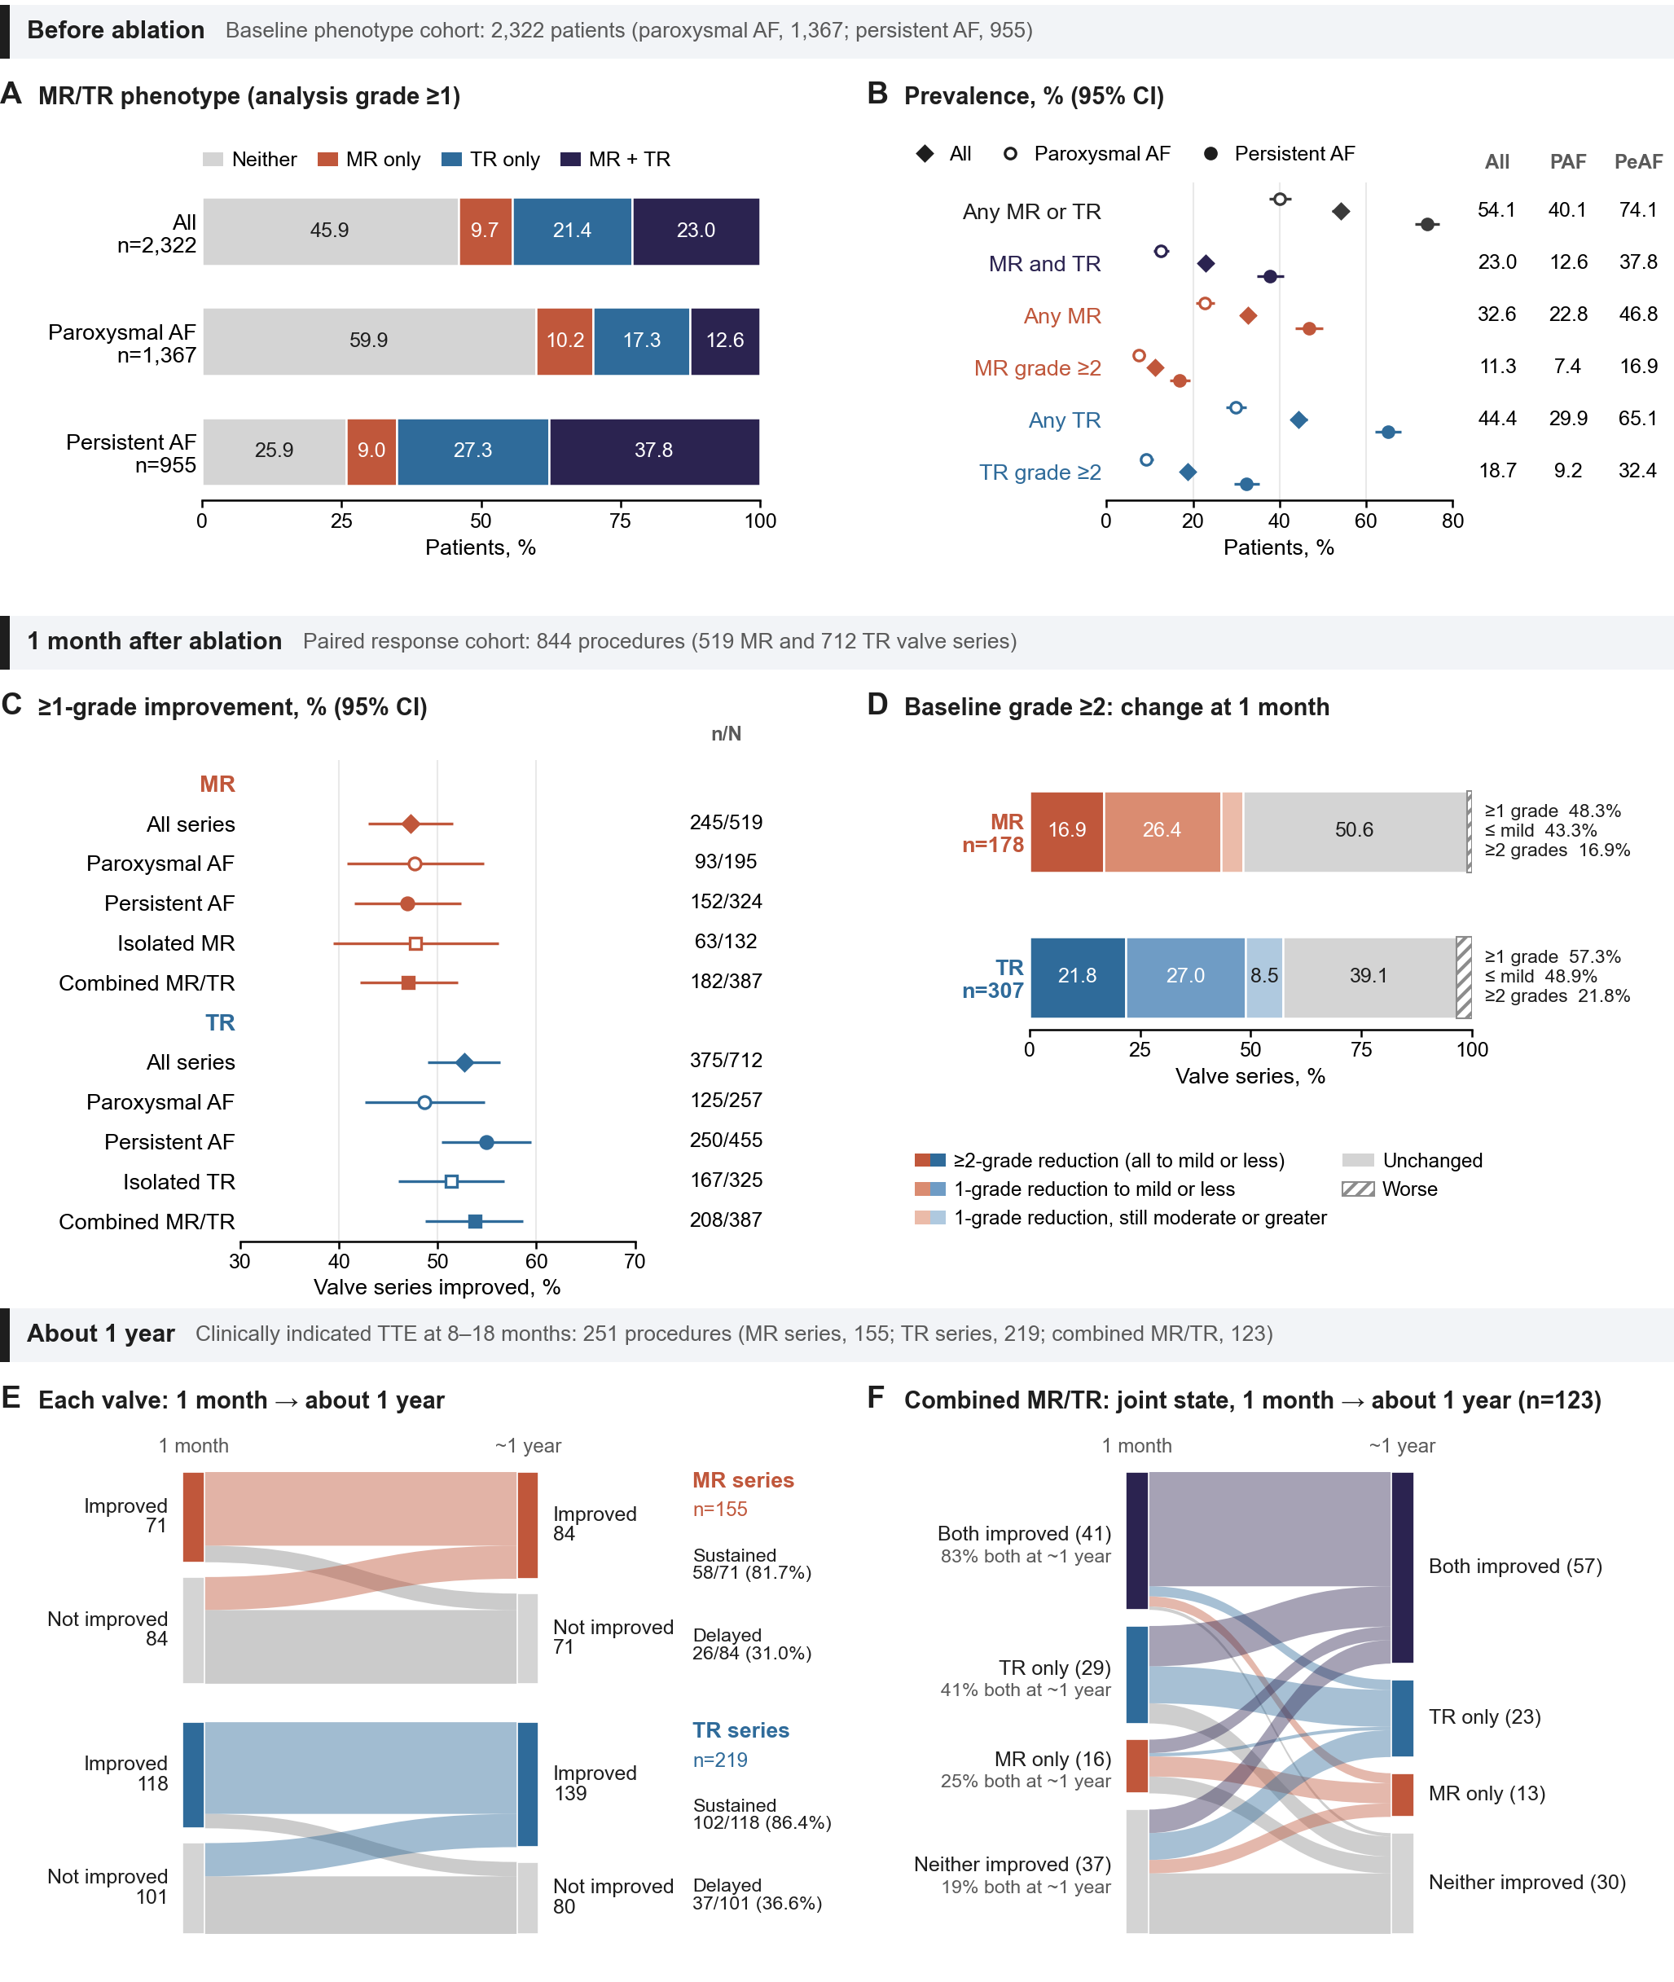
Figure 2. Regurgitation burden before ablation and its course at 1 month and about 1 year.
Table 1. Baseline characteristics by AF type in the baseline phenotype and paired response analysis sets.
Characteristic | Paroxysmal AF | Persistent AF | P value
Baseline phenotype set (patients)
Patients, n | 1,848 | 1,197
Age, years | 63 (54, 71) | 65 (56, 71) | 0.017
Sex, female | 840 (45.5%) | 407 (34.0%) | <0.001
MR/TR phenotype (analysis grade ≥1) |  |  | <0.001
Neither | 1,154 (62.4%) | 320 (26.7%)
MR only | 188 (10.2%) | 115 (9.6%)
TR only | 291 (15.7%) | 314 (26.2%)
MR and TR | 215 (11.6%) | 448 (37.4%)
MR analysis grade ≥2 | 120 (6.5%) | 199 (16.6%) | <0.001
TR analysis grade ≥2 | 154 (8.3%) | 365 (30.5%) | <0.001
LAD, mm | 37.0 (34.0, 41.0) | 42.0 (39.0, 46.0) | <0.001
LVEDd, mm | 47.0 (45.0, 50.0) | 48.0 (45.0, 51.2) | <0.001
RAD, mm | 35.0 (32.0, 38.0) | 44.0 (39.0, 47.0) | <0.001
RVD, mm | 22.0 (20.0, 23.0) | 23.0 (21.0, 24.0) | <0.001
LVEF, % | 66 (62, 70) | 62 (56, 67) | <0.001
Concomitant LAAO | 197 (10.7%) | 216 (18.0%) | <0.001
Paired response set (procedures)
Procedures (patients), n | 343 (341) | 501 (497)
Age, years | 68 (60, 75) | 67 (59, 72) | 0.008
Sex, female | 193 (56.3%) | 215 (42.9%) | <0.001
BMI, kg/m² | 23.8 (21.8, 25.8) | 24.7 (22.6, 26.8) | <0.001
Hypertension | 165 (48.1%) | 243 (48.5%) | 0.910
DM | 58 (16.9%) | 81 (16.2%) | 0.775
CAD | 44 (12.8%) | 39 (7.8%) | 0.016
HF | 43 (12.5%) | 95 (19.0%) | 0.013
Stroke | 26 (7.6%) | 47 (9.4%) | 0.361
CKD | 14 (4.1%) | 29 (5.8%) | 0.268
COPD | 12 (3.5%) | 17 (3.4%) | 0.934
Pulmonary hypertension on TTE | 22 (6.4%) | 42 (8.4%) | 0.288
Regurgitation phenotype |  |  | <0.001
Isolated MR | 86 (25.1%) | 46 (9.2%)
Isolated TR | 148 (43.1%) | 177 (35.3%)
Combined MR/TR | 109 (31.8%) | 278 (55.5%)
MR analysis grade ≥2 | 56 (16.3%) | 122 (24.4%) | 0.005
TR analysis grade ≥2 | 70 (20.4%) | 237 (47.3%) | <0.001
LAD, mm | 39.0 (35.0, 42.0) | 43.0 (40.0, 47.0) | <0.001
LVEDd, mm | 47.0 (45.0, 50.0) | 48.0 (45.0, 51.0) | 0.173
RAD, mm | 37.0 (33.0, 41.0) | 45.0 (41.0, 49.0) | <0.001
RVD, mm | 22.0 (20.0, 23.0) | 23.0 (21.0, 24.0) | <0.001
LVEF, % | 65 (60, 70) | 62 (57, 67) | <0.001
TRV, m/s | 2.60 (2.40, 2.80) | 2.60 (2.30, 2.80) | 0.596
Concomitant LAAO | 76 (22.2%) | 156 (31.1%) | 0.004
Ablation energy |  |  | <0.001
RFA | 303 (88.3%) | 473 (94.4%)
CBA | 29 (8.5%) | 10 (2.0%)
PFA | 11 (3.2%) | 18 (3.6%)
Additional non-PVI ablation | 82 (23.9%) | 269 (53.7%) | <0.001
SR on 24-hour Holter monitoring near the 1-month TTE | 311 (90.7%) | 335 (66.9%) | <0.001

Paired response analysis set
The paired response set comprised 844 procedures in 837 patients: 132 with isolated MR, 325 with isolated TR, and 387 with both. Thus, isolated disease contributed 457 procedures, and the valve-level analyses included 519 MR and 712 TR series. There were 343 paroxysmal and 501 persistent AF procedures, including 109 and 278 with both valves affected. Compared with paroxysmal AF, persistent AF procedures more often involved combined disease (55.5% vs 31.8%) and study-defined moderate-or-greater TR (47.3% vs 20.4%), had larger atria, and were less often in sinus rhythm near the 1-month TTE (66.9% vs 90.7%; Table 1). The 601 eligible admissions without a 1-month TTE had broadly similar baseline characteristics, apart from less frequent persistent AF; weighting for follow-up changed improvement rates by ≤0.5 percentage points (Supplementary Table S1B).
Combined regurgitation was associated with older age, more frequent persistent AF and HF, greater biatrial enlargement, and higher TR grades than isolated TR (Table 2). Parallel analyses used the same definitions across the two AF types (Supplementary Table S11).
Table 2. Baseline clinical, echocardiographic, and procedural characteristics of the paired response set by regurgitation phenotype.
Variable | isolated MR  (n=132) | isolated TR  (n=325) | combined MR/TR  (n=387) | P value
Baseline characteristics
Age, years | 66 (57, 72) | 66 (58, 72) | 68 (61, 75) | <0.001
BMI, kg/m² | 24.3 (22.6, 27.0) | 24.2 (22.0, 26.6) | 24.2 (22.0, 25.9) | 0.250
Sex, female | 71 (53.8%) | 125 (38.5%) | 212 (54.8%) | <0.001
AF type |  |  |  | <0.001
Paroxysmal | 86 (65.2%) | 148 (45.5%) | 109 (28.2%)
Persistent | 46 (34.8%) | 177 (54.5%) | 278 (71.8%)
Hypertension | 67 (50.8%) | 148 (45.5%) | 193 (49.9%) | 0.429
DM | 29 (22.0%) | 38 (11.7%) | 72 (18.6%) | 0.008
CAD | 23 (17.4%) | 25 (7.7%) | 35 (9.0%) | 0.005
HF | 27 (20.5%) | 32 (9.8%) | 79 (20.4%) | <0.001
Stroke | 11 (8.3%) | 31 (9.5%) | 31 (8.0%) | 0.763
CKD | 6 (4.5%) | 16 (4.9%) | 21 (5.4%) | 0.909
COPD | 5 (3.8%) | 10 (3.1%) | 14 (3.6%) | 0.911
Pulmonary hypertension on TTE | 3 (2.3%) | 14 (4.3%) | 47 (12.1%) | <0.001
Echocardiographic Characteristics
LAD, mm | 40.0 (37.8, 44.0) | 40.0 (36.0, 44.0) | 43.0 (40.0, 47.0) | <0.001
LVEDd, mm | 49.0 (46.0, 53.0) | 47.0 (45.0, 50.0) | 48.0 (45.0, 50.1) | <0.001
RAD, mm | 37.0 (33.0, 41.0) | 41.0 (36.0, 46.0) | 44.0 (40.0, 48.0) | <0.001
RVD, mm | 21.0 (20.0, 23.0) | 22.0 (21.0, 24.0) | 23.0 (21.0, 24.0) | <0.001
LVEF, % | 63 (58, 68) | 65 (60, 69) | 62 (56, 68) | <0.001
TRV, m/s | 2.40 (2.20, 2.60) | 2.50 (2.30, 2.70) | 2.70 (2.40, 3.00) | <0.001
MR |  |  |  | 0.032
Grade 1 | 96 (72.7%) | - | 245 (63.3%)
Grade 2 | 35 (26.5%) | - | 125 (32.3%)
Grade 3 | 1 (0.8%) | - | 17 (4.4%)
TR |  |  |  | <0.001
Grade 1 | - | 231 (71.1%) | 174 (45.0%)
Grade 2 | - | 76 (23.4%) | 157 (40.6%)
Grade 3 | - | 18 (5.5%) | 55 (14.2%)
Grade 4 | - | 0 (0.0%) | 1 (0.3%)
Procedural Characteristics
Ablation energy type |  |  |  | 0.240
RFA | 116 (87.9%) | 299 (92.0%) | 361 (93.3%)
CBA | 9 (6.8%) | 13 (4.0%) | 17 (4.4%)
PFA | 7 (5.3%) | 13 (4.0%) | 9 (2.3%)
Concomitant LAAO | 31 (23.5%) | 77 (23.7%) | 124 (32.0%) | 0.024
Additional non-PVI ablation | 43 (32.6%) | 119 (36.6%) | 189 (48.8%) | <0.001

Individual-valve responses in both AF types
The paroxysmal AF group of the paired response set comprised 343 procedures: 86 with isolated MR, 148 with isolated TR, and 109 with both. At 1 month, MR improved in 93/195 valve series (47.7%) and TR in 125/257 (48.6%; Figure 2C). Adjusted isolated-versus-combined ORs were 0.98 (95% CI, 0.48–1.99) for MR and 1.00 (0.53–1.87) for TR. AR improved in 7/64 procedures (10.9%; Supplementary Table S11).
The persistent AF group comprised 501 procedures: 46 with isolated MR, 177 with isolated TR, and 278 with both. MR improved in 152/324 valve series (46.9%) and TR in 250/455 (54.9%). Adjusted isolated-versus-combined ORs were 0.77 (95% CI, 0.38–1.55) for MR and 0.91 (0.58–1.41) for TR. AR improved in 4/85 procedures (4.7%; Supplementary Table S11).
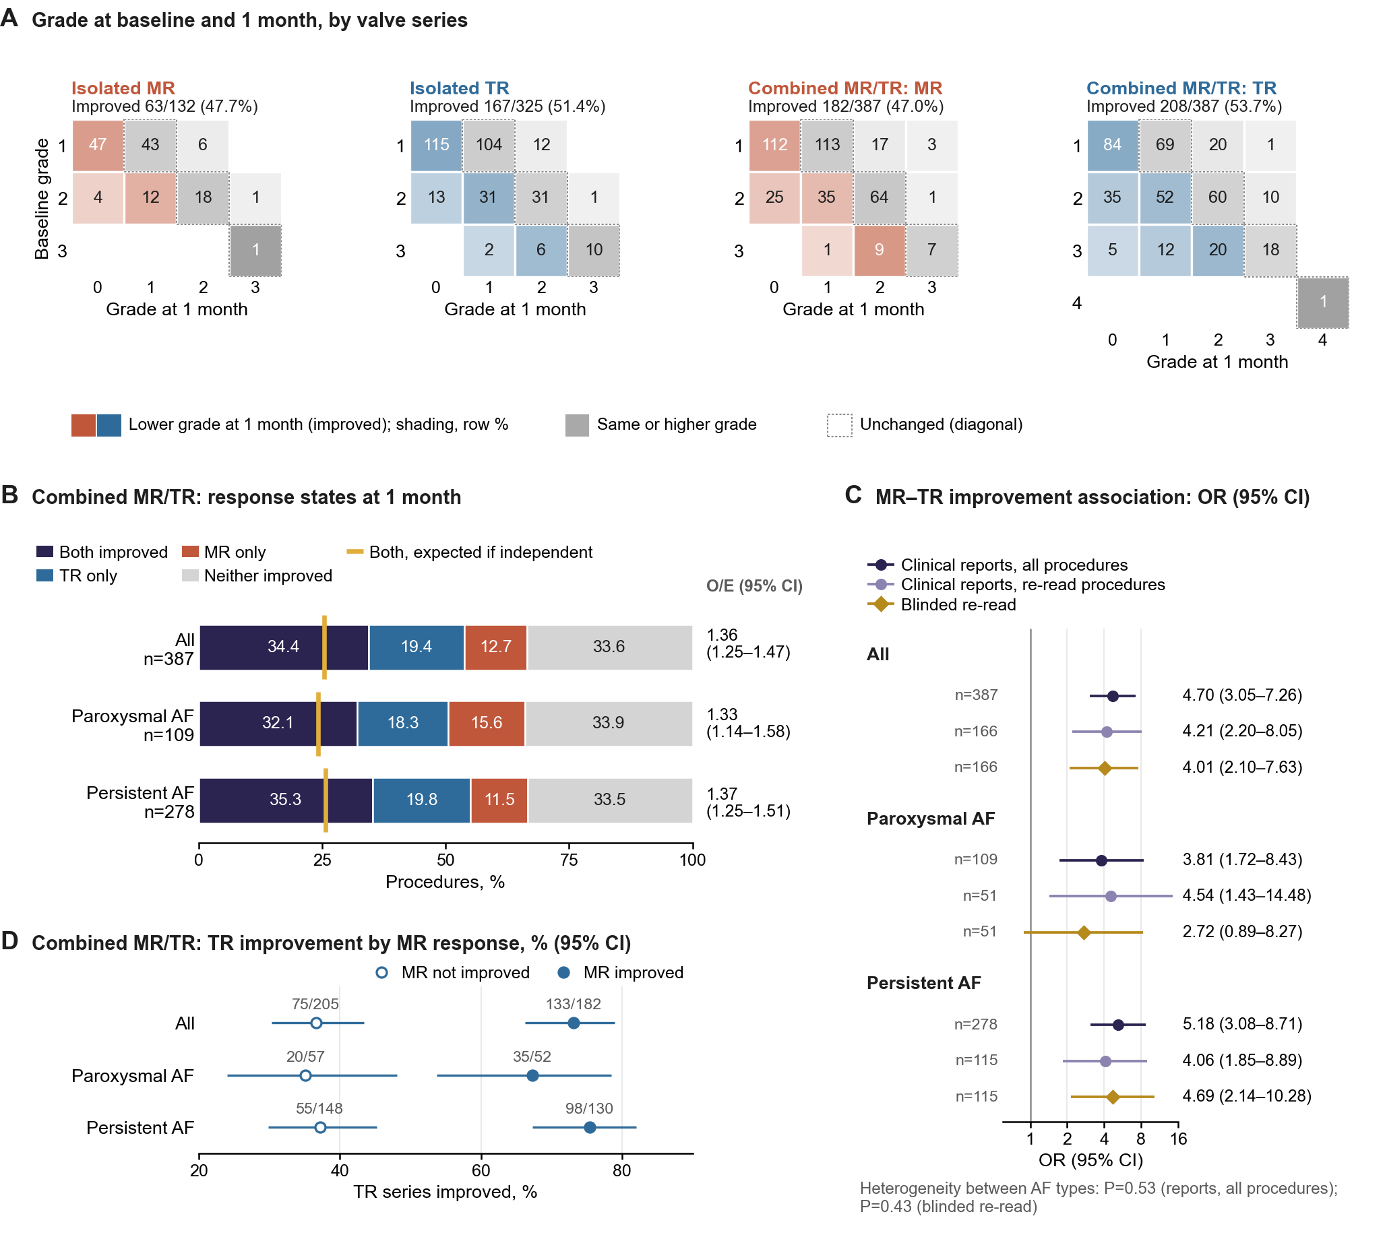
Figure 3. Individual-valve grade transitions and joint MR/TR responses in paroxysmal and persistent AF.
Overall improvement rates were 47.7% for isolated MR, 47.0% for combined MR, 51.4% for isolated TR, and 53.7% for combined TR (Table 3). Grades decreased in all four series (all p<0.001; Figure 3A). IPTW estimates and alternative weighting, endpoints, and grading scales showed no clear isolated-versus-combined difference (Supplementary Figure S1 and Tables S3A–S4). AR improved less often than MR or TR within the same procedures (Table 3).
Table 3. One-month improvement by valve series, isolated versus combined disease, and the aortic regurgitation negative control.
Valve series | n | Improved, n (%) | 95% CI | Comparison
All valve series
MR, isolated disease | 132 | 63 (47.7) | 39.4–56.2 | OR 0.84 (0.51–1.38)ª
MR, combined disease | 387 | 182 (47.0) | 42.1–52.0 | Reference
TR, isolated disease | 325 | 167 (51.4) | 46.0–56.8 | OR 1.08 (0.76–1.51)ª
TR, combined disease | 387 | 208 (53.7) | 48.8–58.7 | Reference
Moderate or greater (analysis grade ≥2)
MR, grade ≥2 | 178 | 86 (48.3) | 41.1–55.6 | To grade ≤1: 77 (43.3%)
TR, grade ≥2 | 307 | 176 (57.3) | 51.7–62.7 | To grade ≤1: 150 (48.9%)
Negative control: procedures with baseline AR and AR documented at 1 month
AR | 149 | 11 (7.4) | 4.2–12.7 | Reference
MR, same procedures | 96 | 34 (35.4) | 26.6–45.4 | P<0.001^{b}
TR, same procedures | 126 | 72 (57.1) | 48.4–65.4 | P<0.001^{b}

Depth of improvement and residual regurgitation
Among valve series with baseline analysis grade ≥2, 86/178 MR series (48.3%) and 176/307 TR series (57.3%) improved by ≥1 grade. Reductions of ≥2 grades occurred in 30/178 (16.9%) and 67/307 (21.8%), respectively. Regression to mild or less occurred in 77/178 MR (43.3%) and 150/307 TR series (48.9%; Figure 2D). Isolated and combined disease did not differ clearly in these endpoints (Supplementary Table S4).

Joint and discordant responses across AF types
In paroxysmal AF, both valves improved in 35/109 combined-disease procedures (32.1%). TR alone improved in 20 (18.3%), MR alone in 17 (15.6%), and neither in 37 (33.9%; Figure 3B). Joint improvement exceeded the independent expectation of 24.1% (observed/expected ratio, 1.33; 95% CI, 1.14–1.58). The MR–TR response OR was 3.81 (95% CI, 1.72–8.43; Figure 3C). Blinded re-reading gave an OR of 2.72 (95% CI, 0.89–8.27; n=51), leaving the association uncertain in this smaller sample.
In persistent AF, both valves improved in 98/278 combined-disease procedures (35.3%). TR alone improved in 55 (19.8%), MR alone in 32 (11.5%), and neither in 93 (33.5%; Figure 3B). Joint improvement exceeded the independent expectation of 25.7% (observed/expected ratio, 1.37; 95% CI, 1.25–1.51; Figure 3B). The MR–TR response OR was 5.18 (95% CI, 3.08–8.71). Blinded re-reading supported this association (OR, 4.69; 95% CI, 2.14–10.28; n=115; Figure 3C; Supplementary Table S11).
The AF-type groups showed no detectable heterogeneity in their response ORs (p=0.53), despite different baseline burdens. Discordant improvement occurred in 33.9% of paroxysmal and 31.3% of persistent AF procedures. Overall, both valves improved in 133/387 (34.4%), exceeding the independent expectation (observed/expected ratio, 1.36; 95% CI, 1.25–1.47; OR, 4.70; 95% CI, 3.05–7.26). Only one improved in 124/387 (32.0%; Figure 3B). TR improved in 133/182 procedures with MR improvement (73.1%) versus 75/205 without (36.6%; Figure 3D).
Overall blinded re-reading confirmed joint improvement in 60/166 interpretable combined-disease procedures (36.1%; OR, 4.01; 95% CI, 2.10–7.63). This met the criterion specified before the expanded reading. Joint-state agreement was 84.3% (κ, 0.78; 95% CI, 0.70–0.85; Supplementary Table S2). In the first sample, weighted grade agreement was 0.88 for MR and 0.85 for TR.
Within the 387 combined-disease procedures, 142 had baseline MR grade ≥2 and 213 had TR grade ≥2; 98 met both criteria. In this 98-procedure subset, both valves improved in 40 (40.8%), TR alone in 19, MR alone in 10, and neither in 29 (observed/expected ratio, 1.33; Supplementary Table S5).
In paroxysmal AF, 18 procedures met the dual grade ≥2 threshold. Both valves improved in 7 (38.9%) and only one in 7 (38.9%). In persistent AF, 80 procedures met the same threshold. Both valves improved in 33 (41.3%) and only one in 22 (27.5%; Supplementary Table S11).

Baseline features associated with early improvement
Higher BMI was associated with improvement of both valves in the mutually adjusted 12-factor model (Figure 4A; Supplementary Table S6). ORs for approximately 26 versus 22 kg/m² were 1.38 for MR (95% CI, 1.08–1.77; q=0.044) and 1.58 for TR (1.24–2.02; q=0.003). Larger LV end-diastolic diameter, smaller RA diameter, and higher baseline TR grade accompanied TR improvement. Female sex accompanied less MR improvement (OR, 0.53; 95% CI, 0.35–0.79; q=0.012).
In paroxysmal AF, higher BMI had a positive but imprecise association with TR improvement (OR, 1.54; 95% CI, 0.96–2.46). The MR estimate was weaker (OR, 1.10; 95% CI, 0.73–1.65). Larger LV end-diastolic diameter accompanied TR improvement (OR, 1.64; 95% CI, 1.10–2.46), whereas the RA and female-sex estimates remained imprecise (Supplementary Table S11).
In persistent AF, higher BMI accompanied both TR (OR, 1.61; 95% CI, 1.21–2.15) and MR improvement (1.70; 1.23–2.36). Larger LV end-diastolic diameter and smaller RA diameter accompanied TR improvement; female sex accompanied less MR improvement. None of these selected associations showed significant between-cohort heterogeneity, including BMI–MR (p=0.10; Supplementary Table S11).
Among grade ≥2 series, the BMI association persisted for both valves (each OR, 1.66), alongside the RA and LV associations for TR (Supplementary Table S5). Optimism-corrected C statistics were 0.57 for MR and 0.64 for TR. Standardized probabilities of improvement are shown across BMI in Figure 4C and across RA and LV end-diastolic diameters in Supplementary Figure S2.
In the 387 combined-disease procedures, higher BMI (26 vs 22 kg/m²) was associated with improvement of both valves (OR, 1.79; 95% CI, 1.33–2.40; q=0.001) and, among the 257 procedures with at least one improved valve, with extension of improvement to both valves (OR, 1.63; 95% CI, 1.13–2.34). Larger LA diameter (47 vs 40 mm) was associated with less joint improvement (OR, 0.62; 95% CI, 0.43–0.89) and less extension to both valves (OR, 0.54; 95% CI, 0.34–0.85), and larger RA diameter (48 vs 40 mm) with less joint improvement (OR, 0.69; 95% CI, 0.48–0.98); these atrial estimates did not reach q<0.05. The other factors showed no clear association (Figure 4B; Supplementary Table S13).
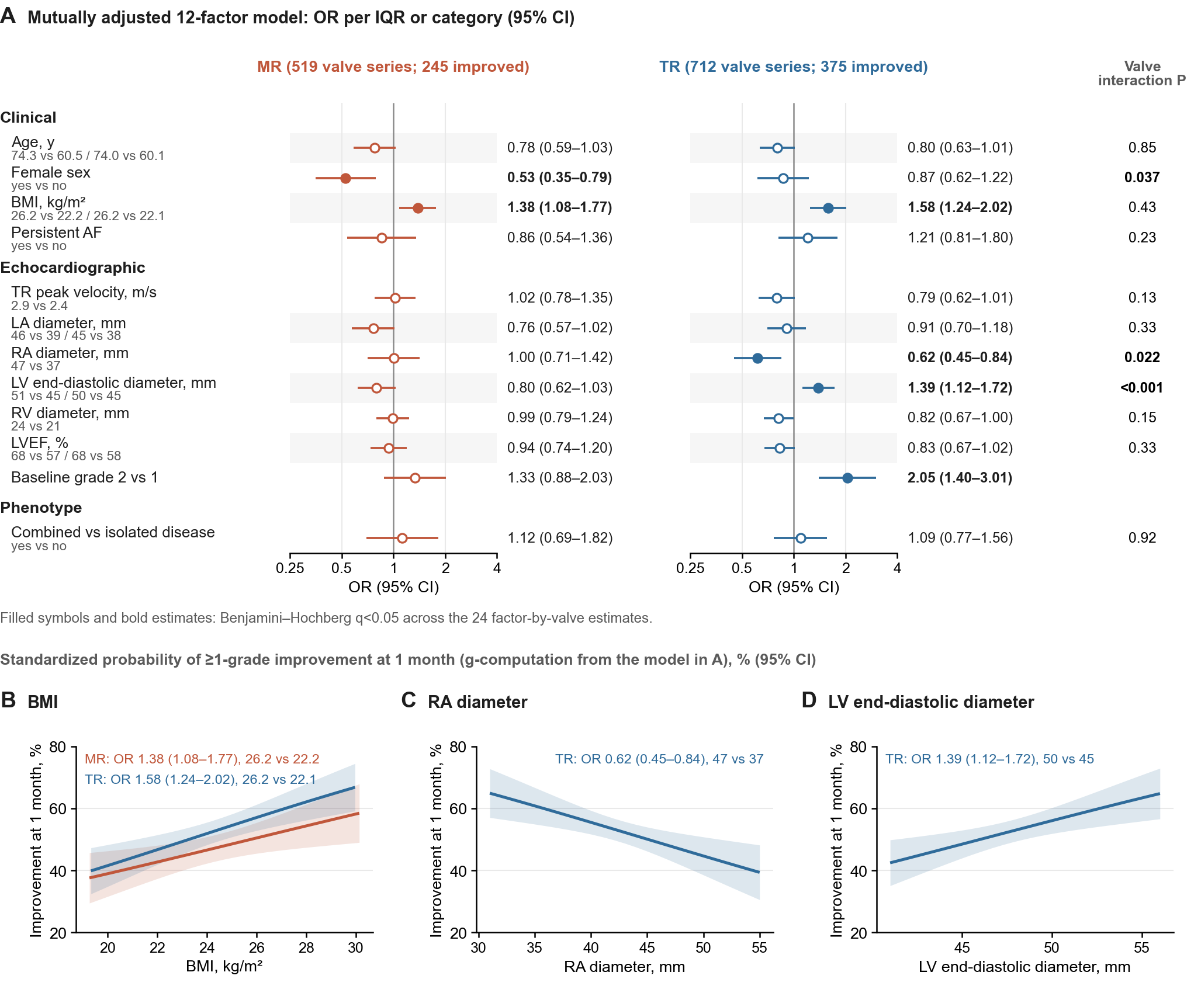
Figure 4. Baseline factors associated with 1-month MR and TR improvement and with improvement of both valves.

Rhythm and atrial changes accompanying the response
In paroxysmal AF, 311/343 procedures (90.7%) were in SR near the 1-month TTE. The whole-cohort interaction model showed no clear SR–TR association (OR, 0.91; 95% CI, 0.40–2.07; Figure 5A); the MR estimate was also imprecise (1.90; 0.69–5.25). In separate cohort models, TR improvement accompanied RA reduction (OR per 5 mm, 2.92; 95% CI, 1.88–4.52), but not LA reduction. MR improvement accompanied reduction of both atria. The MR–TR response OR remained 4.05 after baseline-factor and SR adjustment, then fell to 2.63 after atrial-change adjustment (95% CI, 0.93–7.41; Supplementary Table S11).
In persistent AF, 335/501 procedures (66.9%) were in SR near the 1-month TTE. SR accompanied TR improvement (OR, 5.81; 95% CI, 3.62–9.33) and MR improvement (2.64; 1.60–4.34; Figure 5A). In separate cohort models, TR improvement accompanied RA reduction (OR per 5 mm, 2.54; 95% CI, 1.96–3.30), but not clearly LA reduction. MR improvement again accompanied reduction of both atria. The MR–TR response OR was 4.01 after baseline-factor and SR adjustment, then 2.82 after atrial-change adjustment (95% CI, 1.42–5.61; Supplementary Table S11).
SR–TR associations differed by AF type (interaction p<0.001), whereas SR–MR associations did not (p=0.56). Overall, SR accompanied joint and TR-only improvement, but not clearly MR-only improvement (Figure 5B). Joint improvement rose from 15.1% to 56.3% across tertiles of biatrial reduction, while discordance remained at 28.6–39.3% (Figure 5E). Overall atrial associations, grade ≥2 analyses, and TRV changes are reported in Figure 5C–D and Supplementary Tables S5 and S7–S9.
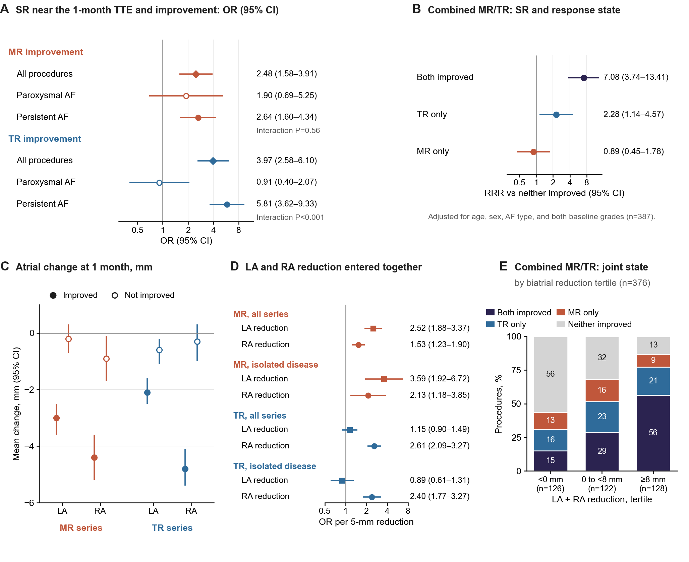
Figure 5. Sinus rhythm, atrial remodeling, and 1-month MR and TR improvement.

One-year trajectories
Clinically indicated TTE at approximately 1 year was available for 155 MR and 219 TR series. Early improvement persisted in 58/71 MR (81.7%) and 102/118 TR series (86.4%); delayed improvement occurred in 26/84 (31.0%) and 37/101 (36.6%), respectively (Figure 2E; Supplementary Table S10).
In paroxysmal AF, early improvement persisted at 1 year in 20/27 MR series (74.1%) and 29/35 TR series (82.9%). Both valves remained improved in 6/10 procedures with early joint improvement (60.0%; Supplementary Table S11).
In persistent AF, early improvement persisted in 38/44 MR series (86.4%) and 73/83 TR series (88.0%). Both remained improved in 28/31 procedures with early joint improvement (90.3%). Overall, late joint improvement occurred in 34/41 procedures with early joint improvement versus 7/37 with neither initially improved (Figure 2F).

Discussion
In patients undergoing AF ablation, about half had functional MR or TR before the procedure and one in five had both. After ablation, the two valves tended to improve together beyond chance in both paroxysmal and persistent AF, consistent with a shared atrial substrate. Patients with higher BMI and smaller atria were more likely to improve in both valves, whereas with a larger LA, improvement was more often confined to one valve. The joint state at 1 month anticipated the course at about 1 year.

Regurgitation burden before ablation
Among 3,045 patients with an in-hospital baseline TTE report, 51.6% had MR and/or TR and 21.8% had both. Combined regurgitation was three times as frequent in persistent as in paroxysmal AF and accompanied greater biatrial enlargement and higher grades. MR–TR co-occurrence remained after adjustment for chamber dimensions in both AF types, consistent with an atrial substrate.^{1,2,7,8} These data extend the combined phenotype described before cardioversion to a larger ablation population that includes both AF types.⁹ Individual-valve improvement was not confined to combined disease, although nonsignificant phenotype comparisons do not establish equivalence.

Joint improvement and a shared atrial substrate
Joint improvement exceeded chance in both AF types, without detectable heterogeneity between them, and blinded re-reading supported it overall. The two valves shared their response with atrial reverse remodeling: across tertiles of biatrial reduction, joint improvement rose from 15% to 56% and the proportion with neither valve improved fell, whereas discordance remained at about one-third. RA reduction accompanied TR improvement, and reduction of both atria accompanied MR improvement, in both AF types, extending earlier individual-valve findings.6,10,11 These patterns are consistent with a common atrial substrate; changes in atrial contraction and annular geometry are plausible contributors19–21 but were not directly measured, atrial size did not account for all coupling, and concurrent changes cannot establish which change preceded or caused another. SR accompanied TR improvement mainly in persistent AF, whereas SR was nearly universal in paroxysmal AF, limiting the rhythm contrast.
Blinded re-reading supported the overall finding and the persistent AF estimate; the smaller paroxysmal estimate remained inconclusive. Adjustment for baseline severity reduced the possibility that the coupling reflected baseline grade alone. Shared acquisition conditions, rhythm-related grading variation, and regression to the mean remain possible contributors.

Who improves in both valves
Higher BMI was associated with improvement of each valve and, in combined disease, with improvement of both; when one valve improved, it was also associated with extension of improvement to the other. Conversely, a larger LA was associated with less joint improvement and, when one valve improved, with improvement confined to that valve; a larger RA showed a similar but weaker association. A larger atrium may reflect more advanced atrial remodeling with less reversible annular dilatation; neither this nor a load-related explanation for the BMI association was tested directly. These associations describe the baseline phenotype and do not imply that increasing weight improves regurgitation, and unindexed chamber diameters and residual body-size-related confounding require consideration. The joint-improvement analysis was post hoc, and its atrial estimates did not reach the false discovery threshold.
The valve-specific associations refine these expectations. Larger RA diameter was associated with less TR improvement after mutual adjustment, while larger LV end-diastolic diameter was associated with more improvement; these conditional estimates may reflect different structural and loading backgrounds.^{22–25} Female sex was associated with less MR improvement, and higher baseline TR grade with more grade reduction, partly reflecting greater opportunity to decrease. Limited discrimination restricts individual prediction without negating the group-level associations.

The 1-month joint state and clinical implications
In combined disease, early joint improvement persisted at about 1 year in 83% of procedures with late imaging, whereas only 19% of those with neither valve improved at 1 month showed joint improvement later (OR, 22.7). Loss or delay of TR improvement accompanied changes in RA size, consistent with previous observations of TR evolution.26 Late imaging was clinically indicated and available in about 30%, and the paroxysmal estimate rested on only 10 procedures; these findings cannot establish long-term durability across the full population.
Current guidelines incorporate treatment of underlying AF and appropriate rhythm control into functional-regurgitation management, alongside assessment of valve-intervention indications.27 Our findings support valve-by-valve TTE assessment about 1 month after ablation. When both valves have improved, improvement usually persists. When only one or neither valve has improved, particularly in patients with a large atrium or lower BMI, targeted reassessment and further evaluation of the valve may be warranted, guided by residual severity, symptoms, and cardiac consequences. Whether this approach changes treatment sequencing or outcomes requires prospective evaluation.

Limitations
Semi-quantitative clinical reports lacked comprehensive core-laboratory adjudication or quantitative TTE/CMR. The study-defined moderate category included mild-to-moderate reports; individual examinations were not independently classified against guideline thresholds. Rhythm and examination variability and regression to the mean can influence grade changes. Re-reading covered part of the cohort; exact eight-level agreement between readers was 80% for MR and 60% for TR in 20 shared examinations. Selection remains possible: patients without an in-hospital baseline TTE report were not included, and 42% of eligible admissions lacked 1-month TTE. Weighting and scenario analyses cannot exclude this bias. The AF-type framework was added after initial analyses; both groups shared the center and readers, one patient contributed to both, and several estimates were imprecise. It provides internal corroboration; higher-grade and joint-improvement factor analyses were also post hoc. Without a nonablated comparator, baseline associations cannot establish treatment effects or modifiers. Valve intervention, symptoms, HF admissions, and survival were not endpoints. Concurrent rhythm and chamber changes cannot establish temporal mechanisms, and 24-hour Holter monitoring cannot establish long-term rhythm control. Clinically indicated late TTE was available in about 30%, limiting generalization of persistence estimates.

Conclusion
About half of patients undergoing AF ablation had functional MR or TR, and one in five had both. After ablation, the two valves tended to improve together beyond chance in both paroxysmal and persistent AF, more often in patients with higher BMI and smaller atria, and joint improvement at 1 month usually persisted at 1 year. Valve-specific reassessment at 1 month can identify patients whose improvement is incomplete.
Funding
This work was supported financially by grants from the 135 Project for Disciplines of Excellence-Clinical Research Incubation Project of West China Hospital of Sichuan University (2023HXFH002), and the Sichuan Science and Technology Program (2024YFFK0046, 2026NSFSC1723).
Acknowledgments:
We thank the clinical staff at West China Hospital of Sichuan University for their assistance with patient enrollment and data collection.
Conflict of interest: none declared.
Ethics Approval: This study was approved by the Institutional Ethics Committee of West China Hospital, Sichuan University (approval number: 2022-306), which waived the requirement for informed consent because of the retrospective design.
Data Availability: The data underlying this article will be shared on reasonable request to the corresponding author.
Code Availability: The analysis code is available from the corresponding author on reasonable request.
References
1. Moiud Mohyeldin, Ahmed Abdelghafar, Sai Allu, et al. Atrial Functional Tricuspid Regurgitation: A Comprehensive Review of Pathophysiology, Diagnosis, and Management Strategies. Rev. Cardiovasc. Med. 2024, 25(12), 435.
2. Muraru D, Guta AC, Ochoa-Jimenez RC, et al. Functional Regurgitation of Atrioventricular Valves and Atrial Fibrillation: An Elusive Pathophysiological Link Deserving Further Attention. J Am Soc Echocardiogr. 2020 Jan;33(1):42-53.
3. Saito C, Minami Y, Arai K, Haruki S, et al. Prevalence, clinical characteristics, and outcome of atrial functional mitral regurgitation in hospitalized heart failure patients with atrial fibrillation. J Cardiol. 2018 Oct;72(4):292-299.
4. Chang KC, Lin TT, Wang TC, et al. Fibrosis-4 index reflects the severity of tricuspid regurgitation and patient prognosis in atrial fibrillation. Eur J Heart Fail. 2025 Jul 14.
5. Al-Hashedi EM, Abdu FA, Ahmad A, et al. Impact of Atrial Fibrillation Catheter Ablation on Functional Mitral Regurgitation. Am J Cardiol. 2025 Nov 1;254:127-138.
6. Attanasio P, Schwarz F, Barbieri F, et al. Improvement of functional mitral and tricuspid regurgitation in patients with atrial fibrillation after sinus rhythm restoration—the Berlin FMTR registry. Clin Res Cardiol. 2026. doi:10.1007/s00392-026-02877-8.
7. Lv J, Lu Q, Wang W, et al; CHINA-VHD Collaborators. Clinical Characteristics, Outcomes, and Risk Stratification of Combined Mitral and Tricuspid Regurgitation: The China-VHD Study. JACC Asia. 2025 Mar;5(3 Pt 2):436-452.
8. Murata A, Kaneko T, Amano M, et al. Qualitative and quantitative assessment of atrial functional mitral regurgitation: analysis from the REVEAL-AFMR registry. Eur Heart J Cardiovasc Imaging. 2025 Jan 31;26(2):299-306.
9. Nour AA, Hădăreanu DR, Toader DM, Hădăreanu CD, Iovănescu ML, Mihu-Marinescu A, et al. Combined Atrial Functional Mitral and Tricuspid Regurgitation in Atrial Fibrillation: Prevalence, Associated Factors, and Three-Dimensional Valve Remodeling. J Clin Med. 2026;15(13):5198. doi:10.3390/jcm15135198.
10. Soulat-Dufour L, Lang S, Addetia K, et al. Restoring Sinus Rhythm Reverses Cardiac Remodeling and Reduces Valvular Regurgitation in Patients With Atrial Fibrillation. J Am Coll Cardiol. 2022 Mar 15;79(10):951-961.
11. Park J, Choi HM, Lee JH, et al. Influence of Rhythm Control on Functional Mitral and Tricuspid Regurgitation Severity and Clinical Outcome in Patients With Atrial Fibrillation: A Propensity-Matched Cohort Study. Korean Circ J. 2025 Jul 1.
12. Baumgartner H, Falk V, Bax JJ, et al; ESC Scientific Document Group. 2017 ESC/EACTS Guidelines for the management of valvular heart disease. Eur Heart J. 2017 Sep 21;38(36):2739-2791.
13. Zoghbi WA, Adams D, Bonow RO, et al. Recommendations for noninvasive evaluation of native valvular regurgitation: a report from the American Society of Echocardiography developed in collaboration with the Society for Cardiovascular Magnetic Resonance. J Am Soc Echocardiogr. 2017;30(4):303-371.
14. Lancellotti P, Pibarot P, Chambers J, et al. Multi-modality imaging assessment of native valvular regurgitation: an EACVI and ESC Council of Valvular Heart Disease position paper. Eur Heart J Cardiovasc Imaging. 2022;23(5):e171-e232.
15. Hahn RT, Zamorano JL. The need for a new tricuspid regurgitation grading scheme. Eur Heart J Cardiovasc Imaging. 2017;18(12):1342-1343.
16. Bohbot Y, Tordjman L, Dreyfus J, Le Tourneau T, Lavie-Badie Y, Selton-Suty C, et al. Comparison of effective regurgitant orifice area by the PISA method and tricuspid coaptation gap measurement to identify very severe tricuspid regurgitation and stratify mortality risk. Front Cardiovasc Med. 2023;10:1090572. doi:10.3389/fcvm.2023.1090572.
17. McDonagh TA, Metra M, Adamo M, Gardner RS, Baumbach A, Böhm M, et al. 2021 ESC Guidelines for the diagnosis and treatment of acute and chronic heart failure. Eur Heart J. 2021;42(36):3599–3726. doi:10.1093/eurheartj/ehab368.
18. Humbert M, Kovacs G, Hoeper MM, et al; ESC/ERS Scientific Document Group. 2022 ESC/ERS Guidelines for the diagnosis and treatment of pulmonary hypertension. Eur Heart J. 2022;43(38):3618-3731.
19. Farhan S, Silbiger JJ, Halperin JL, et al. Pathophysiology, Echocardiographic Diagnosis, and Treatment of Atrial Functional Mitral Regurgitation: JACC State-of-the-Art Review. J Am Coll Cardiol. 2022 Dec 13;80(24):2314-2330.
20. Liang JJ, Silvestry FE. Mechanistic insights into mitral regurgitation due to atrial fibrillation: “Atrial functional mitral regurgitation”. Trends in Cardiovascular Medicine 2016; 26(8): 681–9.
21. Deferm S, Bertrand PB, Verbrugge FH, et al. Atrial Functional Mitral Regurgitation: JACC Review Topic of the Week. J Am Coll Cardiol. 2019 May 21;73(19):2465-2476.
22. Barrows RK, Augustin CM, Gsell MAF, et al. Rhythm control benefits left ventricular function compared with rate control in patients with atrial fibrillation: A computational study. Heart Rhythm O2. 2025 May 9;6(7):1011-1019.
23. Lam CS, Rienstra M, Tay WT, et al. Atrial Fibrillation in Heart Failure With Preserved Ejection Fraction: Association With Exercise Capacity, Left Ventricular Filling Pressures, Natriuretic Peptides, and Left Atrial Volume. JACC Heart Fail. 2017 Feb;5(2):92-98.
24. Doldi PM, Thienel M, Willy K. Right Ventricular Dynamics in Tricuspid Regurgitation: Insights into Reverse Remodeling and Outcome Prediction Post Transcatheter Valve Intervention. Int J Mol Sci. 2025 Jun 30;26(13):6322.
25. Melillo F, Fabiani D, Santoro A, et al. Multimodality Imaging for Right Ventricular Function Assessment in Severe Tricuspid Regurgitation. J Clin Med. 2024 Aug 27;13(17):5076.
26. Arteagoitia Bolumburu A, Monteagudo Ruiz JM, Mahia P, et al. Determinants of Tricuspid Regurgitation Progression and Its Implications for Adequate Management. JACC Cardiovasc Imaging. 2024;17(6):579-591.
27. Praz F, Borger MA, Lanz J, et al; ESC/EACTS Scientific Document Group. 2025 ESC/EACTS Guidelines for the management of valvular heart disease. Eur Heart J. 2025;46(44):4635–4736. doi:10.1093/eurheartj/ehaf194.
Supplementary Material
Tables S1A, S1B, S2, S3A–S3D, and S4–S13; Figures S1 and S2
Figure legends
Figure 1. Study population and analysis sets.
Flow of the study population: patients undergoing AF ablation between January 2020 and September 2024 with an in-hospital baseline TTE report. Exclusions were applied uniformly before the analysis sets were defined. Organic valve disease comprised rheumatic heart disease, mitral stenosis, aortic stenosis of mild-to-moderate or worse, and valve prolapse; congenital heart disease comprised unrepaired atrial septal defect with shunt, residual shunt after repair or closure, and complex congenital heart disease. The baseline phenotype set comprised one admission per patient (the first ablation admission in the study period), whose baseline TTE report was graded to estimate prevalence; the paired response set comprised procedures with MR and/or TR of analysis grade ≥1 (very mild or worse) on the baseline TTE and a 1-month TTE. Overall, 372 patients belonged to both sets; for the 366 whose baseline-set admission was a paired procedure, the baseline grades of the paired analysis were used. Each set was analyzed separately in paroxysmal and persistent AF. Eligible admissions without a 1-month TTE were compared with included procedures in Supplementary Table S1B. AF indicates atrial fibrillation; HCM, hypertrophic cardiomyopathy; MR, mitral regurgitation; TR, tricuspid regurgitation; TTE, transthoracic echocardiography.
Figure 2. Regurgitation burden before ablation and its course at 1 month and about 1 year.
(A) MR/TR phenotypes (analysis grade ≥1) in the baseline phenotype set, overall and by AF type; numbers are percentages. (B) Prevalence with Wilson 95% CIs of any MR or TR, combined MR/TR, any MR, any TR, and study-defined moderate-or-greater MR and TR (analysis grade ≥2) in all patients (diamonds), paroxysmal AF (open circles), and persistent AF (filled circles); point estimates (%) are listed on the right. (C) ≥1-grade improvement at 1 month (Wilson 95% CIs) in all MR and TR valve series, by AF type (circles) and by phenotype (squares; open, isolated disease; filled, combined MR/TR). (D) Change at 1 month in valve series with baseline analysis grade ≥2: reduction by ≥2 grades (all reaching grade ≤1), 1-grade reduction to grade ≤1 (mild or less), 1-grade reduction with residual grade ≥2, unchanged grade, or a higher grade; numbers are percentages, and the summaries on the right give ≥1-grade reduction, regression to mild or less, and ≥2-grade reduction. (E) MR (n=155) and TR (n=219) series with a clinically indicated TTE at 8–18 months: sustained improvement (improved at 1 month and still improved) and delayed improvement (not improved at 1 month but improved later); improvement at about 1 year is defined relative to baseline. (F) Joint state at 1 month and at about 1 year in combined MR/TR procedures with late TTE (n=123); ribbons are coloured by the state at about 1 year, and the percentage under each 1-month state is the proportion with both valves improved at about 1 year. Panels A–B describe patients of the baseline phenotype set (n=3,045) and panels C–F valve series or procedures of the paired response set; the two sets share 372 patients. Late TTE was clinically indicated and available in about 30% of series (unweighted; weighted estimates in Supplementary Table S10). AF indicates atrial fibrillation; MR, mitral regurgitation; TR, tricuspid regurgitation; TTE, transthoracic echocardiography.
Figure 3. Individual-valve grade transitions and joint MR/TR responses in paroxysmal and persistent AF.
(A) Grade transition matrices from baseline (rows) to 1 month (columns) for each valve series; cells show numbers of valve series, coloured cells indicate ≥1-grade improvement and grey cells no improvement, shading is proportional to row percentages, and dotted outlines mark unchanged grades. (B) Four response states at 1 month in combined MR/TR, overall (n=387), in paroxysmal AF (n=109), and in persistent AF (n=278); numbers are percentages, and the yellow mark shows joint improvement expected under independence (product of the marginal MR and TR improvement probabilities in each group). O/E, observed/expected ratio of joint improvement with bootstrap 95% CI. (C) Odds ratios (95% CIs) between MR and TR improvement from clinical reports in all combined MR/TR procedures, from clinical reports in the procedures that were re-read, and from blinded re-reading, by AF type. The paroxysmal re-read estimate is imprecise and its CI includes 1. (D) Proportion of combined MR/TR procedures with TR improvement according to whether MR improved, with Wilson 95% CIs; numbers above the symbols are n/N. The AF-type groups come from the same center; analysis timing is described in Methods. Numeric estimates are reported in Supplementary Tables S2, S7, and S11. AF indicates atrial fibrillation; MR, mitral regurgitation; TR, tricuspid regurgitation.
Figure 4. Baseline factors associated with 1-month MR and TR improvement and with improvement of both valves.
(A) Mutually adjusted odds ratios (95% CIs) for ≥1-grade MR (all series) and TR (all series) improvement from one valve-level logistic model including 12 baseline factors (multiple imputation; patient-clustered standard errors). Continuous factors are compared at the 75th versus 25th percentile of each valve series (MR / TR contrasts are given under each factor), and chamber diameters are unindexed. Filled symbols and bold estimates indicate q<0.05 (Benjamini–Hochberg false discovery rate across all 24 factor-by-valve estimates); P values are for the factor-by-valve interaction. (B) Mutually adjusted odds ratios (95% CIs) of the same 12 factors, with both baseline grades in place of phenotype, for improvement of both valves (joint; n=387) and, among procedures with at least one improved valve, for extension of improvement to both valves (extension; n=257) in combined MR/TR; continuous factors are compared at the 75th versus 25th percentile in combined MR/TR (post hoc; Supplementary Table S13). (C) Standardized probabilities (95% CIs) of ≥1-grade improvement at 1 month derived by g-computation from the model in A across BMI for MR and TR; curves across RA and LV end-diastolic diameters for TR are shown in Supplementary Figure S2. Abbreviations as in Table 2.
Figure 5. Sinus rhythm, atrial remodeling, and 1-month MR and TR improvement.
(A) Odds ratios (95% CIs) of SR on 24-hour Holter monitoring near the 1-month TTE for ≥1-grade MR and TR improvement. Overall estimates (diamonds) are from the 12-factor valve-level model with SR added; AF-type estimates (open circles, paroxysmal; filled circles, persistent) are from the corresponding whole-cohort model with an SR × AF type interaction. Multiple imputation and patient-clustered standard errors were used. (B) Relative risk ratios (RRR; 95% CIs) of SR for each joint response state versus neither valve improved in combined disease, from multinomial logistic regression adjusted for age, sex, AF type, and both baseline grades. (C) Mean 1-month change in LA and RA diameters (95% CIs) in improved (filled) and nonimproved (open) valve series. (D) Odds ratios per 5-mm reduction in LA (squares) and RA (circles) diameters entered together, in all and isolated valve series, adjusted for the 12 baseline factors. (E) Joint response states in combined MR/TR by tertile of biatrial reduction (sum of LA and RA reductions from baseline to 1 month; negative values indicate enlargement) in the 376 procedures with both diameters at both time points; numbers are percentages. SR, sinus rhythm; other abbreviations as in Table 2.
Table Legends
Table 1. Baseline characteristics by AF type in the baseline phenotype and paired response analysis sets.
Data are median (interquartile range) or n (%) of observed values. The baseline phenotype set counts patients (first ablation admission in the study period) and the paired response set counts procedures; the two sets shared 372 patients. In the baseline phenotype set, chamber dimensions were available from the same report in 2,755 (LAD), 3,009 (LVEDd), 2,755 (RAD), 2,916 (RVD), and 3,009 (LVEF) patients; BMI, comorbidities, TRV, and procedural details other than concomitant LAAO were abstracted only for the paired response set, in which BMI was available for 760 and TRV for 801 procedures. Regurgitation phenotypes and grades are analysis grades (Methods); MR and TR grade ≥2 denote study-defined moderate or greater and are shown as proportions of all patients or procedures. P values compare paroxysmal and persistent AF (Kruskal–Wallis test or chi-square test). AF, atrial fibrillation; BMI, body mass index; CAD, coronary artery disease; CBA, cryoballoon ablation; CKD, chronic kidney disease; COPD, chronic obstructive pulmonary disease; DM, diabetes mellitus; HF, heart failure; LAAO, left atrial appendage occlusion; LAD, left atrial diameter; LVEDd, left ventricular end-diastolic diameter; LVEF, left ventricular ejection fraction; MR, mitral regurgitation; PFA, pulsed field ablation; PVI, pulmonary vein isolation; RAD, right atrial diameter; RFA, radiofrequency ablation; RVD, right ventricular diameter; SR, sinus rhythm; TR, tricuspid regurgitation; TRV, peak tricuspid regurgitant velocity; TTE, transthoracic echocardiography.
Table 2. Baseline clinical, echocardiographic, and procedural characteristics of the paired response set by regurgitation phenotype.
Data are presented as median (interquartile range) or n (%). Baseline TRV was missing in 37 (no recordable TR jet), 1, and 5 procedures in isolated MR, isolated TR, and combined MR/TR. TRV, peak tricuspid regurgitant velocity on the baseline TTE. MR and TR are analysis grades: 1, very mild or mild; 2, moderate (including mild-to-moderate); 3, moderate-to-severe or severe (MR, moderate-to-severe or worse); 4, very severe. Moderate or greater denotes analysis grade ≥2 under the study definition (Methods). AF, atrial fibrillation; BMI, body mass index; CBA, cryoballoon ablation; CAD, coronary artery disease; CKD, chronic kidney disease; COPD, chronic obstructive pulmonary disease; DM, diabetes mellitus; HF, heart failure; LAD, left atrial diameter; LVEDd, left ventricular end-diastolic diameter; RAD, right atrial diameter; RVD, right ventricular diameter; LVEF, left ventricular ejection fraction; LAAO, left atrial appendage occlusion; MR, mitral regurgitation; PFA, pulsed field ablation; PVI, pulmonary vein isolation; RFA, radiofrequency ablation; TR, tricuspid regurgitation.
Table 3. One-month improvement by valve series, isolated versus combined disease, and the aortic regurgitation negative control.
Improvement was a ≥1-grade reduction from baseline to 1 month; grades were lower than at baseline in all four valve series (paired Wilcoxon signed-rank test, all P<0.001). Proportions are shown with Wilson 95% CIs. For study-defined moderate-or-greater series (baseline grade ≥2), the last column shows regression to grade ≤1 (mild or less). ªIPTW-weighted odds ratio for isolated versus combined disease (average treatment effect in the treated; Supplementary Tables S3A–S3D). ^{b}Exact McNemar test versus AR within the same procedures. AR improvement did not differ between procedures with and without SR at 1 month (7.1% vs 8.7%) and would have been 23.3% had all 31 procedures without AR documented at 1 month improved (Supplementary Table S12). AR, aortic regurgitation; IPTW, inverse probability of treatment weighting; MR, mitral regurgitation; OR, odds ratio; SR, sinus rhythm; TR, tricuspid regurgitation.

