**CSCI4120**

## Principle of Computer Game Software

**Assignment 1**

**Level Editing & Scripting**

# Due: Feb 18, 2022(Friday)

Level building is extremely important in game development as this is the world where the player will interact. This assignment will let you have a first experience in level building, in addition to scripting of in game objects (entities).

Requirement

You are required to build a simple level with Unreal engine (recommended 4.28) which has the following:

1. The stylistic science centre lecture theatre complex, commonly called “Rice cooker” in CUHK main campus(only those in the red rectangular region),

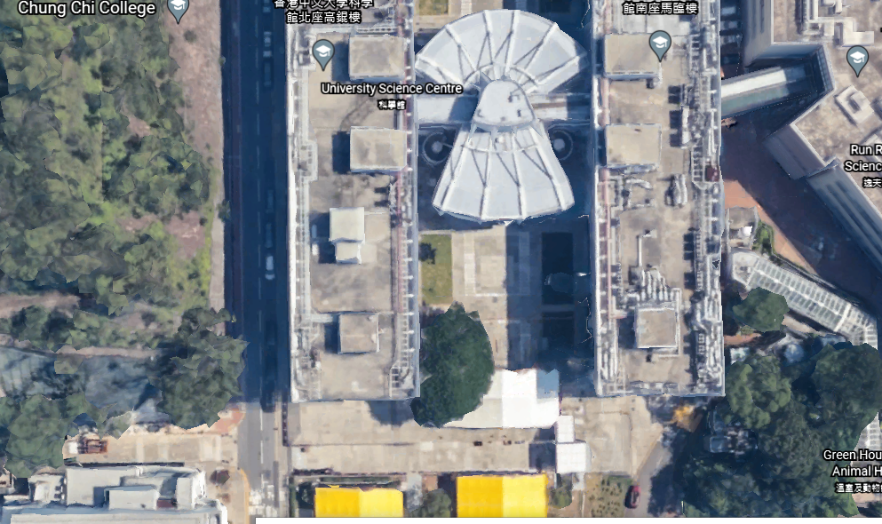

1. Build a simple flying bus(moving platform) with enough space for player to step in, and place it at the red star position. Once the player jump onto the bus, the bus will bring the player cycle along the red oval path, and stop again at the red star position to let the player get off. Once the player get on again, the bus will go through the route again. Note that the path will ascend gradually along the path to the *top* of lecture theatre complex at the midst of the path i.e at the sun position(see below). Throughout the journey, unless the player intentionally moving off the bus, the player should not be left off from the platform due to accelerate, decelerate or other motion of the platform. Then it will descend gradually again until reach the ground at around the start position.

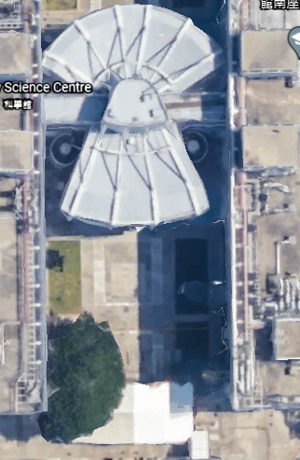

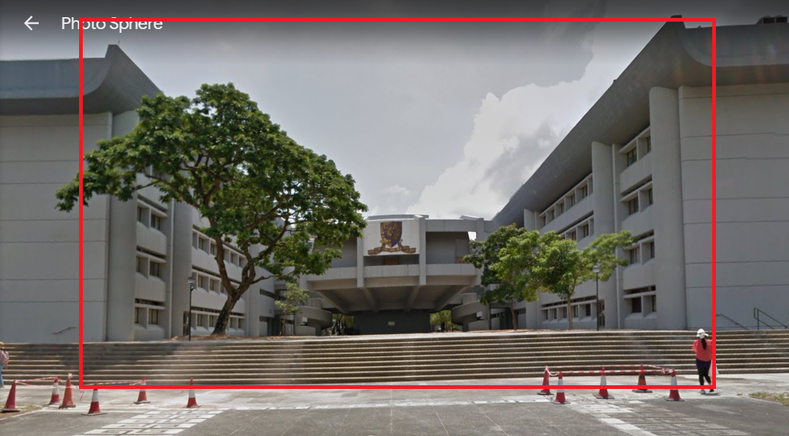

X

Requirements:

1. You should reconstruct the building façade of science centre both north and south block, but there is no need for their interior. This means there is no entry into all the buildings in the enclosed region. This also include the lecture theatres.
2. You need to build also the stairs i.e. stairs at the start position, we mark the position with ‘X’ in above picture. But the stairs are only limited to those in enclosed region.
3. You should also plant the same number of trees as that in the area.
4. Spiral staircases leading to the first floor outside lecture theatre must be built so that player can navigate to outside all lecture theatres (L1-3). There is no need to build L4 & 5 as you won’t be able to reach there. However you should build those passages at second floor as they are visible from first floor. You need not construct interior of all lecture theatres, only the exterior (doors, walls) are needed. Below is a screenshot from Google Earth on the region we are going to reconstruct.

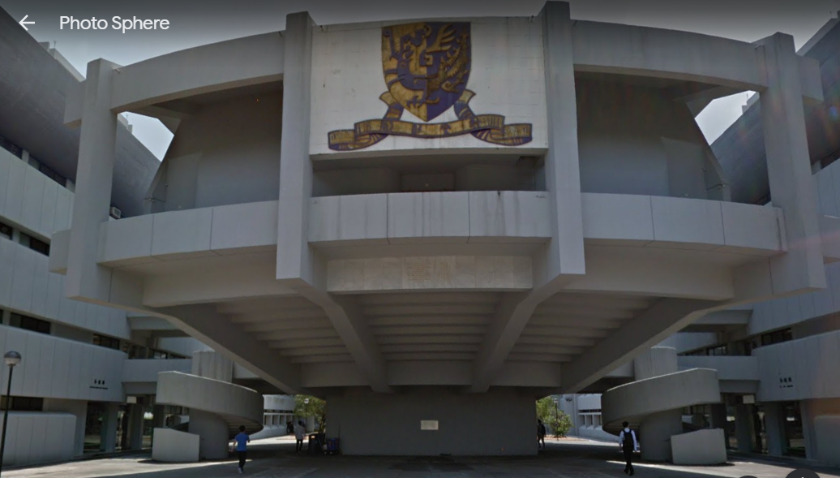

1. There is no need to model the buildings behind SCL1 i.e. the parts for SCL4,5 and those part behind for Science center north and south block. Façade for SCL1 i.e the big Chinese University emblem must be built. Also remember there is a human passage below the emblem which circle around lecture theatre L1.
2. The lamp posts, patterns on ground and vegetation should be reproduced to the best you can. However due to COVID-19, most of us cannot easily go to the venue for more details survey, thus you are allowed to just build something similar to that in Google Earth and street view will do. The objective is to build a level giving player similar feel of the original complex.
3. The simple bus behavior should be same as stated above – triggered per player entering the bus internal, loop for a turn and stop, then wait for next enter.

You may go to this link at Google Earth to get more information for this assignment

<https://earth.google.com/web/search/The+Chinese+University+of+Hong+Kong+MA+Lin+Building,+Science+Centre+South+Block,+Ma+Liu+Shui/@22.4192228,114.2080649,109.31351987a,967.83712324d,35y,0h,0t,0r/data=CigiJgokCYKcdVoabDZAEdvRTwKKajZAGc8vOvSbjVxAITZJqOoFjVxA>

The marking scheme will be based on:

1. how close is your level in appearance to that of Science Center lecture theatre complex. (70%)  
   I. major consideration : **North and South block building facade, Lecture theatre complex, spiral staircase**,   
   II. Minor details such as trees/vegetation placement, lamp posts, and other minor details that are whether as close to original as possible.
2. the bus performance as stated above (30%)

## Submissions

Submit your level together with associated material files and whatever additions as a single zip file. Then upload the zip file to your cloud drive account eg CUHK OneDrive. Finally share the file and give us the link in your submission to the CSCI4120 assignment submission slot at Blackboard.

Reference

1. Google Earth,
2. Wiki <https://en.wikipedia.org/wiki/Chinese_University_of_Hong_Kong>