**CSCI4120** Principle of Computer Game Software

**Assignment 2**

**Tank Game (FSM Scripting & Defeating Boss by TearBlaster)**

# Due: Mar 25, 2022(Friday)

Scripting refers to the techniques of writing scripts for pawns in 3D games so that the pawns will have desired behavior according to the game design. In this assignment, you are required to implement a finite state machine (FSM) to control some tanks in Unity game engine with various behaviors, and with a special weapon being built for the player to defeat a boss tank.

Requirements

You can use the level built according to our tutorial document to continue the work in this assignment.

You should :

1. write the scripts(finite state machine) for two different behaviors to apply on two enemy tanks,
2. implement a boss tank which has indestructable armor against any shell attack from player,
3. write the scripts to produce a tearblaster weapon for the player to defeat the boss tank.
4. Finite State Machine

The tanks should have *common* behavior (in addition to the working style later) as follow:

The tank should scan for whether the player is nearby continuously. If the player is visible within a distance of 30 units, then the tank should enter attack mode. The scanning process should be able to :

1. detect the player within its view cone of angle 120 degree forward with 30 units distance,
2. check visibility of the player through an unobstructed line of sight i.e. no walls or other objects in between.

In attack mode, the tank will first check whether player is within attack distance (30 units). If yes, it will then orient itself towards you, and fire a missile at you. Then it will wait for 1 second and repeat checking attac distance. Otherwise eg. Enemy tank leave, the tank will return to normal(original working state) mode.

In addition, the tanks should have two different styles of working.

1. Goal seeking

A goal point is set in the level (the flag of the player). The tank should proceed towards the goal point.

1. Patrol  
   **Three** waypoints will be set up in level (ordinary GameObject with collider). The tank should patrol between these waypoints.

Each tank should have a life point of **300**, and with each hit by missile, no matter from friendly fire or player, a reduction of 10 life points will be deducted. A zero life point will see the *removal* of the tank from game.

The fired shell should also be removed from game if they collide with tanks or player tank. However you need not handle those fired shells which did not collide with tanks.

1. Boss Tank

We are going to build a boss tank which has a special capability of protecting it against any ordinary attack from player. The setting here is that the boss tank got two flipping armor pieces. The armor has two states :

1. Attack which will open up the two armors so that the tank can fire missiles,

When the armor are in open position, the boss tank will fire a missile towards the player. After the missile fired (a 2 second interval), the armor will be closed again.

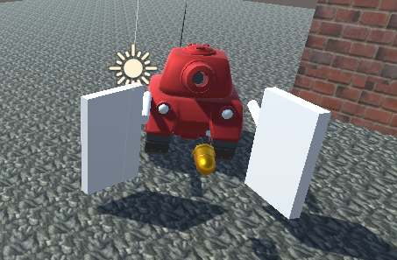

1. Protect, which the two pieces will fold together and provide a shelter against any incoming attacks.

The armor won’t be damaged by any ordinary missiles/shells.

The boss tank will transit back to attack mode after in protect mode for 10 seconds.

1. Tearblaster

Tearblaster is a weapon in Horizon Zero Dawn. The Tearblaster is a short-range ranged weapon that fires blasts of compressed air that easily strip armor and components from machines and stagger human and small machine enemies. We will implement a tearblaster for our player tank so as to help it to beat the boss tank.

The tearblaster is fired using the “space” key. You can make the tear ammo into whatever shape as it suppose won’t interact with all other entities except protect armor. The tear ammo upon hitting any armor will tear the armor from the equipped position, thus splitting away from its owner. The tearing action should be just breaking the armor from its connected body.

The boss tank should still be working properly with one or even both armors ripped off. Obviously your program should not crash or sending error/warning messages in these situation as well.

You need not implement the lightning effect of tearing off.

Tear ammo only have effect with armor and won’t cause any damage on other units.

**Remark**

1. This assignment needs you to use extensive scripting and physics engine knowledge. Unity official scripting documentation should help.

# Waypoint in Unity <http://forum.unity3d.com/threads/a-waypoint-script-explained-in-super-detail.54678/>

1. Game object rotation is a relatively difficult issue. In this assignment, you are not required to handle them cleanly. We will only focus on the actions taken by the tanks.
2. You can use joints in Unity to implement the protective armors as well as tearblaster actions.

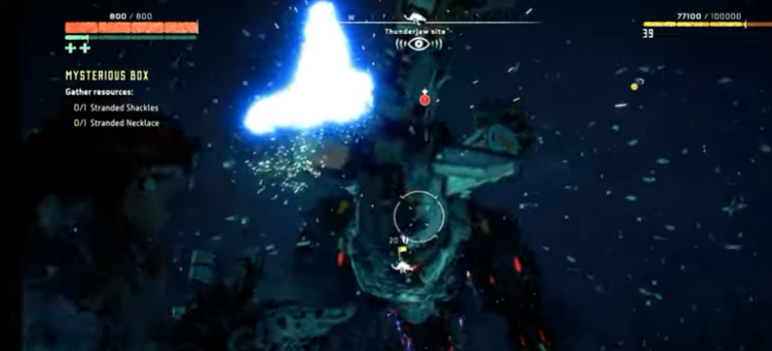  
Tearing armor from a thunderJaw in Horizon Zero Dawn

Tearblaster   
<https://horizon.fandom.com/wiki/Tearblaster>

## Submissions

Submit your completed scripts together with other needed files (zip the complete project folder) in a single archive to your cloud drive, and send us the public link so that our tutor will be able to download and test. Remember you are required to submit the link to our Blackboard assignment page on or before the deadline.

<http://blackboard.cuhk.edu.hk>