**CSCI4120** Principle of Computer Game Software

**Assignment 3**

**Animation Controller in Unity**

# Due: Apr 29, 2022(Friday)

In this assignment, we want you to apply the technique that we have learnt in character animation tutorial to add an attack motion and change the character to another animated character other than Ethan.

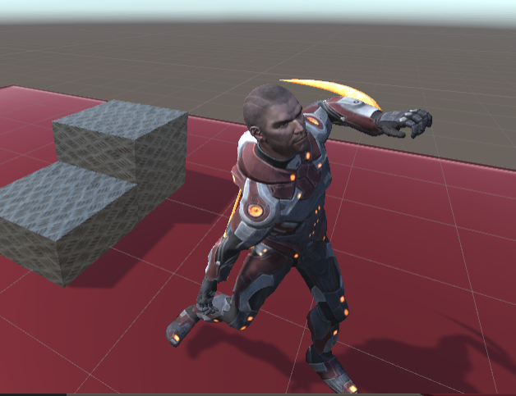

Requirements

You should continue the work in the tutorial on character animation controller to add the attack motion in this assignment.

You should:

1. Demonstrate that you can change the character to another character, with that all the original animation controls eg turn left/right, run etc are still be able to displayed by the controller,
2. Enhance the character in our tutorial to be able to do at least an attack animation. This should be based on what we have finished in the character animator tutorial, i.e. the character should be able to do walk, run, turn left and right, as well as jump motion.
3. The attack should be triggered by pressing the key “Fire1” in Unity, which corresponds to left “Ctl” key or left mouse click.

You can download any suitable character as well as attack animation from Mixamo (mixamo.com). Our chosen character here is Ely. You may also pick any attack animation from Miaxmo to use in your assignment (ours is “Surprise uppercut).

For changing character model under the animation controller, you can refer to this video

<https://www.youtube.com/watch?v=g4CsmzZq8uA>

Once you grasp this technique, it is easy for you to change to whatever suitable character (Warrok below)

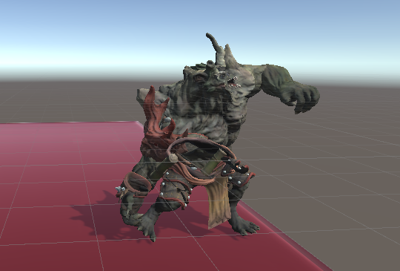

## Submissions

Submit your completed level together with other needed files (zip the complete project folder) in a single archive to your cloud drive, and send us the public link so that our tutor will be able to download and test. Remember you are required to submit the link to our Blackboard assignment page on or before the deadline.

<http://blackboard.cuhk.edu.hk>