**CSC4120 Principle of Computer Game Software**

**Written Assignment**

*Due: Apr 18, 2022(Monday) 5:30pm*

Answer all the questions below in a document and submit it into Blackboard collection page.

1. a) Construct a solid leafy BSP tree from the following top view of a level. (20%) You must use the following cost function to evaluate the hyperplane selection, and you must show your steps in building the tree. During hyperplane selection, if there exist any other polygons on the same plane, those polygons will be treated as *in front of* the hyperplane. Arrows are the normal of polygons.

Score(p) = abs(num of front_faces – num of back_faces) + num_split * 2

num_split : number of splitting polygons

The polygon with the lowest cost function will be selected as the next hyperplane. If there are more than one candidate with same lowest cost function score, you can choose any one of the candidates.

solid

solid

A

B

C

D

E

F

G

H

solid

solid

solid

solid

**You must show your intermediate steps/calculations in your answer, just showing the resulting tree will only get half of the score. You may take a photo of your work on paper and insert into the document.**

1. Unreal Engine 5 is released in April 2022, featuring two major engine components called “lumen” and “nanite”. Lumen provides real time global illumination calculation within the engine on all game world objects. The following video explains the working principle:

[Lumen in UE5: Let there be light! - Unreal Engine](https://www.unrealengine.com/en-US/blog/lumen-in-ue5-let-there-be-light)

1. Global lighting calculation is always difficult to be interactive as it requires lighting calculation on every point in scene as well as their inter-reflections i.e. ray tracing. Explain how Epic software engineers work to achieve this. You should explain the tricks (algorithm) and the data structures they used in brief. Describe a scene where the global calculation by Lumen will fail to correctly calculate the lighting result. (30%)
2. Nanite is another important feature in which together with Lumen, Epic claimed that the work flow in game creation can now be more unified and easy. Study the features of Nanite and explain i) why artists now can freely use whatever high-res polycount models, ii) any possible problems will Nanite have when being deployed in game development? (20%)
3. Below are two screenshots showing in game scene of the game Biohazard 3 (Resident Evil 3). After 20 years, the game was remade in 2020. Both are AAA productions in horror games as of their times, there are quite significant differences in these “same” games. For example, the perspectives in 1999 one is CCTV camera views while 2020 one is over-the-shoulder 3rd person view.

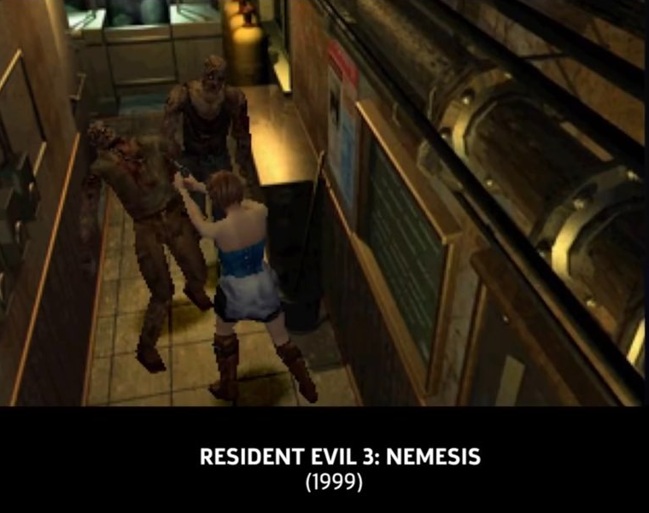

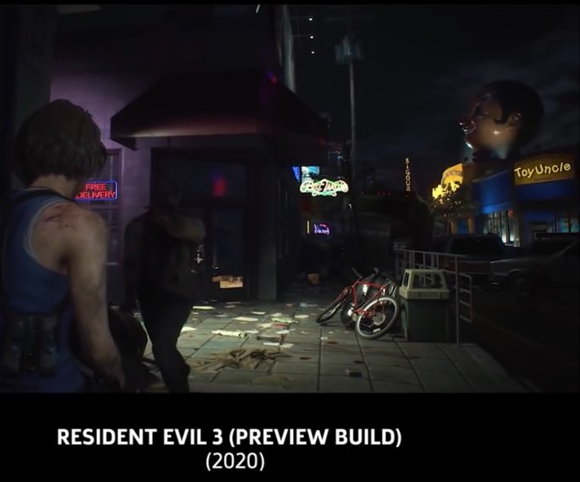

Although you may not have played these games, try answer the following questions by inspecting the two screenshots above.

a) Why the camera view control of both games has such difference? (10%)  
  
b) By comparing two screenshots, predict whether forward or deferred rendering each game used. Justify your answers. What are the possible shortcomings in this case? (10%)

c) Any other points you can infer from comparisons between these two screenshots with respect to what we have learnt so far in our course? (10%)

**Submissions**

Submit your completed document (possibly with scanned image if needed) to Blackboard assignment submission page. Late submission will risk a deduction of 30%.

<http://blackboard.cuhk.edu.hk>