GSM BASED HOME AUTOMATION SYSTEM

Industrial Internship Report

*Submitted by*

**Pannala Manish Reddy**

**17BEC1211**

**ECE3099 – INDUSTRIAL INTERNSHIP**

*in partial fulfillment for the award of the degree of*

# BACHELOR OF TECHNOLOGY

in

## ELECTRONICS AND COMMUNICATION ENGINEERING



OCTOBER 2020

# School of Electronics Engineering

**DECLARATION BY THE CANDIDATE**

I hereby declare that the Industrial Internship Report entitled “**GSM BASED HOME AUTOMATION SYSTEM”** submitted by me to VIT, Chennai in partial fulfillment of the requirement for the award of the degree of **Bachelor of Technology** in **Electronics and communication Engineering.** This is a record of bonafide industrial training undertaken by me under the supervision of **Sridhara Shetty (Head, CED) and Mr. Vijaya Chandra (Project leader), Secunderabad.** I further declare that the work reported in this report has not been submitted and will not be submitted, either in part or in full, for the award of any other degree or diploma in this institute or any other institute or university.

Chennai Signature of the Candidate



Date:19/10/2020 Register Number: **17BEC1211**

Student Name: **P. Manish Reddy**

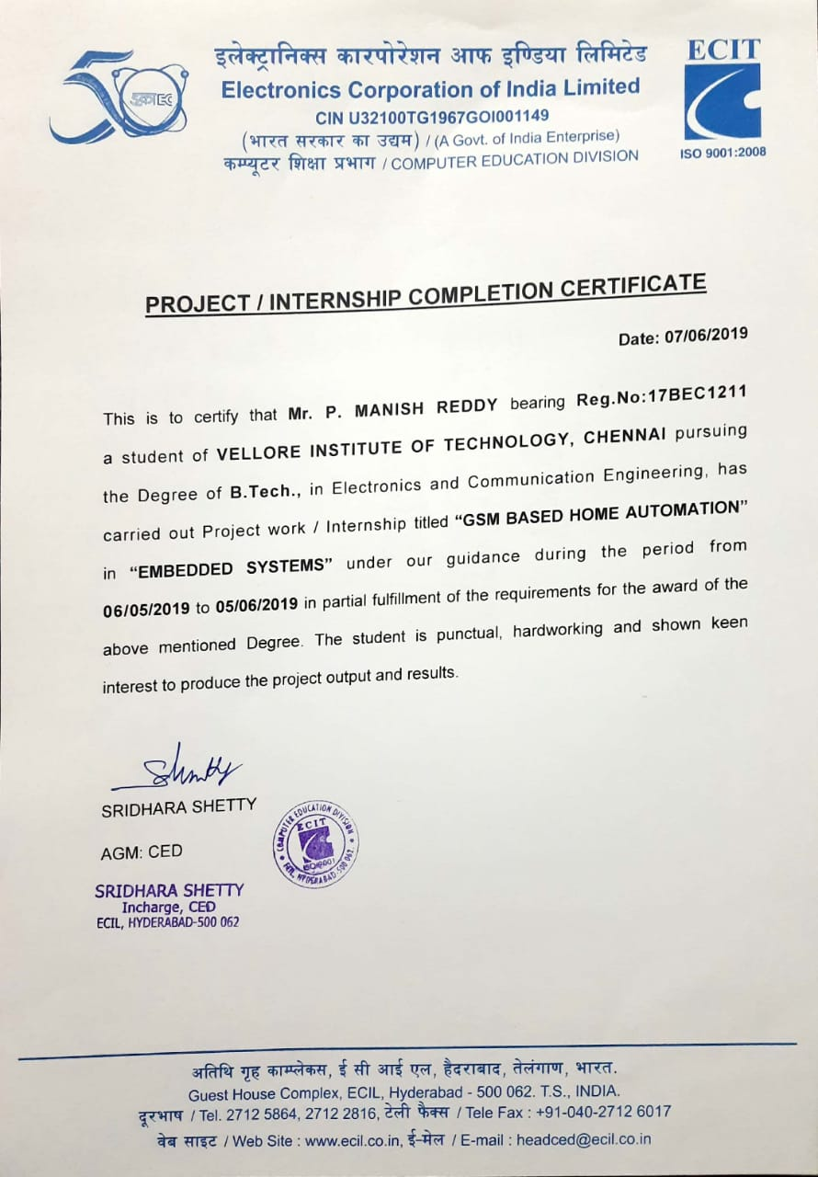



# School of Electronics Engineering

**BONAFIDE CERTIFICATE**

This is to certify that the Industrial Internship Report entitled “**GSM Based home automation System”** submitted by **Pannala Manish Reddy (17BEC1211)** to VIT University, Chennai in partial fulfillment of the requirement for the award of the degree of **Bachelor of Technology** in **Electronics and communication Engineering** is a record of bonafide internship undertaken by him/her fulfills the requirements as per the regulations of this institute and in my opinion meets the necessary standards for submission. The contents of this report have not been submitted and will not be submitted either in part or in full, for the award of any other degree or diploma in this institute or any other institute or university.

**Head of the Department (B.Tech ECE)**

# ACKNOWLEDGEMENT

I wish to thank those who were involved in the successful completion of my in-plant training at ECIL (Electronics corporation of India Limited), starting from **Sridhara Shetty (Head, CED) , Secunderabad**, for giving me the opportunity and freedom to learn as per my interests. The head of the team at ECIL, for being a constant support and guidance; the project leader **Mr. Vijaya Chandra**, for providing me with the necessary resources; and the entire staff of the company for their support and positivity, which made my internship a worthwhile experience.

I would also like to thank my parents, for being my motivation to take up this internship; and last, but not the least, the faculty and management at ECIL, Secunderabad for providing me with such an avenue to help realize how interesting it is to work in today's industry.

Pannala Manish Reddy

# TABLE OF CONTENTS

## DECLARATION CERTIFICATE

**BONAFIED CERTIFICATE ACKNOWLEDGEMENT TABLE OF CONTENTS LIST OF ABBREVIATIONS ABSTRACT**

1. **INTRODUCTION**
   1. ABOUT THE COMPANY
   2. INTERNSHIP SUMMARY
   3. PROBLEM STATEMENT
   4. PROJECT OBJECTIVE

## INTRODUCTION TO EMBEDDED SYSTEMS

* 1. INTRODUCTION
  2. FEATURES OF AN EMBEDDED SYSTEM:
  3. CHARACTERISTICS OF AN EMBEDDED SYSTEM:

## DESIGN ELEMENTS

* 1. MICROCONTROLLER
  2. POWER SUPPLY
  3. LIQUID CRYSTAL DISPLAY
  4. MAX232
  5. GSM (Global System for Mobile communications)

## CIRCUIT EXPLANATION

* 1. DESCRIPTION
  2. CODE
  3. INTERFACING LCD WITH CONTROLLER

## ADVANTAGES

1. **DISADVANTAGES**
2. **FUTURE SCOPE**
3. **CONCLUSION**
4. **REFERENCES**

**LIST OF ABBREVIATIONS**

* PSW**:** Program status word
* IP: Interrupt Priority
* SFR: Special Function Register
* ALE: Address Latch Enable
* SP: Stack Pointer
* DPL/DPH: Data Pointer Low/Data Pointer High
* PSEN: Program Store Enable
* PCON: Power Control
* TCON: Timer Control
* TMOD: Timer Mode
* CAN: Control Area Network
* LCD: Liquid Crystal Display
* EA: External Access Enable
* RTS: Request to send
* CTS: Clear to send
* ISP : In system Programmable
* DTR: Data terminal ready
* DSR: Data set ready
* DB: Define byte
* SCON: Selection control
* SBUF: Selection buffer
* RS: Selection register
* RW: Read write
* EN: Enable

# ABSTRACT

In today’s fast changing world, everything is becoming compact, portable and mobile. The mobile handsets for communication are the biggest advancement in the area. These have made our lives much simpler and connected. Today almost everyone is familiar with its usage, and is able to draw advantage from it. The technologies for mobile communication have been ever evolving. Each had their share of pro’s and con’s. The Global System for Mobile communication represents the second generation of mobile communications.

The idea behind the project is to utilize the mobile nature of communication and application provided by the GSM technology, namely SMS. Mobile phone is a revolutionary invention of the century. It was primarily designed for making and receiving calls & text messages, but it has become the whole world after the Smart phone appears. In this project, no Smart phone is used; just the old GSM phone will work to switch ON and OFF any home electronic appliances, from anywhere. This is easy to use control of appliances will not only make our daily life easy but it will also reduce the unnecessary consumption of electricity.

# INTRODUCTION

## ABOUT THE COMPANY

ECIL was setup under the Department of Atomic Energy on 11th of April 1967 with a view to generate a strong indigenous capability in the field of professional grade electronics. The initial accent was on total self-reliance and ECIL was engaged in the design development, Manufacture and Marketing of several products with emphasis on three technology lines viz. Computers, Control Systems and Communications. Over the years, ECIL pioneered the development of various complex electronics products without any external technology help and scored several ‘firsts’ in this fields prominent among them being country’s

1. First Digital Computer
2. First Solid State TV
3. First Control & Instrumentation of Nuclear Power Plants
4. First Earth Station Antenna
5. First Computerized Operator Information System
6. First radiation Monitoring & Detection System
7. First Automatic Message Switching System
8. First Operation & Maintenance Center for E-108 Exchange 10.First Programmable Logic Controller

11.First Solid state Cockpit Voice Recorder 12.First Electronics Voting Machines

The company played a very significant role in the training and growth of high caliber technical and managerial men power especially in the fields of Computer and Information Technology. Though the initial thrust was on meeting the Control & Instrumentation requirements of the Nuclear Power Program, the expand scope of self-reliance pursued by ECIL enabled the company to develop various products to cater to the needs of Defense, Civil Aviation, Information & Broadcasting, Telecommunications, Insurance, banking, Police and Para-Military Forces, Oil & Gas, Power, Space Education, Health, Agriculture Steel and Coal Sectors and various user departments in the Government domain. ECIL thus evolved as multi- product company serving multiple sectors of Indian economy with emphasis on import of country substitution and development of products & services that are of economic and strategic significance to the country.

## INTERNSHIP SUMMARY

As a part of our curriculum, we have been instructed to do industrial internship for a span of at least 28 days. The intention of introducing industrial internship as a part of our curriculum is to gain practical knowledge of the subjects learnt in our classroom and to gain industrial exposure. The in-plant training’s duration is from 6th of May 2019 to 5th of June 2019. We were divided into batches at ECIL and were asked to select projects in the stream of embedded systems for which problem statements were given and out of our interest and curiosity we have selected the project **GSM Based Home Automation System**.

Being a student, it was a wonderful experience to get a chance to work in an esteemed Organization. I have learnt Organizational etiquette and attained

industrial work experience while maintaining the bi-lateral relations of the University and the Organization and thereby fulfilling the intention of the University in introducing in-plant training as a part of our curriculum.

## PROBLEM STATEMENT

Technology has advanced so much in the last decade that it has made life more efficient and comfortable. The comfort of being able to take control of devices from one location has become imperative as it saves a lot of time and effort. Therefore, there arises a need to do so in a systematic manner, which we have tried to implement with our system. The system we have proposed is an extended approach to automating a control system. The application of our system comes in handy when people who forget to do simple things such as turn ON or OFF devices at their home or in their office, they can now do so without their presence by the transmission of a simple text message from their mobile phone. For the device to be controlled as per desire, a particular “line” or “path” of communication need not be taken care of. For example, TV cannot be controlled unless a clear path is maintained for the infrared rays to reach the TV. Our project outreaches such problems and makes it comfortable for the user to operate devices.

## PROJECT OBJECTIVE

* The goal of the project is to develop a system, which uses Mobile technology that keeps control of the various units of the automobiles, which executes with respect to the signal sent by the mobile.
* For utilization of appliances the new concept has been thought to manage them remotely by using GSM, which enables the user to remotely control switching of domestic appliances. Just by dialing keypad of remote telephone, from where you are calling you can perform ON / OFF operation of the appliances.
* The ranges of appliances that can be controlled through tele remote systems are many in numbers. Some of them are as follows and this depends upon the usage priority of the appliances i.e. parking Lights, Music System, TV or other electrical / electronic appliances.

## BLOCK DIAGRAM

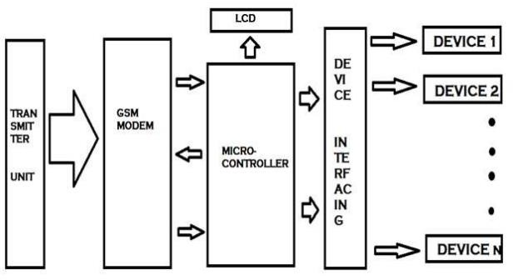

* + 1. **INTRODUCTION TO EMBEDDED SYSTEMS**
  1. **INTRODUCTION**

Each day, our lives become more dependent on 'embedded systems', digital information technology that is embedded in our environment. More than 98% of processors applied today are in embedded systems and are no longer visible to the customer as 'computers' in the ordinary sense. An Embedded System is a special- purpose system in which the computer is completely encapsulated by or dedicated to the device or system it controls. The increasing use of PC hardware is one of the most important developments in high-end embedded systems in recent years. Hardware costs of high-end systems have dropped dramatically as a result of this trend, making feasible some projects which previously would not have been done because of the high cost of non-PC-based embedded hardware. But software choices for the embedded PC platform are not nearly as attractive as the hardware.

Typically, an embedded system is housed on a single microprocessor board with the programs stored in ROM. Virtually all appliances that have a digital interface -- watches, microwaves, VCRs, cars -- utilize embedded systems. Some embedded systems include an operating system, but many are so specialized that the entire logic can be implemented as a single program.

Physically, Embedded Systems range from portable devices such as digital watches and MP3 players, to large stationary installations like traffic lights, factory controllers, or the systems controlling nuclear power plants.

In terms of complexity embedded systems can range from very simple with a single microcontroller chip, to very complex with multiple units, peripherals and networks mounted inside a large chassis or enclosure.

## FEATURES OF AN EMBEDDED SYSTEM

The versatility of the embedded computer system lends itself to utility in all kinds of enterprises, from the simplification of deliverable products to a reduction in costs in their development and manufacture. Complex systems with rich functionality employ special operating systems that take into account major characteristics of embedded systems. Embedded operating systems have minimized footprint and may follow real-time operating system specifics.

The special computers system is usually less powerful than general-purpose systems, although some expectations do exist where embedded systems are very powerful and complicated. Usually a low power consumption CPU with a limited amount of memory is used in embedded systems. Many embedded systems use very small operating systems; most of these provide very limited operating system capabilities.

Since the embedded system is dedicated to specific tasks, design engineers can optimize it, reducing the size and cost of the product, or increasing the reliability and performance. Some embedded systems are mass-produced, benefiting from economies of scale.

Some embedded systems have to operate in extreme environment conditions such as very high temperature & humidity.

For high volume systems such as portable music players or mobile phones, minimizing cost is usually the primary design consideration. Engineers typically select hardware that is just “good enough” to implement the necessary functions.

For low volume or prototype-embedded systems, general-purpose computers may be adapted by limiting the programs or by replacing the operating system with a real-time operating system.

## 2.4 CHARACTERISTICS OF AN EMBEDDED SYSTEM

An Embedded computing systems generally exhibit rich functionality complex functionality is usually the reason for introducing CPUs into the design. However, they also exhibit many non-functional requirements that make the task especially challenging:

* Real-time deadlines that will cause system failure if not met;
* Multi-rate operation;
* In many cases, low power consumption;
* Low manufacturing cost, which often means limited code size.

Workstation programmers often concentrate on functionality. They may consider the performance characteristics of a few computational kernels of their software, but rarely analyze the total application. They almost never consider power consumption and manufacturing cost. The need to juggle all these requirements makes embedded system programming very challenging and is the reason why embedded system designers need to understand computer architecture.

# 3. DESIGN ELEMENTS

## MICROCONTROLLER

* + 1. **INTRODUCTION:**

Microcontrollers as the name suggests are small controllers. They are like single chip computers that are often embedded into other systems to function as processing/controlling unit. For example the remote control you are using probably has microcontrollers inside that do decoding and other controlling functions. They are also used in automobiles, washing machines, microwave ovens, toys ... etc, where automation is needed.

Micro-controllers are useful to the extent that they communicate with other devices, such as sensors, motors, switches, keypads, displays, memory and even other micro-controllers. Many interface methods have been developed over the years to solve the complex problem of balancing circuit design criteria such as features, cost, size, weight, power consumption, reliability, availability, manufacturability.

Basically, a microcontroller is a device which integrates a number of the components of a microprocessor system onto a single microchip. So a microcontroller combines onto the same microchip. The following components:

1. CPU
2. Core Memory (Both RAM and ROM)
3. Some Parallel Digital I/Os

Essentially, a microcontroller is obtained by integrating the key components of microprocessor, RAM, ROM, and Digital I/O onto the same chip die. Modern

microcontrollers also contain a wealth of other modules such as Serial I/O, Timers, and Analogue to Digital Converters. There are a large number of specialized devices with additional modules for specific needs. E.g. CAN controllers.

## FEATURES:

* 8K Bytes of In-System Reprogrammable Flash Memory
* Endurance: 1,000 Write/Erase Cycles
* Fully Static Operation: 0 Hz to 24 MHz
* 256 x 8-bit Internal RAM
* 32 Programmable I/O Lines
* Three 16-bit Timer/Counters
* Eight Interrupt Sources
* Programmable Serial Channel
* Low-power Idle and Power-down Modes

## DESCRIPTION:

The AT89S52 is a low-power, high-performance CMOS 8-bit micro controller with 8Kbytes of in-system programmable Flash memory.

The device is manufactured using Atmel’s high-density non-volatile memory technology and is compatible with the industry-standard 80C51 micro controller. The on-chip Flash allows the program memory to be reprogrammed in-system or by a conventional non-volatile memory programmer. By combining a versatile 8- bit CPU with in-system programmable flash one monolithic chip; the Atmel AT89S52 is a powerful micro controller, which provides a highly flexible and cost- effective solution to many embedded control applications.

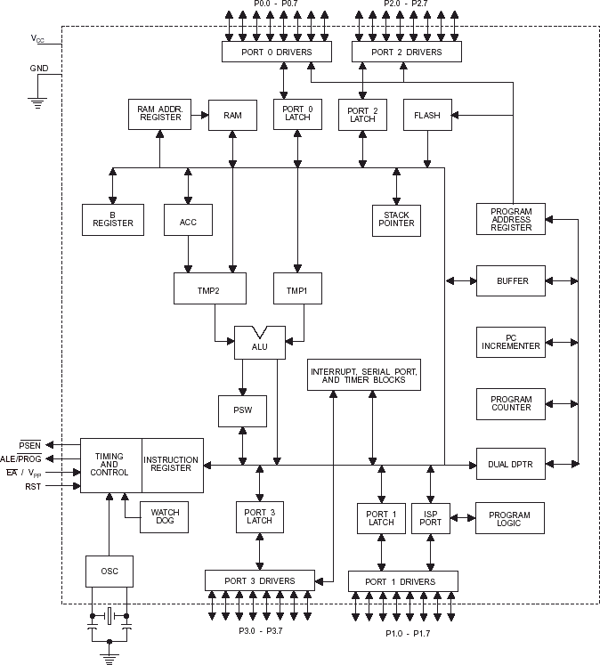

## FIG: BLOCK DIAGRAM OF AT89S52

* + 1. **PIN CONFIGURATION:**

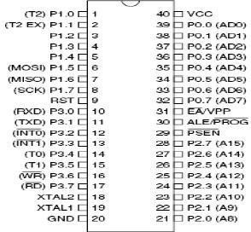

**FIG: PIN DIAGRAM OF 8051 MICROCONTROLLER**

The AT89S52 provides the following standard features: 8K bytes of Flash, 256 bytes of RAM, 32 I/O lines, Watchdog timer, two data pointers, three 16-bit timer/counters, full duplex serial port, on-chip oscillator, and clock circuitry. In addition, the AT89S52 is designed with static logic for perationdown to zero frequency and supports two software selectable power saving modes. The Idle Mode stops the CPU while allowing the RAM timer/counters, serial port, and interrupt system to continue functioning. The Power-down mode saves the RAM contents but freezes the oscillator, disabling all other chip functions until the next interrupt or hardware reset.

## PIN DESCRIPTION:

**Vcc:** Supply voltage.

**GND:** Ground.

**PORT 0:** Port 0 is an 8-bit open drain bi-directional I/O port. As an output port, each pin can sink eight TTL inputs. When 1s are written to port 0 pins, the pins can be used as high impedance inputs. Port 0 can also be configured to be the multiplexed low order address/data bus during accesses to external program and data memory. In this mode, P0 has internal pull-ups. Port 0 also receives the code bytes during Flash programming and outputs the code bytes during program verification. External pull-ups are required during program verification.

**PORT 1:** Port 1 is an 8-bit bi-directional I/O port with internal pull-ups. The Port 1 Output buffers can sink/source four TTL inputs. When 1s are written to Port 1 pins, they are pulled high by the internal pull-ups and can be used as inputs. In addition, P1.0 and P1.1 can be configured to be the timer/counter 2 external count input (P1.0/T2) and the timer/counter 2 trigger input P1.1/T2EX), respectively, as hown in the following table. Port 1 also receives the low-order address bytes during Flash programming.

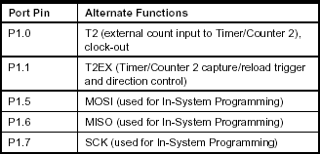

## TABLE: PORT 1 FUNCTIONS.

**PORT 2:** Port 2 is an 8-bit bi-directional I/O port with internal pull-ups. The Port 2 output buffers can sink/source four TTL inputs. When 1s are written to Port 2 pins, they are pulled high by the internal pull-ups and can be used as inputs. Port 2 emits the high-order address byte during fetches from external program memory and during accesses to external data memory that uses 16-bit addresses (MOVX @DPTR). In this application, Port 2 uses strong internal pull-ups when emitting 1s. During accesses to external data memory that use 8-bit addresses (MOVX @ RI), Port 2emits the contents of the P2 Special Function Register. Port 2 also receives the high-order address bits and some control signals during Flash programming and verification.

**PORT 3:** Port 3 is an 8-bit bi-directional I/O port with internal pull-ups. The Port 3 output buffers can sink/source four TTL inputs. When 1s are written to Port 3 pins, they are pulled high by the internal pull-ups and can be used as inputs. As inputs, Port 3 pins that are externally being pulled low will source current (IIL) because of the pull-ups. Port 3 also serves the functions of various special features of the AT89S52, as shown in the following table.

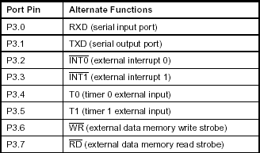

## TABLE: PORT 3 FUNCTIONS.

**RST:** Reset input. A high on this pin for two machine cycles while the oscillator is running resets the device.

**ALE/PROG:** Address Latch Enable (ALE) is an output pulse for latching the low byte of the address during accesses to external memory. This pin is also the program pulse input (PROG) during Flash programming.

In normal operation, ALE is emitted at a constant rate of1/6 the oscillator frequency and may be used for external timing or clocking purposes. Note, however, that one ALE pulse is skipped during each access to external data Memory. If desired, ALE operation can be disabled by setting bit 0 of SFR location 8EH. with the bit set, ALE is active only during a MOVX or MOVC instruction. Otherwise, the pin is weakly pulled high.

**PSEN:** Program Store Enable (PSEN) is the read strobe to external program memory. When the AT89S52 is executing code from external program memory, PSEN is activated twice each machine cycle, except that two PSEN activations are skipped during each access to external data memory.

**EA/VPP:** External Access Enable. EA must be strapped to GND in order to enable the device to fetch code from external program memory locations starting at 0000H up to FFFFH. Note, however, that if lock bit 1 is programmed, EA will be internally latched on reset. A should be strapped to VCC for internal program executions. This pin also receives the 12-voltProgramming enables voltage (VPP) during Flash programming.

**XTAL1:** Input to the inverting oscillator amplifier and input to the internal clock operating circuit.

**XTAL2:** Output from the inverting oscillator amplifier.

## POWER SUPPLY DESCRIPTION:

As the microcontroller operating voltage is +5V DC. Through this power supply circuit we have to create a +5V DC which is given to the micro controller. The below components are used to create the power supply

230V AC

supply

Step down transformer

Bridge rectifier

Filter

Regulator

## FIG: BLOCK DIAGRAM OF POWER SUPPLY

230V AC supply is given to the step down transformer of 12A type. It may be a 230V to 9V or 12V step down transformer. The output of the step down transformer is given to bridge rectifier. The bridge rectifier is formed with 1N4007 diodes. The bridge rectifier converts the AC Voltage into DC Voltage. But the output DC Voltage contains some AC component (ripples). So we use a capacitors- 2200uF/25V, 0.1uF/D and resistor of 10K as a filter for removing ripples. That output DC Voltage is given to the positive voltage regulator LM7805 (i.e., 78 represents the positive series and 5 represent the output voltage it can provide). So the output of the regulator will be the regulated +5V DC. To indicate the condition of the circuit we place a LED at the end of the circuit.

## LIQUID CRYSTAL DISPLAY

Liquid crystal display is a type of display used in digital watches and many portable computers.

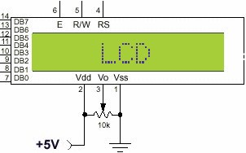

## FIG: PIN DIAGRAM OF LCD

LCD displays utilize two sheets of polarizing material with a liquid crystal solution between them. An electric current passed through the liquid causes the crystals to align so that light cannot pass through them. Each crystal, therefore, is like a shutter, either allowing light to pass through or blocking the light.

The input which we give to the microcontroller is displayed on the LCD of the transmitter side and the message sent is received at the receiver side which displays at the receiver end of the LCD and the corresponding operation is performed .They make complicated equipment easier to operate.

## 3.2.1 PIN DESCRIPTION of LCD:

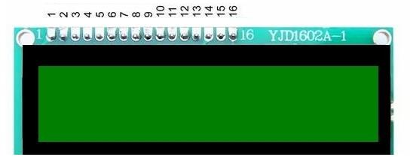

|  |  |  |  |
| --- | --- | --- | --- |
| **PIN** | **SYMBOL** | **I/O** | **DESCRIPTION** |
| 1 | Vss | -- | Ground |
| 2 | Vcc | -- | +5V power supply |
| 3 | Vee | -- | Power supply to control contrast |
| 4 | RS | I | RS=0 to select command register  RS=1 to select data register |
| 5 | R/W | I | R/W=0 for write  R/W=1 for read |

|  |  |  |  |
| --- | --- | --- | --- |
| 6 | EN | I/O | Enable |
| 7 | DB0 | I/O | The 8-bit data bus |
| 8 | DB1 | I/O | The 8-bit data bus |
| 9 | DB2 | I/O | The 8-bit data bus |
| 10 | DB3 | I/O | The 8-bit data bus |
| 11 | DB4 | I/O | The 8-bit data bus |
| 12 | DB5 | I/O | The 8-bit data bus |
| 13 | DB6 | I/O | The 8-bit data bus |
| 14 | DB7 | I/O | The 8-bit data bus |
| 15 | Backlight Anode(+ve) | - | Display purpose using backlight |
| 16 | Backlight Cathode(Ground) | - | Display purpose using backlight |

The ASCII code to be displayed is eight bits long and is sent to the LCD either four or eight bits at a time.

* If four bit mode is used, two "nibbles" of data (Sent high four bits and then low four bits with an "E" Clock pulse with each nibble) are sent to make up a full eight bit transfer.
* The "E" Clock is used to initiate the data transfer within the LCD.
* Deciding how to send the data to the LCD is most critical decision to be made for an LCD interface application.
* Eight-bit mode is best used when speed is required in an application and at least ten I/O pins are available.
* The "R/S" bit is used to select whether data or an instruction is being transferred between the microcontroller and the LCD.
* If the Bit is set, then the byte at the current LCD "Cursor" Position can be reader written.
* When the Bit is reset, either an instruction is being sent to the LCD or the execution status of the last instruction is read back.

## MAX 232

A standard serial interface for PC, RS232C, requires negative logic, i.e., logic 1 is - 3V to -12V and logic 0 is +3V to +12V. To convert TTL logic, say, TxD and RxD pins of the microcontroller thus need a converter chip. A MAX232 chip has long been using in many microcontrollers boards. It is a dual RS232 receiver / transmitter that meets all RS232 specifications while using only +5V power supply. It has two onboard charge pump voltage converters which generate +10V to -10V power supplies from a single 5V supply. It has four level translators, two

of which are RS232 transmitters that convert TTL/CMOS input levels into +9V RS232 outputs. The other two level translators are RS232 receivers that convert RS232 input to 5V. Typical MAX232 circuit is shown below.

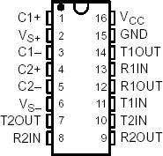

**Circuit connections:** A standard serial interfacing for PC, RS232C, requires negative logic, i.e., logic '1' is -3V to -12V and logic '0' is +3V to +12V. To convert a TTL logic, say, TxD and RxD pins of the uC chips, thus need a converter chip. A MAX232 chip has long been using in many uC boards. It provides 2- channel RS232C port and requires external 10uF capacitors. A DS275 however, no need external capacitor and smaller.

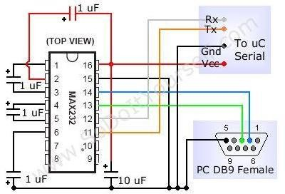

## GSM (GLOBAL SYSTEM FOR MOBILE COMMUNICATION)

GSM (Global System for Mobile communications) is a cellular network, which means that mobile phones connect to it by searching for cells in the immediate vicinity. GSM networks operate in four different frequency ranges. Most GSM networks operate in the 900 MHz or 1800 MHz bands. Some countries in the Americas use the 850 MHz and 1900 MHz bands because the 900 and 1800 MHz frequency bands were already allocated.

The rarer 400 and 450 MHz frequency bands are assigned in some countries, where these frequencies were previously used for first-generation systems.

GSM-900 uses 890–915 MHz to send information from the mobile station to the base station (uplink) and 935–960 MHz for the other direction (downlink), providing 124 RF channels (channel numbers 1 to 124) spaced at 200 kHz. Duplex spacing of 45 MHz is used. In some countries the GSM-900 band has been extended to cover a larger frequency range. This 'extended GSM', E-GSM, uses 880–915 MHz (uplink) and 925–960 MHz (downlink), adding 50 channels (channel numbers 975 to 1023 and 0) to the original GSM-900 band. Time division multiplexing is used to allow eight full-rate or sixteen half-rate speech channels per radio frequency channel. There are eight radio timeslots (giving eight burst periods) grouped into what is called a TDMA frame. Half rate channels use alternate frames in the same timeslot. The channel data rate is 270.833 kbit/s, and the frame duration is 4.615 ms.

## GSM Advantages:

GSM also pioneered a low-cost, to the network carrier, alternative to voice calls, the Short t message service (SMS, also called "text messaging"), which is now supported on other mobile standards as well. Another advantage is that the standard includes one worldwide Emergency telephone number, 112. This makes it easier for international travelers to connect to emergency services without knowing the local emergency number.

## The GSM Network:

GSM provides recommendations, not requirements. The GSM specifications define the functions and interface requirements in detail but do not address the hardware. The GSM network is divided into three major systems: the switching system (SS), the base station system (BSS), and the operation and support system (OSS).

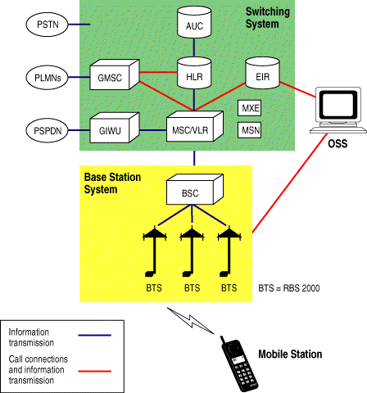

* The Switching System (SS):The SS is responsible for performing call processing and subscriber-related functions. The switching system includes the following functional units.
* Home location register (HLR): The HLR is a database used for storage and management of subscriptions. The HLR is considered the most important database, as it stores permanent data about subscribers, including a subscriber's service profile, location information, and activity status. When an individual buys a subscription from one of the PCS operators, he or she is registered in the HLR of that operator.
* Mobile services switching center (MSC):The MSC performs the telephony switching functions of the system. It controls calls to and from other telephone and data systems. It also performs such functions as toll ticketing, network interfacing, common channel signaling, and others.
* Visitor location register (VLR)**:** The VLR is a database that contains temporary information about subscribers that is needed by the MSC in order to service visiting subscribers. The VLR is always integrated with the MSC. When a mobile station roams into a new MSC area, the VLR connected to that MSC will request data about the mobile station from the HLR. Later, if the mobile station makes a call, the VLR will have the information needed for call setup without having to interrogate the HLR each time.
* Authentication center (AUC)**:** A unit called the AUC provides authentication and encryption parameters that verify the user's identity and ensure the confidentiality of each call. The AUC protects network operators from different types of fraud found in today's cellular world.
* Equipment identity register (EIR)**:** The EIR is a database that contains information about the identity of mobile equipment that prevents calls from

stolen, unauthorized, or defective mobile stations. The AUC and EIR are implemented as stand-alone nodes or as a combined AUC/EIR node.

## The Base Station System (BSS):

All radio-related functions are performed in the BSS, which consists of base station controllers (BSCs) and the base transceiver stations (BTSs).

* BSC**:** The BSC provides all the control functions and physical links between the MSC and BTS. It is a high-capacity switch that provides functions such as handover, cell configuration data, and control of radio frequency (RF) power levels in base transceiver stations. A number of BSCs are served by an MSC.
* BTS**:** The BTS handles the radio interface to the mobile station. The BTS is the radio equipment (transceivers and antennas) needed to service each cell in the network. A group of BTSs are controlled by a BSC.

## The Operation and Support System

The operations and maintenance center (OMC) is connected to all equipment in the switching system and to the BSC. The implementation of OMC is called the operation and support system (OSS). The OSS is the functional entity from which the network operator monitors and controls the system. The purpose of OSS is to offer the customer cost-effective support for centralized, regional and local operational and maintenance activities that are required for a GSM network. An important function of OSS is to provide a network overview and support the maintenance activities of different operation and maintenance organizations.

## Additional Functional Elements

* Message center (MXE)**:** The MXE is a node that provides integrated voice, fax, and data messaging. Specifically, the MXE handles short message service, cell broadcast, voice mail, fax mail, e-mail, and notification.
* Mobile service node (MSN)**:** The MSN is the node that handles the mobile intelligent network (IN) services.
* Gateway mobile services switching center (GMSC)**:** A gateway is a node used to interconnect two networks. The gateway is often implemented in an MSC. The MSC is then referred to as the GMSC.
* GSM inter-working unit (GIWU)**:** The GIWU consists of both hardware and software that provides an interface to various networks for data communications. Through the GIWU, users can alternate between speech and data during the same call. The GIWU hardware equipment is physically located at the MSC/VLR.

## GSM Network Areas:

The GSM network is made up of geographic areas. As shown in bellow figure, these areas include cells, location areas (LAs), MSC/VLR service areas, and public land mobile network (PLMN) areas.

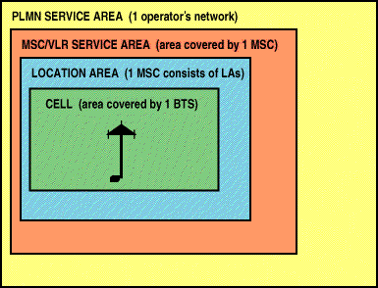

Location Areas:The cell is the area given radio coverage by one base transceiver station. The GSM network identifies each cell via the cell global identity (CGI) number assigned to each cell. The location area is a group of cells. It is the area in which the subscriber is paged. Each LA is served by one or more base station controllers, yet only by a single MSC Each LA is assigned a location area identity (LAI) number.

MSC/VLR service areas:An MSC/VLR service area represents the part of the GSM network that is covered by one MSC and which is reachable, as it is registered in the VLR of the MSC.

PLMN service areas:The PLMN service area is an area served by one network operator.

## GSM Specifications:

Specifications for different personal communication services (PCS) systems vary among the different PCS networks. Listed below is a description of the specifications and characteristics for GSM.

* Frequency band**:** The frequency range specified for GSM is 1,850 to 1,990 MHz (mobile station to base station).
* Duplex distance**:** The duplex distance is 80 MHz. Duplex distance is the distance between the uplink and downlink frequencies. A channel has two frequencies, 80 MHz apart.
* Channel separation**:** The separation between adjacent carrier frequencies. In GSM, this is 200 kHz.
* Modulation**:** Modulation is the process of sending a signal by changing the characteristics of a carrier frequency. This is done in GSM via Gaussian minimum shift keying (GMSK).
* Transmission rate**:** GSM is a digital system with an over-the-air bit rate of 270 kbps.
* Access method**:** GSM utilizes the time division multiple access (TDMA) concept. TDMA is a technique in which several different calls may share the same carrier. Each call is assigned a particular time slot.
* Speech coder**:** GSM uses linear predictive coding (LPC). The purpose of LPC is to reduce the bit rate. The LPC provides parameters for a filter that mimics the vocal tract. The signal passes through this filter, leaving behind a residual signal. Speech is encoded at 13 kbps.

## GSM Subscriber Services:

Dual-tone multifrequency (DTMF)**:** DTMF is a tone signaling scheme often used for various control purposes via the telephone network, such as remote control of an answering machine. GSM supports full-originating DTMF.

Facsimile group III**—**GSM supports CCITT Group 3 facsimile. As standard fax machines are designed to be connected to a telephone using analog signals, a special fax converter connected to the exchange is used in the GSM system. This enables a GSM–connected fax to communicate with any analog fax in the network.

Short message services**:** A convenient facility of the GSM network is the short message service. A message consisting of a maximum of 160 alphanumeric characters can be sent to or from a mobile station. This service can be viewed as an

advanced form of alphanumeric paging with a number of advantages. If the subscriber's mobile unit is powered off or has left the coverage area, the message is stored and offered back to the subscriber when the mobile is powered on or has reentered the coverage area of the network. This function ensures that the message will be received.

Cell broadcast: A variation of the short message service is the cell broadcast facility. A message of a maximum of 93 characters can be broadcast to all mobile subscribers in a certain geographic area. Typical applications include traffic congestion warnings and reports on accidents.

Voice mail: This service is actually an answering machine within the network, which is controlled by the subscriber. Calls can be forwarded to the subscriber's voice-mail box and the subscriber checks for messages via a personal security code.

Fax mail: With this service, the subscriber can receive fax messages at any fax machine. The messages are stored in a service center from which they can be retrieved by the subscriber via a personal security code to the desired fax number

## Supplementary Services:

GSM supports a comprehensive set of supplementary services that can complement and support both telephony and data services.

Call forwarding: This service gives the subscriber the ability to forward incoming calls to another number if the called mobile unit is not reachable, if it is busy, if there is no reply, or if call forwarding is allowed unconditionally.

Barring of outgoing calls: This service makes it possible for a mobile subscriber to prevent all outgoing calls.

Barring of incoming calls: This function allows the subscriber to prevent incoming calls. The following two conditions for incoming call barring exist: baring of all incoming calls and barring of incoming calls when roaming outside the home PLMN.

Advice of charge (AoC): The AoC service provides the mobile subscriber with an estimate of the call charges. There are two types of AoC information: one that provides the subscriber with an estimate of the bill and one that can be used for immediate charging purposes. AoC for data calls is provided on the basis of time measurements.

Call hold: This service enables the subscriber to interrupt an ongoing call and then subsequently reestablish the call. The call hold service is only applicable to normal telephony.

Call waiting: This service enables the mobile subscriber to be notified of an incoming call during a conversation. The subscriber can answer, reject, or ignore the incoming call. Call waiting is applicable to all GSM telecommunications services using a circuit-switched connection.

Multiparty service: The multiparty service enables a mobile subscriber to establish a multiparty conversation—that is, a simultaneous conversation between three and six subscribers. This service is only applicable to normal telephony.

Calling line identification presentation/restriction: These services supply the called party with the integrated services digital network (ISDN) number of the calling

party. The restriction service enables the calling party to restrict the presentation. The restriction overrides the presentation.

Closed user groups (CUGs)**:** CUGs are generally comparable to a PBX. They are a group of subscribers who are capable of only calling themselves and certain numbers

## Main AT commands:

"AT command set for GSM Mobile Equipment” describes the Main AT commands to communicate via a serial interface with the GSM subsystem of the phone.

AT commands are instructions used to control a modem. AT is the abbreviation of Attention. Every command line starts with "AT" or "at". That's why modem commands are called AT commands. Many of the commands that are used to control wired dial-up modems, such as ATD (Dial), ATA (Answer), ATH (Hook control) and ATO (Return to online data state), are also supported by GSM/GPRS modems and mobile phones. Besides this common AT command set, GSM/GPRS modems and mobile phones support an AT command set that is specific to the GSM technology, which includes SMS-related commands like AT+CMGS (Send SMS message), AT+CMSS (Send SMS message from storage), AT+CMGL (List SMS messages) and AT+CMGR (Read SMS messages).

Note that the starting "AT" is the prefix that informs the modem about the start of a command line. It is not part of the AT command name. For example, D is the actual AT command name in ATD and +CMGS is the actual AT command name

in AT+CMGS. However, some books and web sites use them interchangeably as the name of an AT command.

Here are some of the tasks that can be done using AT commands with a GSM/GPRS modem or mobile phone:

* Get basic information about the mobile phone or GSM/GPRS modem. For example, name of manufacturer (AT+CGMI), model number (AT+CGMM), IMEI number (International Mobile Equipment Identity) (AT+CGSN) and software version (AT+CGMR).
* Get basic information about the subscriber. For example, MSISDN (AT+CNUM) and IMSI number (International Mobile Subscriber Identity) (AT+CIMI).
* Get the current status of the mobile phone or GSM/GPRS modem. For example, mobile phone activity status (AT+CPAS), mobile network registration status (AT+CREG), radio signal strength (AT+CSQ), battery charge level and battery charging status (AT+CBC).
* Establish a data connection or voice connection to a remote modem (ATD, ATA, etc).
* Send and receive fax (ATD, ATA, AT+F*).
* Send (AT+CMGS, AT+CMSS), read (AT+CMGR, AT+CMGL), write (AT+CMGW) or delete (AT+CMGD) SMS messages and obtain notifications of newly received SMS messages (AT+CNMI).
* Read (AT+CPBR), write (AT+CPBW) or search (AT+CPBF) phonebook entries.
* Perform security-related tasks, such as opening or closing facility locks (AT+CLCK), checking whether a facility is locked (AT+CLCK) and changing

passwords (AT+CPWD).

(Facility lock examples: SIM lock [a password must be given to the SIM card every time the mobile phone is switched on] and PH-SIM lock [a certain SIM card is associated with the mobile phone. To use other SIM cards with the mobile phone, a password must be entered.])

* Control the presentation of result codes / error messages of AT commands. For example, you can control whether to enable certain error messages (AT+CMEE) and whether error messages should be displayed in numeric format or verbose format (AT+CMEE=1 or AT+CMEE=2).
* Get or change the configurations of the mobile phone or GSM/GPRS modem. For example, change the GSM network (AT+COPS), bearer service type (AT+CBST), radio link protocol parameters (AT+CRLP), SMS center address (AT+CSCA) and storage of SMS messages (AT+CPMS).
* Save and restore configurations of the mobile phone or GSM/GPRS modem. For example, save (AT+CSAS) and restore (AT+CRES) settings related to SMS messaging such as the SMS center address

# CIRCUIT EXPLANATION

## DESCRIPTION

The system shown below works in the following manner, the SMS sent by user is received by the GSM receiver and then sent to an 8051 microcontroller in order to

process it. The appliances used in our project are a bulb and a fan.

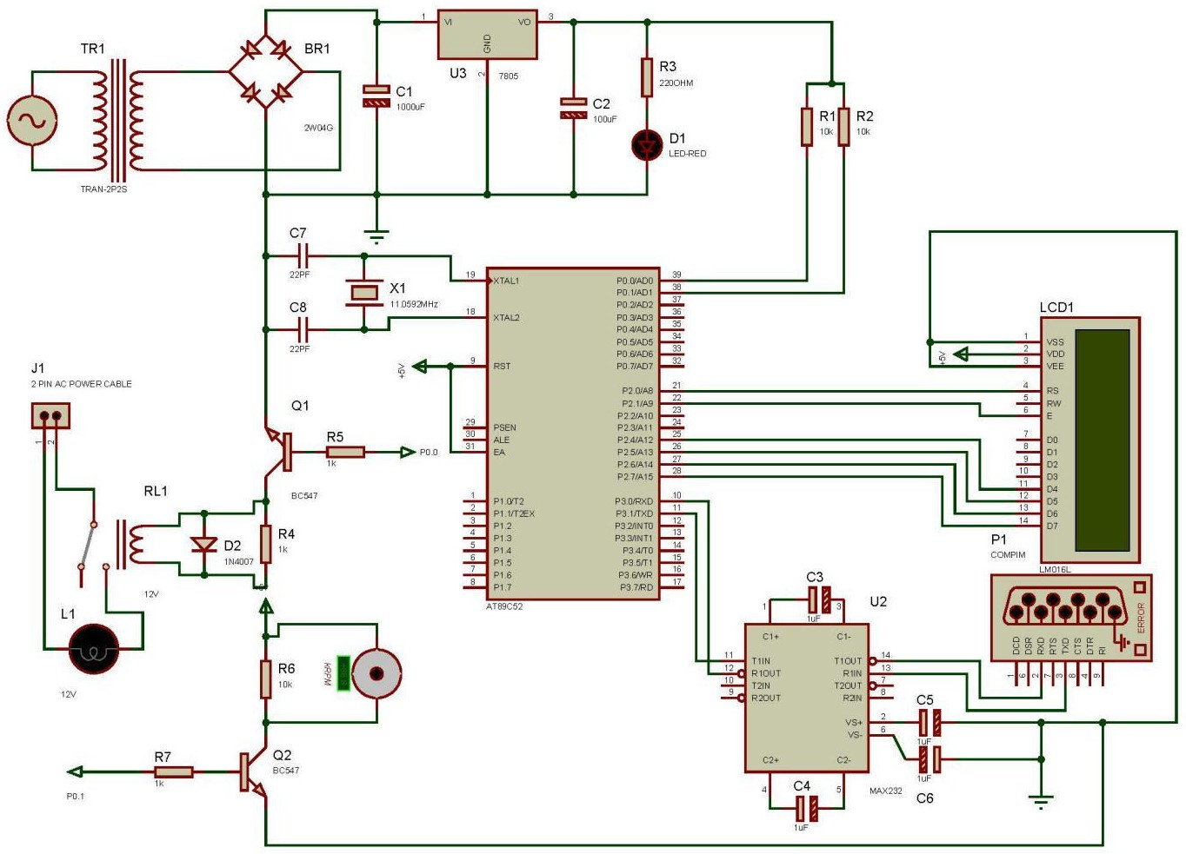

## FIG: CIRCUIT DIAGRAM OF THE PROJECT

The 230V AC supply is the first step down to 12V AC using transformer. This is then converted to the DC using bridge rectifier. The AC ripples are filtered out by [using a capacitor](http://www.edgefxkits.com/blog/how-to-make-a-capacitor-and-its-working/) and given to the input pin of the voltage regulator 7805.At the output pin of this regulator, we get a constant 5V DC which is used for MC and other ICs in this project. An LED is used as an indication to know whether the power supply is provided. The [MAX232 is an IC](http://www.edgefxkits.com/blog/max232ic-and-interfacing-needs/) that converts signals from an RS- 232serial port to signals suitable for use in TTL compatible digital logic circuits.

When the MAX232 IC receives a TTL level to convert, it changes a TTL Logic 0 to between +3 and +15V, and changes TTL Logic 1 to between -3 to -15V, and

vice versa for converting from RS232 to TTL. However, in this project we only send commands to the microcontroller and do not need to receive messages. Hence the main purpose of MAX232 in this project is to convert signals from an RS-232 serial port to TTL signals suitable for use in 8051 microcontroller.

When a command is sent by the user, it is received by the GSM receiver and then sent to MAX232 for conversion to TTL form. Once it is done, the signals are given to the microcontroller 8051 for functioning as per the command.

The commands used in our project are as follows:

<111> : Fan ON <222> : Bulb ON

<333> : Fan OFF <444> :Bulb OFF

An SPDT relay (switching circuit) is used to ensure the current flow is unidirectional from the 8051 to the bulb. The bulb is connected to the NO (Normally open) terminal of the relay.

The appliances remain in the previous state until a command is received.

On reset, the appliances are turned on shortly due to the high state present in the pins of 8051 microcontroller at that time.

## CODE

#include<REG51.H> #include"UART.c" #include"lcd4bitP2.h"

sbit device1 = P0^0;

sbit device2 = P0^1;

main()

{

int i,j,k;

char a[68],temp;

P0=0x00;

lcd_init(); Init_Uart(); for(j=0;j<4444;j++);

lcdcmd(0x01); lcdcmd(0x80);

msgdisplay("HOME AUTOMATIOM"); lcdcmd(0xC0);

msgdisplay(" USING GSM ");

send_char(0x0A); // catrige return send_char(0x0D); // catrige return send_string("AT+CNMI=2,2,2,0,0"); // for send_char(0x0A); // catrige return send_char(0x0D); // catrige return for(i=0;i<6;i++)

temp=RX_CHAR();

send_char(0x0A); // catrige return send_char(0x0D); // catrige return

send_string("AT+CMGF=1");//for making the GSM modem to work in text mode.

send_char(0x0A); // catrige return send_char(0x0D); // catrige return for(i=0;i<6;i++)

temp=RX_CHAR(); delay(100); lcdcmd(0x01); lcdcmd(0x80);

msgdisplay(" waiting for sms "); for(i=0;i<6;i++)

temp=RX_CHAR(); // just for discarding ok

P0=0x00;

while(1)

{

for (i=0;i<20;i++)

{

ended with '>'

}

k=k-1;

a[i]=RX_CHAR();

if(a[i]=='>') // the SMS message from the mobile should be

{

k=i; temp=SBUF; temp=SBUF; break;

}

if(a[k]=='1') //DEVICE 1 ON WHEN MESSAGE READ

{

device1=1; lcdcmd(0x01); lcdcmd(0x80);

msgdisplay(" DEVICE 1 ON "); delay(2000);

lcdcmd(0x01); lcdcmd(0x80);

msgdisplay("HOME AUTOMATIOM"); lcdcmd(0xC0);

msgdisplay(" USING GSM ");

}

else if(a[k]=='2') // DEVICE 1 off WHEN MESSAGE READ

{

device1=0; lcdcmd(0x01); lcdcmd(0x80);

msgdisplay(" DEVICE 1 OFF");

delay(2000); lcdcmd(0x01); lcdcmd(0x80);

msgdisplay("HOME AUTOMATIOM"); lcdcmd(0xC0);

msgdisplay(" USING GSM ");

}

else if(a[k]=='3') // DEVICE 2 ON WHEN MESSAGE UNREAD

{

device2=1; lcdcmd(0x01); lcdcmd(0x80);

msgdisplay(" DEVICE 2 ON"); delay(2000);

lcdcmd(0x01); lcdcmd(0x80);

msgdisplay("HOME AUTOMATIOM"); lcdcmd(0xC0);

msgdisplay(" USING GSM ");

}

else if(a[k]=='4') // DEVICE 2 Off WHEN MESSAGE UNREAD..

{

device2=0; lcdcmd(0x01); lcdcmd(0x80);

msgdisplay(" DEVICE 2 OFF"); delay(2000);

lcdcmd(0x01); lcdcmd(0x80);

msgdisplay("HOME AUTOMATIOM"); lcdcmd(0xC0);

msgdisplay(" USING GSM ");

}

/* else if(a[k]=='5') // DEVICE 1&2 ON WHEN MESSAGE UNREAD..

{

device1=1;device2=1; lcdcmd(0x01); lcdcmd(0x80);

msgdisplay(" DEVICE 1&2 ON"); delay(2000);

lcdcmd(0x01); lcdcmd(0x80);

msgdisplay("HOME AUTOMATIOM"); lcdcmd(0xC0);

msgdisplay(" USING GSM ");

}

else if(a[k]=='6') // DEVICE 1&2 ON WHEN MESSAGE UNREAD..

{

} */

device1=0;device2=0; lcdcmd(0x01); lcdcmd(0x80);

msgdisplay(" DEVICE 1&2 OFF"); delay(2000);

lcdcmd(0x01); lcdcmd(0x80);

msgdisplay("HOME AUTOMATIOM"); lcdcmd(0xC0);

msgdisplay(" USING GSM ");

temp=SBUF; // jus for clearing the read buffer

}

}

## INTERFACING LCD WITH CONTROLLER: CODE:

#define lcd_data P2 #include<string.h>

void lcd_init(void);

void lcdcmd(unsigned char value); void lcddata(unsigned char value); void msgdisplay(unsigned char b[]); void delay(unsigned int value);

void conv(unsigned int temp1_value) ;

void lcd_init(void)

{

lcdcmd(0x28); lcdcmd(0x28); lcdcmd(0x28); lcdcmd(0x0c); lcdcmd(0x06); lcdcmd(0x01); lcdcmd(0x80); delay(5);

}

//////////////////////////////////////////////////////////////////////////

void lcdcmd(unsigned char value) // LCD COMMAND

{

lcd_data = ((value & 0xF0) | 0x02); lcd_data = 0;

lcd_data = ((value << 4) | 0x02); lcd_data = 0;

delay(5);

}

///////////////////////////////////////////////////////////////////////// void lcddata(unsigned char value)

{

lcd_data = ((value & 0xF0) | 0x03); lcd_data = 0;

lcd_data = ((value << 4) | 0x03); lcd_data = 0;

delay(5);

}

///////////////////////////////////////////////////////////////////////// void msgdisplay(unsigned char b[])

{

unsigned char s,count=0; for(s=0;b[s]!='\0';s++)

{

if(s==16) lcdcmd(0xc0); if(s==32) lcdcmd(0x01); lcddata(b[s]);

}

}

/////////////////////////////////////////////////////////////// void delay(unsigned int value)

{

unsigned int x,y; for(x=0;x<100;x++) for(y=0;y<value;y++);

}

/////////////////////////////////////////////////////////////////////// void conv(unsigned int temp1_value)

{

unsigned char value,d1,d2,d3,d4,val1; value=temp1_value/10;

d4=temp1_value%10; val1=value/10; d3=value%10; d2=val1%10; d1=val1/10;

if(d1==0) lcddata(d1+48);delay(10); lcddata(d2+48);delay(10); lcddata(d3+48);delay(10);

lcddata(d4+48);delay(10);

}

## ADVANTAGES

* + - This will help to eliminate need of human personnel attending the device to switch it on or off.
    - It will also help to control device while attending to other work.
    - Energy conservation.
    - Devices can be controlled from long distances.
    - Economical design.
    - Can be easily implemented in homes.
    - Cost of implementation is not very high thus, it is affordable.
    - Can be used by everyone with just the knowledge of text SMS format.
    - Format of the SMS is simple to understand and write
    - Device is very useful when modified and implemented in multiplex mall and showroom, which covers a very large area and utilized more time to switch on or off the electrical appliances.

## DISADVANTAGES

* + - The system is network dependent. Hence, network congestion can reduce the reliability of the system.
    - If user makes any mistakes while typing the message format, the microcontroller will not be acknowledged the message and the hence the system will not work.
    - As technology has made our life easier, it has also made us more irresponsible and thus with this device, we can switch on or off the appliances from anywhere but this also makes us lazy and more irresponsible towards our daily chaos.

## FUTURE SCOPE

The project “GSM BASED HOME AUTOMATION” is intended to automate the certain functions of home appliances. Smart home technologies have been around for about 30 years, mostly relying on some proprietary technologies and applications. With the recent expansion of communication networks, smart home applications can be further enhanced with new dimension of capabilities that were not available before. In particular, wireless access technologies will soon enable exotic and economically feasible applications. The device is much helpful in controlling home. It reduces the wastage of valuable time and our daily life become easier and flexible. In future this device can be further modifies for large infrastructure like City mall, showrooms, restaurants, hotels etc. and thus saves a lot of time and physical labor.

## CONCLUSION

The main purpose of the project is to provide a smart and efficient way to control our home appliances with the help of modern communication technology. With the combination of

GSM this project is not only a modern approach to next generation home controlled at our fingertips but also a very friendly and easy to use system. This project will give our daily life a new dimension at the same time it will help us to save energy.

## REFERENCES

TEXT BOOKS REFERRED

* + - The 8051 Micro controller and Embedded Systems by Muhammad Ali Mazidi andJanice Gillispie Mazidi
    - The 8051 Micro controller Architecture, Programming &Applications by Kenneth J.Ayala
    - Electronic Components by D.V.Prasad ;Goldsmith, Wireless Communications, Cambridge Press, 2005.
    - S. Haykin, Communication Systems, Wiley, New York, 2002.

WEBSITES REFERRED

* + - [www.allthedatasheets.com](http://www.allthedatasheets.com/)
    - [www.atmel.com](http://www.atmel.com/)
    - [www.microcontroller.com](http://www.microcontroller.com/)
    - [www.howstuffworks.com](http://www.howstuffworks.com/)