Submit button not working in below screen.

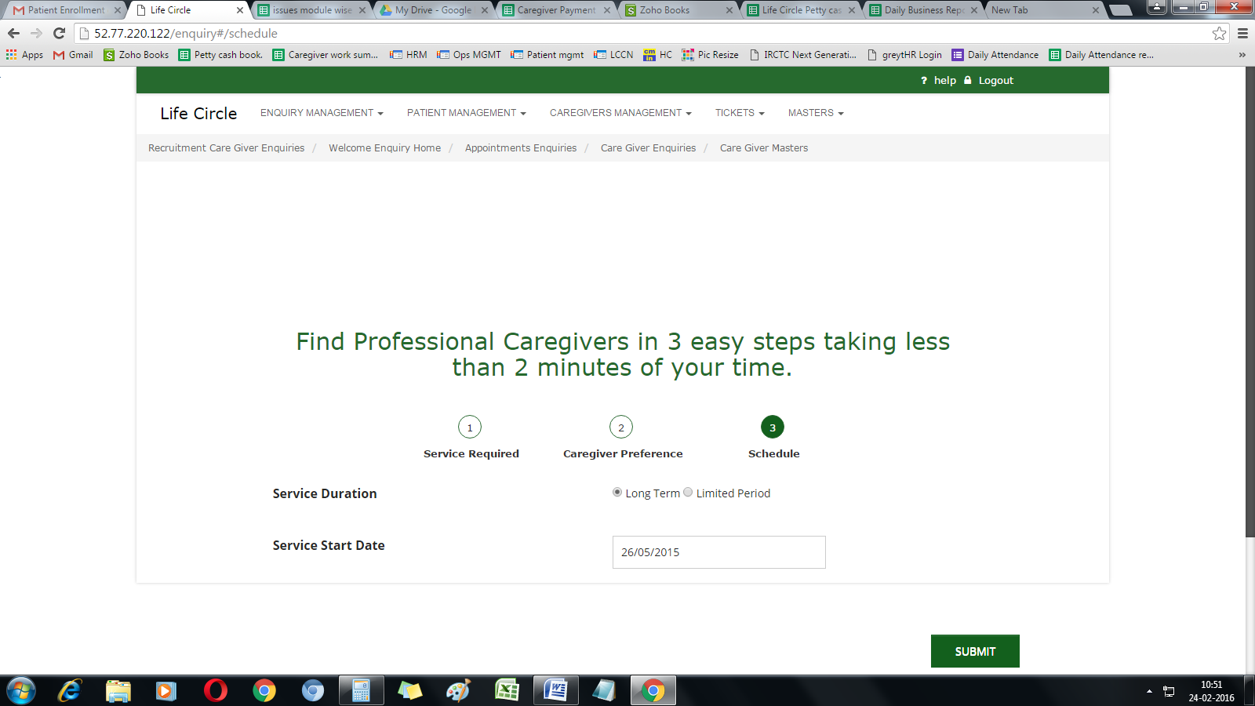

Caregiver registration form not sign up

Please note it should without email address also.

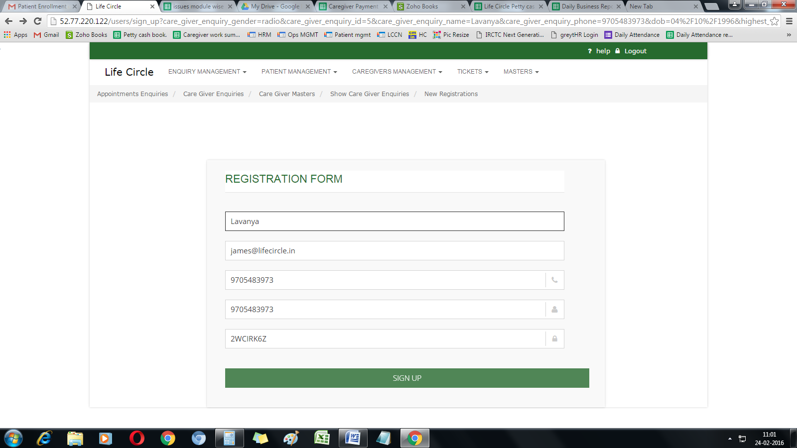

Because of this we are not able to go to the CG background details of Caregiver and Approve.

Please see the error below.

I have saved gender is Female but the screen is showing below radio.

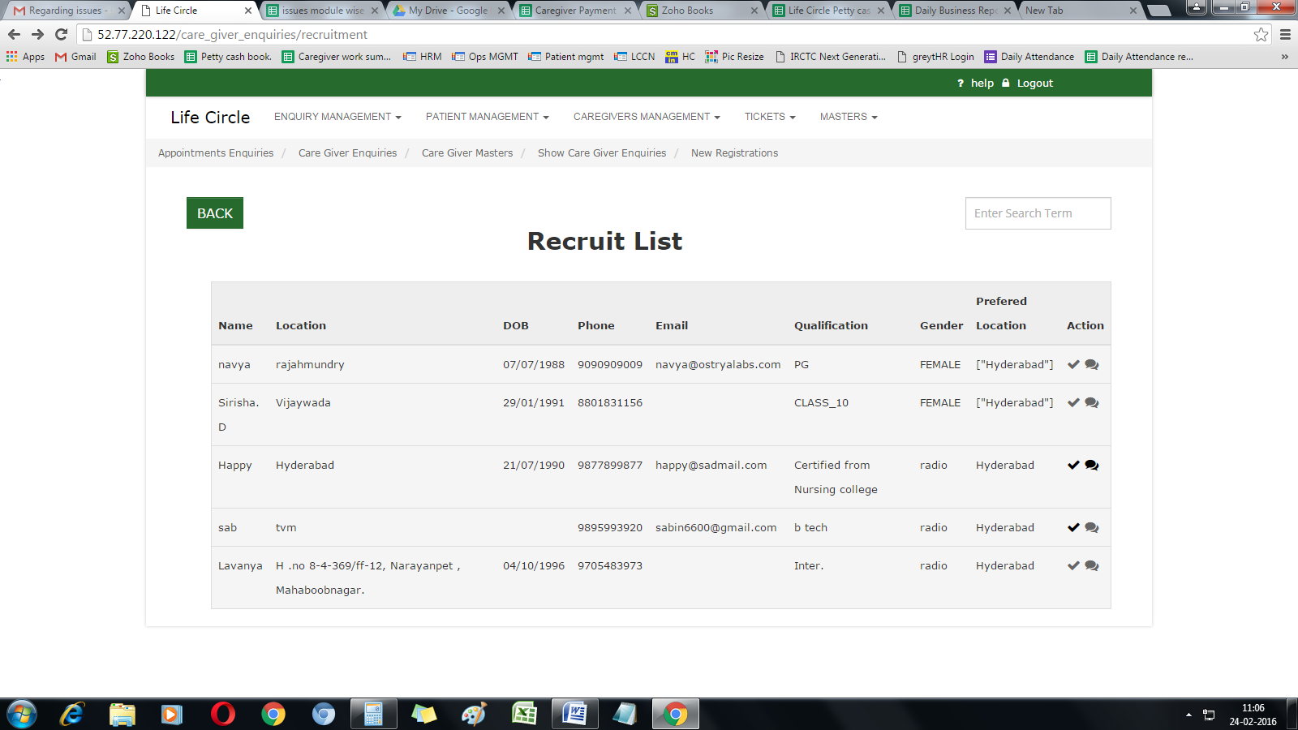

Please see the screen below when i edit the Users roles menu after edit it gives this error. actually it should save and give a message for successfully saved.

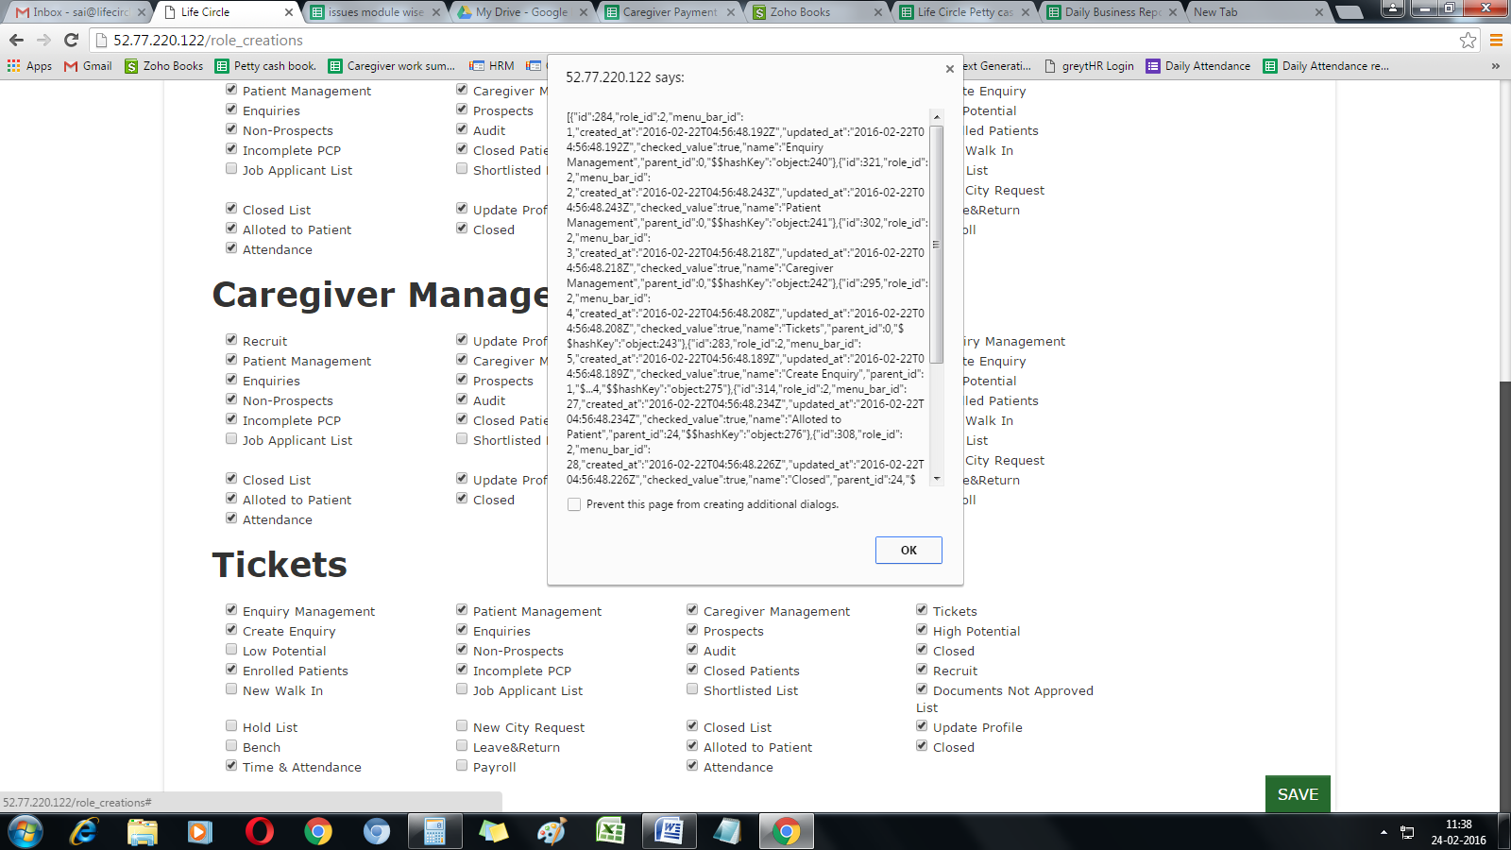

CG Management in Empanel when i tried to put CG in Leave update button is not working. In below screen.

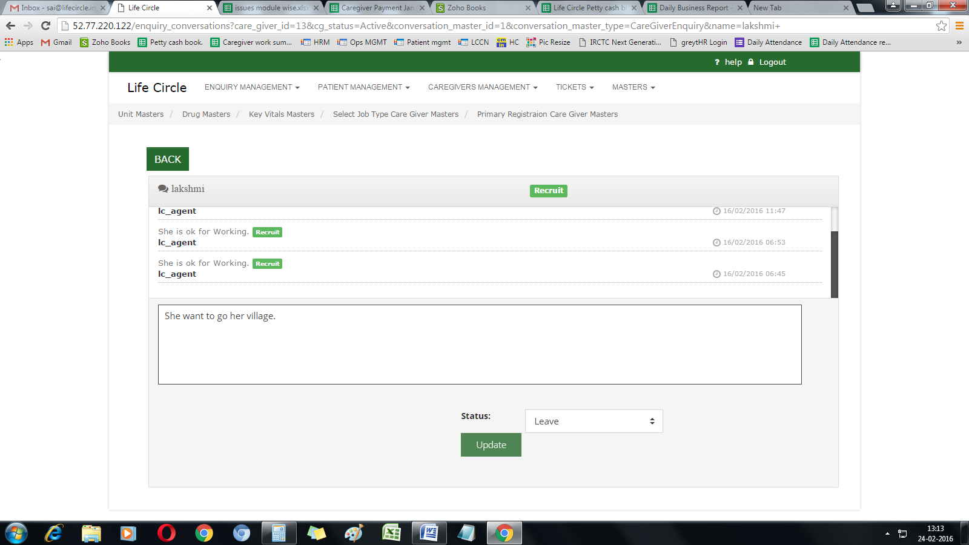

Caregiver name is not coming in list.

