**Pannu Kumar Manjhi**

Udaypura, Gopalganj, Bihar

[pannumanjhi78@gmail.com](mailto:Pannumanjhi78@gmail.com) +91 7667497634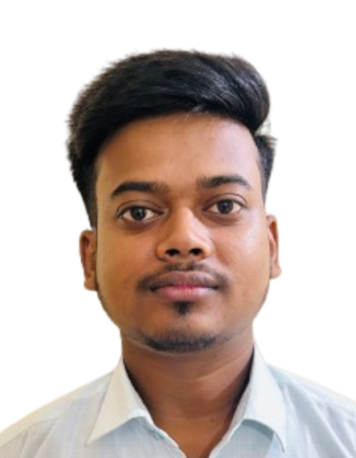

# EDUCATION

**Bachelor of Computer Application, *GLA University, Mathura*** Sept 2022 - Present

**Intermediate, *PPG College , Chaumukha, Bihar*** May 2020

**High School, *SGH School, Udaypura, Bihar*** May 2018

# PROJECTS

* **Cancer Awareness Website**
  + Developed a website providing comprehensive information about cancer using HTML and CSS.
* **All-in-One Web Application**
* Collaborated in a team of six to create a multi-functional web application with three main features:
  + Car rental booking
  + Hotel reservation
  + Part-time job search
* Utilized HTML, CSS, JavaScript, and Django for this project.

# SKILLS

**Technical Skills**

**Professional Skills**

* Effective analytical skills
* Problem-solving abilities
* Leadership qualities
* Time management
* HTML, CSS
* JavaScript (Basic)
* Java
* Python
* Microsoft Office (Excel, PowerPoint, Word)

**CERTIFICATIONS/COURSES___________________________________________________________________________**

* **Enviroment and Development**

- NPTEL Online Certification, IIT Guwahati

* **Ethics in Engineering Practice**

- NPTEL Online Certification, IIT Kanpur

# EXTRA/CO-CURRICULAR ACTIVITIES

* Attended a workshop on Abacus.
* Participated in an English seminar.

**DECLARATION________________________________________________________________________________________**

I hereby declare that all the above-mentioned information is true and correct to the best of my knowledge.