**Assignment10**

**Flow chart:-**

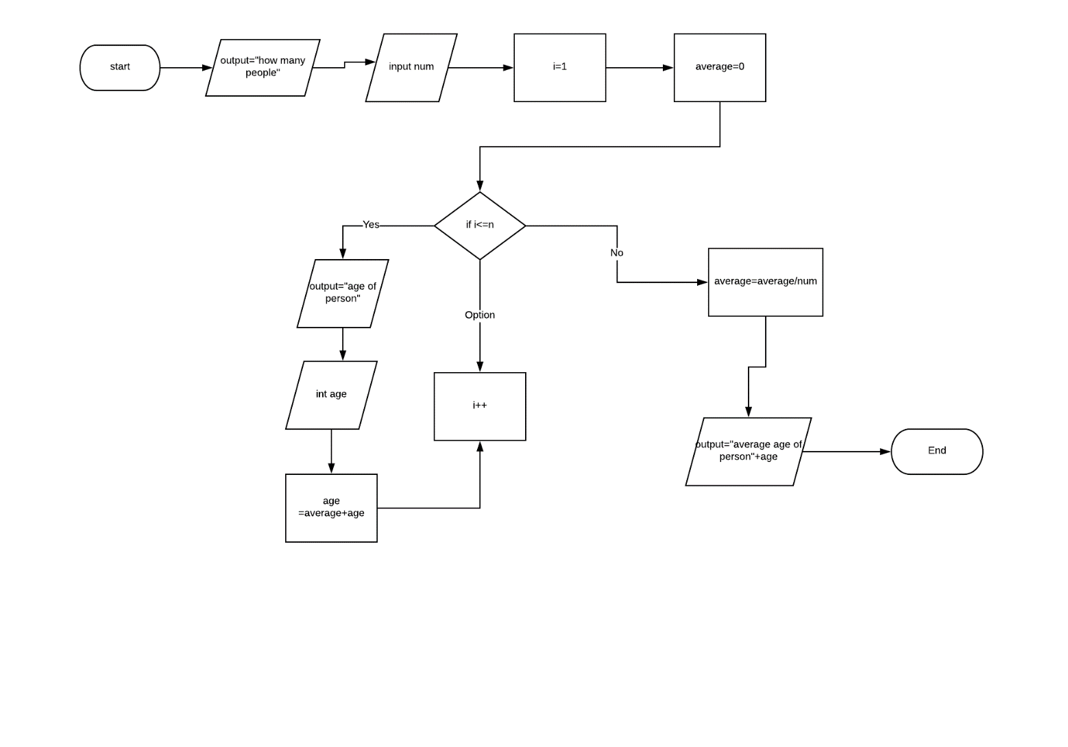

Pseudo code:

1. DECLARE num
2. DECLARE int
3. DECLARE average
4. DECLARE age
5. Output “how many people”
6. Input num
7. i=1
8. average =0
9. FOR ( i to num)
10. OUTPUT “How old is person “ + i
11. Input age
12. Average=average+age
13. LOOP
14. average =average/num
15. output ”average age of person” +age
16. END

Trace of pseudo code:-

|  |  |  |  |  |  |  |
| --- | --- | --- | --- | --- | --- | --- |
| Line no. | Input buffer | num | i | average | age | Output buffer |
| 1 | - | - | - | - | - | - |
| 2 | - | - | - | - | - | - |
| 3 | - | - | - | - | - | - |
| 4 | - | - | - | - | - | - |
| 5 | - | - | - | - | - | “How many people” |
| 6 | 3 | 3 | - | - | - | - |
| 7 | - | 3 | 1 | - | - | - |
| 8 | - | 3 | 1 | 0 | - | - |
| 9 |  | 3 | 1 | 0 | - | - |
| 10 | - | - | - | - | - | “how old is person”+i |
| 11 | - | 3 | 1 | 0 | 25 | - |
| 12 | - | 3 | 1 |  | 25 | - |
| 9 | - | 3 | 1 | 25 | 25 | - |
| 14 | - | 3 | 1 | 25 | 25 | - |
| 15 | - | - | - | - | - | “Average age of person”+age |