# WAN_checks

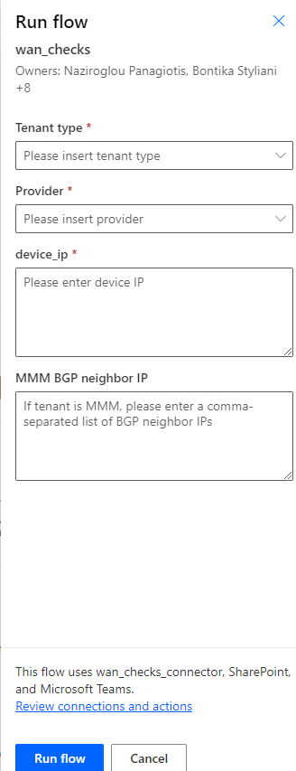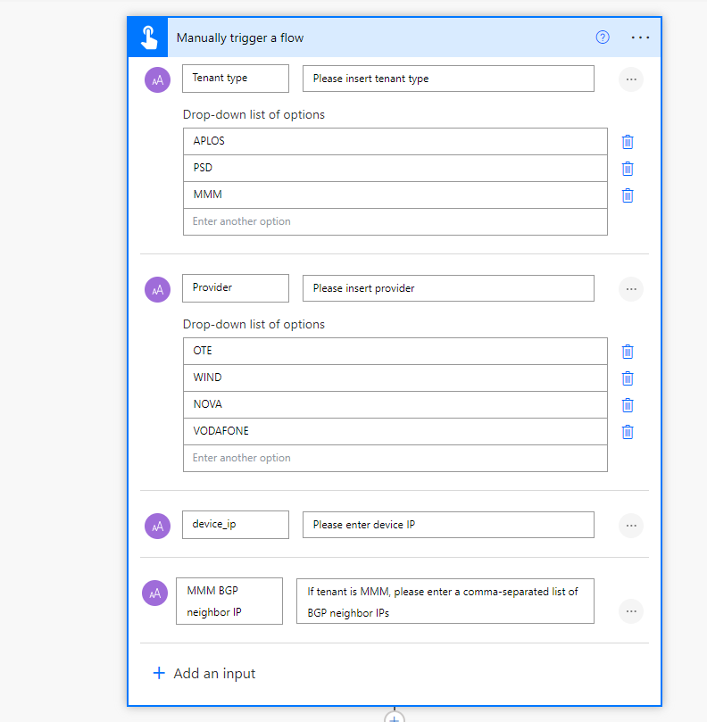

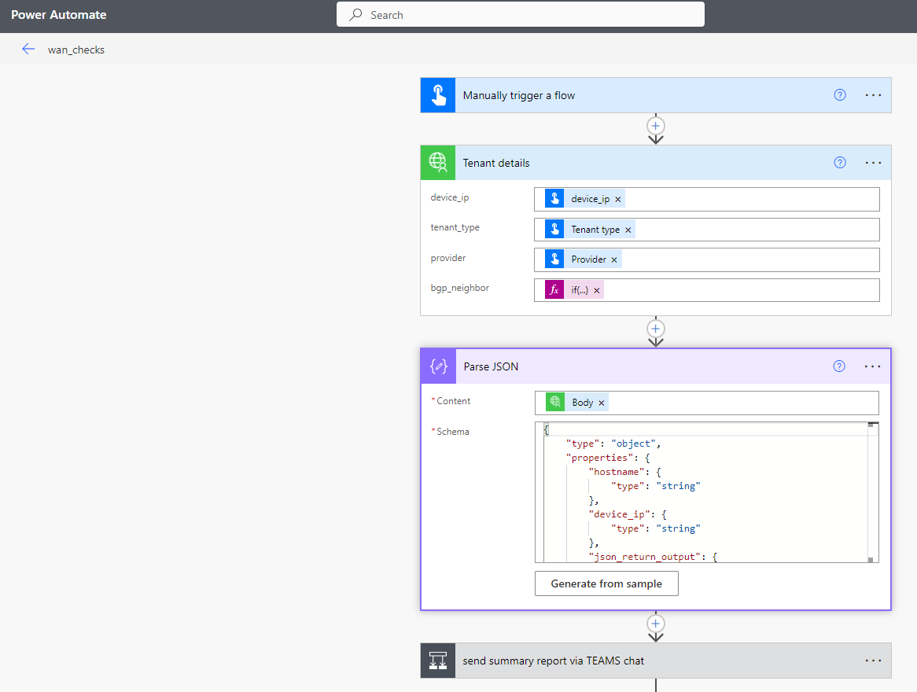

Bgp_neighbor:

if(contains(triggerBody(),'Text_3'),triggerBody()['text_3'],'')

if(contains(triggerBody(),'Text_1'),triggerBody()['text_1'],'')

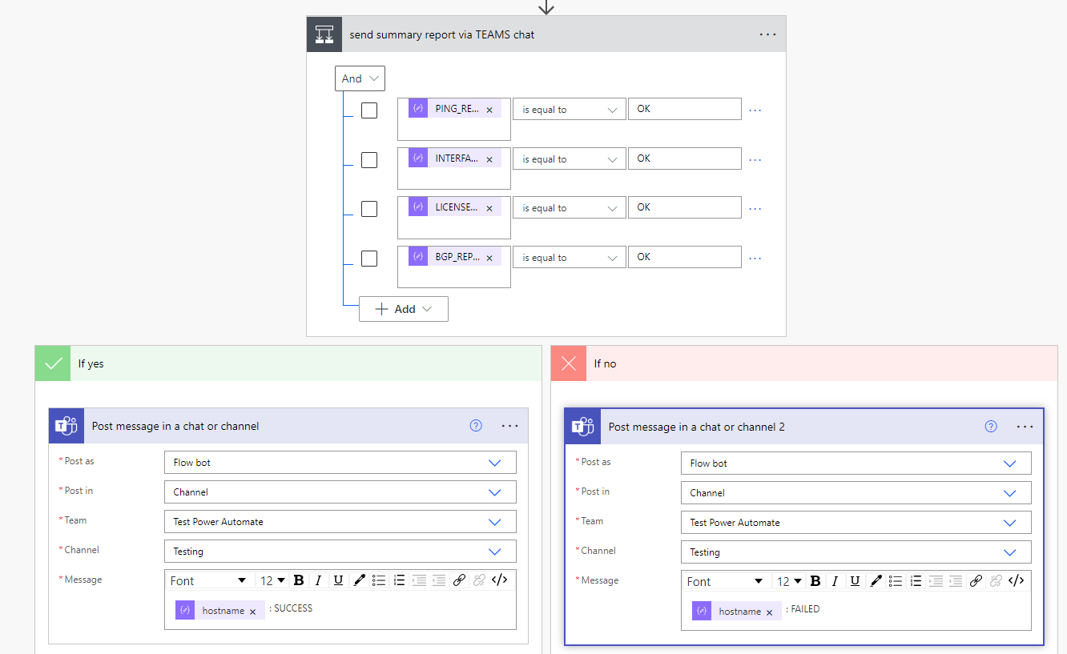

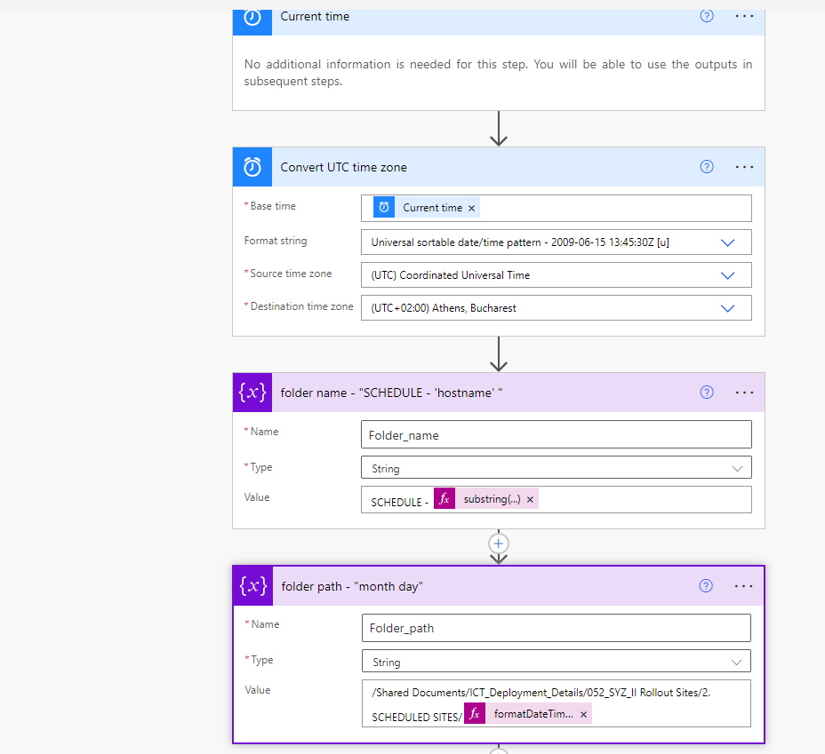

substring(body('Parse_JSON')?['hostname'],0,11)

formatDateTime(parseDateTime(split(body('Convert_UTC_time_zone'), ' ')[0]), 'MMMM d', 'en-US')

encodeUriComponent(variables('Folder_path'))

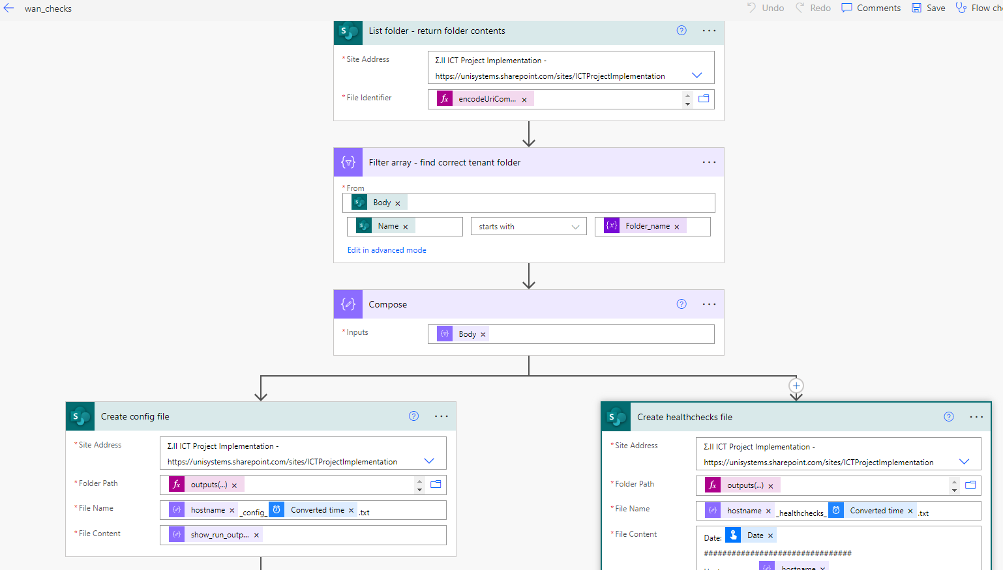

outputs('Compose')?[0]?['Path']

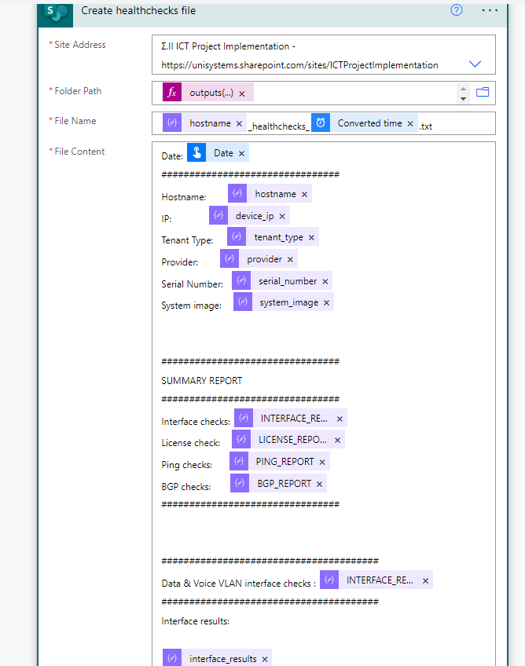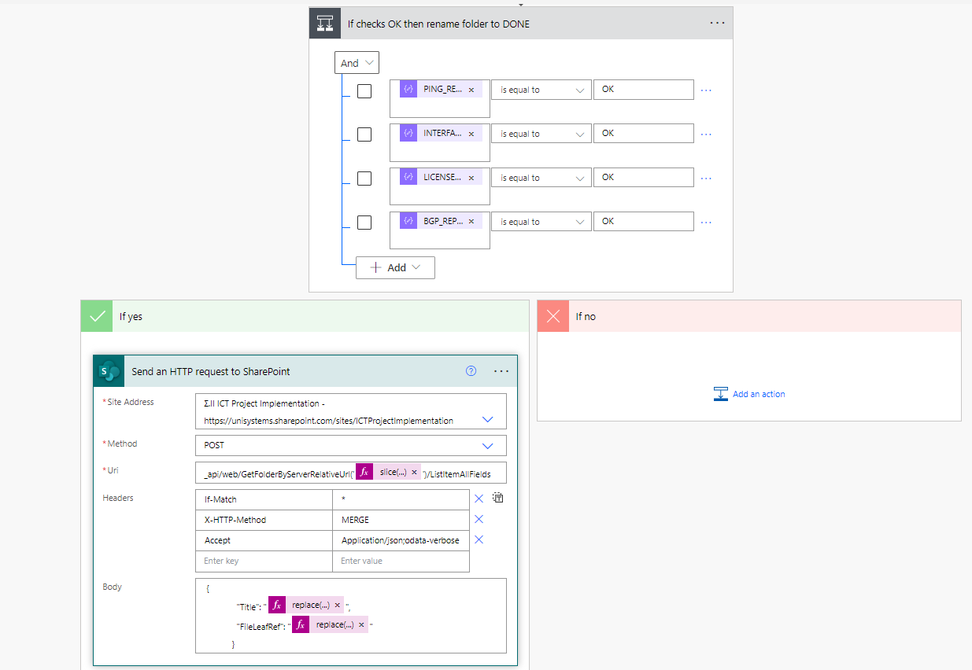

slice(outputs('Compose')?[0]?['Path'], add(indexOf(outputs('Compose')?[0]?['Path'], '/'), 1))

## connectors:

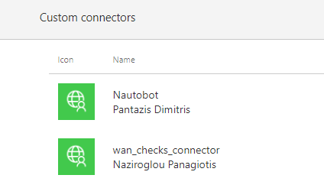

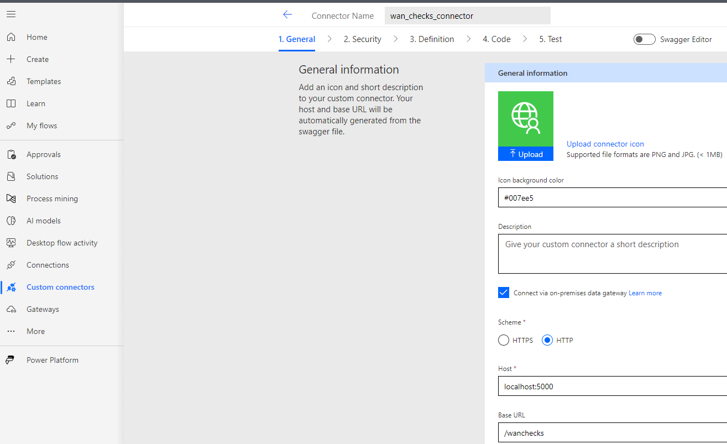

{

"device_ip": "172.23.53.123",

"tenant_type": "PSD",

"provider": "WIND",

"bgp_neighbor": ""

}

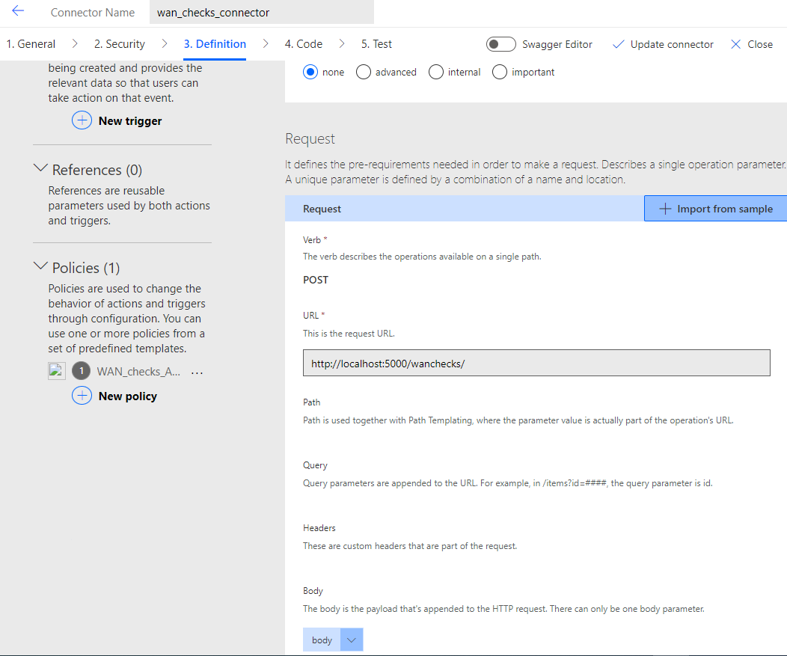

# WAN_checks_API

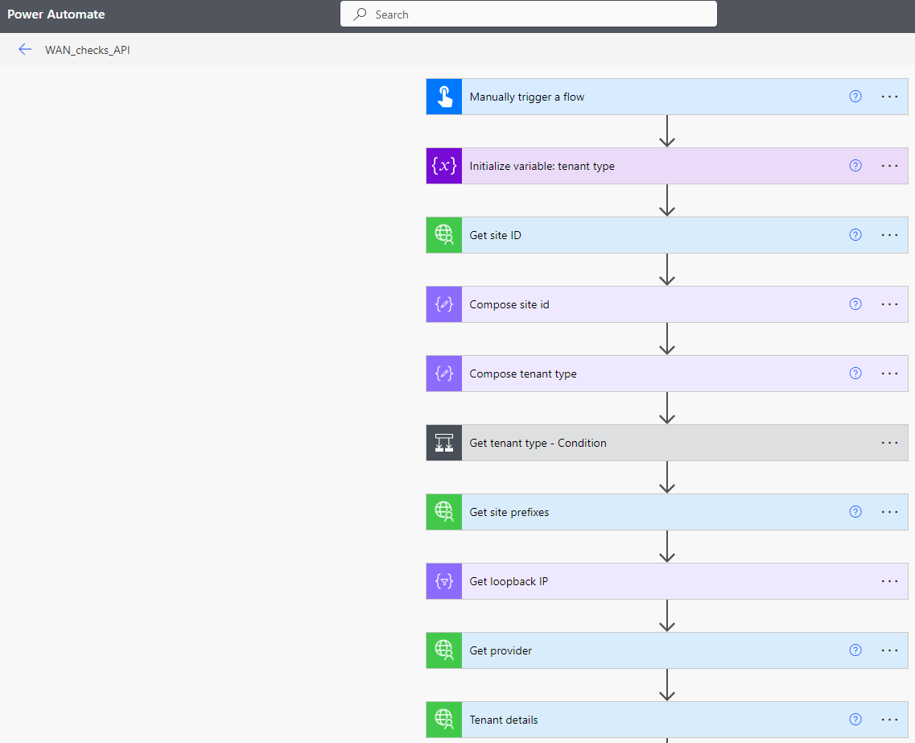

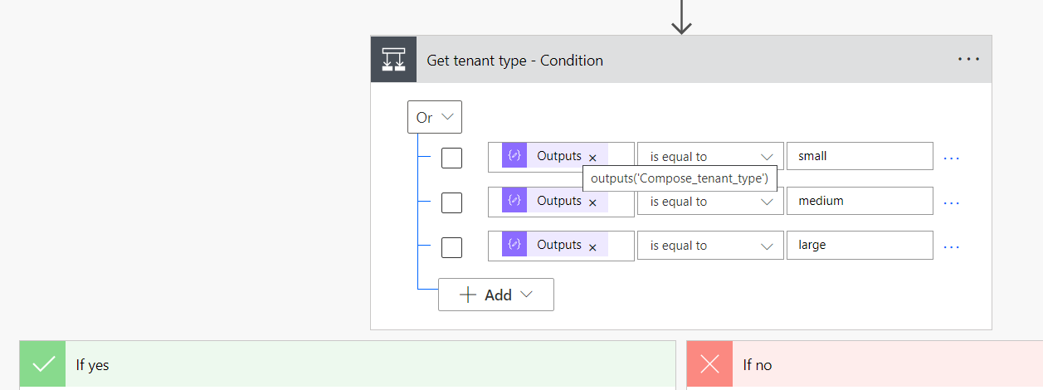

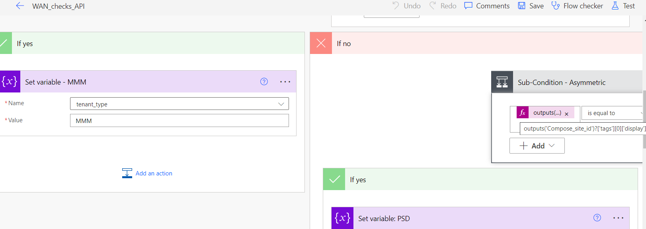

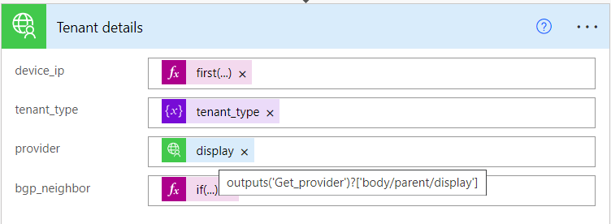

first(split(body('Get_loopback_IP')?[0]?['prefix'], '/'))

if(contains(triggerBody(),'Text_1'),triggerBody()['text_1'],'')

