**BN1119 Applications Development**

Testing

Candidate number : 620165

|  |  |  |  |  |  |  |
| --- | --- | --- | --- | --- | --- | --- |
| No. | Description | Test Data | Expected Results | Actual  Results | Pass  /Fail | Notes  /Action |
| 1. | *Test type: White Box*  Test how the programme will handle the final repayment month in which the repayment amount will (possible) be bigger than the loan amount left.  IF statement in which we only test the TRUE result. | Since we are referring to the final month of repayment (monthly repayment is always the same) it means that the final amount left to be repaid can be lower than the monthly repayment (e.g. Closing balance of final month is £100 and monthly repayment is £250)  Please refer to ***Figure1*** for the inputs provided and ***Figure 2*** for an example we want to avoid. | The Closing Balance on the final month must always be £0 as by then the Loan has fully been repaid and the Total Amount payed for the Loan should only include the Loan amount that was left for the month and not the whole repayment that was to be made. (Only the £100 must be considered as charge and not the whole  £250) | For the viewing of the actual output refer to ***Figure 3***. | ***Pass*** | No further actions are needed |
| 2. | *Test type: White Box*  Path Coverage  Test if the loop is functioning properly and stops when either the repayment period is over, or the loan has been repaid | We can either test this by having as Loan input a random number (e.g. £35000) and period of 30 years.  For the viewing of the inputs provided please refer to ***Figure 4***. | Even though the repayment period has not been reached, the program stopped when Closing balance got £0. So, this means the program has worked properly | For the viewing of the actual output refer to ***Figure 5***. | ***Pass*** | No further actions are needed |
| 3. | *Test type: Black Box*  Test whether any of the input textboxes can handle an empty value (e.g. Loan Amount) | There have been default values included in the rest of the textboxes except for the example (Loan Amount)  For the viewing of the inputs provided please refer to ***Figure 6***. | An error message should appear, providing description text for the input error of the specific text box and the program will not proceed to any further actions. | For the viewing of the error message box please refer to ***Figure 7***. | ***Pass*** | No further actions are needed |
| 4. | *Test type: Black Box*  Test whether a textbox (e.g. Salary) can handle a negative value as input. | There have been default values included in the rest of the textboxes except for the example (Salary) which has a negative value.  For the viewing of the inputs provided please refer to ***Figure 8***. | An error message should appear, providing description text for the input error of the specific text box. There will also be a Lebel message to the user specifying the problem. | For the viewing of the error message box please refer to ***Figure 9***. | ***Pass*** | No further actions are needed |
| 5. | *Test type: Acceptance testing.*  Providing the application to a user, we test whether it is clear and easy to use and easy to navigate. Also, the application does what it is expected for its role by the user’s perspective | The application will be provided to a Non-BCIT student, unaware of the programming aspect of the programme. | Propper feedback will be provided by the user to establish the functionality condition of the application and list any problems that may have been encountered. | For the viewing of the actual feedback refer to ***Figure 10***. | ***Pass*** | The user run the programme and tested the “Reset” button and it worked properly. |
| 6. | *Test type: Integration Testing*  Unit 1: Subroutine A calculates the total Repayment and the Total Interest Payed.  Unit 2: Subroutine B displays the Total Repayment and Total Interest Payed through the whole period. | Once all the inputs have been provided; the programme will do the calculations and will find the Total amount and Interest that was payed.  Refer to ***Figure 11*** for the inputs provided. | When both subroutines are executed, both results will be displayed in their assigned output boxed. | For the viewing of the actual output refer to ***Figure 12***. | ***Pass*** | No further actions are needed |
| 7. | Testing the “Reset” button.  The program needs to have the ability to be repetitive. The users need to be able to reset the process of Loan calculating, without any issues or previous results effecting their new ones. | For the following test we can use any input; in this case the input is provided in ***Figure 13***. (As well as the results ***Figure 14***) | When the user presses the “Reset” button then Form 3 (which was showing previous results) should be completely cleared, then Form 2 (input screen) should appear, leaving the main input boxes empty. | For viewing the results for the aftermath of the “Reset “button being clicked, refer to ***Figure15*** and ***Figure 16***. | ***Pass*** | No further actions are needed |

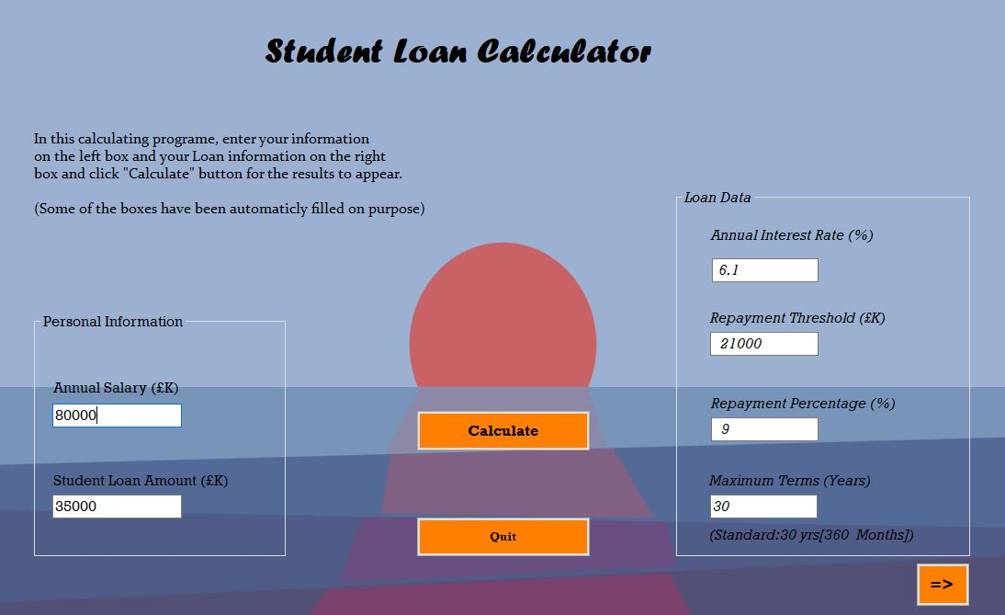Figure 1: Inputs provided for T1

Figure 2: An example of what we want to avoid at T1 (to specify more what is the aim of the test)

The negative value of the closing balance at the final month of repayment, is what we need to avoid

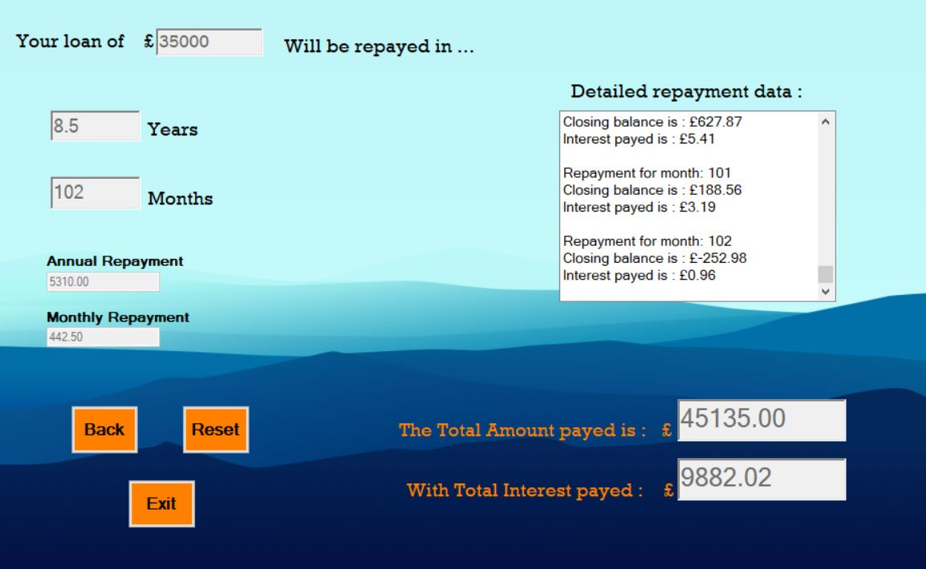

Figure 3: Results of T1

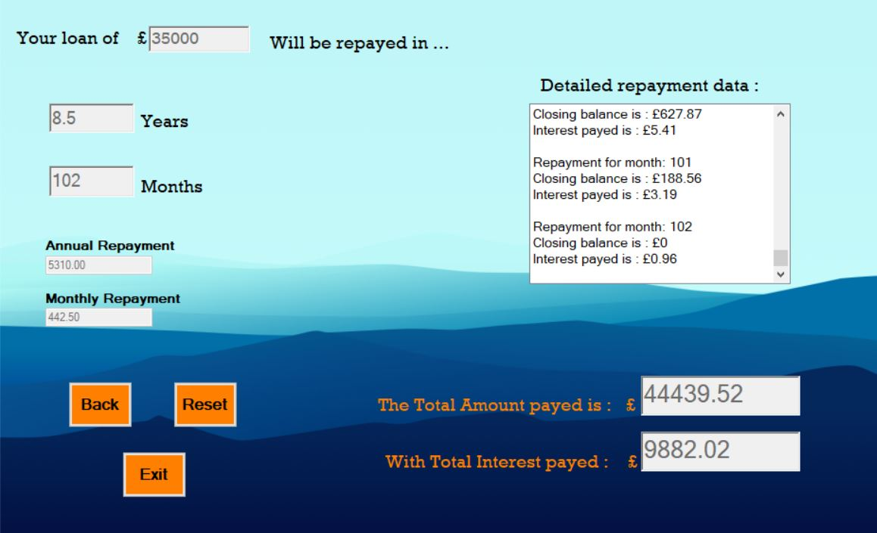

The value is 0 as we wanted

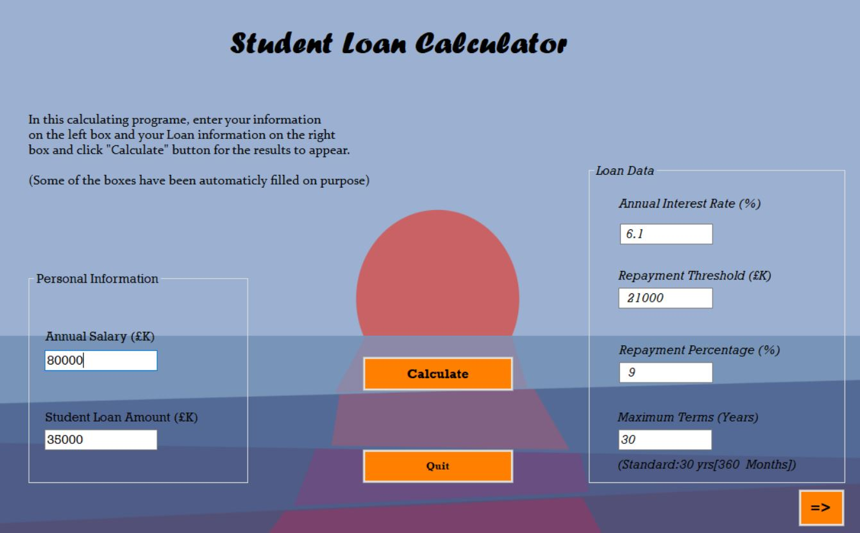Figure 4: Input for T2

Figure 5: Output for T2

But calculations stopped once it reached Closing Balance = 0

The period had not been reached

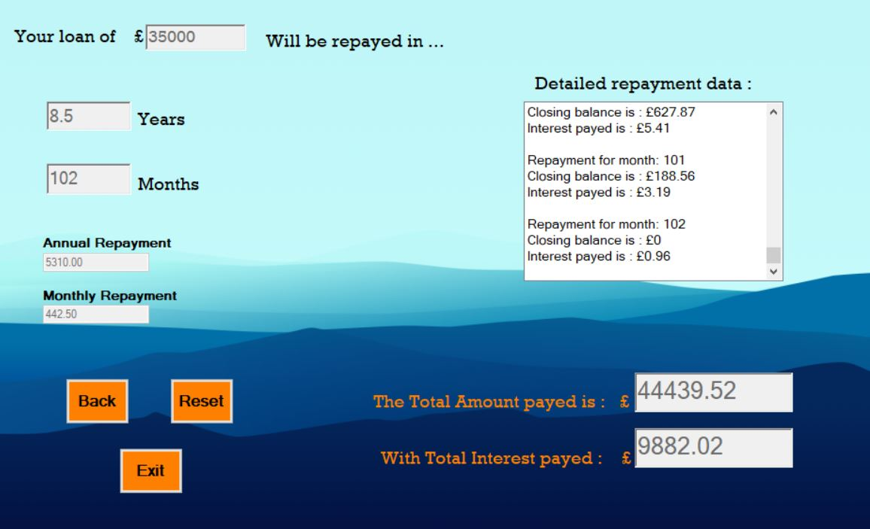

Figure 6: Input for T3

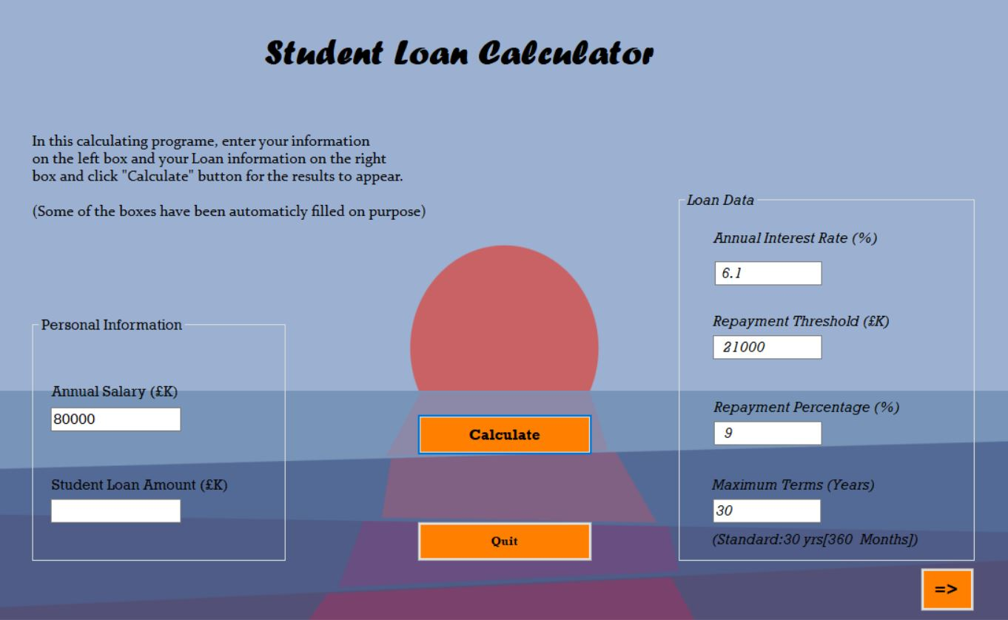

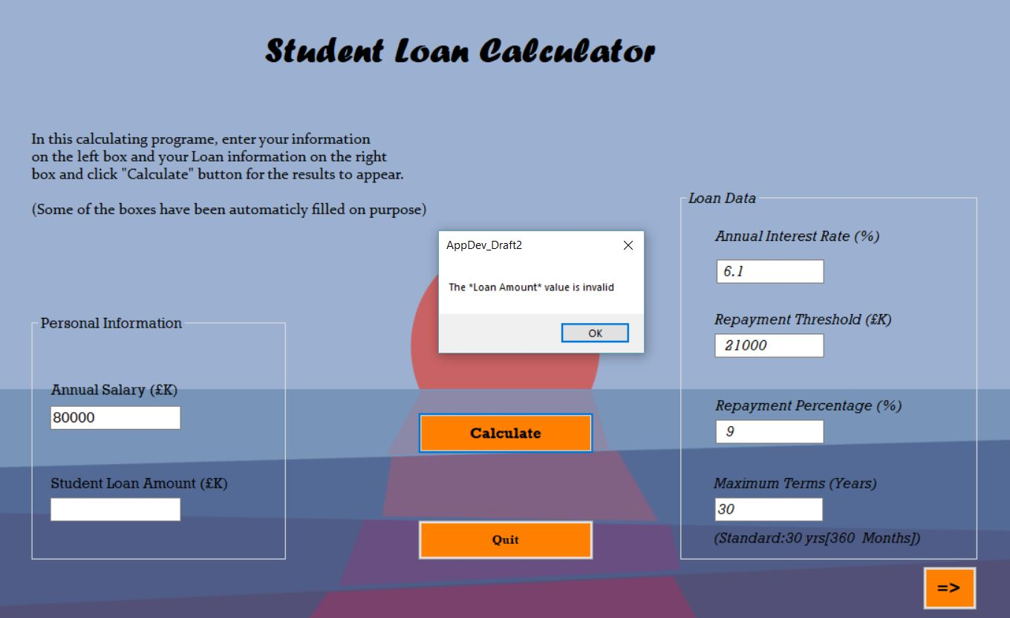Figure 7: Results of T3

Error message describing the error

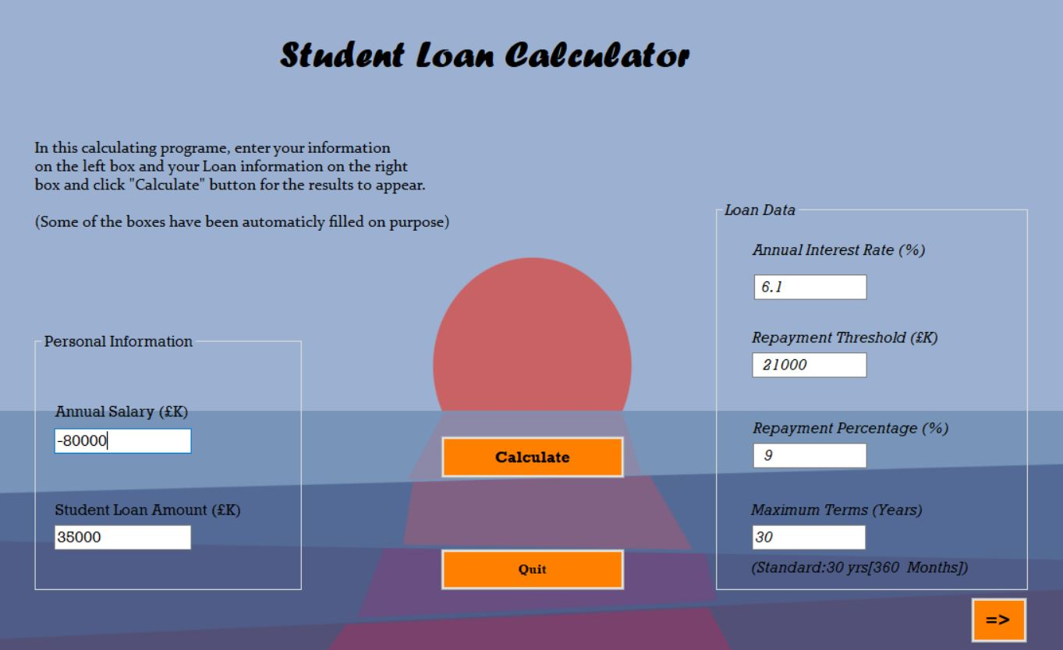Figure 8: Input for T4

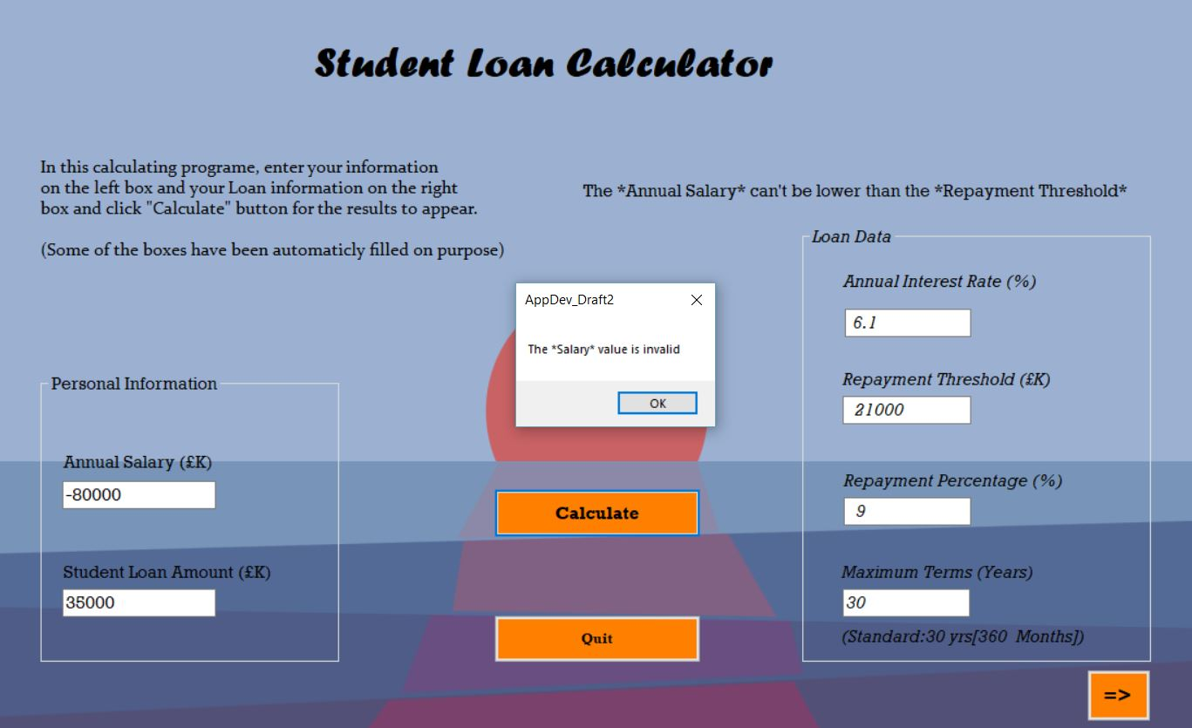Figure 9: Output for T4

Also, an error label appears describing the Salary<Threshold error

Error message describing input validation he error

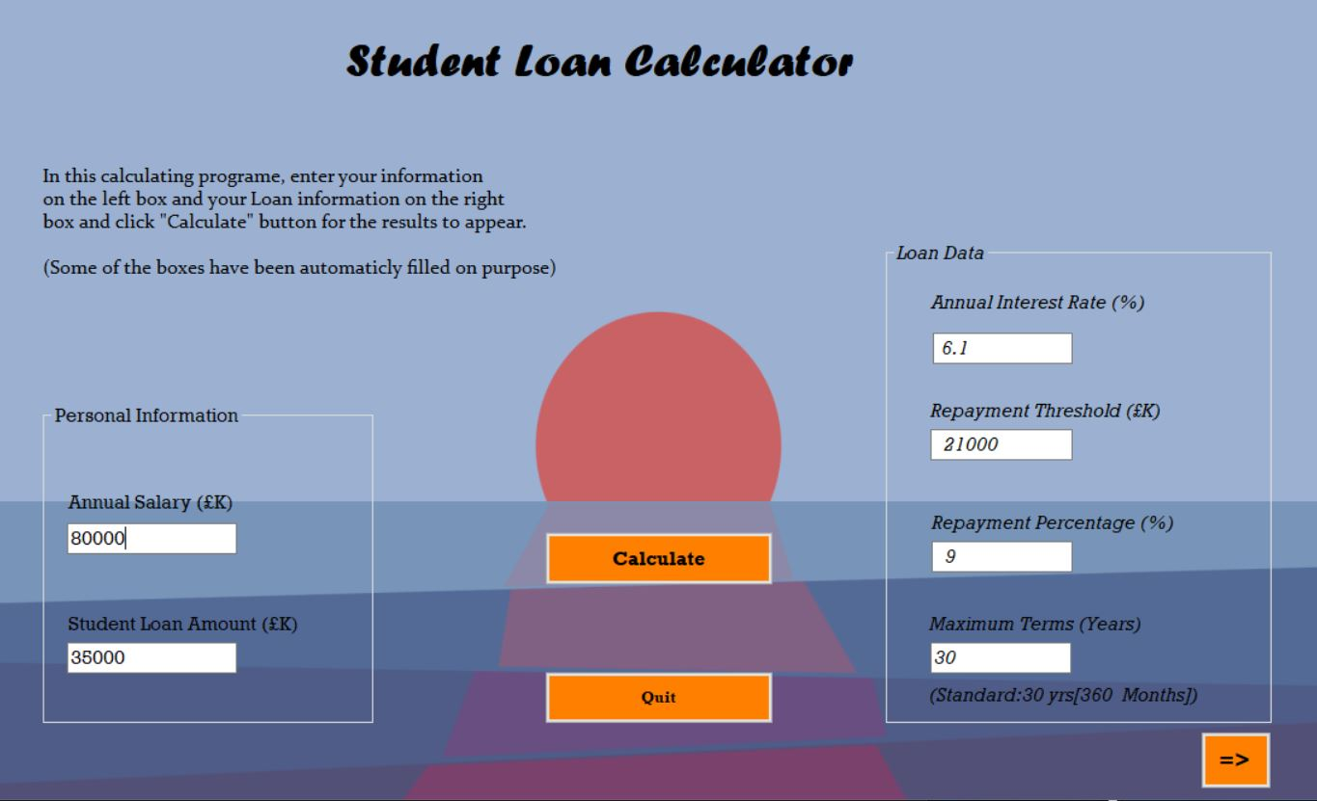Figure 11: Input for T6

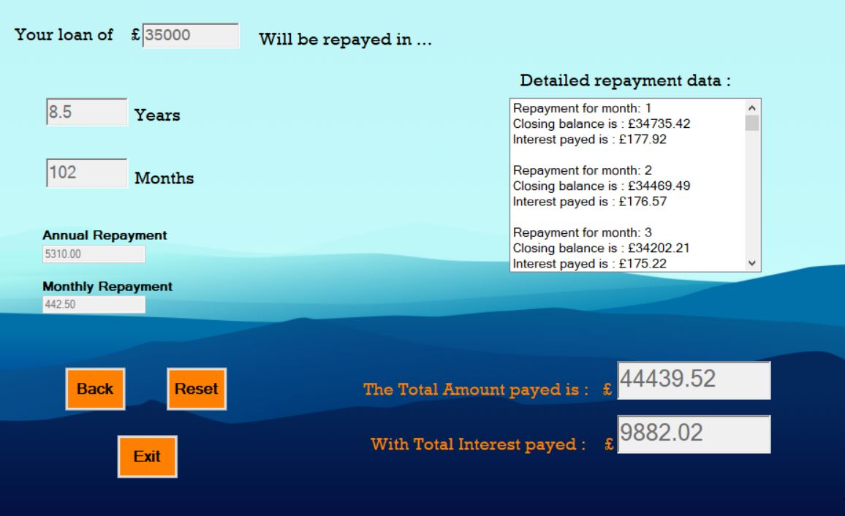Figure 12: Output for T6

The results properly appear in their output Textboxes

Figure 13: Input for T7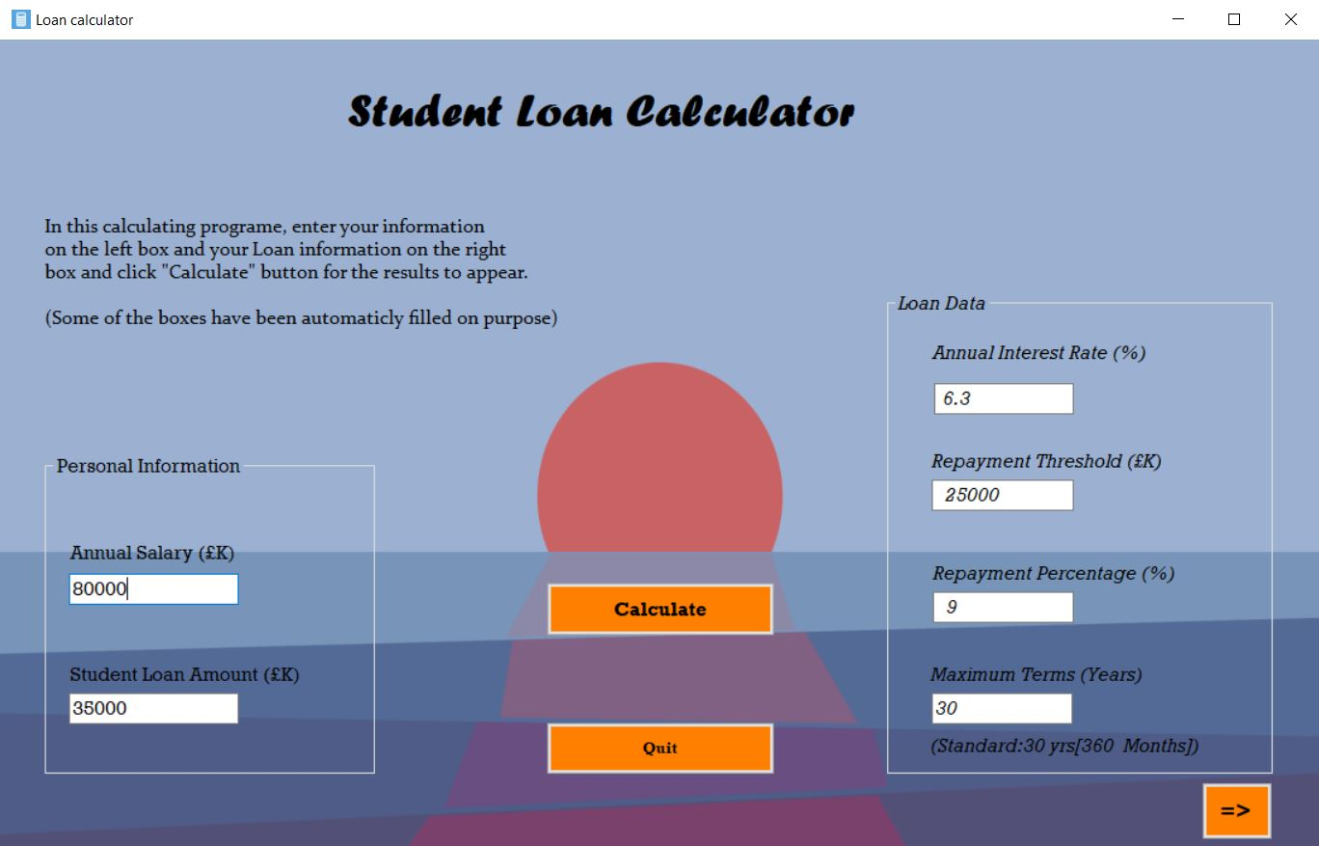

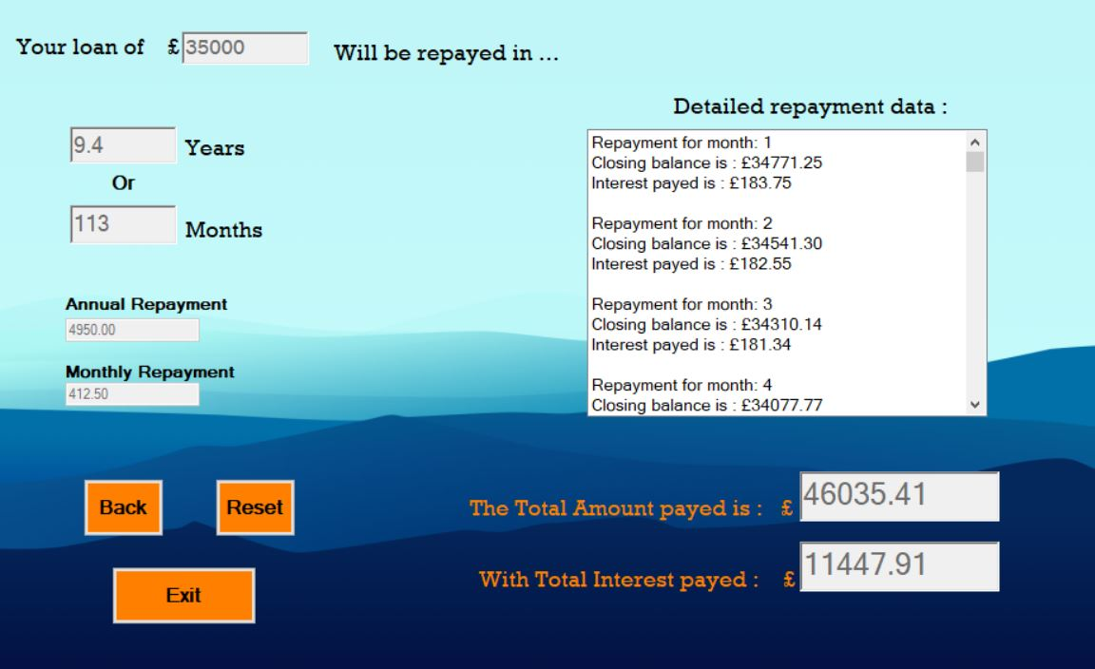Figure 14: Output from T7 calculations

Figure 15: Expected outcom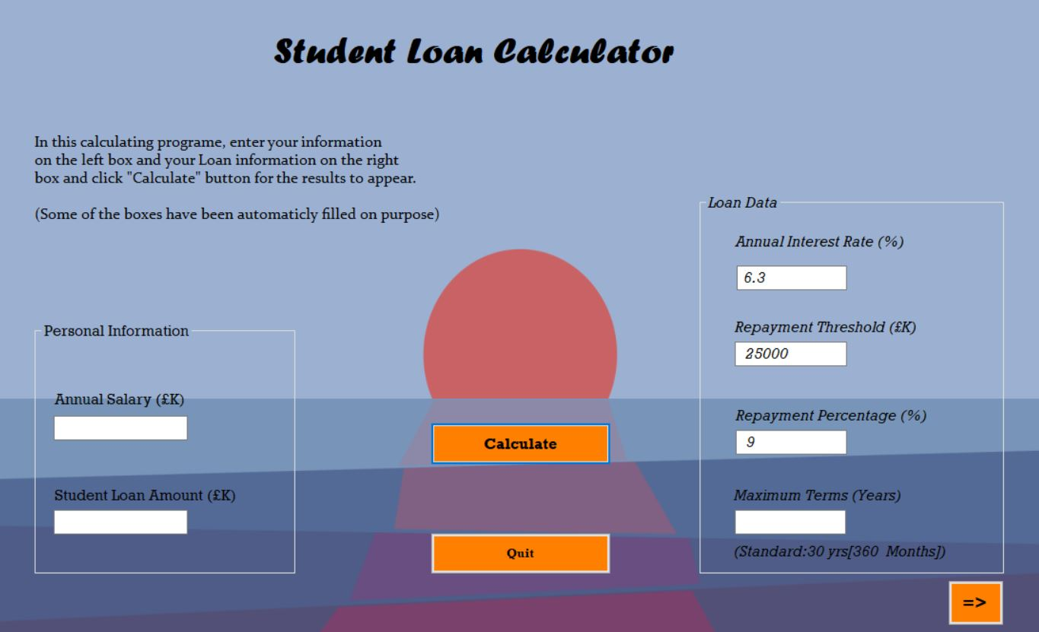e after we press “Reset”. (1/2)

Figure 16: Expected outcome after we click “Reset” (2/2) // (We can view it by clicking the “Arrow”(=>) button when we get navigated to form 2)