**十三.[**[**机器学习**](http://lib.csdn.net/base/machinelearning)**入门] 李宏毅机器学习笔记-13 （Semi-supervised Learning ;半监督学习）**

# Introduction

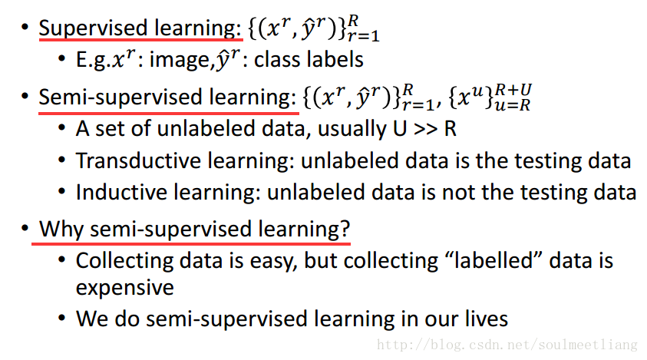

# Why semi-supervised learning helps?

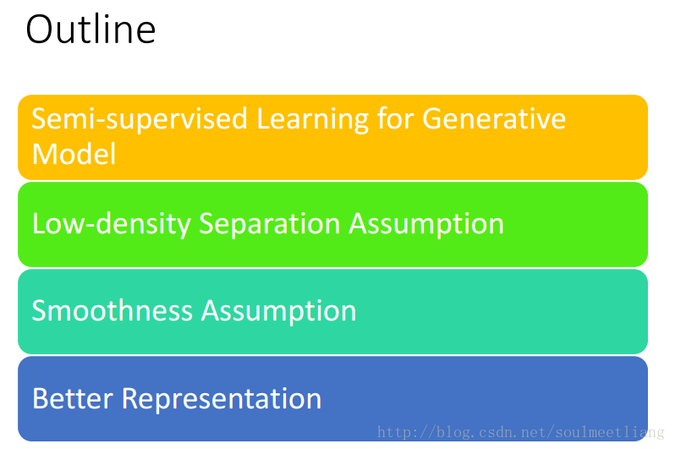

# Semi-supervised Learning for Generative Model

# Supervised Generative Model VS Semi-supervised Generative Model

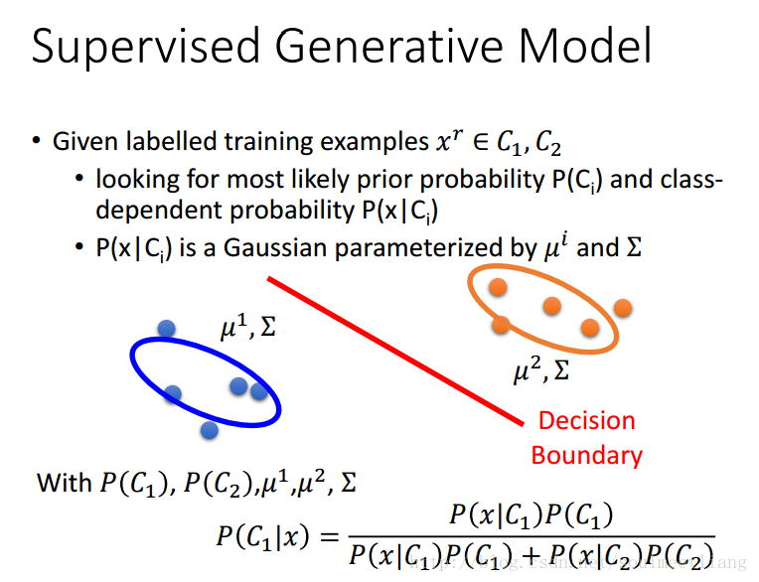

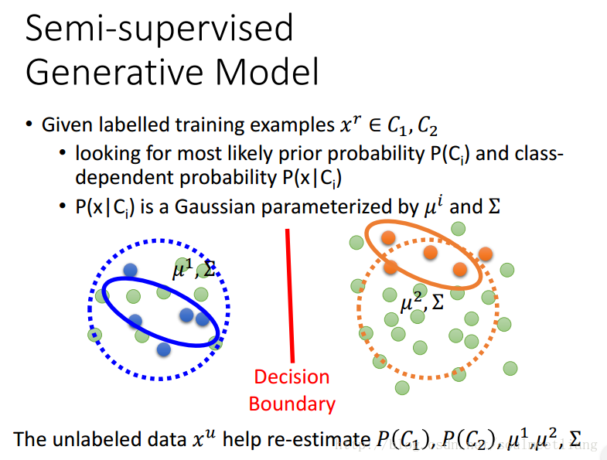

# Step

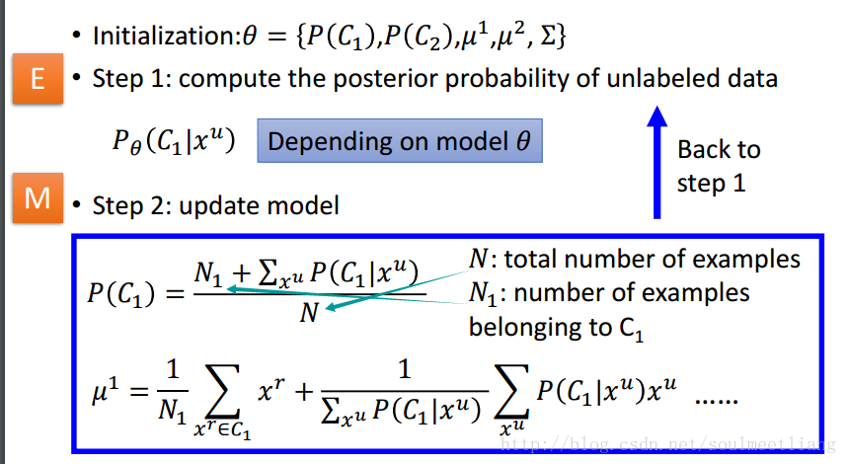

# Why？

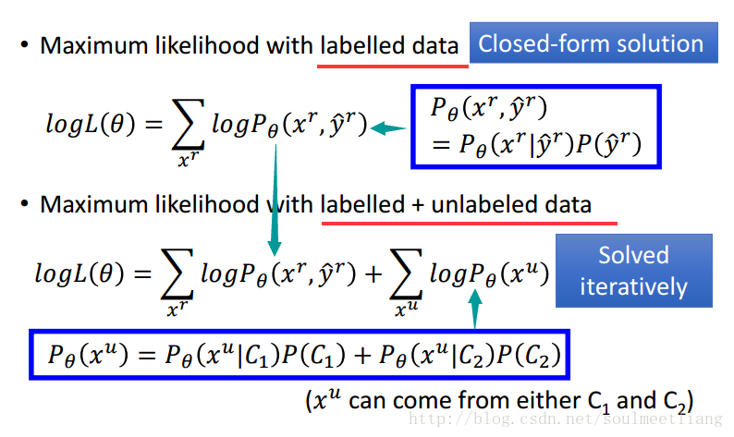

# Low-density Separation

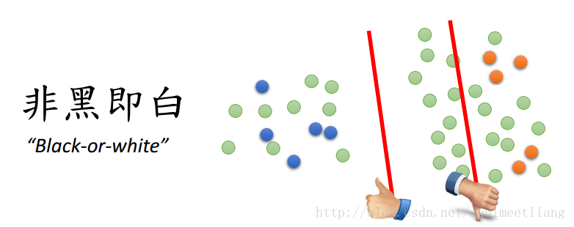

# Self-training

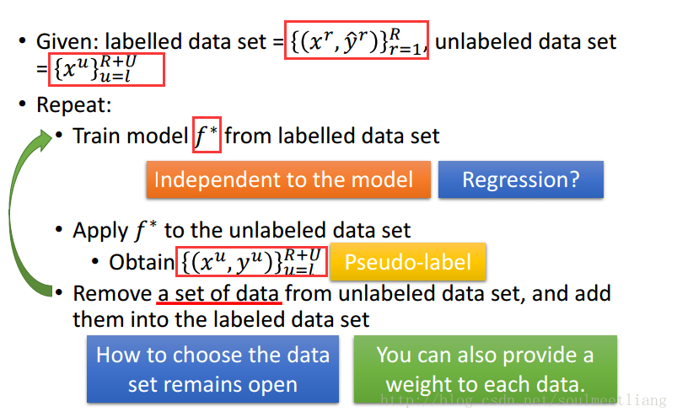

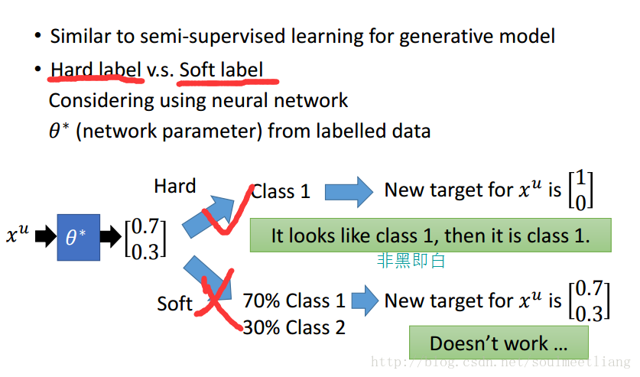

# Entropy-based Regularization

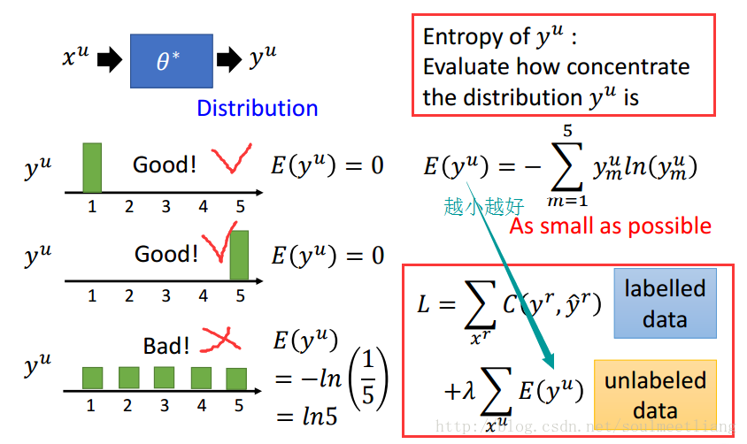

# Outlook: Semi-supervised SVM

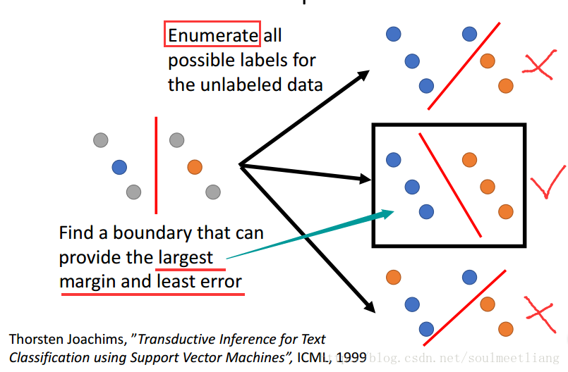

# Smoothness Assumption

**核心思想：近朱者赤，近墨者黑**

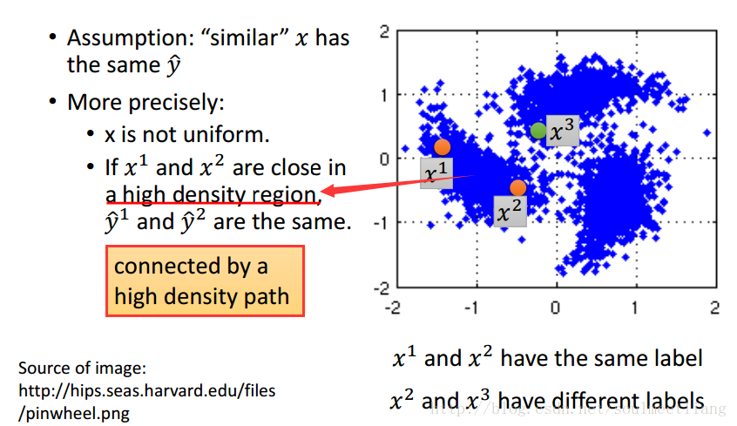

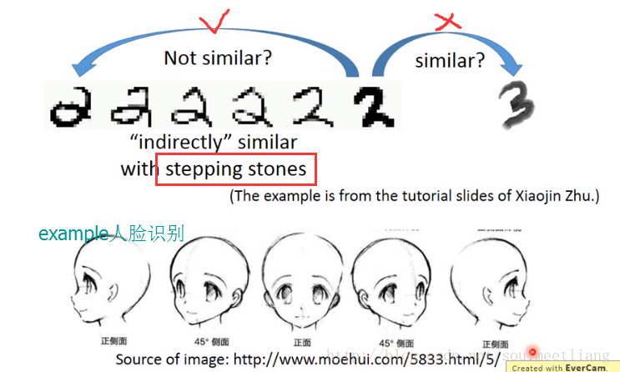

# Classify astronomy vs. travel articles

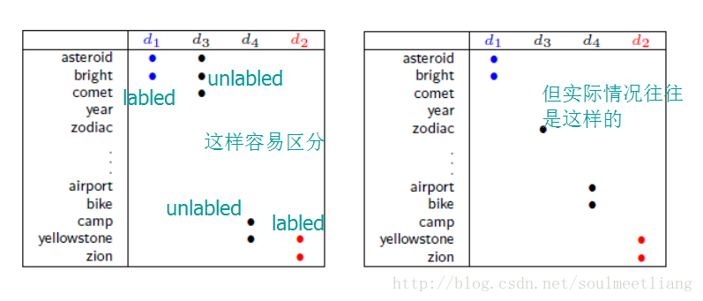

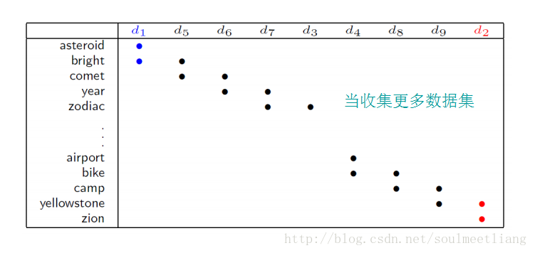

更多的数据连在一起，很难分类，那么如何做呢？

# Cluster（群集 ） and then Label

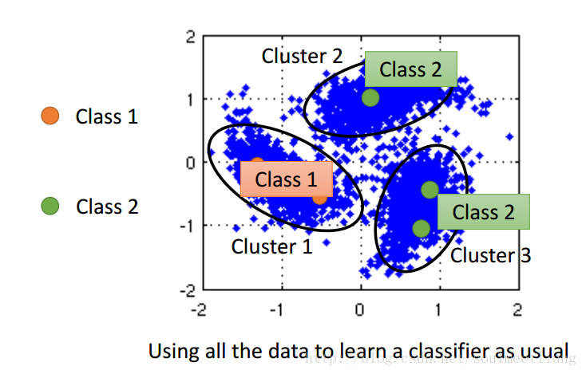

这种方法不一定made sense ，需要class很强。   
But，How to know x1 and x2 are close in a high density region (connected by a high density path)   
还有另一种方法：

# Graph-based Approach

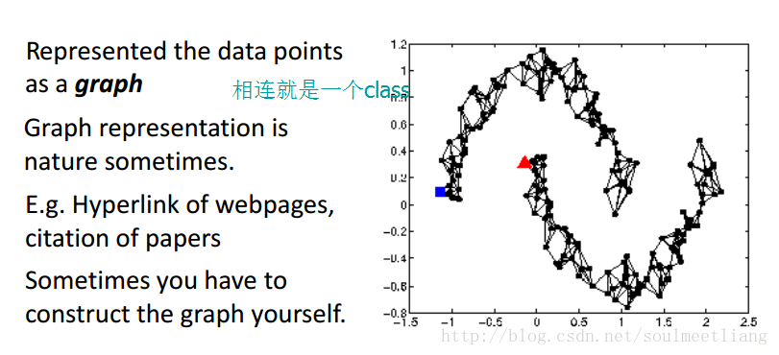

Graph Construction

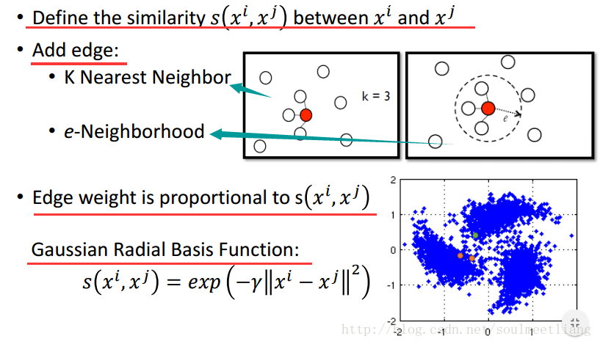

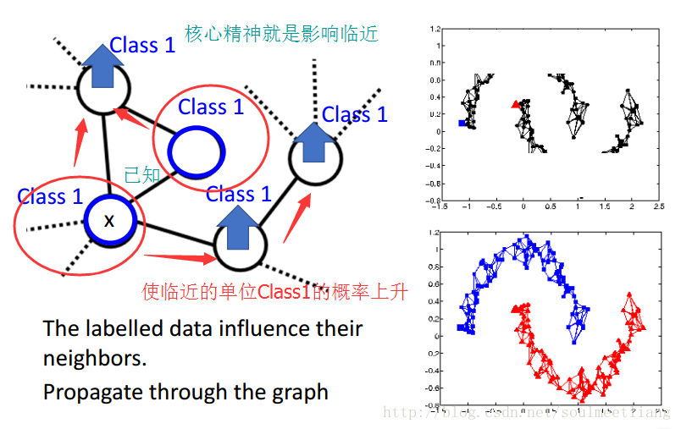

怎样在Graph 中定量地表示平滑度

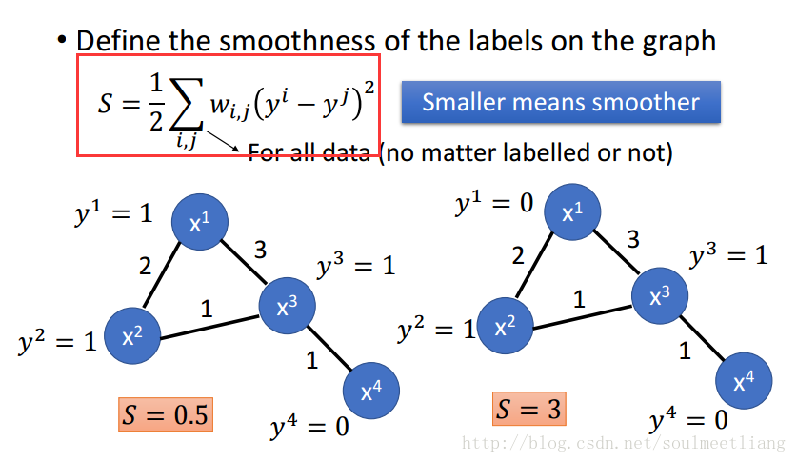

将该式子整理一下，换个形式

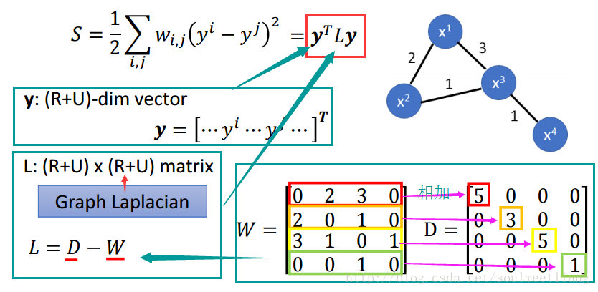

如此，让smoothness 影响Loss，as a regularization term

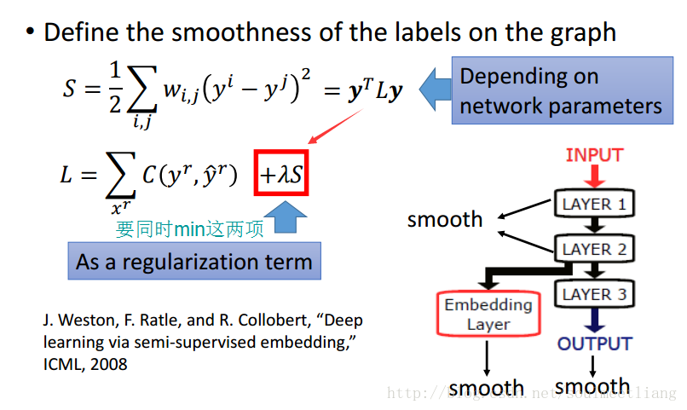

smoothness不一定要放在output上，放到任何一层都可以。

# Better Representation

去蕪存菁，化繁為簡   
Looking for Better Representation

这里写图片描述