**Title: Sustainable Waste Management (EcoTrack)**

EcoTrack is a practical, scalable waste management system designed to keep cities cleaner by combining community-driven reporting, sensor-based detection, and AI-powered scheduling.

Traditional waste collection follows rigid schedules, leading to wasted resources and overflowing bins. EcoTrack optimizes waste collection by ensuring timely pickups where they are actually needed, reducing inefficiencies and improving urban sanitation.

**Modules:**

Waste Segregation

Smart Waste Collection

Recycling

Energy & Carbon Footprint Monitor

Community Dashboard

**Tools for Planning and Scheduling:**

**ZOHO**

Zoho Projects offers rich scheduling and planning tools, anchored by interactive Gantt charts that support drag-and-drop task arrangement, the four standard task dependencies (Finish-to-Start, Start-to-Start, etc.), and visual tracking via critical path and baseline comparisons to monitor project health and timelines.

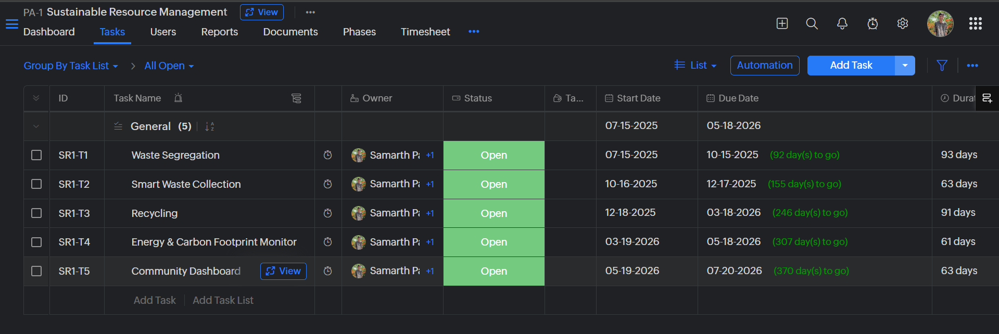

**Project libre**

ProjectLibre is a free, open-source desktop alternative to Microsoft Project, built in Java and compatible with Windows, macOS, and Linux.

It’s released under the CPAL license and widely adopted - garnering over 7.6 million downloads across 193 countries, with support for around 31 languages

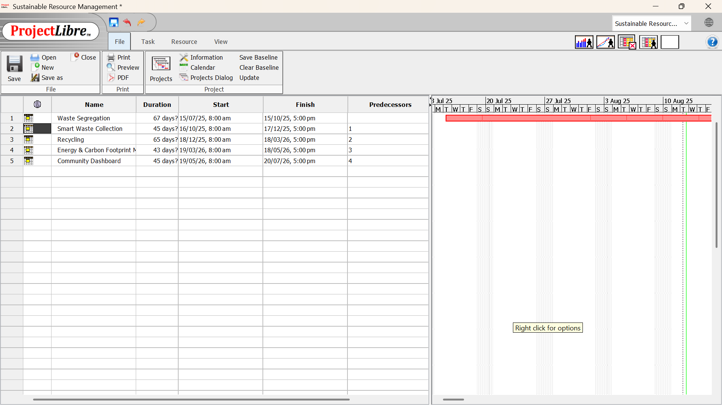

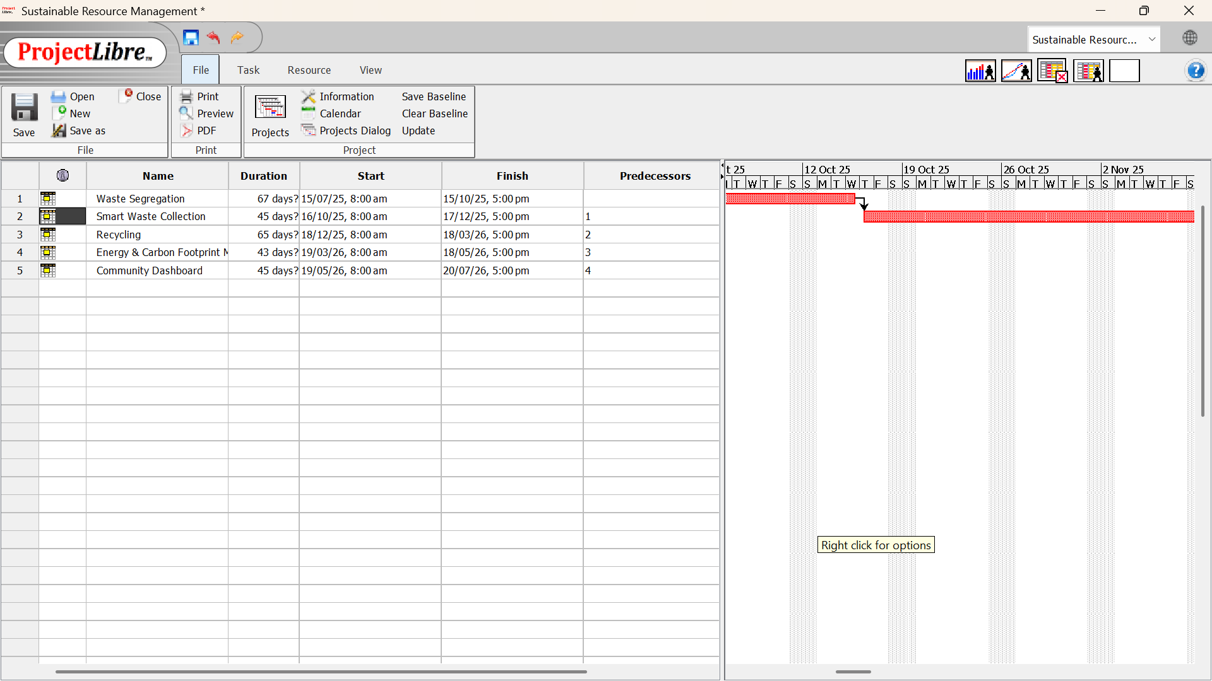

**Task juggler**

TaskJuggler is a powerful, open-source project management tool that uses a domain-specific declarative language - written in text files - to define projects rather than relying on graphical editors.

Initiated in 2001 by Chris Schläger, it was originally developed with a GUI built on Qt/KDE, but the current version (3.x) has transitioned to a console-based workflow in Ruby, functioning like a compiler: write your project in .tjp text files, and TaskJuggler schedules tasks, allocates resources, and outputs detailed reports

**Open source - Red mine + ai plugins**

Adds a chat sidebar directly within Redmine, enabling AI-assisted interaction.

You can search issues, summarize wiki or issue content, generate subtasks, and even draft comments—all powered by configurable AI models like OpenAI or Anthropic.

Includes vector search via Qdrant and an AI-generated project health report (exportable as Markdown or PDF).

**Open source - Open project + machine learning**

OpenProject is experimenting with AI via internal hackathon prototypes that show promising capabilities for report automation, guidance, and document assistance.

While AI isn’t yet a broadly shipped feature, the platform’s flexible APIs and growing interest in AI use-cases make it ripe for custom ML integrations - especially for task templating or smart assistance.

**Risk management**

**Project: EcoTrack - Sustainable Waste Management System**

## **Step 1: Identify Potential Risks**

Here are the key domains to consider and associated risks for our project:

### **1. Technical Risks**

**Sensor integration failures** - unreliable hardware or communication issues.

Physical sensors can malfunction due to hardware interferences, environmental conditions, or communication breakdowns. Data inconsistencies can arise if sensors lose connectivity or send corrupted data.

**Machine Learning inaccuracies** - poor model performance due to insufficient or biased data.

When models make incorrect predictions, leading to ineffective scheduling or false alerts.

**Scalability issues** - performance degradation under high load (many users/sensors).

Under real-world loads (many sensors, users, data), the system may slow down or crash.

**API/API key issues** - unstable or limited OpenStreetMap or third-party service quotas.

Your system could be hampered by rate limits, changes, or outages in services like OpenStreetMap.

**Data inconsistencies or corruption** - especially with MongoDB in concurrent write scenarios.

With concurrent writes or crashes, MongoDB may reflect inconsistent or lost data.

### **2. Functional & Requirements Risks**

**Changing user needs** - evolving requirements could misalign with current development.

Users or stakeholders may request new or altered features mid-project, causing delays.

**Mismatch in reported vs. sensor data** - conflict between community reports and sensor readings.

Community inputs (e.g., user reports) may contradict sensor readings, making resolution confusing.

### **3. Project Management Risks**

**Scope creep** - feature creep leading to delays or resource strain.

Uncontrolled introduction of new features adds complexity and risk.

**Inadequate testing** - insufficient unit/integration testing causing bugs in production.

Lack of adequate unit, integration, and regression testing leads to bugs in production.

### **4. Operational & Security Risks**

**Security vulnerabilities** - e.g., unvalidated user uploads (photos), injection attacks.

Flaws such as unsecured file uploads, injection attacks, or unauthorized access.

**Privacy concerns** - location data from reports or sensors could lead to privacy breaches.

Sensitive location or user data may be exposed or mishandled.

**Unauthorized access** - weak auth/authorization on the admin panel.

Weak authentication or missing access controls could permit unauthorized access to sensitive controls.

### **5. External Risks**

**Third-party service downtime** - e.g., OpenStreetMap outage or rate limits.

Outages in services like OpenStreetMap disrupt functionality.

**Community participation low** - few user reports resulting in insufficient coverage.

Without enough community reporting, sensor coverage may be insufficient, impairing system usefulness.

## **Step 2: Define the Risk Matrix**

We'll use a standard 5×5 risk matrix:

| **Impact ↓ / Likelihood →** | **Very Unlikely (1)** | **Unlikely (2)** | **Possible (3)** | **Probable (4)** | **Very Likely (5)** |
| --- | --- | --- | --- | --- | --- |
| **Catastrophic (5)** | 5 | 10 | 15 | 20 | 25 |
| **Significant (4)** | 4 | 8 | 12 | 16 | 20 |
| **Moderate (3)** | 3 | 6 | 9 | 12 | 15 |
| **Low (2)** | 2 | 4 | 6 | 8 | 10 |
| **Negligible (1)** | 1 | 2 | 3 | 4 | 5 |

Risk score = Likelihood × Impact.

## **Step 3: Assign Likelihood & Impact, Calculate Scores**

| **No.** | **Risk Description** | **Likelihood** | **Impact** | **Score (L×I)** |
| --- | --- | --- | --- | --- |
| 1 | Sensor integration failures | Possible (3) | High (3) | **9** |
| 2 | ML model inaccuracies | Unlikely (2) | Very High (4) | **8** |
| 3 | Scalability performance issues | Possible (3) | Very High (4) | **12** |
| 4 | OpenStreetMap API/key limitations | Possible (3) | Medium (2) | **6** |
| 5 | Data inconsistencies in MongoDB | Unlikely (2) | High (3) | **6** |
| 6 | Changing user requirements | Likely (4) | Medium (2) | **8** |
| 7 | Conflict between report vs. sensor data | Possible (3) | Medium (2) | **6** |
| 8 | Scope creep | Likely (4) | High (3) | **12** |
| 9 | Insufficient testing | Likely (4) | Very High (4) | **16** |
| 10 | Security vulnerabilities (e.g., photo upload) | Possible (3) | Critical (5) | **15** |
| 11 | Privacy breaches (geo-data exposure) | Unlikely (2) | Critical (5) | **10** |
| 12 | Unauthorized access to admin panel | Unlikely (2) | Very High (4) | **8** |
| 13 | Third-party service downtime | Possible (3) | High (3) | **9** |
| 14 | Low community participation | Unlikely (2) | High (3) | **6** |

## **Step 4: Prioritize Risks**

Highest risk scores:

**Insufficient testing** – **16**

**Security vulnerabilities** – **15**

**Scalability performance issues** – **12**

**Scope creep** – **12**

**Sensor integration failures** – **9**

**Third-party downtime** – **9**

**ML inaccuracies** – **8**

**Changing requirements** – **8**

Others follow accordingly...

## **Step 5: Mitigation Strategies**

**Testing**: Build robust unit/integration tests, staging environments, CI pipelines.

**Security**: Input validation for uploads; authentication, strong password policies, secure practices.

**Scalability**: Load testing, horizontal scaling, monitoring performance (e.g., load balancers).

**Scope Control**: Clear requirement definitions, stakeholder sign-off, agile sprint planning.

**Sensor Reliability**: Simulations, fallback manual reporting, sensor health checks.

**Third-party Resilience**: Caching, fallback geolocation mechanisms.

**ML Quality**: Validate model with diverse datasets, monitor post-deployment.

### **Summary Table**

| **Risk ID** | **Description** | **Likelihood** | **Impact** | **Score** |
| --- | --- | --- | --- | --- |
| R9 | Insufficient testing | Likely (4) | Very High (4) | 16 |
| R10 | Security vulnerabilities | Possible (3) | Critical (5) | 15 |
| R3 | Scalability issues | Possible (3) | Very High (4) | 12 |
| R8 | Scope creep | Likely (4) | High (3) | 12 |
| R1 | Sensor integration failure | Possible (3) | High (3) | 9 |
| R13 | Third-party service downtime | Possible (3) | High (3) | 9 |
| R2 | ML model inaccuracies | Unlikely (2) | Very High (4) | 8 |
| R6 | Changing requirements | Likely (4) | Medium (2) | 8 |
| (and so on) |  |  |  |  |

# **Cost vs. Quality Trade-Off Analysis Using COCOMO for a Sustainable Waste Management System**

## **1. Introduction**

The **Sustainable Waste Management System (SWMS)** project aims to design and implement a software solution that digitizes waste collection, segregation, monitoring, and recycling processes. Given the importance of sustainability and resource efficiency, achieving an optimal balance between **development cost** and **software quality** is crucial.

This section uses the **Constructive Cost Model (COCOMO)** to analyze how varying resource allocations influence cost, development schedule, and overall software quality.

## **2. COCOMO Framework Overview**

The **COCOMO model** estimates software development effort and cost based on project size (measured in KLOC – thousands of lines of code).

### **Key Equations:**

**Effort (Person-Months):**



**Development Time (Months):**



**Cost:  
**

Where parameters a,b,c,d depend on project type:

**Organic** – small, simple projects

**Semi-Detached** – intermediate projects (fits SWMS)

**Embedded** – complex, highly constrained systems

For **Semi-Detached Projects**:

a=3.0,b=1.12,c=2.5,d=0.35

## **3. Assumptions for SWMS Project**

**Project Link:** [**EcoTrack - Waste Management System**](https://github.com/pansalasamarth/EcoTrack-Waste-Management-System.git)

**Estimated Size:** 14 KLOC (medium-scale system: web + mobile + analytics).

**Project Type:** Semi-Detached.

**Average Developer Cost:** $10,000 per person-month.

**Baseline Effort & Time (from COCOMO):**

Effort = 3.0×(14)^1.12 = 58 Person-Months

Development Time = 2.5×(58)^0.35 = 11 Months

Cost = 58×10,000 = $ 5,80,000

## **4. Cost vs. Quality Trade-Off Scenarios**

To analyze the effect of resource allocation, we simulate multiple scenarios:

| **Scenario** | **Resource Allocation** | **Effort (PM)** | **TDEV (Months)** | **Cost (@$10k/PM)** | **Quality Impact** |
| --- | --- | --- | --- | --- | --- |
| **A** – Baseline | COCOMO Estimate | 58 | 11 | $ 5,80,000 | Balanced schedule and quality |
| **B** – Higher Resources | 1.5 × Staff | 82 | 7 | $ 8,20,000 | Faster delivery, but risk of defects due to team coordination overhead |
| **C** – Lower Resources | 0.7 × Staff | 38 | 13 | $ 3,80,000 | Cheaper but delays increase risks of defects and technical debt |
| **D** – Optimal Balance | Adjusted Staffing | 60 | 9 | $ 6,00,000 | Balanced cost, reasonable schedule, and best quality outcome |

## **5. Interpretation**

**Scenario A (Baseline):**

Effort ~58 PM, cost ~$580K.

Balanced trade-off.

**Scenario B (High Resources):**

Delivery ~2.5 months earlier.

Cost rises ~50%.

Quality risks: more people = more communication issues.

**Scenario C (Low Resources):**

Saves ~$167K, but delivery is ~4 months late.

Quality suffers due to longer development cycle and pressure.

**Scenario D (Optimal):**

Small increase in staffing keeps timeline under control.

Best quality outcome with controlled costs.

## **6. Cost vs. Quality Relationship**

**U-shaped Curve:** Both under-allocation and over-allocation of resources negatively affect quality.

**Balanced Allocation:** Yields the best quality-to-cost ratio.

**Sustainable Software Engineering View:** Optimal staffing ensures reduced waste (time, cost, and defects), aligning with sustainability principles.

## **7. Conclusion**

The COCOMO-based trade-off analysis for the **Sustainable Waste Management System** demonstrates that:

**Throwing excessive resources** increases cost and risks reduced quality.

**Understaffing** lowers costs but delays the project and harms quality.

**Balanced allocation (Scenario D)** provides the **best sustainability outcome** by minimizing wasted effort, cost, and defects while delivering high-quality software.

Thus, careful resource allocation is essential for building cost-effective, high-quality, and sustainable waste management systems.

**Six Sigma**

"The Tools and Techniques" for process improvement, which appears to be based on the DMAIC (Define, Measure, Analyze, Improve, Control) methodology commonly used in Six Sigma and other quality management frameworks.

**Define**

**Tool used:** Project Charter

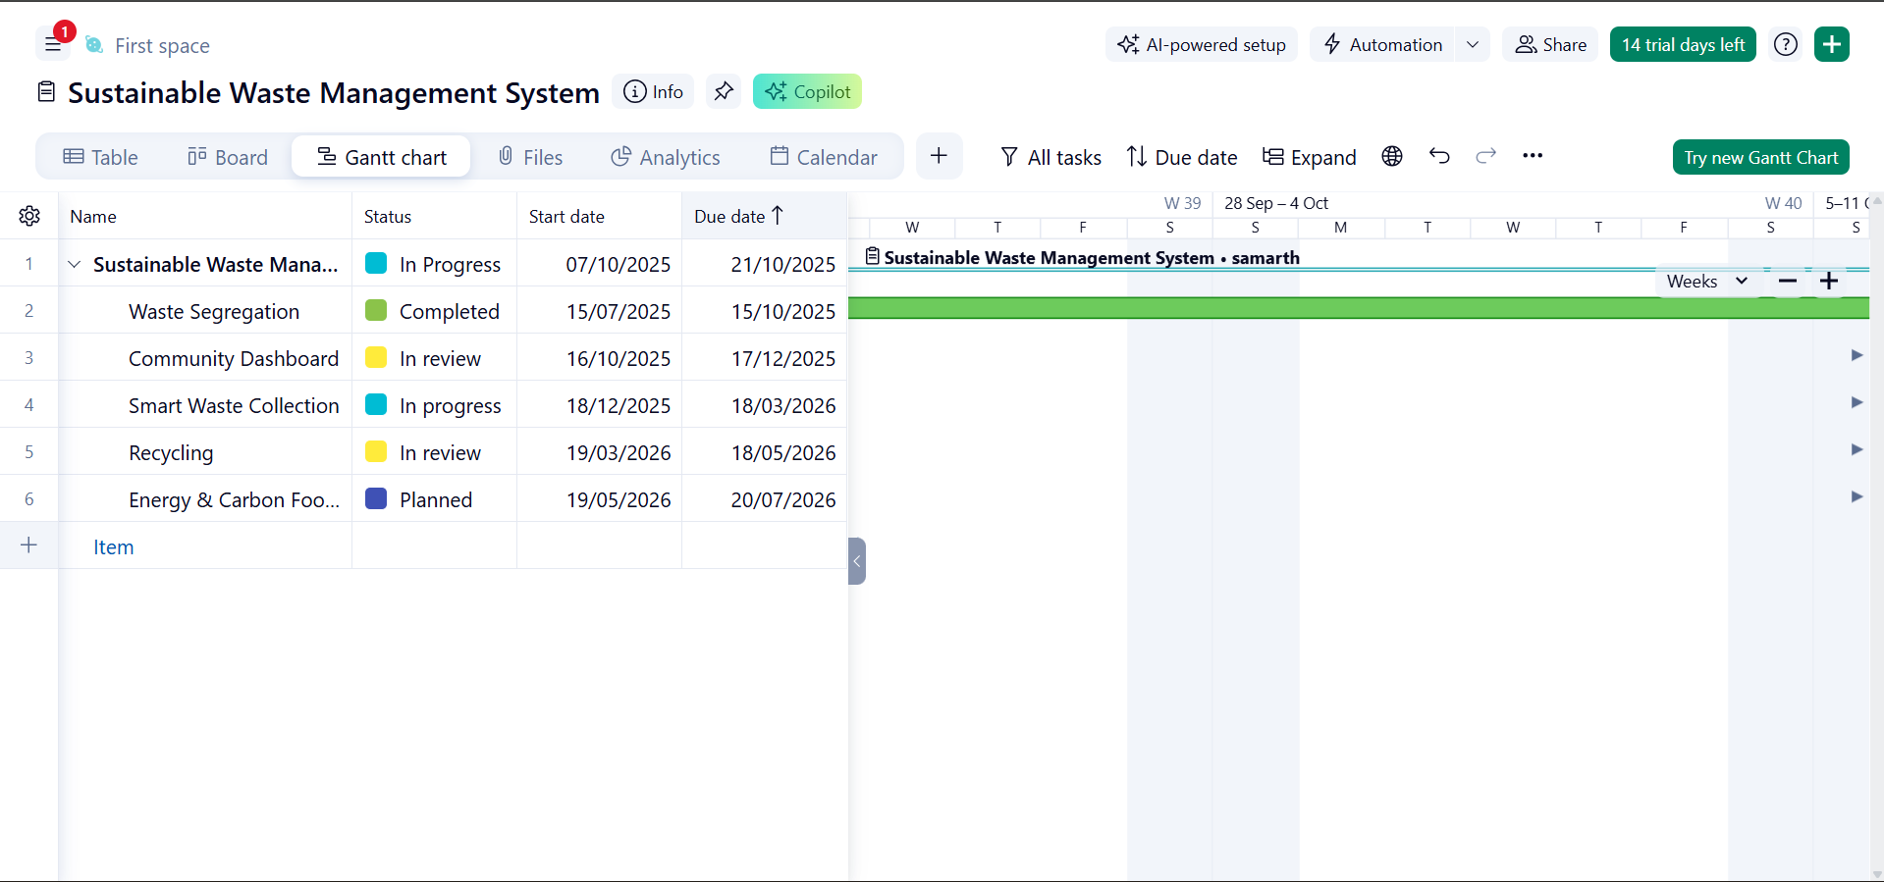

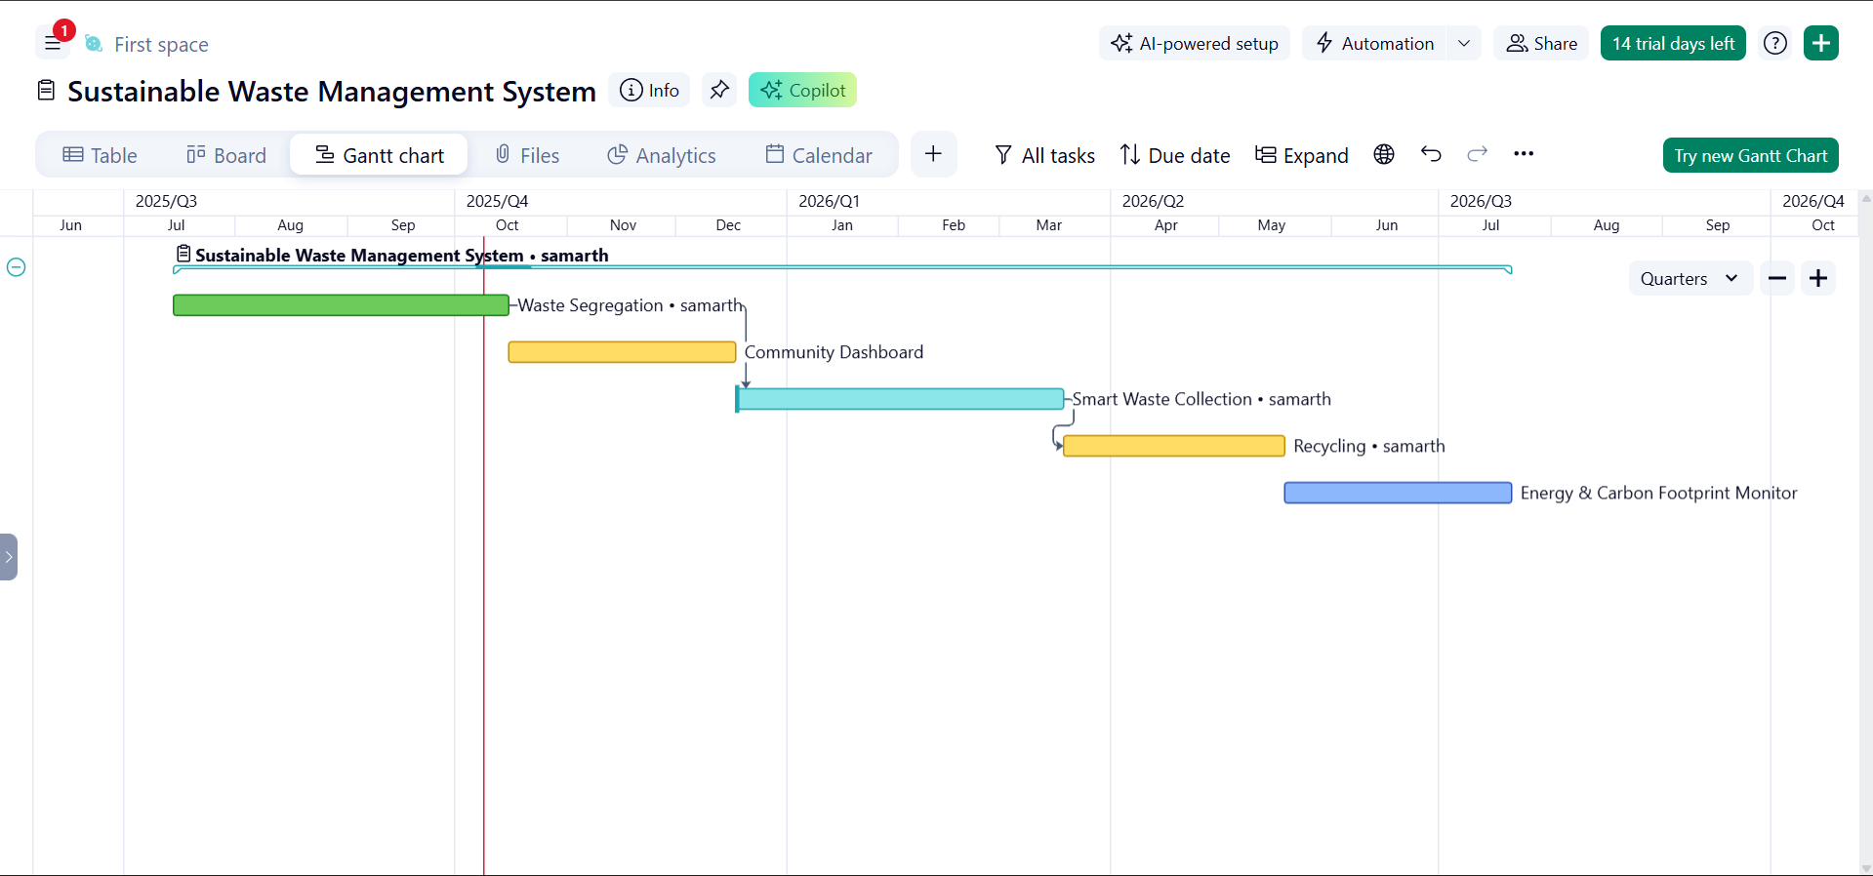

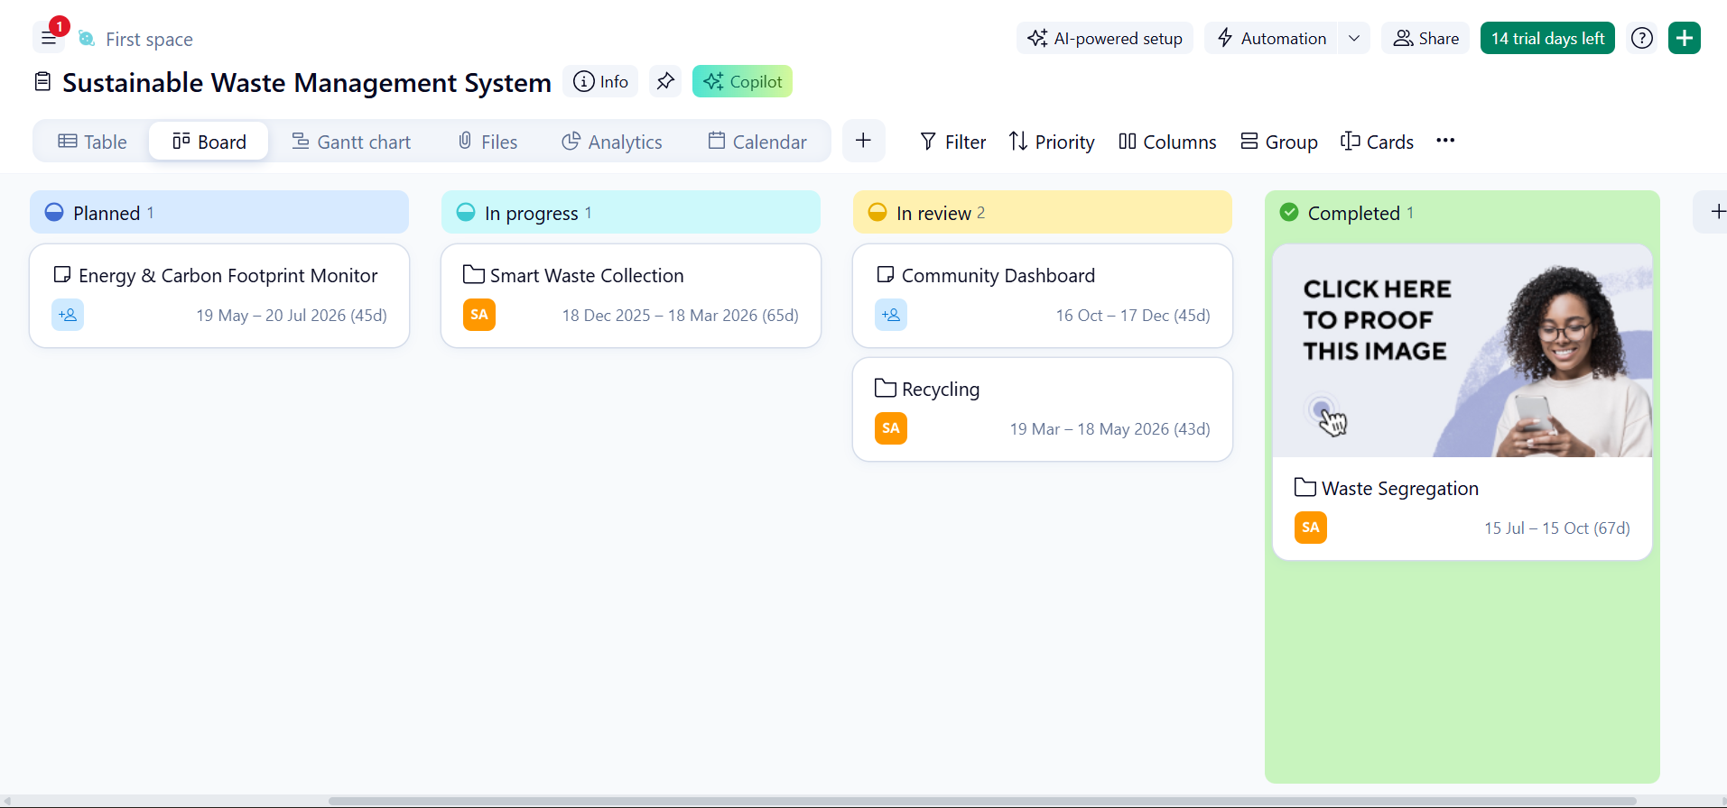

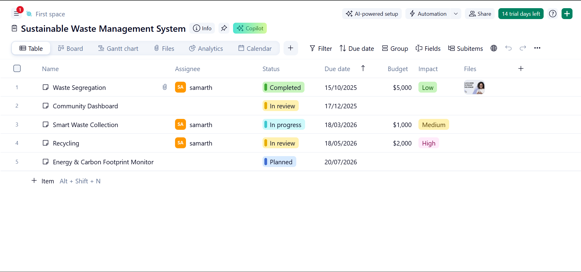

**Measure**

**Tool used:** Process Flow Diagram

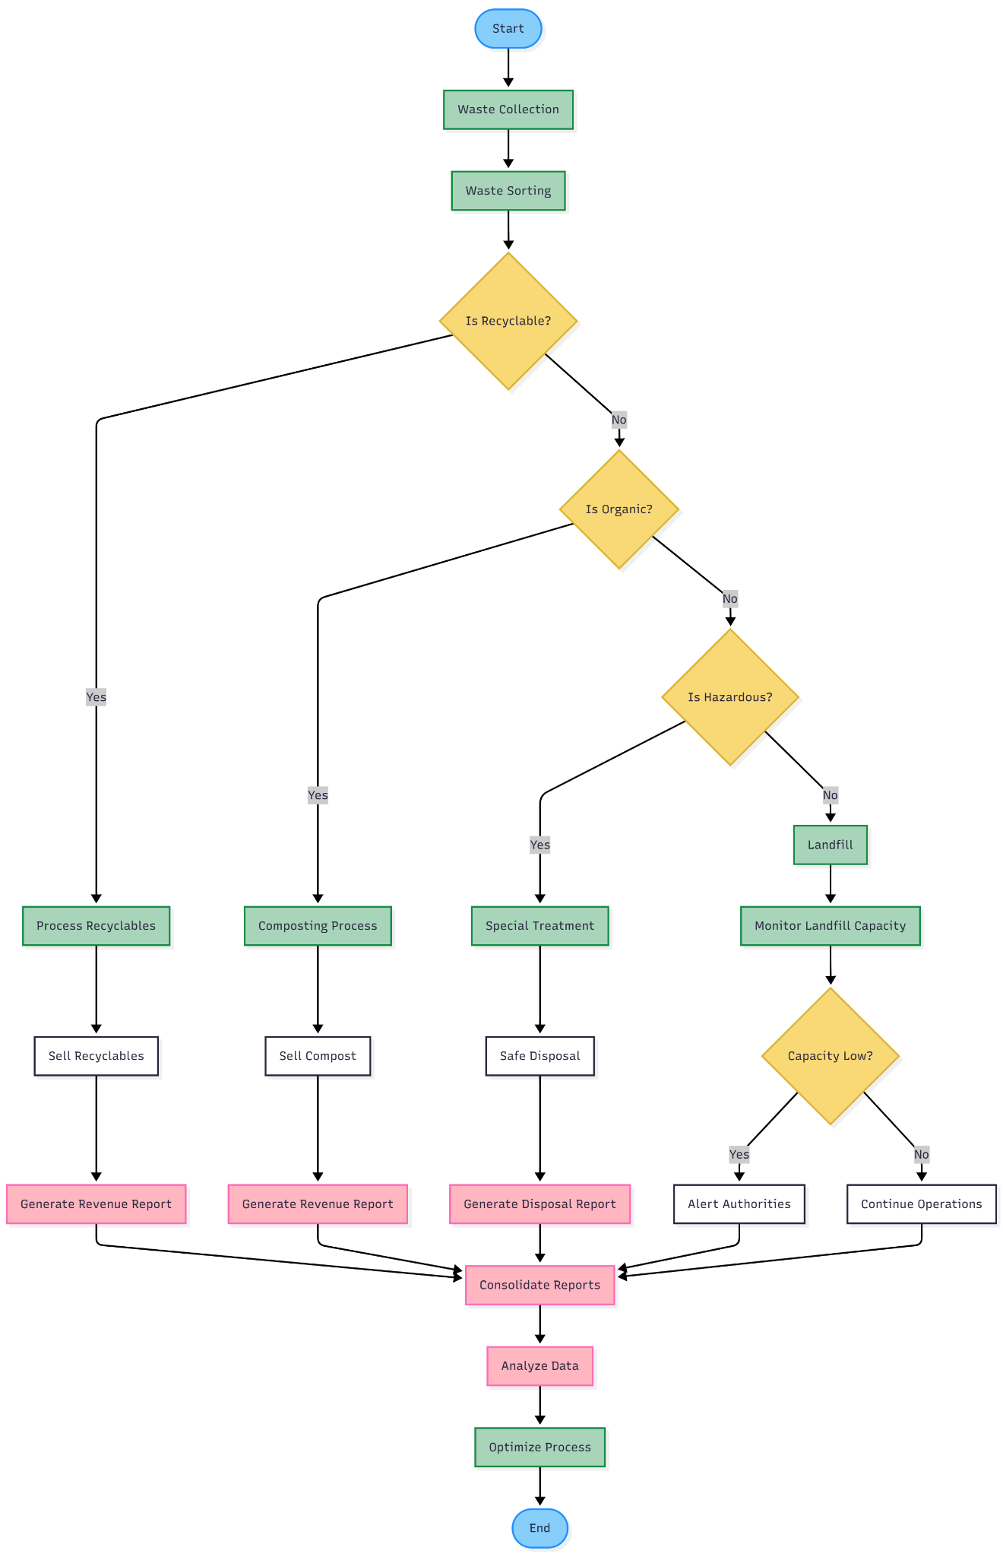

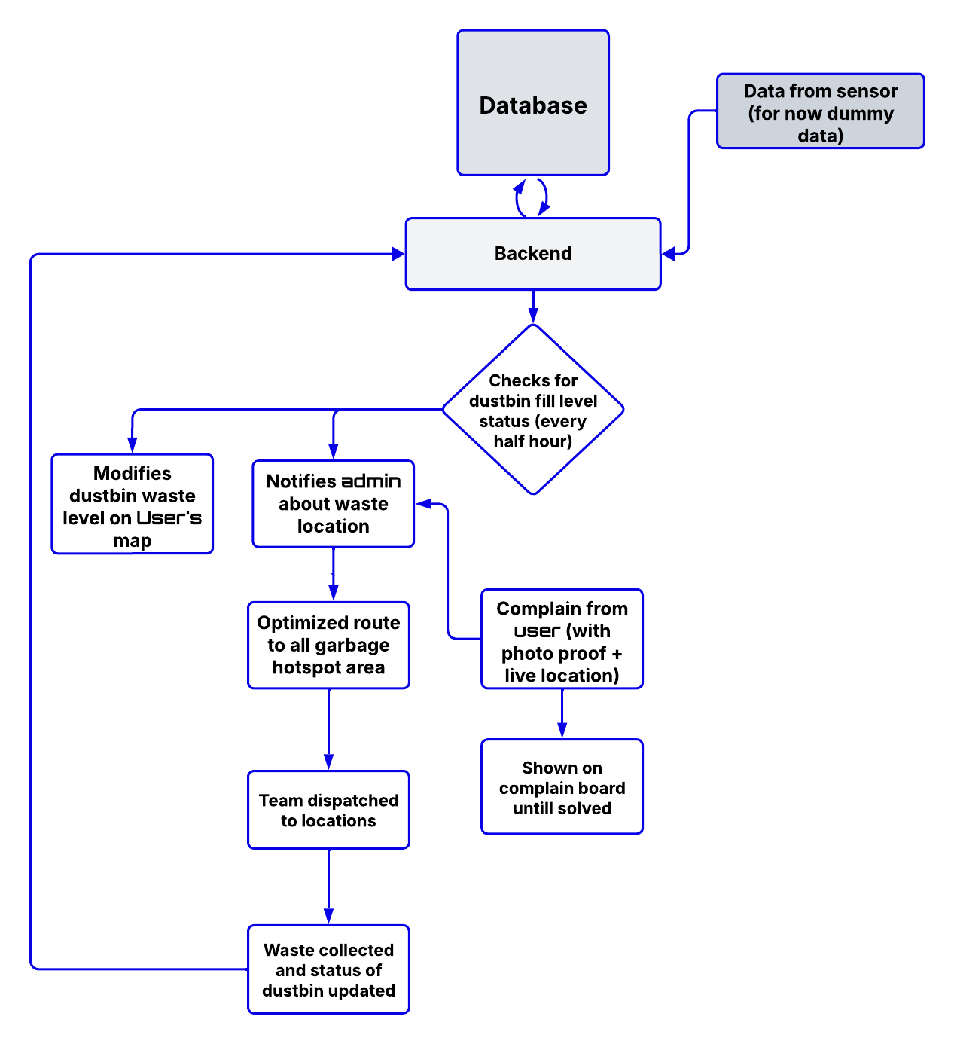

**Analyze**

**Tool used:** Cause & Effect Diagram

EcoTrack Waste Management System – Inefficient Waste Management (Fishbone Diagram Analysis)

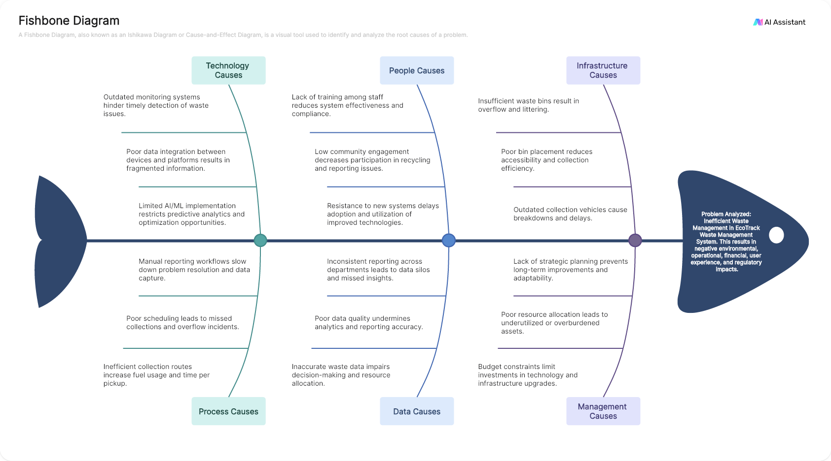

**Improve**

**Tool used:** Work Cell Design

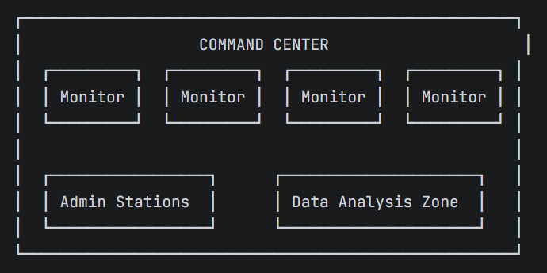

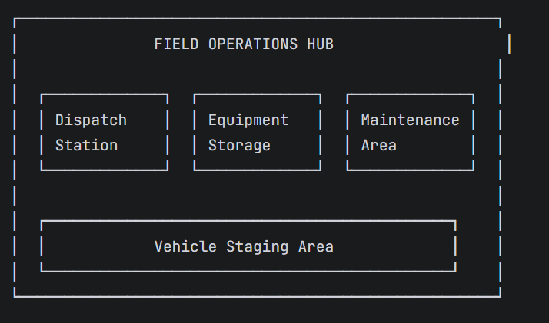

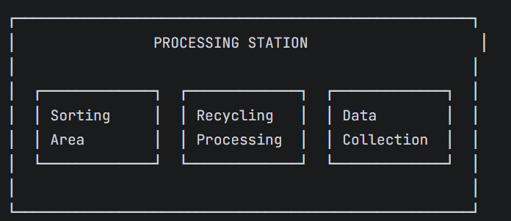

**Control**

**Tool used:** Control Charts

