Curriculum Vitae

Christiawan **Eko Saputro**

Kampung Sewu Rt:01 Rw:05 Kelurahan : Sewu ,Kec : Jebres • 57123 • Surakarta , Central Java , Indonesia

**HP : 0856 9729 8464** • **E-MAIL :** christiawaneko@gmail.com • **WEBSITE :** christiawan.web.id



Profile

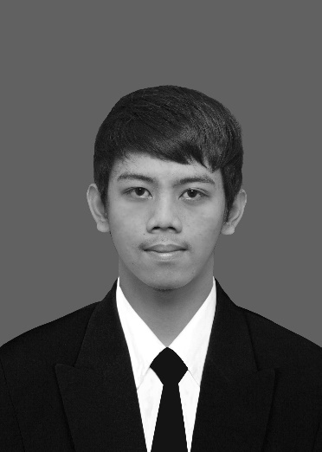**Christiawan Eko Saputro.** Born 27st April 1994 in Surakarta**,** . Graduated from SD Widya Wacana 1 Surakarta in 2007, and then continue study at SMP Kristen 1 Surakarta graduated in 2010 and continue at Vocational High School Surakarta 2 major in Software Enginering graduated in 2013 and worked at Sejati Digital Printing until Agust 2013 and I had received scholarship from SEAMEO SEAMOLEC to study at Bandung Institute of Technology major in Information Technology and D3 Amik Wahana Mandiri major in Information Technology

Im have a passion in Internet and digital world a coffe addict and cycling as hobby. I enjoy the process of making website and writing article. I spend my days with programming as blogging on my personal site ( [christiawan.web.id](http://www.christiawan.id) )



Personal Information

Name : Christiawan Eko Saputro

Place, Date of Birth : Surakarta, 27st April 1994

Gender : Male

Religion : Christian

Marital Status : Single (Unmarried)

Nationality : Indonesian

Home Address : Kampung Sewu Rt:01 Rw:05 , Kec. Jebres (57123)

Surakarta , Central Java , Indonesia

Phone : 0856 9729 8464

Email : christiawaneko@gmail.com

Facebook : <http://www.facebook.com/christiawaneko>

Website : <http://www.christiawan.web.id>



Skills Programming

|  |  |  |
| --- | --- | --- |
| **PHP ( Native OOP + Framework Laravel )** | **HTML5 + CSS + JS** | **Go Language** |
| **Java Android Mobile** | **MYSQL + SQLite** |  |



Hobby and Activities

**Coding / Programming Traveling Swimming**

**Browsing Chatting Listening Music**

**Watching Movie Cycling Writing Article**



Educational Background

**Academy of Informatic Management and Computer**

D3 TKJ | 2014 - 2016

**Bandung Institute of Technology**

D1 TKJ (STEI) | 2014 - 2015

**Surakarta 2 Public Vocational High School**

RPL (Software Engineering) | 2010 - 2013

**Surakarta 1 Christian Junior High School**

- | 2007 - 2010

**Widya Wacana 1 Elementary School, Surakarta**

- | 2001 - 2007



Working Experiences

**Seamolec**

Jan 2016 – Current Now

Staff IT Content Division

**Seamolec**

August 2013 – Dec 2015

Internship in Network Division

**Integrasi Group Indonesia**

May 2014 - August 2014

Beginner Java Programmer

**Sejati Digital Printing**

June 2013 - August 2013

Design Graphic

**CV Intermedia Solusindo**

June 2011 - August 2012

Web Development/Programming Internship Program



Seminar And Workshop

**Training Online Ditigal Class -** Mentor SEAMOLEC

October 2016

SEAMEO SEAMOLEC

**MagisCamp 2016**

September 2016

Santika Teras Kota, Tangerang

**Technical Workshop On Android-based Programming and Interface Design**

August 2016

Ploy Palace Hotel, Mukdahan Province, Thailand

**Worshop Pengembangan Digital Class**

June 2016

SD N 31, Payakumbuh

**Workshop Augmented Reality For Digital Learning**

June 2016

SLB B N PTN, Jimbaran, Bali

**Worshop Pengembangan Digital Class**

Mey 2016

SMA N 4 Mataram

**Workshop Video Based Digital Learning Materials Developments**

Mey 2016

SMA N 4 Padalarang

**Training On Establishing School Garden for Nutrition, Literacy, and Entrepreneurship**

March 2016

Mentor SEAMOLEC