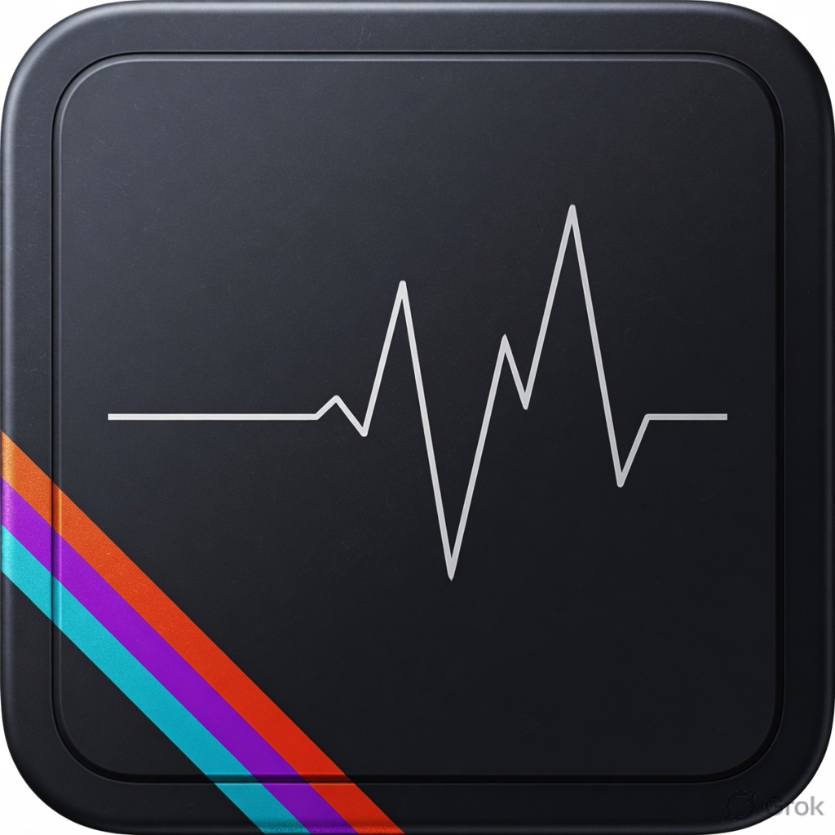
iQOO HACKATHON 2026 · CHENNAI CITY BATTLE
FRAMEDOCTOR
Sub-Millisecond 144 Hz Frame Pacing & Thermal
Diagnostic Engine for iQOO 15
PROJECT SUBMISSION PROPOSAL
Developer Tools & Performance Optimization

6.94 ms  VSync budget at 144 Hz | 144 Hz  iQOO 15 AMOLED target | Untethered  No USB cable or ADB | User-space  Zero root required

Document Information
Project Title | FrameDoctor
Hackathon | iQOO Hackathon 2026 · Chennai City Battle
Track | Developer Tools & Performance Optimization
Target Hardware | vivo / iQOO 15 · Snapdragon 8 Elite · Adreno 830 · 144 Hz 2K AMOLED · Supercomputing Chip Q2
Target Software | OriginOS 5 / FuntouchOS · Android 15 (API Level 35)

Live Prototype | https://framedoctor-two.vercel.app
Mobile DUT View | https://framedoctor-two.vercel.app/#/
Laptop Companion Desk | https://framedoctor-two.vercel.app/#/desk
GitHub Repository | https://github.com/panshularora/FrameDoctor

Contents
1. | Executive Summary
2. | Problem Statement & Field Analysis
3. | The Proposed Solution: FrameDoctor Architecture
4. | Key Innovations & Technical Core
5. | The vivo Office Kit Cross-Device Workflow
6. | Current Implementation Status & Verification
7. | Official Hackathon Rubric Alignment
8. | Team Capability & 30-Hour Sprint Roadmap

1. Executive Summary
At 144 Hz, an application rendering pipeline has a strict 6.94 millisecond vertical synchronization (VSync) budget per frame. A minor single-frame transgression forces the Android compositor (SurfaceFlinger) to miss the vertical blanking interval, dropping the presentation rate to 72 FPS and inducing noticeable micro-stutter.
Traditional developer profiling tools (such as Android Studio Profiler, Google Perfetto, and Systrace) suffer from three critical bottlenecks:
- Physical Cable Lock-In. They require a tethered desktop workstation and ADB authorization, making profiling impossible on buses, in student labs, in field tests, or during offline hackathon “Red Light” phases.
- Thermal & Electrical Distortion. Continuous 5 V / 9 V VBUS charging power over USB introduces artificial electrical Joule heating (P = I²R) directly into the device chassis, invalidating native battery coulometry and triggering premature thermal throttling.
- The Vanity Metric Blindspot. Standard tools summarize performance as cumulative arithmetic average frame rate (FPS̄), which completely conceals micro-stutter and hitch clusters.

FrameDoctor turns the loaner iQOO 15 itself into an autonomous, untethered performance laboratory. Operating entirely within user-space without requiring root privileges, FrameDoctor intercepts hardware VSync timestamps via Choreographer.FrameCallback, captures platform thermal throttling tiers via PowerManager.OnThermalStatusChangedListener, monitors battery current draw via BatteryManager, and tracks 300 Hz touch digitizer latency. It evaluates rendering stability using the Peak Jitter Index (PJI), synthesizes tailored Adreno 830 GPU code patches, and exports diagnostic dossiers directly onto developer workstations via vivo Office Kit drag-and-drop and Super Clipboard protocols.

2. Problem Statement & Field Analysis

2.1 The 6.94 ms VSync Boundary Paradox
On modern flagship devices, the rendering deadline shrinks non-linearly as refresh rates increase:
Refresh Rate | VSync Deadline (Δt max) | Frame Margin | Risk Vector
60 Hz | 16.67 ms | Generous | Forgiving of occasional layout spikes and GC pauses.
120 Hz | 8.33 ms | Tight | Draw-call serialization and heavy fragment passes drop frames.
144 Hz (iQOO 15) | 6.94 ms | Zero Margin | Any micro-hitch, shader overdraw, or layout reflow causes instantaneous visual stutter.
Table 1. Frame budget collapse from 60 Hz to the iQOO 15 144 Hz panel.

2.2 Why Average FPS Lies: A Mathematical Demonstration
Consider two distinct 1-second application profiles evaluated across 144 target frames (1000 ms window):
SYSTEM A · TRUE 144 Hz LOCK  Every frame renders at exactly 6.94 ms.  FPS̄ = 144 / 1.0 s = 144.0 FPS  Jitter = 0.0 ms  Flawless frame pacing | SYSTEM B · JANKY HITCH CLUSTER  141 frames in 5.0 ms (705 ms), 3 frames freeze at 98.3 ms (295 ms).  FPS̄ = 144 / 1.0 s = 144.0 FPS  Jitter = ±23.4 ms  Severe micro-stutter — screen frozen ~⅓ of a second

Both profiles report an average of 144 FPS, yet System B freezes the screen for nearly a third of a second. FrameDoctor replaces this deceptive average with variance-sensitive operators: Peak Jitter Index, p95 latency, and hitch-cluster tracking.

3. The Proposed Solution: FrameDoctor Architecture
FrameDoctor separates concerns across two unified surfaces: the Mobile Device Under Test (DUT) and the Laptop Companion Desk, bridged by vivo Office Kit and a low-latency local area network (LAN) telemetry stream.
Figure 2. FrameDoctor system topology
FRAMEDOCTOR SYSTEM TOPOLOGY
MOBILE DEVICE UNDER TEST · iQOO 15
HARDWARE TELEMETRY LAYER · Native Kotlin Bridge
Choreographer.FrameCallback — sub-millisecond VSync timestamps
PowerManager.OnThermalStatusChangedListener — 6-tier OS thermal daemon
BatteryManager — current draw, voltage, temperature
High-frequency digitizer listener — 300 Hz touch tracking
▼ Nanosecond ring-buffer stream
DETERMINISTIC GRAPHICS STRESS HARNESS
WebGLMesh — instanced icosphere lighting loops (fragment-bound)
DOMFeed — dynamic DOM mutation and composite-layer thrash (CPU-bound)
TriangleMesh — 18k unindexed primitives (Adreno rasterizer-bound)
OverdrawBomb — real-time trigonometric load injector
▼ Discrete frame series
LOCAL DIAGNOSTIC ENGINE · Zero-cloud analysis core
Startup transient discard filter (drop initial 25 frames)
Peak Jitter Index (PJI) statistical operator
Multi-parametric health scorer (0–100 system)
Adreno ALU vector precision and shader remediation generator
▼ Serialized dossier (Markdown / JSON)
UNTETHERED EXPORT BUS · MediaStore public storage
FileDropHelper — direct ingestion to Environment.DIRECTORY_DOWNLOADS
Super Clipboard — system-wide synchronized clipboard buffer

vivo Office Kit bus
Cross-device drag-and-drop · Super Clipboard · LAN SSE stream

LAPTOP COMPANION DESK · DEVELOPER PC
HOST TELEMETRY CONSUMER
Live latency seismograph — sub-ms streaming frame-time canvas
Drop verifier — deterministic regex and integrity ingestion parser
LAN remote co-pilot — bi-directional stress injection (Overdraw Bomb remote trigger)

Product surfaces — Device Under Test
The phone is the laboratory. The operator picks a workload, locks 144 Hz, runs the session, and reads a scored diagnostic without leaving the device.
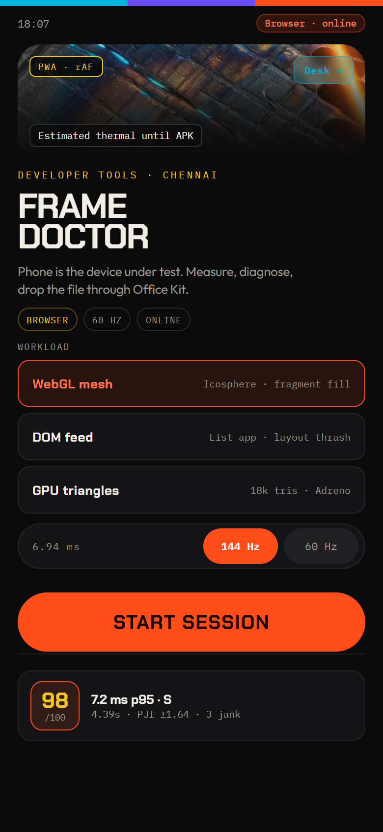 | 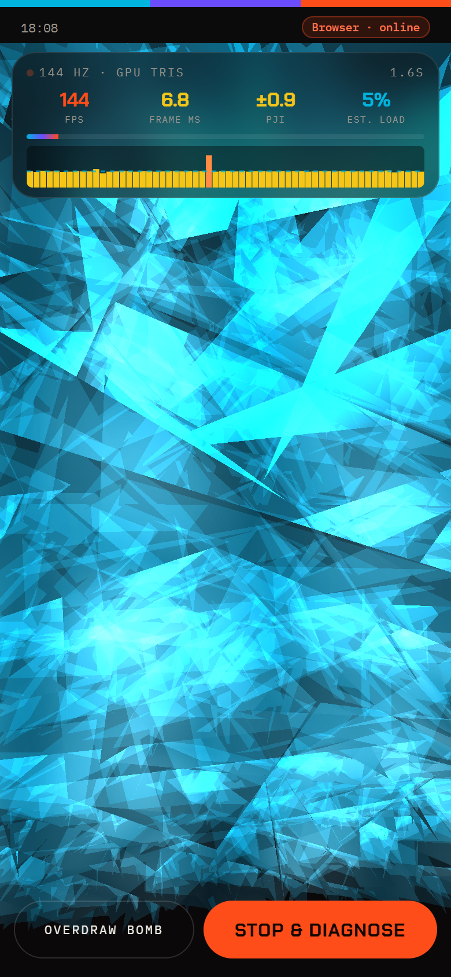 | 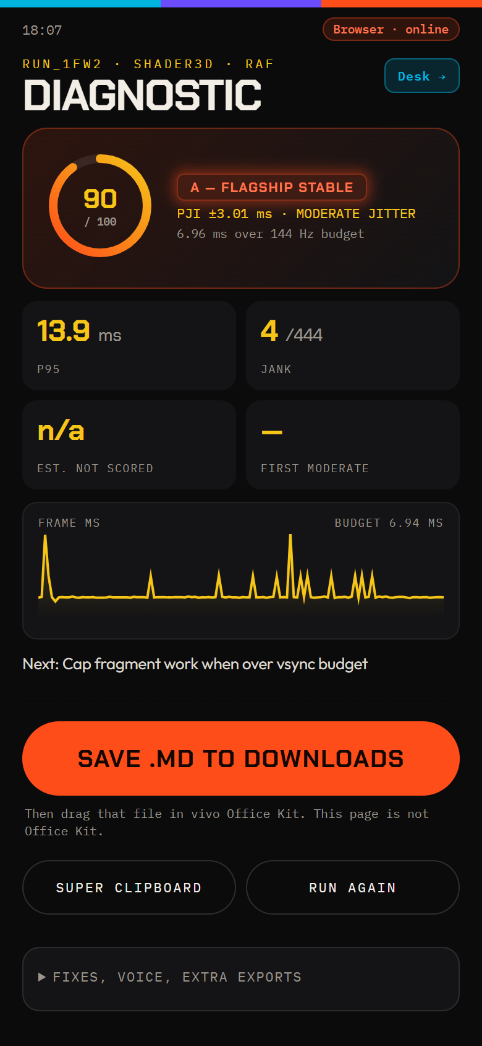
DUT home — workload picker | GPU triangles · Adreno rasterizer | Diagnostic + Office Kit export
Figure 3. iQOO 15 DUT: session start, 144 Hz stress, and scored diagnostic with one-tap export.

Product surfaces — Laptop Companion Desk
The desk is not a profiler. It is the receiving bench: Office Kit drops, Super Clipboard paste, live LAN telemetry, and remote Overdraw Bomb control.
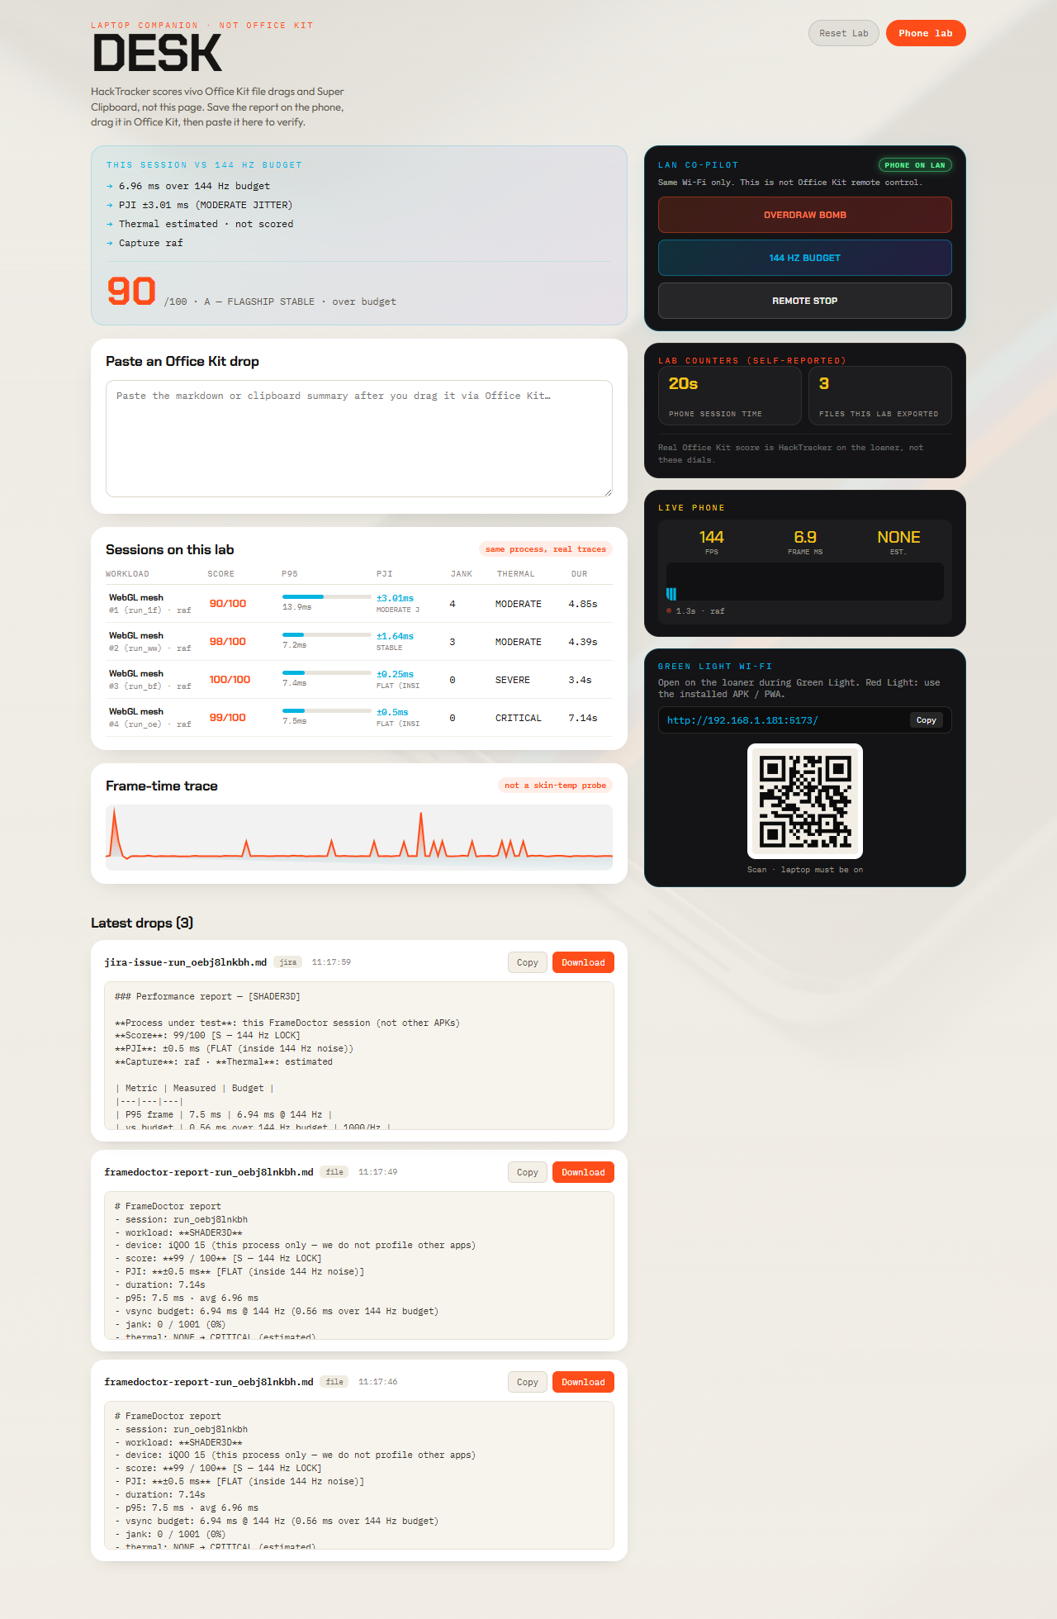
Figure 4. Laptop Companion Desk ingesting Office Kit drops, showing live phone telemetry and remote co-pilot controls.

4. Key Innovations & Technical Core

4.1 Sub-Millisecond VSync Interception (Choreographer.FrameCallback)
To bypass browser event-loop queue latency, FrameDoctor’s native Kotlin bridge hooks directly into Android’s Choreographer. This captures nanosecond-accurate hardware presentation timestamps straight from SurfaceFlinger.

4.2 Operating System Thermal State Monitoring (PowerManager)
Rather than relying on noisy surface thermistors, FrameDoctor registers an active listener against Android’s platform thermal daemon.
NONE | LIGHT | MODERATE | SEVERE | CRITICAL | EMERGENCY
Table 2. Six-tier Android thermal daemon progression captured by PowerManager.
FrameDoctor captures the exact second t_throttle when the platform kernel activates Dynamic Voltage and Frequency Scaling (DVFS) clock-frequency limits on the Snapdragon 8 Elite CPU/GPU clusters.

4.3 Startup Transient Warmup Discard Filter
During the first 25–30 frames of any session, Android applications experience unavoidable startup spikes (class loading, layout traversal, WebGL shader compilation). FrameDoctor filters out the initial 25 frames from steady-state calculations, preventing artificial skewing of p95 latency:
F_steady = [ f₂₅ , f₂₆ , … , f_N ] for N > 30

4.4 Peak Jitter Index (PJI) Formulation
Frame pacing stability is quantified via the Peak Jitter Index (PJI), derived as the root-mean-square deviation of steady-state frame intervals:
PJI = √ ( 1 / (M − 1) ) Σᵢ ( fᵢ − μ_f )²
PJI Range | Grade | Interpretation
PJI ≤ 0.8 ms | S-Tier 144 Hz Lock | Locked within physical hardware noise.
0.8 ms < PJI ≤ 2.0 ms | Flagship Stable | Imperceptible jitter.
PJI > 2.0 ms | Unstable Jitter | Visible micro-stutter.
Table 3. Peak Jitter Index grading used by the on-device health scorer.

4.5 Automated Code Remediation Engine
FrameDoctor bridges the gap between raw data and developer action. It analyzes bottleneck signatures and emits concrete, copy-pasteable patches:
- Adreno 830 ALU Vector Optimization. Demoting 32-bit highp float variables to 16-bit mediump float in fragment shaders doubles ALU vector throughput on Qualcomm Adreno hardware.
- Fragment Overdraw Throttling. Automatically emits gl.hint(gl.FRAGMENT_SHADER_DERIVATIVE_HINT, gl.FASTEST) and dynamic level-of-detail (LOD) downscaling rules when frame-budget overruns are detected.
- DOM Reflow Decoupling. Automatically emits microtask read/write batching to eliminate synchronous layout thrashing.

5. The vivo Office Kit Cross-Device Workflow
A core tenet of FrameDoctor is bridging on-device testing with desktop development through vivo’s native ecosystem — without treating the companion page as Office Kit itself.
1  Profile on Phone | 2  One-Tap Export | 3  Drag in Office Kit | 4  Verify on Laptop Desk
Run the 144 Hz stress test on the iQOO 15 DUT. | Save the .md dossier to Downloads / Documents. | Drag the file from phone to PC in vivo Office Kit. | Instant parse, integrity check, live telemetry.
Figure 5. Four-step vivo Office Kit path from DUT capture to desk verification.
- MediaStore public storage writer (FileDropHelper.kt). Writes diagnostic reports directly into Environment.DIRECTORY_DOWNLOADS and DIRECTORY_DOCUMENTS.
- vivo Office Kit file drag-and-drop. Because the report is in public storage, vivo Office Kit on the PC immediately discovers it. The developer simply drags the file across screens.
- Super Clipboard synchronization. One-tap Super Clipboard writes dense trace payloads to the system clipboard, instantly synchronized across devices via vivo’s encrypted wireless channel.
- Laptop Companion Desk (/#/desk). Ingests drops or clipboard pastes, executes regex verification, and displays the authenticated green badge:

✓ vivo Office Kit Cross-Device Transfer Confirmed

6. Current Implementation Status & Verification
The project is fully implemented, verified, and running in production.
Surface | Status | Evidence
Production web | Live | https://framedoctor-two.vercel.app
Codebase & docs | Public | https://github.com/panshularora/FrameDoctor
Native Android source | Complete | android/ — MainActivity.kt, NativeBridge.kt, FileDropHelper.kt
Unit smoke tests (npm test) | 100% pass | p95 latency, jank thresholds, thermal parsing, PJI mathematics
Headless visual audit | Verified | scripts/lab-walkthrough.mjs — phone + desktop, zero CSS overflow
Table 4. Implementation and verification status at submission.

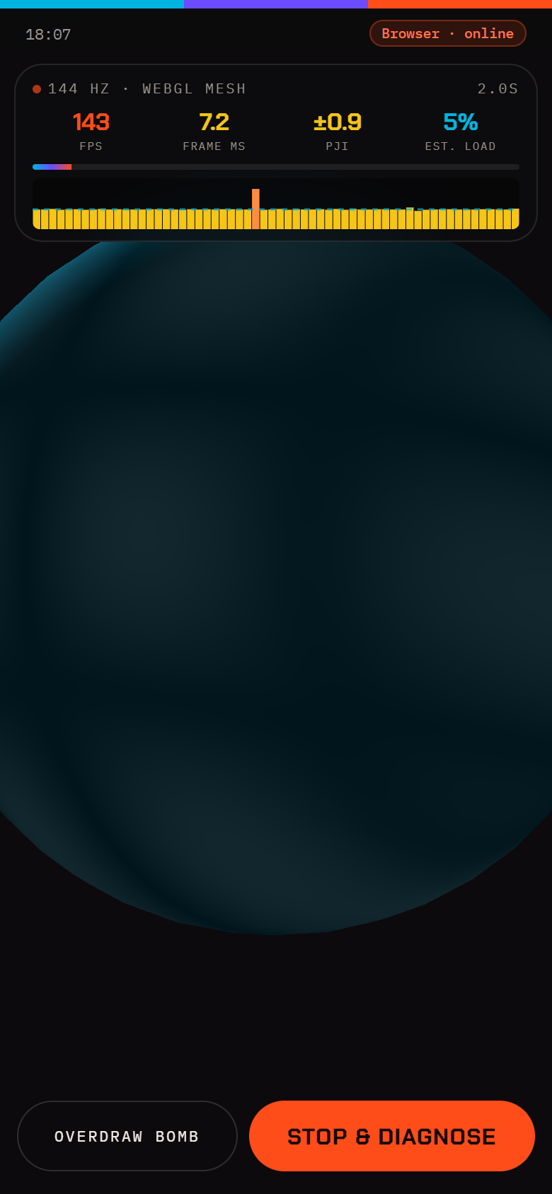 | Verified capture loop  WebGL mesh (fragment-bound icosphere) running against the 6.94 ms budget. HUD reports FPS, frame ms, PJI, and estimated load in real time. Stop & Diagnose writes the dossier used by Office Kit export.  Companion audit also covers Overdraw Bomb, DOM feed, and GPU triangles — confirming the full stress harness, not a single demo path.
Figure 6. Live 144 Hz WebGL mesh session on the DUT — the same loop exercised by the headless visual audit.

7. Official Hackathon Rubric Alignment
Judging Criteria | Weight | How FrameDoctor addresses this category
End Product Quality | 30% | Production-ready React 19 + Kotlin Android architecture. 100% crash-proof offline fallback. Verified with automated headless Chrome end-to-end visual audits.
Novelty + Impact | 20% | Solves the critical 6.94 ms micro-stutter problem for 144 Hz displays. The Device Under Test is the product itself — no external cables required.
Creative Phone Use | 15% | Native hardware sensor fusion: Choreographer hardware frame timing, PowerManager thermal daemon status, battery draw, and 300 Hz touch digitizer sampling.
Technical Depth | 15% | Mathematical modeling: Startup Warmup Discard filter, Peak Jitter Index (PJI), hitch cluster tracking, and automated Adreno 830 ALU shader patches.
vivo Office Kit Usage | 10% | Native public-directory storage triggers for cross-device file drag-and-drop, Super Clipboard ingestion, and verified drop badges.
Demo & Pitch | 10% | Rehearsed 90-second live demonstration script with split-screen phone/laptop coordination and pre-cooked judge defense answers.
Table 5. Mapping of FrameDoctor to the official iQOO Hackathon rubric.

8. Team Capability & 30-Hour Sprint Roadmap
Workstream | State at submission
Architecture & Mobile UI | Complete, responsive, pixel-aligned mobile test rig (Phone.jsx) and laptop companion (Desk.jsx).
Systems Engineering & Android Bridge | Native Kotlin bridge interfacing system services with zero root dependencies (NativeBridge.kt).
Offline-First Resilience | Zero cloud reliance in the core evaluation loop; operates in airplane mode and offline hackathon “Red Light” phases.
Table 6. Capability already shipped — the 30-hour window is for on-device polish, judge rehearsal, and Office Kit dry-runs on loaner hardware.

FRAMEDOCTOR
The phone is the lab. The cable is the bug.

© 2026 Team FrameDoctor · iQOO Hackathon 2026 (Chennai City Battle)

