Finlocale is in partnership with Achain by accepting ACT tokens in Finlocale ICO as investment.

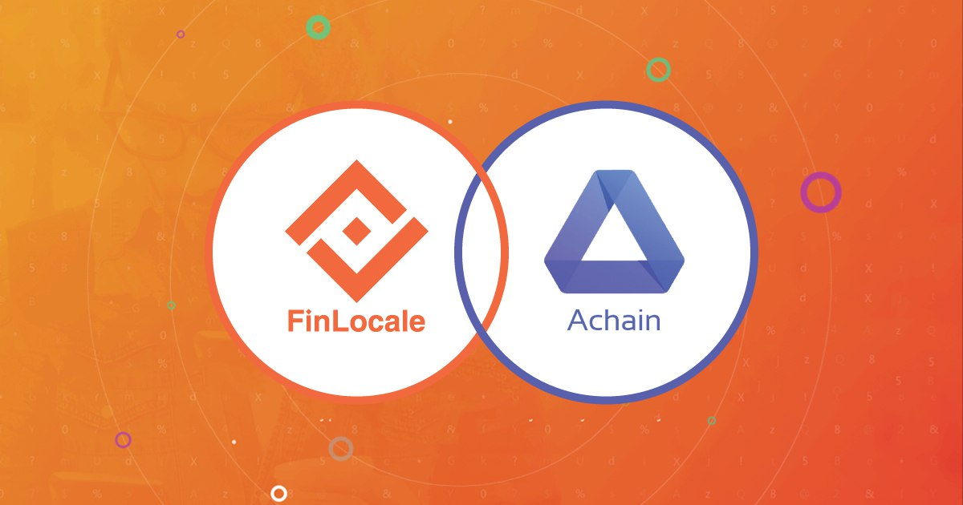

Achain - Building a Boundless Blockchain Reality. Achain is a public blockchain platform that enables developers of all levels to issue tokens and create smart contracts, decentralized applications and blockchain systems. Achain is committed to building a global blockchain network for information exchange and value transactions.

Finlocale (www.finlocale.com) is a peer to peer crypto marketplace. In which, buyers and sellers connect, exchange bitcoins through secure escrow and private online chat. Its unlimited payment type capabilities bring buyers and sellers from around the globe with any possible world payment type, enable them do crypto currency exchange. It is considered to be most profiting platform for merchants and vendors

FNL, Token Value & Appreciation
- ICO Site : www.finlocale.io
- Project in Alpha running phase
- Projected Revenue generation during ICO
- Projected Operationally profitable between Q1 or Q2 after ICO
- Every quarter, 20% of our profits to buy back FNL and destroy them, until we buy 50% of all the FNL (500MM) back
- When you use FNL to pay for fees, you will receive a significant promotional discount as below table
 | 1st year | 2nd year | 3rd year | 4th year
Discount Rate | 30% | 15% | 7.5% | no discount

ICO Milestones:
- Investments are accepted in BTC, ETH, ACT
- Presale Oct 2018 with 25% bonus, Public Sale Nov & Dec 2018 with upto 10% bonus
- Distribution planned immediately after ICO
- Listing planned for New Year Eve, 31st Dec 2018

