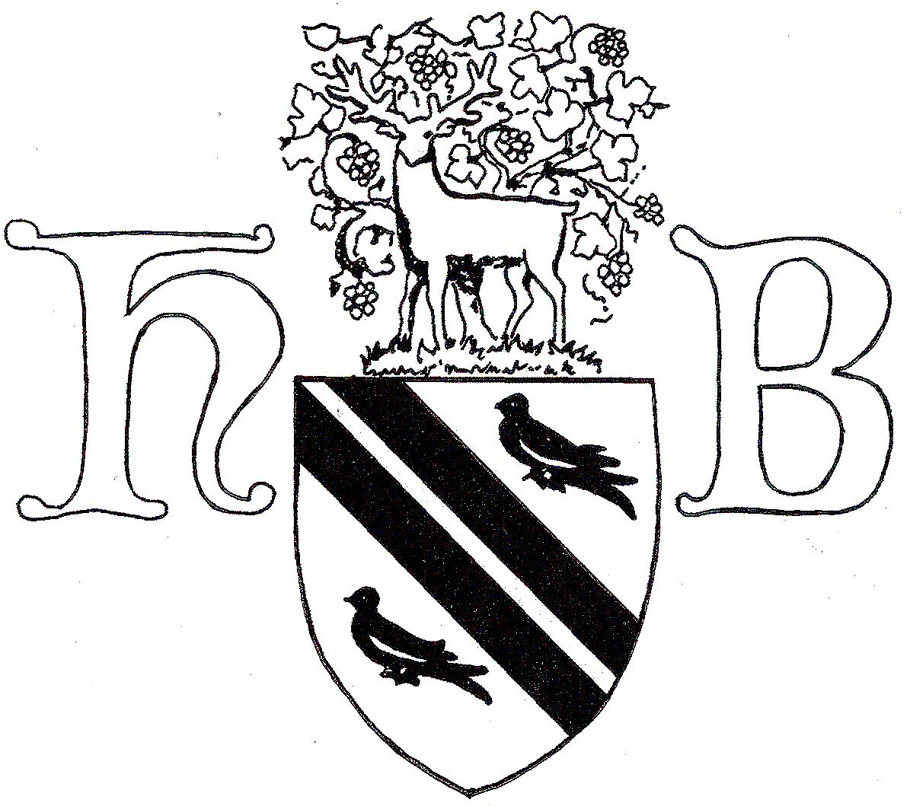

Henry Bradshaw Society

Annual Reports for 2009

ANNUAL MEETING
23 April 2010

Henry Bradshaw Society
Registered UK Charity no. 278781
www.henrybradshawsociety.org

President
Dom Cuthbert Johnson OSB

Vice-Presidents
Professor Helmut Gneuss
Miss Barbara Harvey
M. Michel Huglo
The Revd Professor R. W. Pfaff

Chairman of Council
Professor Michael Lapidge
Clare College, Cambridge CB2 1TL
email: ML26@cam.ac.uk

General Secretary
Dr Nicolas Bell
Music Collections, The British Library, 96 Euston Road, London NW1 2DB
email: Nicolas.Bell@bl.uk

Publications Secretary
Dr Rosalind Love
Department of Anglo-Saxon, Norse and Celtic, University of Cambridge
9 West Road, Cambridge CB3 9DP
email: RCL10@cam.ac.uk

Treasurer
Dr M. B. Moreton
Waterloo House, High Street, Rolvenden, Cranbrook, Kent TN17 4LN
email: hbs.treasurer@googlemail.com

Assistant Treasurer
Mr Peter Jackson
5A Green Place, Oxford OX1 4RF
email: Peter.Jackson14@btinternet.com

Publisher to the Society
UK: Boydell & Brewer Ltd, Whitwell House, St Audry’s Park Road,
Melton, Woodbridge, Suffolk IP12 1SY
North America: Boydell & Brewer Inc., 668 Mount Hope Avenue,
Rochester, NY 14620-2731, USA
www.boydell.co.uk

1 Notice of Annual Meeting

The one hundred and seventh Annual Meeting of the Society will be held on Friday 23 April 2010 at 2 p.m. in the Panizzi Room, The British Library, 96 Euston Road, London NW1 2DB.

The meeting will be preceded by a sandwich lunch at 1.15 p.m., to which all members attending the meeting are cordially invited. The Secretary will meet members at the Information Desk in the entrance hall of the Library at 1.15, and will return at 2 to collect those who do not require lunch.

2 Agenda for Annual Meeting

1. APOLOGIES

To receive apologies for absence.

2. COMMEMORATIONS

3. MINUTES

To receive the Minutes of the one hundred and sixth Annual Meeting.

4. STATEMENTS FROM THE CHAIR

5. REPORTS

To receive the Reports of the Secretary and Treasurer.

6. ELECTION OF THE PRESIDENT

To report that the Annual Meeting of 2009 elected Dom Cuthbert Johnson as President of the Society for 2009–10.

To consider the election of the President for 2010–11.

7. ELECTION OF THE ADMINISTRATIVE OFFICERS

To report that the Officers of the Council for 2009–10 elected by the 2009 Annual Meeting were as follows:

Chairman Professor M. Lapidge
General Secretary Mr P. Jackson (to serve until
31 July 2009); Dr N. J. Bell (to serve from 1 August 2010)
Publications Secretary Dr Rosalind Love
Treasurer Dr M. B. Moreton
Assistant Treasurer Mr P. Jackson

To consider the election of Officers for 2010–11.

3 Minutes of the 2009 Annual Meeting

The one hundred and sixth Annual Meeting of the Society was held on Friday 24 April 2009 in the Institute of Historical Research, Senate House, Malet Street, London.

Present: Dom Cuthbert Johnson (President, in the Chair), Dr N. J. Bell, Dr J. D. Billett, Mr M. J. Burr, Mr P. L. Clinton, Dr Catherine Cubitt, Professor D. Ganz, Mr P. Jackson, Professor M. Lapidge, Dr Rosalind Love, Dr M. B. Moreton, Professor N. Morgan, Mr N. Orchard, Dr D. Pelteret, The Revd Professor R. W. Pfaff (Honorary Vice-President), Professor Susan Rankin, Dom Alcuin Reid, Dr Elizabeth Robinson, Dr Rebecca Rushforth, Dr A. Thacker, The Revd Canon J. Toy.

Apologies for absence were received from Professor Virginia Brown, Dr Alicia Corrêa, The Revd Dr H. E. J. Cowdrey (Honorary Vice-President), Dr Cristina Dondi, Professor H. Gneuss (Honorary Vice-President), Professor Ritva Maria Jacobsson, Professor Rosamond McKitterick, Fr A. Ward, The Very Revd Dr M. G. Witczak.

1. MINUTES

The Minutes of the one hundred and fifth Annual Meeting were confirmed.

2. COMMEMORATION

Commemoration was made of The Revd Professor Henry Chadwick, President of the Society 1989–97 and Honorary Vice-President 1997–2008.

3. STATEMENTS FROM THE CHAIR

The President observed that several members of the Society, including the immediate past President (Miss Barbara Harvey), the Secretary and himself, had been present at Professor Chadwick’s memorial service in Christ Church Cathedral, Oxford. He expressed his pleasure at the large attendance at the Annual Meeting; hoped that it might herald a revival in liturgical study; and hoped that the Society might play its part in that revival, particularly through development of its website.

4. REPORTS

The Reports of the Secretary and the Treasurer were considered. The Treasurer observed that the 2008 Accounts were the first to be presented since Mr Patrick Clinton had succeeded Mr James Cleggett as Independent Accounts Examiner, and had been set out in a new format which, he hoped, might be more intelligible to non-accountants. The Meeting adopted both Reports; recorded a vote of thanks to the Secretary and the Treasurer; and expressed its appreciation of Mr Clinton’s services.

5. ELECTION OF THE PRESIDENT

Dom Cuthbert Johnson was elected President for the year 2009–10.

6. ELECTION OF OFFICERS

Mr Jackson informed the Meeting that he did not wish to seek re-election as Secretary, as he

