Contents

1. POLICE 3

1.1. The common polices 3

1.2. Size of police 3

1.3. Bold, Italic, Underlined 3

1.4. Colors 3

1.5. Text Highlight Color 3

1.6. Superscript 4

2. THE POSITION OF THE PARAGRAPHS 4

2.1. Alignments 4

2.1.1. Aligned on the left 4

2.1.2. Center 4

2.1.3. Signature on the right 4

2.2. Withdrawals 4

2.3. Line spaces 4

3. LISTS 5

3.1. Lists with bullets 5

3.2. Numbered lists 5

3.3. Personalization 5

3.4. Hierarchical lists 5

4. TEXT 6

4.1. Drop Cap 6

4.2. WordArt 6

5. Page layout 6

6. SHADING AND BORDER 6

7. TABLE 7

7.1. Word 7

7.2. Excel 8

8. ILLUSTRATIONS 8

8.1. Photograph without text 8

8.2. Photograph with text 9

8.3. Clipart 9

8.4. Forms 10

9. BONDS 10

9.1. Hyperlinks 10

9.2. References 11

10. REVISIONS 11

10.1. Comments 11

10.2. Modifications 11

# POLICE

## The common polices

This is a sentence in Arial.

This is a sentence in Arial Black.

This is a sentence in Courier New.

This is a sentence in Times New Roman.

This is another police.

## Size of police

This is text of size 12.

This is text of size 18.

## Bold, Italic, Underlined

**This is bold.**

*This is in italic.*

This is underlined.

~~This is strikethrough.~~

This is with an index.

This is with an exposing.

**Other types of Underline**

This is underlined in red continuous feature.

This is underlined in double blue feature.

This is underlined in black point-indent.

This is underlined in corrugated green.

## Colors

that it is Google.

## Text Highlight Color

This is highlighted in yellow.

## Superscript

A2 = A X A

a2 = a X a

S = π R 2

# THE POSITION OF THE PARAGRAPHS

## Alignments

### Aligned on the left

Microsoft Word is a word processor published by Microsoft.

The most recent version is Word 2013. []

### Center

***TITLE CENTER***

### Signature on the right

*Cordially,*

*QA*

## Withdrawals

James Bond, also known by his number 007, is a character of fiction created in 1952 by the writer and former British spy Ian Fleming in the novel Espions, made your plays (Casino Royale). Ian Fleming mainly took as a starting point a Serb double agent working for the Nazis and the British of the name of Dusko Popov which in the beginning was an agent of the Kingdom of Yugoslavia.

## Line spaces

Simple space: From 1953 with his death in 1964, Ian Fleming will publish twelve novels and nine news gathered in two collections (including one posthumous) with the character of James Bond.

Double space: After the death of Fleming, the adventures of Jump were successively written by Kingsley Amis (under the name of Robert Markham), John Gardner and Raymond Benson, Charlie Higson, Sebastian Faulks then Jeffery Deaver.

# LISTS

## Lists with bullets

* A manga;
* One band-drawn;
* A book;
* A play;
* A film;
* A series;
* A music;
* And many other things still.

## Numbered lists

1. A manga;
2. One band-drawn;
3. A book;
4. A play;
5. A film;
6. A series;
7. A music;
8. And many other things still.

## Personalization

* A manga;
* One band-drawn;
* A book;
* A play;
* A film;
* A series;
* A music;
* And many other things still.

## Hierarchical lists

1. Microsoft
2. Windows XP;
3. Windows Vista;
4. Windows Seven.
5. 32 bits;
6. 64 bits.
7. Apple
8. Mac OS X.
9. Linux

# TEXT

## Drop Cap

T

he town of Paris has a dense network of lines of bus (100 lines) and subway (16 lines), but also some other modes of transport which develop gradually, like the tram.

## WordArt

he subway, present since July 19th, 1900, date of opening of the first section of line 1, are regarded as one of the symbols of the city, in particular thanks to its architectural style in Art nouveau

**T**

# Page layout

Like all the large metropolises of planet, Paris undergoes dependant environmental consequences at the level of its population and of its economic activity. Paris is the densest capital of Europe as a population. The share of green spaces is reduced, and this in spite of the parks and gardens which were created during two last decades in order to mitigate this deficiency, from where a biodiversity relatively limited []. Atmospheric pollution and the noise constitute public health problems; they justified the creation of inspection networks (like Airparif).

# SHADING AND BORDER

**ORANGE SHADING AND BLACK BORDER**

# TABLE

## Word

|  |  |  |  |
| --- | --- | --- | --- |
| Use | Microsoft Office | Open Office | iWork (Mac) |
| To write a document | Word *Word* | Writer Writer | Pages Pages |
| Spreadsheet | Excel *Excel* | Cacl Calc | Numbers Numbers |
| Presentation | PowerPoint *PowerPoint* | Impress Impress | Keynote Keynote |
| Transport, Calendar | Outlook *Outlook* | ThunderBird ThunderBird* | iCal iCal* and Mail* |
| Databases | Access Access | Base Base |  |

| Identifier of the format | Associated contents |
| --- | --- |
| TEXT | Data with the alphanumeric format. Authorized characters [0-9] [A-Z] [éèàçùâêîôûäëïöü] [- '.!? ></= ″]  The maximum size is detailed for each field. |
| TEXTE_NUM | Data with the digital format not signed. The maximum size is detailed for each field. |
| STATUT_GCR | Possible data “01”, “02”, “03”, “04” or “05” |
| BOOL | Data with Boolean format O/N |
| HTML | Data with format HTML.  No definite maximum size. |

## Excel



# ILLUSTRATIONS

## Photograph without text

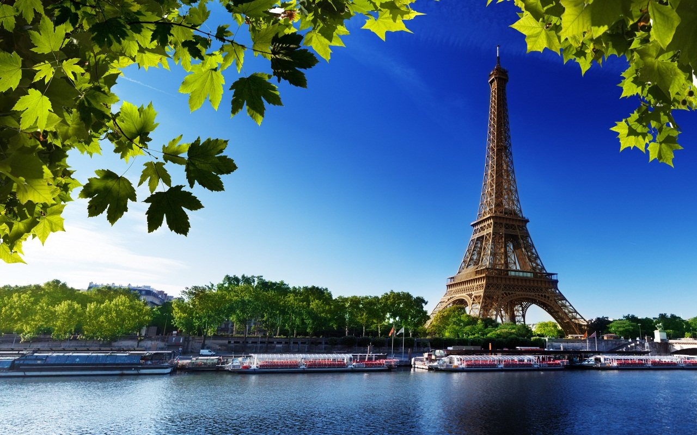

Appear Tour Eiffel

## Photograph with text



## Clipart

C:\Program Files (x86)\Microsoft Office\MEDIA\CAGCAT10\j0090386.wmf

## Forms

0 - > N

To knock on the door

N + 1 - > N

To wait 10 seconds

Answer = “ENTER”

To enter

To leave

N > 2

O

O

NR

NR

# BONDS

## Hyperlinks

Paris is the most populated commune and [the capital of France](http://fr.wikipedia.org/wiki/Capitale_de_la_France), the [chief town](http://fr.wikipedia.org/wiki/Chef-lieu) of the [Île-de-France](http://fr.wikipedia.org/wiki/%C3%8Ele-de-France) area and the single commune-department of the country. It is located at the center of the [Paris basin](http://fr.wikipedia.org/wiki/Bassin_parisien), on a loop of the [Seine](http://fr.wikipedia.org/wiki/Seine), between the confluences of this one with the Marne and Oise. Its inhabitants are called the Parisians. The city is divided into twenty district

## References

According to the census of INSEE[1], the commune of Paris counted at January 1st, 2010 more than 2,2 million inhabitants.

# REVISIONS

## Comments

Several reliefs made up of gypseous flat-topped outliers form small hills: on the Right Bank Montmartre (131 m), Belleville (128,5 m), Ménilmontant (108 m), Hillock-Chaumont (103 m), Passy (71 m) and Chaillot (67 m); on the left bank Montparnasse (66 m), the Ridge-with-Quails (65m) and the Mountain Holy-Genevieve (61 m).

## Modifications

The **SEINE** crosses the capital by forming an arc of a circle, entering there by south-east to leave there to south-west. More than thirty bridges allow to cross the river.

1. Institut national de la statistique et des études économiques