SQL Assignment
Student: Pandeli Balli
Course: Data Management
Date: November 09, 2025

1. ERD to model

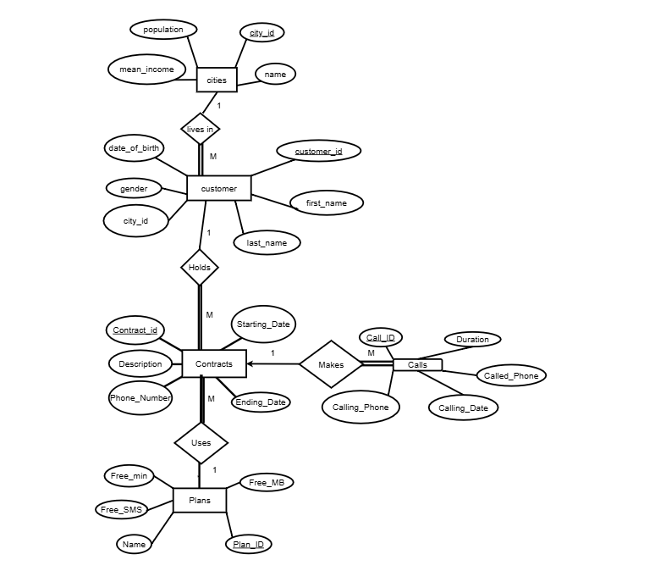2. Database Schema

CREATE OR REPLACE TABLE dbo.City (
city_id INT PRIMARY KEY,
name NVARCHAR(100) NOT NULL,
population INT NOT NULL,
mean_income DECIMAL(10,2)
);
GO

CREATE OR REPLACE TABLE dbo.Customer (
customer_id INT PRIMARY KEY,
first_name NVARCHAR(50) NOT NULL,
last_name NVARCHAR(50) NOT NULL,
date_of_birth DATE NOT NULL,
gender NVARCHAR(10) NOT NULL
CHECK (gender IN ('male','female')),
city_id INT NOT NULL,
CONSTRAINT fk_customer_city
FOREIGN KEY (city_id)
REFERENCES dbo.City(city_id)
);
GO

CREATE OR REPLACE TABLE dbo.[Plan] (
plan_id INT PRIMARY KEY,
name NVARCHAR(100) NOT NULL,
free_minutes INT NOT NULL,
free_sms INT NOT NULL,
free_mb INT NOT NULL
);
GO

CREATE OR REPLACE TABLE dbo.Contract (
contract_id INT PRIMARY KEY,
phone_number NVARCHAR(20) NOT NULL UNIQUE,
start_date DATE NOT NULL,
end_date DATE NULL,
description NVARCHAR(255),
customer_id INT NOT NULL,
plan_id INT NOT NULL,
CONSTRAINT fk_contract_customer
FOREIGN KEY (customer_id)
REFERENCES dbo.Customer(customer_id),
CONSTRAINT fk_contract_plan
FOREIGN KEY (plan_id)
REFERENCES dbo.[Plan](plan_id)
);
GO

CREATE OR REPLACE TABLE dbo.Calls (
call_id BIGINT PRIMARY KEY,
contract_id INT NOT NULL,
call_datetime DATETIME2 NOT NULL,
called_number NVARCHAR(20) NOT NULL,
duration_seconds INT NOT NULL,
CONSTRAINT fk_call_contract
FOREIGN KEY (contract_id)
REFERENCES dbo.Contract(contract_id)
);
GO

2.1) Data (INSERT)
-- City (20)
INSERT INTO dbo.City (city_id, name, population, mean_income)
VALUES
(1, N'Athens', 3000000, 22000.00),
(2, N'Thessaloniki', 800000, 20500.00),
…
(20, N'Corfu', 100000, 19500.00);

-- Customer (20)
INSERT INTO dbo.Customer (customer_id, first_name, last_name, date_of_birth, gender, city_id)
VALUES
(101, N'Maria', N'Papadopoulou', '1990-05-12', 'female', 1),
(102, N'Giorgos', N'Nikolaou', '1985-11-03', 'male', 2),
…
(120, N'Leonidas', N'Kritikos', '1986-04-14', 'male', 20);

-- Plan (20)
INSERT INTO dbo.[Plan] (plan_id, name, free_minutes, free_sms, free_mb)
VALUES
(10, N'Freedom Max', 500, 200, 5000),
(11, N'Red1', 200, 100, 2000),
(12, N'Blue Basic', 100, 100, 1000),
(13, N'Unlimited Talk', 2000, 100, 800),
…
(29, N'Premium Gold', 1200, 600, 20000);

-- Contract (20)
INSERT INTO dbo.Contract (contract_id, phone_number, start_date, end_date, description, customer_id, plan_id)
VALUES
(1001, N'6901111111', '2021-12-01', '2025-12-31', N'Main line Maria', 101, 10),
(1002, N'6902222222', '2022-01-15', '2025-11-15', N'Work phone Giorgos', 102, 11),
(1003, N'6903333333', '2022-06-01', '2024-06-01', N'Old phone Eleni', 103, 10),
…
(1020, N'6910000010', '2022-01-01', '2025-01-01', N'Leonidas premium gold', 120, 29);

INSERT INTO dbo.Calls (call_id, phone_number, call_datetime, called_number, duration_seconds)
VALUES
(900000001, N'6901111111', '2022-06-15 08:15:00', N'2105551234', 25),
(900000002, N'6901111111', '2022-06-15 09:45:00', N'2105558888', 120),
(900000003, N'6902222222', '2022-06-15 11:00:00', N'2104449999', 300),
(900000004, N'6902222222', '2022-01-20 19:30:00', N'6901234567', 40),
…
(900000040, N'6910000010', '2022-01-03 14:14:00', N'2106060606', 600);

3. Queries (a–j) with Explanations

(a) call_id of calls 08:00–09:59 in June 2022 with duration < 30s
Original version (function-based filtering):

SELECT call_id
FROM dbo.CallRecord
WHERE DATEPART(YEAR,call_datetime)=2022
AND DATEPART(MONTH,call_datetime )=6
AND DATEPART(HOUR,call_datetime)>=8
AND DATEPART(HOUR,call_datetime)<10

AND duration_seconds<30;

(b) Customer names in cities with population > 20000

SELECT cu.first_name, cu.last_name
FROM dbo.Customer AS cu
JOIN dbo.City AS ci
ON cu.city_id = ci.city_id
WHERE ci.population>20000;

(c) customer_id that have contracts in plans with name LIKE '%Freedom%'

SELECT DISTINCT customer_id
FROM dbo.Contract
WHERE plan_id IN (
SELECT plan_id
FROM dbo.[Plan]
WHERE name LIKE N'Freedom%'
);

(d) Contracts ending within next 60 days (id, phone, customer id/name)
SELECT
co.contract_id,
co.phone_number,
cu.customer_id,
cu.first_name,
cu.last_name
FROM dbo.Contract AS co
JOIN dbo.Customer AS cu
ON co.customer_id = cu.customer_id
WHERE co.end_date IS NOT NULL
AND co.end_date > CAST(GETDATE() AS date)
AND co.end_date <= DATEADD(DAY, 60, CAST(GETDATE() AS date));

(e) For each contract and each month in 2022: average call duration
SELECT
cr.contract_id,
DATEPART(YEAR, cr.call_datetime) AS [year],
DATEPART(MONTH, cr.call_datetime) AS [month],
AVG(cr.duration_seconds) AS avg_duration_seconds
FROM dbo.CallRecord AS cr
WHERE DATEPART(YEAR, cr.call_datetime) = 2022
GROUP BY
cr.contract_id,
DATEPART(YEAR, cr.call_datetime),
DATEPART(MONTH, cr.call_datetime)
ORDER BY cr.contract_id, [month];

(f) Total call duration in 2022 by plan_id
SELECT l.plan_id ,SUM(k.duration_seconds) as total_duration
FROM Calls AS K
INNER JOIN Contract AS b
on K.contract_id=b.contract_id
INNER JOIN [TelcoX].[dbo].[Plan] as l
on b.plan_id = l.plan_id
WHERE DATEPART(YEAR,K.call_datetime) = 2022
GROUP BY l.plan_id

(g) Most frequently called number (2022) – by call count
SELECT TOP 1 WITH TIES
cr.called_number,
COUNT(*) AS times_called
FROM dbo.CallRecord AS cr
WHERE DATEPART(YEAR, cr.call_datetime) = 2022
GROUP BY cr.called_number
ORDER BY COUNT(*) DESC;

(h) Months where per-contract total seconds exceed plan’s free_minutes (x60)
SELECT b.contract_id , DATEPART(MONTH, K.call_datetime) AS Month,sum(K.duration_seconds) AS Duration,sum(distinct(l.free_minutes))*60 AS free_minutes
FROM Calls AS K
INNER JOIN Contract AS b
on K.contract_id=b.contract_id
INNER JOIN [TelcoX].[dbo].[Plan] as l
on b.plan_id = l.plan_id
GROUP BY b.contract_id, DATEPART(MONTH, K.call_datetime)
HAVING sum(distinct(l.free_minutes))*60<sum(K.duration_seconds)

ORDER BY b.contract_id,DATEPART(MONTH, K.call_datetime)

(i) % change of monthly total duration: 2022 vs same month 2021
WITH m2021 AS (
SELECT DATEPART(MONTH, call_datetime) AS [month],
SUM(duration_seconds) AS total_2021
FROM dbo.Calls
WHERE DATEPART(YEAR, call_datetime) = 2021
GROUP BY DATEPART(MONTH, call_datetime)
),
m2022 AS (
SELECT DATEPART(MONTH, call_datetime) AS [month],
SUM(duration_seconds) AS total_2022
FROM dbo.Calls
WHERE DATEPART(YEAR, call_datetime) = 2022
GROUP BY DATEPART(MONTH, call_datetime)
)
SELECT
COALESCE(m2.[month], m1.[month]) AS [month],
m2.total_2022,
m1.total_2021,
CASE WHEN m1.total_2021 IS NULL OR m1.total_2021 = 0
THEN NULL
ELSE (m2.total_2022 - m1.total_2021) * 100.0 / m1.total_2021
END AS pct_change_vs_2021
FROM m2022 AS m2
FULL JOIN m2021 AS m1
ON m2.[month] = m1.[month]
ORDER BY [month];

(j) For each city (2022): avg call duration for female and male

SELECT
ci.city_id,
AVG(CASE WHEN cu.gender = N'female' THEN c.duration_seconds END) AS avg_female_sec,
AVG(CASE WHEN cu.gender = N'male' THEN c.duration_seconds END) AS avg_male_sec
FROM dbo.Calls AS c
JOIN dbo.Contract AS co ON co.contract_id = c.contract_id
JOIN dbo.Customer AS cu ON cu.customer_id = co.customer_id
JOIN dbo.City AS ci ON ci.city_id = cu.city_id
WHERE c.call_datetime >= '2022-01-01'
AND c.call_datetime < '2023-01-01'
GROUP BY ci.city_id
ORDER BY ci.city_id;

(K) For each city id, show the city id, the ratio of the total duration of the calls made from customers staying in that city in 2022 over the total duration of all calls made in 2022, and the ratio of the city’s population over the total population of all cities (i.e three columns)

WITH per_city AS (
SELECT
ci.city_id,
SUM(CASE WHEN c.call_datetime >= '2022-01-01' AND c.call_datetime < '2023-01-01'
THEN c.duration_seconds ELSE 0 END) AS total_sec_2022,
ci.population
FROM dbo.City AS ci
LEFT JOIN dbo.Customer AS cu ON cu.city_id = ci.city_id
LEFT JOIN dbo.Contract AS co ON co.customer_id = cu.customer_id
LEFT JOIN dbo.Calls AS c ON c.contract_id = co.contract_id
GROUP BY ci.city_id, ci.population
)
SELECT
city_id,
CASE
WHEN SUM(total_sec_2022) OVER () = 0 THEN NULL
ELSE total_sec_2022 * 1.0 / SUM(total_sec_2022) OVER ()
END AS ratio_city_calls_2022_vs_all,
population * 1.0 / SUM(population) OVER () AS ratio_population_vs_all
FROM per_city
ORDER BY city_id;

4. Final Question in Python
import pyodbc
import pandas as pd

conn = pyodbc.connect(
"Driver={SQL Server};"
"Server=localhost;"
"Database=TelcoX;"
"Trusted_Connection=Yes;"
)

df_contract_city = pd.read_sql_query("""
SELECT co.contract_id, cu.city_id
FROM dbo.Contract AS co
JOIN dbo.Customer AS cu ON cu.customer_id = co.customer_id;
""", conn)

df_cities = pd.read_sql_query("SELECT city_id, population FROM dbo.City;", conn)

df_calls = pd.read_sql_query("""
SELECT contract_id, duration_seconds
FROM dbo.Calls
WHERE call_datetime >= '2022-01-01' AND call_datetime < '2023-01-01';
""", conn)

conn.close()

# Join calls -> city
df = df_calls.merge(df_contract_city, on="contract_id", how="inner")

# Aggregate per city (Pandas groupby, not SQL GROUP BY)
per_city = df.groupby("city_id", as_index=False)["duration_seconds"].sum() \
.rename(columns={"duration_seconds": "total_sec_2022"})

# Ensure every city appears (even those with 0 calls)
per_city = df_cities[["city_id"]].merge(per_city, on="city_id", how="left").fillna({"total_sec_2022": 0})

total_all_calls = per_city["total_sec_2022"].sum()
total_population = df_cities["population"].sum()

per_city["ratio_city_calls_2022_vs_all"] = per_city["total_sec_2022"].astype(float) / (total_all_calls if total_all_calls else float("nan"))
per_city["ratio_population_vs_all"] = df_cities.set_index("city_id").loc[per_city["city_id"], "population"].astype(float) / (total_population if total_population else float("nan"))

per_city = per_city[["city_id", "ratio_city_calls_2022_vs_all", "ratio_population_vs_all"]].sort_values("city_id")
print(per_city.to_string(index=False))

