Two Months Industrial Training Project Report

On

**e-Presense**

Submitted in the Partial fulfillment of the requirement for the Award of

Degree of

**B.Tech**

In

**COMPUTER SCIENCE AND ENGINEERING**

Batch (2015-2019)



**Submitted to: Submitted by:**

Department of Computer Application Ashish (15110606)

Judge Grover(99150280329)

# **CERTIFICATE**

I hereby certify that I Judge Grover,Ashish have completed the Two Months Training in partial fulfillment of the requirements for the award of **B .Tech in Computer Science Engineering.** We did our training Sebiz Finishing School(Sebiz Infotech) from 01-06-18 to 31-07-18.

The matter presented in this Report has not been submitted by us for the award of any other degree elsewhere.

**ACKNOWLEDGMENT**

Many of the ideas that lead us to design and to develop “EPRESENSE” from a distillation

Of the experience and opinions of many people. It would be prudent to commence this report

With a sincere tribute to all those who have played an indispensable role in the accomplishment

Of this work by providing whenever their able guidance was required.

We would sincerely like to thanks our project guide **Ms. Jyotsana Joshi** for her valuable guidance, constant supervision during the project period.

We are greatly indebted toDr.Daljit Kaur(Head of Department computer science and engineering,S.B.S.S.T.C.,Ferozepur) for their invaluable suggestions and guidance. We are highly grateful to all teachers for providing the required help whenever required.

Finally, I would like to thanks to all my family members for their cooperation and good wishes in completing my work.

I feel short to words to express my deep sense of gratitude towards the Almighty God with whose grace present study has been completed.

**Project Members**

Ashish

Judge Grover

**ABSTRACT**

Attendance Management System (epresence) is an Android based application that is designed to modernize our age-old attendance system, which primarily uses a pen and a register. Our application provides every teacher with a digital or electronic register which can be their very own android based smart phone. The application provides with simple and easy to use UI for the teachers so that they can easily and conveniently access the application.The mobile attendance system has been built to eliminate the time and effort wasted in taking attendances in schools and colleges. It also greatly reduces the amount of paper resources needed in attendance data management. This is an android mobile app. It’s built to be used for school/college faculty so that they may take student attendance on their phones.

**INDEX**

|  |  |  |
| --- | --- | --- |
| S.NO | Contents | Page Number |
| **Chapter1**  1.1  1.2  1.3  1.4  1.5 | **Introduction to Project**  Introduction  Features  Advantages  Disadvantages  Project overview | **5-6** |
| **Chapter2** | **About the Oragnization** | **7-10** |
| **Chapter3**  **Chapter4**  4.1  4.2  **Chapter5**  5.1  5.2  5.3  5.4  **Chapter6**  6.1  6.1.1.  6.1.2.  6.1.3.  **Chapter7**  **Chapter8**  8.1  8.2  8.3  8.3.1  8.3.4  **Chapter9**  9.1  **Chapter10**  10.1  10.2  10.3  10.3  10.3.2  10.4  **Chapter11**  **Chapter12**  **Chapter13** | **Introduction to language**  **Requirement specification**  Software requirements specifications  Hardware requirements specifications  **System analysis**  Definition and reason for system analysis  Purpose of the system  Exisiting system  Proposed system  **Analysis model**  Feasibility study  Technical feasibility  Operational feasibility  Economic feasibility  **Data flow diagrams**  **System design**  Input design  Output design  System specifications  System specifications are  Part description  **System implementation**  Project description problem definition  **System testing**  Code testing  Specification testing  Levels of testing  Unit testing system testing  Sample test  Real test  **System maintance**  **Conclusion and future enhancement**  **Screenshorts** | **11-18**  **19**  **20-21**  **22-25**  **26-30**  **31-33**  **34**  **35-37**  **38**  **39**  **40-45** |
|  | **Suggestion & Recommendation** | **46** |
|  | **Appendix** | **47** |
|  | **Bibliography** | **48** |

**UNIT-1**

**INTRODUCTION**

**1.1PURPOSE**

The mobile attendance system has been built to eliminate the time and effort wasted in taking attendances in schools and colleges. It also greatly reduces the amount of paper resources needed in attendance data management.This is an android mobile app. It’s built to be used for school/college faculty so that they may take student attendance on their phones.

The system is divided into following modules:

* **Student Attendance List Creation:** Once this App is installed on a phone, a it allows user to create a student attendance sheet consisting of name, roll number, date, Absent/Present mark and subject. He has to fill student names along with associated roll numbers.
* **Attendance Marking:** The faculty has the list on his phone now. He may see the list call roll numbers and select absent id the student is absent or select present if student is present.
* **Attendance Storage:** This data is now stored in the faculty mobile phone. Faculty may also view it anytime on their phone.
* **Attendance sheet transfer:** The faculty can transfer the file to a server (normal computer) via a bluetooth connection where this data can be stored and maintained by the school or college.

Thus, this system automates attendance system and eliminates the use of paperwork needed for attendance marking and monitoring student attendance.

# **1.2 Features**

* Beautiful Login Screen.
* Teachers will be able to take attendance and save in database on server.
* Fetch attendance data according to calendar date selection.

##### **1.3 Advantages**

* The system eliminates the use of paperwork needed for attendance marking and monitoring.
* The file can be transferred from mobile to computer or server via Bluetooth.
* This gives the overall performance of class in attendance.
* There is no need for laptop or computer in every class to run the system as the system is run on mobile so no need of extra efforts and resources.
* The app is easy to install and use.

##### **1.4 Disadvantages**

* The system can be run on android platform only. Though most of the mobiles now are android version and available in reasonable rate so it won’t be a big issue.

**1.5 PROJECT OVERVIEW**

Attendance Management System basically has two main modules for proper functioning Admin module is has rights for creating any new entry of faculty and student details. User has a rights of making daily attendance, generating report. Attendance report can be taken by given details of student details, date, class.

**UNIT-2**

**About the Organization**

**Sebiz Infotech** is located in Sec 67, IT park Mohali, Punjab, India. Sebiz an IT company with a fast growing global presence. Sebiz has development facilities both in the U.S. and India.

Bounded in 1999 and headquartered in **Rochester, NY, Sebiz** has a well-deserved and exciting multimedia content and creating innovative internet business applications, offering high quality, low cost solutions.

At SFS, we tend to believe that coaching need not be a one-size-fits-all resolution. We tend to work with you to perceive your company’s distinctive business processes and build tailor-made coaching solutions that address your specific needs. Our knowledgeable team understands your coaching desires and helps you deliver custom company coaching programs that drive your employees to succeed in their highest potential. Our trainers use real-world examples and case studies that serve to elucidate the sensible applications of the coaching imparted.

**Sebiz Finishing School -education and beyond:**

The Sebiz Finishing School came into existence with the purpose of brushing up skills of fresh IT graduates to make them industry-ready. Today SFS is fast becoming an education hub in the Trinity area. It has been in existence for over 10 years and has shaped a lot of great careers. SFS has helped train over 2000 IT graduates and place over 1500 graduates in jobs. It offers a range of products and services ranging from Industrial Training , Online Courses, Weekend Workshops for working  
professionals to Corporate Training.

**Highlights of SFS:**

**Industrial Training:**

Industrial Training are high quality courses of 6 weeks’ duration within the **Sebiz** Campus with courses covering .NET, PHP, JAVA, ANDROID, PYTHON, ANGULAR. Courses in allied subjects like HR, Finance and Sales & Marketing are also offered. Similar courses are offered through the Center of Excellence programs pioneered by SFS and conducted on college campuses in the region.

**Emphasis on soft skills and communication:**

Session on business etiquette, workshops on acing interviews, group discussions and preparing resumes are frequently held by professional trainers. This translates into confidence for the real world

**Under the SFS industrial training umbrella we run two types of training programs:**

**6 weeks industrial training:**

Don’t have lot of time on your hands but want to get familiar with a technology fast? Our 6 weeks industrial training is the way to go. These courses cover many of the key concepts in our 6 weeks industrial training. They are perfect as fast track courses and are meant to be summer training courses for IT students.

**Centers of Excellence Programs**

The Centers of Excellence Programs is a path – breaking initiative where SFS partners with local colleges to provide training on the college campus itself. This ensures wider participation and a lower cost of training. If our college does not offer this program perhaps you could request our college principal collaborate with us in this initiative or let us know of your interest and we will try to follow it up with the concerned authorities.

**SEBIZ - Development & Implementation:**

SEBIZ Experience in Development and Implementation includes:

* Order processing and management systems
* Portal Development
* Data warehouse, reporting, Financial application
* E-learning application
* Interactive websites
* E-commerce application
* Desktop application
* Data integration application
* Sales proposal generation application
* CRM implementation
* SAP implementation
* ERP implementation

**SEBIZ – Clients Details**

* VOLVO Cars of North America
* American HONDA
* INTEL
* FORD
* Global Crossing
* KODAK

**Some Government schemes we have been involved with:**

We have been an NSDC partner for UDAAN and have also been involved in other schemes like Swarna Jayanti Shahari Rozgar Yojana (SJSRY), Haryana and National Urban Livelihood Mission (NULM), Chandigarh, Odisha, Sikkim and Uttar Pradesh, Uttar Pradesh Skill Development Mission, UP and Pradhan Mantri Kaushal Vikas Yojana(PMKVY).

#### Sebiz, helping businesses shine in the online arena:

#### Sebiz can help you achieve your IT and training goals. We are the IT partner you can depend on to increase business efficiencies and help your business be more visible online.  To date we have more than 3000 projects under our belt and many more underway. We provide [Software Development](http://www.sebiz.net/index.php/services/servise/) services including Web & Mobile application development and [Search Engine Marketing](http://www.sebiz.net/index.php/services/search-engine-marketing/) services to businesses big and small. Under the aegis of the [Sebiz Finishing School](http://www.sebiz.net/index.php/sebiz-finishing-school/sebiz-finishing-school/) we have also flagged off a number of important training and educational initiatives.

**CERTIFICATION**

* **Microsoft Gold Certified Partner**
* **ISO 9001:2008 Certified**
* **CMMi Level 3 Certified**
* **Google ADWORDS Qualified Company**

**UNIT-3**

**Introduction to language**

**FRONT END:**

**Java:**

A part from being a system independent language, there are other reasons too for the immense popularity of this language. Let us have a look at some of its features.

FEATURES OF JAVA

• SECURITY

Every time you that you download a “normal” program; you are risking a viral infection. Prior to Java, most users did not download executable programs frequently, and those who did scan them for viruses prior to execution. Most users still worried about the possibility of infecting their systems with a virus. In addition, another type of malicious program exists that must be guarded against. This type of program can gather private information, such as credit card numbers, bank account balances, and passwords. Java answers both these concerns by providing a “firewall” between a network application and your computer.

When you use a Java-compatible Web browser, you can safely download Java applets without fear of virus infection or malicious intent.

• PORTABILITY

For programs to be dynamically downloaded to all the various types of platforms connected to the Internet, some means of generating portable executable code is needed .As you will see, the same mechanism that helps ensure security also helps create portability. Indeed, Java’s solution to these two problems is both elegant and efficient.

• OBJECT ORIENTED

Java was not designed to be source-code compatible with any other language. This allowed the Java team the freedom to design with a blank slate. One outcome of this was a clean usable, pragmatic approach to objects. The object model in Java is simple and easy to extend, while simple types, such as integers, are kept as high-performance non-objects.

• ROBUST

The multi-platform environment of the Web places extraordinary demands on a program, because the program must execute reliably in a variety of systems. The ability to create robust programs was given a high priority in the design of Java. Java is strictly typed language; it checks your code at compile time and run time.

Java virtually eliminates the problems of memory management and reallocation, which is completely automatic. In a well-written Java program, all run time errors can –and should –be managed by your program.

JAVA VIRTUAL MACHINE:

As we know that all programming language compilers convert the source code to machine code. Same job done by Java Compiler to run a Java program, but the difference is that Java compiler convert the source code into Intermediate code is called as byte code.

**Android:**

Android is a mobile operating system developedby Google, based on a modified version of the Linux Kernel and other open source software and designed primarily for touchscreen mobile devices such as smartphones and tablets. In addition, Google has further developed Android Tv for, televisions, Android Auto for cars, and Wear OS for wrist watches, each with a specialized user interface. Variants of Android are also used on game consoles, digital cameras, PCs and other electronics.

**Android SDK:**

The Android SDK provides you the API libraries and developer tools necessary to build, test, and debug apps for Android. It helps to quickly start developing applications in Android.

**Android Architecture:**

Android architecture or Android software stack is categorized into five parts:

1. Linux kernel

2. Native libraries (middleware),

3. Android Runtime

4. Application Framework

5. Applications

**FEATURES OF ANDROID**

**1) Near Field Communication (NFC)**

Most Android devices support NFC, which allows electronic devices to easily interact across short distances. The main aim here is to create a payment option that is simpler than carrying credit cards or cash, and while the market hasn’t exploded as many experts had predicted, there may be an alternative in the works, in the form of Bluetooth Low Energy (BLE).

**2) Alternate Keyboards**

Android supports multiple keyboards and makes them easy to install; the SwiftKey, Skype, and 8pen apps all offer ways to quickly change up your keyboard style. Other mobile operating systems either don’t permit extra keyboards at all, or the process to install and use them are tedious and time-consuming.

**3) Infrared Transmission**

The Android operating system supports a built-in infrared transmitter, allowing you to use your phone or tablet as a remote control.

**4) No-Touch Control**

Using Android apps such as Wave Control, users can control their phones touch-free, using only gestures. Have messy hands but need to turn off your screen or change a song? Simple. This could prove especially useful if you’re driving, so you can keep both eyes on the road.

**5) Automation**

The Tasker app lets you not only control app permissions but also automate them. Do you only want your location services to be active during the day? Want to create a customized way to start your music—for example, with a voice command and at a certain volume? Tasker can help.

**6) Wireless App Downloads**

Accessing app stores on any mobile device can be frustrating, but iOS makes it a little more difficult—download an app on your computer, and it won’t sync to your mobile device until you plug in and access iTunes. Using the Android Market or third-party options like AppBrain, meanwhile, let you download apps on your PC and then automatically sync them your Droid, no plugging required.

**7) Storage and Battery Swap**

Android phones also have unique hardware capabilities. Google’s OS makes it possible to remove and upgrade your battery or to replace one that no longer holds a charge. In addition, Android phones come with SD card slots for expandable storage.

**8) Custom Home Screens**

While it’s possible to hack certain phones to customize the home screen, Android comes with this capability from the get-go. Download a third-party launcher like Nova, Apex or Slide and you can add gestures, new shortcuts, or even performance enhancements for older-model devices.

**BACK END:**

**SqlLite:**

SQLite is lightweight database which is already embedded with Android framework. It is an open source database and takes only about 250 KB of memory at the run time. SQLite database supports a limited number of datatypes. These datatypes are :

• Text

• Integer

• Real

So, all other datatypes must be converted into the above datatypes before inserting them into the database. SQLite supports the standard relational database features such as sql syntax, transactions and prepared syntax.

**MODULES**

storeIntoDb ()

This function connects to database module and uses its API’s via createNote () to store data.

validate ():

This function validates the user input checks for null values.

init()

This function initializes views of user interface view means buttons, textbox etc.

onClickListener ()

This interface listens for the button click event and performs the action specified.

btnSubmit

This button when clicked calls the function storeIntoDb () through the interface onClickListener () which store data present in the views.

btnCancel

This button when clicked cancels the activity and closes the application.

on Receive ()

public abstract void on Receive (Context context, Intent intent)

When Intent broadcast is being received by a BroadcastReciever, this process will be called. During this moment the present result values on BroadcastReciever can be viewed/modified using other methods. Long-run operations shouldnever be performed because functions are called in the main thread of the process (system allows 10 seconds timeout before considering blocking of the receiver and killing the candidate).

If <receiver> tag is used to launch BroadcastReciever, object dies immediately after returning from the function. So no operations should be performed which returns the result asynchronously. So in order to interact with services, instead of using bindService(Intent, ServiceConnection, int) we can use startService(Intent) to interact with already running service. We also use peek Service (Content, Intent) (Developers, Android)

startActivity ()

public abstract void startActivity (Intent intent)

It launches an activity. No information will be received of the activity when it exists.

Note, if it’s been called outside Activity Context, then FLAG_ACTIVITY_NEW_TASK launch flag should be included with the intent. (Android developers)

If no activity exists for given Intent then its throws ActivityNotFound Exception.

**Manifest File**

This file contains all the components of the application their attributes etc. All Android application will have AndroidManifest.xml file in its root directory. All the information about the application should be presented to android which is done by this manifest file, so that the application can run successfully on android. What the manifest file does is explained below

• It creates java package name for application which acts as a unique identifier.

• It describes the components such as services, receivers, activities, broadcast and content providers which are collected in application and also the names of classes which employ all components and publish their capability such as which Intent can they handle.

• It also determines which process host application components.

• It declares permissions in order to access protected space of API and also with which applications it can interact.

• The minimum level of API that the android applications require.

• Lists linked libraries of that particular application.

<application>tag

This is a container tag which defines the application components viz services, activities, receivers, content providers and permissions.

<service> tag

Service is declared as application components. Services doesn’t have visual user interface like activities. These services run in background or as a rich API which can be called by other applications. In manifest file all the services should be represented the one which are not tagged will not run at all.

<activity> tag

Activity is a part of the visual user interface which implements parts of the application. Same as service it should be represented in

manifest file or else will not be run.

<receiver>tag

It declares broadcast receiver as application components. These receivers allow applications to accept intents which are broadcasted by system or any other applications, even if other components are not running,

This can be done in 2 ways either by declaring it in manifest file or by dynamically creating receiver in code and registering with Context.registerReceiver() method.

<uses-permission>tag

This tag is used to get permission in order to correct operation of any application.

These permissions are granted while installing a application not when it’s running already.

**UNIT - 4**

**REQUIREMENT SPECIFICIATIONS**

Following are the minimum hardware and software requirements for building this application.

**4.1 SOFTWARE REQUIREMENT SPECIFICIATIONS**

Operation System : Android

Language : ANDROID SDK 2.3 above

**4.2 HARDWARE REQUIREMENTS SPECIFICATIONS**

CPU type : Intel Pentium 4

Clock Speed : 3.0 GHz

RAM Size : 2 GB Minimum

Hard disk capacity : 40GB

Keyboard type : Internet keyboard

Mobile : ANDROID MOBILE

**UNIT - 5**

**SYSTEM ANALYSIS**

**5.1 Definition and reason for System Analysis**

System analysis will be performed to determine if it is feasible to design an information based on policies and plans of the organization and on user requirements and to eliminate the weaknesses of the present system.

General requirements

1. The new system should be cost effective.

1. To augment management, improve productivity and services.

2. To enhance User/System interface.

3. To improve information qualify and usability.

4. To upgrade system’s reliability, availability, flexibility and growth potential.

Development process of the system starts with System analysis. System analysis involves creating a formal model of the problem to be solved by understanding requirements.

**5.2 PURPOSE OF THE SYSTEM**

Analysis can be defined as breaking up of any whole so as to find out their nature, function etc. It defines design as to make preliminary sketches of; to sketch a pattern or outline for plan. To plan and carry out especially by artistic arrangement or in a skillful wall. System analysis and design can be characterized as a set of techniques and processes, a community of interests, a culture and an intellectual orientation. The various tasks in the system analysis include the following. Understanding application. Planning. Scheduling. Developing candidate solution. Performing trade studies. Performing cost benefit analysis. Recommending alternative solutions. Selling of the system. Supervising, installing and maintaining the system. This system manages to the analysis of the report creation and develops manual entry of the student attendance. First design the students entry form , staff allocation and time table allocation forms. This project will helps the attendance system for the department calculate percentage and reports for eligibility criteria of examination .The application attendance entry system will provide flexible report for all students.

**5.3. EXISTING SYSTEM**

Existing system is a manual entry for the students. Here the attendance will be carried out in the hand written registers. It will be a tedious job to maintain the record for the user. The human effort is more here. The retrieval of the information is not as easy as the records are maintained in the hand written registers. This application requires correct feed on input into the respective field. Suppose the wrong inputs are entered, the application resist to work. so the user find it difficult to use.

**5.4 PROPOSED SYSTEM**

To overcome the drawbacks of the existing system, the proposed system has been evolved. This project aims to reduce the paper work and saving time to generate accurate results from the student’s attendance. The system provides with the best user interface. The efficient reports can be generated by using this proposed system. Advantages of Proposed System It is trouble-free to use. It is a relatively fast approach to enter attendance Is highly reliable, approximate result from user Best user Interface Efficient reports

**UNIT-6**

**ANALYSIS MODEL**

The model that is basically being followed is the WATER FALL MODEL, which states that the phases are organized in a linear order. First of all the feasibility study is done. Once that part is over the requirement analysis and project planning begins. The design starts after the requirement analysis is complete and the coding begins after the design is complete. Once the programming is completed, the testing is done. In this model the sequence of activities performed in a software development project are: -

• Requirement Analysis

• Project Planning

• System design

• Detail design

• Coding

• Unit testing

• System integration & testing

Here the linear ordering of these activities is critical. End of the phase and the output of one phase is the input of other phase. The output of each phase is to be consistent with the overall requirement of the system. Some of the qualities of spiral model are also incorporated like after the people concerned with the project review completion of each of the phase the work done.

WATER FALL MODEL was being chosen because all requirements were known beforehand and the objective of our software development is the computerization/automation of an already existing manual working system.

**6.1 FEASIBILITY STUDY**

Preliminary investigation examine project feasibility, the likelihood the system will be useful to the organization. The main objective of the feasibility study is to test the Technical, Operational and Economical feasibility for adding new modules and debugging old running system. Feasibility analysis begins once the goals are defined. It starts by generating broad possible solutions, which are possible to give an indication of what the new system should look lime. This is where creativity and imagination are used. Analysts must think up new ways of doing things- generate new ideas. There is no need to go into the detailed system operation yet. The solution should provide enough information to make reasonable estimates about project cost and give users an indication of how the new system will fit into the organization. It is important not to exert considerable effort at this stage only to find out that the project is not worthwhile or that there is a need significantly change the original goal. Feasibility of a new system means ensuring that the new system, which we are going to implement, is efficient and affordable. All system is feasible if they are unlimited resources and infinite time. There are aspects in the feasibility study portion of the preliminary investigation:

• Technical Feasibility

• Operational Feasibility

• Economical Feasibility

**6.1.1 TECHNICAL FEASIBILITY**

Technical Feasibility centers on the existing computer system hardware, software, etc. and to some extent how it can support the proposed addition. This involves financial considerations to accommodate technical enhancements. Technical support is also a reason for the success of the project. The techniques needed for the system should be available and it must be reasonable to use. Technical Feasibility is mainly concerned with the study of function, performance, and constraints that may affect the ability to achieve the system. By conducting an efficient technical feasibility we need to ensure that the project works to solve the existing problem area.

Since the project is designed with ASP.NET with C# as Front end and SQL Server 2000 as Back end, it is easy to install in all the systems wherever needed. It is more efficient, easy and user-friendly to understand by almost everyone. Huge amount of data can be handled efficiently using SQL Server as back end. Hence this project has good technical feasibility. The technical requirement for the system is economic and it does not use any other additional Hardware and software. Technical evaluation must also assess whether the existing systems can be upgraded to use the new technology and whether the organization has the expertise to use it. Install all upgrades framework into the .Net package supported widows based application. this application depends on Microsoft office and intranet service ,database. Enter their attendance and generate report to excel sheet

**6.1.2 OPERATIONAL FEASIBILITY**

People are inherently instant to change and computers have been known to facilitate change. An estimate should be made to how strong a reaction the user staff is likely to have towards the development of the computerized system.

The staff is accustomed to computerized systems. These kinds of systems are becoming more common day by day for evaluation of the software engineers. Hence,this system is operationally feasible. As this system is technically, economically and operationally feasible, this system is judged feasible. The system working is quite easy to use and learn due to its simple but attractive interface. User requires no special training for operating the system. Technical performance include issues such as determining whether the system can provide the right informat ion for the Department personnel student details, and whether the system can be organized so that it always delivers this information at the right place and on time using intranet services. Acceptance revolves around the current system and its personal . : Development of this application is highly economically feasible. The only thing to be done is making an environment with an effective supervision. It is cost effective in the sense that has eliminated the paper work completely. The system is also time effective because the calculations are automated which are made at the end of the month or as per the user requirement.

**6.1.3 ECONOMICAL FEASIBILITY**

The role of interface design is to reconcile the differences that prevail among the software engineer’s design model, the designed system meet the end user requirement with economical way at minimal cost within the affordable price by encouraging more of proposed system. Economic feasibility is concerned with comparing the development cost with the income/benefit derived from the developed system. In this we need to derive how this project will help the management to take effective decisions.

Economic Feasibility is mainly concerned with the cost incurred in the implementation of the software. Since this project is developed using ASP.NET with C# and SQL Server which is more commonly available and even the cost involved in the installation process is not high.

Similarly it is easy to recruit persons for operating the software since almost all the people are aware of ASP.NET with C# and SQL Server. Even if we want to train the persons in these area the cost involved in training is also very less. Hence this project has good economic feasibility.

The system once developed must be used efficiently. Otherwise there is no meaning for developing the system. For this a careful study of the existing system and its drawbacks are needed. The user should be able to distinguish the existing one and proposed one, so that one must be able to appreciate the characteristics of the proposed system, the manual one is not highly reliable and also is considerably fast. The proposed system is efficient, reliable and also quickly responding.

**UNIT-7**

**Data Flow Diagram**

A DFD also known as “Bubble Chart” or “Data Flow Diagrams” for the purpose of clarifying system requirement and identifying major transformation that will become programs in system design. So it is the starting point of the design phase that functionally decomposes the requirement specifications down to the lowest level of detail. DFD’s are very useful in understanding a system and can be effectively used during analysis.

A DFD shows the flow of data through a system. It views a system as a function that transforms the inputs into desired outputs. The DFD aims to capture the transformation that take place within a system to the input data so that eventually the output data is produced.

**Three levels of DFDs are:**

**(a)DFD-0**: This DFD level 0; this DFD represents the overall brief view of the Software. It gives us a basic idea that what our software is all about.

**(b) DFD-1**: This is DFD level 1; this DFD represents the working of a module of the software. This gives a bit detailed view of the working of a module.

**(c)DFD-2**: this is DFD level 2; this DFD gives us the most detailed view of working of a module.

**DFD Symbols:**

**Square:** A square defines a source or destination of system data

**Arrow: -**An arrow identifies data.

1. **Circle or bubble:**  It represents a process that transforms incoming data flow(s) into outgoing data flow(s).

**OR**

1. **Open rectangle:** An open rectangle is a data store or data at rest.

**OR**

**DATA FLOW DIAGRAM:**

EPresense

Activity_main

MainActivity

UserLogin

Database

UserLogin

Valid

Database

Teacher

Student

Select Branch

Select Branch

LogOut

Attendence

Attendence

**ER Diagram:**

An ER model is an abstract way to describe a database. Describing a database usually starts with a relational database, which stores data in tables. Some of the data in these tables point to data in other tables - for instance, your entry in the database could point to several entries for each of the phone numbers that are yours. The ER model would say that you are an entity, and each phone number is an entity, and the relationship between you and the phone numbers is 'has a phone number'. Diagrams created to design these entities and relationships are called entity–relationship diagrams or ER diagrams.

Login

Register

Register

User

Login

Valid

Teacher

Student

**UNIT-8**

**SYSTEM DESIGN**

**8.1 INPUT DESIGN**

Input design is part of overall system design that requires special attention designing input data is to make the data entered easy and free from errors. The input forms are designed using the controls available in .NET framework. Validation is made for each and every data that is entered. Help information is provided for the users during when the customer feels difficult. Input design is the process of converting the user originated inputs to a computer based format. A system user interacting through a workstation must be able to tell the system whether to accept the input to produce reports. The collection of input data is considered to be most expensive part of the system design. Since the input has to be planned in such a manner so as to get relevant information, extreme care is taken to obtain pertinent information This project first will entered to the input of allocation forms it will be created on student details form and subject entry form, time table form .it will helps to calculate subject wise attendance system. next one if u want any verification on your data’s also available in details show forms. Attendance to entered single subject wise or all subject wise attendance system available in this project.

**8.2 OUTPUT DESIGN**

Output design this application “Student Attendance management system” generally refers to the results and information that are generated by the system for many end-users; output is the main reason for developing the system and the basis on which they evaluate the usefulness of the application. The output is designed in such a way that it is attractive, convenient and informative. Forms are designed with various features, which make the console output more pleasing. As the outputs are the most important sources of information to the users, better design should improve the system’s relationships with us and also will help in decision making. Form design elaborates the way output is presented and the layout available for capturing information. One of the most important factors of the systemis the output it produces. This system refers to the results and information generated. Basically the output from a computer system is used to communicate the result of processing to the user. Attendance management system to show the report subject wise attendance maintaining by staffs. Taken as a whole report obtain on a administrator privileges only. this forms will show weekly report and consolidate report generated date, batch, and class wise to our end user. we want to change our report to convert Excel format .if you want change any modification.

**8.3 SYSTEM SPECIFICATIONS**

System specification documents most predominantly contain information on basic requirements which include:

Ø Performance levels

Ø Reliability

Ø Quality

Ø Interfaces

Ø Security and Privacy

Ø Constraints and Limitations

Ø Functional Capabilities

Ø Data Structures and elements

**8.3.1 SYSTEM SPECIFICATIONS ARE:**

1. Pentium 4 with minimum 1.x GHz processor or equivalent processor

2. Minimum 128 MB RAM (1 GB RAM recommended)

3. Hard disk with minimum 10 GB free space.

4. Hard disk: 80 GB.

5. Monitor: SVGA color monitor.

6. Keyboard: 105 standard mouse.

**8.3.2 PARTS DESCRIPTION**

There are 4 types of Parts. They are:

1. Adding Part.

2. Editing Part.

3. Searching Part.

4. Record Part.

1. Adding Part: - In this, we can add all the information that will further saved in ms-access’s database.

2. Editing Part: - In this, we can edit or delete the saved information.

3. Searching Part: - In this, we can search the existing information.

4. Record Part: - In this, we can see the total saved records.

**UNIT-9**

**SYSTEM IMPLEMENTATION**

Purpose System implementation is the important stage of project when the theoretical design is tuned into practical system. The main stages in the implementation are as follows: Planning Training System testing and Changeover Planning Planning is the first task in the system implementation. At the time of implementation of any system people from different departments and system analysis involve. They are confirmed to practical problem of controlling various activities of people outside their own data processing departments. The line managers controlled through an implementation coordinating committee. The committee considers ideas, problems and complaints of user department, it must also consider: The implication of system environment Self selection and allocation for implementation tasks Consultation with unions and resources available Standby facilities and channels of communication Student Attendance management system will implement student details ,staff handle subjects details, separate login details ,time table details. It will used to entered subject wise attendance .This application elaborate attendance table generate weekly, consolidate report provide to the End user. Mostly this application will calculate date wise attendance .To select starting date to end date generate reports at the time of activities.

**9.1 PROJECT DESCRIPTION PROBLEM DEFINITION**

This system developed will reduce the manual work and avoid redundant data. By maintaining the attendance manually, then efficient reports cannot be generated. The system can generate efficient weekly,consolidate report based on the attendance. As the attendances are maintained in registers it has been a tough task for admin and staff to maintain for long time. Instead the software can keep long and retrieve the information when needed.

**UNIT - 10**

**SYSTEM TESTING**

System Testing is a process of executing a program with the explicit intention of finding errors, which cause program failure. There are two general strategies for testing software. They are:

* + Code Testing
  + Specification testing

**10.1 CODE TESTING**

This strategy examines the logic of a program and has been carried out to identify three levels of correctness of programs. Possible correctness is first achieved by giving arbitrary inputs. Then the inputs are carefully selected to obtain predicted output. This gives the probable correctness. All potentially problematic areas are checked in this way for the software to achieve probable correctness. Absolute correctness can be demonstrated by a test involving every possible combination of inputs. However, this cannot be performed with the software but to the existence of the various possible combinations of the inputs and due to time restrictions.

**10.2 SPECIFICATION TESTING**

The specifications are examined which states what the program should do and how it should perform under various conditions. Then test cases are developed for each condition or combinations of conditions and submitted for processing. By examining the results, it is determined whether the program performs according to its specified requirements.

**10.3 LEVELS OF TESTING**

The two levels of Testing are:

* Unit Testing
* System Testing

**10.3.1 UNIT TESTING**

Unit testing is done for the programs making up the systems. It is focused to find out module errors and enables to detect errors in coding and logic that are contained in the module. Unit testing is performed from bottom-up, starting with the smallest and lowest levels modules and proceeding one.

**10.3.2 SYSTEM TESTING**

At a time System Testing finds out the discrepancies between the system and its original objective, current specifications and systems documentation.

The training session consists of getting the users used to software by asking them to perform data entry in our presence and look into the problems if encountered.

Testing can be done in two ways.

1. Sample Tests

2. Real Tests

**10.4 SAMPLE TESTS**

The software was tested with sample data that we randomly selected. I tested all functions with such random data and I was successful in getting accurate results. It was at this time I got to know certain intricacies of the system that I had overlooked. Without much delay however, I got over the problems and managed to perfect the software at least to the extent possible.

**10.5. REAL TEST**

For the real test, I have planned to do in due course. I initialized the software and save a student’s information and then in the main window I search the saved information like of that students through their Roll No. and edit the information according to the change in the information and this works perfectly. After that I delete some record and this also works perfectly.

**UNIT-11**

**SYSTEM MAINTENANCE**

Software maintenance is far more than finding mistakes. Provision must be made for environment changes, which may affect either the computer, or other parts of the computer based systems. Such activity is normally called maintenance. It includes both the improvement of the system functions and the corrections of faults, which arise during the operation of a new system. It may involve the continuing involvement of a large proportion of computer department recourses. The main task may be to adapt existing systems in a changing environment. Back up for the entire database files are taken and stored in storage devices like flash drives, pen drives and disks so that it is possible to restore the system at the earliest. If there is a breakdown or collapse, then the system gives provision to restore database files. Storing data in a separate secondary device leads to an effective and efficient maintains of the system. The nominated person has sufficient knowledge of the organization’s computer passed based system to be able to judge the relevance of each proposed change.

**UNIT-12**

**CONCLUSION AND FUTURE ENHANCEMENT**

Conclusion To conclude, Project Data Grid works like a component which can access all the databases and picks up different functions. It overcomes the many limitations incorporated in the attendance. Easy implementation Environment Generate report Flexibly Scope for future development The project has a very vast scope in future. The project can be implemented on intranet in future. Project can be updated in near future as and when requirement for the same arises, as it is very flexible in terms of expansion. With the proposed software of database Space Manager ready and fully functional the client is now able to manage and hence run the entire work in a much better, accurate and error free manner. The following are the future scope for the project. Discontinue of particular student eliminate potential attendance. Bar code Reader based attendance system. Individual Attendance system With photo using Student login.

**UNIT-13**

**SCREENSHOTS**

**SPLASHSCREEN:**

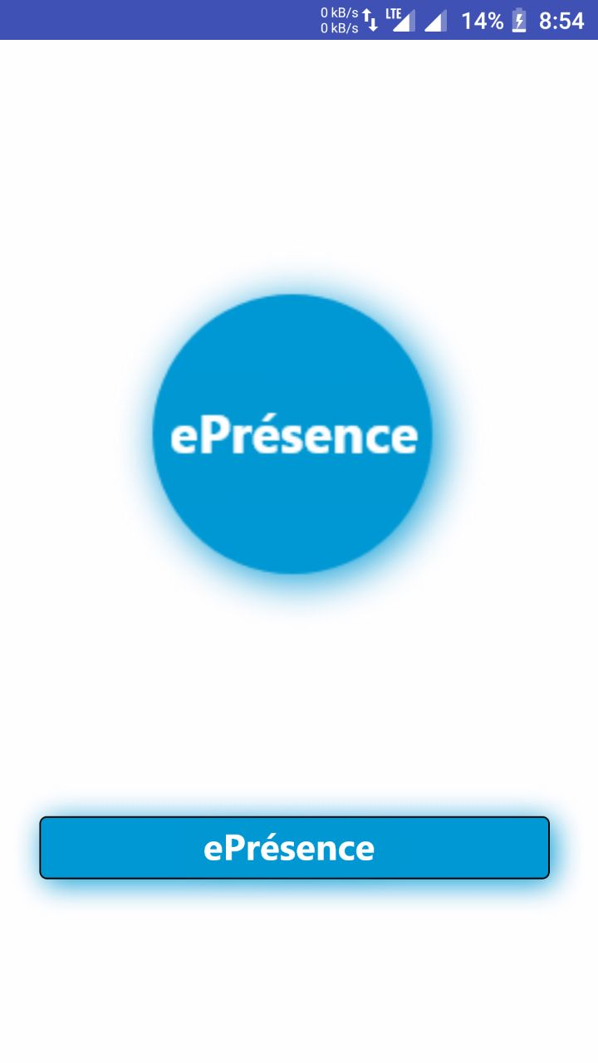

**WELCOMEPAGE:**

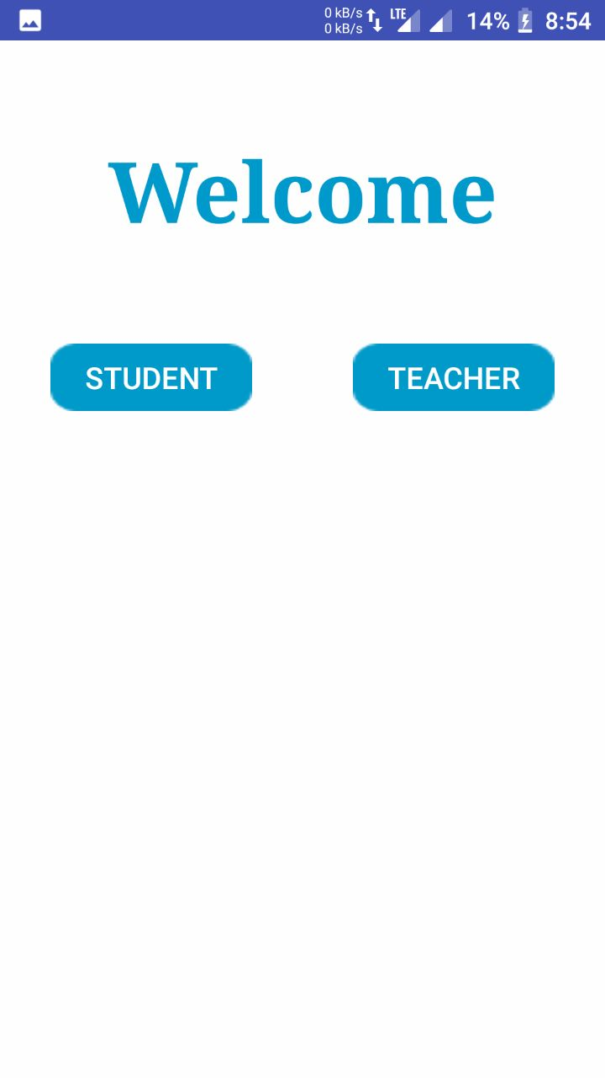

**STUDENT LOGIN:**

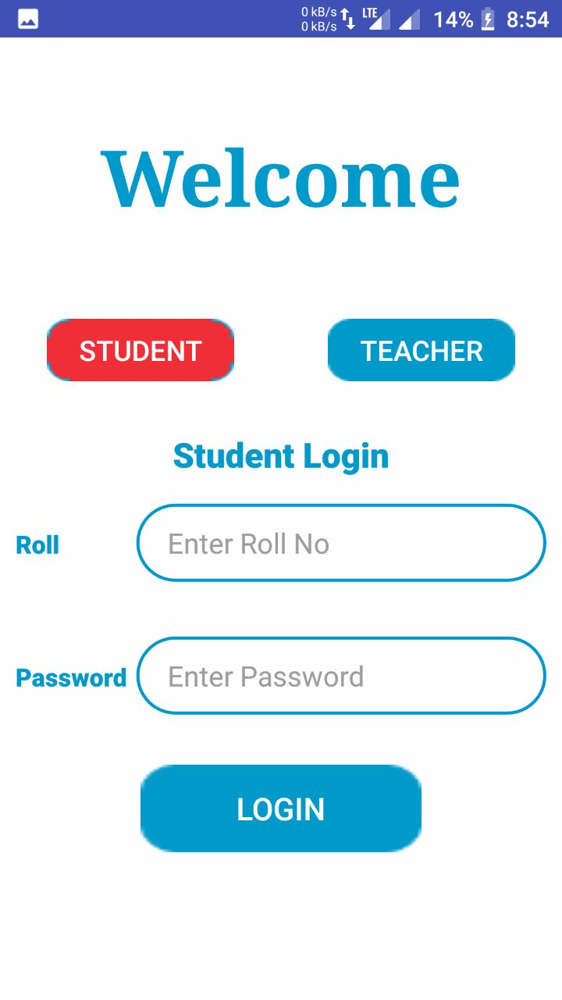

**USER ENTERED:**

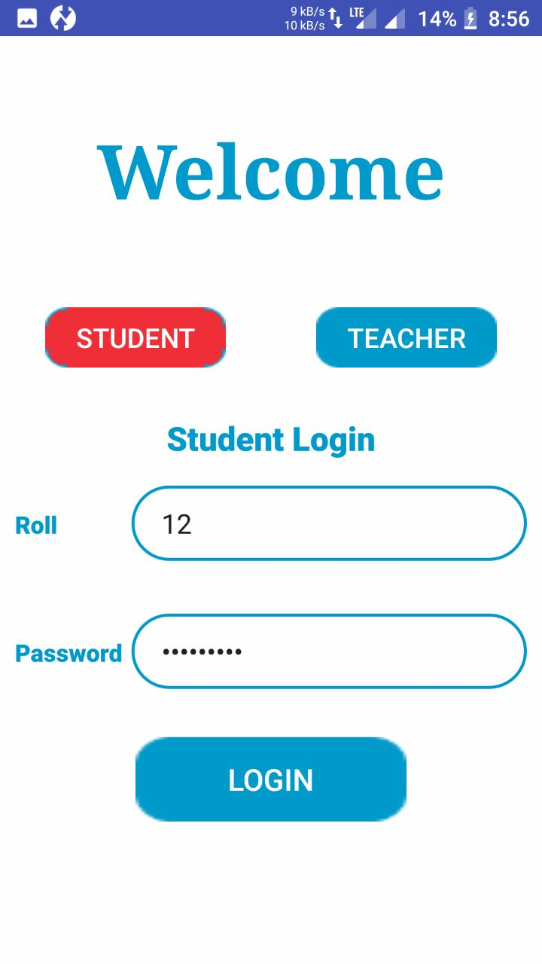

**ENTER DATA FOR CHECKING ATTENDENCE:**

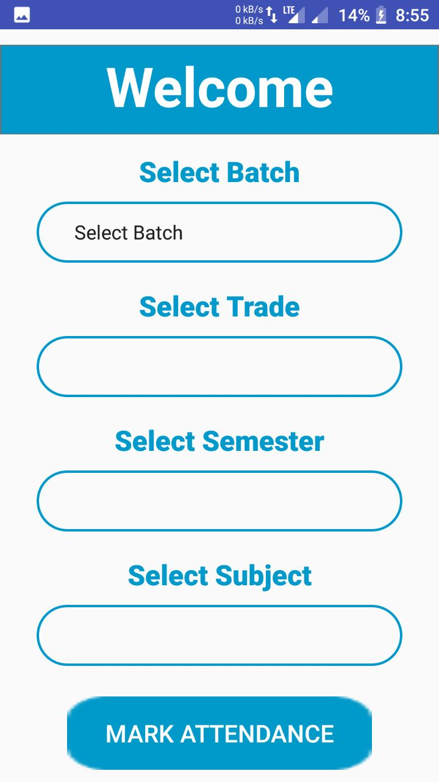

**CHOOSE TRADE,BATCH:**

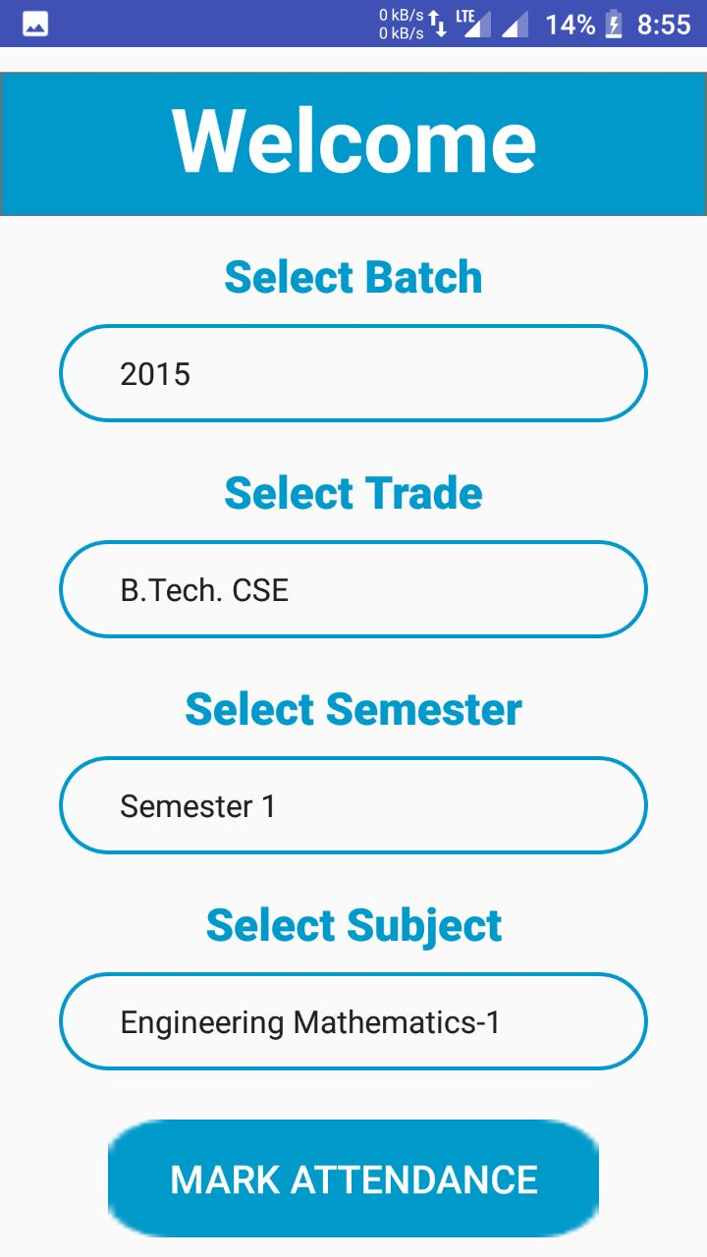

**ATTENDENCE DISPLAY FOR PARTICULAR SUBJECT:**

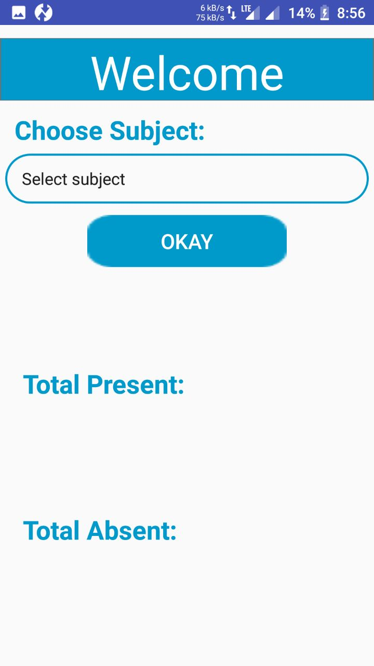

**TEACHER LOGIN:**

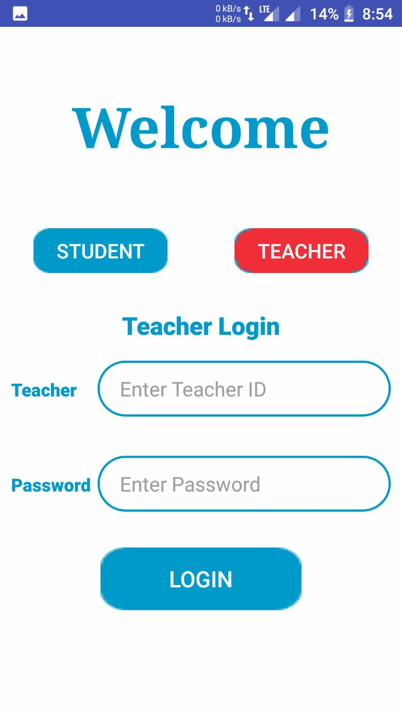

**SELECT RELEVANT OPTION TO MARK ATTENDENCE:**



**MARK STUDENT ATTENDENCE:**

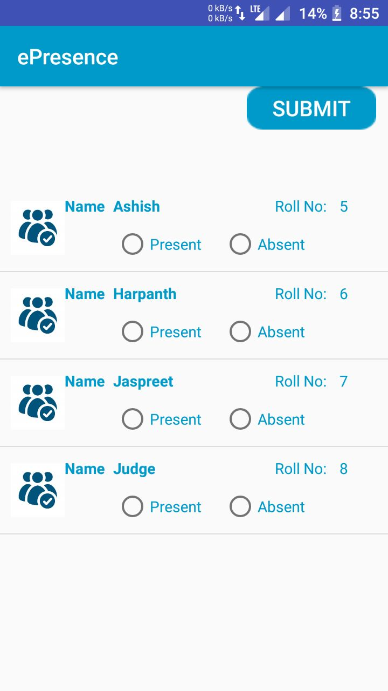

**ATTENDENCE MARKED:**

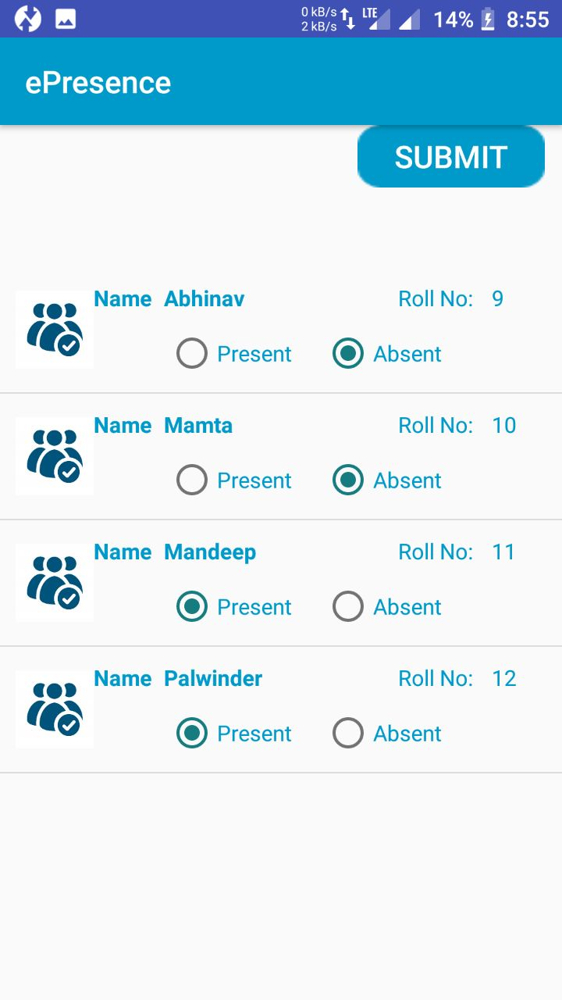

**DISPLAY NUMBER OF STUDENTS PRESENT AND ABSENT:**

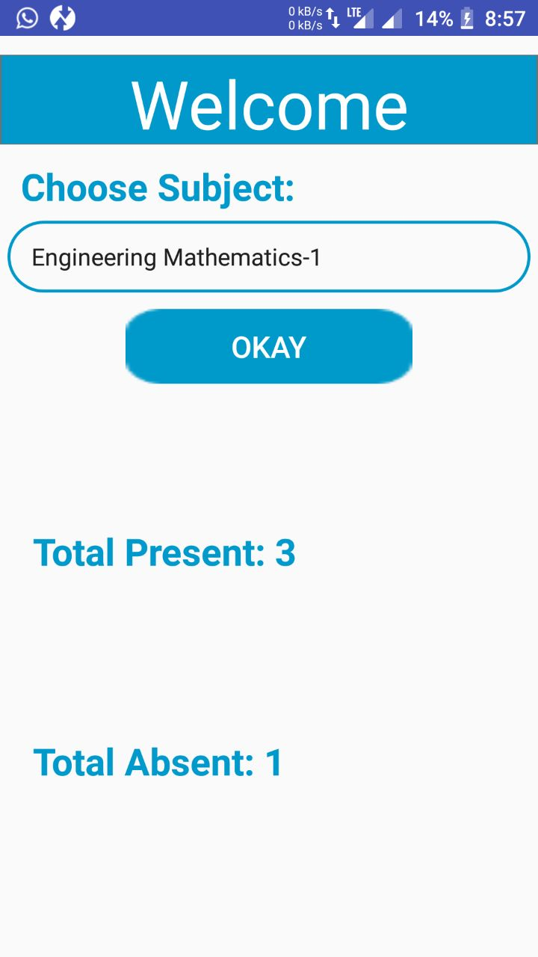

**Suggestion and Recommendation**

Many employees request recommendation letters to help them decide who to hire or internally promote.

Throughout the hiring process the applicant strives to present herself in the best light. Beyond the interview and resume, managers look to recommendation letters to confirm letters the candidate qualifications and to gan insight from an outside party.

The Hiring manager wants to know what experience the candidate will bring to the new role,how they contribute to the company or organization,and how they will behave in day to day. Recommendation letters to confirm the candidates future performance by talking about her past achievements.

Reference letters can also shed light on what it is like to manage, work withor, in the case of character reference be friends with person under consideration. They complement the candidates story and suggest what they will bring to the table in her next job.

If you get asked to write a letter for someone it is safe to assume you want to do good job. Helping someone get hired is not just a satisfying good deed, but it is also good professional karma. So how can you turn those good intentions into a stand out employee letter of recommendation? Each letter will, of

Course, be different, but good letters share certain key features. Read on to learn about three important charactersitics of strong reference letters.

**Appendix**

Think of this appendix as a campus map, it shows you the myriad places you can go, both inside and outside Wikipedia, to learn what you need to know when you are ready. It focuses on three main areas of learning.

**Finding Exactly The Right Information:**

Wikipedia has many hundreds of pages of detailed policies, guidelines, technical advice and essays not to mention specialized pages that simply list other pages. You are most likely to find what you are looking for. Among all these instructional pages, if you choose one of several good starting points.

**Getting Personalized help:**

All assumption about editing in Wikipedia, as you may have noticed, is that you are supposed to figure our things mostly by yourself you can get personal help, if you know where and how to ask

**Understanding Wikipedia as a community:**

You may be curious about what going on in the Wikipedia community,this appendix shows you have to get news and even how to meet other wikipedians face to face if you so desire.

**Bibliography:**

Browsing the net

Google.com

Wikipedia.org

Developer.android.com

SimplifiedCoding.com

JavaTPoint.com