Home | How does it works ? | Upload Notes | Download Notes | Blog | Open Dispute | About Us

Notes Category list

Notes Category list

Recent Uploaded Notes Slides
Recent notes slides

Banner slides

Category 3

Category 2

Category n

Category (n-1)

Category 4

Category 1

Login/Register
Quick Links SOCIAL LINK Email Subscriber
FAQ Face book
Twitter

Send
Email
LOGO

Search

Home | About Us | Upload Notes | Download Notes | Blog | Contact Us | Facilities
Name Upload Date No of Downloads Rating
Category
Filter By Category

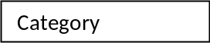

Notes Listing

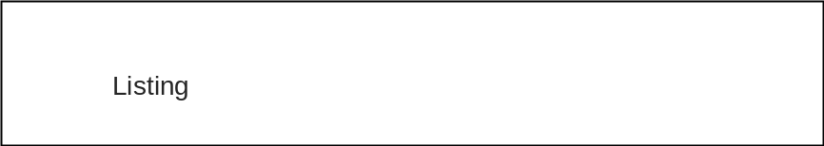

Login/Register
Quick Links SOCIAL LINK Email Subscriber

LOGO

Search

Listing

After clicking on a link of notes
Note brief Information
Notes Preview
(User can click on the Preview which will open a modal box, where he can see the 1 -2 pages of the notes in Zoom) (just like ecommerce site )
Notes Information
- A brief about the notes
- Rating in STAR
- Creator/Contributor information
- Add to Cart

User Rating and Review

Related notes

Login /Register

Login via Username and password

OR

Login via Face book

OR
New User?
Create an account

Quick Links SOCIAL LINK Email newsletter

User Profile
Welcome UserName | Logout

Name :- kumud singh
Email:- abc@gmail.com
Mobile:- 1234567898
Address:- delhi

User image

My Profile
My notes
My Purchases
Change Password
Edit Profile
My Wallet balance
My Balance History
My favorites

Edit Image

User Purchase & Upload Summary

Quick Links SOCIAL LINK Email newsletter

Edit User Profile:
First Name:
LastName:
Email:
Mobile:
Address:
Password:

User Image
Welcome UserName | Logout
SAVE
…………
45/200,delhi
1234656789
Skumud4@gmail.com
sisodia
Kumud singh

My Profile
My notes
My Purchases
Change Password
Edit Profile
My Wallet balance
My Balance History
My favorites

Edit Image

Quick Links SOCIAL LINK Email newsletter

<User> Wallet Balance
Welcome User name | Logout

User Image
Total Available Amount: 10000/-
Withdraw
Deposit

Quick Links SOCIAL LINK Email newsletter

My Profile
My notes
My Purchases
Change Password
Edit Profile
My Wallet balance
My Balance History
My favorites

Net Banking Method
Physical/Manual Method
<User> Purchases
Welcome: User name | Logout

My Profile
My notes
My Purchases
Change Password
Edit Profile
My Wallet balance
My Balance History
My favorites

Edit Image

User Image

Here User can give rating/review to his purchases
Item 1 : Name # Item id
Give Rating
Give Comments:
Item 2: Name # Item id
Give Rating
Give Comments:
Item 3: Name # Item id
Give Rating
Give Comments:
Item 4: Name # Item id
Give Rating
Give Comments:
Item 5: Name # Item id
Give Rating
Give Comments:
Item n-1: Name # Item id
Give Rating
Give Comments:
Item n: Name # Item id
Give Rating
Give Comments:

