Humans of Rangitoto

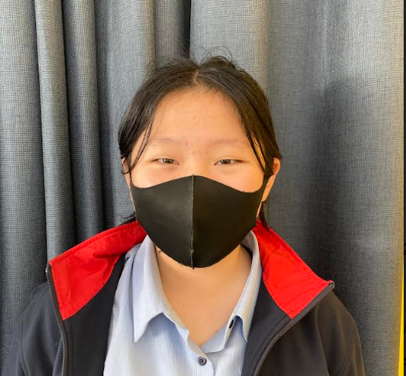

Name: Olivia Li

Age: 13

Form Class: 9HF

Achievements: performing awards,

performing since age 5

| Questions:  What values do you hold?  Confidence, not being afraid to show emotions, being yourself.  What influences led you to doing performing arts and singing?  Tried it and it was fun  What is something you wish you knew five years ago?  Don’t care about what people think  Who are your role models?  Judge Judy Ginsberg  Describe your day.  Tiring, busy  What’s the most difficult challenge you’ve faced?  People: body image issues, not what people usually were, shamed for not being “skinny and tall.”  What interests do you have?  Performing Arts & Music  Who did you look up to when younger?  Singing teacher and my mum  What plans do you have for your future?  Becoming famous, success in the musical career, music major university |
| --- |

| Quotes:  Care about what you think yourself, not what others think of you  If you don’t have confidence, you’ll drown in your sorrow  You need to stop overthinking because the world doesn’t revolve around you, and even if you think everyone’s thinking about how you’ve done, they’re probably not, because you’re not the only person in the world.  Mental health is more important than school work, friends and anything else.  Be nice.  Patriarchy shouldn’t be the way things function in families; |
| --- |

Gwang Ho Kim (Year 9)