**In your queries, please use below fundamentals, make sure all below topics are covered while writing the queries in any of the queries:**

--- Self Join: Find all users who have blocked other users.

SELECT u1.usersname AS blocking_user, u2.usersname AS blocked_user

FROM Users_Block_List ubl

INNER JOIN Users u1 ON ubl.users_id = u1.users_id

INNER JOIN Users u2 ON ubl.blocked_user_id = u2.users_id;

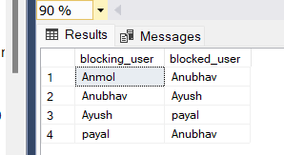

--- Inner Join: Find all users who have been invited to a chat and the inviter's username.

SELECT ci.invitee_id, u.usersname AS invitee_usersname, ci.inviter_id, u2.usersname AS inviter_usersname

FROM Chat_Invite ci

INNER JOIN Users u ON ci.invitee_id = u.users_id

INNER JOIN Users u2 ON ci.inviter_id = u2.users_id;

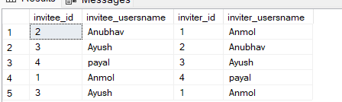

--- Group by: Count the number of messages sent by each user.

SELECT sender_id, COUNT(*) AS message_count

FROM Message

GROUP BY sender_id;

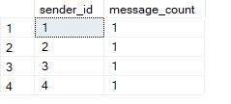

---having clause: Find users who have blocked more than one user.

SELECT users_id, COUNT(blocked_user_id) AS blocked_count

FROM Users_Block_List

GROUP BY users_id

HAVING COUNT(blocked_user_id) > 1;

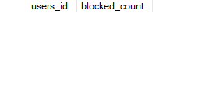

--- Sub Query: Find users who have favorited their own messages using a subquery.

SELECT users_id, message_id

FROM Message_Favorite

WHERE users_id IN (SELECT message_id FROM Message_Favorite);

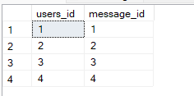

---window function: Rank users based on the number of messages they've sent.

SELECT u.users_id, u.usersname, m.message_count,

RANK() OVER (ORDER BY m.message_count DESC) AS message_rank

FROM (

SELECT sender_id AS users_id, COUNT(*) AS message_count

FROM Message

GROUP BY sender_id

) AS m

JOIN Users u ON m.users_id = u.users_id;

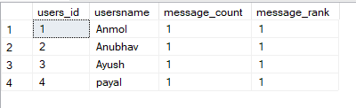

--- String Function: Find all users whose usernames start with 'A'.

SELECT *

FROM Users

WHERE LEFT(usersname, 1) = 'A';

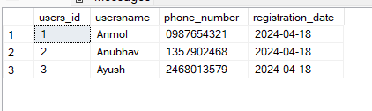

**Identify 4 Analytical queries for the database as per your understanding**

--*Top Active Users*: Find the top 10 users who have sent the most messages.

SELECT TOP 10 u.usersname, COUNT(m.message_id) AS message_count

FROM Users u

INNER JOIN Message m ON u.users_id = m.sender_id

GROUP BY u.usersname

ORDER BY message_count DESC;

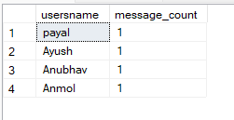

--Call Rating Analysis*: Calculate the average call rating given by users and identify users with the highest and lowest average ratings.

SELECT TOP 1 users_id, AVG(rating) AS avg_rating

FROM Call_Rating

GROUP BY users_id

ORDER BY avg_rating DESC;



--Find out which user_id has the Lowest Avergae Call Rating

SELECT top 1 users_id, AVG(rating) AS avg_rating

FROM Call_Rating

GROUP BY users_id

ORDER BY avg_rating ASC



--Most Popular Chat*: Find the chat with the highest number of messages.

SELECT TOP 1 c.chat_name, COUNT(m.message_id) AS message_count

FROM Chat c

INNER JOIN Message m ON c.chat_id = m.chat_id

GROUP BY c.chat_name

ORDER BY message_count DESC;



**Identify 4 queries which is required for regular operation in any OLTP environment**

1--Insert Data

INSERT INTO Users VALUES

(5, 'Neha', 123456789, '2024-04-18')

select * from Users

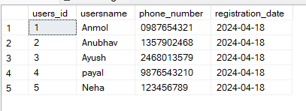

--2. Update Data

UPDATE Users

SET usersname = 'Sameer'

WHERE users_id = 5

select * from Users

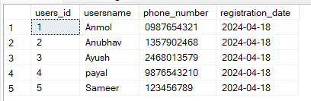

--3. Retrieve Data

SELECT * from Users

WHERE users_id <3

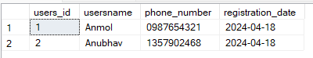

--4. Delete Data

DELETE FROM Users

WHERE users_id = 5

select * from Users

