ASSIGNMENT

Problem 1:

* Basic functionality for versioning and saving/loading data using deltas. However, note that this implementation assumes the base version and deltas are byte arrays, and it simply adds the delta values to the corresponding byte positions in the base version.
* Main1 class demonstrates the usage of the VersionControlSystem class by creating a base version of a file, adding some deltas to it, generating a specific version, saving the version control system to a file, and then loading it back to generate a version again.

**OUTPUT:**

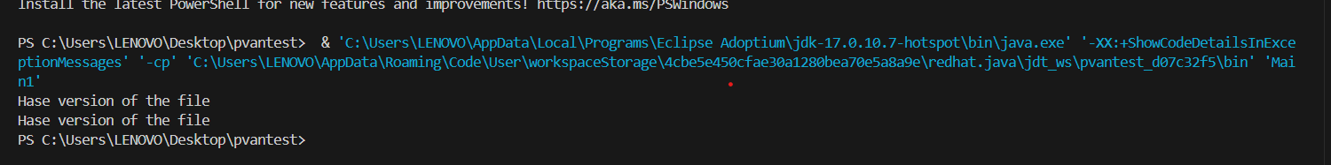

Problem 2:

* Java program implements a word counting functionality using a trie data structure, aiming to efficiently count the occurrences of each word in a large text file.
* In operation, the program prompts the user to input a file path containing the text to be processed.
* It then reads the file, processes each line by splitting it into words, and cleanses each word by removing non-alphabetic characters and converting it to lowercase.

**OUTPUT:**

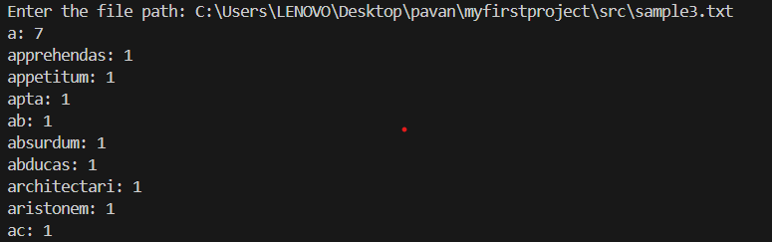

.

Problem 3:

* Java program comprises several classes designed to manage and search through a product database efficiently.
* The **ProductDatabase** class facilitates the addition of products to the database and the subsequent indexing of their attributes such as name, category, and description.
* cohesive system for managing and searching products efficiently within the database.

**OUTPUT:**

