**Exercise 4**

1. Copy class MyBrowser to your source file. Complete methods go, forward, and backward

class MyBrowser

{

private ArrayDeque<String> FW, BW

public MyBrowser()

{

FW = new ArrayDeque<String>(); // tail (top of stack) = latest URL to show

BW = new ArrayDeque<String>();

}

This is how real browser works.

Although ArrayList & indexing can also be used, handling either end of ArrayDeque is much more efficient than keeping track of ArrayList’s index.

public void go()

{ /* Simulate GO button in browser

(1) get URL string from user

(2) open URL in browser

(3) append this URL to FW

(4) FW keeps up to 4 URLs. If #URLs > 4, pop head (oldest) URLs from FW

*/

}

public void backward()

{ /* Simulate BACK button in browser

(1) if FW.size() > 1 🡪 pop tail URL from FW & append it to BW

(2) open URL at the tail of FW

*/

}

public void forward()

{ /* Simulate FORWARD button in browser

(1) if BW.size() > 0 🡪 pop tail URL from BW & append it to FW

(2) open URL at the tail of FW

*/

}

}

2. Write class TestBrowser which acts as the main class. Create a MyBrowser object. Keep asking if the user wants to click GO, BACK, or FORWARD button

Hint : The following code opens a URL in browser (for Windows platform). Unfortunately, we can only keep opening URLs but not closing them

import java.awt.*; // for using Desktop

import java.net.*; // for using URI

String home = "http://www.mahidol.ac.th";

try {

Desktop desktop = Desktop.getDesktop();

desktop.browse(URI.create(home));

}

catch (Exception ex) { System.out.println(ex); }

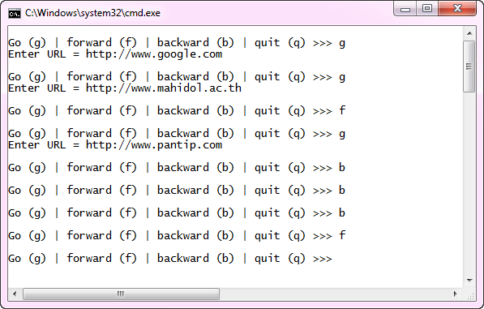

|  |  |  |  |  |
| --- | --- | --- | --- | --- |
|  | **head** |  |  | **tail** |
| **FW** | google | mahidol |  |  |
| **BW** |  |  |  |  |

|  |  |  |  |  |
| --- | --- | --- | --- | --- |
|  |  |  |  |  |
| **FW** | google | mahidol | pantip |  |
| **BW** |  |  |  |  |

can’t pop BW

|  |  |  |  |  |
| --- | --- | --- | --- | --- |
|  |  |  |  |  |
| **FW** | google | mahidol |  |  |
| **BW** | pantip |  |  |  |

pop FW

|  |  |  |  |  |
| --- | --- | --- | --- | --- |
|  |  |  |  |  |
| **FW** | google |  |  |  |
| **BW** | pantip | mahidol |  |  |

pop FW

|  |  |  |  |  |
| --- | --- | --- | --- | --- |
|  |  |  |  |  |
| **FW** | google |  |  |  |
| **BW** | pantip | mahidol |  |  |

can’t pop FW

|  |  |  |  |  |
| --- | --- | --- | --- | --- |
|  |  |  |  |  |
| **FW** | google | mahidol |  |  |
| **BW** | pantip |  |  |  |

pop BW

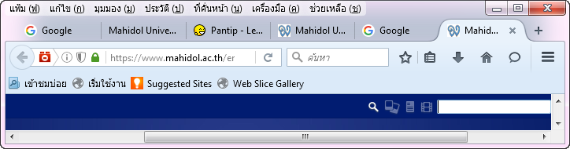

|  |  |  |  |  |
| --- | --- | --- | --- | --- |
|  | **head** |  |  | **tail** |
| **FW** | google | mahidol | pantip | sanook |
| **BW** |  |  |  |  |

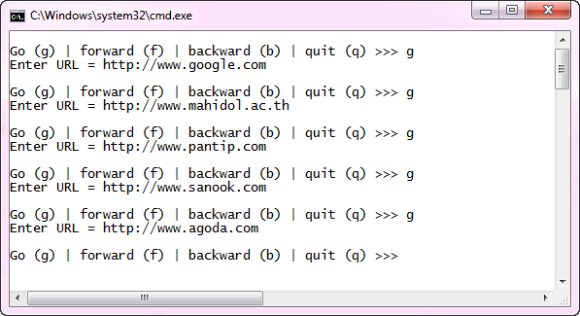

|  |  |  |  |  |
| --- | --- | --- | --- | --- |
|  |  |  |  |  |
| **FW** | mahidol | pantip | sanook | agoda |
| **BW** |  |  |  |  |

last 4 urls

