**Exercise 8**

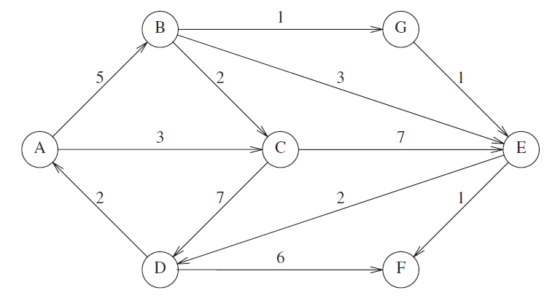

dgraphdata.txt

A B 5

A C 3

B C 2

...

The above graph shows routes between friends’ houses. Make a text file that represents this graph. Write a program to read this file and construct the graph Given a person’s name as an input (e.g. “A”), check whether he will visit other friends or not. A decision to visit a friend (e.g. “B”) is based on:

1. Both forward (from “A” to “B”) route and backward (from “B” to “A”) route must exist
2. Compare the best (i.e. the shortest) forward and backward routes. “A” will visit “B” only if the backward route is not longer than the forward one

