**Exercise 1**

Get a weight from user. Read each planet name & its gravity from input file; calculate the weight that would be measured on that planet. Write the output to another file in the following format

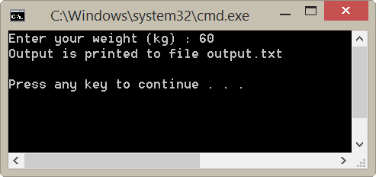

planets.txt

Mercury 0.378

Venus 0.907

Earth 1.000

Moon 0.166

Mars 0.377

Jupiter 2.360

Saturn 0.916

Uranus 0.889

Neptune 1.120

output.txt

Planet Gravity Weight

====================================

Mercury 0.378 22.68

Venus 0.907 54.42

Earth 1.000 60.00

Moon 0.166 9.96

Mars 0.377 22.62

Jupiter 2.360 141.60

Saturn 0.916 54.96

Uranus 0.889 53.34

Neptune 1.120 67.20

The gravities here are in ratio to Earth value.

So the weight on each planet is calculated as

$$W_{planet}=W_{earth}×gravity$$

**Note**

When printing the output to file, use **\r\n** instead of \n

<http://nssdc.gsfc.nasa.gov/planetary/factsheet/planet_table_ratio.html>