**Exercise 2**

1. Copy class FilmBase to your source file **this class must not be changed

abstract class FilmBase {

protected String name;

protected int age; // from release year to 2017

public FilmBase(String n, int a) { name = n; age = a; }

public void print() { /* override this in child */ }

}

2. Write classes Film, and Animation that extend FilmBase

* + Film : add variables director and grossDollars
  + Animation : add variable lengthMinutes
  + Other variables and methods can be added to these class

3. Write class Statistics that acts as the main class. In main method,

3.1 Create an array of 10 FilmBase objects, e.g. FilmBase [ ] FB

3.2 Read each line of input file into FB[i]. For each line, the type of FB[i] may be

Film or Animation object depending on the input

* + Column 1 = type (F = Film, A = Animation)
  + Column 2 = name
  + Column 3 = age
  + Column 4 = director (for Film) or length in minutes (for Animation)
  + Column 5 = opening weekend gross in Dollars (for Film)

input.txt

A, The Incredibles, 13, 115

F, Tropic Thunder, 9, Ben Stiller, 25

A, Despicable Me, 7, 95

F, The Avengers, 5, Joss Whedon, 207

A, Frozen, 4, 102

F, Lucy, 3, Luc Besson, 43

F, Ant-Man, 2, Peyton Reed, 57

F, Rogue One, 1, Gareth Edwards, 155

A, Finding Dory, 1, 97

A, Zootopia, 1, 108

3.3 For both types of objects 🡪 calculate release year from age

3.4 For Film 🡪 convert opening gross from Dollars to Bahts; 1 dollar = 33 bahts

3.5 For Animation 🡪 convert length from minutes to hours & minutes

3.6 Print all Films/Animations in the reverse order of the input

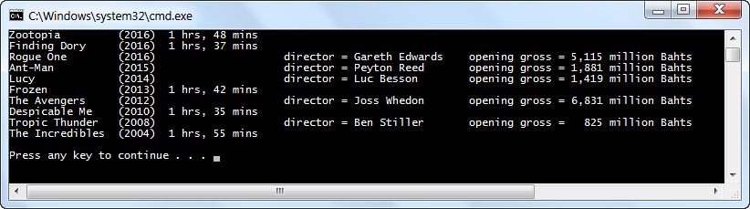

**Hint 1** - Read the whole line into a string (e.g. str) and split at comma

String line = scan.nextLine();

String [] buf = line.split(",");

**Hint 2** – To compare between 2 strings, use method equals or equalsIgnoreCase

String str = "Hi";

if (str.equals("Hi")) System.out.println("Match");

if (str.equalsIgnoreCase("hi")) System.out.println("Match");