**Exercise 7**

Use the given image files and source file (WinterFrame.java)

Complete the source file to make the program work as follows:

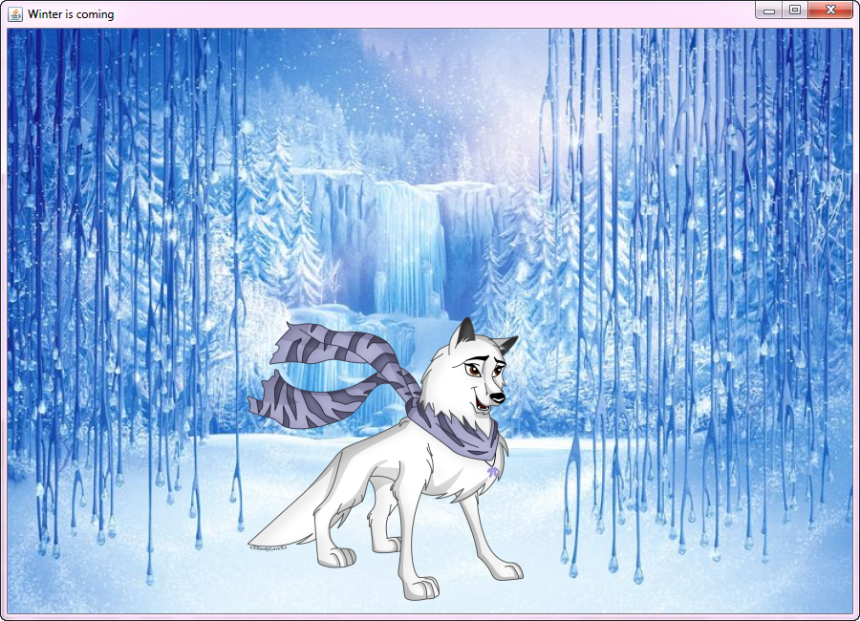

- In wolf mode, the wolf can move with keys LEFT/RIGHT

- It can walk through one side & appear on opposite site

- Key ENTER to switch to dragon & jump

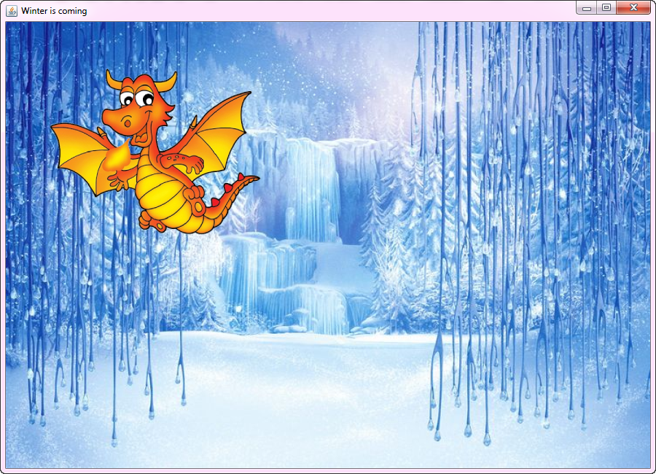

- In dragon mode, the dragon can move with keys UP/DOWN

- It can move only within frame

- Key ENTER or double click the dragon to jump

- Key ESC to switch to wolf

Make class MyToggleLabel implement KeyListener and MouseListener

1. class MyToggleLabel extends JLabel //implements KeyListener, MouseListener
   1. If label = wolf, user can use keys LEFT/RIGHT to move the wolf left/right.

The wolf can walk through one side of the frame & appear on the opposite side

* 1. If label = dragon, user can use keys UP/DOWN to move the dragon up/down

but only within the frame area

* 1. When the user presses key ENTER,
* The wolf will switch to dragon & jump to a new random location
* If the label is already dragon, it will also jump to a new random location
* In both cases the new location must be within the frame area
  1. When the user presses key ESCAPE
* The dragon will switch to wolf & be back on ground
  1. User can also double click the dragon to make it jump 🡪 this works only when

the label is dragon (as in 1.3)

1. Add listener objects to proper component objects

**Hint**

- JLabel can hear MouseEvent but not KeyEvent. You have to make its parent (JFrame)

hearing the event on its behalf

- JLabel can be used as a contentpane for setting background image

- Implement a method that checks & update JLabel positions for all cases, e.g.

public void updateLocation()

{

// update curX and curY

setLocation(curX, curY);

}