BABI DataMining Group 10

## R Markdown

##This is an R Markdown document. Markdown is a simple formatting syntax for authoring HTML, PDF, and MS Word documents. For more details on using R Markdown see <http://rmarkdown.rstudio.com>.

##When you click the **Knit** button a document will be generated that includes both content as well as the output of any embedded R code chunks within the document. You can embed an R code chunk like this:

## Including Plots

#Starting EDA of the Data #

# Read the file and load the data  
library(readr)  
HR_Data <- read_csv("1452762979_586__HR_Employee_Attrition_Data.csv")

## Parsed with column specification:  
## cols(  
## .default = col_double(),  
## Attrition = col_character(),  
## BusinessTravel = col_character(),  
## Department = col_character(),  
## EducationField = col_character(),  
## Gender = col_character(),  
## JobRole = col_character(),  
## MaritalStatus = col_character(),  
## Over18 = col_character(),  
## OverTime = col_character()  
## )

## See spec(...) for full column specifications.

View(HR_Data)  
dim(HR_Data)

## [1] 2940 35

str(HR_Data)

## Classes 'spec_tbl_df', 'tbl_df', 'tbl' and 'data.frame': 2940 obs. of 35 variables:  
## $ Age : num 41 49 37 33 27 32 59 30 38 36 ...  
## $ Attrition : chr "Yes" "No" "Yes" "No" ...  
## $ BusinessTravel : chr "Travel_Rarely" "Travel_Frequently" "Travel_Rarely" "Travel_Frequently" ...  
## $ DailyRate : num 1102 279 1373 1392 591 ...  
## $ Department : chr "Sales" "Research & Development" "Research & Development" "Research & Development" ...  
## $ DistanceFromHome : num 1 8 2 3 2 2 3 24 23 27 ...  
## $ Education : num 2 1 2 4 1 2 3 1 3 3 ...  
## $ EducationField : chr "Life Sciences" "Life Sciences" "Other" "Life Sciences" ...  
## $ EmployeeCount : num 1 1 1 1 1 1 1 1 1 1 ...  
## $ EmployeeNumber : num 1 2 3 4 5 6 7 8 9 10 ...  
## $ EnvironmentSatisfaction : num 2 3 4 4 1 4 3 4 4 3 ...  
## $ Gender : chr "Female" "Male" "Male" "Female" ...  
## $ HourlyRate : num 94 61 92 56 40 79 81 67 44 94 ...  
## $ JobInvolvement : num 3 2 2 3 3 3 4 3 2 3 ...  
## $ JobLevel : num 2 2 1 1 1 1 1 1 3 2 ...  
## $ JobRole : chr "Sales Executive" "Research Scientist" "Laboratory Technician" "Research Scientist" ...  
## $ JobSatisfaction : num 4 2 3 3 2 4 1 3 3 3 ...  
## $ MaritalStatus : chr "Single" "Married" "Single" "Married" ...  
## $ MonthlyIncome : num 5993 5130 2090 2909 3468 ...  
## $ MonthlyRate : num 19479 24907 2396 23159 16632 ...  
## $ NumCompaniesWorked : num 8 1 6 1 9 0 4 1 0 6 ...  
## $ Over18 : chr "Y" "Y" "Y" "Y" ...  
## $ OverTime : chr "Yes" "No" "Yes" "Yes" ...  
## $ PercentSalaryHike : num 11 23 15 11 12 13 20 22 21 13 ...  
## $ PerformanceRating : num 3 4 3 3 3 3 4 4 4 3 ...  
## $ RelationshipSatisfaction: num 1 4 2 3 4 3 1 2 2 2 ...  
## $ StandardHours : num 80 80 80 80 80 80 80 80 80 80 ...  
## $ StockOptionLevel : num 0 1 0 0 1 0 3 1 0 2 ...  
## $ TotalWorkingYears : num 8 10 7 8 6 8 12 1 10 17 ...  
## $ TrainingTimesLastYear : num 0 3 3 3 3 2 3 2 2 3 ...  
## $ WorkLifeBalance : num 1 3 3 3 3 2 2 3 3 2 ...  
## $ YearsAtCompany : num 6 10 0 8 2 7 1 1 9 7 ...  
## $ YearsInCurrentRole : num 4 7 0 7 2 7 0 0 7 7 ...  
## $ YearsSinceLastPromotion : num 0 1 0 3 2 3 0 0 1 7 ...  
## $ YearsWithCurrManager : num 5 7 0 0 2 6 0 0 8 7 ...  
## - attr(*, "spec")=  
## .. cols(  
## .. Age = col_double(),  
## .. Attrition = col_character(),  
## .. BusinessTravel = col_character(),  
## .. DailyRate = col_double(),  
## .. Department = col_character(),  
## .. DistanceFromHome = col_double(),  
## .. Education = col_double(),  
## .. EducationField = col_character(),  
## .. EmployeeCount = col_double(),  
## .. EmployeeNumber = col_double(),  
## .. EnvironmentSatisfaction = col_double(),  
## .. Gender = col_character(),  
## .. HourlyRate = col_double(),  
## .. JobInvolvement = col_double(),  
## .. JobLevel = col_double(),  
## .. JobRole = col_character(),  
## .. JobSatisfaction = col_double(),  
## .. MaritalStatus = col_character(),  
## .. MonthlyIncome = col_double(),  
## .. MonthlyRate = col_double(),  
## .. NumCompaniesWorked = col_double(),  
## .. Over18 = col_character(),  
## .. OverTime = col_character(),  
## .. PercentSalaryHike = col_double(),  
## .. PerformanceRating = col_double(),  
## .. RelationshipSatisfaction = col_double(),  
## .. StandardHours = col_double(),  
## .. StockOptionLevel = col_double(),  
## .. TotalWorkingYears = col_double(),  
## .. TrainingTimesLastYear = col_double(),  
## .. WorkLifeBalance = col_double(),  
## .. YearsAtCompany = col_double(),  
## .. YearsInCurrentRole = col_double(),  
## .. YearsSinceLastPromotion = col_double(),  
## .. YearsWithCurrManager = col_double()  
## .. )

head(HR_Data)

## # A tibble: 6 x 35  
## Age Attrition BusinessTravel DailyRate Department DistanceFromHome  
## <dbl> <chr> <chr> <dbl> <chr> <dbl>  
## 1 41 Yes Travel_Rarely 1102 Sales 1  
## 2 49 No Travel_Freque~ 279 Research ~ 8  
## 3 37 Yes Travel_Rarely 1373 Research ~ 2  
## 4 33 No Travel_Freque~ 1392 Research ~ 3  
## 5 27 No Travel_Rarely 591 Research ~ 2  
## 6 32 No Travel_Freque~ 1005 Research ~ 2  
## # ... with 29 more variables: Education <dbl>, EducationField <chr>,  
## # EmployeeCount <dbl>, EmployeeNumber <dbl>,  
## # EnvironmentSatisfaction <dbl>, Gender <chr>, HourlyRate <dbl>,  
## # JobInvolvement <dbl>, JobLevel <dbl>, JobRole <chr>,  
## # JobSatisfaction <dbl>, MaritalStatus <chr>, MonthlyIncome <dbl>,  
## # MonthlyRate <dbl>, NumCompaniesWorked <dbl>, Over18 <chr>,  
## # OverTime <chr>, PercentSalaryHike <dbl>, PerformanceRating <dbl>,  
## # RelationshipSatisfaction <dbl>, StandardHours <dbl>,  
## # StockOptionLevel <dbl>, TotalWorkingYears <dbl>,  
## # TrainingTimesLastYear <dbl>, WorkLifeBalance <dbl>,  
## # YearsAtCompany <dbl>, YearsInCurrentRole <dbl>,  
## # YearsSinceLastPromotion <dbl>, YearsWithCurrManager <dbl>

tail(HR_Data)

## # A tibble: 6 x 35  
## Age Attrition BusinessTravel DailyRate Department DistanceFromHome  
## <dbl> <chr> <chr> <dbl> <chr> <dbl>  
## 1 26 No Travel_Rarely 1167 Sales 5  
## 2 36 No Travel_Freque~ 884 Research ~ 23  
## 3 39 No Travel_Rarely 613 Research ~ 6  
## 4 27 No Travel_Rarely 155 Research ~ 4  
## 5 49 No Travel_Freque~ 1023 Sales 2  
## 6 34 No Travel_Rarely 628 Research ~ 8  
## # ... with 29 more variables: Education <dbl>, EducationField <chr>,  
## # EmployeeCount <dbl>, EmployeeNumber <dbl>,  
## # EnvironmentSatisfaction <dbl>, Gender <chr>, HourlyRate <dbl>,  
## # JobInvolvement <dbl>, JobLevel <dbl>, JobRole <chr>,  
## # JobSatisfaction <dbl>, MaritalStatus <chr>, MonthlyIncome <dbl>,  
## # MonthlyRate <dbl>, NumCompaniesWorked <dbl>, Over18 <chr>,  
## # OverTime <chr>, PercentSalaryHike <dbl>, PerformanceRating <dbl>,  
## # RelationshipSatisfaction <dbl>, StandardHours <dbl>,  
## # StockOptionLevel <dbl>, TotalWorkingYears <dbl>,  
## # TrainingTimesLastYear <dbl>, WorkLifeBalance <dbl>,  
## # YearsAtCompany <dbl>, YearsInCurrentRole <dbl>,  
## # YearsSinceLastPromotion <dbl>, YearsWithCurrManager <dbl>

summary(HR_Data)

## Age Attrition BusinessTravel DailyRate   
## Min. :18.00 Length:2940 Length:2940 Min. : 102.0   
## 1st Qu.:30.00 Class :character Class :character 1st Qu.: 465.0   
## Median :36.00 Mode :character Mode :character Median : 802.0   
## Mean :36.92 Mean : 802.5   
## 3rd Qu.:43.00 3rd Qu.:1157.0   
## Max. :60.00 Max. :1499.0   
## Department DistanceFromHome Education EducationField   
## Length:2940 Min. : 1.000 Min. :1.000 Length:2940   
## Class :character 1st Qu.: 2.000 1st Qu.:2.000 Class :character   
## Mode :character Median : 7.000 Median :3.000 Mode :character   
## Mean : 9.193 Mean :2.913   
## 3rd Qu.:14.000 3rd Qu.:4.000   
## Max. :29.000 Max. :5.000   
## EmployeeCount EmployeeNumber EnvironmentSatisfaction Gender   
## Min. :1 Min. : 1.0 Min. :1.000 Length:2940   
## 1st Qu.:1 1st Qu.: 735.8 1st Qu.:2.000 Class :character   
## Median :1 Median :1470.5 Median :3.000 Mode :character   
## Mean :1 Mean :1470.5 Mean :2.722   
## 3rd Qu.:1 3rd Qu.:2205.2 3rd Qu.:4.000   
## Max. :1 Max. :2940.0 Max. :4.000   
## HourlyRate JobInvolvement JobLevel JobRole   
## Min. : 30.00 Min. :1.00 Min. :1.000 Length:2940   
## 1st Qu.: 48.00 1st Qu.:2.00 1st Qu.:1.000 Class :character   
## Median : 66.00 Median :3.00 Median :2.000 Mode :character   
## Mean : 65.89 Mean :2.73 Mean :2.064   
## 3rd Qu.: 84.00 3rd Qu.:3.00 3rd Qu.:3.000   
## Max. :100.00 Max. :4.00 Max. :5.000   
## JobSatisfaction MaritalStatus MonthlyIncome MonthlyRate   
## Min. :1.000 Length:2940 Min. : 1009 Min. : 2094   
## 1st Qu.:2.000 Class :character 1st Qu.: 2911 1st Qu.: 8045   
## Median :3.000 Mode :character Median : 4919 Median :14236   
## Mean :2.729 Mean : 6503 Mean :14313   
## 3rd Qu.:4.000 3rd Qu.: 8380 3rd Qu.:20462   
## Max. :4.000 Max. :19999 Max. :26999   
## NumCompaniesWorked Over18 OverTime   
## Min. :0.000 Length:2940 Length:2940   
## 1st Qu.:1.000 Class :character Class :character   
## Median :2.000 Mode :character Mode :character   
## Mean :2.693   
## 3rd Qu.:4.000   
## Max. :9.000   
## PercentSalaryHike PerformanceRating RelationshipSatisfaction  
## Min. :11.00 Min. :3.000 Min. :1.000   
## 1st Qu.:12.00 1st Qu.:3.000 1st Qu.:2.000   
## Median :14.00 Median :3.000 Median :3.000   
## Mean :15.21 Mean :3.154 Mean :2.712   
## 3rd Qu.:18.00 3rd Qu.:3.000 3rd Qu.:4.000   
## Max. :25.00 Max. :4.000 Max. :4.000   
## StandardHours StockOptionLevel TotalWorkingYears TrainingTimesLastYear  
## Min. :80 Min. :0.0000 Min. : 0.00 Min. :0.000   
## 1st Qu.:80 1st Qu.:0.0000 1st Qu.: 6.00 1st Qu.:2.000   
## Median :80 Median :1.0000 Median :10.00 Median :3.000   
## Mean :80 Mean :0.7939 Mean :11.28 Mean :2.799   
## 3rd Qu.:80 3rd Qu.:1.0000 3rd Qu.:15.00 3rd Qu.:3.000   
## Max. :80 Max. :3.0000 Max. :40.00 Max. :6.000   
## WorkLifeBalance YearsAtCompany YearsInCurrentRole  
## Min. :1.000 Min. : 0.000 Min. : 0.000   
## 1st Qu.:2.000 1st Qu.: 3.000 1st Qu.: 2.000   
## Median :3.000 Median : 5.000 Median : 3.000   
## Mean :2.761 Mean : 7.008 Mean : 4.229   
## 3rd Qu.:3.000 3rd Qu.: 9.000 3rd Qu.: 7.000   
## Max. :4.000 Max. :40.000 Max. :18.000   
## YearsSinceLastPromotion YearsWithCurrManager  
## Min. : 0.000 Min. : 0.000   
## 1st Qu.: 0.000 1st Qu.: 2.000   
## Median : 1.000 Median : 3.000   
## Mean : 2.188 Mean : 4.123   
## 3rd Qu.: 3.000 3rd Qu.: 7.000   
## Max. :15.000 Max. :17.000

HR_Data$Attrition <- as.factor(HR_Data$Attrition)  
 HR_Data$BusinessTravel <- as.factor(HR_Data$BusinessTravel)  
 HR_Data$Department <- as.factor(HR_Data$Department)  
 HR_Data$EducationField <- as.factor(HR_Data$EducationField)  
 HR_Data$Gender <- as.factor(HR_Data$Gender)  
 HR_Data$JobRole <- as.factor(HR_Data$JobRole)  
 HR_Data$MaritalStatus <- as.factor(HR_Data$MaritalStatus)  
 HR_Data$Over18 <- as.factor(HR_Data$Over18)  
 HR_Data$OverTime <- as.factor(HR_Data$OverTime)  
   
 str(HR_Data)

## Classes 'spec_tbl_df', 'tbl_df', 'tbl' and 'data.frame': 2940 obs. of 35 variables:  
## $ Age : num 41 49 37 33 27 32 59 30 38 36 ...  
## $ Attrition : Factor w/ 2 levels "No","Yes": 2 1 2 1 1 1 1 1 1 1 ...  
## $ BusinessTravel : Factor w/ 3 levels "Non-Travel","Travel_Frequently",..: 3 2 3 2 3 2 3 3 2 3 ...  
## $ DailyRate : num 1102 279 1373 1392 591 ...  
## $ Department : Factor w/ 3 levels "Human Resources",..: 3 2 2 2 2 2 2 2 2 2 ...  
## $ DistanceFromHome : num 1 8 2 3 2 2 3 24 23 27 ...  
## $ Education : num 2 1 2 4 1 2 3 1 3 3 ...  
## $ EducationField : Factor w/ 6 levels "Human Resources",..: 2 2 5 2 4 2 4 2 2 4 ...  
## $ EmployeeCount : num 1 1 1 1 1 1 1 1 1 1 ...  
## $ EmployeeNumber : num 1 2 3 4 5 6 7 8 9 10 ...  
## $ EnvironmentSatisfaction : num 2 3 4 4 1 4 3 4 4 3 ...  
## $ Gender : Factor w/ 2 levels "Female","Male": 1 2 2 1 2 2 1 2 2 2 ...  
## $ HourlyRate : num 94 61 92 56 40 79 81 67 44 94 ...  
## $ JobInvolvement : num 3 2 2 3 3 3 4 3 2 3 ...  
## $ JobLevel : num 2 2 1 1 1 1 1 1 3 2 ...  
## $ JobRole : Factor w/ 9 levels "Healthcare Representative",..: 8 7 3 7 3 3 3 3 5 1 ...  
## $ JobSatisfaction : num 4 2 3 3 2 4 1 3 3 3 ...  
## $ MaritalStatus : Factor w/ 3 levels "Divorced","Married",..: 3 2 3 2 2 3 2 1 3 2 ...  
## $ MonthlyIncome : num 5993 5130 2090 2909 3468 ...  
## $ MonthlyRate : num 19479 24907 2396 23159 16632 ...  
## $ NumCompaniesWorked : num 8 1 6 1 9 0 4 1 0 6 ...  
## $ Over18 : Factor w/ 1 level "Y": 1 1 1 1 1 1 1 1 1 1 ...  
## $ OverTime : Factor w/ 2 levels "No","Yes": 2 1 2 2 1 1 2 1 1 1 ...  
## $ PercentSalaryHike : num 11 23 15 11 12 13 20 22 21 13 ...  
## $ PerformanceRating : num 3 4 3 3 3 3 4 4 4 3 ...  
## $ RelationshipSatisfaction: num 1 4 2 3 4 3 1 2 2 2 ...  
## $ StandardHours : num 80 80 80 80 80 80 80 80 80 80 ...  
## $ StockOptionLevel : num 0 1 0 0 1 0 3 1 0 2 ...  
## $ TotalWorkingYears : num 8 10 7 8 6 8 12 1 10 17 ...  
## $ TrainingTimesLastYear : num 0 3 3 3 3 2 3 2 2 3 ...  
## $ WorkLifeBalance : num 1 3 3 3 3 2 2 3 3 2 ...  
## $ YearsAtCompany : num 6 10 0 8 2 7 1 1 9 7 ...  
## $ YearsInCurrentRole : num 4 7 0 7 2 7 0 0 7 7 ...  
## $ YearsSinceLastPromotion : num 0 1 0 3 2 3 0 0 1 7 ...  
## $ YearsWithCurrManager : num 5 7 0 0 2 6 0 0 8 7 ...  
## - attr(*, "spec")=  
## .. cols(  
## .. Age = col_double(),  
## .. Attrition = col_character(),  
## .. BusinessTravel = col_character(),  
## .. DailyRate = col_double(),  
## .. Department = col_character(),  
## .. DistanceFromHome = col_double(),  
## .. Education = col_double(),  
## .. EducationField = col_character(),  
## .. EmployeeCount = col_double(),  
## .. EmployeeNumber = col_double(),  
## .. EnvironmentSatisfaction = col_double(),  
## .. Gender = col_character(),  
## .. HourlyRate = col_double(),  
## .. JobInvolvement = col_double(),  
## .. JobLevel = col_double(),  
## .. JobRole = col_character(),  
## .. JobSatisfaction = col_double(),  
## .. MaritalStatus = col_character(),  
## .. MonthlyIncome = col_double(),  
## .. MonthlyRate = col_double(),  
## .. NumCompaniesWorked = col_double(),  
## .. Over18 = col_character(),  
## .. OverTime = col_character(),  
## .. PercentSalaryHike = col_double(),  
## .. PerformanceRating = col_double(),  
## .. RelationshipSatisfaction = col_double(),  
## .. StandardHours = col_double(),  
## .. StockOptionLevel = col_double(),  
## .. TotalWorkingYears = col_double(),  
## .. TrainingTimesLastYear = col_double(),  
## .. WorkLifeBalance = col_double(),  
## .. YearsAtCompany = col_double(),  
## .. YearsInCurrentRole = col_double(),  
## .. YearsSinceLastPromotion = col_double(),  
## .. YearsWithCurrManager = col_double()  
## .. )

library(lattice)  
library(ggplot2)

## Warning: package 'ggplot2' was built under R version 3.6.1

library(corrplot)

## Warning: package 'corrplot' was built under R version 3.6.1

## corrplot 0.84 loaded

library(ggpubr)

## Warning: package 'ggpubr' was built under R version 3.6.1

## Loading required package: magrittr

library(ggplot2)  
library(corrplot)

names(HR_Data)

## [1] "Age" "Attrition"   
## [3] "BusinessTravel" "DailyRate"   
## [5] "Department" "DistanceFromHome"   
## [7] "Education" "EducationField"   
## [9] "EmployeeCount" "EmployeeNumber"   
## [11] "EnvironmentSatisfaction" "Gender"   
## [13] "HourlyRate" "JobInvolvement"   
## [15] "JobLevel" "JobRole"   
## [17] "JobSatisfaction" "MaritalStatus"   
## [19] "MonthlyIncome" "MonthlyRate"   
## [21] "NumCompaniesWorked" "Over18"   
## [23] "OverTime" "PercentSalaryHike"   
## [25] "PerformanceRating" "RelationshipSatisfaction"  
## [27] "StandardHours" "StockOptionLevel"   
## [29] "TotalWorkingYears" "TrainingTimesLastYear"   
## [31] "WorkLifeBalance" "YearsAtCompany"   
## [33] "YearsInCurrentRole" "YearsSinceLastPromotion"   
## [35] "YearsWithCurrManager"

HR_Data_Corr <- subset(HR_Data, select = -c(Attrition , BusinessTravel , Department , EducationField , Gender , JobRole , MaritalStatus , Over18 , OverTime ))  
   
str(HR_Data_Corr)

## Classes 'tbl_df', 'tbl' and 'data.frame': 2940 obs. of 26 variables:  
## $ Age : num 41 49 37 33 27 32 59 30 38 36 ...  
## $ DailyRate : num 1102 279 1373 1392 591 ...  
## $ DistanceFromHome : num 1 8 2 3 2 2 3 24 23 27 ...  
## $ Education : num 2 1 2 4 1 2 3 1 3 3 ...  
## $ EmployeeCount : num 1 1 1 1 1 1 1 1 1 1 ...  
## $ EmployeeNumber : num 1 2 3 4 5 6 7 8 9 10 ...  
## $ EnvironmentSatisfaction : num 2 3 4 4 1 4 3 4 4 3 ...  
## $ HourlyRate : num 94 61 92 56 40 79 81 67 44 94 ...  
## $ JobInvolvement : num 3 2 2 3 3 3 4 3 2 3 ...  
## $ JobLevel : num 2 2 1 1 1 1 1 1 3 2 ...  
## $ JobSatisfaction : num 4 2 3 3 2 4 1 3 3 3 ...  
## $ MonthlyIncome : num 5993 5130 2090 2909 3468 ...  
## $ MonthlyRate : num 19479 24907 2396 23159 16632 ...  
## $ NumCompaniesWorked : num 8 1 6 1 9 0 4 1 0 6 ...  
## $ PercentSalaryHike : num 11 23 15 11 12 13 20 22 21 13 ...  
## $ PerformanceRating : num 3 4 3 3 3 3 4 4 4 3 ...  
## $ RelationshipSatisfaction: num 1 4 2 3 4 3 1 2 2 2 ...  
## $ StandardHours : num 80 80 80 80 80 80 80 80 80 80 ...  
## $ StockOptionLevel : num 0 1 0 0 1 0 3 1 0 2 ...  
## $ TotalWorkingYears : num 8 10 7 8 6 8 12 1 10 17 ...  
## $ TrainingTimesLastYear : num 0 3 3 3 3 2 3 2 2 3 ...  
## $ WorkLifeBalance : num 1 3 3 3 3 2 2 3 3 2 ...  
## $ YearsAtCompany : num 6 10 0 8 2 7 1 1 9 7 ...  
## $ YearsInCurrentRole : num 4 7 0 7 2 7 0 0 7 7 ...  
## $ YearsSinceLastPromotion : num 0 1 0 3 2 3 0 0 1 7 ...  
## $ YearsWithCurrManager : num 5 7 0 0 2 6 0 0 8 7 ...

cor(HR_Data_Corr)

## Warning in cor(HR_Data_Corr): the standard deviation is zero

## Age DailyRate DistanceFromHome  
## Age 1.000000000 0.0106609426 -0.001686120  
## DailyRate 0.010660943 1.0000000000 -0.004985337  
## DistanceFromHome -0.001686120 -0.0049853374 1.000000000  
## Education 0.208033731 -0.0168064332 0.021041826  
## EmployeeCount NA NA NA  
## EmployeeNumber -0.005174672 -0.0257418149 0.016464171  
## EnvironmentSatisfaction 0.010146428 0.0183548543 -0.016075327  
## HourlyRate 0.024286543 0.0233814215 0.031130586  
## JobInvolvement 0.029819959 0.0461348740 0.008783280  
## JobLevel 0.509604228 0.0029663349 0.005302731  
## JobSatisfaction -0.004891877 0.0305710078 -0.003668839  
## MonthlyIncome 0.497854567 0.0077070589 -0.017014445  
## MonthlyRate 0.028051167 -0.0321816015 0.027472864  
## NumCompaniesWorked 0.299634758 0.0381534343 -0.029250804  
## PercentSalaryHike 0.003633585 0.0227036775 0.040235377  
## PerformanceRating 0.001903896 0.0004732963 0.027109618  
## RelationshipSatisfaction 0.053534720 0.0078460310 0.006557475  
## StandardHours NA NA NA  
## StockOptionLevel 0.037509712 0.0421427964 0.044871999  
## TotalWorkingYears 0.680380536 0.0145147387 0.004628426  
## TrainingTimesLastYear -0.019620819 0.0024525427 -0.036942234  
## WorkLifeBalance -0.021490028 -0.0378480510 -0.026556004  
## YearsAtCompany 0.311308770 -0.0340547676 0.009507720  
## YearsInCurrentRole 0.212901056 0.0099320150 0.018844999  
## YearsSinceLastPromotion 0.216513368 -0.0332289848 0.010028836  
## YearsWithCurrManager 0.202088602 -0.0263631782 0.014406048  
## Education EmployeeCount EmployeeNumber  
## Age 0.208033731 NA -0.0051746719  
## DailyRate -0.016806433 NA -0.0257418149  
## DistanceFromHome 0.021041826 NA 0.0164641708  
## Education 1.000000000 NA 0.0209502859  
## EmployeeCount NA 1 NA  
## EmployeeNumber 0.020950286 NA 1.0000000000  
## EnvironmentSatisfaction -0.027128313 NA 0.0087118301  
## HourlyRate 0.016774829 NA 0.0173769037  
## JobInvolvement 0.042437634 NA -0.0035523572  
## JobLevel 0.101588886 NA -0.0090203564  
## JobSatisfaction -0.011296117 NA -0.0229704931  
## MonthlyIncome 0.094960677 NA -0.0071883547  
## MonthlyRate -0.026084197 NA 0.0061773879  
## NumCompaniesWorked 0.126316560 NA -0.0003445734  
## PercentSalaryHike -0.011110941 NA -0.0066847469  
## PerformanceRating -0.024538791 NA -0.0103375736  
## RelationshipSatisfaction -0.009118377 NA -0.0348269429  
## StandardHours NA NA NA  
## StockOptionLevel 0.018422220 NA 0.0312260658  
## TotalWorkingYears 0.148279697 NA -0.0070474759  
## TrainingTimesLastYear -0.025100241 NA 0.0119534797  
## WorkLifeBalance 0.009819189 NA 0.0053700124  
## YearsAtCompany 0.069113696 NA -0.0057786925  
## YearsInCurrentRole 0.060235554 NA -0.0044266305  
## YearsSinceLastPromotion 0.054254334 NA -0.0045753542  
## YearsWithCurrManager 0.069065378 NA -0.0047162091  
## EnvironmentSatisfaction HourlyRate  
## Age 0.010146428 0.024286543  
## DailyRate 0.018354854 0.023381422  
## DistanceFromHome -0.016075327 0.031130586  
## Education -0.027128313 0.016774829  
## EmployeeCount NA NA  
## EmployeeNumber 0.008711830 0.017376904  
## EnvironmentSatisfaction 1.000000000 -0.049856956  
## HourlyRate -0.049856956 1.000000000  
## JobInvolvement -0.008277598 0.042860641  
## JobLevel 0.001211699 -0.027853486  
## JobSatisfaction -0.006784353 -0.071334624  
## MonthlyIncome -0.006259088 -0.015794304  
## MonthlyRate 0.037599623 -0.015296750  
## NumCompaniesWorked 0.012594323 0.022156883  
## PercentSalaryHike -0.031701195 -0.009061986  
## PerformanceRating -0.029547952 -0.002171697  
## RelationshipSatisfaction 0.007665384 0.001330453  
## StandardHours NA NA  
## StockOptionLevel 0.003432158 0.050263399  
## TotalWorkingYears -0.002693070 -0.002333682  
## TrainingTimesLastYear -0.019359308 -0.008547685  
## WorkLifeBalance 0.027627295 -0.004607234  
## YearsAtCompany 0.001457549 -0.019581616  
## YearsInCurrentRole 0.018007460 -0.024106220  
## YearsSinceLastPromotion 0.016193606 -0.026715586  
## YearsWithCurrManager -0.004998723 -0.020123200  
## JobInvolvement JobLevel JobSatisfaction  
## Age 0.029819959 0.509604228 -0.0048918771  
## DailyRate 0.046134874 0.002966335 0.0305710078  
## DistanceFromHome 0.008783280 0.005302731 -0.0036688392  
## Education 0.042437634 0.101588886 -0.0112961167  
## EmployeeCount NA NA NA  
## EmployeeNumber -0.003552357 -0.009020356 -0.0229704931  
## EnvironmentSatisfaction -0.008277598 0.001211699 -0.0067843526  
## HourlyRate 0.042860641 -0.027853486 -0.0713346244  
## JobInvolvement 1.000000000 -0.012629883 -0.0214759103  
## JobLevel -0.012629883 1.000000000 -0.0019437080  
## JobSatisfaction -0.021475910 -0.001943708 1.0000000000  
## MonthlyIncome -0.015271491 0.950299913 -0.0071567424  
## MonthlyRate -0.016322079 0.039562951 0.0006439169  
## NumCompaniesWorked 0.015012413 0.142501124 -0.0556994260  
## PercentSalaryHike -0.017204572 -0.034730492 0.0200020394  
## PerformanceRating -0.029071333 -0.021222082 0.0022971971  
## RelationshipSatisfaction 0.034296821 0.021641511 -0.0124535932  
## StandardHours NA NA NA  
## StockOptionLevel 0.021522640 0.013983911 0.0106902261  
## TotalWorkingYears -0.005533182 0.782207805 -0.0201850727  
## TrainingTimesLastYear -0.015337826 -0.018190550 -0.0057793350  
## WorkLifeBalance -0.014616593 0.037817746 -0.0194587102  
## YearsAtCompany -0.021355427 0.534738687 -0.0038026279  
## YearsInCurrentRole 0.008716963 0.389446733 -0.0023047852  
## YearsSinceLastPromotion -0.024184292 0.353885347 -0.0182135678  
## YearsWithCurrManager 0.025975808 0.375280608 -0.0276562139  
## MonthlyIncome MonthlyRate NumCompaniesWorked  
## Age 0.497854567 0.0280511671 0.2996347580  
## DailyRate 0.007707059 -0.0321816015 0.0381534343  
## DistanceFromHome -0.017014445 0.0274728635 -0.0292508042  
## Education 0.094960677 -0.0260841972 0.1263165602  
## EmployeeCount NA NA NA  
## EmployeeNumber -0.007188355 0.0061773879 -0.0003445734  
## EnvironmentSatisfaction -0.006259088 0.0375996229 0.0125943232  
## HourlyRate -0.015794304 -0.0152967496 0.0221568834  
## JobInvolvement -0.015271491 -0.0163220791 0.0150124132  
## JobLevel 0.950299913 0.0395629510 0.1425011238  
## JobSatisfaction -0.007156742 0.0006439169 -0.0556994260  
## MonthlyIncome 1.000000000 0.0348136261 0.1495152160  
## MonthlyRate 0.034813626 1.0000000000 0.0175213534  
## NumCompaniesWorked 0.149515216 0.0175213534 1.0000000000  
## PercentSalaryHike -0.027268586 -0.0064293459 -0.0102383094  
## PerformanceRating -0.017120138 -0.0098114285 -0.0140948728  
## RelationshipSatisfaction 0.025873436 -0.0040853293 0.0527330486  
## StandardHours NA NA NA  
## StockOptionLevel 0.005407677 -0.0343228302 0.0300754751  
## TotalWorkingYears 0.772893246 0.0264424712 0.2376385898  
## TrainingTimesLastYear -0.021736277 0.0014668806 -0.0660540717  
## WorkLifeBalance 0.030683082 0.0079631575 -0.0083656848  
## YearsAtCompany 0.514284826 -0.0236551067 -0.1184213402  
## YearsInCurrentRole 0.363817667 -0.0128148744 -0.0907539337  
## YearsSinceLastPromotion 0.344977638 0.0015667995 -0.0368138924  
## YearsWithCurrManager 0.344078883 -0.0367459053 -0.1103191554  
## PercentSalaryHike PerformanceRating  
## Age 0.003633585 0.0019038955  
## DailyRate 0.022703677 0.0004732963  
## DistanceFromHome 0.040235377 0.0271096185  
## Education -0.011110941 -0.0245387912  
## EmployeeCount NA NA  
## EmployeeNumber -0.006684747 -0.0103375736  
## EnvironmentSatisfaction -0.031701195 -0.0295479523  
## HourlyRate -0.009061986 -0.0021716974  
## JobInvolvement -0.017204572 -0.0290713334  
## JobLevel -0.034730492 -0.0212220821  
## JobSatisfaction 0.020002039 0.0022971971  
## MonthlyIncome -0.027268586 -0.0171201382  
## MonthlyRate -0.006429346 -0.0098114285  
## NumCompaniesWorked -0.010238309 -0.0140948728  
## PercentSalaryHike 1.000000000 0.7735499964  
## PerformanceRating 0.773549996 1.0000000000  
## RelationshipSatisfaction -0.040490081 -0.0313514554  
## StandardHours NA NA  
## StockOptionLevel 0.007527748 0.0035064716  
## TotalWorkingYears -0.020608488 0.0067436679  
## TrainingTimesLastYear -0.005221012 -0.0155788817  
## WorkLifeBalance -0.003279636 0.0025723613  
## YearsAtCompany -0.035991262 0.0034351261  
## YearsInCurrentRole -0.001520027 0.0349862604  
## YearsSinceLastPromotion -0.022154313 0.0178960661  
## YearsWithCurrManager -0.011985248 0.0228271689  
## RelationshipSatisfaction StandardHours  
## Age 0.0535347197 NA  
## DailyRate 0.0078460310 NA  
## DistanceFromHome 0.0065574746 NA  
## Education -0.0091183767 NA  
## EmployeeCount NA NA  
## EmployeeNumber -0.0348269429 NA  
## EnvironmentSatisfaction 0.0076653835 NA  
## HourlyRate 0.0013304528 NA  
## JobInvolvement 0.0342968206 NA  
## JobLevel 0.0216415105 NA  
## JobSatisfaction -0.0124535932 NA  
## MonthlyIncome 0.0258734361 NA  
## MonthlyRate -0.0040853293 NA  
## NumCompaniesWorked 0.0527330486 NA  
## PercentSalaryHike -0.0404900811 NA  
## PerformanceRating -0.0313514554 NA  
## RelationshipSatisfaction 1.0000000000 NA  
## StandardHours NA 1  
## StockOptionLevel -0.0459524907 NA  
## TotalWorkingYears 0.0240542918 NA  
## TrainingTimesLastYear 0.0024965264 NA  
## WorkLifeBalance 0.0196044057 NA  
## YearsAtCompany 0.0193667869 NA  
## YearsInCurrentRole -0.0151229149 NA  
## YearsSinceLastPromotion 0.0334925021 NA  
## YearsWithCurrManager -0.0008674968 NA  
## StockOptionLevel TotalWorkingYears  
## Age 0.037509712 0.680380536  
## DailyRate 0.042142796 0.014514739  
## DistanceFromHome 0.044871999 0.004628426  
## Education 0.018422220 0.148279697  
## EmployeeCount NA NA  
## EmployeeNumber 0.031226066 -0.007047476  
## EnvironmentSatisfaction 0.003432158 -0.002693070  
## HourlyRate 0.050263399 -0.002333682  
## JobInvolvement 0.021522640 -0.005533182  
## JobLevel 0.013983911 0.782207805  
## JobSatisfaction 0.010690226 -0.020185073  
## MonthlyIncome 0.005407677 0.772893246  
## MonthlyRate -0.034322830 0.026442471  
## NumCompaniesWorked 0.030075475 0.237638590  
## PercentSalaryHike 0.007527748 -0.020608488  
## PerformanceRating 0.003506472 0.006743668  
## RelationshipSatisfaction -0.045952491 0.024054292  
## StandardHours NA NA  
## StockOptionLevel 1.000000000 0.010135969  
## TotalWorkingYears 0.010135969 1.000000000  
## TrainingTimesLastYear 0.011274070 -0.035661571  
## WorkLifeBalance 0.004128730 0.001007646  
## YearsAtCompany 0.015058008 0.628133155  
## YearsInCurrentRole 0.050817873 0.460364638  
## YearsSinceLastPromotion 0.014352185 0.404857759  
## YearsWithCurrManager 0.024698227 0.459188397  
## TrainingTimesLastYear WorkLifeBalance  
## Age -0.019620819 -0.021490028  
## DailyRate 0.002452543 -0.037848051  
## DistanceFromHome -0.036942234 -0.026556004  
## Education -0.025100241 0.009819189  
## EmployeeCount NA NA  
## EmployeeNumber 0.011953480 0.005370012  
## EnvironmentSatisfaction -0.019359308 0.027627295  
## HourlyRate -0.008547685 -0.004607234  
## JobInvolvement -0.015337826 -0.014616593  
## JobLevel -0.018190550 0.037817746  
## JobSatisfaction -0.005779335 -0.019458710  
## MonthlyIncome -0.021736277 0.030683082  
## MonthlyRate 0.001466881 0.007963158  
## NumCompaniesWorked -0.066054072 -0.008365685  
## PercentSalaryHike -0.005221012 -0.003279636  
## PerformanceRating -0.015578882 0.002572361  
## RelationshipSatisfaction 0.002496526 0.019604406  
## StandardHours NA NA  
## StockOptionLevel 0.011274070 0.004128730  
## TotalWorkingYears -0.035661571 0.001007646  
## TrainingTimesLastYear 1.000000000 0.028072207  
## WorkLifeBalance 0.028072207 1.000000000  
## YearsAtCompany 0.003568666 0.012089185  
## YearsInCurrentRole -0.005737504 0.049856498  
## YearsSinceLastPromotion -0.002066536 0.008941249  
## YearsWithCurrManager -0.004095526 0.002759440  
## YearsAtCompany YearsInCurrentRole  
## Age 0.311308770 0.212901056  
## DailyRate -0.034054768 0.009932015  
## DistanceFromHome 0.009507720 0.018844999  
## Education 0.069113696 0.060235554  
## EmployeeCount NA NA  
## EmployeeNumber -0.005778692 -0.004426630  
## EnvironmentSatisfaction 0.001457549 0.018007460  
## HourlyRate -0.019581616 -0.024106220  
## JobInvolvement -0.021355427 0.008716963  
## JobLevel 0.534738687 0.389446733  
## JobSatisfaction -0.003802628 -0.002304785  
## MonthlyIncome 0.514284826 0.363817667  
## MonthlyRate -0.023655107 -0.012814874  
## NumCompaniesWorked -0.118421340 -0.090753934  
## PercentSalaryHike -0.035991262 -0.001520027  
## PerformanceRating 0.003435126 0.034986260  
## RelationshipSatisfaction 0.019366787 -0.015122915  
## StandardHours NA NA  
## StockOptionLevel 0.015058008 0.050817873  
## TotalWorkingYears 0.628133155 0.460364638  
## TrainingTimesLastYear 0.003568666 -0.005737504  
## WorkLifeBalance 0.012089185 0.049856498  
## YearsAtCompany 1.000000000 0.758753737  
## YearsInCurrentRole 0.758753737 1.000000000  
## YearsSinceLastPromotion 0.618408865 0.548056248  
## YearsWithCurrManager 0.769212425 0.714364762  
## YearsSinceLastPromotion YearsWithCurrManager  
## Age 0.216513368 0.2020886024  
## DailyRate -0.033228985 -0.0263631782  
## DistanceFromHome 0.010028836 0.0144060484  
## Education 0.054254334 0.0690653783  
## EmployeeCount NA NA  
## EmployeeNumber -0.004575354 -0.0047162091  
## EnvironmentSatisfaction 0.016193606 -0.0049987226  
## HourlyRate -0.026715586 -0.0201232002  
## JobInvolvement -0.024184292 0.0259758079  
## JobLevel 0.353885347 0.3752806078  
## JobSatisfaction -0.018213568 -0.0276562139  
## MonthlyIncome 0.344977638 0.3440788833  
## MonthlyRate 0.001566800 -0.0367459053  
## NumCompaniesWorked -0.036813892 -0.1103191554  
## PercentSalaryHike -0.022154313 -0.0119852485  
## PerformanceRating 0.017896066 0.0228271689  
## RelationshipSatisfaction 0.033492502 -0.0008674968  
## StandardHours NA NA  
## StockOptionLevel 0.014352185 0.0246982266  
## TotalWorkingYears 0.404857759 0.4591883971  
## TrainingTimesLastYear -0.002066536 -0.0040955260  
## WorkLifeBalance 0.008941249 0.0027594402  
## YearsAtCompany 0.618408865 0.7692124251  
## YearsInCurrentRole 0.548056248 0.7143647616  
## YearsSinceLastPromotion 1.000000000 0.5102236358  
## YearsWithCurrManager 0.510223636 1.0000000000

#corrplot(HR_Data_Corr , method = "number" , type ="lower" , tl.cex = 1.2 , addgrid.col = "gray50" , mar=c(0,0,0,0) )  
  
  
ggcorrplot::ggcorrplot(corr = cor(HR_Data_Corr), type= "lower" , lab = TRUE , lab_size = 2, insig = c("pch") )

## Warning in cor(HR_Data_Corr): the standard deviation is zero

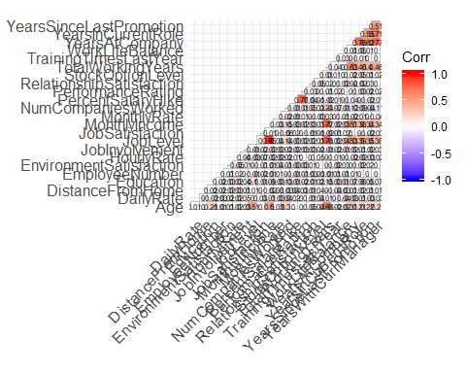 *Based on corr plot it is seen , there is not very strong correlation between ay of the deoendent vriables*

*Stacked Bar chart for categorical variables with Target variable*

Attr_Gender <- ggplot(HR_Data, aes(x = HR_Data$Gender , y = HR_Data$Attrition , fill = HR_Data$Attrition))+  
 geom_bar( position = "stack" , stat = "identity" ) + xlab("Gender") + ylab("Attrition")  
  
plot(Attr_Gender)

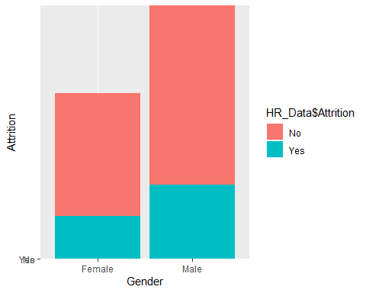

Attr_BusinessTravel <- ggplot(HR_Data, aes(x = HR_Data$BusinessTravel , y = HR_Data$Attrition , fill = HR_Data$Attrition))+  
 geom_bar( position = "stack" , stat = "identity" ) + xlab("BusinessTravel") + ylab("Attrition")  
  
plot(Attr_BusinessTravel)

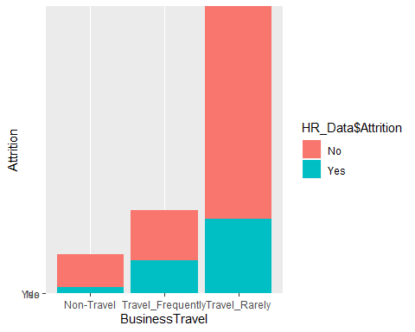

Attr_Department <- ggplot(HR_Data, aes(x = HR_Data$Department , y = HR_Data$Attrition , fill = HR_Data$Attrition))+  
 geom_bar( position = "stack" , stat = "identity" ) + xlab("Department") + ylab("Attrition")  
plot(Attr_Department)

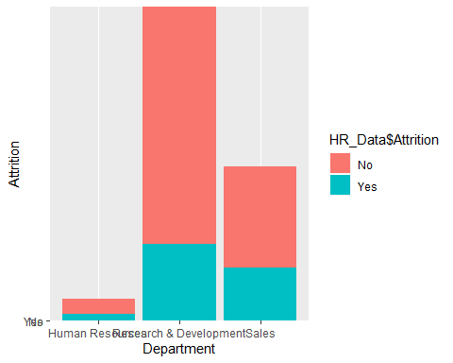

Attr_EducationField <- ggplot(HR_Data, aes(x = HR_Data$EducationField , y = HR_Data$Attrition , fill = HR_Data$Attrition))+  
 geom_bar( position = "stack" , stat = "identity" ) + xlab("EducationalField") + ylab("Attrition")  
  
plot(Attr_EducationField)

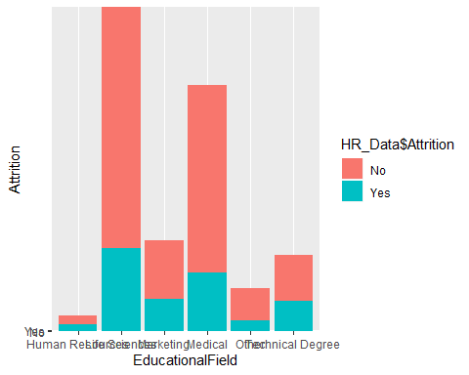

Attr_JobRole <- ggplot(HR_Data, aes(x = HR_Data$JobRole , y = HR_Data$Attrition , fill = HR_Data$Attrition))+  
 geom_bar( position = "stack" , stat = "identity" ) + xlab("JobRole") + ylab("Attrition")  
  
plot(Attr_JobRole)

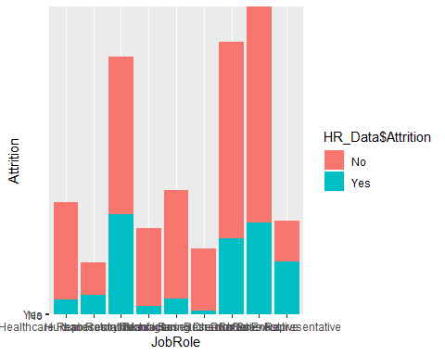

Attr_MaritalStatus <- ggplot(HR_Data, aes(x = HR_Data$MaritalStatus , y = HR_Data$Attrition , fill = HR_Data$Attrition))+  
 geom_bar( position = "stack" , stat = "identity" ) + xlab("MaritalStatus") + ylab("Attrition")  
  
plot(Attr_MaritalStatus)

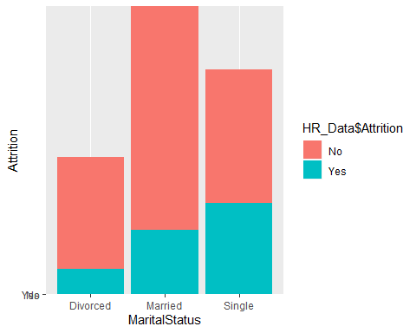

Attr_OverTime <- ggplot(HR_Data, aes(x = HR_Data$OverTime , y = HR_Data$Attrition , fill = HR_Data$Attrition))+  
 geom_bar( position = "stack" , stat = "identity" ) + xlab("Overtime") + ylab("Attrition")  
  
  
plot(Attr_OverTime)

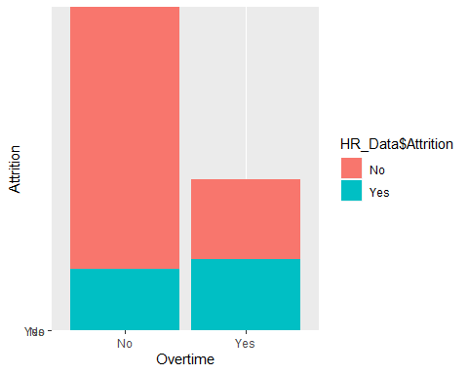

ggarrange(Attr_Gender, Attr_BusinessTravel , Attr_Department , Attr_EducationField, Attr_JobRole, Attr_MaritalStatus, Attr_OverTime + rremove("x.text"),  
 heights = c(4, 4 , 4 , 4), widths = c(15 ,15),  
 ncol = 2, nrow = 4)

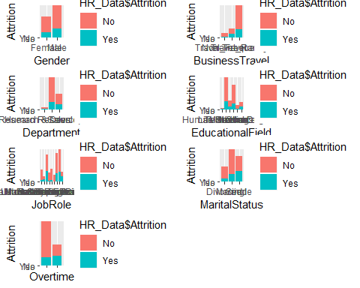

Note that the echo = FALSE parameter was added to the code chunk to prevent printing of the R code that generated the plot.

# Age  
  
Attr_Age <- ggplot(HR_Data, aes( x = HR_Data$Attrition , y = HR_Data$Age))+  
 geom_boxplot(stat ="boxplot" , outlier.colour = "red" ) + xlab("Attrition") + ylab("Age")  
  
plot(Attr_Age)

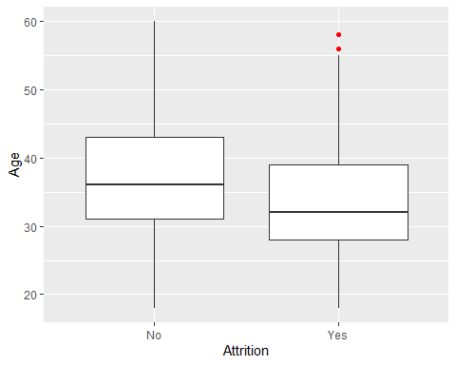

# DistanceFromHome  
  
Attr_DistanceFromHome <- ggplot(HR_Data, aes( x = HR_Data$Attrition , y = HR_Data$DistanceFromHome))+  
 geom_boxplot(stat ="boxplot" , outlier.colour = "red") + xlab("Attrition") + ylab("DistanceFromHome")  
  
plot(Attr_DistanceFromHome)

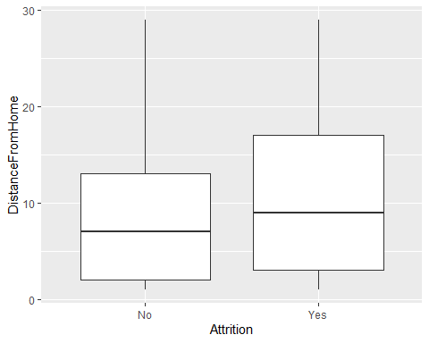

# Education  
  
Attr_Education <- ggplot(HR_Data, aes( x = HR_Data$Attrition , y = HR_Data$Education))+  
 geom_boxplot(stat ="boxplot" , outlier.colour = "red") + xlab("Attrition") + ylab("Education")  
  
plot(Attr_Education)

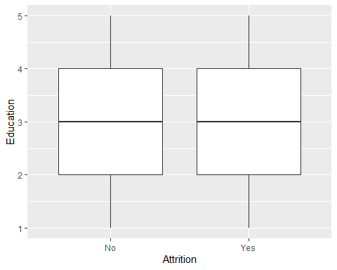

# JobInvolvement  
  
Attr_JobInvolvement <- ggplot(HR_Data, aes( x = HR_Data$Attrition , y = HR_Data$JobInvolvement))+  
 geom_boxplot(stat ="boxplot" , outlier.colour = "red") + xlab("Attrition") + ylab("JobInvolvement")  
  
plot(Attr_JobInvolvement)

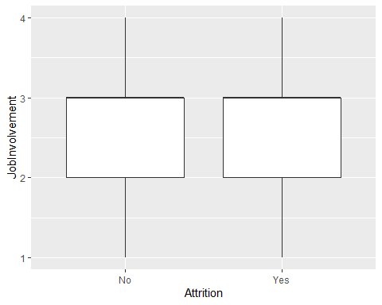

# JobLevel  
  
  
Attr_JobLevel <- ggplot(HR_Data, aes( x = HR_Data$Attrition , y = HR_Data$JobLevel))+  
 geom_boxplot(stat ="boxplot" , outlier.colour = "red") + xlab("Attrition") + ylab("JobLevel")  
  
plot(Attr_JobLevel)

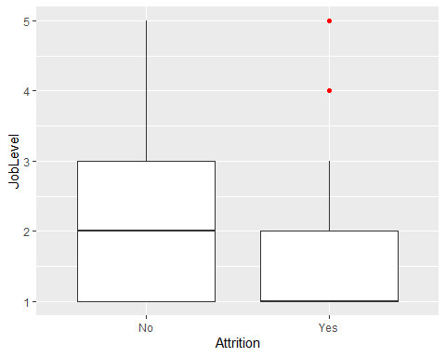

# JobSatisfaction  
  
  
Attr_JobSatisfaction <- ggplot(HR_Data, aes( x = HR_Data$Attrition , y = HR_Data$JobSatisfaction))+  
 geom_boxplot(stat ="boxplot" , outlier.colour = "red") + xlab("Attrition") + ylab("JobSatisfaction")  
  
  
plot(Attr_JobSatisfaction)

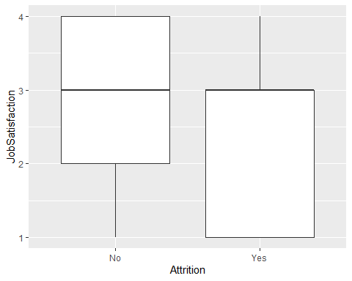

# MonthlyIncome  
  
Attr_MonthlyIncome <- ggplot(HR_Data, aes( x = HR_Data$Attrition , y = HR_Data$MonthlyIncome))+  
 geom_boxplot(stat ="boxplot" , outlier.colour = "red") + xlab("Attrition") + ylab("MonthlyIncome")  
  
  
plot(Attr_MonthlyIncome)

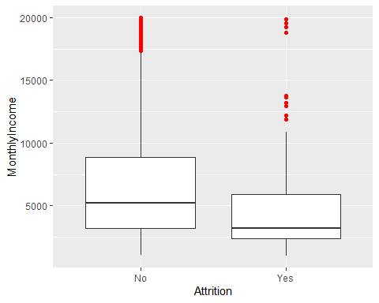

# PercentSalaryHike  
  
Attr_PercentSalaryHike <- ggplot(HR_Data, aes( x = HR_Data$Attrition , y = HR_Data$PercentSalaryHike))+  
 geom_boxplot(stat ="boxplot" , outlier.colour = "red") + xlab("Attrition") + ylab("PercentSalaryHike")  
  
  
plot(Attr_PercentSalaryHike)

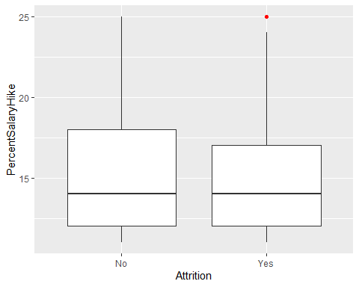

#   
# PerformanceRating  
#   
Attr_PerformanceRating <- ggplot(HR_Data, aes( x = HR_Data$Attrition , y = HR_Data$PerformanceRating))+  
 geom_boxplot(stat ="boxplot" , outlier.colour = "red") + xlab("Attrition") + ylab("PerformanceRating")  
  
  
plot(Attr_PerformanceRating)

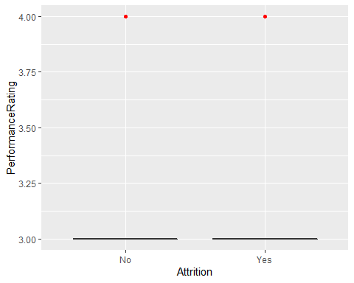

# RelationshipSatisfaction  
#   
  
Attr_RelationshipSatisfaction <- ggplot(HR_Data, aes( x = HR_Data$Attrition , y = HR_Data$RelationshipSatisfaction))+  
 geom_boxplot(stat ="boxplot" , outlier.colour = "red") + xlab("Attrition") + ylab("RelationshipSatisfaction")  
  
  
plot(Attr_RelationshipSatisfaction)

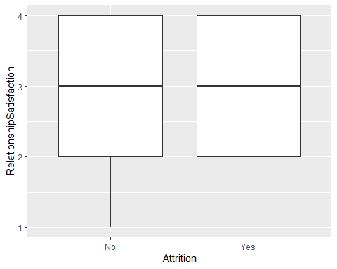

# StockOptionLevel  
  
  
Attr_StockOptionLevel <- ggplot(HR_Data, aes( x = HR_Data$Attrition , y = HR_Data$StockOptionLevel))+  
 geom_boxplot(stat ="boxplot" , outlier.colour = "red") + xlab("Attrition") + ylab("StockOptionLevel")  
  
  
plot(Attr_StockOptionLevel)

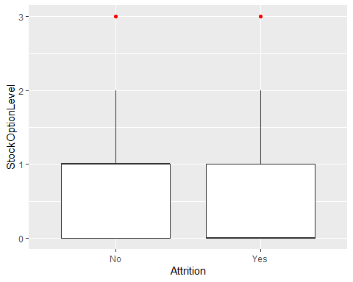

#   
# TotalWorkingYears  
#   
Attr_TotalWorkingYears <- ggplot(HR_Data, aes( x = HR_Data$Attrition , y = HR_Data$TotalWorkingYears))+  
 geom_boxplot(stat ="boxplot" , outlier.colour = "red") + xlab("Attrition") + ylab("TotalWorkingYears")  
  
  
plot(Attr_TotalWorkingYears)

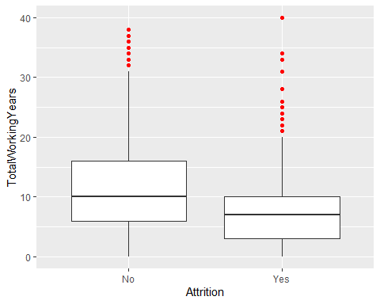

# TrainingTimesLastYear  
  
Attr_TrainingTimesLastYear <- ggplot(HR_Data, aes( x = HR_Data$Attrition , y = HR_Data$TrainingTimesLastYear))+  
 geom_boxplot(stat ="boxplot" , outlier.colour = "red") + xlab("Attrition") + ylab("TrainingTimesLastYear")  
  
  
plot(Attr_TrainingTimesLastYear)

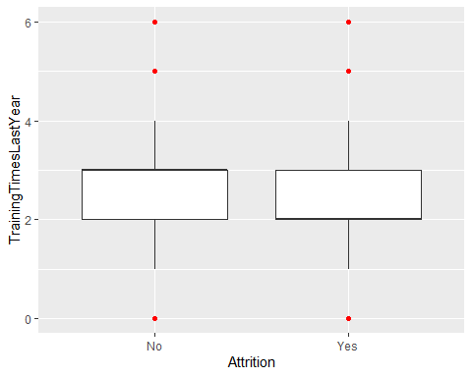

#   
# WorkLifeBalance  
#   
  
Attr_WorkLifeBalance <- ggplot(HR_Data, aes( x = HR_Data$Attrition , y = HR_Data$WorkLifeBalance))+  
 geom_boxplot(stat ="boxplot" , outlier.colour = "red") + xlab("Attrition") + ylab("WorkLifeBalance")  
  
  
plot(Attr_WorkLifeBalance)

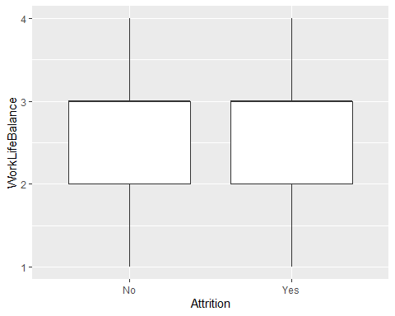

#   
# YearsAtCompany  
#   
Attr_YearsAtCompany <- ggplot(HR_Data, aes( x = HR_Data$Attrition , y = HR_Data$YearsAtCompany))+  
 geom_boxplot(stat ="boxplot" , outlier.colour = "red") + xlab("Attrition") + ylab("YearsAtCompany")  
  
  
plot(Attr_YearsAtCompany)

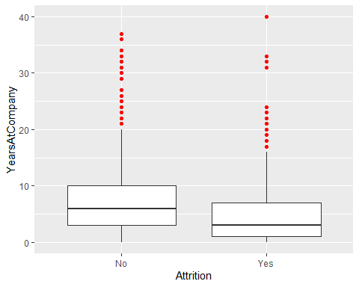

# YearsInCurrentRole  
#   
Attr_YearsInCurrentRole <- ggplot(HR_Data, aes( x = HR_Data$Attrition , y = HR_Data$YearsInCurrentRole))+  
 geom_boxplot(stat ="boxplot" , outlier.colour = "red") + xlab("Attrition") + ylab("YearsInCurrentRole")  
  
  
plot(Attr_YearsInCurrentRole)

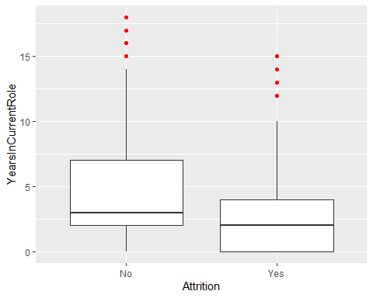

# YearsSinceLastPromotion  
#   
Attr_YearsSinceLastPromotion <- ggplot(HR_Data, aes( x = HR_Data$Attrition , y = HR_Data$YearsSinceLastPromotion))+  
 geom_boxplot(stat ="boxplot" , outlier.colour = "red") + xlab("Attrition") + ylab("YearsSinceLastPromotion")  
  
  
plot(Attr_YearsSinceLastPromotion)

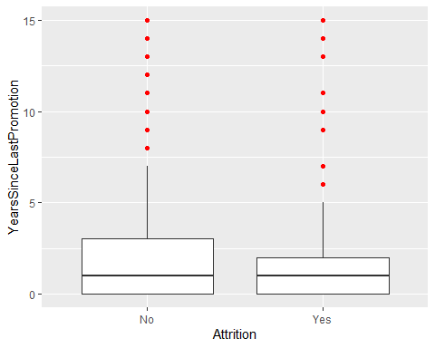

#   
# YearsWithCurrManager  
  
Attr_YearsWithCurrManager <- ggplot(HR_Data, aes( x = HR_Data$Attrition , y = HR_Data$YearsWithCurrManager))+  
 geom_boxplot(stat ="boxplot" , outlier.colour = "red") + xlab("Attrition") + ylab("YearsWithCurrManager")  
  
  
plot(Attr_YearsWithCurrManager)

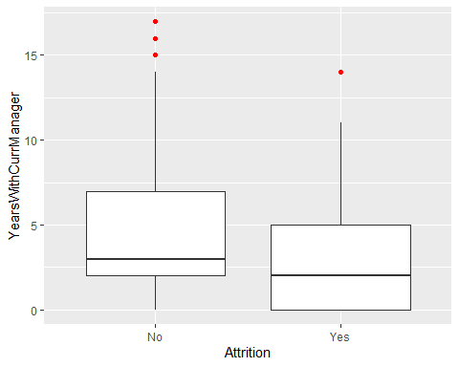

# ggarrange(Attr_Age , Attr_DistanceFromHome , Attr_Education, Attr_JobInvolvement , Attr_JobLevel , Attr_JobSatisfaction , Attr_MonthlyIncome , Attr_PercentSalaryHike , Attr_PerformanceRating , Attr_RelationshipSatisfaction , Attr_StockOptionLevel , Attr_TotalWorkingYears , Attr_TrainingTimesLastYear , Attr_WorLifeBalance , Attr_YearsAtCompany , Attr_YearsInCurrentRole , Attr_YearsSinceLastPromotion , Attr_YearsWithCurrManager + rremove("x.text"),heights = rep( 100 , each = 9), widths = c(15 ,15), ncol = 2, nrow = 9)

*Begin Decision tree analysis*

str(HR_Data)

## Classes 'spec_tbl_df', 'tbl_df', 'tbl' and 'data.frame': 2940 obs. of 35 variables:  
## $ Age : num 41 49 37 33 27 32 59 30 38 36 ...  
## $ Attrition : Factor w/ 2 levels "No","Yes": 2 1 2 1 1 1 1 1 1 1 ...  
## $ BusinessTravel : Factor w/ 3 levels "Non-Travel","Travel_Frequently",..: 3 2 3 2 3 2 3 3 2 3 ...  
## $ DailyRate : num 1102 279 1373 1392 591 ...  
## $ Department : Factor w/ 3 levels "Human Resources",..: 3 2 2 2 2 2 2 2 2 2 ...  
## $ DistanceFromHome : num 1 8 2 3 2 2 3 24 23 27 ...  
## $ Education : num 2 1 2 4 1 2 3 1 3 3 ...  
## $ EducationField : Factor w/ 6 levels "Human Resources",..: 2 2 5 2 4 2 4 2 2 4 ...  
## $ EmployeeCount : num 1 1 1 1 1 1 1 1 1 1 ...  
## $ EmployeeNumber : num 1 2 3 4 5 6 7 8 9 10 ...  
## $ EnvironmentSatisfaction : num 2 3 4 4 1 4 3 4 4 3 ...  
## $ Gender : Factor w/ 2 levels "Female","Male": 1 2 2 1 2 2 1 2 2 2 ...  
## $ HourlyRate : num 94 61 92 56 40 79 81 67 44 94 ...  
## $ JobInvolvement : num 3 2 2 3 3 3 4 3 2 3 ...  
## $ JobLevel : num 2 2 1 1 1 1 1 1 3 2 ...  
## $ JobRole : Factor w/ 9 levels "Healthcare Representative",..: 8 7 3 7 3 3 3 3 5 1 ...  
## $ JobSatisfaction : num 4 2 3 3 2 4 1 3 3 3 ...  
## $ MaritalStatus : Factor w/ 3 levels "Divorced","Married",..: 3 2 3 2 2 3 2 1 3 2 ...  
## $ MonthlyIncome : num 5993 5130 2090 2909 3468 ...  
## $ MonthlyRate : num 19479 24907 2396 23159 16632 ...  
## $ NumCompaniesWorked : num 8 1 6 1 9 0 4 1 0 6 ...  
## $ Over18 : Factor w/ 1 level "Y": 1 1 1 1 1 1 1 1 1 1 ...  
## $ OverTime : Factor w/ 2 levels "No","Yes": 2 1 2 2 1 1 2 1 1 1 ...  
## $ PercentSalaryHike : num 11 23 15 11 12 13 20 22 21 13 ...  
## $ PerformanceRating : num 3 4 3 3 3 3 4 4 4 3 ...  
## $ RelationshipSatisfaction: num 1 4 2 3 4 3 1 2 2 2 ...  
## $ StandardHours : num 80 80 80 80 80 80 80 80 80 80 ...  
## $ StockOptionLevel : num 0 1 0 0 1 0 3 1 0 2 ...  
## $ TotalWorkingYears : num 8 10 7 8 6 8 12 1 10 17 ...  
## $ TrainingTimesLastYear : num 0 3 3 3 3 2 3 2 2 3 ...  
## $ WorkLifeBalance : num 1 3 3 3 3 2 2 3 3 2 ...  
## $ YearsAtCompany : num 6 10 0 8 2 7 1 1 9 7 ...  
## $ YearsInCurrentRole : num 4 7 0 7 2 7 0 0 7 7 ...  
## $ YearsSinceLastPromotion : num 0 1 0 3 2 3 0 0 1 7 ...  
## $ YearsWithCurrManager : num 5 7 0 0 2 6 0 0 8 7 ...  
## - attr(*, "spec")=  
## .. cols(  
## .. Age = col_double(),  
## .. Attrition = col_character(),  
## .. BusinessTravel = col_character(),  
## .. DailyRate = col_double(),  
## .. Department = col_character(),  
## .. DistanceFromHome = col_double(),  
## .. Education = col_double(),  
## .. EducationField = col_character(),  
## .. EmployeeCount = col_double(),  
## .. EmployeeNumber = col_double(),  
## .. EnvironmentSatisfaction = col_double(),  
## .. Gender = col_character(),  
## .. HourlyRate = col_double(),  
## .. JobInvolvement = col_double(),  
## .. JobLevel = col_double(),  
## .. JobRole = col_character(),  
## .. JobSatisfaction = col_double(),  
## .. MaritalStatus = col_character(),  
## .. MonthlyIncome = col_double(),  
## .. MonthlyRate = col_double(),  
## .. NumCompaniesWorked = col_double(),  
## .. Over18 = col_character(),  
## .. OverTime = col_character(),  
## .. PercentSalaryHike = col_double(),  
## .. PerformanceRating = col_double(),  
## .. RelationshipSatisfaction = col_double(),  
## .. StandardHours = col_double(),  
## .. StockOptionLevel = col_double(),  
## .. TotalWorkingYears = col_double(),  
## .. TrainingTimesLastYear = col_double(),  
## .. WorkLifeBalance = col_double(),  
## .. YearsAtCompany = col_double(),  
## .. YearsInCurrentRole = col_double(),  
## .. YearsSinceLastPromotion = col_double(),  
## .. YearsWithCurrManager = col_double()  
## .. )

prop.table(table(HR_Data$Attrition))

##   
## No Yes   
## 0.8387755 0.1612245

library(caTools)

## Warning: package 'caTools' was built under R version 3.6.1

library(caret)

## Warning: package 'caret' was built under R version 3.6.1

library(rpart)

## Warning: package 'rpart' was built under R version 3.6.1

library(rpart.plot)

## Warning: package 'rpart.plot' was built under R version 3.6.1

*Based on the dataset shared , the data doesn’t seem be extremely biased towards a specific class i.e class of Yes / No*

## split into training and test sets  
  
  
set.seed(123)  
split = sample.split(HR_Data$Attrition, SplitRatio = 0.7)  
HR_traindata = subset(HR_Data, split == TRUE)  
HR_testdata = subset(HR_Data, split == FALSE)  
  
## Check if distribution of partition data is correct Testing dataset  
  
  
# Check the distribution of the proportion in train and test data as well  
  
prop.table(table(HR_traindata$Attrition))

##   
## No Yes   
## 0.8386783 0.1613217

prop.table(table(HR_testdata$Attrition))

##   
## No Yes   
## 0.8390023 0.1609977

*Post split , its seen that train and test data are split retaining the same ratio between Yes and No* *We should drop the 4 columns , which are not significant , as there is no criteria for them to split*

# Develop a fully grown tree  
set.seed(123)  
  
# data$EmployeeCount = NULL  
# data$EmployeeNumber = NULL  
# data$Over18 = NULL  
# data$StandardHours = NULL  
  
hr_tree_full = rpart(formula = HR_traindata$Attrition~., data = HR_traindata , method = "class" )  
rpart.plot(hr_tree_full, cex=0.5)

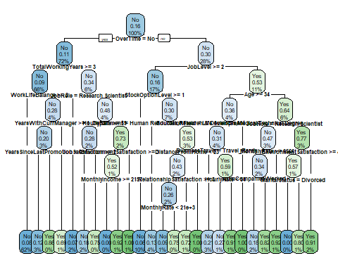

boxcols <- c("palegreen3", "orange")[hr_tree_full$frame$yval]  
  
par(xpd=TRUE)  
prp(hr_tree_full, faclen = 0, cex = 0.8, extra = 1, box.col = boxcols)

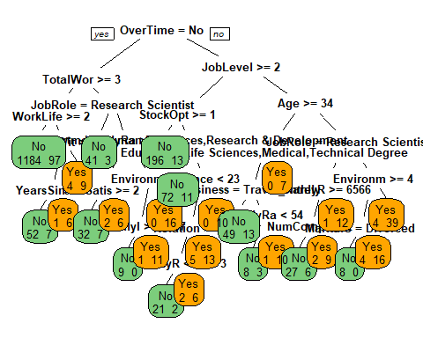

#summary(tree_full)

`*Variable importance of full Tree* ****************Documentation - Compare CART , RF and NN*********

#summary(hr_tree_fulltree_full)  
hr_tree_full$variable.importance

## JobRole MonthlyIncome TotalWorkingYears   
## 53.581458 50.985706 46.846094   
## JobLevel Age OverTime   
## 36.609214 32.337837 29.560112   
## YearsAtCompany MonthlyRate HourlyRate   
## 25.726497 17.200791 16.159010   
## StockOptionLevel NumCompaniesWorked EducationField   
## 15.926418 15.618099 14.531594   
## MaritalStatus Department EnvironmentSatisfaction   
## 13.766011 13.234490 13.132521   
## YearsWithCurrManager YearsInCurrentRole DailyRate   
## 12.560925 12.490785 12.490702   
## YearsSinceLastPromotion JobSatisfaction DistanceFromHome   
## 9.802058 9.737403 9.446297   
## WorkLifeBalance PercentSalaryHike BusinessTravel   
## 6.936529 6.720520 6.548583   
## RelationshipSatisfaction JobInvolvement EmployeeNumber   
## 6.217770 6.067617 3.095307   
## Education Gender TrainingTimesLastYear   
## 2.525662 1.619835 1.304698   
## PerformanceRating   
## 1.287001

hr_df_cart=data.frame(round(hr_tree_full$variable.importance,2))  
hr_df_cart

## round.hr_tree_full.variable.importance..2.  
## JobRole 53.58  
## MonthlyIncome 50.99  
## TotalWorkingYears 46.85  
## JobLevel 36.61  
## Age 32.34  
## OverTime 29.56  
## YearsAtCompany 25.73  
## MonthlyRate 17.20  
## HourlyRate 16.16  
## StockOptionLevel 15.93  
## NumCompaniesWorked 15.62  
## EducationField 14.53  
## MaritalStatus 13.77  
## Department 13.23  
## EnvironmentSatisfaction 13.13  
## YearsWithCurrManager 12.56  
## YearsInCurrentRole 12.49  
## DailyRate 12.49  
## YearsSinceLastPromotion 9.80  
## JobSatisfaction 9.74  
## DistanceFromHome 9.45  
## WorkLifeBalance 6.94  
## PercentSalaryHike 6.72  
## BusinessTravel 6.55  
## RelationshipSatisfaction 6.22  
## JobInvolvement 6.07  
## EmployeeNumber 3.10  
## Education 2.53  
## Gender 1.62  
## TrainingTimesLastYear 1.30  
## PerformanceRating 1.29

*Predict using Train and Test Dataset*

## Predict using the CART model  
HR_traindata$predict.class=predict(hr_tree_full,HR_traindata,type="class")  
HR_traindata$predict.score=predict(hr_tree_full,HR_traindata)  
head(HR_traindata$predict.score)

## No Yes  
## 1 0.2777778 0.72222222  
## 2 0.9242779 0.07572209  
## 3 0.8181818 0.18181818  
## 4 0.9242779 0.07572209  
## 5 0.9242779 0.07572209  
## 6 0.7903226 0.20967742

## Creating the confusion matrix  
tabtrain=with(HR_traindata,table(HR_traindata$Attrition,predict.class))  
tabtrain

## predict.class  
## No Yes  
## No 1699 27  
## Yes 162 170

TN_train = tabtrain[1,1]  
TP_train = tabtrain[2,2]  
FN_train = tabtrain[2,1]  
FP_train = tabtrain[1,2]  
  
train_acc = (TN_train+TP_train)/(TN_train+TP_train+FN_train+FP_train)  
train_acc

## [1] 0.9081633

train_sens = TP_train/(TP_train+FN_train)  
train_sens

## [1] 0.5120482

train_spec = TN_train/(TN_train+FP_train)  
train_spec

## [1] 0.9843569

# Prediction on Test Data using the same tree built  
  
## Predict using the CART model  
HR_testdata$predict.class=predict(hr_tree_full,HR_testdata,type="class")  
HR_testdata$predict.score=predict(hr_tree_full,HR_testdata)  
  
## Creating the confusion matrix  
tabtest=with(HR_testdata,table(HR_testdata$Attrition,predict.class))  
tabtest

## predict.class  
## No Yes  
## No 719 21  
## Yes 82 60

TN_test = tabtest[1,1]  
TP_test = tabtest[2,2]  
FN_test = tabtest[2,1]  
FP_test = tabtest[1,2]  
  
test_acc = (TN_test+TP_test)/(TN_test+TP_test+FN_test+FP_test)  
test_acc

## [1] 0.88322

test_sens = TP_test/(TP_test+FN_test)  
test_sens

## [1] 0.4225352

test_spec = TN_test/(TN_test+FP_test)  
test_spec

## [1] 0.9716216

*Comparing the results of train and test*

hr_df_results_train = data.frame(train_acc, train_sens, train_spec)  
names(hr_df_results_train) = c("ACC", "SENS", "SPEC")  
hr_df_results_test = data.frame(test_acc, test_sens, test_spec)  
names(hr_df_results_test) = c("ACC", "SENS", "SPEC")  
  
?rbind

## starting httpd help server ... done

hr_df_final =rbind(hr_df_results_train, hr_df_results_test)  
row.names(hr_df_final) = c('hr_tree_full_train', 'hr_tree_full_test')  
hr_df_final

## ACC SENS SPEC  
## hr_tree_full_train 0.9081633 0.5120482 0.9843569  
## hr_tree_full_test 0.8832200 0.4225352 0.9716216

*Model is performing relatively closer wrt Train and test data* *Next steps are to optimize the model , to validate for better accuracy and performance*

*Optimization chosen is by means of pruning the tree based on CV Error, which is minimum*

# Some cleanup before building the next tree  
  
#remove predicted score and class before running other models  
HR_traindata$predict.class = NULL  
HR_traindata$predict.score = NULL  
HR_testdata$predict.class = NULL  
HR_testdata$predict.score = NULL

*The unncessarily complex tree above can be pruned using a cost complexity threshold. Using a complexity threshold of 0.015 gives us a much simpler tree*

hr_ptree = prune(hr_tree_full, cp= 0.00001 ,"CP" )  
printcp(hr_ptree)

##   
## Classification tree:  
## rpart(formula = HR_traindata$Attrition ~ ., data = HR_traindata,   
## method = "class")  
##   
## Variables actually used in tree construction:  
## [1] Age BusinessTravel   
## [3] Department DistanceFromHome   
## [5] EducationField EnvironmentSatisfaction   
## [7] HourlyRate JobLevel   
## [9] JobRole JobSatisfaction   
## [11] MaritalStatus MonthlyIncome   
## [13] MonthlyRate NumCompaniesWorked   
## [15] OverTime RelationshipSatisfaction  
## [17] StockOptionLevel TotalWorkingYears   
## [19] WorkLifeBalance YearsSinceLastPromotion   
## [21] YearsWithCurrManager   
##   
## Root node error: 332/2058 = 0.16132  
##   
## n= 2058   
##   
## CP nsplit rel error xerror xstd  
## 1 0.036145 0 1.00000 1.00000 0.050261  
## 2 0.021084 3 0.89157 0.99699 0.050200  
## 3 0.017068 7 0.80723 0.96687 0.049578  
## 4 0.013554 10 0.75602 0.90060 0.048151  
## 5 0.012048 18 0.64759 0.88253 0.047747  
## 6 0.010040 22 0.59940 0.85843 0.047197  
## 7 0.010000 25 0.56928 0.84337 0.046847

hr_ptree

## n= 2058   
##   
## node), split, n, loss, yval, (yprob)  
## * denotes terminal node  
##   
## 1) root 2058 332 No (0.83867833 0.16132167)   
## 2) OverTime=No 1488 162 No (0.89112903 0.10887097)   
## 4) TotalWorkingYears>=2.5 1360 119 No (0.91250000 0.08750000)   
## 8) WorkLifeBalance>=1.5 1281 97 No (0.92427791 0.07572209) *  
## 9) WorkLifeBalance< 1.5 79 22 No (0.72151899 0.27848101)   
## 18) YearsWithCurrManager>=0.5 66 13 No (0.80303030 0.19696970)   
## 36) YearsSinceLastPromotion< 6 59 7 No (0.88135593 0.11864407) *  
## 37) YearsSinceLastPromotion>=6 7 1 Yes (0.14285714 0.85714286) *  
## 19) YearsWithCurrManager< 0.5 13 4 Yes (0.30769231 0.69230769) *  
## 5) TotalWorkingYears< 2.5 128 43 No (0.66406250 0.33593750)   
## 10) JobRole=Research Scientist 44 3 No (0.93181818 0.06818182) *  
## 11) JobRole=Human Resources,Laboratory Technician,Sales Representative 84 40 No (0.52380952 0.47619048)   
## 22) HourlyRate>=58.5 47 13 No (0.72340426 0.27659574)   
## 44) JobSatisfaction>=1.5 39 7 No (0.82051282 0.17948718) *  
## 45) JobSatisfaction< 1.5 8 2 Yes (0.25000000 0.75000000) *  
## 23) HourlyRate< 58.5 37 10 Yes (0.27027027 0.72972973)   
## 46) EnvironmentSatisfaction>=2.5 21 10 Yes (0.47619048 0.52380952)   
## 92) MonthlyIncome>=2156.5 9 0 No (1.00000000 0.00000000) *  
## 93) MonthlyIncome< 2156.5 12 1 Yes (0.08333333 0.91666667) *  
## 47) EnvironmentSatisfaction< 2.5 16 0 Yes (0.00000000 1.00000000) *  
## 3) OverTime=Yes 570 170 No (0.70175439 0.29824561)   
## 6) JobLevel>=1.5 351 55 No (0.84330484 0.15669516)   
## 12) StockOptionLevel>=0.5 209 13 No (0.93779904 0.06220096) *  
## 13) StockOptionLevel< 0.5 142 42 No (0.70422535 0.29577465)   
## 26) Department=Human Resources,Research & Development 83 11 No (0.86746988 0.13253012) *  
## 27) Department=Sales 59 28 Yes (0.47457627 0.52542373)   
## 54) DistanceFromHome< 22.5 49 21 No (0.57142857 0.42857143)   
## 108) RelationshipSatisfaction>=2.5 31 8 No (0.74193548 0.25806452)   
## 216) MonthlyRate< 21282 23 2 No (0.91304348 0.08695652) *  
## 217) MonthlyRate>=21282 8 2 Yes (0.25000000 0.75000000) *  
## 109) RelationshipSatisfaction< 2.5 18 5 Yes (0.27777778 0.72222222) *  
## 55) DistanceFromHome>=22.5 10 0 Yes (0.00000000 1.00000000) *  
## 7) JobLevel< 1.5 219 104 Yes (0.47488584 0.52511416)   
## 14) Age>=33.5 91 33 No (0.63736264 0.36263736)   
## 28) EducationField=Life Sciences,Medical,Technical Degree 84 26 No (0.69047619 0.30952381)   
## 56) BusinessTravel=Travel_Rarely 62 13 No (0.79032258 0.20967742) *  
## 57) BusinessTravel=Non-Travel,Travel_Frequently 22 9 Yes (0.40909091 0.59090909)   
## 114) HourlyRate< 53.5 11 3 No (0.72727273 0.27272727) *  
## 115) HourlyRate>=53.5 11 1 Yes (0.09090909 0.90909091) *  
## 29) EducationField=Human Resources,Marketing,Other 7 0 Yes (0.00000000 1.00000000) *  
## 15) Age< 33.5 128 46 Yes (0.35937500 0.64062500)   
## 30) JobRole=Research Scientist 57 27 No (0.52631579 0.47368421)   
## 60) MonthlyRate>=6566 44 15 No (0.65909091 0.34090909)   
## 120) NumCompaniesWorked< 2 33 6 No (0.81818182 0.18181818) *  
## 121) NumCompaniesWorked>=2 11 2 Yes (0.18181818 0.81818182) *  
## 61) MonthlyRate< 6566 13 1 Yes (0.07692308 0.92307692) *  
## 31) JobRole=Human Resources,Laboratory Technician,Sales Representative 71 16 Yes (0.22535211 0.77464789)   
## 62) EnvironmentSatisfaction>=3.5 28 12 Yes (0.42857143 0.57142857)   
## 124) MaritalStatus=Divorced 8 0 No (1.00000000 0.00000000) *  
## 125) MaritalStatus=Married,Single 20 4 Yes (0.20000000 0.80000000) *  
## 63) EnvironmentSatisfaction< 3.5 43 4 Yes (0.09302326 0.90697674) *

# rpart.plot(hr_ptree)  
  
rpart.plot(hr_ptree, cex=0.8)

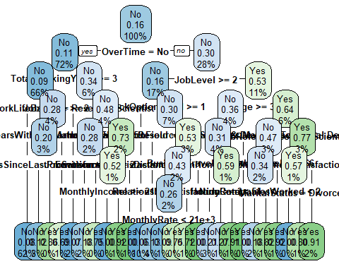

boxcols <- c("palegreen3", "orange")[hr_ptree$frame$yval]  
  
par(xpd=TRUE)  
prp(hr_ptree, faclen = 0, cex = 0.8, extra = 1, box.col = boxcols)



#Variable Importance  
hr_ptree$variable.importance

## JobRole MonthlyIncome TotalWorkingYears   
## 53.581458 50.985706 46.846094   
## JobLevel Age OverTime   
## 36.609214 32.337837 29.560112   
## YearsAtCompany MonthlyRate HourlyRate   
## 25.726497 17.200791 16.159010   
## StockOptionLevel NumCompaniesWorked EducationField   
## 15.926418 15.618099 14.531594   
## MaritalStatus Department EnvironmentSatisfaction   
## 13.766011 13.234490 13.132521   
## YearsWithCurrManager YearsInCurrentRole DailyRate   
## 12.560925 12.490785 12.490702   
## YearsSinceLastPromotion JobSatisfaction DistanceFromHome   
## 9.802058 9.737403 9.446297   
## WorkLifeBalance PercentSalaryHike BusinessTravel   
## 6.936529 6.720520 6.548583   
## RelationshipSatisfaction JobInvolvement EmployeeNumber   
## 6.217770 6.067617 3.095307   
## Education Gender TrainingTimesLastYear   
## 2.525662 1.619835 1.304698   
## PerformanceRating   
## 1.287001

#summary(hr_tree_fulltree_full)  
hr_ptree$variable.importance

## JobRole MonthlyIncome TotalWorkingYears   
## 53.581458 50.985706 46.846094   
## JobLevel Age OverTime   
## 36.609214 32.337837 29.560112   
## YearsAtCompany MonthlyRate HourlyRate   
## 25.726497 17.200791 16.159010   
## StockOptionLevel NumCompaniesWorked EducationField   
## 15.926418 15.618099 14.531594   
## MaritalStatus Department EnvironmentSatisfaction   
## 13.766011 13.234490 13.132521   
## YearsWithCurrManager YearsInCurrentRole DailyRate   
## 12.560925 12.490785 12.490702   
## YearsSinceLastPromotion JobSatisfaction DistanceFromHome   
## 9.802058 9.737403 9.446297   
## WorkLifeBalance PercentSalaryHike BusinessTravel   
## 6.936529 6.720520 6.548583   
## RelationshipSatisfaction JobInvolvement EmployeeNumber   
## 6.217770 6.067617 3.095307   
## Education Gender TrainingTimesLastYear   
## 2.525662 1.619835 1.304698   
## PerformanceRating   
## 1.287001

hr_df_cart=data.frame(round(hr_ptree$variable.importance,2))  
hr_df_cart

## round.hr_ptree.variable.importance..2.  
## JobRole 53.58  
## MonthlyIncome 50.99  
## TotalWorkingYears 46.85  
## JobLevel 36.61  
## Age 32.34  
## OverTime 29.56  
## YearsAtCompany 25.73  
## MonthlyRate 17.20  
## HourlyRate 16.16  
## StockOptionLevel 15.93  
## NumCompaniesWorked 15.62  
## EducationField 14.53  
## MaritalStatus 13.77  
## Department 13.23  
## EnvironmentSatisfaction 13.13  
## YearsWithCurrManager 12.56  
## YearsInCurrentRole 12.49  
## DailyRate 12.49  
## YearsSinceLastPromotion 9.80  
## JobSatisfaction 9.74  
## DistanceFromHome 9.45  
## WorkLifeBalance 6.94  
## PercentSalaryHike 6.72  
## BusinessTravel 6.55  
## RelationshipSatisfaction 6.22  
## JobInvolvement 6.07  
## EmployeeNumber 3.10  
## Education 2.53  
## Gender 1.62  
## TrainingTimesLastYear 1.30  
## PerformanceRating 1.29

*Predict using Train and Test Dataset of pruned Tree , pruned on CP*

## Predict using the CART model  
HR_traindata$predict.class=predict(hr_ptree,HR_traindata,type="class")  
HR_traindata$predict.score=predict(hr_ptree,HR_traindata)  
head(HR_traindata$predict.score)

## No Yes  
## 1 0.2777778 0.72222222  
## 2 0.9242779 0.07572209  
## 3 0.8181818 0.18181818  
## 4 0.9242779 0.07572209  
## 5 0.9242779 0.07572209  
## 6 0.7903226 0.20967742

## Creating the confusion matrix  
tabtrain=with(HR_traindata,table(HR_traindata$Attrition,predict.class))  
tabtrain

## predict.class  
## No Yes  
## No 1699 27  
## Yes 162 170

TN_train = tabtrain[1,1]  
TP_train = tabtrain[2,2]  
FN_train = tabtrain[2,1]  
FP_train = tabtrain[1,2]  
  
train_acc = (TN_train+TP_train)/(TN_train+TP_train+FN_train+FP_train)  
train_acc

## [1] 0.9081633

train_sens = TP_train/(TP_train+FN_train)  
train_sens

## [1] 0.5120482

train_spec = TN_train/(TN_train+FP_train)  
train_spec

## [1] 0.9843569

# Prediction on Test Data using the same tree built  
  
## Predict using the CART model  
HR_testdata$predict.class=predict(hr_ptree,HR_testdata,type="class")  
HR_testdata$predict.score=predict(hr_ptree,HR_testdata)  
  
## Creating the confusion matrix  
tabtest=with(HR_testdata,table(HR_testdata$Attrition,predict.class))  
tabtest

## predict.class  
## No Yes  
## No 719 21  
## Yes 82 60

TN_test = tabtest[1,1]  
TP_test = tabtest[2,2]  
FN_test = tabtest[2,1]  
FP_test = tabtest[1,2]  
  
test_acc = (TN_test+TP_test)/(TN_test+TP_test+FN_test+FP_test)  
test_acc

## [1] 0.88322

test_sens = TP_test/(TP_test+FN_test)  
test_sens

## [1] 0.4225352

test_spec = TN_test/(TN_test+FP_test)  
test_spec

## [1] 0.9716216

*Comparing the results of train and test of a pruned tree pruned on cp*

hr_df_results_train = data.frame(train_acc, train_sens, train_spec)  
names(hr_df_results_train) = c("ACC", "SENS", "SPEC")  
hr_df_results_test = data.frame(test_acc, test_sens, test_spec)  
names(hr_df_results_test) = c("ACC", "SENS", "SPEC")  
  
?rbind  
hr_df_final =rbind(hr_df_results_train, hr_df_results_test)  
row.names(hr_df_final) = c('hr_pruned_cp_tree_train', 'hr_pruned_cp_tree_test')  
hr_df_final

## ACC SENS SPEC  
## hr_pruned_cp_tree_train 0.9081633 0.5120482 0.9843569  
## hr_pruned_cp_tree_test 0.8832200 0.4225352 0.9716216

*Not much of change seen after pruning the tree based on CP* *Try pruning the tree based on lowest value of CV , which is considering the option of pruning based on best CP*

*cleanup predictor collector variables before that*

#remove predicted score and class before running other models  
HR_traindata$predict.class = NULL  
HR_traindata$predict.score = NULL  
HR_testdata$predict.class = NULL  
HR_testdata$predict.score = NULL

*Pruning for best CP, based on XV at a minimum*

library(rpart.plot)  
printcp(hr_tree_full)

##   
## Classification tree:  
## rpart(formula = HR_traindata$Attrition ~ ., data = HR_traindata,   
## method = "class")  
##   
## Variables actually used in tree construction:  
## [1] Age BusinessTravel   
## [3] Department DistanceFromHome   
## [5] EducationField EnvironmentSatisfaction   
## [7] HourlyRate JobLevel   
## [9] JobRole JobSatisfaction   
## [11] MaritalStatus MonthlyIncome   
## [13] MonthlyRate NumCompaniesWorked   
## [15] OverTime RelationshipSatisfaction  
## [17] StockOptionLevel TotalWorkingYears   
## [19] WorkLifeBalance YearsSinceLastPromotion   
## [21] YearsWithCurrManager   
##   
## Root node error: 332/2058 = 0.16132  
##   
## n= 2058   
##   
## CP nsplit rel error xerror xstd  
## 1 0.036145 0 1.00000 1.00000 0.050261  
## 2 0.021084 3 0.89157 0.99699 0.050200  
## 3 0.017068 7 0.80723 0.96687 0.049578  
## 4 0.013554 10 0.75602 0.90060 0.048151  
## 5 0.012048 18 0.64759 0.88253 0.047747  
## 6 0.010040 22 0.59940 0.85843 0.047197  
## 7 0.010000 25 0.56928 0.84337 0.046847

plotcp(hr_tree_full)

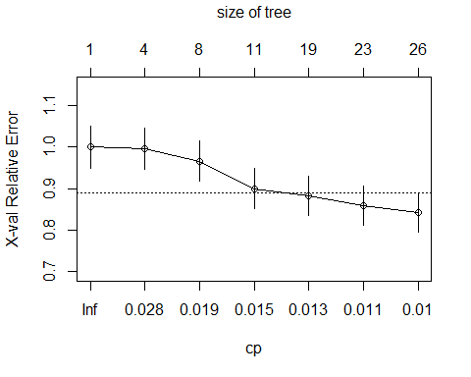

hr_bestcp=hr_tree_full$cptable[which.min(hr_tree_full$cptable[,"xerror"]),"CP"]  
hr_bestcp

## [1] 0.01

plot(hr_tree_full$cptable)

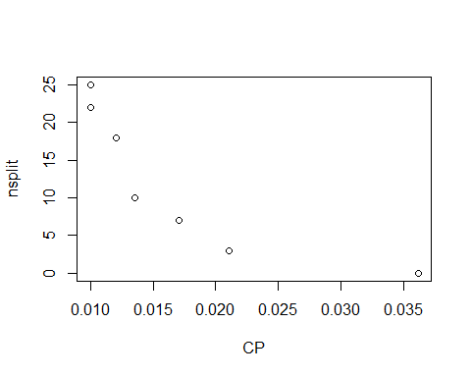

hr_best_ptree=prune(hr_tree_full,cp=hr_bestcp)  
print(hr_best_ptree)

## n= 2058   
##   
## node), split, n, loss, yval, (yprob)  
## * denotes terminal node  
##   
## 1) root 2058 332 No (0.83867833 0.16132167)   
## 2) OverTime=No 1488 162 No (0.89112903 0.10887097)   
## 4) TotalWorkingYears>=2.5 1360 119 No (0.91250000 0.08750000)   
## 8) WorkLifeBalance>=1.5 1281 97 No (0.92427791 0.07572209) *  
## 9) WorkLifeBalance< 1.5 79 22 No (0.72151899 0.27848101)   
## 18) YearsWithCurrManager>=0.5 66 13 No (0.80303030 0.19696970)   
## 36) YearsSinceLastPromotion< 6 59 7 No (0.88135593 0.11864407) *  
## 37) YearsSinceLastPromotion>=6 7 1 Yes (0.14285714 0.85714286) *  
## 19) YearsWithCurrManager< 0.5 13 4 Yes (0.30769231 0.69230769) *  
## 5) TotalWorkingYears< 2.5 128 43 No (0.66406250 0.33593750)   
## 10) JobRole=Research Scientist 44 3 No (0.93181818 0.06818182) *  
## 11) JobRole=Human Resources,Laboratory Technician,Sales Representative 84 40 No (0.52380952 0.47619048)   
## 22) HourlyRate>=58.5 47 13 No (0.72340426 0.27659574)   
## 44) JobSatisfaction>=1.5 39 7 No (0.82051282 0.17948718) *  
## 45) JobSatisfaction< 1.5 8 2 Yes (0.25000000 0.75000000) *  
## 23) HourlyRate< 58.5 37 10 Yes (0.27027027 0.72972973)   
## 46) EnvironmentSatisfaction>=2.5 21 10 Yes (0.47619048 0.52380952)   
## 92) MonthlyIncome>=2156.5 9 0 No (1.00000000 0.00000000) *  
## 93) MonthlyIncome< 2156.5 12 1 Yes (0.08333333 0.91666667) *  
## 47) EnvironmentSatisfaction< 2.5 16 0 Yes (0.00000000 1.00000000) *  
## 3) OverTime=Yes 570 170 No (0.70175439 0.29824561)   
## 6) JobLevel>=1.5 351 55 No (0.84330484 0.15669516)   
## 12) StockOptionLevel>=0.5 209 13 No (0.93779904 0.06220096) *  
## 13) StockOptionLevel< 0.5 142 42 No (0.70422535 0.29577465)   
## 26) Department=Human Resources,Research & Development 83 11 No (0.86746988 0.13253012) *  
## 27) Department=Sales 59 28 Yes (0.47457627 0.52542373)   
## 54) DistanceFromHome< 22.5 49 21 No (0.57142857 0.42857143)   
## 108) RelationshipSatisfaction>=2.5 31 8 No (0.74193548 0.25806452)   
## 216) MonthlyRate< 21282 23 2 No (0.91304348 0.08695652) *  
## 217) MonthlyRate>=21282 8 2 Yes (0.25000000 0.75000000) *  
## 109) RelationshipSatisfaction< 2.5 18 5 Yes (0.27777778 0.72222222) *  
## 55) DistanceFromHome>=22.5 10 0 Yes (0.00000000 1.00000000) *  
## 7) JobLevel< 1.5 219 104 Yes (0.47488584 0.52511416)   
## 14) Age>=33.5 91 33 No (0.63736264 0.36263736)   
## 28) EducationField=Life Sciences,Medical,Technical Degree 84 26 No (0.69047619 0.30952381)   
## 56) BusinessTravel=Travel_Rarely 62 13 No (0.79032258 0.20967742) *  
## 57) BusinessTravel=Non-Travel,Travel_Frequently 22 9 Yes (0.40909091 0.59090909)   
## 114) HourlyRate< 53.5 11 3 No (0.72727273 0.27272727) *  
## 115) HourlyRate>=53.5 11 1 Yes (0.09090909 0.90909091) *  
## 29) EducationField=Human Resources,Marketing,Other 7 0 Yes (0.00000000 1.00000000) *  
## 15) Age< 33.5 128 46 Yes (0.35937500 0.64062500)   
## 30) JobRole=Research Scientist 57 27 No (0.52631579 0.47368421)   
## 60) MonthlyRate>=6566 44 15 No (0.65909091 0.34090909)   
## 120) NumCompaniesWorked< 2 33 6 No (0.81818182 0.18181818) *  
## 121) NumCompaniesWorked>=2 11 2 Yes (0.18181818 0.81818182) *  
## 61) MonthlyRate< 6566 13 1 Yes (0.07692308 0.92307692) *  
## 31) JobRole=Human Resources,Laboratory Technician,Sales Representative 71 16 Yes (0.22535211 0.77464789)   
## 62) EnvironmentSatisfaction>=3.5 28 12 Yes (0.42857143 0.57142857)   
## 124) MaritalStatus=Divorced 8 0 No (1.00000000 0.00000000) *  
## 125) MaritalStatus=Married,Single 20 4 Yes (0.20000000 0.80000000) *  
## 63) EnvironmentSatisfaction< 3.5 43 4 Yes (0.09302326 0.90697674) *

rpart.plot(hr_tree_full, cex = 0.8)



*Summary of Variable Importance for Bestfit Tree*

#summary(hr_tree_fulltree_full)  
hr_best_ptree$variable.importance

## JobRole MonthlyIncome TotalWorkingYears   
## 53.581458 50.985706 46.846094   
## JobLevel Age OverTime   
## 36.609214 32.337837 29.560112   
## YearsAtCompany MonthlyRate HourlyRate   
## 25.726497 17.200791 16.159010   
## StockOptionLevel NumCompaniesWorked EducationField   
## 15.926418 15.618099 14.531594   
## MaritalStatus Department EnvironmentSatisfaction   
## 13.766011 13.234490 13.132521   
## YearsWithCurrManager YearsInCurrentRole DailyRate   
## 12.560925 12.490785 12.490702   
## YearsSinceLastPromotion JobSatisfaction DistanceFromHome   
## 9.802058 9.737403 9.446297   
## WorkLifeBalance PercentSalaryHike BusinessTravel   
## 6.936529 6.720520 6.548583   
## RelationshipSatisfaction JobInvolvement EmployeeNumber   
## 6.217770 6.067617 3.095307   
## Education Gender TrainingTimesLastYear   
## 2.525662 1.619835 1.304698   
## PerformanceRating   
## 1.287001

hr_df_cart=data.frame(round(hr_best_ptree$variable.importance,2))  
hr_df_cart

## round.hr_best_ptree.variable.importance..2.  
## JobRole 53.58  
## MonthlyIncome 50.99  
## TotalWorkingYears 46.85  
## JobLevel 36.61  
## Age 32.34  
## OverTime 29.56  
## YearsAtCompany 25.73  
## MonthlyRate 17.20  
## HourlyRate 16.16  
## StockOptionLevel 15.93  
## NumCompaniesWorked 15.62  
## EducationField 14.53  
## MaritalStatus 13.77  
## Department 13.23  
## EnvironmentSatisfaction 13.13  
## YearsWithCurrManager 12.56  
## YearsInCurrentRole 12.49  
## DailyRate 12.49  
## YearsSinceLastPromotion 9.80  
## JobSatisfaction 9.74  
## DistanceFromHome 9.45  
## WorkLifeBalance 6.94  
## PercentSalaryHike 6.72  
## BusinessTravel 6.55  
## RelationshipSatisfaction 6.22  
## JobInvolvement 6.07  
## EmployeeNumber 3.10  
## Education 2.53  
## Gender 1.62  
## TrainingTimesLastYear 1.30  
## PerformanceRating 1.29

*Predict using Train and Test Dataset of pruned Tree , pruned on best CP with Min XV*

## Predict using the CART model  
HR_traindata$predict.class=predict(hr_best_ptree,HR_traindata,type="class")  
HR_traindata$predict.score=predict(hr_best_ptree,HR_traindata)  
head(HR_traindata$predict.score)

## No Yes  
## 1 0.2777778 0.72222222  
## 2 0.9242779 0.07572209  
## 3 0.8181818 0.18181818  
## 4 0.9242779 0.07572209  
## 5 0.9242779 0.07572209  
## 6 0.7903226 0.20967742

## Creating the confusion matrix  
tabtrain=with(HR_traindata,table(HR_traindata$Attrition,predict.class))  
tabtrain

## predict.class  
## No Yes  
## No 1699 27  
## Yes 162 170

TN_train = tabtrain[1,1]  
TP_train = tabtrain[2,2]  
FN_train = tabtrain[2,1]  
FP_train = tabtrain[1,2]  
  
train_acc = (TN_train+TP_train)/(TN_train+TP_train+FN_train+FP_train)  
train_acc

## [1] 0.9081633

train_sens = TP_train/(TP_train+FN_train)  
train_sens

## [1] 0.5120482

train_spec = TN_train/(TN_train+FP_train)  
train_spec

## [1] 0.9843569

# Prediction on Test Data using the same tree built  
  
## Predict using the CART model  
HR_testdata$predict.class=predict(hr_best_ptree,HR_testdata,type="class")  
HR_testdata$predict.score=predict(hr_best_ptree,HR_testdata)  
  
## Creating the confusion matrix  
tabtest=with(HR_testdata,table(HR_testdata$Attrition,predict.class))  
tabtest

## predict.class  
## No Yes  
## No 719 21  
## Yes 82 60

TN_test = tabtest[1,1]  
TP_test = tabtest[2,2]  
FN_test = tabtest[2,1]  
FP_test = tabtest[1,2]  
  
test_acc = (TN_test+TP_test)/(TN_test+TP_test+FN_test+FP_test)  
test_acc

## [1] 0.88322

test_sens = TP_test/(TP_test+FN_test)  
test_sens

## [1] 0.4225352

test_spec = TN_test/(TN_test+FP_test)  
test_spec

## [1] 0.9716216

*Comparing the results of train and test of a pruned tree pruned on best cp with min XV*

hr_df_results_train = data.frame(train_acc, train_sens, train_spec)  
names(hr_df_results_train) = c("ACC", "SENS", "SPEC")  
hr_df_results_test = data.frame(test_acc, test_sens, test_spec)  
names(hr_df_results_test) = c("ACC", "SENS", "SPEC")  
  
?rbind  
hr_df_final =rbind(hr_df_results_train, hr_df_results_test)  
row.names(hr_df_final) = c('hr_pruned_bestxv_tree_train', 'hr_pruned_bestxv_tree_test')  
hr_df_final

## ACC SENS SPEC  
## hr_pruned_bestxv_tree_train 0.9081633 0.5120482 0.9843569  
## hr_pruned_bestxv_tree_test 0.8832200 0.4225352 0.9716216

#Calculate AUC and KS with best model

## Predict using the CART model  
HR_traindata$predict.class=predict(hr_best_ptree,HR_traindata,type="class")  
HR_traindata$predict.score=predict(hr_best_ptree,HR_traindata)  
HR_traindata$predict.score

## No Yes  
## 1 0.27777778 0.72222222  
## 2 0.92427791 0.07572209  
## 3 0.81818182 0.18181818  
## 4 0.92427791 0.07572209  
## 5 0.92427791 0.07572209  
## 6 0.79032258 0.20967742  
## 7 0.92427791 0.07572209  
## 8 0.92427791 0.07572209  
## 9 0.86746988 0.13253012  
## 10 0.92427791 0.07572209  
## 11 0.09302326 0.90697674  
## 12 0.92427791 0.07572209  
## 13 0.81818182 0.18181818  
## 14 1.00000000 0.00000000  
## 15 0.92427791 0.07572209  
## 16 0.92427791 0.07572209  
## 17 0.93181818 0.06818182  
## 18 0.92427791 0.07572209  
## 19 0.07692308 0.92307692  
## 20 0.92427791 0.07572209  
## 21 0.92427791 0.07572209  
## 22 0.92427791 0.07572209  
## 23 0.92427791 0.07572209  
## 24 0.92427791 0.07572209  
## 25 0.92427791 0.07572209  
## 26 0.00000000 1.00000000  
## 27 0.82051282 0.17948718  
## 28 0.79032258 0.20967742  
## 29 0.92427791 0.07572209  
## 30 0.82051282 0.17948718  
## 31 1.00000000 0.00000000  
## 32 0.00000000 1.00000000  
## 33 0.92427791 0.07572209  
## 34 0.92427791 0.07572209  
## 35 0.92427791 0.07572209  
## 36 0.91304348 0.08695652  
## 37 0.86746988 0.13253012  
## 38 0.09302326 0.90697674  
## 39 0.93779904 0.06220096  
## 40 0.93779904 0.06220096  
## 41 0.86746988 0.13253012  
## 42 0.79032258 0.20967742  
## 43 0.92427791 0.07572209  
## 44 0.93779904 0.06220096  
## 45 0.92427791 0.07572209  
## 46 0.93779904 0.06220096  
## 47 0.92427791 0.07572209  
## 48 0.92427791 0.07572209  
## 49 0.92427791 0.07572209  
## 50 0.92427791 0.07572209  
## 51 0.79032258 0.20967742  
## 52 0.92427791 0.07572209  
## 53 0.93181818 0.06818182  
## 54 0.92427791 0.07572209  
## 55 0.92427791 0.07572209  
## 56 0.92427791 0.07572209  
## 57 0.93779904 0.06220096  
## 58 0.92427791 0.07572209  
## 59 0.93779904 0.06220096  
## 60 0.92427791 0.07572209  
## 61 0.92427791 0.07572209  
## 62 0.92427791 0.07572209  
## 63 0.91304348 0.08695652  
## 64 0.93779904 0.06220096  
## 65 0.93779904 0.06220096  
## 66 0.88135593 0.11864407  
## 67 0.92427791 0.07572209  
## 68 0.92427791 0.07572209  
## 69 0.92427791 0.07572209  
## 70 0.92427791 0.07572209  
## 71 0.93181818 0.06818182  
## 72 0.20000000 0.80000000  
## 73 0.92427791 0.07572209  
## 74 0.86746988 0.13253012  
## 75 0.25000000 0.75000000  
## 76 0.93181818 0.06818182  
## 77 0.82051282 0.17948718  
## 78 0.92427791 0.07572209  
## 79 0.86746988 0.13253012  
## 80 0.92427791 0.07572209  
## 81 0.92427791 0.07572209  
## 82 0.92427791 0.07572209  
## 83 0.92427791 0.07572209  
## 84 0.92427791 0.07572209  
## 85 0.92427791 0.07572209  
## 86 0.92427791 0.07572209  
## 87 0.20000000 0.80000000  
## 88 0.92427791 0.07572209  
## 89 0.93779904 0.06220096  
## 90 0.92427791 0.07572209  
## 91 0.92427791 0.07572209  
## 92 0.92427791 0.07572209  
## 93 0.92427791 0.07572209  
## 94 0.92427791 0.07572209  
## 95 0.86746988 0.13253012  
## 96 0.92427791 0.07572209  
## 97 0.92427791 0.07572209  
## 98 0.92427791 0.07572209  
## 99 0.92427791 0.07572209  
## 100 0.82051282 0.17948718  
## 101 0.92427791 0.07572209  
## 102 0.93779904 0.06220096  
## 103 0.88135593 0.11864407  
## 104 0.92427791 0.07572209  
## 105 0.92427791 0.07572209  
## 106 0.92427791 0.07572209  
## 107 0.92427791 0.07572209  
## 108 0.93181818 0.06818182  
## 109 0.88135593 0.11864407  
## 110 0.88135593 0.11864407  
## 111 0.93779904 0.06220096  
## 112 0.81818182 0.18181818  
## 113 0.92427791 0.07572209  
## 114 0.25000000 0.75000000  
## 115 0.92427791 0.07572209  
## 116 0.92427791 0.07572209  
## 117 0.00000000 1.00000000  
## 118 0.92427791 0.07572209  
## 119 0.82051282 0.17948718  
## 120 0.18181818 0.81818182  
## 121 0.00000000 1.00000000  
## 122 0.92427791 0.07572209  
## 123 0.92427791 0.07572209  
## 124 0.92427791 0.07572209  
## 125 0.92427791 0.07572209  
## 126 0.92427791 0.07572209  
## 127 0.86746988 0.13253012  
## 128 0.79032258 0.20967742  
## 129 0.92427791 0.07572209  
## 130 0.88135593 0.11864407  
## 131 0.92427791 0.07572209  
## 132 0.93779904 0.06220096  
## 133 0.93779904 0.06220096  
## 134 0.81818182 0.18181818  
## 135 0.92427791 0.07572209  
## 136 0.92427791 0.07572209  
## 137 0.92427791 0.07572209  
## 138 0.92427791 0.07572209  
## 139 0.92427791 0.07572209  
## 140 0.92427791 0.07572209  
## 141 0.92427791 0.07572209  
## 142 0.92427791 0.07572209  
## 143 0.92427791 0.07572209  
## 144 0.92427791 0.07572209  
## 145 0.92427791 0.07572209  
## 146 0.92427791 0.07572209  
## 147 0.92427791 0.07572209  
## 148 0.92427791 0.07572209  
## 149 0.92427791 0.07572209  
## 150 0.09302326 0.90697674  
## 151 0.93779904 0.06220096  
## 152 0.92427791 0.07572209  
## 153 0.91304348 0.08695652  
## 154 0.92427791 0.07572209  
## 155 0.20000000 0.80000000  
## 156 0.92427791 0.07572209  
## 157 0.92427791 0.07572209  
## 158 0.92427791 0.07572209  
## 159 0.92427791 0.07572209  
## 160 0.92427791 0.07572209  
## 161 0.92427791 0.07572209  
## 162 0.92427791 0.07572209  
## 163 0.86746988 0.13253012  
## 164 0.92427791 0.07572209  
## 165 0.92427791 0.07572209  
## 166 0.79032258 0.20967742  
## 167 0.92427791 0.07572209  
## 168 0.93181818 0.06818182  
## 169 0.92427791 0.07572209  
## 170 0.88135593 0.11864407  
## 171 0.92427791 0.07572209  
## 172 0.92427791 0.07572209  
## 173 0.93779904 0.06220096  
## 174 0.30769231 0.69230769  
## 175 0.92427791 0.07572209  
## 176 0.92427791 0.07572209  
## 177 0.92427791 0.07572209  
## 178 0.86746988 0.13253012  
## 179 0.86746988 0.13253012  
## 180 0.93779904 0.06220096  
## 181 0.92427791 0.07572209  
## 182 0.92427791 0.07572209  
## 183 0.93779904 0.06220096  
## 184 0.92427791 0.07572209  
## 185 0.93779904 0.06220096  
## 186 0.88135593 0.11864407  
## 187 0.92427791 0.07572209  
## 188 0.93779904 0.06220096  
## 189 0.92427791 0.07572209  
## 190 0.92427791 0.07572209  
## 191 0.93779904 0.06220096  
## 192 0.92427791 0.07572209  
## 193 0.72727273 0.27272727  
## 194 0.92427791 0.07572209  
## 195 0.09302326 0.90697674  
## 196 0.92427791 0.07572209  
## 197 0.92427791 0.07572209  
## 198 0.82051282 0.17948718  
## 199 0.27777778 0.72222222  
## 200 0.08333333 0.91666667  
## 201 0.92427791 0.07572209  
## 202 0.82051282 0.17948718  
## 203 0.92427791 0.07572209  
## 204 0.92427791 0.07572209  
## 205 0.92427791 0.07572209  
## 206 0.93779904 0.06220096  
## 207 0.81818182 0.18181818  
## 208 0.81818182 0.18181818  
## 209 0.92427791 0.07572209  
## 210 0.92427791 0.07572209  
## 211 0.86746988 0.13253012  
## 212 0.92427791 0.07572209  
## 213 0.81818182 0.18181818  
## 214 0.25000000 0.75000000  
## 215 0.27777778 0.72222222  
## 216 0.92427791 0.07572209  
## 217 0.92427791 0.07572209  
## 218 0.92427791 0.07572209  
## 219 0.27777778 0.72222222  
## 220 0.92427791 0.07572209  
## 221 0.92427791 0.07572209  
## 222 0.92427791 0.07572209  
## 223 0.93779904 0.06220096  
## 224 0.92427791 0.07572209  
## 225 0.92427791 0.07572209  
## 226 0.93779904 0.06220096  
## 227 0.09302326 0.90697674  
## 228 0.92427791 0.07572209  
## 229 0.92427791 0.07572209  
## 230 0.92427791 0.07572209  
## 231 0.92427791 0.07572209  
## 232 0.93779904 0.06220096  
## 233 0.86746988 0.13253012  
## 234 0.93779904 0.06220096  
## 235 0.92427791 0.07572209  
## 236 0.92427791 0.07572209  
## 237 0.86746988 0.13253012  
## 238 0.92427791 0.07572209  
## 239 0.79032258 0.20967742  
## 240 0.30769231 0.69230769  
## 241 0.93779904 0.06220096  
## 242 0.93779904 0.06220096  
## 243 0.92427791 0.07572209  
## 244 0.92427791 0.07572209  
## 245 0.92427791 0.07572209  
## 246 0.79032258 0.20967742  
## 247 0.92427791 0.07572209  
## 248 0.20000000 0.80000000  
## 249 0.92427791 0.07572209  
## 250 0.92427791 0.07572209  
## 251 0.92427791 0.07572209  
## 252 0.93779904 0.06220096  
## 253 0.81818182 0.18181818  
## 254 0.82051282 0.17948718  
## 255 0.92427791 0.07572209  
## 256 0.92427791 0.07572209  
## 257 0.92427791 0.07572209  
## 258 0.92427791 0.07572209  
## 259 0.86746988 0.13253012  
## 260 0.93779904 0.06220096  
## 261 0.82051282 0.17948718  
## 262 0.93181818 0.06818182  
## 263 0.92427791 0.07572209  
## 264 0.07692308 0.92307692  
## 265 0.92427791 0.07572209  
## 266 0.92427791 0.07572209  
## 267 0.92427791 0.07572209  
## 268 0.86746988 0.13253012  
## 269 0.92427791 0.07572209  
## 270 0.92427791 0.07572209  
## 271 0.92427791 0.07572209  
## 272 0.92427791 0.07572209  
## 273 0.86746988 0.13253012  
## 274 0.27777778 0.72222222  
## 275 0.93779904 0.06220096  
## 276 0.92427791 0.07572209  
## 277 0.92427791 0.07572209  
## 278 0.92427791 0.07572209  
## 279 0.92427791 0.07572209  
## 280 0.92427791 0.07572209  
## 281 0.86746988 0.13253012  
## 282 0.92427791 0.07572209  
## 283 0.88135593 0.11864407  
## 284 0.92427791 0.07572209  
## 285 0.92427791 0.07572209  
## 286 0.92427791 0.07572209  
## 287 0.09302326 0.90697674  
## 288 0.92427791 0.07572209  
## 289 0.72727273 0.27272727  
## 290 0.92427791 0.07572209  
## 291 0.88135593 0.11864407  
## 292 0.92427791 0.07572209  
## 293 0.92427791 0.07572209  
## 294 0.92427791 0.07572209  
## 295 0.92427791 0.07572209  
## 296 0.92427791 0.07572209  
## 297 0.88135593 0.11864407  
## 298 0.92427791 0.07572209  
## 299 0.93779904 0.06220096  
## 300 0.92427791 0.07572209  
## 301 0.86746988 0.13253012  
## 302 0.92427791 0.07572209  
## 303 0.86746988 0.13253012  
## 304 0.92427791 0.07572209  
## 305 0.92427791 0.07572209  
## 306 0.92427791 0.07572209  
## 307 0.92427791 0.07572209  
## 308 0.92427791 0.07572209  
## 309 0.91304348 0.08695652  
## 310 0.93779904 0.06220096  
## 311 0.92427791 0.07572209  
## 312 0.92427791 0.07572209  
## 313 0.09302326 0.90697674  
## 314 0.92427791 0.07572209  
## 315 0.86746988 0.13253012  
## 316 0.92427791 0.07572209  
## 317 0.92427791 0.07572209  
## 318 0.92427791 0.07572209  
## 319 0.92427791 0.07572209  
## 320 0.92427791 0.07572209  
## 321 0.92427791 0.07572209  
## 322 0.92427791 0.07572209  
## 323 0.93779904 0.06220096  
## 324 0.92427791 0.07572209  
## 325 0.92427791 0.07572209  
## 326 0.92427791 0.07572209  
## 327 0.93779904 0.06220096  
## 328 0.92427791 0.07572209  
## 329 0.82051282 0.17948718  
## 330 0.92427791 0.07572209  
## 331 0.09302326 0.90697674  
## 332 0.25000000 0.75000000  
## 333 0.79032258 0.20967742  
## 334 0.88135593 0.11864407  
## 335 0.92427791 0.07572209  
## 336 0.92427791 0.07572209  
## 337 0.93779904 0.06220096  
## 338 0.93779904 0.06220096  
## 339 0.92427791 0.07572209  
## 340 0.93779904 0.06220096  
## 341 0.88135593 0.11864407  
## 342 0.92427791 0.07572209  
## 343 0.92427791 0.07572209  
## 344 0.92427791 0.07572209  
## 345 0.93779904 0.06220096  
## 346 0.93779904 0.06220096  
## 347 0.93181818 0.06818182  
## 348 0.92427791 0.07572209  
## 349 0.92427791 0.07572209  
## 350 0.92427791 0.07572209  
## 351 0.92427791 0.07572209  
## 352 0.88135593 0.11864407  
## 353 0.92427791 0.07572209  
## 354 0.81818182 0.18181818  
## 355 0.07692308 0.92307692  
## 356 0.92427791 0.07572209  
## 357 0.92427791 0.07572209  
## 358 0.92427791 0.07572209  
## 359 0.92427791 0.07572209  
## 360 0.93779904 0.06220096  
## 361 0.79032258 0.20967742  
## 362 0.92427791 0.07572209  
## 363 0.92427791 0.07572209  
## 364 0.92427791 0.07572209  
## 365 0.92427791 0.07572209  
## 366 0.93779904 0.06220096  
## 367 0.92427791 0.07572209  
## 368 0.92427791 0.07572209  
## 369 0.93779904 0.06220096  
## 370 0.92427791 0.07572209  
## 371 0.92427791 0.07572209  
## 372 0.92427791 0.07572209  
## 373 0.92427791 0.07572209  
## 374 0.92427791 0.07572209  
## 375 0.92427791 0.07572209  
## 376 0.92427791 0.07572209  
## 377 0.82051282 0.17948718  
## 378 0.09090909 0.90909091  
## 379 0.92427791 0.07572209  
## 380 0.92427791 0.07572209  
## 381 0.79032258 0.20967742  
## 382 0.88135593 0.11864407  
## 383 0.82051282 0.17948718  
## 384 0.92427791 0.07572209  
## 385 0.92427791 0.07572209  
## 386 0.92427791 0.07572209  
## 387 0.79032258 0.20967742  
## 388 0.92427791 0.07572209  
## 389 0.92427791 0.07572209  
## 390 0.07692308 0.92307692  
## 391 0.92427791 0.07572209  
## 392 0.93181818 0.06818182  
## 393 0.92427791 0.07572209  
## 394 0.92427791 0.07572209  
## 395 0.92427791 0.07572209  
## 396 0.92427791 0.07572209  
## 397 0.92427791 0.07572209  
## 398 0.93779904 0.06220096  
## 399 0.92427791 0.07572209  
## 400 0.79032258 0.20967742  
## 401 0.86746988 0.13253012  
## 402 0.92427791 0.07572209  
## 403 0.92427791 0.07572209  
## 404 0.92427791 0.07572209  
## 405 0.92427791 0.07572209  
## 406 0.09302326 0.90697674  
## 407 0.92427791 0.07572209  
## 408 0.09302326 0.90697674  
## 409 0.92427791 0.07572209  
## 410 0.92427791 0.07572209  
## 411 0.93779904 0.06220096  
## 412 0.92427791 0.07572209  
## 413 0.86746988 0.13253012  
## 414 0.92427791 0.07572209  
## 415 0.93779904 0.06220096  
## 416 0.92427791 0.07572209  
## 417 0.92427791 0.07572209  
## 418 0.92427791 0.07572209  
## 419 0.93181818 0.06818182  
## 420 0.92427791 0.07572209  
## 421 0.92427791 0.07572209  
## 422 0.92427791 0.07572209  
## 423 0.92427791 0.07572209  
## 424 0.93779904 0.06220096  
## 425 0.92427791 0.07572209  
## 426 0.27777778 0.72222222  
## 427 0.88135593 0.11864407  
## 428 0.93181818 0.06818182  
## 429 0.92427791 0.07572209  
## 430 0.92427791 0.07572209  
## 431 0.92427791 0.07572209  
## 432 0.92427791 0.07572209  
## 433 0.92427791 0.07572209  
## 434 0.92427791 0.07572209  
## 435 0.93779904 0.06220096  
## 436 0.93779904 0.06220096  
## 437 0.92427791 0.07572209  
## 438 0.88135593 0.11864407  
## 439 0.79032258 0.20967742  
## 440 0.72727273 0.27272727  
## 441 0.92427791 0.07572209  
## 442 0.91304348 0.08695652  
## 443 0.93779904 0.06220096  
## 444 0.09090909 0.90909091  
## 445 0.92427791 0.07572209  
## 446 0.92427791 0.07572209  
## 447 0.92427791 0.07572209  
## 448 0.92427791 0.07572209  
## 449 0.92427791 0.07572209  
## 450 0.93779904 0.06220096  
## 451 0.18181818 0.81818182  
## 452 0.09302326 0.90697674  
## 453 0.92427791 0.07572209  
## 454 0.92427791 0.07572209  
## 455 0.92427791 0.07572209  
## 456 0.93779904 0.06220096  
## 457 0.91304348 0.08695652  
## 458 0.92427791 0.07572209  
## 459 0.92427791 0.07572209  
## 460 1.00000000 0.00000000  
## 461 0.09302326 0.90697674  
## 462 0.92427791 0.07572209  
## 463 0.79032258 0.20967742  
## 464 0.92427791 0.07572209  
## 465 0.09090909 0.90909091  
## 466 0.92427791 0.07572209  
## 467 0.08333333 0.91666667  
## 468 0.93181818 0.06818182  
## 469 0.93779904 0.06220096  
## 470 0.79032258 0.20967742  
## 471 0.79032258 0.20967742  
## 472 0.92427791 0.07572209  
## 473 0.93181818 0.06818182  
## 474 0.82051282 0.17948718  
## 475 0.93779904 0.06220096  
## 476 0.92427791 0.07572209  
## 477 0.93779904 0.06220096  
## 478 0.92427791 0.07572209  
## 479 0.92427791 0.07572209  
## 480 0.92427791 0.07572209  
## 481 0.79032258 0.20967742  
## 482 0.92427791 0.07572209  
## 483 0.20000000 0.80000000  
## 484 0.25000000 0.75000000  
## 485 0.93779904 0.06220096  
## 486 0.72727273 0.27272727  
## 487 0.92427791 0.07572209  
## 488 0.93779904 0.06220096  
## 489 0.92427791 0.07572209  
## 490 0.92427791 0.07572209  
## 491 0.92427791 0.07572209  
## 492 0.92427791 0.07572209  
## 493 0.92427791 0.07572209  
## 494 0.92427791 0.07572209  
## 495 0.92427791 0.07572209  
## 496 0.92427791 0.07572209  
## 497 0.00000000 1.00000000  
## 498 0.92427791 0.07572209  
## 499 0.93779904 0.06220096  
## 500 0.92427791 0.07572209  
## 501 0.92427791 0.07572209  
## 502 0.93779904 0.06220096  
## 503 0.91304348 0.08695652  
## 504 0.18181818 0.81818182  
## 505 0.93779904 0.06220096  
## 506 0.92427791 0.07572209  
## 507 0.92427791 0.07572209  
## 508 0.92427791 0.07572209  
## 509 0.00000000 1.00000000  
## 510 0.92427791 0.07572209  
## 511 0.92427791 0.07572209  
## 512 0.93779904 0.06220096  
## 513 0.93779904 0.06220096  
## 514 0.92427791 0.07572209  
## 515 0.92427791 0.07572209  
## 516 0.92427791 0.07572209  
## 517 0.92427791 0.07572209  
## 518 0.92427791 0.07572209  
## 519 0.92427791 0.07572209  
## 520 0.86746988 0.13253012  
## 521 0.30769231 0.69230769  
## 522 0.93779904 0.06220096  
## 523 0.92427791 0.07572209  
## 524 0.92427791 0.07572209  
## 525 0.93779904 0.06220096  
## 526 0.92427791 0.07572209  
## 527 0.92427791 0.07572209  
## 528 0.92427791 0.07572209  
## 529 0.93779904 0.06220096  
## 530 0.92427791 0.07572209  
## 531 0.92427791 0.07572209  
## 532 0.18181818 0.81818182  
## 533 0.79032258 0.20967742  
## 534 0.82051282 0.17948718  
## 535 0.92427791 0.07572209  
## 536 0.93779904 0.06220096  
## 537 0.92427791 0.07572209  
## 538 0.92427791 0.07572209  
## 539 0.92427791 0.07572209  
## 540 0.92427791 0.07572209  
## 541 0.92427791 0.07572209  
## 542 0.92427791 0.07572209  
## 543 0.92427791 0.07572209  
## 544 0.08333333 0.91666667  
## 545 0.93779904 0.06220096  
## 546 0.79032258 0.20967742  
## 547 0.92427791 0.07572209  
## 548 0.92427791 0.07572209  
## 549 0.92427791 0.07572209  
## 550 0.92427791 0.07572209  
## 551 0.92427791 0.07572209  
## 552 0.92427791 0.07572209  
## 553 0.92427791 0.07572209  
## 554 0.27777778 0.72222222  
## 555 0.92427791 0.07572209  
## 556 0.93779904 0.06220096  
## 557 0.20000000 0.80000000  
## 558 0.07692308 0.92307692  
## 559 0.92427791 0.07572209  
## 560 0.00000000 1.00000000  
## 561 0.92427791 0.07572209  
## 562 0.92427791 0.07572209  
## 563 0.92427791 0.07572209  
## 564 0.93779904 0.06220096  
## 565 0.92427791 0.07572209  
## 566 0.92427791 0.07572209  
## 567 0.92427791 0.07572209  
## 568 0.92427791 0.07572209  
## 569 0.92427791 0.07572209  
## 570 0.81818182 0.18181818  
## 571 0.92427791 0.07572209  
## 572 0.88135593 0.11864407  
## 573 0.92427791 0.07572209  
## 574 0.92427791 0.07572209  
## 575 0.92427791 0.07572209  
## 576 0.92427791 0.07572209  
## 577 0.93779904 0.06220096  
## 578 0.92427791 0.07572209  
## 579 0.81818182 0.18181818  
## 580 0.27777778 0.72222222  
## 581 0.79032258 0.20967742  
## 582 0.82051282 0.17948718  
## 583 0.92427791 0.07572209  
## 584 0.92427791 0.07572209  
## 585 0.92427791 0.07572209  
## 586 0.88135593 0.11864407  
## 587 0.88135593 0.11864407  
## 588 0.27777778 0.72222222  
## 589 0.92427791 0.07572209  
## 590 0.92427791 0.07572209  
## 591 0.92427791 0.07572209  
## 592 0.09302326 0.90697674  
## 593 0.92427791 0.07572209  
## 594 0.93779904 0.06220096  
## 595 0.92427791 0.07572209  
## 596 1.00000000 0.00000000  
## 597 0.25000000 0.75000000  
## 598 0.92427791 0.07572209  
## 599 0.92427791 0.07572209  
## 600 0.93181818 0.06818182  
## 601 0.82051282 0.17948718  
## 602 0.79032258 0.20967742  
## 603 0.92427791 0.07572209  
## 604 0.07692308 0.92307692  
## 605 0.92427791 0.07572209  
## 606 0.92427791 0.07572209  
## 607 0.92427791 0.07572209  
## 608 0.30769231 0.69230769  
## 609 0.92427791 0.07572209  
## 610 0.92427791 0.07572209  
## 611 0.92427791 0.07572209  
## 612 0.92427791 0.07572209  
## 613 0.82051282 0.17948718  
## 614 0.92427791 0.07572209  
## 615 0.92427791 0.07572209  
## 616 0.92427791 0.07572209  
## 617 0.93779904 0.06220096  
## 618 0.86746988 0.13253012  
## 619 0.93779904 0.06220096  
## 620 0.92427791 0.07572209  
## 621 0.92427791 0.07572209  
## 622 0.86746988 0.13253012  
## 623 0.93779904 0.06220096  
## 624 0.81818182 0.18181818  
## 625 0.92427791 0.07572209  
## 626 0.92427791 0.07572209  
## 627 0.92427791 0.07572209  
## 628 0.92427791 0.07572209  
## 629 0.92427791 0.07572209  
## 630 0.92427791 0.07572209  
## 631 0.92427791 0.07572209  
## 632 0.93779904 0.06220096  
## 633 0.92427791 0.07572209  
## 634 0.93181818 0.06818182  
## 635 0.92427791 0.07572209  
## 636 0.93779904 0.06220096  
## 637 0.81818182 0.18181818  
## 638 0.93181818 0.06818182  
## 639 0.81818182 0.18181818  
## 640 0.27777778 0.72222222  
## 641 0.93779904 0.06220096  
## 642 0.00000000 1.00000000  
## 643 0.93779904 0.06220096  
## 644 0.92427791 0.07572209  
## 645 0.92427791 0.07572209  
## 646 0.20000000 0.80000000  
## 647 0.92427791 0.07572209  
## 648 0.79032258 0.20967742  
## 649 0.86746988 0.13253012  
## 650 0.92427791 0.07572209  
## 651 0.86746988 0.13253012  
## 652 0.92427791 0.07572209  
## 653 0.86746988 0.13253012  
## 654 0.09302326 0.90697674  
## 655 0.92427791 0.07572209  
## 656 0.93181818 0.06818182  
## 657 0.92427791 0.07572209  
## 658 0.93779904 0.06220096  
## 659 0.93181818 0.06818182  
## 660 0.92427791 0.07572209  
## 661 0.92427791 0.07572209  
## 662 0.92427791 0.07572209  
## 663 0.92427791 0.07572209  
## 664 0.92427791 0.07572209  
## 665 0.86746988 0.13253012  
## 666 0.00000000 1.00000000  
## 667 0.25000000 0.75000000  
## 668 0.93779904 0.06220096  
## 669 0.92427791 0.07572209  
## 670 0.93779904 0.06220096  
## 671 0.92427791 0.07572209  
## 672 0.20000000 0.80000000  
## 673 0.92427791 0.07572209  
## 674 0.92427791 0.07572209  
## 675 0.92427791 0.07572209  
## 676 0.92427791 0.07572209  
## 677 0.92427791 0.07572209  
## 678 0.93779904 0.06220096  
## 679 0.92427791 0.07572209  
## 680 0.92427791 0.07572209  
## 681 0.86746988 0.13253012  
## 682 0.92427791 0.07572209  
## 683 0.92427791 0.07572209  
## 684 0.92427791 0.07572209  
## 685 0.82051282 0.17948718  
## 686 0.92427791 0.07572209  
## 687 0.91304348 0.08695652  
## 688 0.93779904 0.06220096  
## 689 0.92427791 0.07572209  
## 690 0.92427791 0.07572209  
## 691 0.92427791 0.07572209  
## 692 0.93779904 0.06220096  
## 693 0.92427791 0.07572209  
## 694 0.92427791 0.07572209  
## 695 0.93779904 0.06220096  
## 696 0.93779904 0.06220096  
## 697 0.92427791 0.07572209  
## 698 0.93779904 0.06220096  
## 699 0.92427791 0.07572209  
## 700 0.92427791 0.07572209  
## 701 0.93779904 0.06220096  
## 702 0.92427791 0.07572209  
## 703 0.92427791 0.07572209  
## 704 0.88135593 0.11864407  
## 705 0.92427791 0.07572209  
## 706 0.92427791 0.07572209  
## 707 0.92427791 0.07572209  
## 708 0.92427791 0.07572209  
## 709 0.92427791 0.07572209  
## 710 0.86746988 0.13253012  
## 711 0.92427791 0.07572209  
## 712 0.92427791 0.07572209  
## 713 0.00000000 1.00000000  
## 714 0.92427791 0.07572209  
## 715 0.92427791 0.07572209  
## 716 0.92427791 0.07572209  
## 717 0.93181818 0.06818182  
## 718 0.92427791 0.07572209  
## 719 0.92427791 0.07572209  
## 720 0.92427791 0.07572209  
## 721 0.92427791 0.07572209  
## 722 0.92427791 0.07572209  
## 723 0.93779904 0.06220096  
## 724 0.92427791 0.07572209  
## 725 0.92427791 0.07572209  
## 726 0.79032258 0.20967742  
## 727 0.92427791 0.07572209  
## 728 0.92427791 0.07572209  
## 729 0.92427791 0.07572209  
## 730 0.93779904 0.06220096  
## 731 0.92427791 0.07572209  
## 732 0.09302326 0.90697674  
## 733 0.93779904 0.06220096  
## 734 0.00000000 1.00000000  
## 735 0.92427791 0.07572209  
## 736 0.92427791 0.07572209  
## 737 0.92427791 0.07572209  
## 738 0.92427791 0.07572209  
## 739 0.92427791 0.07572209  
## 740 0.92427791 0.07572209  
## 741 0.92427791 0.07572209  
## 742 0.92427791 0.07572209  
## 743 0.92427791 0.07572209  
## 744 0.93181818 0.06818182  
## 745 0.92427791 0.07572209  
## 746 0.92427791 0.07572209  
## 747 0.92427791 0.07572209  
## 748 0.92427791 0.07572209  
## 749 0.00000000 1.00000000  
## 750 0.82051282 0.17948718  
## 751 0.82051282 0.17948718  
## 752 0.86746988 0.13253012  
## 753 0.92427791 0.07572209  
## 754 0.86746988 0.13253012  
## 755 0.92427791 0.07572209  
## 756 0.93779904 0.06220096  
## 757 0.92427791 0.07572209  
## 758 0.93181818 0.06818182  
## 759 0.92427791 0.07572209  
## 760 0.92427791 0.07572209  
## 761 0.92427791 0.07572209  
## 762 0.86746988 0.13253012  
## 763 0.92427791 0.07572209  
## 764 0.92427791 0.07572209  
## 765 0.92427791 0.07572209  
## 766 0.92427791 0.07572209  
## 767 0.92427791 0.07572209  
## 768 0.88135593 0.11864407  
## 769 0.92427791 0.07572209  
## 770 0.30769231 0.69230769  
## 771 0.91304348 0.08695652  
## 772 0.14285714 0.85714286  
## 773 0.79032258 0.20967742  
## 774 0.92427791 0.07572209  
## 775 0.92427791 0.07572209  
## 776 0.92427791 0.07572209  
## 777 0.92427791 0.07572209  
## 778 0.92427791 0.07572209  
## 779 0.86746988 0.13253012  
## 780 1.00000000 0.00000000  
## 781 0.92427791 0.07572209  
## 782 0.92427791 0.07572209  
## 783 0.79032258 0.20967742  
## 784 0.92427791 0.07572209  
## 785 0.92427791 0.07572209  
## 786 0.88135593 0.11864407  
## 787 0.92427791 0.07572209  
## 788 0.92427791 0.07572209  
## 789 0.92427791 0.07572209  
## 790 0.79032258 0.20967742  
## 791 0.92427791 0.07572209  
## 792 0.92427791 0.07572209  
## 793 0.92427791 0.07572209  
## 794 0.93181818 0.06818182  
## 795 0.92427791 0.07572209  
## 796 0.92427791 0.07572209  
## 797 0.93181818 0.06818182  
## 798 0.92427791 0.07572209  
## 799 0.92427791 0.07572209  
## 800 0.86746988 0.13253012  
## 801 0.92427791 0.07572209  
## 802 0.93779904 0.06220096  
## 803 0.92427791 0.07572209  
## 804 0.92427791 0.07572209  
## 805 0.92427791 0.07572209  
## 806 0.82051282 0.17948718  
## 807 0.81818182 0.18181818  
## 808 0.93779904 0.06220096  
## 809 0.93779904 0.06220096  
## 810 0.92427791 0.07572209  
## 811 0.86746988 0.13253012  
## 812 0.93779904 0.06220096  
## 813 0.92427791 0.07572209  
## 814 0.92427791 0.07572209  
## 815 0.92427791 0.07572209  
## 816 0.92427791 0.07572209  
## 817 0.09302326 0.90697674  
## 818 0.92427791 0.07572209  
## 819 0.92427791 0.07572209  
## 820 0.92427791 0.07572209  
## 821 0.92427791 0.07572209  
## 822 0.88135593 0.11864407  
## 823 0.92427791 0.07572209  
## 824 0.92427791 0.07572209  
## 825 0.86746988 0.13253012  
## 826 0.86746988 0.13253012  
## 827 0.92427791 0.07572209  
## 828 0.81818182 0.18181818  
## 829 0.92427791 0.07572209  
## 830 0.79032258 0.20967742  
## 831 0.92427791 0.07572209  
## 832 0.92427791 0.07572209  
## 833 0.92427791 0.07572209  
## 834 0.92427791 0.07572209  
## 835 0.92427791 0.07572209  
## 836 0.92427791 0.07572209  
## 837 0.93779904 0.06220096  
## 838 0.92427791 0.07572209  
## 839 0.92427791 0.07572209  
## 840 0.92427791 0.07572209  
## 841 0.79032258 0.20967742  
## 842 0.92427791 0.07572209  
## 843 0.92427791 0.07572209  
## 844 1.00000000 0.00000000  
## 845 0.20000000 0.80000000  
## 846 0.92427791 0.07572209  
## 847 0.09090909 0.90909091  
## 848 0.82051282 0.17948718  
## 849 0.92427791 0.07572209  
## 850 0.92427791 0.07572209  
## 851 0.92427791 0.07572209  
## 852 0.09302326 0.90697674  
## 853 0.09090909 0.90909091  
## 854 0.93779904 0.06220096  
## 855 0.92427791 0.07572209  
## 856 0.08333333 0.91666667  
## 857 0.14285714 0.85714286  
## 858 0.92427791 0.07572209  
## 859 0.92427791 0.07572209  
## 860 0.92427791 0.07572209  
## 861 0.93779904 0.06220096  
## 862 0.92427791 0.07572209  
## 863 0.92427791 0.07572209  
## 864 0.92427791 0.07572209  
## 865 0.92427791 0.07572209  
## 866 0.30769231 0.69230769  
## 867 0.93779904 0.06220096  
## 868 0.92427791 0.07572209  
## 869 0.88135593 0.11864407  
## 870 0.92427791 0.07572209  
## 871 0.92427791 0.07572209  
## 872 0.92427791 0.07572209  
## 873 0.92427791 0.07572209  
## 874 0.92427791 0.07572209  
## 875 0.92427791 0.07572209  
## 876 0.92427791 0.07572209  
## 877 0.92427791 0.07572209  
## 878 0.00000000 1.00000000  
## 879 0.86746988 0.13253012  
## 880 0.79032258 0.20967742  
## 881 0.92427791 0.07572209  
## 882 0.92427791 0.07572209  
## 883 0.93181818 0.06818182  
## 884 0.92427791 0.07572209  
## 885 0.92427791 0.07572209  
## 886 0.93779904 0.06220096  
## 887 0.72727273 0.27272727  
## 888 0.92427791 0.07572209  
## 889 0.92427791 0.07572209  
## 890 0.93779904 0.06220096  
## 891 0.93779904 0.06220096  
## 892 0.92427791 0.07572209  
## 893 0.92427791 0.07572209  
## 894 0.00000000 1.00000000  
## 895 0.92427791 0.07572209  
## 896 0.09302326 0.90697674  
## 897 0.92427791 0.07572209  
## 898 0.92427791 0.07572209  
## 899 0.93779904 0.06220096  
## 900 0.09090909 0.90909091  
## 901 0.92427791 0.07572209  
## 902 0.00000000 1.00000000  
## 903 0.92427791 0.07572209  
## 904 0.92427791 0.07572209  
## 905 0.92427791 0.07572209  
## 906 0.92427791 0.07572209  
## 907 0.92427791 0.07572209  
## 908 0.92427791 0.07572209  
## 909 0.92427791 0.07572209  
## 910 0.88135593 0.11864407  
## 911 0.92427791 0.07572209  
## 912 0.92427791 0.07572209  
## 913 0.88135593 0.11864407  
## 914 0.93779904 0.06220096  
## 915 0.92427791 0.07572209  
## 916 0.20000000 0.80000000  
## 917 0.92427791 0.07572209  
## 918 0.92427791 0.07572209  
## 919 0.93779904 0.06220096  
## 920 0.92427791 0.07572209  
## 921 0.92427791 0.07572209  
## 922 0.92427791 0.07572209  
## 923 0.93779904 0.06220096  
## 924 0.86746988 0.13253012  
## 925 0.25000000 0.75000000  
## 926 0.09302326 0.90697674  
## 927 0.92427791 0.07572209  
## 928 0.93779904 0.06220096  
## 929 0.20000000 0.80000000  
## 930 0.92427791 0.07572209  
## 931 0.92427791 0.07572209  
## 932 0.92427791 0.07572209  
## 933 0.92427791 0.07572209  
## 934 0.92427791 0.07572209  
## 935 0.92427791 0.07572209  
## 936 0.92427791 0.07572209  
## 937 0.92427791 0.07572209  
## 938 0.92427791 0.07572209  
## 939 0.92427791 0.07572209  
## 940 0.92427791 0.07572209  
## 941 0.92427791 0.07572209  
## 942 0.92427791 0.07572209  
## 943 0.92427791 0.07572209  
## 944 0.92427791 0.07572209  
## 945 0.92427791 0.07572209  
## 946 0.93779904 0.06220096  
## 947 0.92427791 0.07572209  
## 948 0.93779904 0.06220096  
## 949 0.86746988 0.13253012  
## 950 0.92427791 0.07572209  
## 951 0.92427791 0.07572209  
## 952 0.81818182 0.18181818  
## 953 0.92427791 0.07572209  
## 954 0.92427791 0.07572209  
## 955 0.92427791 0.07572209  
## 956 0.92427791 0.07572209  
## 957 0.93779904 0.06220096  
## 958 0.91304348 0.08695652  
## 959 0.92427791 0.07572209  
## 960 0.92427791 0.07572209  
## 961 0.92427791 0.07572209  
## 962 0.08333333 0.91666667  
## 963 0.92427791 0.07572209  
## 964 0.86746988 0.13253012  
## 965 0.25000000 0.75000000  
## 966 0.92427791 0.07572209  
## 967 0.92427791 0.07572209  
## 968 0.92427791 0.07572209  
## 969 0.93779904 0.06220096  
## 970 0.93779904 0.06220096  
## 971 0.18181818 0.81818182  
## 972 0.92427791 0.07572209  
## 973 0.93779904 0.06220096  
## 974 0.92427791 0.07572209  
## 975 0.07692308 0.92307692  
## 976 0.92427791 0.07572209  
## 977 0.92427791 0.07572209  
## 978 0.92427791 0.07572209  
## 979 0.92427791 0.07572209  
## 980 0.91304348 0.08695652  
## 981 0.92427791 0.07572209  
## 982 0.92427791 0.07572209  
## 983 0.00000000 1.00000000  
## 984 0.00000000 1.00000000  
## 985 0.92427791 0.07572209  
## 986 1.00000000 0.00000000  
## 987 0.86746988 0.13253012  
## 988 0.92427791 0.07572209  
## 989 0.92427791 0.07572209  
## 990 0.92427791 0.07572209  
## 991 0.92427791 0.07572209  
## 992 0.92427791 0.07572209  
## 993 1.00000000 0.00000000  
## 994 0.92427791 0.07572209  
## 995 0.92427791 0.07572209  
## 996 0.93779904 0.06220096  
## 997 0.92427791 0.07572209  
## 998 0.88135593 0.11864407  
## 999 0.92427791 0.07572209  
## 1000 0.93779904 0.06220096  
## 1001 0.92427791 0.07572209  
## 1002 0.92427791 0.07572209  
## 1003 0.92427791 0.07572209  
## 1004 0.92427791 0.07572209  
## 1005 0.92427791 0.07572209  
## 1006 0.93779904 0.06220096  
## 1007 0.93779904 0.06220096  
## 1008 0.92427791 0.07572209  
## 1009 0.79032258 0.20967742  
## 1010 0.09302326 0.90697674  
## 1011 0.92427791 0.07572209  
## 1012 0.08333333 0.91666667  
## 1013 0.92427791 0.07572209  
## 1014 0.92427791 0.07572209  
## 1015 0.18181818 0.81818182  
## 1016 0.92427791 0.07572209  
## 1017 0.14285714 0.85714286  
## 1018 0.92427791 0.07572209  
## 1019 0.92427791 0.07572209  
## 1020 0.92427791 0.07572209  
## 1021 0.92427791 0.07572209  
## 1022 0.92427791 0.07572209  
## 1023 0.92427791 0.07572209  
## 1024 0.92427791 0.07572209  
## 1025 0.92427791 0.07572209  
## 1026 0.93779904 0.06220096  
## 1027 0.88135593 0.11864407  
## 1028 0.93779904 0.06220096  
## 1029 0.92427791 0.07572209  
## 1030 0.92427791 0.07572209  
## 1031 0.92427791 0.07572209  
## 1032 0.92427791 0.07572209  
## 1033 0.92427791 0.07572209  
## 1034 0.00000000 1.00000000  
## 1035 0.92427791 0.07572209  
## 1036 0.92427791 0.07572209  
## 1037 0.79032258 0.20967742  
## 1038 0.82051282 0.17948718  
## 1039 0.92427791 0.07572209  
## 1040 0.86746988 0.13253012  
## 1041 0.92427791 0.07572209  
## 1042 0.92427791 0.07572209  
## 1043 1.00000000 0.00000000  
## 1044 0.92427791 0.07572209  
## 1045 0.79032258 0.20967742  
## 1046 0.92427791 0.07572209  
## 1047 0.92427791 0.07572209  
## 1048 0.93181818 0.06818182  
## 1049 0.92427791 0.07572209  
## 1050 0.92427791 0.07572209  
## 1051 0.07692308 0.92307692  
## 1052 0.92427791 0.07572209  
## 1053 0.92427791 0.07572209  
## 1054 0.92427791 0.07572209  
## 1055 0.86746988 0.13253012  
## 1056 0.92427791 0.07572209  
## 1057 0.07692308 0.92307692  
## 1058 0.82051282 0.17948718  
## 1059 0.79032258 0.20967742  
## 1060 0.00000000 1.00000000  
## 1061 0.92427791 0.07572209  
## 1062 0.92427791 0.07572209  
## 1063 0.92427791 0.07572209  
## 1064 0.91304348 0.08695652  
## 1065 1.00000000 0.00000000  
## 1066 0.86746988 0.13253012  
## 1067 0.92427791 0.07572209  
## 1068 0.92427791 0.07572209  
## 1069 0.92427791 0.07572209  
## 1070 0.92427791 0.07572209  
## 1071 0.92427791 0.07572209  
## 1072 0.92427791 0.07572209  
## 1073 0.92427791 0.07572209  
## 1074 0.79032258 0.20967742  
## 1075 0.92427791 0.07572209  
## 1076 0.92427791 0.07572209  
## 1077 0.92427791 0.07572209  
## 1078 0.86746988 0.13253012  
## 1079 0.92427791 0.07572209  
## 1080 0.93779904 0.06220096  
## 1081 0.93779904 0.06220096  
## 1082 0.92427791 0.07572209  
## 1083 0.92427791 0.07572209  
## 1084 0.93779904 0.06220096  
## 1085 0.92427791 0.07572209  
## 1086 0.92427791 0.07572209  
## 1087 0.92427791 0.07572209  
## 1088 0.92427791 0.07572209  
## 1089 0.92427791 0.07572209  
## 1090 0.92427791 0.07572209  
## 1091 0.91304348 0.08695652  
## 1092 0.93779904 0.06220096  
## 1093 0.93779904 0.06220096  
## 1094 0.88135593 0.11864407  
## 1095 0.92427791 0.07572209  
## 1096 0.92427791 0.07572209  
## 1097 0.92427791 0.07572209  
## 1098 0.00000000 1.00000000  
## 1099 0.93181818 0.06818182  
## 1100 0.20000000 0.80000000  
## 1101 0.92427791 0.07572209  
## 1102 0.92427791 0.07572209  
## 1103 0.86746988 0.13253012  
## 1104 0.25000000 0.75000000  
## 1105 0.82051282 0.17948718  
## 1106 0.92427791 0.07572209  
## 1107 0.86746988 0.13253012  
## 1108 0.92427791 0.07572209  
## 1109 0.92427791 0.07572209  
## 1110 0.92427791 0.07572209  
## 1111 0.92427791 0.07572209  
## 1112 0.93779904 0.06220096  
## 1113 0.92427791 0.07572209  
## 1114 0.79032258 0.20967742  
## 1115 0.92427791 0.07572209  
## 1116 0.27777778 0.72222222  
## 1117 0.92427791 0.07572209  
## 1118 0.92427791 0.07572209  
## 1119 0.92427791 0.07572209  
## 1120 0.92427791 0.07572209  
## 1121 0.92427791 0.07572209  
## 1122 0.93779904 0.06220096  
## 1123 0.92427791 0.07572209  
## 1124 0.92427791 0.07572209  
## 1125 0.92427791 0.07572209  
## 1126 0.86746988 0.13253012  
## 1127 0.92427791 0.07572209  
## 1128 0.92427791 0.07572209  
## 1129 0.92427791 0.07572209  
## 1130 0.92427791 0.07572209  
## 1131 0.92427791 0.07572209  
## 1132 0.93779904 0.06220096  
## 1133 0.88135593 0.11864407  
## 1134 0.92427791 0.07572209  
## 1135 0.92427791 0.07572209  
## 1136 0.92427791 0.07572209  
## 1137 0.92427791 0.07572209  
## 1138 0.93181818 0.06818182  
## 1139 0.88135593 0.11864407  
## 1140 0.93779904 0.06220096  
## 1141 0.81818182 0.18181818  
## 1142 0.92427791 0.07572209  
## 1143 0.92427791 0.07572209  
## 1144 0.92427791 0.07572209  
## 1145 0.92427791 0.07572209  
## 1146 0.92427791 0.07572209  
## 1147 0.93779904 0.06220096  
## 1148 0.79032258 0.20967742  
## 1149 0.00000000 1.00000000  
## 1150 0.92427791 0.07572209  
## 1151 0.82051282 0.17948718  
## 1152 0.92427791 0.07572209  
## 1153 0.00000000 1.00000000  
## 1154 0.92427791 0.07572209  
## 1155 0.92427791 0.07572209  
## 1156 0.92427791 0.07572209  
## 1157 0.92427791 0.07572209  
## 1158 0.92427791 0.07572209  
## 1159 0.92427791 0.07572209  
## 1160 0.92427791 0.07572209  
## 1161 0.86746988 0.13253012  
## 1162 0.92427791 0.07572209  
## 1163 0.79032258 0.20967742  
## 1164 0.92427791 0.07572209  
## 1165 0.92427791 0.07572209  
## 1166 0.88135593 0.11864407  
## 1167 0.92427791 0.07572209  
## 1168 0.72727273 0.27272727  
## 1169 0.86746988 0.13253012  
## 1170 0.92427791 0.07572209  
## 1171 0.81818182 0.18181818  
## 1172 0.92427791 0.07572209  
## 1173 0.88135593 0.11864407  
## 1174 0.92427791 0.07572209  
## 1175 0.92427791 0.07572209  
## 1176 0.92427791 0.07572209  
## 1177 0.88135593 0.11864407  
## 1178 0.91304348 0.08695652  
## 1179 0.92427791 0.07572209  
## 1180 0.92427791 0.07572209  
## 1181 0.92427791 0.07572209  
## 1182 0.92427791 0.07572209  
## 1183 0.92427791 0.07572209  
## 1184 0.92427791 0.07572209  
## 1185 0.92427791 0.07572209  
## 1186 0.92427791 0.07572209  
## 1187 0.92427791 0.07572209  
## 1188 0.81818182 0.18181818  
## 1189 0.92427791 0.07572209  
## 1190 0.92427791 0.07572209  
## 1191 0.92427791 0.07572209  
## 1192 0.93779904 0.06220096  
## 1193 0.91304348 0.08695652  
## 1194 0.92427791 0.07572209  
## 1195 0.92427791 0.07572209  
## 1196 0.92427791 0.07572209  
## 1197 0.92427791 0.07572209  
## 1198 0.92427791 0.07572209  
## 1199 0.92427791 0.07572209  
## 1200 0.93181818 0.06818182  
## 1201 0.92427791 0.07572209  
## 1202 0.92427791 0.07572209  
## 1203 0.92427791 0.07572209  
## 1204 0.92427791 0.07572209  
## 1205 0.92427791 0.07572209  
## 1206 0.86746988 0.13253012  
## 1207 0.92427791 0.07572209  
## 1208 0.92427791 0.07572209  
## 1209 0.93181818 0.06818182  
## 1210 0.92427791 0.07572209  
## 1211 0.88135593 0.11864407  
## 1212 0.92427791 0.07572209  
## 1213 0.92427791 0.07572209  
## 1214 0.93779904 0.06220096  
## 1215 0.30769231 0.69230769  
## 1216 0.92427791 0.07572209  
## 1217 0.92427791 0.07572209  
## 1218 0.86746988 0.13253012  
## 1219 0.92427791 0.07572209  
## 1220 0.86746988 0.13253012  
## 1221 0.92427791 0.07572209  
## 1222 0.92427791 0.07572209  
## 1223 0.93779904 0.06220096  
## 1224 0.93779904 0.06220096  
## 1225 0.88135593 0.11864407  
## 1226 0.92427791 0.07572209  
## 1227 0.93779904 0.06220096  
## 1228 0.92427791 0.07572209  
## 1229 0.93779904 0.06220096  
## 1230 0.93779904 0.06220096  
## 1231 0.72727273 0.27272727  
## 1232 0.92427791 0.07572209  
## 1233 0.09302326 0.90697674  
## 1234 0.92427791 0.07572209  
## 1235 0.92427791 0.07572209  
## 1236 0.82051282 0.17948718  
## 1237 0.27777778 0.72222222  
## 1238 0.72727273 0.27272727  
## 1239 0.92427791 0.07572209  
## 1240 0.08333333 0.91666667  
## 1241 0.92427791 0.07572209  
## 1242 0.92427791 0.07572209  
## 1243 0.92427791 0.07572209  
## 1244 0.92427791 0.07572209  
## 1245 0.92427791 0.07572209  
## 1246 0.92427791 0.07572209  
## 1247 0.92427791 0.07572209  
## 1248 0.92427791 0.07572209  
## 1249 0.92427791 0.07572209  
## 1250 0.93779904 0.06220096  
## 1251 0.92427791 0.07572209  
## 1252 0.92427791 0.07572209  
## 1253 0.92427791 0.07572209  
## 1254 0.86746988 0.13253012  
## 1255 0.86746988 0.13253012  
## 1256 0.92427791 0.07572209  
## 1257 0.81818182 0.18181818  
## 1258 0.25000000 0.75000000  
## 1259 0.92427791 0.07572209  
## 1260 0.18181818 0.81818182  
## 1261 0.92427791 0.07572209  
## 1262 0.92427791 0.07572209  
## 1263 0.92427791 0.07572209  
## 1264 0.27777778 0.72222222  
## 1265 0.92427791 0.07572209  
## 1266 0.92427791 0.07572209  
## 1267 0.92427791 0.07572209  
## 1268 0.93779904 0.06220096  
## 1269 0.92427791 0.07572209  
## 1270 0.92427791 0.07572209  
## 1271 0.92427791 0.07572209  
## 1272 0.93779904 0.06220096  
## 1273 0.09302326 0.90697674  
## 1274 0.92427791 0.07572209  
## 1275 0.92427791 0.07572209  
## 1276 0.93779904 0.06220096  
## 1277 0.93779904 0.06220096  
## 1278 0.92427791 0.07572209  
## 1279 0.92427791 0.07572209  
## 1280 0.86746988 0.13253012  
## 1281 0.92427791 0.07572209  
## 1282 0.92427791 0.07572209  
## 1283 0.92427791 0.07572209  
## 1284 0.79032258 0.20967742  
## 1285 0.92427791 0.07572209  
## 1286 0.30769231 0.69230769  
## 1287 0.93779904 0.06220096  
## 1288 0.93779904 0.06220096  
## 1289 0.92427791 0.07572209  
## 1290 0.09302326 0.90697674  
## 1291 0.92427791 0.07572209  
## 1292 0.92427791 0.07572209  
## 1293 0.79032258 0.20967742  
## 1294 0.20000000 0.80000000  
## 1295 0.92427791 0.07572209  
## 1296 0.92427791 0.07572209  
## 1297 0.92427791 0.07572209  
## 1298 0.92427791 0.07572209  
## 1299 0.93779904 0.06220096  
## 1300 0.92427791 0.07572209  
## 1301 0.92427791 0.07572209  
## 1302 0.92427791 0.07572209  
## 1303 0.92427791 0.07572209  
## 1304 0.92427791 0.07572209  
## 1305 0.92427791 0.07572209  
## 1306 0.86746988 0.13253012  
## 1307 0.82051282 0.17948718  
## 1308 0.93181818 0.06818182  
## 1309 0.92427791 0.07572209  
## 1310 0.92427791 0.07572209  
## 1311 0.92427791 0.07572209  
## 1312 0.86746988 0.13253012  
## 1313 0.92427791 0.07572209  
## 1314 0.88135593 0.11864407  
## 1315 0.92427791 0.07572209  
## 1316 0.93779904 0.06220096  
## 1317 0.92427791 0.07572209  
## 1318 0.92427791 0.07572209  
## 1319 0.92427791 0.07572209  
## 1320 0.92427791 0.07572209  
## 1321 0.92427791 0.07572209  
## 1322 0.92427791 0.07572209  
## 1323 0.92427791 0.07572209  
## 1324 0.92427791 0.07572209  
## 1325 0.92427791 0.07572209  
## 1326 0.09302326 0.90697674  
## 1327 0.72727273 0.27272727  
## 1328 0.88135593 0.11864407  
## 1329 0.92427791 0.07572209  
## 1330 0.00000000 1.00000000  
## 1331 0.92427791 0.07572209  
## 1332 0.92427791 0.07572209  
## 1333 0.92427791 0.07572209  
## 1334 0.92427791 0.07572209  
## 1335 0.92427791 0.07572209  
## 1336 0.92427791 0.07572209  
## 1337 0.92427791 0.07572209  
## 1338 0.92427791 0.07572209  
## 1339 0.92427791 0.07572209  
## 1340 0.92427791 0.07572209  
## 1341 0.93779904 0.06220096  
## 1342 0.92427791 0.07572209  
## 1343 0.92427791 0.07572209  
## 1344 0.92427791 0.07572209  
## 1345 0.92427791 0.07572209  
## 1346 0.92427791 0.07572209  
## 1347 0.92427791 0.07572209  
## 1348 0.92427791 0.07572209  
## 1349 0.92427791 0.07572209  
## 1350 0.93779904 0.06220096  
## 1351 0.92427791 0.07572209  
## 1352 0.09302326 0.90697674  
## 1353 0.92427791 0.07572209  
## 1354 0.92427791 0.07572209  
## 1355 0.92427791 0.07572209  
## 1356 0.09302326 0.90697674  
## 1357 0.92427791 0.07572209  
## 1358 0.86746988 0.13253012  
## 1359 0.92427791 0.07572209  
## 1360 0.09302326 0.90697674  
## 1361 0.92427791 0.07572209  
## 1362 0.92427791 0.07572209  
## 1363 0.92427791 0.07572209  
## 1364 0.92427791 0.07572209  
## 1365 0.93779904 0.06220096  
## 1366 0.92427791 0.07572209  
## 1367 0.92427791 0.07572209  
## 1368 0.93779904 0.06220096  
## 1369 0.81818182 0.18181818  
## 1370 0.92427791 0.07572209  
## 1371 0.09302326 0.90697674  
## 1372 0.79032258 0.20967742  
## 1373 0.88135593 0.11864407  
## 1374 0.92427791 0.07572209  
## 1375 0.92427791 0.07572209  
## 1376 0.92427791 0.07572209  
## 1377 0.93181818 0.06818182  
## 1378 0.93779904 0.06220096  
## 1379 0.88135593 0.11864407  
## 1380 0.92427791 0.07572209  
## 1381 0.92427791 0.07572209  
## 1382 0.92427791 0.07572209  
## 1383 0.92427791 0.07572209  
## 1384 0.92427791 0.07572209  
## 1385 0.93181818 0.06818182  
## 1386 0.92427791 0.07572209  
## 1387 0.92427791 0.07572209  
## 1388 0.09302326 0.90697674  
## 1389 0.92427791 0.07572209  
## 1390 0.92427791 0.07572209  
## 1391 0.92427791 0.07572209  
## 1392 0.93779904 0.06220096  
## 1393 0.92427791 0.07572209  
## 1394 0.07692308 0.92307692  
## 1395 0.08333333 0.91666667  
## 1396 0.92427791 0.07572209  
## 1397 0.92427791 0.07572209  
## 1398 0.92427791 0.07572209  
## 1399 0.92427791 0.07572209  
## 1400 0.92427791 0.07572209  
## 1401 0.93779904 0.06220096  
## 1402 0.92427791 0.07572209  
## 1403 0.92427791 0.07572209  
## 1404 0.92427791 0.07572209  
## 1405 0.92427791 0.07572209  
## 1406 0.92427791 0.07572209  
## 1407 0.92427791 0.07572209  
## 1408 0.92427791 0.07572209  
## 1409 0.92427791 0.07572209  
## 1410 0.92427791 0.07572209  
## 1411 0.92427791 0.07572209  
## 1412 0.92427791 0.07572209  
## 1413 0.92427791 0.07572209  
## 1414 0.92427791 0.07572209  
## 1415 0.92427791 0.07572209  
## 1416 0.82051282 0.17948718  
## 1417 0.09090909 0.90909091  
## 1418 0.92427791 0.07572209  
## 1419 0.92427791 0.07572209  
## 1420 0.92427791 0.07572209  
## 1421 0.88135593 0.11864407  
## 1422 0.79032258 0.20967742  
## 1423 0.88135593 0.11864407  
## 1424 0.92427791 0.07572209  
## 1425 0.79032258 0.20967742  
## 1426 0.92427791 0.07572209  
## 1427 0.92427791 0.07572209  
## 1428 0.07692308 0.92307692  
## 1429 0.92427791 0.07572209  
## 1430 0.93779904 0.06220096  
## 1431 0.92427791 0.07572209  
## 1432 0.92427791 0.07572209  
## 1433 0.92427791 0.07572209  
## 1434 0.92427791 0.07572209  
## 1435 0.92427791 0.07572209  
## 1436 0.86746988 0.13253012  
## 1437 0.92427791 0.07572209  
## 1438 0.92427791 0.07572209  
## 1439 0.92427791 0.07572209  
## 1440 0.82051282 0.17948718  
## 1441 0.92427791 0.07572209  
## 1442 0.92427791 0.07572209  
## 1443 0.09302326 0.90697674  
## 1444 0.92427791 0.07572209  
## 1445 0.92427791 0.07572209  
## 1446 0.92427791 0.07572209  
## 1447 0.92427791 0.07572209  
## 1448 0.92427791 0.07572209  
## 1449 0.93779904 0.06220096  
## 1450 0.92427791 0.07572209  
## 1451 0.92427791 0.07572209  
## 1452 0.92427791 0.07572209  
## 1453 0.92427791 0.07572209  
## 1454 0.86746988 0.13253012  
## 1455 0.93181818 0.06818182  
## 1456 0.92427791 0.07572209  
## 1457 0.92427791 0.07572209  
## 1458 0.92427791 0.07572209  
## 1459 0.92427791 0.07572209  
## 1460 0.92427791 0.07572209  
## 1461 0.93779904 0.06220096  
## 1462 0.27777778 0.72222222  
## 1463 0.93181818 0.06818182  
## 1464 0.92427791 0.07572209  
## 1465 0.92427791 0.07572209  
## 1466 0.92427791 0.07572209  
## 1467 0.92427791 0.07572209  
## 1468 0.92427791 0.07572209  
## 1469 0.93779904 0.06220096  
## 1470 0.93779904 0.06220096  
## 1471 0.92427791 0.07572209  
## 1472 0.92427791 0.07572209  
## 1473 0.88135593 0.11864407  
## 1474 0.79032258 0.20967742  
## 1475 0.72727273 0.27272727  
## 1476 0.09090909 0.90909091  
## 1477 0.92427791 0.07572209  
## 1478 0.92427791 0.07572209  
## 1479 0.92427791 0.07572209  
## 1480 0.93779904 0.06220096  
## 1481 0.09302326 0.90697674  
## 1482 0.92427791 0.07572209  
## 1483 0.92427791 0.07572209  
## 1484 0.92427791 0.07572209  
## 1485 0.92427791 0.07572209  
## 1486 0.92427791 0.07572209  
## 1487 0.91304348 0.08695652  
## 1488 0.92427791 0.07572209  
## 1489 1.00000000 0.00000000  
## 1490 0.92427791 0.07572209  
## 1491 0.79032258 0.20967742  
## 1492 0.92427791 0.07572209  
## 1493 0.09090909 0.90909091  
## 1494 0.08333333 0.91666667  
## 1495 0.93779904 0.06220096  
## 1496 0.79032258 0.20967742  
## 1497 0.93779904 0.06220096  
## 1498 0.79032258 0.20967742  
## 1499 0.92427791 0.07572209  
## 1500 0.79032258 0.20967742  
## 1501 0.93181818 0.06818182  
## 1502 0.82051282 0.17948718  
## 1503 0.92427791 0.07572209  
## 1504 0.93779904 0.06220096  
## 1505 0.92427791 0.07572209  
## 1506 0.92427791 0.07572209  
## 1507 0.92427791 0.07572209  
## 1508 0.92427791 0.07572209  
## 1509 0.92427791 0.07572209  
## 1510 0.09302326 0.90697674  
## 1511 0.92427791 0.07572209  
## 1512 0.92427791 0.07572209  
## 1513 0.79032258 0.20967742  
## 1514 0.92427791 0.07572209  
## 1515 0.20000000 0.80000000  
## 1516 0.25000000 0.75000000  
## 1517 0.93779904 0.06220096  
## 1518 0.72727273 0.27272727  
## 1519 0.92427791 0.07572209  
## 1520 0.14285714 0.85714286  
## 1521 0.92427791 0.07572209  
## 1522 0.92427791 0.07572209  
## 1523 0.92427791 0.07572209  
## 1524 0.92427791 0.07572209  
## 1525 0.92427791 0.07572209  
## 1526 0.27777778 0.72222222  
## 1527 0.92427791 0.07572209  
## 1528 0.00000000 1.00000000  
## 1529 0.92427791 0.07572209  
## 1530 0.81818182 0.18181818  
## 1531 0.92427791 0.07572209  
## 1532 0.92427791 0.07572209  
## 1533 0.92427791 0.07572209  
## 1534 0.93779904 0.06220096  
## 1535 0.92427791 0.07572209  
## 1536 0.93779904 0.06220096  
## 1537 0.91304348 0.08695652  
## 1538 0.18181818 0.81818182  
## 1539 0.93779904 0.06220096  
## 1540 0.92427791 0.07572209  
## 1541 0.92427791 0.07572209  
## 1542 0.00000000 1.00000000  
## 1543 0.92427791 0.07572209  
## 1544 0.93181818 0.06818182  
## 1545 0.92427791 0.07572209  
## 1546 0.93779904 0.06220096  
## 1547 0.93779904 0.06220096  
## 1548 0.81818182 0.18181818  
## 1549 0.92427791 0.07572209  
## 1550 0.92427791 0.07572209  
## 1551 0.92427791 0.07572209  
## 1552 0.92427791 0.07572209  
## 1553 0.92427791 0.07572209  
## 1554 0.92427791 0.07572209  
## 1555 0.92427791 0.07572209  
## 1556 0.92427791 0.07572209  
## 1557 0.92427791 0.07572209  
## 1558 0.92427791 0.07572209  
## 1559 0.86746988 0.13253012  
## 1560 0.30769231 0.69230769  
## 1561 0.93779904 0.06220096  
## 1562 0.92427791 0.07572209  
## 1563 0.92427791 0.07572209  
## 1564 0.93779904 0.06220096  
## 1565 0.92427791 0.07572209  
## 1566 0.92427791 0.07572209  
## 1567 0.92427791 0.07572209  
## 1568 0.92427791 0.07572209  
## 1569 0.92427791 0.07572209  
## 1570 0.18181818 0.81818182  
## 1571 0.79032258 0.20967742  
## 1572 0.82051282 0.17948718  
## 1573 0.92427791 0.07572209  
## 1574 0.93779904 0.06220096  
## 1575 0.92427791 0.07572209  
## 1576 0.92427791 0.07572209  
## 1577 0.92427791 0.07572209  
## 1578 0.92427791 0.07572209  
## 1579 0.92427791 0.07572209  
## 1580 0.92427791 0.07572209  
## 1581 0.08333333 0.91666667  
## 1582 0.93779904 0.06220096  
## 1583 0.79032258 0.20967742  
## 1584 0.92427791 0.07572209  
## 1585 0.92427791 0.07572209  
## 1586 0.92427791 0.07572209  
## 1587 0.92427791 0.07572209  
## 1588 0.92427791 0.07572209  
## 1589 0.92427791 0.07572209  
## 1590 0.92427791 0.07572209  
## 1591 0.92427791 0.07572209  
## 1592 0.27777778 0.72222222  
## 1593 0.92427791 0.07572209  
## 1594 0.92427791 0.07572209  
## 1595 0.20000000 0.80000000  
## 1596 0.00000000 1.00000000  
## 1597 0.07692308 0.92307692  
## 1598 0.92427791 0.07572209  
## 1599 0.91304348 0.08695652  
## 1600 0.92427791 0.07572209  
## 1601 0.92427791 0.07572209  
## 1602 0.92427791 0.07572209  
## 1603 0.92427791 0.07572209  
## 1604 0.93779904 0.06220096  
## 1605 0.92427791 0.07572209  
## 1606 0.92427791 0.07572209  
## 1607 0.92427791 0.07572209  
## 1608 0.92427791 0.07572209  
## 1609 0.92427791 0.07572209  
## 1610 0.92427791 0.07572209  
## 1611 0.92427791 0.07572209  
## 1612 0.88135593 0.11864407  
## 1613 0.92427791 0.07572209  
## 1614 0.92427791 0.07572209  
## 1615 0.92427791 0.07572209  
## 1616 0.92427791 0.07572209  
## 1617 0.81818182 0.18181818  
## 1618 0.79032258 0.20967742  
## 1619 0.82051282 0.17948718  
## 1620 0.92427791 0.07572209  
## 1621 0.88135593 0.11864407  
## 1622 0.88135593 0.11864407  
## 1623 0.92427791 0.07572209  
## 1624 0.92427791 0.07572209  
## 1625 0.09302326 0.90697674  
## 1626 0.92427791 0.07572209  
## 1627 0.92427791 0.07572209  
## 1628 0.92427791 0.07572209  
## 1629 1.00000000 0.00000000  
## 1630 0.25000000 0.75000000  
## 1631 0.92427791 0.07572209  
## 1632 0.93181818 0.06818182  
## 1633 0.79032258 0.20967742  
## 1634 0.92427791 0.07572209  
## 1635 0.82051282 0.17948718  
## 1636 0.79032258 0.20967742  
## 1637 0.92427791 0.07572209  
## 1638 0.81818182 0.18181818  
## 1639 0.92427791 0.07572209  
## 1640 0.92427791 0.07572209  
## 1641 0.30769231 0.69230769  
## 1642 0.92427791 0.07572209  
## 1643 0.92427791 0.07572209  
## 1644 0.92427791 0.07572209  
## 1645 0.92427791 0.07572209  
## 1646 0.92427791 0.07572209  
## 1647 0.92427791 0.07572209  
## 1648 1.00000000 0.00000000  
## 1649 0.92427791 0.07572209  
## 1650 0.92427791 0.07572209  
## 1651 0.93779904 0.06220096  
## 1652 0.82051282 0.17948718  
## 1653 0.93779904 0.06220096  
## 1654 0.92427791 0.07572209  
## 1655 0.92427791 0.07572209  
## 1656 0.92427791 0.07572209  
## 1657 0.81818182 0.18181818  
## 1658 0.93779904 0.06220096  
## 1659 0.81818182 0.18181818  
## 1660 0.88135593 0.11864407  
## 1661 0.92427791 0.07572209  
## 1662 0.07692308 0.92307692  
## 1663 0.92427791 0.07572209  
## 1664 0.86746988 0.13253012  
## 1665 0.92427791 0.07572209  
## 1666 0.92427791 0.07572209  
## 1667 0.92427791 0.07572209  
## 1668 0.92427791 0.07572209  
## 1669 0.93779904 0.06220096  
## 1670 0.92427791 0.07572209  
## 1671 0.93181818 0.06818182  
## 1672 0.92427791 0.07572209  
## 1673 0.93779904 0.06220096  
## 1674 0.81818182 0.18181818  
## 1675 0.93181818 0.06818182  
## 1676 0.09302326 0.90697674  
## 1677 0.81818182 0.18181818  
## 1678 0.27777778 0.72222222  
## 1679 0.93779904 0.06220096  
## 1680 0.00000000 1.00000000  
## 1681 0.92427791 0.07572209  
## 1682 0.91304348 0.08695652  
## 1683 0.93779904 0.06220096  
## 1684 0.92427791 0.07572209  
## 1685 0.92427791 0.07572209  
## 1686 0.20000000 0.80000000  
## 1687 0.92427791 0.07572209  
## 1688 0.86746988 0.13253012  
## 1689 0.92427791 0.07572209  
## 1690 0.86746988 0.13253012  
## 1691 0.92427791 0.07572209  
## 1692 0.09302326 0.90697674  
## 1693 0.92427791 0.07572209  
## 1694 0.93181818 0.06818182  
## 1695 0.92427791 0.07572209  
## 1696 0.92427791 0.07572209  
## 1697 0.92427791 0.07572209  
## 1698 0.92427791 0.07572209  
## 1699 0.00000000 1.00000000  
## 1700 0.25000000 0.75000000  
## 1701 0.92427791 0.07572209  
## 1702 0.93779904 0.06220096  
## 1703 0.92427791 0.07572209  
## 1704 0.20000000 0.80000000  
## 1705 0.92427791 0.07572209  
## 1706 0.92427791 0.07572209  
## 1707 0.92427791 0.07572209  
## 1708 0.92427791 0.07572209  
## 1709 0.92427791 0.07572209  
## 1710 0.92427791 0.07572209  
## 1711 0.92427791 0.07572209  
## 1712 0.92427791 0.07572209  
## 1713 0.92427791 0.07572209  
## 1714 0.86746988 0.13253012  
## 1715 0.92427791 0.07572209  
## 1716 0.92427791 0.07572209  
## 1717 0.92427791 0.07572209  
## 1718 0.92427791 0.07572209  
## 1719 0.82051282 0.17948718  
## 1720 0.92427791 0.07572209  
## 1721 0.92427791 0.07572209  
## 1722 0.92427791 0.07572209  
## 1723 0.92427791 0.07572209  
## 1724 0.93779904 0.06220096  
## 1725 0.92427791 0.07572209  
## 1726 0.92427791 0.07572209  
## 1727 0.93779904 0.06220096  
## 1728 0.92427791 0.07572209  
## 1729 0.92427791 0.07572209  
## 1730 0.93779904 0.06220096  
## 1731 0.92427791 0.07572209  
## 1732 0.93779904 0.06220096  
## 1733 0.86746988 0.13253012  
## 1734 0.81818182 0.18181818  
## 1735 0.92427791 0.07572209  
## 1736 0.92427791 0.07572209  
## 1737 0.92427791 0.07572209  
## 1738 0.86746988 0.13253012  
## 1739 0.92427791 0.07572209  
## 1740 0.92427791 0.07572209  
## 1741 0.91304348 0.08695652  
## 1742 0.92427791 0.07572209  
## 1743 0.92427791 0.07572209  
## 1744 0.92427791 0.07572209  
## 1745 0.93181818 0.06818182  
## 1746 0.92427791 0.07572209  
## 1747 0.92427791 0.07572209  
## 1748 0.92427791 0.07572209  
## 1749 0.92427791 0.07572209  
## 1750 0.88135593 0.11864407  
## 1751 0.92427791 0.07572209  
## 1752 0.92427791 0.07572209  
## 1753 0.93779904 0.06220096  
## 1754 0.92427791 0.07572209  
## 1755 0.79032258 0.20967742  
## 1756 0.92427791 0.07572209  
## 1757 0.92427791 0.07572209  
## 1758 0.09090909 0.90909091  
## 1759 0.93779904 0.06220096  
## 1760 0.92427791 0.07572209  
## 1761 0.09302326 0.90697674  
## 1762 0.93779904 0.06220096  
## 1763 0.00000000 1.00000000  
## 1764 0.92427791 0.07572209  
## 1765 0.92427791 0.07572209  
## 1766 0.92427791 0.07572209  
## 1767 0.92427791 0.07572209  
## 1768 0.92427791 0.07572209  
## 1769 0.92427791 0.07572209  
## 1770 0.92427791 0.07572209  
## 1771 0.92427791 0.07572209  
## 1772 0.92427791 0.07572209  
## 1773 0.92427791 0.07572209  
## 1774 0.92427791 0.07572209  
## 1775 0.92427791 0.07572209  
## 1776 0.92427791 0.07572209  
## 1777 0.92427791 0.07572209  
## 1778 0.30769231 0.69230769  
## 1779 0.09302326 0.90697674  
## 1780 0.86746988 0.13253012  
## 1781 0.92427791 0.07572209  
## 1782 0.92427791 0.07572209  
## 1783 0.92427791 0.07572209  
## 1784 0.93779904 0.06220096  
## 1785 0.92427791 0.07572209  
## 1786 0.93181818 0.06818182  
## 1787 0.92427791 0.07572209  
## 1788 0.86746988 0.13253012  
## 1789 0.92427791 0.07572209  
## 1790 0.92427791 0.07572209  
## 1791 0.88135593 0.11864407  
## 1792 0.92427791 0.07572209  
## 1793 0.92427791 0.07572209  
## 1794 0.88135593 0.11864407  
## 1795 0.92427791 0.07572209  
## 1796 0.30769231 0.69230769  
## 1797 0.91304348 0.08695652  
## 1798 0.14285714 0.85714286  
## 1799 0.86746988 0.13253012  
## 1800 0.79032258 0.20967742  
## 1801 0.92427791 0.07572209  
## 1802 0.92427791 0.07572209  
## 1803 0.92427791 0.07572209  
## 1804 0.92427791 0.07572209  
## 1805 0.92427791 0.07572209  
## 1806 0.93779904 0.06220096  
## 1807 0.86746988 0.13253012  
## 1808 0.92427791 0.07572209  
## 1809 0.92427791 0.07572209  
## 1810 0.92427791 0.07572209  
## 1811 0.92427791 0.07572209  
## 1812 0.92427791 0.07572209  
## 1813 0.88135593 0.11864407  
## 1814 0.92427791 0.07572209  
## 1815 0.92427791 0.07572209  
## 1816 0.92427791 0.07572209  
## 1817 0.92427791 0.07572209  
## 1818 0.79032258 0.20967742  
## 1819 0.92427791 0.07572209  
## 1820 0.92427791 0.07572209  
## 1821 0.93181818 0.06818182  
## 1822 0.92427791 0.07572209  
## 1823 0.92427791 0.07572209  
## 1824 0.92427791 0.07572209  
## 1825 0.92427791 0.07572209  
## 1826 0.92427791 0.07572209  
## 1827 0.09302326 0.90697674  
## 1828 0.92427791 0.07572209  
## 1829 0.92427791 0.07572209  
## 1830 0.92427791 0.07572209  
## 1831 0.92427791 0.07572209  
## 1832 0.92427791 0.07572209  
## 1833 0.88135593 0.11864407  
## 1834 0.09302326 0.90697674  
## 1835 0.81818182 0.18181818  
## 1836 0.93779904 0.06220096  
## 1837 0.92427791 0.07572209  
## 1838 0.92427791 0.07572209  
## 1839 0.86746988 0.13253012  
## 1840 0.92427791 0.07572209  
## 1841 0.92427791 0.07572209  
## 1842 0.92427791 0.07572209  
## 1843 0.92427791 0.07572209  
## 1844 0.92427791 0.07572209  
## 1845 0.92427791 0.07572209  
## 1846 0.92427791 0.07572209  
## 1847 0.92427791 0.07572209  
## 1848 0.92427791 0.07572209  
## 1849 0.09302326 0.90697674  
## 1850 0.92427791 0.07572209  
## 1851 0.92427791 0.07572209  
## 1852 0.92427791 0.07572209  
## 1853 0.92427791 0.07572209  
## 1854 0.88135593 0.11864407  
## 1855 0.92427791 0.07572209  
## 1856 0.92427791 0.07572209  
## 1857 0.14285714 0.85714286  
## 1858 0.86746988 0.13253012  
## 1859 0.86746988 0.13253012  
## 1860 0.92427791 0.07572209  
## 1861 0.92427791 0.07572209  
## 1862 0.92427791 0.07572209  
## 1863 0.92427791 0.07572209  
## 1864 0.92427791 0.07572209  
## 1865 1.00000000 0.00000000  
## 1866 0.92427791 0.07572209  
## 1867 0.92427791 0.07572209  
## 1868 0.93779904 0.06220096  
## 1869 0.92427791 0.07572209  
## 1870 0.92427791 0.07572209  
## 1871 0.27777778 0.72222222  
## 1872 0.93779904 0.06220096  
## 1873 0.92427791 0.07572209  
## 1874 0.92427791 0.07572209  
## 1875 0.79032258 0.20967742  
## 1876 1.00000000 0.00000000  
## 1877 0.92427791 0.07572209  
## 1878 0.79032258 0.20967742  
## 1879 0.20000000 0.80000000  
## 1880 0.92427791 0.07572209  
## 1881 0.92427791 0.07572209  
## 1882 0.82051282 0.17948718  
## 1883 0.92427791 0.07572209  
## 1884 0.92427791 0.07572209  
## 1885 0.92427791 0.07572209  
## 1886 0.92427791 0.07572209  
## 1887 0.92427791 0.07572209  
## 1888 0.09302326 0.90697674  
## 1889 0.93779904 0.06220096  
## 1890 0.92427791 0.07572209  
## 1891 0.92427791 0.07572209  
## 1892 0.92427791 0.07572209  
## 1893 0.08333333 0.91666667  
## 1894 0.14285714 0.85714286  
## 1895 0.92427791 0.07572209  
## 1896 0.92427791 0.07572209  
## 1897 0.93779904 0.06220096  
## 1898 0.92427791 0.07572209  
## 1899 0.92427791 0.07572209  
## 1900 0.30769231 0.69230769  
## 1901 0.93779904 0.06220096  
## 1902 0.93779904 0.06220096  
## 1903 0.92427791 0.07572209  
## 1904 0.88135593 0.11864407  
## 1905 0.92427791 0.07572209  
## 1906 0.92427791 0.07572209  
## 1907 0.92427791 0.07572209  
## 1908 0.92427791 0.07572209  
## 1909 0.92427791 0.07572209  
## 1910 0.92427791 0.07572209  
## 1911 0.92427791 0.07572209  
## 1912 0.00000000 1.00000000  
## 1913 0.86746988 0.13253012  
## 1914 0.92427791 0.07572209  
## 1915 0.79032258 0.20967742  
## 1916 0.92427791 0.07572209  
## 1917 0.92427791 0.07572209  
## 1918 0.92427791 0.07572209  
## 1919 0.92427791 0.07572209  
## 1920 0.92427791 0.07572209  
## 1921 0.93779904 0.06220096  
## 1922 0.92427791 0.07572209  
## 1923 0.92427791 0.07572209  
## 1924 0.92427791 0.07572209  
## 1925 0.92427791 0.07572209  
## 1926 0.93779904 0.06220096  
## 1927 0.92427791 0.07572209  
## 1928 0.92427791 0.07572209  
## 1929 0.92427791 0.07572209  
## 1930 0.92427791 0.07572209  
## 1931 0.92427791 0.07572209  
## 1932 0.93779904 0.06220096  
## 1933 0.09090909 0.90909091  
## 1934 0.00000000 1.00000000  
## 1935 0.92427791 0.07572209  
## 1936 0.92427791 0.07572209  
## 1937 0.92427791 0.07572209  
## 1938 0.92427791 0.07572209  
## 1939 0.92427791 0.07572209  
## 1940 0.92427791 0.07572209  
## 1941 0.88135593 0.11864407  
## 1942 0.92427791 0.07572209  
## 1943 0.88135593 0.11864407  
## 1944 0.20000000 0.80000000  
## 1945 0.92427791 0.07572209  
## 1946 0.92427791 0.07572209  
## 1947 0.92427791 0.07572209  
## 1948 0.92427791 0.07572209  
## 1949 0.92427791 0.07572209  
## 1950 0.92427791 0.07572209  
## 1951 0.92427791 0.07572209  
## 1952 0.92427791 0.07572209  
## 1953 0.92427791 0.07572209  
## 1954 0.92427791 0.07572209  
## 1955 0.86746988 0.13253012  
## 1956 0.93181818 0.06818182  
## 1957 0.25000000 0.75000000  
## 1958 0.09302326 0.90697674  
## 1959 0.92427791 0.07572209  
## 1960 0.92427791 0.07572209  
## 1961 0.20000000 0.80000000  
## 1962 0.92427791 0.07572209  
## 1963 0.92427791 0.07572209  
## 1964 0.92427791 0.07572209  
## 1965 0.92427791 0.07572209  
## 1966 0.92427791 0.07572209  
## 1967 0.92427791 0.07572209  
## 1968 0.92427791 0.07572209  
## 1969 0.82051282 0.17948718  
## 1970 0.81818182 0.18181818  
## 1971 0.93779904 0.06220096  
## 1972 0.92427791 0.07572209  
## 1973 0.92427791 0.07572209  
## 1974 0.93779904 0.06220096  
## 1975 0.86746988 0.13253012  
## 1976 0.92427791 0.07572209  
## 1977 0.92427791 0.07572209  
## 1978 0.92427791 0.07572209  
## 1979 0.92427791 0.07572209  
## 1980 0.92427791 0.07572209  
## 1981 0.92427791 0.07572209  
## 1982 0.88135593 0.11864407  
## 1983 0.93779904 0.06220096  
## 1984 0.91304348 0.08695652  
## 1985 0.92427791 0.07572209  
## 1986 0.92427791 0.07572209  
## 1987 0.08333333 0.91666667  
## 1988 0.92427791 0.07572209  
## 1989 0.92427791 0.07572209  
## 1990 0.86746988 0.13253012  
## 1991 0.25000000 0.75000000  
## 1992 0.92427791 0.07572209  
## 1993 0.92427791 0.07572209  
## 1994 0.93779904 0.06220096  
## 1995 0.18181818 0.81818182  
## 1996 0.92427791 0.07572209  
## 1997 0.92427791 0.07572209  
## 1998 0.00000000 1.00000000  
## 1999 0.88135593 0.11864407  
## 2000 0.92427791 0.07572209  
## 2001 0.92427791 0.07572209  
## 2002 0.92427791 0.07572209  
## 2003 0.92427791 0.07572209  
## 2004 0.92427791 0.07572209  
## 2005 0.92427791 0.07572209  
## 2006 0.92427791 0.07572209  
## 2007 0.91304348 0.08695652  
## 2008 0.92427791 0.07572209  
## 2009 0.92427791 0.07572209  
## 2010 0.00000000 1.00000000  
## 2011 0.92427791 0.07572209  
## 2012 0.92427791 0.07572209  
## 2013 0.93779904 0.06220096  
## 2014 1.00000000 0.00000000  
## 2015 0.92427791 0.07572209  
## 2016 0.92427791 0.07572209  
## 2017 0.86746988 0.13253012  
## 2018 0.92427791 0.07572209  
## 2019 0.92427791 0.07572209  
## 2020 0.92427791 0.07572209  
## 2021 1.00000000 0.00000000  
## 2022 0.82051282 0.17948718  
## 2023 0.92427791 0.07572209  
## 2024 0.92427791 0.07572209  
## 2025 0.93779904 0.06220096  
## 2026 0.92427791 0.07572209  
## 2027 0.79032258 0.20967742  
## 2028 0.92427791 0.07572209  
## 2029 0.92427791 0.07572209  
## 2030 0.92427791 0.07572209  
## 2031 0.92427791 0.07572209  
## 2032 0.92427791 0.07572209  
## 2033 0.93779904 0.06220096  
## 2034 0.93779904 0.06220096  
## 2035 0.79032258 0.20967742  
## 2036 0.09302326 0.90697674  
## 2037 0.92427791 0.07572209  
## 2038 0.92427791 0.07572209  
## 2039 0.18181818 0.81818182  
## 2040 0.92427791 0.07572209  
## 2041 0.92427791 0.07572209  
## 2042 0.92427791 0.07572209  
## 2043 0.92427791 0.07572209  
## 2044 0.92427791 0.07572209  
## 2045 0.92427791 0.07572209  
## 2046 0.92427791 0.07572209  
## 2047 0.92427791 0.07572209  
## 2048 0.92427791 0.07572209  
## 2049 0.92427791 0.07572209  
## 2050 0.93779904 0.06220096  
## 2051 0.88135593 0.11864407  
## 2052 0.92427791 0.07572209  
## 2053 0.92427791 0.07572209  
## 2054 0.92427791 0.07572209  
## 2055 0.92427791 0.07572209  
## 2056 0.93779904 0.06220096  
## 2057 0.92427791 0.07572209  
## 2058 0.92427791 0.07572209

#View(HR_traindata)

library(pROC)

## Warning: package 'pROC' was built under R version 3.6.1

## Type 'citation("pROC")' for a citation.

##   
## Attaching package: 'pROC'

## The following objects are masked from 'package:stats':  
##   
## cov, smooth, var

hr_roc_obj_train = roc(HR_traindata$Attrition, HR_traindata$predict.score[,2])

## Setting levels: control = No, case = Yes

## Setting direction: controls < cases

plot(hr_roc_obj_train, print.auc = T)

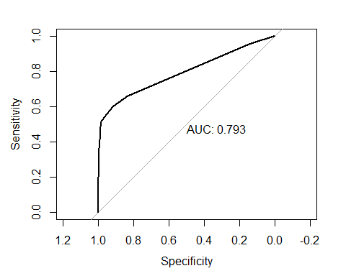

hr_roc_obj_test = roc(HR_testdata$Attrition, HR_testdata$predict.score[,2])

## Setting levels: control = No, case = Yes  
## Setting direction: controls < cases

plot(hr_roc_obj_test, print.auc = T)

