Python Project Proposal

The Chicken Invader

Introduction to Computer and Programming

International College, King Mongkut’s Institute of Technology

Ladkrabang

By

Panupong Viriyasuebpong

ID 59090018

Semester 1, 2016

1. Project Developer

59090018 - Panupong Viriyasuebpong

2. Project Title

The Chicken Invader

3. Project Description and Functions

The Chicken Invader original game was released in 1999.  
It’s my inspiration on developing this project. It is an arcade – action - shooting game with impressive graphic interface. Player play as a spaceship controlled my mouse cursor. The objective is to survive through many kind of moving mad chickens and their boss. Provided with weapon and bonus randomly dropped, the player get stronger. After several levels (5 - 10) the survivors get to inscribe their name on the Hall of Fame or high score board.

This game will be develop based on concept of OOP, which makes the program more stable and efficient. And also   
this will be a good opportunity for developer to get familiar with  
more object-oriented programming

4. Project Requirements

This project is based on the Pygame module. With ability to creates GUI window and receiving real time inputs.  
Also it comes with built-in classes and functions which is really useful on game developing. Without it all sprites, character and interfaces won’t be able to come to life.

Screenshot

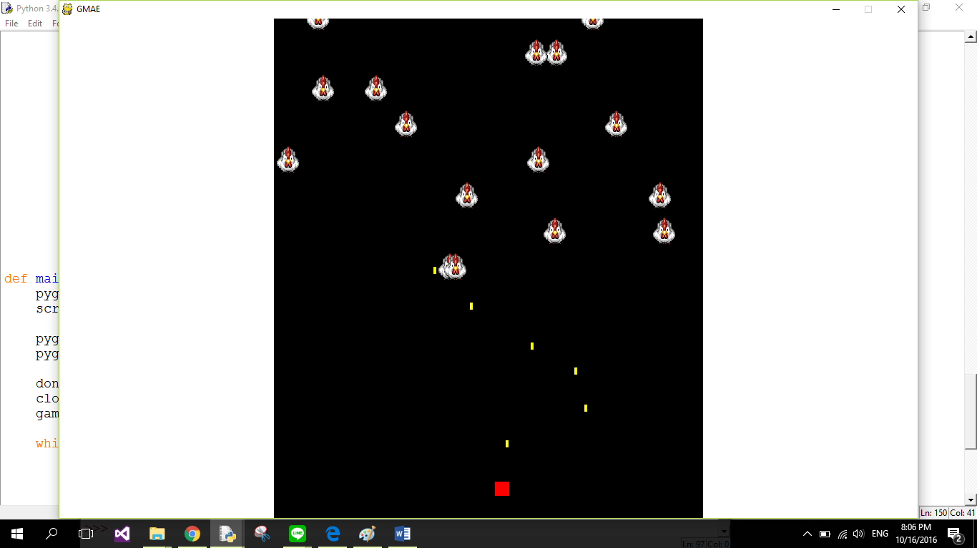

\*This is just a template to try the mechanic of my game.

\*The finished version will include sprites and more graphics.