Assignment 1

# Description:

1. Assume that you have the following JavaScript code:

Code –

const user = 'iiht_code'; const attempts = 5;

console.log('%s failed to login %i times', user, attempts);

let’s format a message containing a string and an integer

# Show the output.

1. **Get the console log output**

# The output is ‘iiht is failed to login 5 times’

1. **Using const can we define a variable in above code or not.**

# Yes we can declare variable using the const keyword but we can’t change the

**variable value once it is declared**

# %s and %i are replaced with values of user and attempts. The specifier %s is converted to a iihtcode , while %i is converted to a 5 .

**Output:**

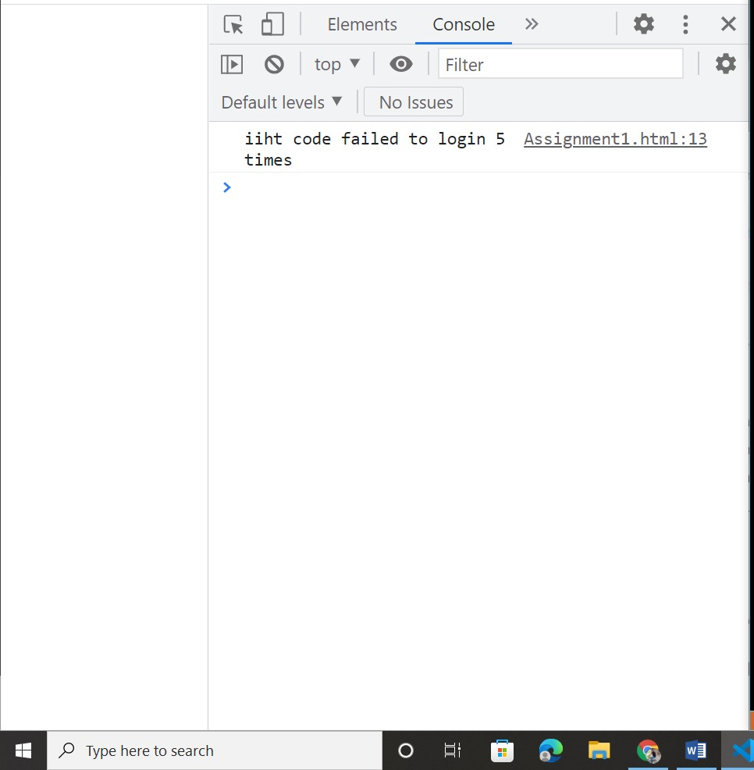

# Performance Outcomes:

Upon successful completion of the assignment, the participant is well versed in

* 1. User are able to create const and use with log function and find the appropriate result.
  2. Knowledge to maintain the output value using log based on string and int.
  3. Able to know how can assigns and get variable value print single line.