ADAPTIVE RETRIEVAL STRATEGY FOR COST-EFFICIENT AND RELIABLE THAI RAG SYSTEMS
Panupong Chaichun
Affiliation pending
Corresponding author: panuponghaichun@gmail.com
Advisor pending | Working manuscript

ABSTRACT
Uniform neural reranking may waste computation in retrieval-augmented generation. We evaluate an interpretable router selecting dense, hybrid, or hybrid-plus-reranking retrieval for Thai question answering. A frozen experiment uses 60 held-out questions from 55 article groups, a shared corpus of 3,223 chunks, and three retrieval timing repetitions. The router achieves Recall@5 of 0.9833, matching always-reranking, while reducing mean retrieval latency from 1.0511 to 0.2013 seconds, including routing overhead. However, nDCG@5 decreases from 0.9314 to 0.9231, and dense and hybrid baselines remain faster. Removing reranking improves the router's observed nDCG to 0.9399. Direct mean request latency is 42.489 seconds for the router and 42.141 seconds for always-reranking, with uncertainty spanning zero difference. Independent semantic-correctness and faithfulness judgments remain pending. These results support a limited retrieval-efficiency tradeoff, not general superiority, answer non-inferiority, or hallucination reduction.
Keywords: Thai question answering; retrieval-augmented generation; adaptive retrieval; hybrid retrieval; computational efficiency.
I. INTRODUCTION
Retrieval-augmented generation combines parametric language models with external evidence [1]. Retrieval can fail through lexical mismatch, semantic ambiguity, or poorly ranked evidence. Dense passage retrieval provides a learned semantic representation [2], while lexical retrieval preserves exact-term signals [3]. Combining these approaches and adding a cross encoder can improve evidence ranking but introduces additional computation.
A fixed expensive pipeline may be unnecessary for some questions, but an adaptive pipeline also incurs decision overhead. The relevant research question is therefore whether query-adaptive selection can reduce measured costs while preserving answer quality and evidence-grounded reliability in Thai. This study focuses on an experimentally testable tradeoff. We do not introduce adaptive retrieval as a new concept.
Research questions and scope
We distinguish three questions. First, does routing reduce warm retrieval effort relative to the most expensive fixed pipeline while preserving retrieval quality? Second, does any retrieval-stage saving survive once a shared generator produces the answer? Third, do retrieved passages support the generated claims, independently of whether a short reference string appears in the response? These questions require different observations. A faster retrieval call does not establish a faster complete request, and a relevant passage does not establish a faithful answer.
The working hypothesis is a conditional tradeoff: selective reranking can avoid unnecessary cross-encoder work, but may lose evidence quality when the decision features are weak. A stronger hypothesis that routing simultaneously improves ranking, answer correctness, faithfulness and cost is not assumed. We report unfavorable comparisons and ablations because they identify the boundary of the proposed decision mechanism. Reliability remains an evaluation objective, rather than an achieved property asserted by the project title.
The study is deliberately limited to a transparent three-action policy on one Thai corpus and a modest local model configuration. Its empirical contribution consists of matched baselines, explicit decision overhead, a reproducible split and query manifest, and a diagnosis of disagreements between derived relevance and passage content. This scope does not establish a first adaptive RAG method or a general optimum for Thai retrieval. It also does not replace specialist domain evaluation in law, medicine or other high-stakes applications.
II. RELATED WORK
RRF combines rankings without requiring score calibration [4], although subsequent analysis shows that fusion behavior depends on parameters and tuned score combinations can be stronger [5]. Cross-encoder reranking jointly processes query and passage [6]. These methods motivate the fixed retrieval baselines.
Adaptive-RAG learns to choose retrieval effort from question complexity [7]. Self-RAG integrates retrieval and reflection decisions into generation [8]. MBA-RAG makes cost-sensitive retrieval choices through a bandit formulation [9]. External-feature adaptive retrieval also predates this study [10]. Thus, the candidate contribution is a controlled Thai evaluation of transparent A/B/C routing and its overhead, rather than an unrestricted novelty claim. MIRACL provides a complementary multilingual retrieval benchmark [11]. Ragas motivates separate evaluation of retrieval relevance and grounded generation [12], but automatic judgments require Thai-specific validation.
Thai-specific work further constrains novelty. Similarity-based Thai QA has measured quality and runtime [13]. Thai legal RAG has combined sparse/dense retrieval and neural reranking [14]. A recent Thai Royal Gazette study compares retrieval units and methods with span-level evidence judgments [15]. TSWAP includes query-dependent forced retrieval for Thai entity lookups [16]. These precedents mean that neither Thai hybrid retrieval nor Thai query-dependent retrieval can be claimed as new. Our proposed contribution remains a narrowly controlled evaluation of discrete strategy selection and its measured costs.
Position relative to earlier adaptive systems
The action space is a central distinction. Systems that decide whether to retrieve at all, whether to perform multiple retrieval rounds, or whether to reflect on an answer address different decisions from choosing among three retrieval implementations for a single evidence budget. Our policy always performs an initial dense search. This imposes a minimum query-encoding cost even when lexical evidence is useful, but also makes the dense score margin available without a second search. The comparison therefore evaluates selective additional work after dense retrieval, not arbitrary selection among independently priced black-box systems.
External-feature routing is close prior work and limits claims about novelty [10]. Query length and lexical indicators are inexpensive signals, but cheap observability does not establish that they predict the marginal benefit of a cross encoder. The present evaluation consequently treats the features as hypotheses and tests their removal. We do not infer novelty from using Thai text alone. Existing Thai hybrid and reranking studies [14], and Thai query-dependent retrieval [16], already occupy important parts of that design space.
Evaluation design is equally consequential. MIRACL provides a multilingual retrieval resource [11], while the Thai Royal Gazette study uses evidence spans to compare retrieval units [15]. Our source-span conversion is operationally simple but does not provide exhaustive pooled relevance. A second benchmark with independently judged evidence would be required to establish whether observed policy behavior transfers beyond Wikipedia-derived factoid questions. Ragas [12] provides an automated evaluation framework, but using its terminology or an unvalidated judge would not supply independent Thai human evidence for this experiment.
III. PROPOSED METHOD
Given query q, compute a normalized dense embedding and cosine scores against a fixed chunk index. Reuse this search if further processing is selected. Extract Thai-token count, an exact-token proxy indicating digits/Latin strings/quotation marks, and the score margin between the first two dense candidates.
A provisional deterministic policy selects reranking when the query is long or the margin is small; otherwise it selects hybrid retrieval for exact-token queries and dense retrieval for remaining queries. The fixed thresholds are 24 Thai tokens and a cosine-score margin of 0.02. They were frozen before test access and were not calibrated on test outcomes. Neither token length nor margin is a validated measure of reasoning complexity or correctness. The selected pipeline returns the same number of evidence chunks as every baseline.
Hybrid retrieval uses RRF over truncated BM25 and dense rankings. Reranking applies a shared multilingual cross encoder to the fused candidate list. The no-hybrid ablation uses dense candidates for reranking. Feature ablations suppress one decision input at a time. All query-side work is included in online retrieval timing.
Retrieval and fusion procedure
Let D be the fixed passage collection and q the query. The dense encoder maps the prefixed query and passages to normalized vectors. Passage scores are dot products, equivalent to cosine similarities under normalization. Dense retrieval returns the highest-scoring candidates with a stable tie rule. BM25 operates on lowercased Thai newmm tokens. Sparse and dense candidate lists each contain at most 20 passages. Reciprocal-rank fusion assigns each candidate the sum of 1/(60 + rank) over lists in which it appears. The fused list is truncated to 20 candidates before optional reranking.
The cross encoder scores query–passage pairs jointly and orders the same candidate set; it does not retrieve unseen passages. Every strategy returns five passages to generation. Consequently, differences in answers can arise from which passages appear and their order, although the passage-count budget is fixed. Character lengths and generator token counts can still differ across strategies, so equal K does not imply equal input-token cost. Token counts are measured rather than inferred from the evidence count.
Transparent decision rule
Define L as the Thai-token count, E as the presence of a digit, Latin character or quotation mark, and M as the difference between the top two dense scores. The policy chooses C when L is at least 24 or M is below 0.02; otherwise it chooses B when E is true, and A in the remaining cases. The order is consequential: a low-margin exact-token query selects C before the lexical indicator is considered. The rule does not use answer labels, source titles, reference strings or generated text as inputs.
The name “complexity” refers only to a length proxy. The implementation does not estimate reasoning steps, named entities or semantic ambiguity directly. In particular, a Thai name need not trigger the Latin/digit/quote indicator, and two overlapping answer-bearing passages can produce a small dense margin without indicating difficulty. These limitations are part of the method rather than hidden assumptions about feature validity.
Ablation controls and implementation
Each ablation removes exactly one component from the fixed policy. Removing length, exact-token indicators or margin suppresses the corresponding condition. Removing hybrid retrieval replaces B by A and uses dense candidates for C reranking. Removing reranking maps C to B. These are policy interventions; they need not preserve route frequencies or candidate sets. We therefore report both quality and actual effort, and do not treat every ablation as an equal-cost comparison.
The code uses a single shared retrieval implementation for the original runner and the integrated latency benchmark. Extraction of the retrieval function changes its callable scope without changing scoring, fusion, model revisions, thresholds or tie handling. The integrated run records parity with prior rankings and answers. Random seeds, source hashes, dataset hashes, package versions and the evaluation schedule accompany raw outputs. Assertions reject incomplete paired analyses instead of silently reporting a subset as the planned experiment.
IV. EXPERIMENTAL SETUP
The initial corpus derives from the training partition of the public iApp Thai Wikipedia QA repository [17]. We validate answer offsets, deduplicate exact normalized questions, and partition connected components of identical normalized titles or contexts by a deterministic hash. The fixed retrieval corpus includes all source contexts, while evaluation labels remain partitioned. Identical contexts cannot cross partitions. A corpus-only audit identified duplicate-title/context pairs, which were joined before the frozen evaluation. Three distinct-entity template pairs remain a near-duplicate sensitivity concern; model-pretraining contamination remains unknown.
B1, B2, B3 and P1 share multilingual E5 small embeddings, the corpus, chunking and retrieval budget. B3/P1 share a multilingual mMiniLM cross encoder. Local generation is implemented using a fixed instruction model, common Thai prompt and deterministic decoding. Model identities and resolved revisions are recorded by the runner. The initial generator is resource-driven and requires Thai suitability validation.
Recall@5, MRR@5 and binary nDCG@5 quantify derived span relevance. Strict normalized exact match and human semantic correctness evaluate answers. Independent Thai annotators will label atomic claims for support and contradiction; abstention evaluation requires validated unanswerable examples. Wall latency, process CPU time, reranked pairs and generator token counts quantify efficiency. Bootstrap intervals resample source-context groups while retaining paired system outputs. A proposed 0.03 correctness non-inferiority margin was not finalized as a confirmatory test. No answer non-inferiority claim is made. The present analysis is exploratory; further tuning must use development/validation data and a new untouched evaluation sample.
Hardware detected: Intel Core i5-12450H, approximately 32 GiB system RAM, NVIDIA RTX 3050 laptop-class GPU with 4 GiB VRAM. The initial retrieval configuration uses CPU inference with four torch threads. This hardware statement is environment evidence, not a performance measurement.
Dataset provenance and leakage controls
Only the pinned upstream training file is used to construct the custom research partitions. Each retained question has a validated source answer offset and a nonempty set of chunks fully covering that source span. NFC normalization, zero-width-space removal and whitespace normalization are applied to text. Chunking uses raw character windows of 600 characters with 100-character overlap, and identifiers combine the raw-context hash and offset. This prevents distinct raw whitespace variants from overwriting one another before normalized grouping.
Questions are deduplicated by normalized question text. Contexts sharing a normalized title or normalized text are joined into connected components before a deterministic hash allocates groups to development, validation or test. Article groups do not cross partitions. The shared corpus includes contexts associated with every partition, as in open-book retrieval, while test questions and answer labels do not select thresholds. Access to test documents is therefore permitted by design; using test answer labels to fit a router would not be.
The test query manifest contains 60 predetermined questions selected by seeded hash order, rather than by performance or ease. It covers 55 article groups, so treating all questions as independent would ignore within-article dependence. The final test partition has additional unused questions, but evaluating only this fixed sample limits precision and coverage. The sample is not described as a full benchmark evaluation. Hash-based grouping reduces known leakage paths but cannot identify every paraphrase, template similarity or occurrence in pretrained model data.
Models and resource controls
The dense model is intfloat/multilingual-e5-small at revision 614241f622f53c4eeff9890bdc4f31cfecc418b3. The reranker is cross-encoder/mmarco-mMiniLMv2-L12-H384-v1 at revision 1427fd652930e4ba29e8149678df786c240d8825. The generator is Qwen/Qwen2.5-0.5B-Instruct at revision 7ae557604adf67be50417f59c2c2f167def9a775. These revisions, rather than mutable model names alone, define the experiment. Downloaded E5 and generator weight files pass recorded SHA256 checks. The local generator is chosen for feasibility, not on evidence that it is the strongest Thai model.
The generation prompt instructs the model to answer in Thai using only the supplied evidence, cite passage identifiers and abstain when evidence is insufficient. It also instructs the model not to follow instructions embedded in evidence. Decoding is greedy with a maximum of 128 new tokens and a 4,096-token request budget. Exceeding the budget raises an error rather than introducing method-specific truncation. Long passage identifiers are retained across all systems for consistency; their cost is a limitation to address only in a future development protocol.
Measurement boundaries
The initial retrieval experiment measures query encoding, score computation, optional BM25/fusion, routing and reranking within each retrieval call. System order is shuffled for each query and timing repetition. Corpus encoding and index construction are setup operations, reported separately. All experiments use local inference, so external API charges are zero; this excludes electricity and hardware amortization. CPU process time counts processor time across threads and is not identical to elapsed wall time.
A follow-up integrated benchmark executes a complete request rather than reusing saved retrieval outputs. Its timer starts before query encoding and ends after final answer decoding. The interval contains routing, retrieval, reranking, evidence lookup and assembly, chat-template processing, tokenization and generation. Model/index loading and file logging are outside the request interval. Each system is warmed on a development query. The frozen test query order is randomized, and four-query blocks balance each system's position within a query. This benchmark makes one request per method per question; it cannot estimate repeated-request jitter for a single question or production queueing delay.
Statistical estimands
Recall@5 is the fraction of labeled relevant chunks retrieved within the first five positions. MRR@5 uses the reciprocal position of the first labeled relevant chunk, or zero if absent. Binary nDCG@5 discounts each labeled hit by its rank and normalizes by the ideal ranking. Unjudged passages are treated as nonrelevant in these computations; the resulting incompleteness is investigated rather than concealed. Retrieval timing repeats are averaged within query before paired comparisons, avoiding threefold inflation of the quality sample size.
For uncertainty, 2,000 bootstrap replicates sample the 55 article groups with replacement and retain all associated query pairs. The same resampled indices are applied to every system. We report percentile intervals for mean differences in Recall@5, nDCG@5 and latency. Mean, median and p95 latency are also reported with cluster intervals; differences of medians and p95 values are distinct from quantiles of per-query differences. Tail estimates are unstable with only 60 observations. The analysis is exploratory, without multiplicity-adjusted hypothesis tests, and does not declare statistical significance or non-inferiority from overlapping or nonoverlapping intervals alone.
Independent answer evaluation protocol
A fixed blinded packet contains all 240 original responses, their questions, reference answers and retrieved evidence, identified only by opaque response IDs. Method names, routes, timings and retrieval scores are omitted. A separate coordinator mapping permits linkage after annotation. Two Thai-proficient raters should independently judge semantic correctness and segment factual claims, recording supporting passage IDs and rationales. The author has confirmed that independent raters are not yet available; all human labels therefore remain missing, not correct, incorrect or faithful by default.
Correctness permits paraphrase and equivalent values but rejects a materially wrong answer or misleading additional assertions. Ambiguous questions and defective references receive an uncertainty flag for adjudication. Claim support distinguishes entailed, contradicted, unsupported and uncertain claims. A factually correct claim can be ungrounded in the supplied passages, and a claim faithfully copied from the wrong entity's passage can fail to answer the intended question. Citations alone do not establish support. Unsupported claims combine contradicted and unsubstantiated claims for the aggregate while retaining the subtypes in raw ratings.
Before adjudication, report agreement and Cohen's kappa where its denominator is defined. Preserve disagreements and claim-boundary decisions. Faithfulness is supported factual claims divided by all adjudicated factual claims, with annotation coverage stated. Zero-claim refusals have undefined claim faithfulness and do not count as perfect responses. Response-level hallucination is operationalized as at least one unsupported factual claim among adjudicated factual responses. The answerable-only dataset cannot support balanced abstention accuracy. These definitions are a protocol, not collected measurements.
V. RESULTS
The fixed test sample contains 60 questions from 55 article groups. All nine systems (four primary systems and five ablations) completed three repetitions, producing 1,620 raw retrieval records. Query IDs match the frozen list; group disjointness and identical rankings across repetitions were checked. Index preparation required 158.07 seconds and is excluded from warm retrieval timing.
Table 1. Frozen primary retrieval comparison.
System | Recall@5 | MRR@5 | nDCG@5 | Mean retrieval (ms)
B1 | 0.9500 | 0.9139 | 0.9232 | 17.49
B2 | 0.9667 | 0.9131 | 0.9263 | 25.10
B3 | 0.9833 | 0.9139 | 0.9314 | 1051.13
P1 | 0.9833 | 0.9028 | 0.9231 | 201.29
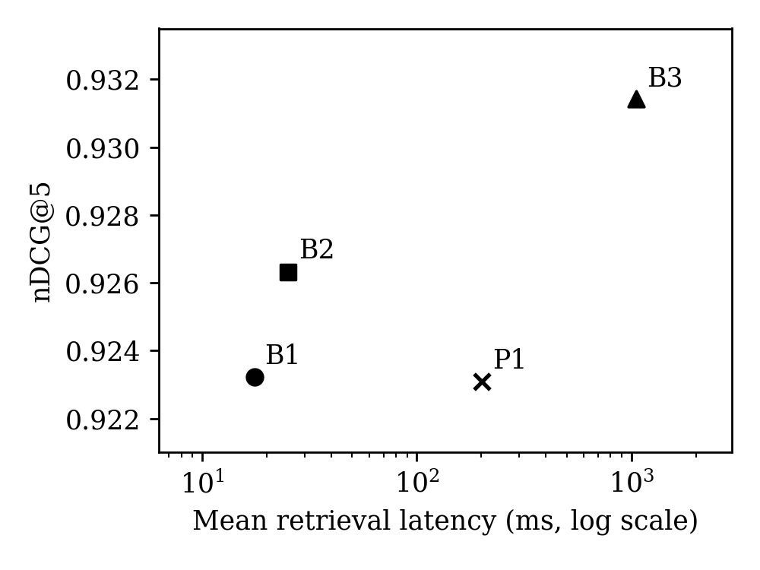
Figure 1. Retrieval quality and latency. The horizontal axis uses a logarithmic scale.
P1 reduces observed mean retrieval time by 80.85% relative to B3 and reranks 3.33 rather than 20 pairs per query (83.33% fewer). Mean router overhead is 0.230 ms and is included. P1 routes 48 questions to dense, two to hybrid, and ten to reranking. Its nDCG difference against B3 is −0.00833 (article-cluster bootstrap 95% interval [−0.02343, 0.00000]); the retrieval-time difference is −0.84984 seconds [−0.94705, −0.74234]. P1 is approximately 11.51 times slower than B1 and 8.02 times slower than B2. Its observed nDCG is lower than both, although Recall@5 is higher. Thus no primary method is universally best across the selected objectives.
Table 2. Removal of individual P1 components.
Removed P1 component | Recall@5 | nDCG@5 | Mean retrieval (ms)
Query length | 0.9833 | 0.9231 | 174.39
Exact-token indicator | 0.9833 | 0.9231 | 193.41
Dense score margin | 0.9500 | 0.9232 | 52.02
Hybrid retrieval | 0.9500 | 0.9068 | 195.63
Reranking | 0.9667 | 0.9399 | 19.25
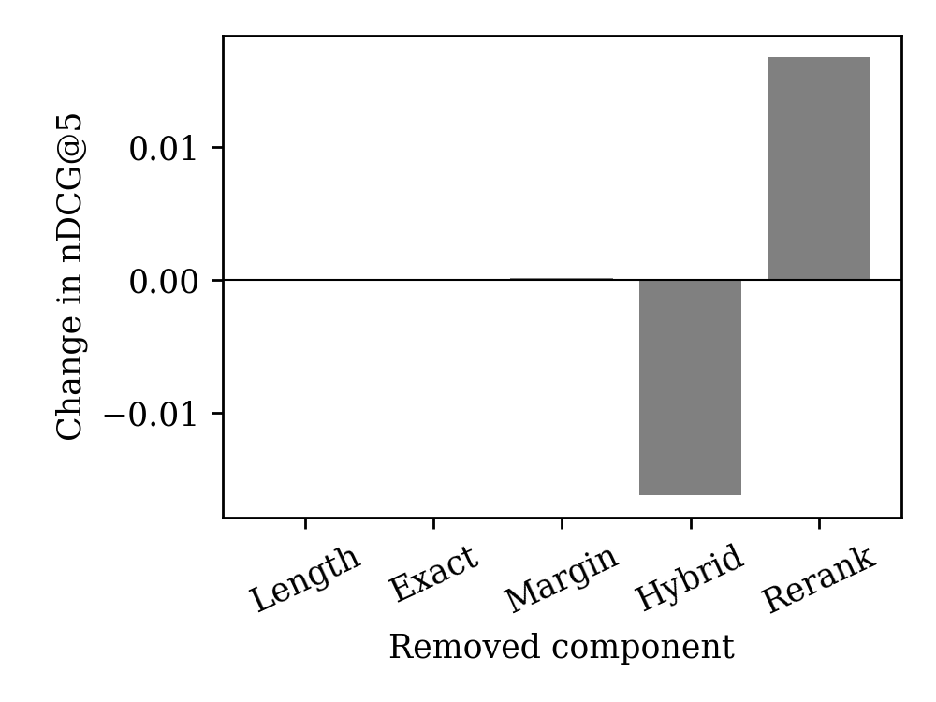
Figure 2. Change in measured nDCG after component removal. Source-derived relevance is non-exhaustive.
Removing reranking yields the highest observed nDCG among the tested configurations, while reducing recall relative to full P1. This is an exploratory ablation result, not a newly selected confirmatory policy. Length and exact-token removals do not change aggregate retrieval quality on this sample. The score-margin feature improves recall but does not establish an nDCG benefit.
Data preparation retained 5,667 questions (3,360 development, 1,133 validation, 1,174 test) and excluded 94 records for invalid/uncovered spans or duplicate questions. All corpus chunks are available as an open-book index; test query labels do not train or tune the router. The 60-question test sample is a subset, not the entire held-out partition.
All 240 matched generation responses completed. Strict exact match is 0.0333 for B1, B2 and P1, and 0.0167 for B3. These low scores are not semantic correctness estimates because the metric penalizes explanatory text and citations. Estimated mean request latency is 42.275 seconds for B1, 41.758 for B2, 42.841 for B3 and 43.495 for P1. P1 therefore provides no observed overall latency saving; its paired difference from B3 is +0.6545 seconds [−0.5456, 1.8908]. P1 uses 1,940.22 input and 60.82 output tokens per query, compared with B3's 1,917.45 and 54.58. Total generation usage is 461,175 input and 13,557 output tokens. API charges are zero because inference is local; this does not imply zero computational cost. Independent semantic correctness, faithfulness, unsupported-claim rate, hallucination rate and balanced abstention accuracy remain pending. Separately measured retrieval and generation durations provide an estimated request latency; direct full-request timing is reported below; electricity/hardware monetary cost remains unmeasured.
Direct end-to-end latency validation
The integrated benchmark completed 240 requests on the same 60 frozen questions, with one request per method/question and balanced within-query execution positions. The reported interval starts before dense query encoding and ends after final answer decoding. No separate stage durations are added to obtain this measurement.
Table 3. Direct request measurements.
Method | Mean (s) | Median (s) | p95 (s) | SD (s)
B1 | 41.765 | 41.839 | 53.509 | 7.312
B2 | 40.590 | 42.051 | 54.061 | 8.439
B3 | 42.141 | 43.027 | 52.882 | 7.370
P1 | 42.489 | 41.660 | 55.272 | 7.823
Mean latency 95% article-cluster bootstrap intervals are B1 [39.911, 43.494] seconds; B2 [38.481, 42.615] seconds; B3 [40.272, 43.974] seconds; P1 [40.545, 44.450] seconds.
P1 versus B3 has an observed direct mean latency reduction of -0.83% (negative means slower). This comparison measures the complete warm request and should not be confused with the 80.85% retrieval-only reduction.
The P1-minus-B3 mean difference is 0.3477 seconds, with 95% interval [-1.2076, 1.8974]. No formal significance or equivalence test is claimed.
Rankings match the original run on 240/240 requests, and decoded answers match on 240/240 requests. Model revisions, thresholds, CPU thread count, prompt and generation budget remain fixed. The generator's recorded dtype is bfloat16 on CPU. The workstation was not isolated from other activity; the benchmark quantifies this session, not guaranteed production latency.
Median and p95 intervals and all six pairwise comparisons are retained in the supplementary statistical output. The p95 is sensitive to a few observations and only one request was timed per query/method.
VI. DISCUSSION
The observed policy saves work relative to always-reranking but is not competitive with the cheapest baselines on nDCG and latency jointly. Six queries incur positive regret under source-derived relevance labels: four choose reranking and two remain on dense retrieval. These are label-defined discrepancies, not six independently established semantic routing errors. Evidence inspection shows that the park query retrieves an unjudged first passage that explicitly contains the answer. The band-nationality query also omits the band name. Low score margin does not reliably identify improvement in the measured ranking metric, but incomplete judgments and question ambiguity constrain that interpretation. The no-reranking ablation reinforces this conclusion. Because relevance is non-exhaustive, these ranking failures should also be inspected against full passage text.
Qualitative inspection identifies generation errors despite available evidence: one answer gives the English name of Aphrodite when the question asks for her Roman name, although the retrieved passage explicitly gives Venus. Another supplies an unsupported death year. These assistant-reviewed cases are not independent human annotations and do not estimate hallucination rates. Long evidence identifiers can consume the fixed generation budget, and strict exact match penalizes otherwise relevant explanatory answers. Neither prompt nor router is retuned after examining these test outcomes.
The defensible contribution is a reproducible, overhead-inclusive Thai comparison showing where a transparent three-way policy does and does not offer value. Learned routing is not yet justified: this small sample provides error hypotheses, not evidence of generalizable predictability. Calibration or learning should proceed only on development/validation data, with any new claims evaluated on untouched questions.
Mechanism-level error analysis
Among ten C-route questions, removing reranking improves nDCG on four, reduces it on one and leaves it unchanged on five. The other 50 questions retain their original action and ranking. The four gains are 0.369070 for the regional fish name, 0.130930 for the abbreviated Tolkien death question, 0.369070 for park type and 0.569323 for band nationality. One director question loses 0.430677 because reranking had recovered the labeled passage at rank four while hybrid missed the top five. Dividing their net change by 60 yields the observed increase of 0.016795. The one lost hit explains the recall decrease of 1/60.
The fish example is an answer-localization failure: the reranker promotes the article's general species description over its later regional-name sentence. The Tolkien example combines an abbreviated entity with competing death-related passages, so semantic topical similarity does not ensure the correct subject. The docusate query is a missed reranking opportunity under the labels: the dense margin is relatively large, but the answer-bearing secondary use is ranked below the general introduction. The Diana concert query promotes a similar sentence about another performance within the same article; the exact-token proxy does not recognize a Thai personal name as an entity feature.
The park example changes how the aggregate must be interpreted. Its first reranked passage explicitly contains the requested park classification, but the qrel identifies a different source chunk. Thus an apparent nDCG loss can coexist with adequate evidence. The band question lacks the band's name, and the director question similarly omits the work being directed. These source-context-dependent questions are weak standalone retrieval tests. We preserve their scores and disclose the problem rather than remove unfavorable examples after seeing results.
Retrieval savings and complete-request cost
A reduction in cross-encoder calls can be large relative to retrieval time while small relative to generation. Furthermore, different evidence changes prompt length and output length even when the number of passages is fixed. The original generation run uses more input and output tokens for P1 than for B3 on average. Adding separate measurements suggested no overall saving, but that estimate is not a substitute for a complete timed request. The integrated benchmark is designed to distinguish these quantities under the same policy, model and evidence budget.
The system-level objective should therefore be explicit. If the priority is recovering a source-labeled passage while avoiding always-reranking, the observed P1 recall/time tradeoff may be useful. If the priority is maximizing nDCG at minimal latency, dense, hybrid or the no-reranking ablation can be preferable in this sample. If the objective is reliable generated answers, neither comparison is decisive without grounded answer judgments. A contribution that states these boundaries is more defensible than selecting whichever metric makes the proposed system look strongest.
Development-only next steps
Future work should first improve evaluation validity through pooled judgments and standalone-question assessment on development data. It may then estimate the incremental quality benefit of reranking, conditioned on observable query and retrieval features, under an explicit cost budget. A calibrated decision tree or other lightweight model would be justified only by out-of-group development/validation performance and sufficient labeled decision variation. The six test diagnostics are not a training set for a new policy. Any new thresholds, entity features, prompt format or learned router must be frozen before evaluation on a new untouched sample.
VII. LIMITATIONS
The current evidence labels are derived from answer spans and are not exhaustive relevance judgments. Overlapping chunks can inflate the number of relevant items. Character windows may split Thai words. Wikipedia factoid QA does not represent all Thai information needs. Model pretraining may include benchmark content. Heuristic features require calibration and may not transfer. Human grounding evaluation, residual near-duplicate sensitivity analysis and full literature detail verification remain incomplete. Three retrieval repetitions quantify within-session variability, but do not establish cross-machine or cross-session latency stability. The small held-out sample and 55 article groups limit precision. The small initial generator may be inadequate for Thai. Generation was run once per query/system; five responses resumed after an interruption, and session drift may affect timing. Long evidence IDs and the output cap can also impair answer formatting. Official conference pages disagree on the submission deadline and page limits; final formatting requires reconciliation.
Threats to validity and reproducibility boundaries
Construct validity is limited by source-span relevance, strict answer matching and the use of length as a complexity proxy. The park case shows that derived qrels can penalize a passage that answers the question. Exhaustive judgments are unavailable, so retrieval scores measure recovery of labeled source evidence rather than all acceptable evidence. Exact match can reject correct explanatory responses and should not be presented as semantic accuracy. Conversely, a matching reference substring would not prove that all generated claims are supported.
Internal validity depends on preserving common models, candidate budgets, prompt instructions and query sets. Fixed revisions and output hashes make silent changes detectable. Randomized or balanced execution order reduces some order effects, but this is a workstation experiment rather than an isolated serving environment. Background load, CPU frequency, thermal conditions and memory residency can influence latency. One integrated request per method/query and three retrieval repetitions do not establish robustness across days, concurrent workloads or deployment stacks. Confidence intervals quantify the resampling variability in this sample, not every source of measurement error.
External validity is restricted to Thai Wikipedia-derived questions, a small local generator, the selected multilingual retriever/reranker and CPU hardware. Domain terminology, multi-hop reasoning, long documents and user-authored queries may behave differently. The derived test sample contains no independently validated unanswerable subset. The same public text may have appeared during model pretraining; hash-based research splits do not resolve that contamination. Results should not be generalized to all Thai RAG systems or interpreted as evidence that a particular architecture is unsuitable for other applications.
Conclusion validity is limited by the small sample, dependent article questions, exploratory ablations and unavailable independent answer judgments. The highest observed ablation score is not an independently validated new method, because it was identified after test access. We report effect sizes and intervals rather than a favorable binary significance narrative. The correct inference from missing faithfulness annotations is that reliability remains unestablished. Negative results and measurement limitations remain part of the record even if future policies improve.
The reproducibility package stores the source-data revision and hash, model revisions and weight checks, frozen query IDs, configuration files, raw rankings and answers, per-request timings, token counts, environment locks and analysis scripts. Existing held-out artifacts are hashed before follow-up work and are not overwritten. Blinded annotation templates contain no judgments, and mapping files are separated from rater material. Model licenses, corpus attribution and contributor-data minimization must be respected when sharing the package; source payment/contributor fields are not used in processed experimental records.
VIII. CONCLUSION
The frozen policy reduces retrieval latency relative to always-reranking while matching observed Recall@5, but loses nDCG and remains substantially slower than dense or hybrid retrieval. Removing reranking produces a stronger observed nDCG/latency tradeoff, revealing a weakness in the current decision mechanism. These results support a bounded empirical contribution and an honest negative finding about the policy, rather than a claim that adaptive routing is generally superior. Direct request timing shows no observed mean latency saving for P1 against any primary baseline; its difference from B3 has a bootstrap interval spanning zero. Reliability and semantic-answer conclusions await independent annotation.
REFERENCES
[1] P. Lewis et al., “Retrieval-Augmented Generation for Knowledge-Intensive NLP Tasks,” 2020. https://arxiv.org/abs/2005.11401
[2] V. Karpukhin et al., “Dense Passage Retrieval for Open-Domain Question Answering,” 2020. https://arxiv.org/abs/2004.04906
[3] S. Robertson and H. Zaragoza, “The Probabilistic Relevance Framework: BM25 and Beyond,” 2009. https://doi.org/10.1561/1500000019
[4] G. V. Cormack, C. L. A. Clarke, and S. Büttcher, “Reciprocal Rank Fusion outperforms Condorcet and individual Rank Learning Methods,” 2009. https://doi.org/10.1145/1571941.1572114
[5] S. Bruch, S. Gai, and A. Ingber, “An Analysis of Fusion Functions for Hybrid Retrieval,” 2023. https://doi.org/10.1145/3596512
[6] R. Nogueira and K. Cho, “Passage Re-ranking with BERT,” 2019. https://arxiv.org/abs/1901.04085
[7] S. Jeong et al., “Adaptive-RAG: Learning to Adapt Retrieval-Augmented Large Language Models through Question Complexity,” 2024. https://aclanthology.org/2024.naacl-long.389/
[8] A. Asai et al., “Self-RAG: Learning to Retrieve, Generate, and Critique through Self-Reflection,” 2023. https://arxiv.org/abs/2310.11511
[9] X. Tang et al., “MBA-RAG: a Bandit Approach for Adaptive Retrieval-Augmented Generation through Question Complexity,” 2025. https://arxiv.org/abs/2412.01572
[10] M. Marina et al., “LLM-Independent Adaptive RAG: Let the Question Speak for Itself,” 2025. https://arxiv.org/abs/2505.04253
[11] X. Zhang et al., “Making a MIRACL: Multilingual Information Retrieval Across a Continuum of Languages,” 2022. https://arxiv.org/abs/2210.09984
[12] S. Es et al., “Ragas: Automated Evaluation of Retrieval Augmented Generation,” 2023. https://arxiv.org/abs/2309.15217
[13] K. Jearanaitanakij et al., “Thai Question-Answering System Using Similarity Search and LLM,” 2024. https://doi.org/10.37936/ecti-cit.2024183.256043
[14] P. Promwang and P. Boonma, “Development of a Retrieval-Augmented Generation System for Legal Data in Thai Language,” DSE Record, vol. 6, no. 1, n.d. [Online]. Accessed: Oct. 29, 2026. Available: https://datascience.cmu.ac.th/storage/articles/73.pdf
[15] P. Suyasri, P. Akarajaradwong, and C. Chaksangchaichot, “An Empirical Study of Evidence Retrieval for Retrieval Augmented Generation over the Thai Royal Gazette,” NLLP, 2026. https://aclanthology.org/2026.nllp-1.19/
[16] P. Ukosaramig and K. Viriyayudhakorn, “TSWAP: A Multilingual Retrieval-Augmented Thai Wellness Advisor,” 2026. https://arxiv.org/abs/2608.22917
[17] iApp Technology, “iapp-wiki-qa-dataset,” repository, accessed October 29, 2026. https://github.com/iapp-technology/iapp-wiki-qa-dataset

