Skroutz.gr XML Feed

Installation
In order to install this module please follow any method you like from PrestaShop addons how to

Configuration

Main options
Above the main options you see a message similar to the one bellow
This is the link that you should use when submitting your XML to skroutz.gr
The options bellow are already set to some default values. In most of the cases this is enough but please review them to make sure everything is set up properly.
You can get information about all option through tips that appear on mouse over in every option label.

Mapping options
Mapping options help you modify XML fields. In example you can choose the source of the product id by changing the value in the dropdown menu of this option.
If you have any question about these fields you can consult the skroutz.gr XML specs documentation.

Info Panel
In module configuration screen you should see a panel similar to the one bellow
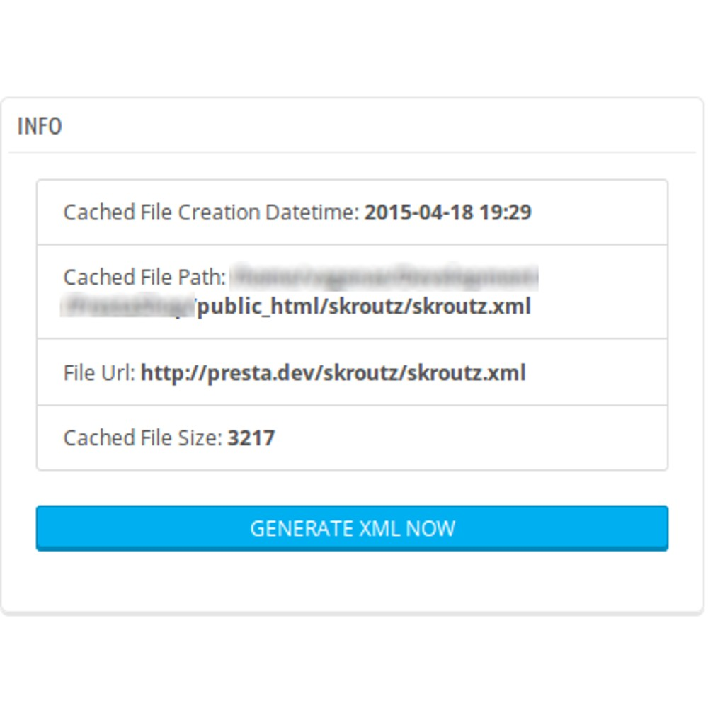
This panel contains information about the cached XML file and a button you can use to generate the XML file anytime.

Disclaimer
This module is not associated in any way to skroutz.gr or any of it's products or services.

