**Manvendra Singh Panwar**

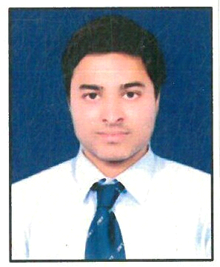

|  |  |
| --- | --- |
| **Title:** | Analyst (A4) |
| **Location:** | Mumbai, Maharashtra, India |
| **Languages:** | English (fluent), Hindi(fluent), Marwari(Native) |

# Experience Summary

Manvendra Singh Panwar is an Analyst who was trained under shadowing in Takeda for 2 months in SAP ABAP. He has excellent communication skills and can work in a team.

**KEY SKILLS:**

* **Functional:** Strategic/Tactical Planning, Excellent Communication and Interpretation skills
* **Technical:** SAP ABAP, SAP PI, C, C++, JAVA, HTML, CSS, JavaScript, SQL, PHP.

**PROFILE SUMMARY:**

* Understanding the functional and technical specifications according to the requirement.
* Developed an interactive ALV (ABAP List Viewer) Report.
* Worked with tables, data types, type groups, views, search helps in Data Dictionary.
* Worked on Module-pool programming.
* Developed an Adobe form.
* Developed a Smart forms.
* Developed file handling program using presentation and application server.
* Developed a BDC for data transfer using both call transaction and session method.
* Basic knowledge on ALE/IDocs, OOPS ABAP, SAP Workflow.

**SHADOW WORK IN TAKEDA:**

* Created a program on interactive ALV report with the details fetched from various tables and joined using for all entries to display the data. The currency translation button is added to convert the existing currency to the given currency.
* Created screen for user input and displaying details depending on the input and validations on screens fields. Worked on table control, sub screens, tab strip control.
* Created a driver program to display calibration protocol form by using combination of various tables, barcodes and validation of various fields.
* Created a driver program to display data in the form of table using different sub forms for header, data and table.
* Created a program to upload file from system to the SAP server and to download the file from SAP to system using presentation server.
* Created a program to upload file in SAP directory to open and read the file and downloading the file from SAP directory using application server.
* Created a program to transfer the data by recording the fields and changing the data in MM02 transaction using call transaction and session method.
* Created a basic smart form to display text (text module, standard text, dynamic text), displayed logo, address and designed tables.

# Training, Certifications & Affiliations

* Trained in SAP ABAP in **Takeda project**.
* Trained in SAP PI by Capgemini.
* Trained in SAP HANA, UI5 and Gateway at Beginner level by Capgemini.
* Trained in OOPS ABAP and ALE IDOC by Capgemini.
* Certified on Web Development in Tech Fly (1st June-30th July, 2016)

# Published & Presented / Awards

* Presented paper on Partitioned Global Address Space (PGAS) Programming model in 2016 at University level.

# Higher Education

* Jodhpur Institute of Engineering and Technology, Jodhpur, RTU - Bachelor of Technology in Computer Science and Engineering.