# 

# **WEEK-01 BASICS OF POWER BI**

**Submitted by**

Hardil Panwar

22-01-2025

### **CONCEPT OF ETL**

ETL i.e., Extract Transform Load.

ETL is the most important concept for any analysis. It helps and provides a very concise knowledge about the whole analysis process.

1. Extract
   1. The process of extracting the data from the data sources.
   2. Data is stored in various data files like CSV, text, etc.
2. Transform
   1. The process of transforming the data.
   2. This includes data processing and data cleaning. Removing all the errors and null values.
3. Load
   1. The process of loading the data is when the data is cleaned and ready to be loaded.
   2. This includes loading the data into the analyst software and then the analysis steps begin.

Now, one of the most important keywords many people tend to ignore i.e. Analysis. It means, analysing the source medium and keeping all the **facts intact.**

### **ABOUT POWER BI**

Microsoft’s Power BI is a common business intelligence tool used by business analysts and professionals. It is a data visualization and reporting platform which uses built-in AI and machine learning. It stands for, Power Business Intelligence and refers to a collection of software services, tools, and connectors that help to transform data from multiple sources into actionable insights. Power BI itself is composed of several interrelated applications and we will use the Power BI Desktop application.

How can we use Power BI for the data-driven insights:

1. Data Visualization and reporting.
2. Data Integration.
3. Business Intelligence.
4. Collaboration and sharing.
5. Financial analysis.

### **POWER BI CANVAS**

1. **Sign-in**

You can Sign-in with your email address and can perform collaboration and access organizational content.  
You can also continue and use it, without any Sign-in.

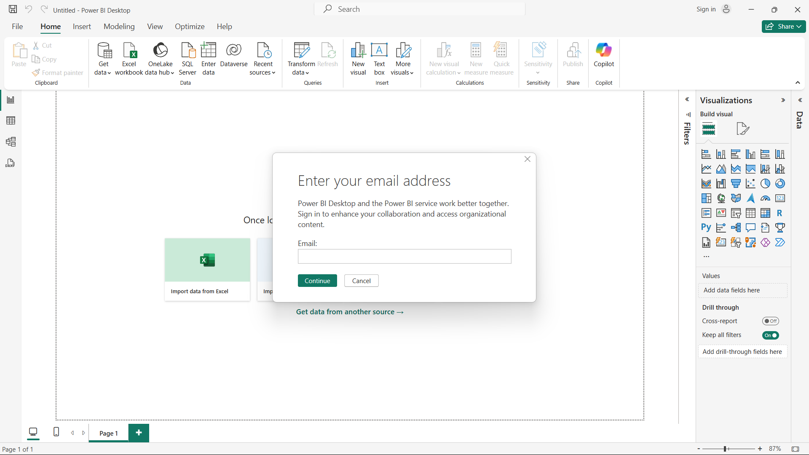

1. **Canvas**

When you open the Power BI, you will get this canvas.   
  
On the right side, we have the Visualizations Bar which will be used to create charts, graphs, pie charts, and Area-chart basically, build visuals.

On the left-hand side, we have 4 icons that represent different view options i.e.,

* Report View
* Table View
* Mode View
* DAX Query View

On the upper side, we have beautifully aligned different bars that have various functions and functionalities underneath them i.e.,

* File
* Home
* Insert
* Modeling
* View
* Optimize
* Help

At the centre, we have various options to add data sources to the power BI.

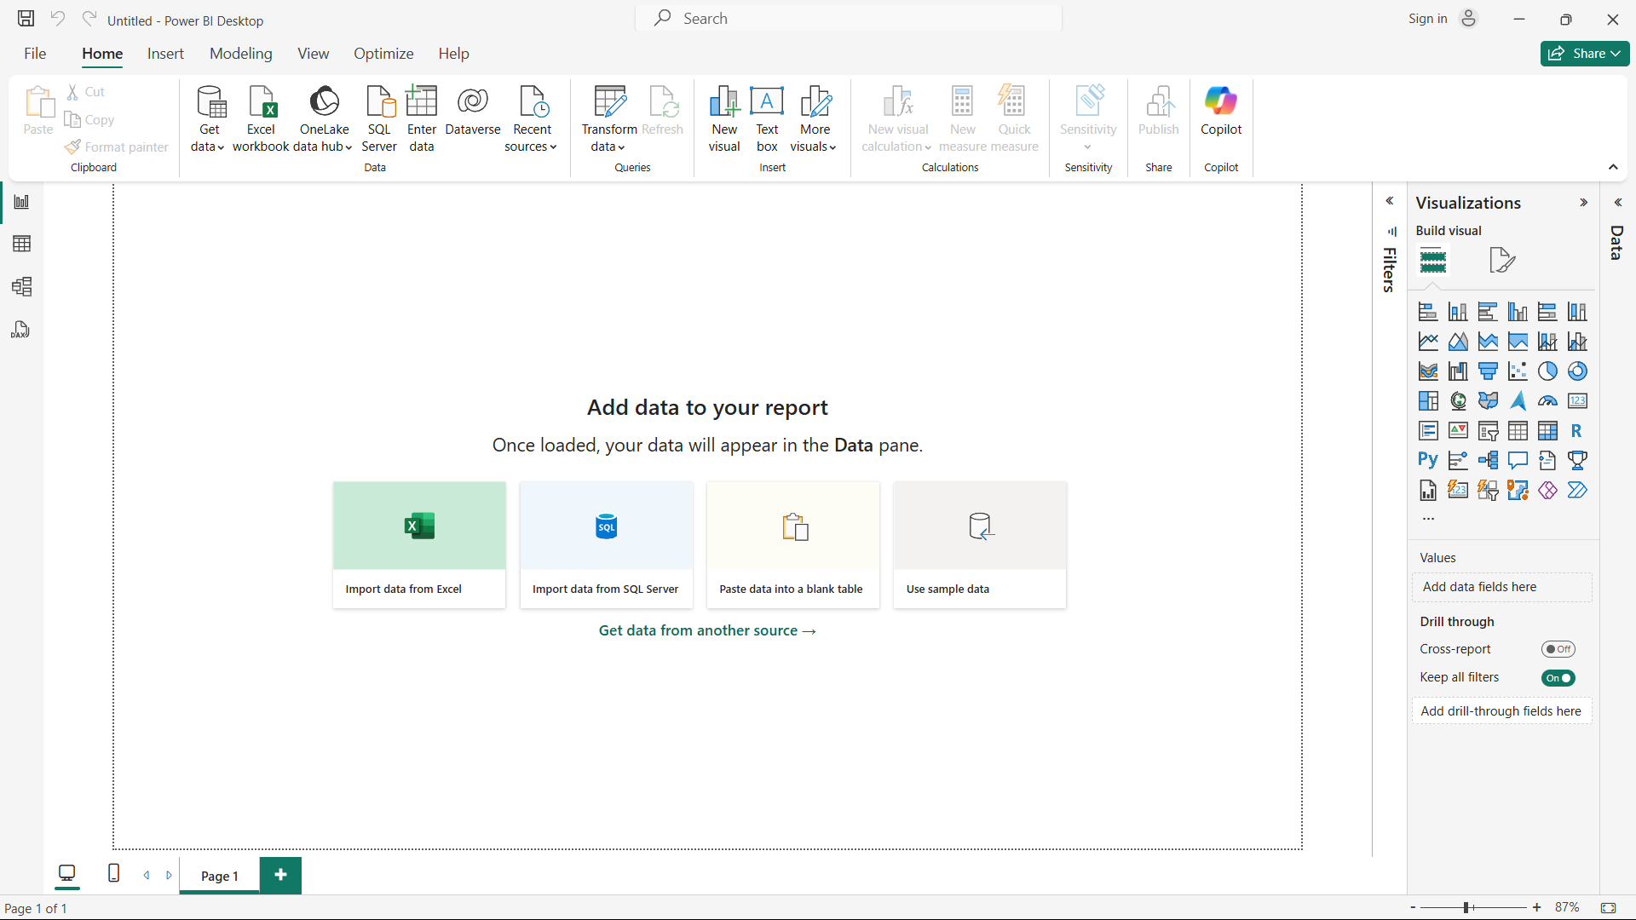

### **WORKING WITH DATA FILE**

Let’s add a **CSV** source file to the Power BI to do the analysis.

**Steps:**

1. Go to the upper side tab “Home” > Get data > Select Text/CSV

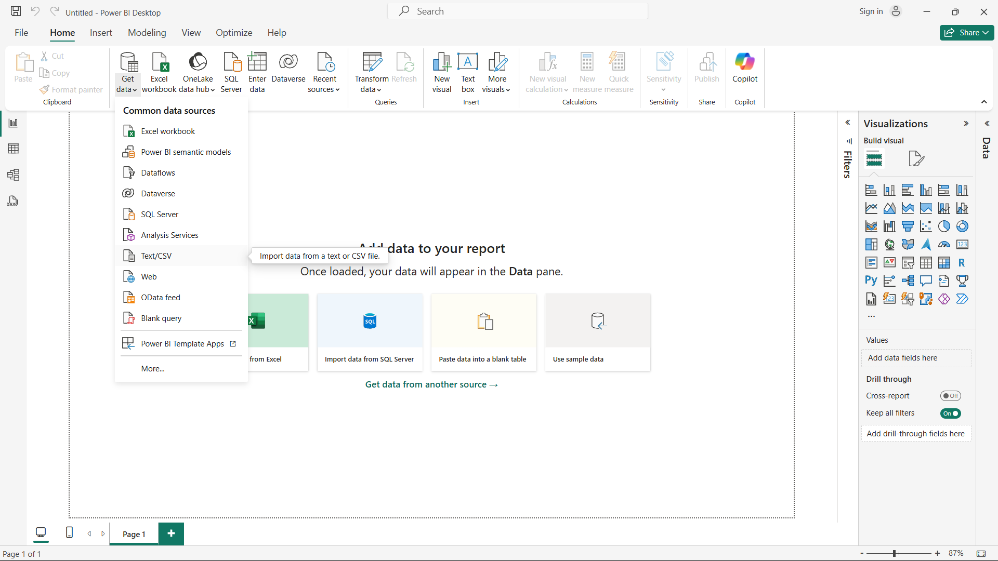

1. Select the source data file.

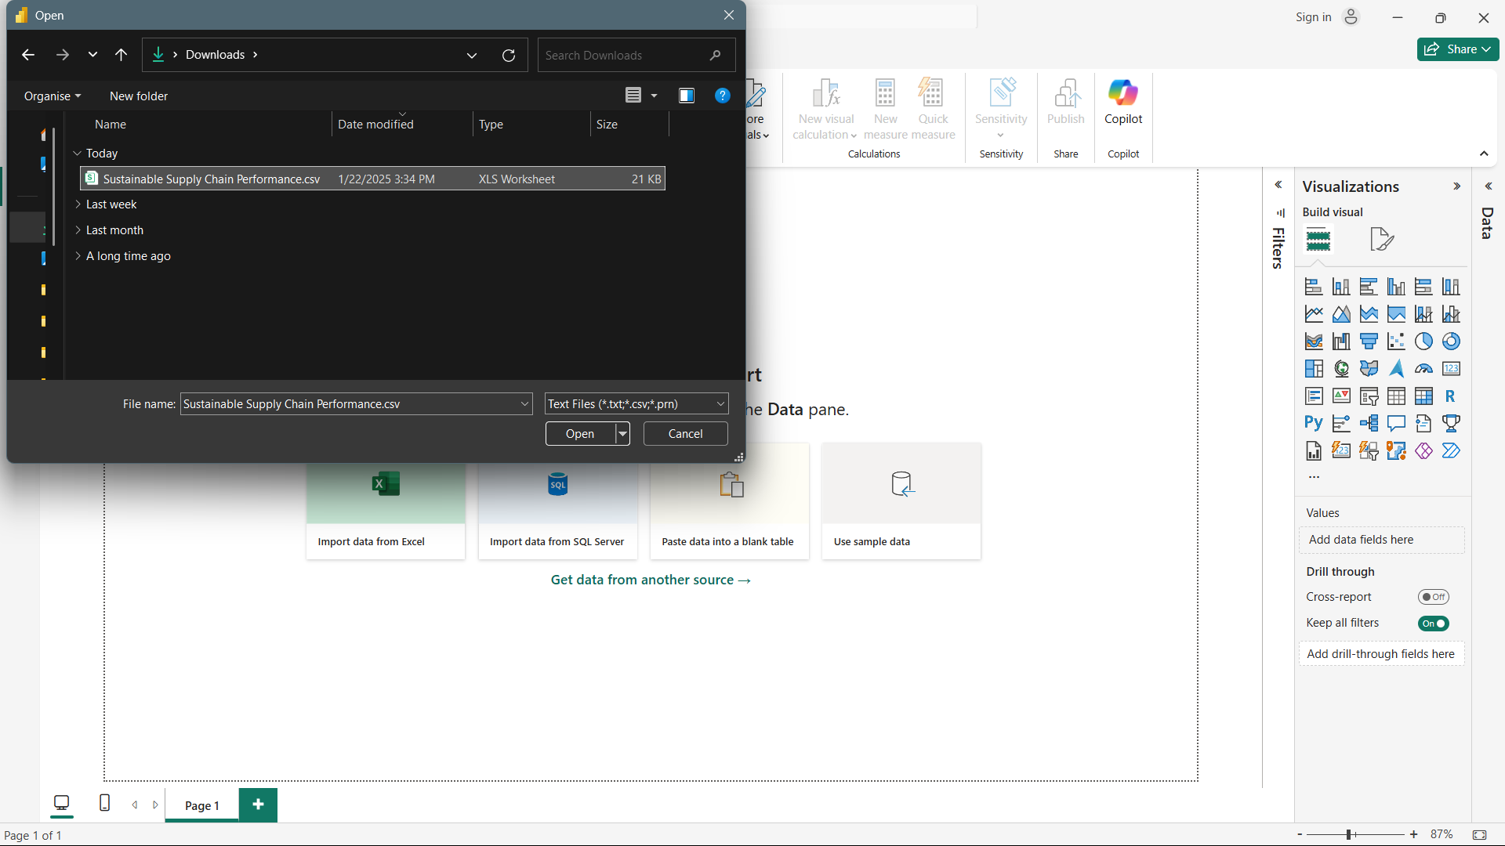

1. Load the source data file.

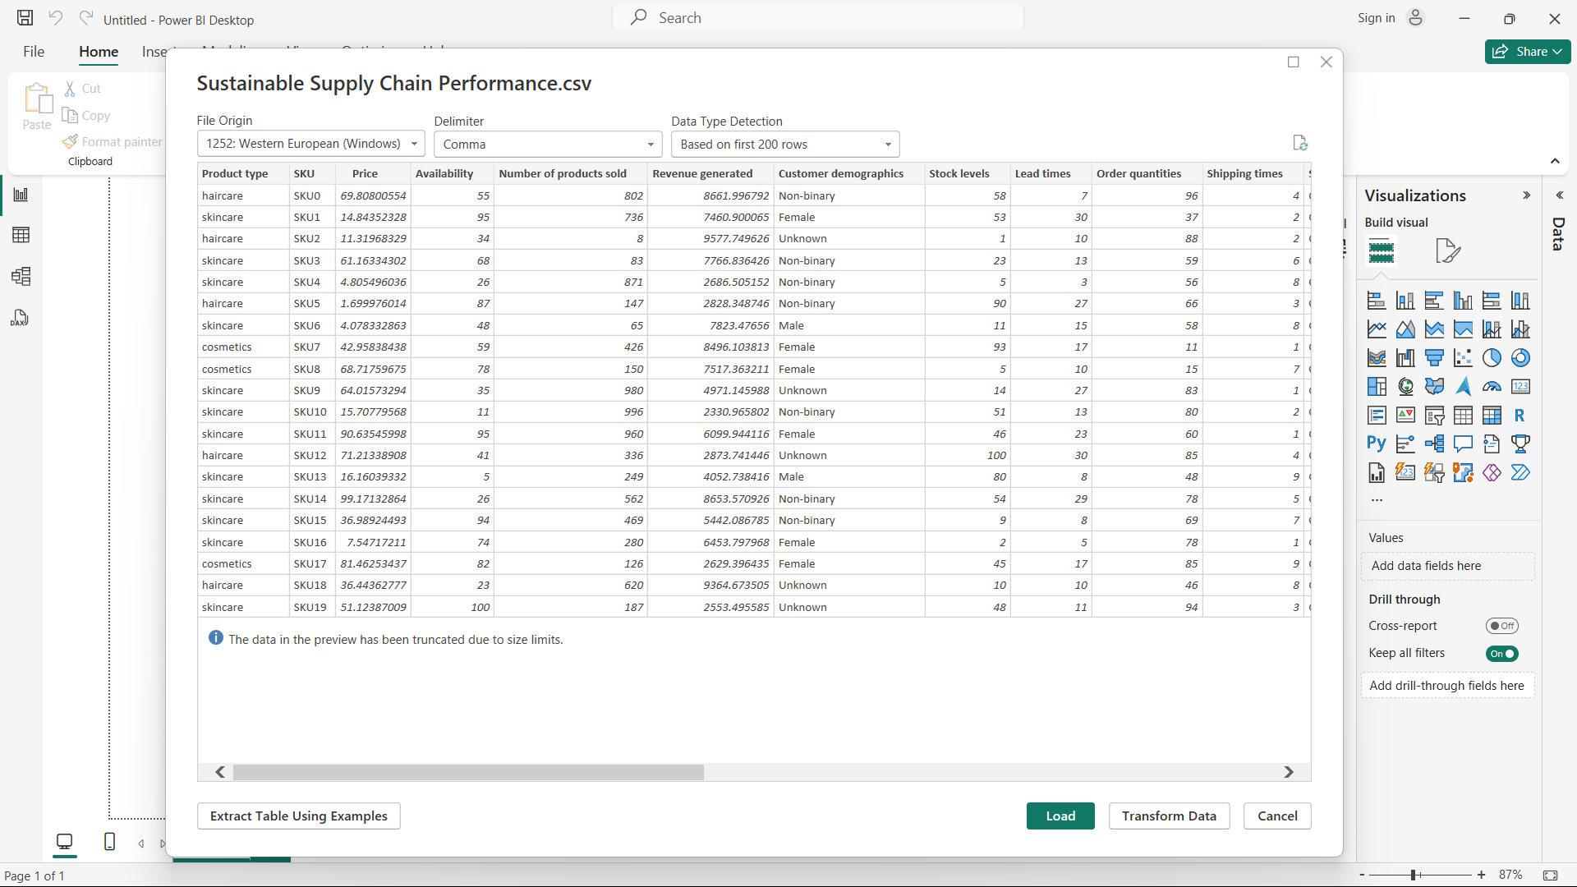

1. Click on the transform data to clean and process the data.

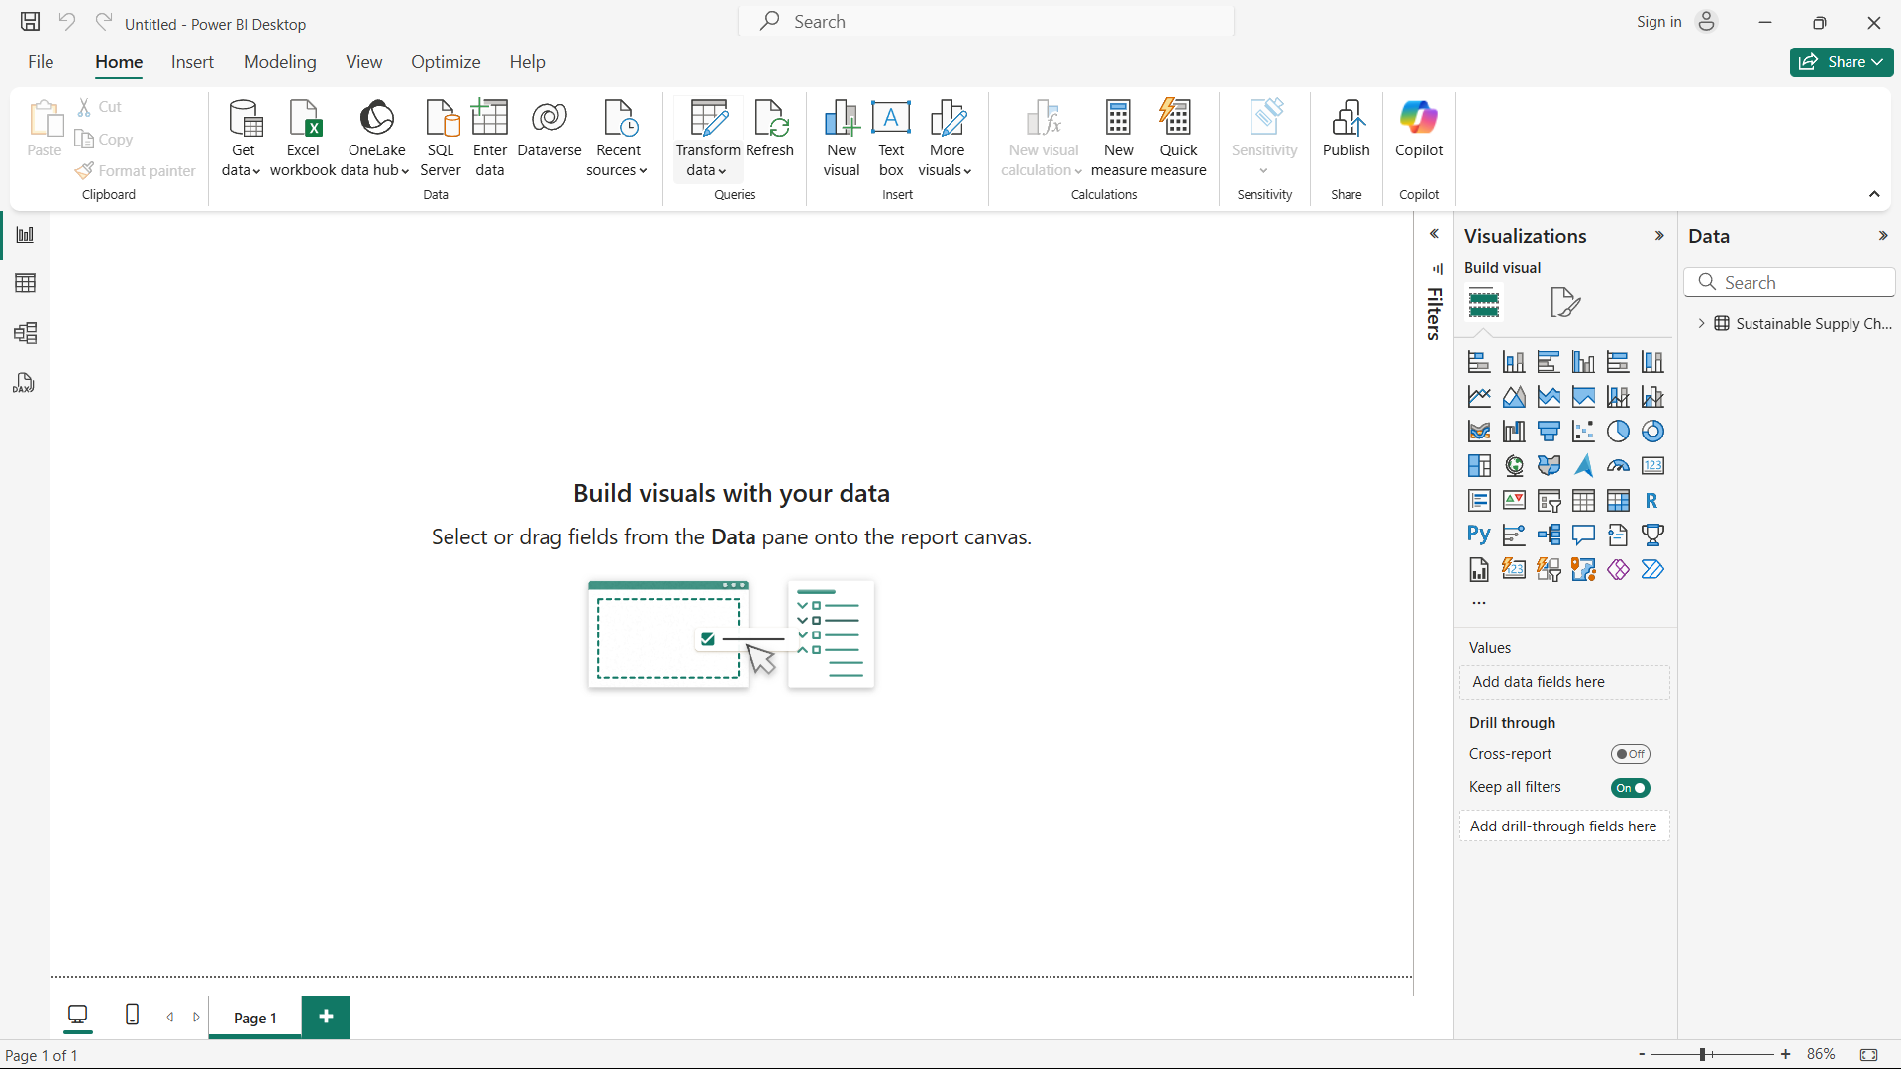

1. We have various options to transform the data like removing Rows, removing columns, replacing values, etc.
   1. Also, we can observe the type of data each column is storing in the column heading name like ABC, 123, etc. However, we can change the type accordingly.
   2. On the right side, we have this tab “APPLIED STEPS” which acts like history and we can revert back to the changes we have made.
   3. Below the column title name, we can observe three values i.e., Valid, Error and Empty.  
      Valid implies how much percentage of the column data is healthy.  
      Error implies how much percentage of the column data is in bad shape, which needs attention and correction.  
      Empty implies how much percentage of the column data has empty values in it.
   4. All of the columns are in good shape. So, we can continue with other steps.

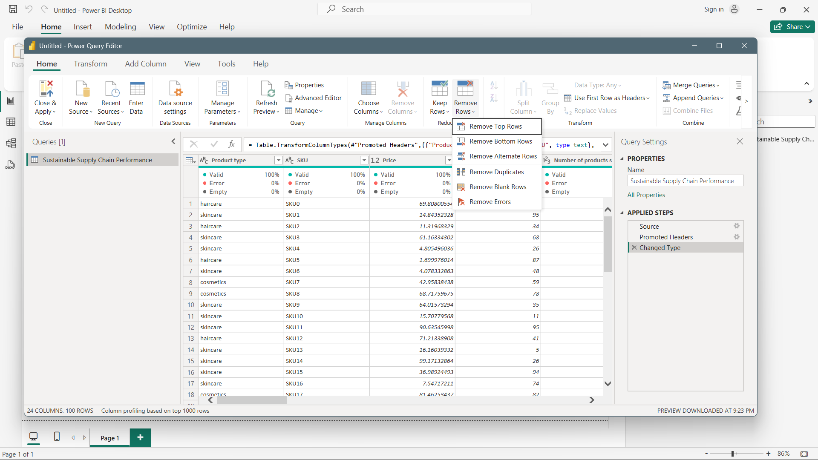

### **TRANSFORM DATA**

The objective is to make different tables with the most appropriate columns which belong to that domain. To do that, we’ll use the transform data tab as we were using previously.

**Steps:**

1. Duplicate the source table, rename it with the most preferred name delete the unrelated columns and keep the related columns.

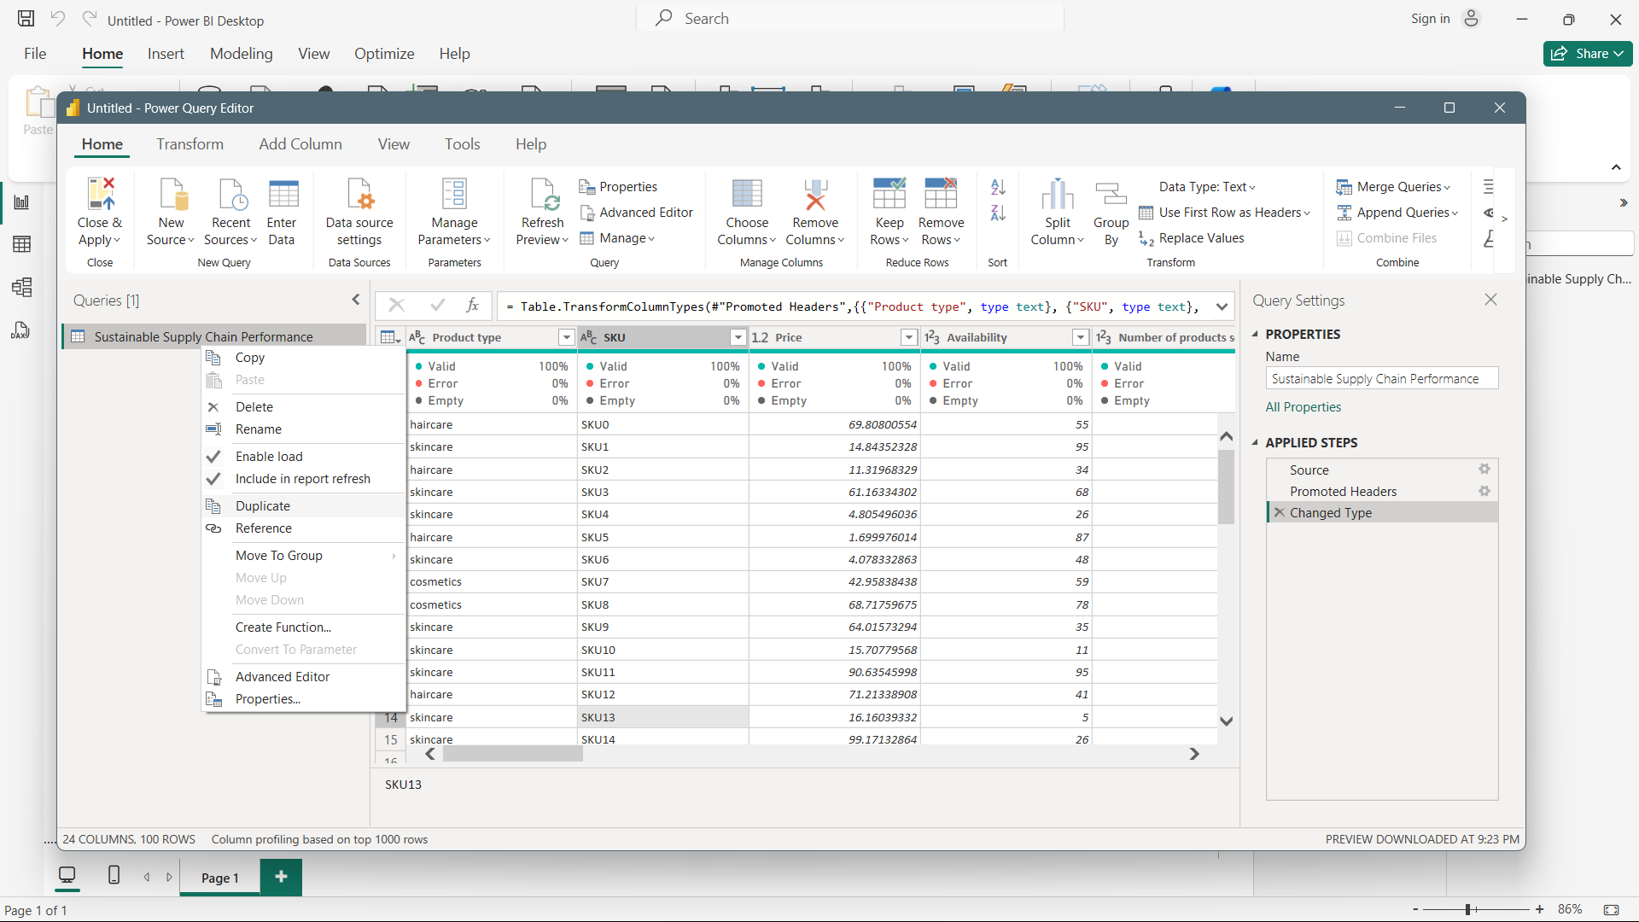

1. We want to have the four tables mentioned below with their fields. We’ll follow the same method and make three different tables.
   1. **Inventory Table:**
      1. Product type
      2. SKU
      3. Availability
      4. Number of products sold
      5. Customer demographics
      6. Stock levels
      7. Lead times
      8. Order quantities
      9. Lead time
      10. Revenue generated
   2. **Manufacturing table**
      1. Product type
      2. SKU
      3. Production volumes
      4. Manufacturing lead time
      5. Manufacturing costs
      6. Inspection results
      7. Defect rates
   3. **Supplier table**
      1. Supplier name
      2. Location
      3. Lead time
      4. Transportation modes
      5. Routes
   4. **Supply chain table**
      1. Product type
      2. SKU
      3. Price
      4. Availability
      5. Number of products sold
      6. Revenue generated
      7. Customer demographics
      8. Stock levels
      9. Lead times
      10. Order quantities
      11. Shipping times
      12. Shipping carriers
      13. Shipping costs
      14. Supplier name
      15. Location
      16. Lead time
      17. Transportation modes
      18. Routes

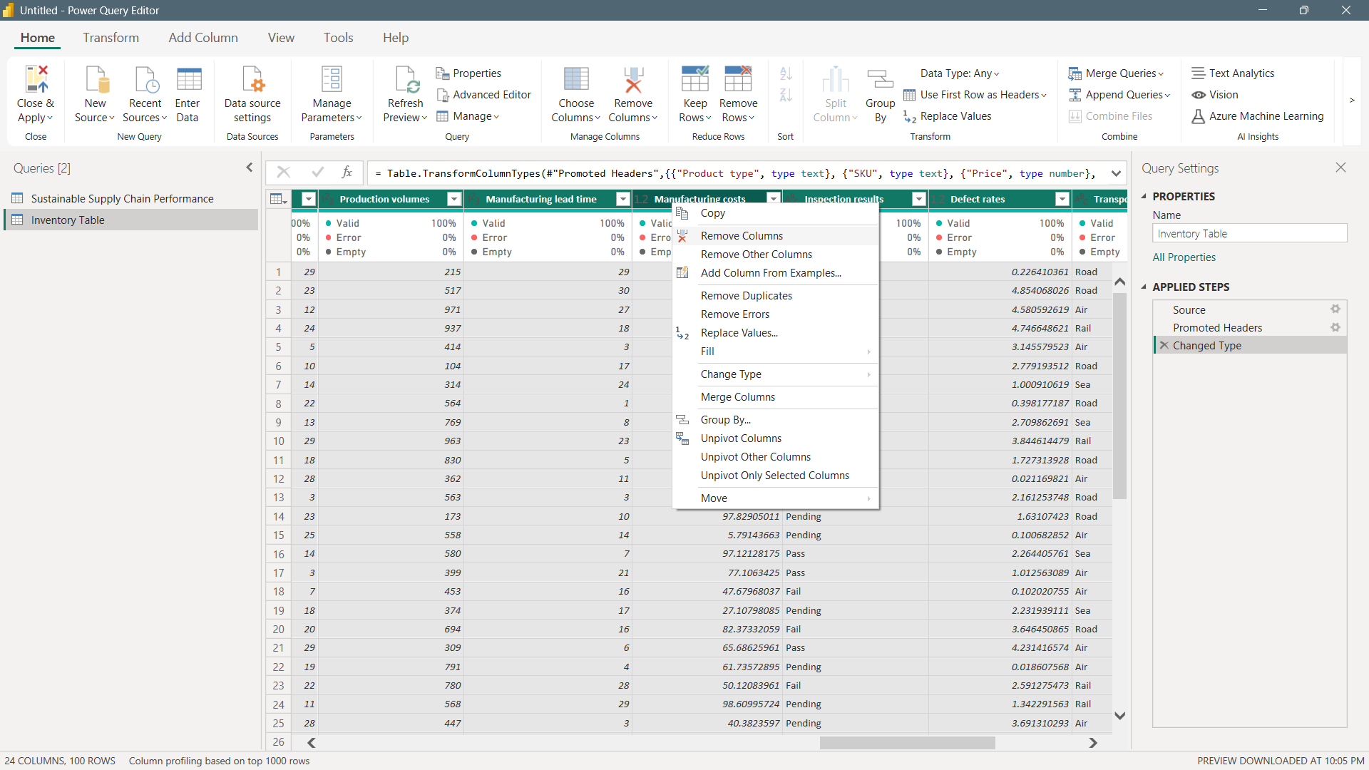

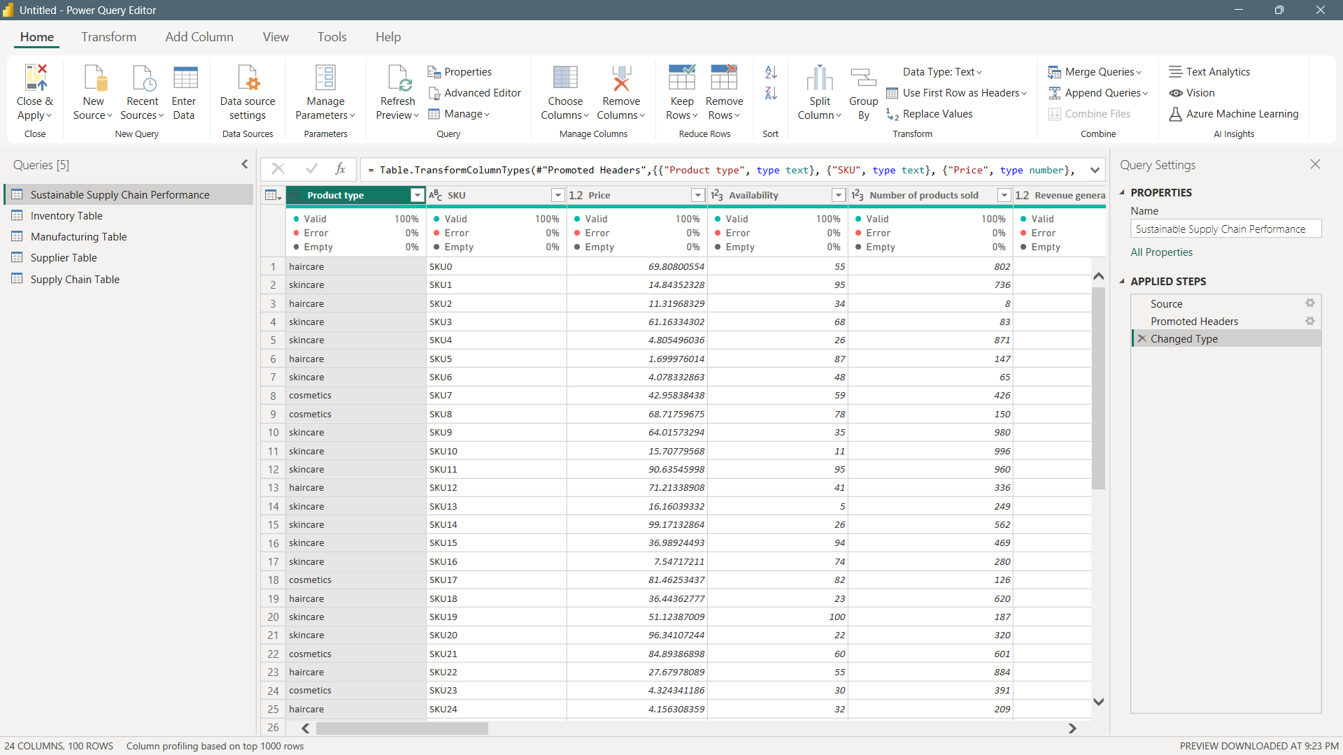

1. Now that we have created a separate table. To make these changes reflect on your project, we have to choose the **Close and Apply** buttons.

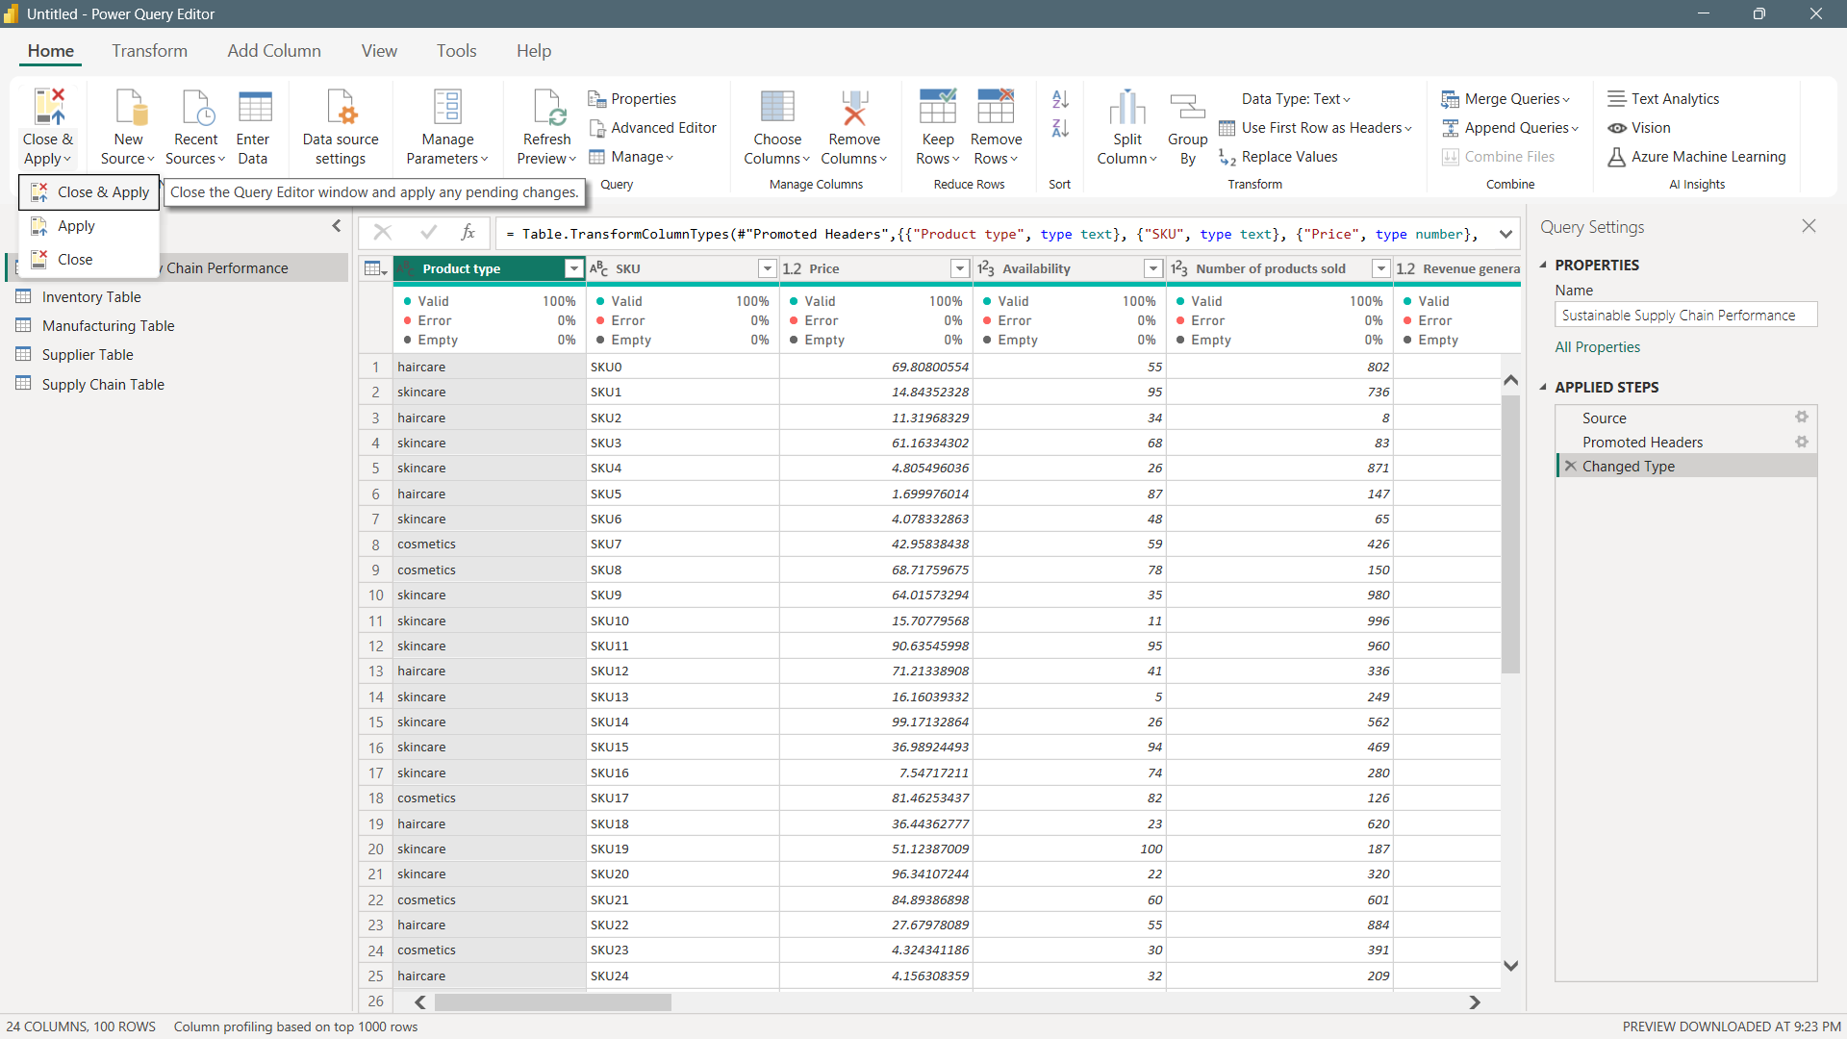

1. We can see the changes on the right side of our canvas. We have 5 different tables.

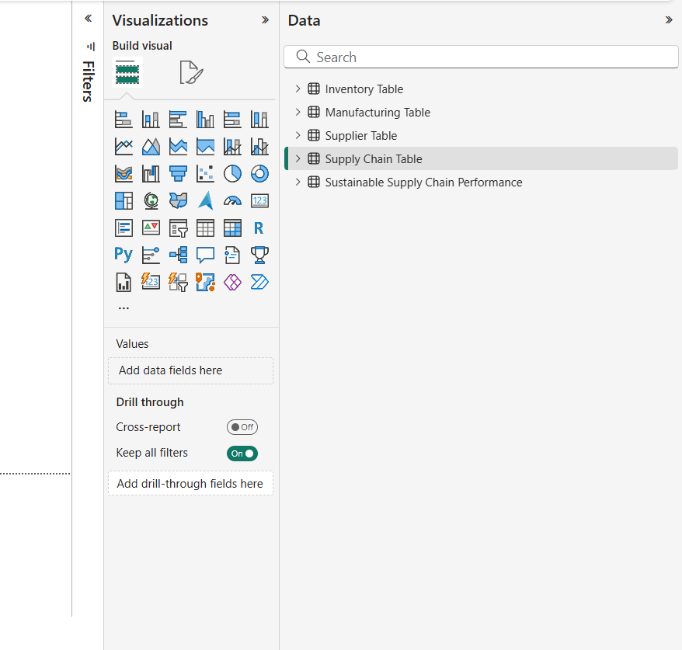

1. Let’s save our file as *Week01-hardil*. Hence, our data is well-structured and ready for analysis.

