Contents

DATA CLEAN 1

1 convert text to number for analyst 1

2 Sort the country, then find the UK and United Kingdom. Replace United Kingdom by UK 2

Question Analysis 2

Data prepare 2

1 Data Integration 2

2 Data processing 3

Data Presentation and Analysis 5

1 Recovery country and condition of alive or dead 5

2 Recovery latitudes and condition of alive or dead 6

3 Recovery longitude and Condition of alive or dead 7

4 Recovery day/month/year and Conditions of alive or dead 8

5 Recovery circumstances and conditions of alive or dead 10

6 recovery circumstances and recovery countries 11

7 Flight distance and migration/migration month 12

8 Time in days and condition of dead 13

9 Ringing analysts 14

10 migration factors and death 14

11 recovery countries analysis 17

Summary 19

# 

# DATA CLEAN

## 1 convert text to number for analyst

[ Ring Day/Month/Year Recovery Day/Month/Year]

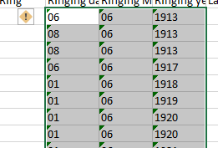

**Figure 1 wrong type data**

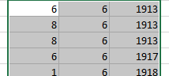

**Figure 2 data fixed**

## 2 Sort the country, then find the UK and United Kingdom. Replace United Kingdom by UK

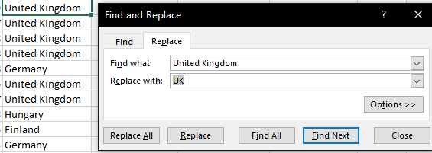

**Figure 3 repeated table for one**

# Question Analysis

1 Research the dead condition influence factors and how to improve alive percentage

2 Analysis of bird migration ability

# Data prepare

## 1 Data Integration

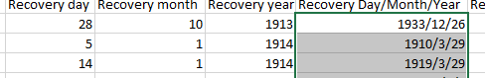

**Figure 4 combine date for sorting**

Insert two columns to display the date of ringing and recovery day.

## 2 Data processing

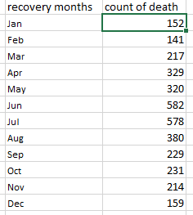

**Figure 5 count each month's death**

Use function COUNTIFS(clean!J2:J3947,1,clean!Q2:Q3947,"Dead") to find the number death each month for data analyst .

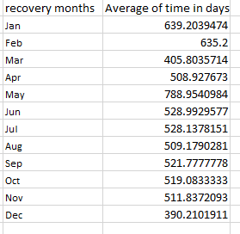

**Figure 6 Average of time in days**

Use function=AVERAGEIFS(clean!R2:R3947,clean!Q2:Q3947,"Dead",clean!J2:J3947,1) to find the average of time in days of each month.

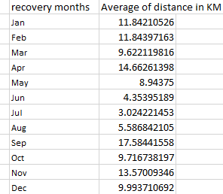

**Figure 7 Average of distance in KM**

Use function=AVERAGEIFS(clean!S2:S3947,clean!Q2:Q3947,"Dead",clean!J2:J3947,1) to find the average of distance in KM of each month.

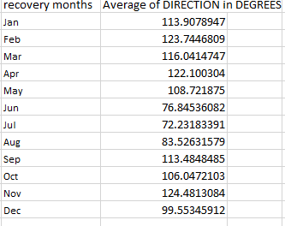

**Figure 8 Average of direction in degrees**

Use function=AVERAGEIFS(clean!T2:T3947,clean!Q2:Q3947,"Dead",clean!J2:J3947,1) to find the average of direction in degrees of each month.

# Data Presentation and Analysis

## 1 Recovery country and condition of alive or dead

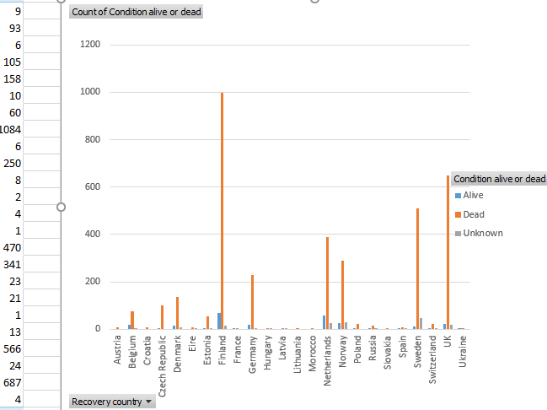

**Figure 9 recovery country and condition of alive and dead**

Use the pivot chart to present relationship of recovery country and condition of alive or dead. Use ‘Condition alive or dead’ as Legend and Values count, use ‘Recovery country’ as Axis to draw the pivot charts. From the chart we can find that most dead happen in Finland (999), UK (647), Sweden (509), Netherland (390) and Norway (288).

## 2 Recovery latitudes and condition of alive or dead

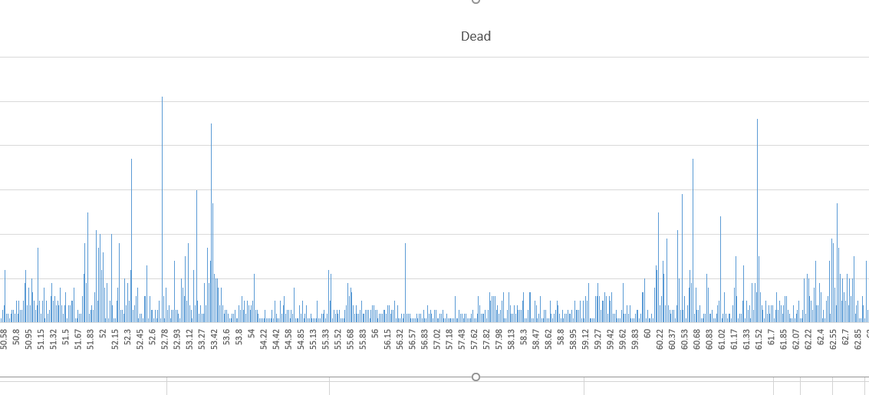

**Figure 10 recovery latitudes and condition of dead**

Use the pivot chart to present relationship between recovery latitudesand condition of dead. Use ‘Condition alive or dead’ as Columns and Values count, use ‘Recovery latitude as rows to draw the pivot chart. Then from figure, we can find that most dead happen at latitude from52-53 and 60-62 like above findings (countries shown at figure above).

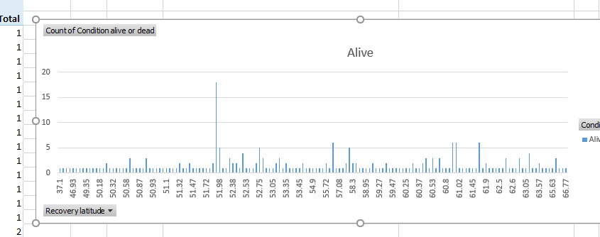

**Figure 11 recovery latitudes and condition of alive**

Use the pivot chart to present relationship between recovery latitudeand condition of alive. Use ‘Condition alive or dead’ as Columns and Values count, use ‘Recovery latitude as rows to draw the pivot charts. Then from figure, we can find that most alive latitude is around 50

## 3 Recovery longitude and Condition of alive or dead

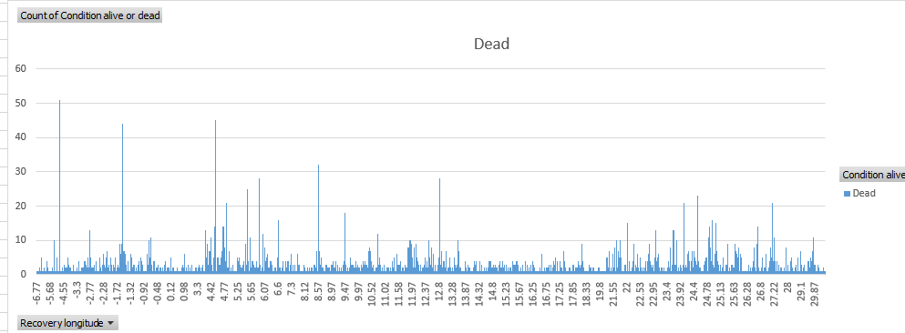

**Figure 12 recovery longitude and condition of dead**

Use the pivot chart to present relationship of recovery longitude and conditions of dead. Use ‘Condition alive or dead’ as Columns and Values count, use ‘Recovery longitude as rows to draw the pivot charts. Then from figure, we can find that most dead happen at longitude are -4.8(52), -1.53(44) , 4.53(45), 4.8(21) , 5.5(25) , 5.9(28) , 8.55(32) , 12.83(28) like above findings( countries shown above).

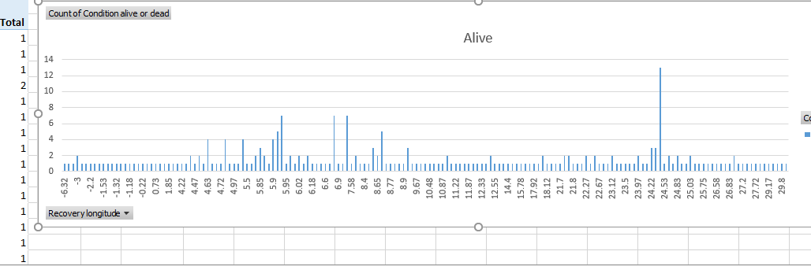

**Figure 13 recovery longitude and condition of alive**

Use the pivot chart to present relationship of recovery longitude and conditions of alive. Use ‘Condition alive or dead’ as Columns and Values count, use ‘Recovery longitude as rows to draw the pivot charts. Then from figure, we can find that most alive longitude are 5-8 and 24 like above findings (countries shown above).

## 4 Recovery day/month/year and Conditions of alive or dead

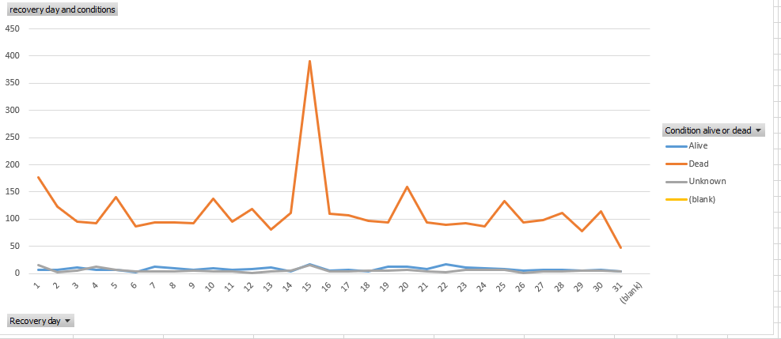

**Figure 14 Recovery day and Conditions of alive or dead**

Use the pivot chart to present relationship of recovery daysand conditions of alive or dead. Use ‘Condition alive or dead’ as Legend and Values count, use ‘Recovery day as Axis to draw the pivot charts. From figure we can find the most dead happen at mid of recovery month (15), and most likely alive is 22. Although the amount of data obtained in other months has fluctuated, it is basically around 150. At the same time, in the recorded data, the number of survivors is very small, and the maximum survival may be on the 22nd and 7th.

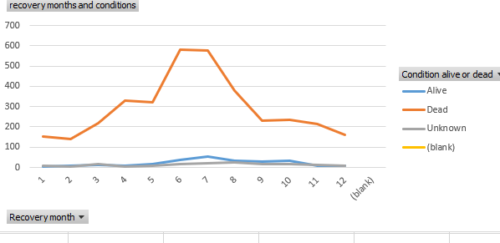

**Figure 15 Recovery months and Conditions of alive or dead**

Use the pivot chart to present relationship between recovery monthsand conditions of alive or dead. Use ‘Condition alive or dead’ as Legend and Values count, use ‘Recovery month as Axis to draw the pivot charts. From the data in the figure we can see that the maximum number of deaths occurred between June and August, and fell to a minimum in January and December. There was a sharp upward trend after April and May, and there was a sharp decline after mid-July. At the same time, the number of survivors began to rise in May and reached its peak in July, after which it fell next time.

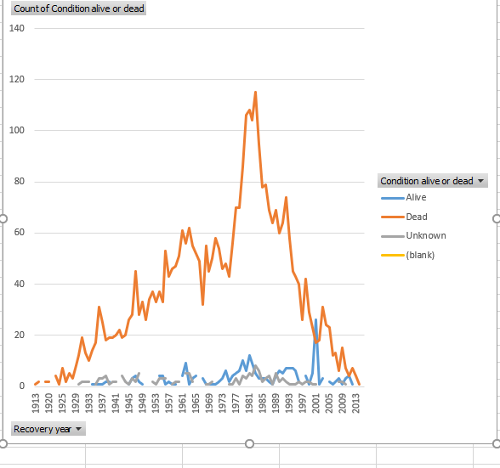

**Figure 16 Recovery years and Conditions of alive or dead**

Use the pivot chart to present recovery yearand conditions of alive or dead. Use ‘Condition alive or dead’ as Legend and Values count, use ‘Recovery year as Axis to draw the pivot charts. From the figure we can see that the number of deaths per year has a large fluctuation, but from 1913 the overall trend is gradually increasing. There was a slight decline in 1965, then rose sharply and fell rapidly after reaching its peak in 1981 (115), and rebounded slightly to around 77 in 1993 and gradually reduced the number of deaths afterwards. Stable until 2013. At the same time, survival data showed little, and it was higher in 1981 (10) and reached its peak in 2001 (22).

## 5 Recovery circumstances and conditions of alive or dead

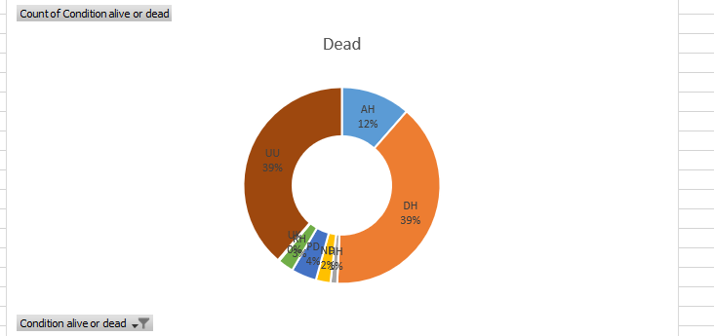

**Figure 17 Dead percentage of recovery circumstances**

Use the pivot chart to present relationship of dead percentage and recovery circumstances. Use ‘Condition alive or dead’ as Legend and Values count, use ‘Recovery circumstance as Axis to draw the pivot chart. From figure we can find the mainly dead factors in recovery circumstances are UU (unknown-39%), DH (Deliberate by human-39%) and AH (Accidentally by humans-12%). The remaining uk, rh, pd, nd, hh are basically kept at around 4 percent, with little impact.

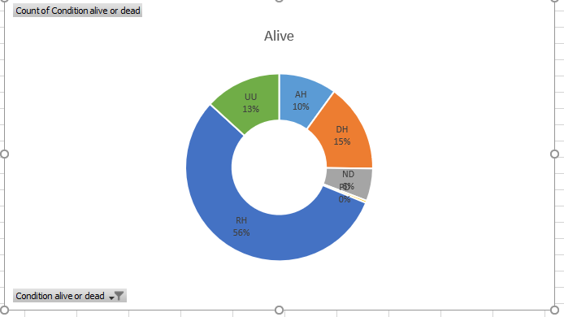

**Figure 18 Alive percentage of recovery circumstance**

Use the pivot chart to present relationship of alive percentage and recovery circumstances. Use ‘Condition alive or dead’ as Legend and Values count, use ‘Recovery circumstance as Axis to draw the pivot charts. From figure we can find the mainly alive circumstances factor in recovery circumstance is RH (Ringer related-56%) which means recaptured or found by a bird ringer.

## 6 recovery circumstances and recovery countries

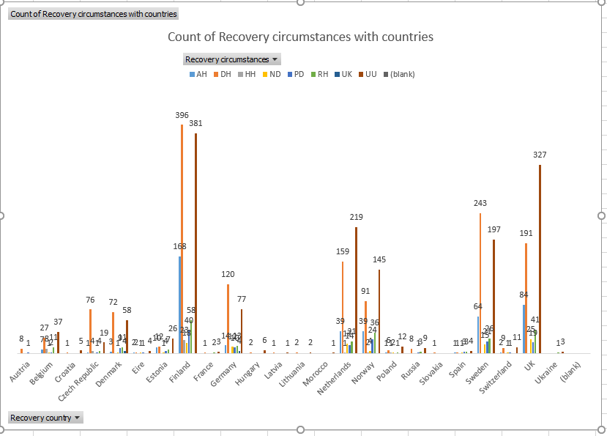

**Figure 19 recovery circumstances and recovery countries**

Use the pivot chart to present relationship of recovery circumstances and recovery countries. Use ‘recovery circumstances’ as Legend and Values count, use ‘Recovery country as Axis to draw the pivot charts. From figure we can find the mainly circumstances in most recovery countries are DH (Deliberate by humans) except unknown. Especially in Finland [DH (396)], Sweden [DH (243)], UK [DH (191)].

## 7 Flight distance and migration/migration month

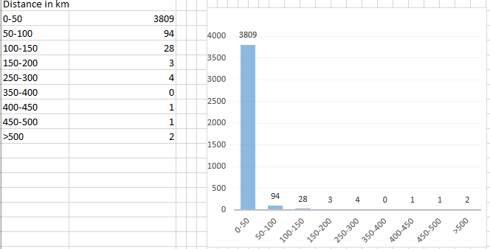

**Figure 20 flight distance**

First, we use count to get a table which show distance, then use the charts to display the flight distance. From the figure we can see that the maximum number of deaths (3809) occurred in the shortest flight time (0-50), and the number of deaths in the late migration became very small.

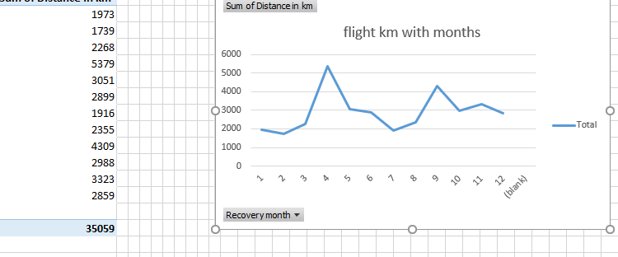

**Figure 21 flight km with months**

Use the pivot chart to display the relationship of flight distance and months. Use ‘recovery months ‘as Axis, use ‘Sum of Distance in KM ‘as values to draw the pivot charts. From the figure we can see that the flight distance has a certain relationship with the month, the farthest flight occurred in April and September, and the shortest distance (2000) occurred in July after the peak was lowered. At the same time, we can find that the monthly change is large.

## 8 Time in days and condition of dead

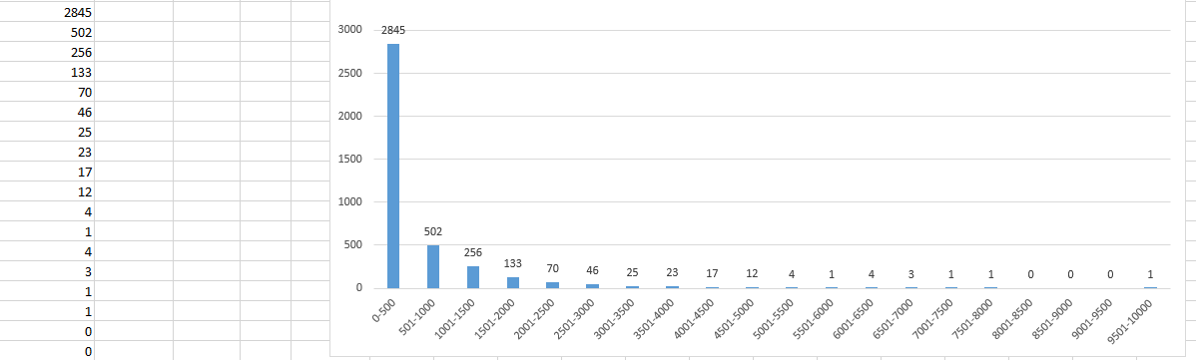

**Figure 22 count of time in days**

Use count to display the number of times in days. We can find that most time in days is 0-500 (2845). Then, the number of deaths gradually decreased and remained basically below 20 after 2500.

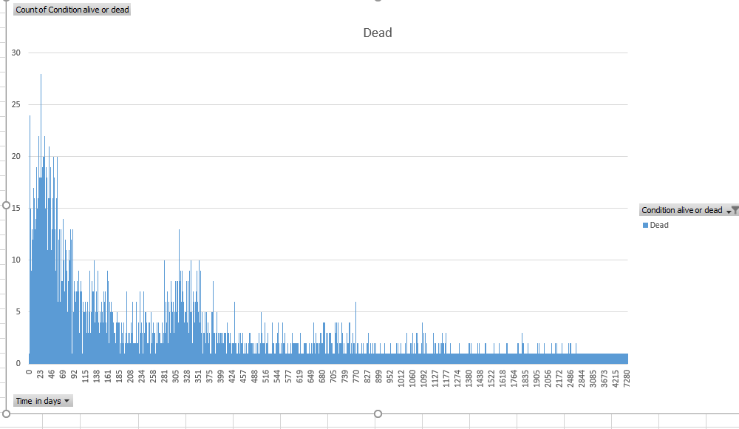

**Figure 23 Time in days and condition of dead**

Use the pivot chart to display the relationship of time in days and condition of dead. Use ‘time in days ‘as Axis, use ‘condition alive or dead’ as values to draw the pivot charts. From figure we can find most dead happen at time 0-500.

## 9 Ringing analysts

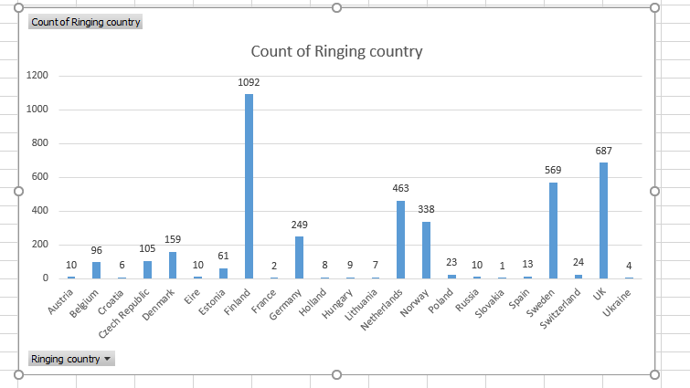

**Figure 24 ringing country**

Do a count to calculate the attendance of ringing plan among countries, from the chart we can find that the country with the highest participation are Finland (1092), UK (687).

# 10 migration factors and death

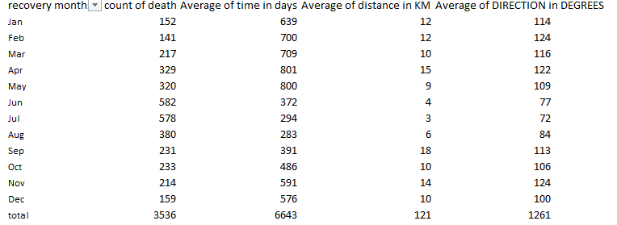

**Figure 25 gather together of factors**

Gather “count of death with months” and “average of distance/direction/time” together, and create the dynamic table to analyst the relationship in chart shown as below.

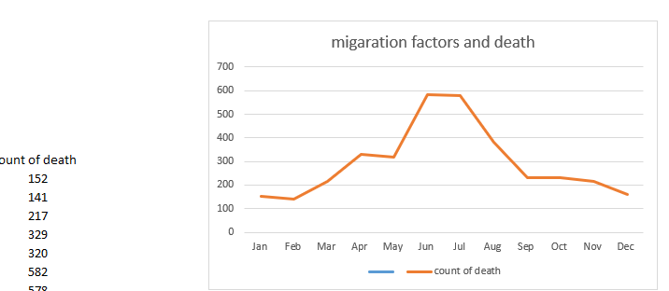

**Figure 26 count of death in dashboard**

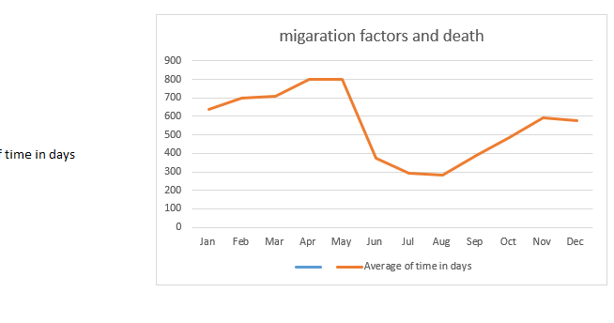

**Figure 27 death factor 1(Average of time in days)**

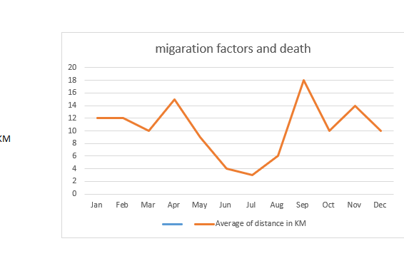

**Figure 28 death factor 2(Average of distance in KM)**

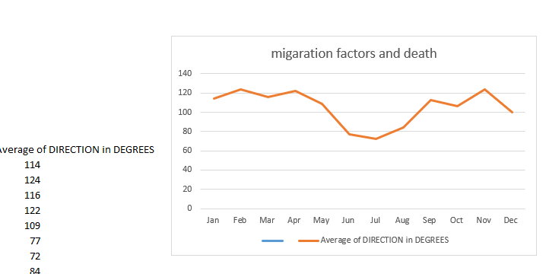

**Figure 29 death factor 3(Average of direction in degrees)**

From chart shown above, we find that most death happen at June and July. The longest flight time is May and November. The farthest month of flight is April and September, flying in the opposite direction every six months. The direction of the direction is basically reversed on the date of the cold and warm poles.

## 11 recovery countries analysis

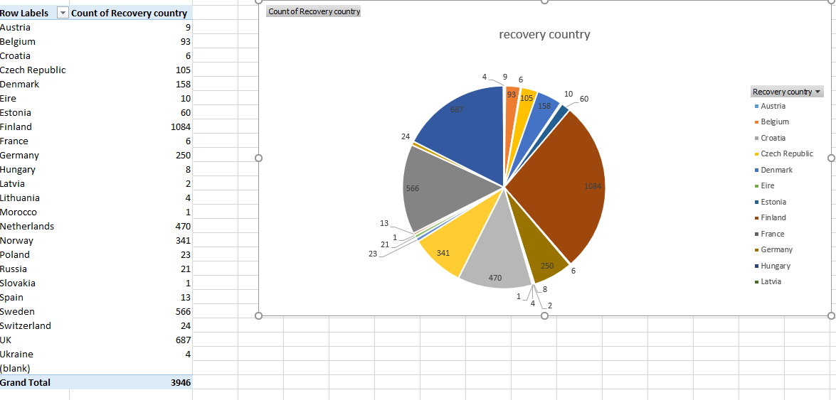

**Figure 30 recovery countries**

Use the pivot chart to create a pie chart. Display the recovery countries clearly in figure.

Most attendance in recovery recording are Denmark/ Finland/ Netherlands/ Sweden.

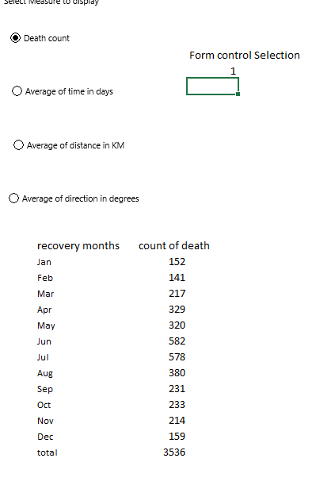

**Figure 31 dynamic table**

Then use function =INDEX($R$35:V$48,MATCH(B18,$Q$35:$Q$48,0),$E$6 to represent the dynamic table controlled by the form control selection . Anyway, you choose the table the data changed.

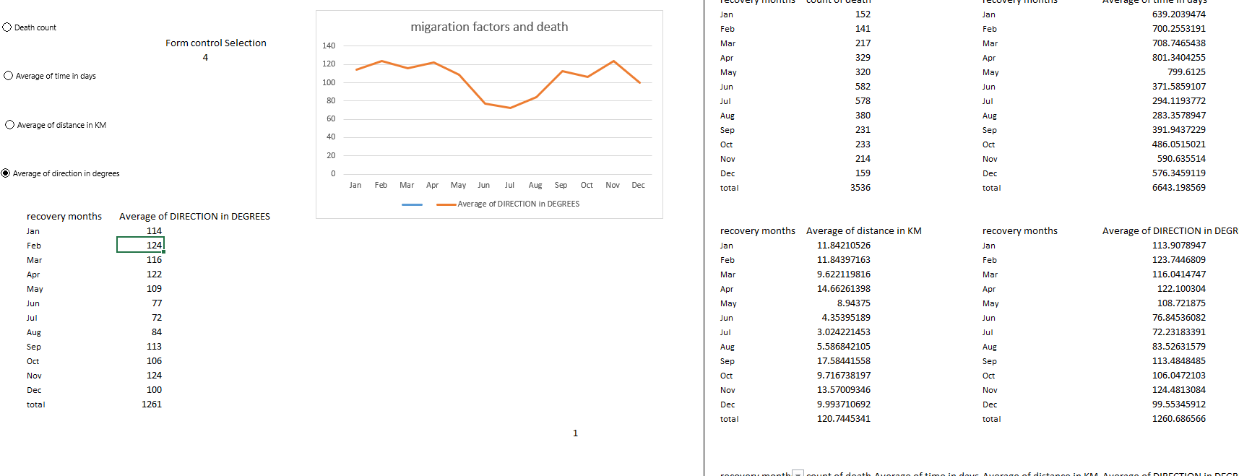

**Figure 32 dashboard for analysing factors**

# Summary

1 From figure 9 and 24/30, Finland (999), UK (647), Sweden (509), Netherland (390) and Norway (288) are countries with high deaths, but also the countries that attache the most attention to the ringing plan. Most attendance in recovery recording are Denmark/ Finland/ Netherlands/ Sweden.

2 From figure 10 and 11 most death happen at high latitude countries or regions and regions with no land at its north.

3 From figure 12 and 13, longitude death distributions display that most death happen at countries talked above. We can find the truth like that on the world map by longitudes and latitudes

4 From figure14/15/16, we can find that time factors influence the death sharply, the most likely date of death is 15th, the most likely month of death is June and July, and the year with the highest number of deaths is 2001.

5 From figure17/18, we can find that death also have relationships with recovery circumstances. mainly dead factors in recovery circumstances are UU (unknown-39%), DH (Deliberate by human-39%) and AH (Accidentally by humans-12%), and the mainly alive circumstances factor in recovery circumstance is RH (Ringer related-56%) which means recaptured or found by a bird ringer.

6 From figure 19, we can find that the recovery circumstance which influences the death most are also have highly relationships with countries. Mainly circumstances in most recovery countries are DH (Deliberate by humans) except unknown. Especially in Finland [DH (396)], Sweden [DH (243)], UK [DH (191)].

7 Talking about the migration of them, from figure 20, we can find that most likely flight is 0-50(3809). Meanwhile, migration generally takes place in April and September, so it explains the farthest flight distance shown in the figure 28 for the two months.

8 From figure 22, we will find that the most common flight distance is 0-500, which is also the flight time of most deaths. A small part can survive and migrate for a long time.

9 From figure 25 and 5/6/7/8, we use the dashboard technology to display ‘count of death ‘and ‘average of distance/direction/time ‘together. We can find clearly from dynamic table that most death happen at June and July. The longest flight time is May and November. The farthest month of flight is April and September, flying in the opposite direction every six months. Migration is the must but most death happen at that duration.