Heater & Chiller Circulate Device
Model No.GDSZ series
- Ordinary type
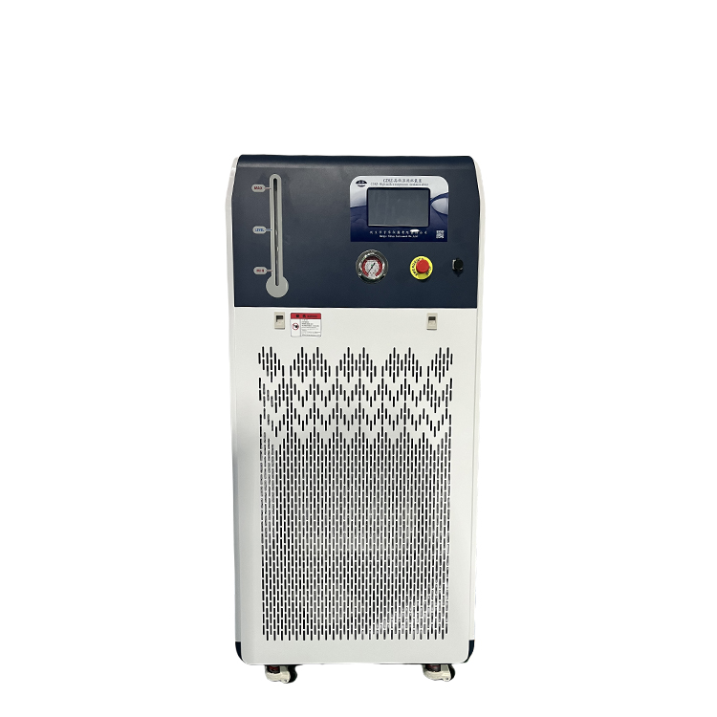
- Explosive Proof Type
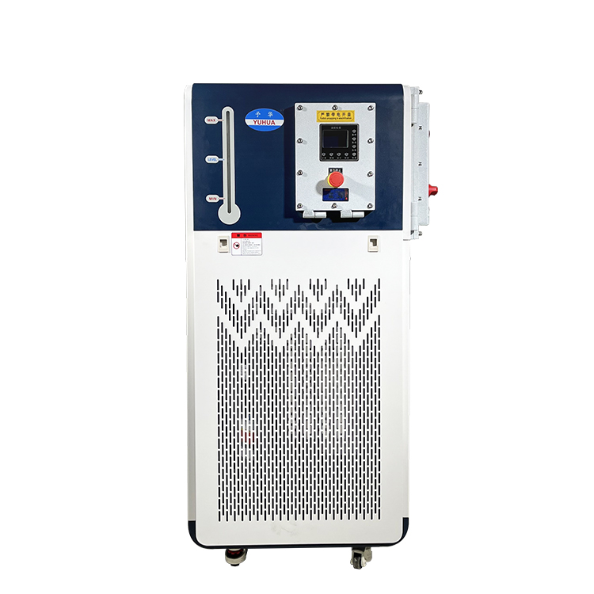

Model No. GDSZ-100/40+200
Data sheet

Model Name |  | Heater chiller
Model NO. |  | GDSZ-100/40+200
Temp accuracy(℃） |  | ±1
Temp range(℃) |  | -40～200℃ (300℃ is option,need extra cost)
Ambient temp(℃) |  | 5～35
Best humidity |  | ≤60%
Power voltage |  | 3PH/380V/50HZ
Safety protection |  | Delay, over current, overheating, over temperature protection, over and under voltage, lack of phase
Total power(kW/A) |  | 21.5/34.5
Display |  | PLC touch screen/digital control
Cooling capacity(kW) |  | 5.43
Heating pow（kW) |  | 15
Heat dissipating |  | Air-cold
Compressor | Item No. | YM125A1G-100
 | HP | 7
 | Type | Full sealed
 | Refrigerant | R404A
 | 0℃ | 29.64
 | -5℃ | 17.69
 | -10℃ | 14.74
 | -30℃ | 6.6
 | -40℃ | 4.64
Cycle pump | Power(W) | 370
 | Flow (L/min) | 42
 | Lift（M） | 28
 | Pressure(bar) | 22
Cycle port size |  | DN20
Communication port(optional) |  | RS485
Heating storage tank |  | SUS304
Heating transfer tube material |  | SUS304
Expansion Tank (L) |  | 23
Cycle medium |  | Silicon case 50cs below
Machine Weight |  | 170kg

