Model No. | 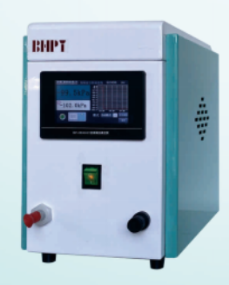DP-0630HC1
Environmental Temperature | 5--35
Environmental humidity | ≤70
Motor power(W) | 180
vacuum degree | -0.0994
Control Accuracy | ±0.2kPa
Maximum pumping rate (L/min) | 30
Availability of gas ballast valve | Yes
Working power supply | 220--240V,50Hz
Inlet nozzle bore | ɸ7
Outlet nozzle bore | ɸ7
Inlet and outlet hoses | ɸ14*ɸ8
Shell protection class | IP20
Anti-pollution level | Level 2
Size(mm) | 300*210*330
Weight(Kg) | 15
Frequency-regulated vacuum pumps

