Explosive Proof Single Layer Reactor
Model No.YDF-100LEX

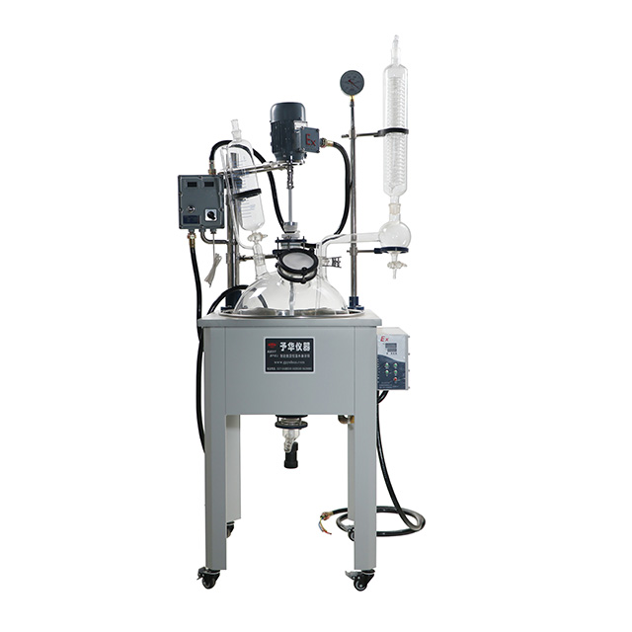
The below type is with cooling tubes. Need extra cooling chiller to supply cool coolant liquid.
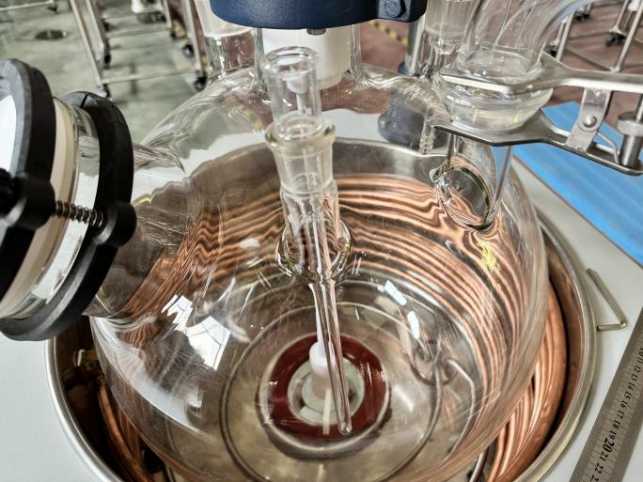
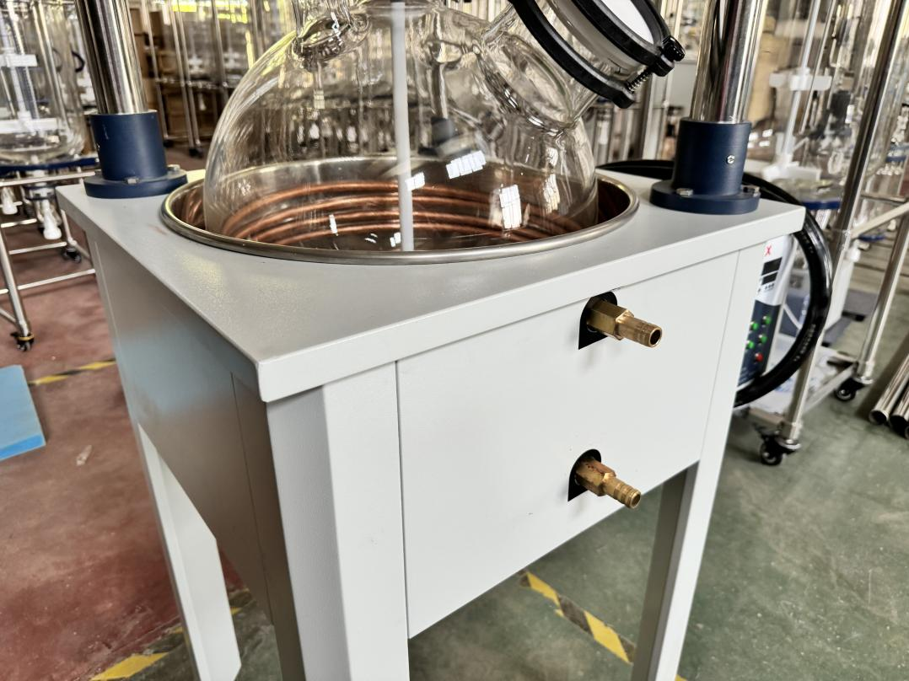

Work Principle
Single-layer glass reactor has stirring system, condensation reflux system, dripping system and heating system. While stirring the material, the bath pot heats the material in the kettle, and the evaporation efficiency can be improved under the vacuum condition (need to connect the vacuum device), and the solvent vapor is cooled into liquid when it passes through the glass condensation coil (need to connect the cooling device), which can be refluxed back to kettle, and can also be recovered through the lower valve of the reflux elbow. When the reaction is finished, the material can be discharged from the side outlet at the bottom of kettle. The use of this series of products need to be supported by vacuum devices, cooling circulating devices and other components of the system device.

Translated with DeepL.com (free version)
Feature:
1. This product is a unique equipment, the whole machine adopts cold plate electrostatic spraying + stainless steel frame structure, compact and sturdy not to go, easy to move.
2. All parts in contact with materials are made of high borosilicate glass (expansion coefficient 3.3) and PTFE materials, which have stable performance and are not easy to react with materials chemically, so it is easy and safe to use.
3. Explosion-proof speed control box shows the rotating speed and temperature of material in kettle, explosion-proof stirring motor and explosion-proof heating pot control the set temperature. Explosion-proof grade EXdIIBT4.
4. The stirring system adopts ceramic bearing and mechanical sealing to prevent the stirring rod from wearing out and dropping chips, high temperature resistance, abrasion resistance and good sealing effect.
5. Adopt PT100 temperature sensor and glass thermometer casing.
6. Vacuum pressure gauge shows real-time vacuum, pointer display.
7. Crescent type stirring paddle, 304 stainless steel + PTFE stirring blade; stirring rod material is 304 stainless steel. Outsourced PTFE tube, high strength and corrosion resistance.
8. Glass + PTFE discharge valve, no accumulation of liquid side discharge, recovery solution is very fast.
9. The thermostatic bath has a built-in heating ring, and the heating bath is independently temperature-controlled with high temperature-control precision.
10. The bottom of the bath is equipped with a liquid discharge port, which is convenient for replacement.
11. The bottom of the machine is equipped with universal wheels with brakes, which can be moved as a whole and is convenient for operation.

Product Specification
Model No. |  |  | YDF-100LEX
Reaction Area（L） |  |  | 100L
Work Voltage |  |  | Stirring 220V50HZ / Heating 380V50HZ
Total Power |  |  | 9.4KW
Material Material |  |  | High borosolicate glass 3.3
Reactor Heat-resistant temp |  |  | -80℃～+250℃
Measure accuracy |  |  | ±1℃
Feeding Funnel（L） |  |  | 2L
Condenser size |  |  | Φ120×750H（mm）
Heat Exchange Area（㎡） |  |  | About 0.7㎡
Reactor inside pressure allowed（Mpa） |  |  | -0.1-0.0
EX heating bath |  | Heating Power（W） | 9000W
 |  | Temp range | RT-180℃
 |  | Control temp.accuracy | ±1℃
EX Stirring Motor | Rated power（W） |  | 370W
 | Stirring adjust type |  | Frequency
 | Speed Range（rpm） |  | 0~600rpm/min
Lid anddischageValve（Six Port） | Stirring Port |  | 80#法兰口
 | Feeding Funnel Port |  | 40磨口
 | Temp.Sensor |  | 29磨口
 | Inlet/Outlet |  | 34磨口
 | Solid |  | 125#法兰口
 | Condenser |  | 50球磨口
Frame |  |  | SU304 Ss
Impeller and stirring |  |  | Φ 15×900H（mm） Impeller 205 mm
Temp.sensor |  |  | PT100，With glass tube
Discharge Valve |  |  | 34# glass
Ambient（℃） |  |  | 5-35
Machine Size(mm） |  |  | 850L×700W×2150H（mm）

Model No. |  |  | YDF-50LEX
Reaction Area（L） |  |  | 50L
Work Voltage |  |  | Stirring 220V50HZ / Heating 380V50HZ
Total Power |  |  | 8.3KW
Material Material |  |  | High borosolicate glass 3.3
Reactor Heat-resistant temp |  |  | -80℃～+250℃
Measure accuracy |  |  | ±1℃
Feeding Funnel（L） |  |  | 2L
Condenser size |  |  | Φ98×680H（mm）
Heat Exchange Area（㎡） |  |  | About 0.5㎡
Reactor inside pressure allowed（Mpa） |  |  | -0.1-0.0
EX heating bath |  | Heating Power（W） | 8000W
 |  | Temp range | RT-180℃
 |  | Control temp.accuracy | ±1℃
EX Stirring Motor | Rated power（W） |  | 300W
 | Stirring adjust type |  | Frequency
 | Speed Range（rpm） |  | 0~800rpm/min
Lid anddischageValve（Six Port） | Stirring Port |  | 80#法兰口
 | Feeding Funnel Port |  | 40磨口
 | Temp.Sensor |  | 24磨口
 | Inlet/Outlet |  | 34磨口
 | Solid |  | 125#法兰口
 | Condenser |  | 50球磨口
Frame |  |  | SU304 Ss
Impeller and stirring |  |  | Φ 15×900H（mm） Impeller 205 mm
Temp.sensor |  |  | PT100，With glass tube
Discharge Valve |  |  | 34# glass
Ambient（℃） |  |  | 5-35
Machine Size(mm） |  |  | 800L×700W×2150H（mm）

