Zhengzhou Eastar Instrument Equipment Co.,Ltd. (a branch of Nanbei Instrument Limited). It has been exported to more than 100 countries around the world for 20 years , and it is one of the largest and the most comprehensive instrument and equipment manufacturers in China. It integrates research,development,production and sales as one of the independent legal personality persified technology group. The headquarter is in Zhengzhou (International Air Port Area),China. And it also has the office in Beijing, Shanghai,Shenzhen and Hong Kong of China. Nanbei had obtained ISO9001:2015 quality management system certification,SGS certification,and its products had passed EU CE certification and RoHS certification.
https://chinayingshida.en.alibaba.com/productgrouplist-939864170/Pharmaceutical_testing_equipment.html
BIOBASE 120L Laboratory Bottle Washing Machine Customized OEM Glassware Washer and Dryer
Laboratory Glassware Washer

BIOBASE Lab Automatic Glassware Washer BK-LW300P Washer March New Trade Festival Welfare Price for Lab or Hospital
SCITEK 0-800L/min 3 Layer Glassware Washer Laboratory Washer Disinfector
place of origin Shandong, China
warranty 2 years
customized support OEM, ODM
brand name SCITEK
model number WD-320I
Capacity(L) 317L
Screen Size 7inch
Standard Program 30
Self-defined Program 120
Pump Flow 0-800L/min
Drying System Injection drying
Cleaning Basket Layer 3 layer
Power Supply 220/110V,50/60Hz
Power(kW) 5
Air Heating Power(kW) 4

Factory Direct Fully Automatic Bottle and Laboratory Glassware Washer

Model | YHCQ-100 | ALGW-200 | ALGW-300
Dimensions(mm) | 907*785*740 | 907*756*1062 | 701*845*1655
Working size(mm) | 530*560*633 | 540*560*800 | 630*640*930
Power Supply | 3 phase
Capacity(L) | 126 | 206 | 308
Washing capacity(L) | 100±5 | 200±5 | 300±5
Circulating pump power (KW) | 0.5 | 0.75 | 1.5
Circulating pump flow (L / min) | 295 | 430 | 1000
Water heating power (KW) | 2 | 4 | 6
Power of drying fan (KW) | 0.85 | 0.85 | 0.85
Drying heating power (KW) | 2.2 | 2.2 | 3.3
Cleaning temperature(℃) | RT~93 | RT~93 | RT~93
Number of cleaning layers one | 1 | 2 | 2
Rated total power (KW) | 4 | 5 | 7.5
Peristaltic pump dosage (ml / min) | 360 | 360 | 360
Maximum noise (dB) | 45 | 45 | 45
Operating temperature (℃) | 5~40 | 5~40 | 5~40

China High Efficient Laboratory Automatic Glassware Washer Washer Disinfector
Model | FGLW-120 | FGLW-220 | FGLW-320 | FGLW-420
Capacity(L) | 120 | 220 | 320 | 420
Water Consumption/Cycle(L) | 15 |  | 18 | 25
Inlet Water Pressure(Mpa) | 0.3~0.8
Noise | ≤50dB | ≤55dB
External &Internal Material | Stainless steel
Overall Power Consumption(KW) | 6 | 6.5/16.5 | 6.5/18 | 6.5/18
Power Consumption-Water Washing(KW) | 0.75 | 0.75 | 1.5/2.8 | 1.5/2.8
Power Consumption-Water Heating (KW) | 5 | 5/15 | 5/15 | 5/15
Power Consumption-Drying (KW) | 2.1 | 3.6 | 3.6 | 3.6
Cleaning Racks | 1 pcs | 2pcs | 3pcs | 2pcs
Power Supply | AC220V , 50/60Hz | AC220V , 50/60Hz 380V , 50/60Hz
Washer Chamber Size(W*D*H )(mm) | 600*629*465 | 600*629*658 | 600*629*820 | 688*700*703
External Size (W*D*H mm) | 980*740*870 | 690*790*1810 | 690*790*1950 | 1100*900*2165
Packing Size (W*D*H mm) | 1080*990*1065 | 990*840*2090 | 990*840*2250 | 1300*1040*2235
Gross Weight | 150kg | 330kg | 400kg | 450kg
Optional Accessories | USB interface, printer ,Cleaning racks

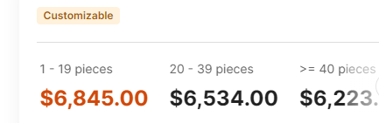
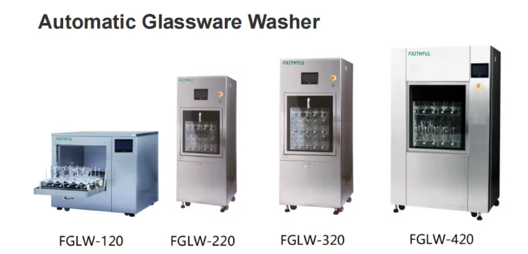
place of origin Hebei, China
warranty 1 year
customized support OEM
brand name Faithful
model number FGLW-120
Product name Automatic Glassware Washer
Capacity(L) 120
Inlet Water Pressure(Mpa) 0.3~0.8
Noise ≤50dB
External &Internal Material Stainless steel
Overall Power Consumption(KW) 6
Cleaning Racks 1 pcs
Power Supply AC220V , 50/60Hz
Washer Chamber Size(W*D*H )(mm) 600*629*465
Gross Weight 150kg
Packaging and delivery
Packaging Details standard export strong carton

