Heater & Chiller Circulator
Model No.GDSZ series

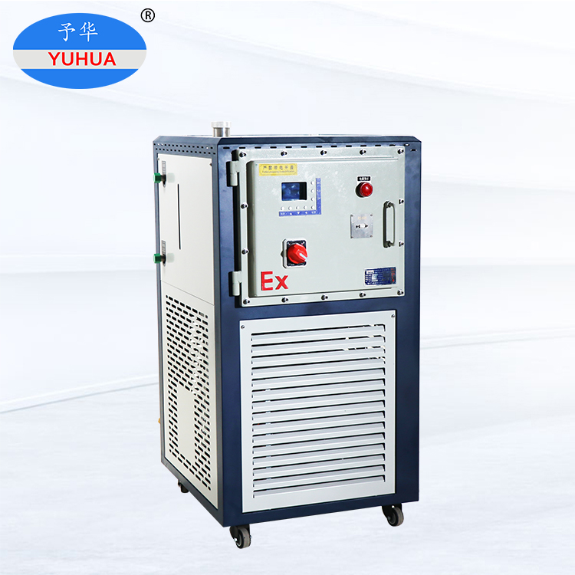

Model No. GDSZ-50/20EX
Data sheet
Model Name |  | Heater chiller Circulator
Model NO. |  | GDSZ-50/20EX
Temp accuracy(℃） |  | ±1
Operate temp(℃) |  | -20～200℃
Ambient temp(℃) |  | 5～35
Best humidity |  | ≤60%
Power voltage |  | 3PH/380V/50HZ
Safety protection |  | Overvoltage, time delay, overcurrent, overheating, leakage, protector
Total power(kW/A) |  | 10.12/16.96
Display |  | PLC touch screen/digital control
Cooling capacity(kW) |  | 2.25
Heating pow（kW) |  | 7.5
Heat dissipating |  | Air-cold
Compressor | Item No. | YM49A1G-100
 | HP | 3
 | Type | Full sealed
 | Refrigerant | R404A
Cooling capacity(kW) | 100℃ | 11.62
 | 30℃ | 11.62
 | 0℃ | 8.28
 | -5℃ | 6.93
 | -10℃ | 5.78
 | -15℃ | 4.78
 | -20℃ | 3.94
Cycle pump | Power(W) | 370
 | Flow Rate (L/min) | 22
 | Pressure(bar) | 2.2
Cycle port size |  | DN15
Communication port(optional) |  | RS485
Heating storage tank |  | SUS304
Heating transfer tube material |  | SUS304
Expansion Tank (L) |  | 20
Cycle medium |  | Silicon case 50cs below
Machine Size cm |  | About 66 W*65 L*150H

