Heater & Chiller Circulator
Model No.GDSZ series

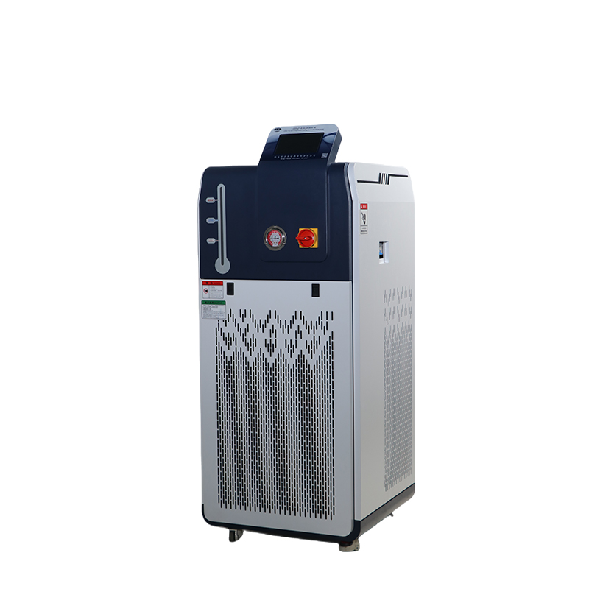

Model No. GDSZ-50/30+200
Data sheet
Model Name |  | Heater chiller Circulator
Model NO. |  | GDSZ-50/30+200
Temp accuracy(℃） |  | ±1
Operate temp(℃) |  | -30～200℃ (300℃ is option,need extra cost)
Ambient temp(℃) |  | 5～35
Best humidity |  | ≤60%
Power voltage |  | 3PH/380V/50HZ
Safety protection |  | Delay, over current, overheating, over temperature protection, over and under voltage, lack of phase
Total power(kW/A) |  | 11.6/19.66
Display |  | PLC touch screen/digital control
Cooling capacity(kW) |  | 3.74
Heating pow（kW) |  | 7.5
Heat dissipating |  | Air-cold
Compressor | Item No. | YM86A1G-100
 | HP | 5
 | Type | Full sealed
 | Refrigerant | R404A
Cooling capacity(kW) | 100℃ | 17.4
 | 30℃ | 15.66
 | 0℃ | 13.96
 | -5℃ | 11.87
 | -10℃ | 9.99
 | -20℃ | 6.89
 | -30℃ | 4.55
Cycle pump | Power(W) | 370
 | Flow (L/min) | 42
 | Lift（M） | 28
 | Pressure(bar) | 22
Cycle port size |  | DN15
Communication port(optional) |  | RS485
Heating storage tank |  | SUS304
Heating transfer tube material |  | SUS304
Expansion Tank (L) |  | 20
Cycle medium |  | Silicon case 50cs below
Machine Weight |  | 150KG

