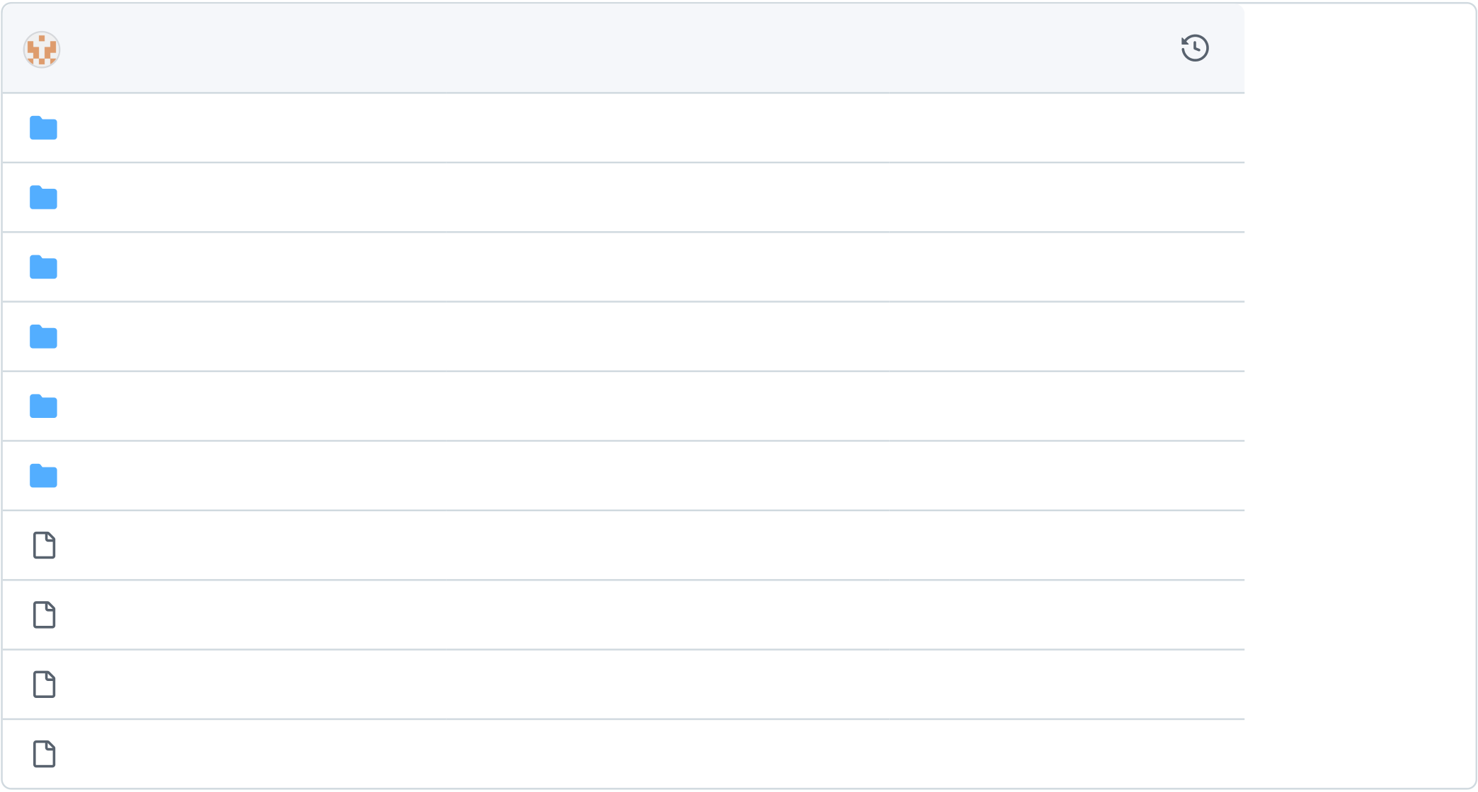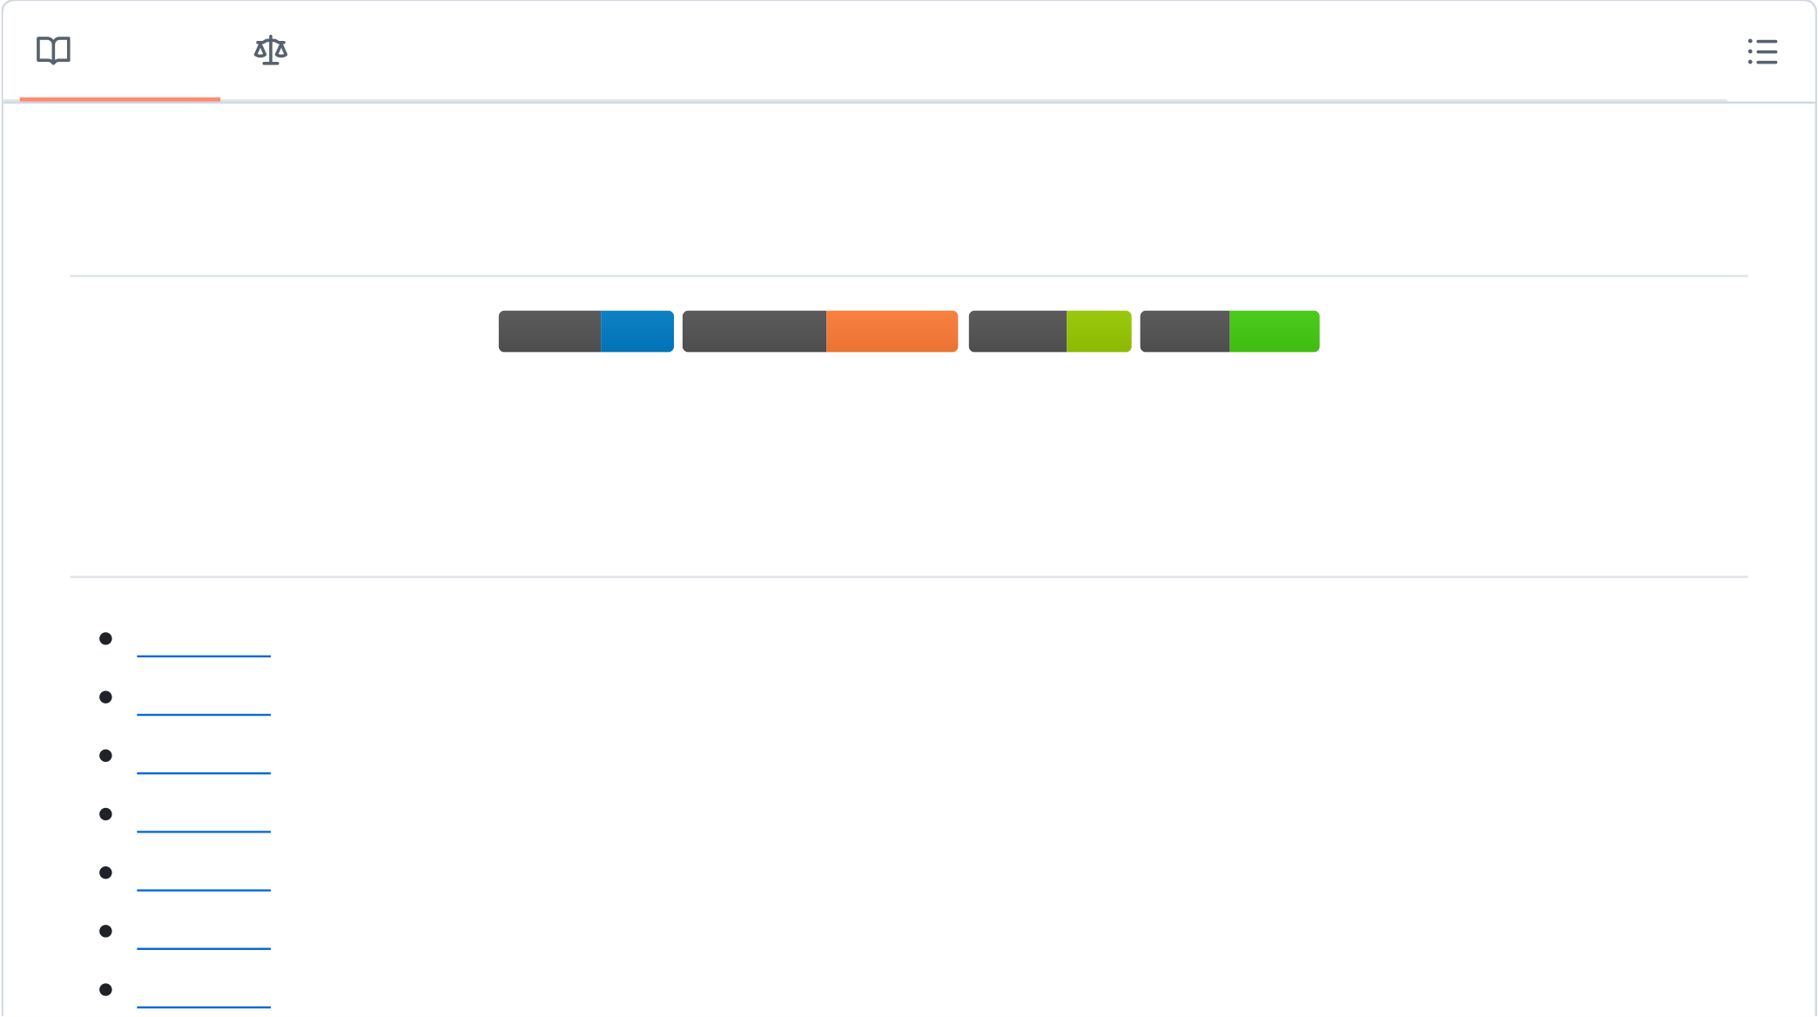

[panxingfeng](https://github.com/panxingfeng) / **[agent_chat_wechat](https://github.com/panxingfeng/agent_chat_wechat)**  **Public**

使用langchain/Ollama开发智能体agent聊天机器人框架，基于VChat框架支持微信的群聊和个人用户聊天，实现飞书机器人

的接入，也可接入使用react进行前端UI(支持二次开发)开发框架的AI支持。

[MIT license](https://github.com/panxingfeng/agent_chat_wechat/blob/master/LICENSE)

|  |  |  |  |  |  |  |  |  |  |  |  |  |
| --- | --- | --- | --- | --- | --- | --- | --- | --- | --- | --- | --- | --- |
| **35** stars | **[0](https://github.com/panxingfeng/agent_chat_wechat/forks)** [forks](https://github.com/panxingfeng/agent_chat_wechat/forks) | | [Branches](https://github.com/panxingfeng/agent_chat_wechat/branches) | | | | [Tags](https://github.com/panxingfeng/agent_chat_wechat/tags) | [Activity](https://github.com/panxingfeng/agent_chat_wechat/activity) | | **Notifications** | | [Insights](https://github.com/panxingfeng/agent_chat_wechat/pulse) |
| **Star** | | | | | | | | | |
| **Code** | [Issues](https://github.com/panxingfeng/agent_chat_wechat/issues) | **[1](https://github.com/panxingfeng/agent_chat_wechat/issues)** | | [Pull requests](https://github.com/panxingfeng/agent_chat_wechat/pulls) | | | | [Discussions](https://github.com/panxingfeng/agent_chat_wechat/discussions) | [Actions](https://github.com/panxingfeng/agent_chat_wechat/actions) | [Projects](https://github.com/panxingfeng/agent_chat_wechat/projects) | [Security](https://github.com/panxingfeng/agent_chat_wechat/security) |
| **master** | **[1 Branch](https://github.com/panxingfeng/agent_chat_wechat/branches)** | | | |  | **[0 Tags](https://github.com/panxingfeng/agent_chat_wechat/tags)** |  |  | Go to file | **Go to file** | | **Code** |
| **[panxingfeng](https://github.com/panxingfeng/agent_chat_wechat/commits?author=panxingfeng)** [Update README.md](https://github.com/panxingfeng/agent_chat_wechat/commit/df894580baacd600457f8a2d7bd72ac4faf7c69b) | | | | | | | | | | [df89458](https://github.com/panxingfeng/agent_chat_wechat/commit/df894580baacd600457f8a2d7bd72ac4faf7c69b) · 8 hours ago | |
| [.idea](https://github.com/panxingfeng/agent_chat_wechat/tree/master/.idea) | [新建任务](https://github.com/panxingfeng/agent_chat_wechat/commit/fb689af4889024048dbf3b639e2916ad4eba46fe) | | | | | | | | | 3 months ago | |
| [config](https://github.com/panxingfeng/agent_chat_wechat/tree/master/config) | [Update config.py](https://github.com/panxingfeng/agent_chat_wechat/commit/df5cc98502243d56536061fb2519330999a20901) | | | | | | | | | 2 weeks ago | |
| [images](https://github.com/panxingfeng/agent_chat_wechat/tree/master/images) | [Add files via upload](https://github.com/panxingfeng/agent_chat_wechat/commit/27e09d31116b475df852ddbd50d3909978355e3c) | | | | | | | | | 2 weeks ago | |
| [playground](https://github.com/panxingfeng/agent_chat_wechat/tree/master/playground) | [Update agent.py](https://github.com/panxingfeng/agent_chat_wechat/commit/c7de71c9e533844c3761247340f96d024d53f803) | | | | | | | | | 2 months ago | |
| [server](https://github.com/panxingfeng/agent_chat_wechat/tree/master/server) | [Update gpt_model.py](https://github.com/panxingfeng/agent_chat_wechat/commit/d13108b406680409ead3f28e5f2898ea9f35521a) | | | | | | | | | last month | |
| [tools](https://github.com/panxingfeng/agent_chat_wechat/tree/master/tools) | [Update tool.py](https://github.com/panxingfeng/agent_chat_wechat/commit/99095790a64a22da2de203bf3741cbade6a389b5) | | | | | | | | | 2 months ago | |
| [LICENSE](https://github.com/panxingfeng/agent_chat_wechat/blob/master/LICENSE) | [Create LICENSE](https://github.com/panxingfeng/agent_chat_wechat/commit/d1673ca011be0e083a861f8a95038119d5797687) | | | | | | | | | last week | |
| [README.md](https://github.com/panxingfeng/agent_chat_wechat/blob/master/README.md) | | | | [Update README.md](https://github.com/panxingfeng/agent_chat_wechat/commit/df894580baacd600457f8a2d7bd72ac4faf7c69b) | | | | | | 8 hours ago | |
| [main.py](https://github.com/panxingfeng/agent_chat_wechat/blob/master/main.py) | [Update main.py](https://github.com/panxingfeng/agent_chat_wechat/commit/e4d0dd873e57ad8c991e8af7ca1f4bac27e18eff) | | | | | | | | | 2 months ago | |
| [requirements.txt](https://github.com/panxingfeng/agent_chat_wechat/blob/master/requirements.txt) | | | | | [Update requirements.txt](https://github.com/panxingfeng/agent_chat_wechat/commit/627f765ae659d5b1457d9a8cc67f58316f7af1d5) | | | | | 2 months ago | |
| **README** | MIT license | | | | | | | | |

**AgentChatBot**

[python 3.10 3.10](https://camo.githubusercontent.com/1285b1059a69a51878dfb49eb0fbac318730acd72b2f04f6b6e807e5f40be74d/68747470733a2f2f696d672e736869656c64732e696f2f62616467652f707974686f6e2d332e31302d626c7565)[framework framework langchain langchain](https://camo.githubusercontent.com/f0d6dbf6f55d87b3ee85c9e8f2660779136b40ef4a9b79836abd5a39f9b8e5be/68747470733a2f2f696d672e736869656c64732e696f2f62616467652f6672616d65776f726b2d6c616e67636861696e2d6f72616e6765)[license license MIT MIT](https://camo.githubusercontent.com/4c8edb73fd95ab52c2eceb5635ead9af07567d17386848ed80d79358fe48b72a/68747470733a2f2f696d672e736869656c64732e696f2f62616467652f6c6963656e73652d4d49542d677265656e)[status status active](https://camo.githubusercontent.com/976c3e4769bb70412583d3b6fa35f16ca5faa900663d1b22d4df821461c7e6da/68747470733a2f2f696d672e736869656c64732e696f2f62616467652f7374617475732d6163746976652d73756363657373)

基于 langchain/Ollama 的智能对话机器人，支持微信与飞书部署

📚**目录**

项目概览

核心功能

最新更新

快速开始

配置说明

工具开发

开发计划



模型支持

相关项目

🌟**项目概览**

AgentChatBot 是一个基于 langchain/Ollama 的智能体框架，支持：

|  |  |
| --- | --- |
|  | 🤖私人微信部署 (通过 VChat) 💼飞书机器人集成  🎨 React UI 界面  🛠自定义工具扩展 |

🚀**核心功能**

**代码生成**

基于本地 Ollama 部署

支持多种编程语言

智能代码补全

**多平台支持**

|  |  |
| --- | --- |
|  | ✅微信接入 ✅飞书部署 ✅ React UI 界面 🔧更多平台持续集成中... |

📢**最新更新**

**2024-10-16**

🆕新增 Swarm Agent 框架支持

实现智能客服示例（水果店场景）

支持 Ollama/GPT 双模式切换

# Ollama模式  
OLLAMA_DATA{'use': True} # config/config.py

# GPT模式  
CHATGPT_DATA{'use': True} # config/config.py

🚀**快速开始**

**环境依赖**

点击展开详细安装步骤

🤖**启动智能体**  
在聊天框中输入#智能体即可激活。

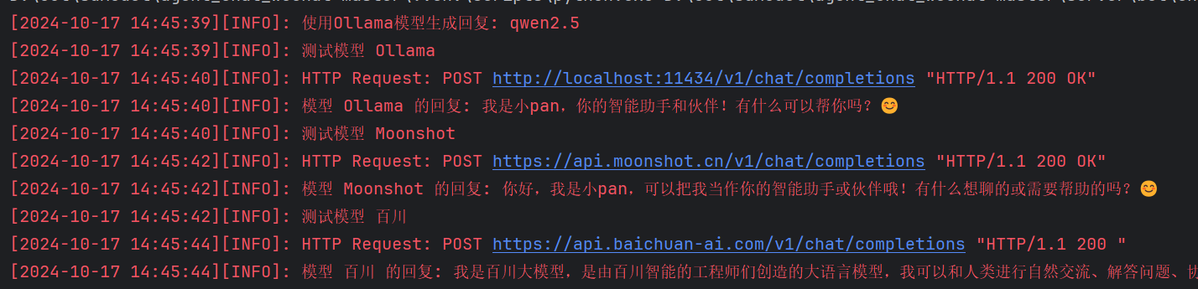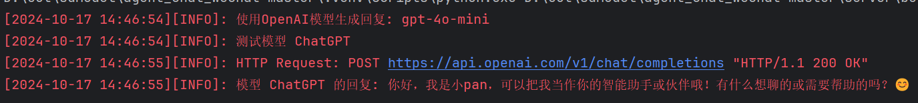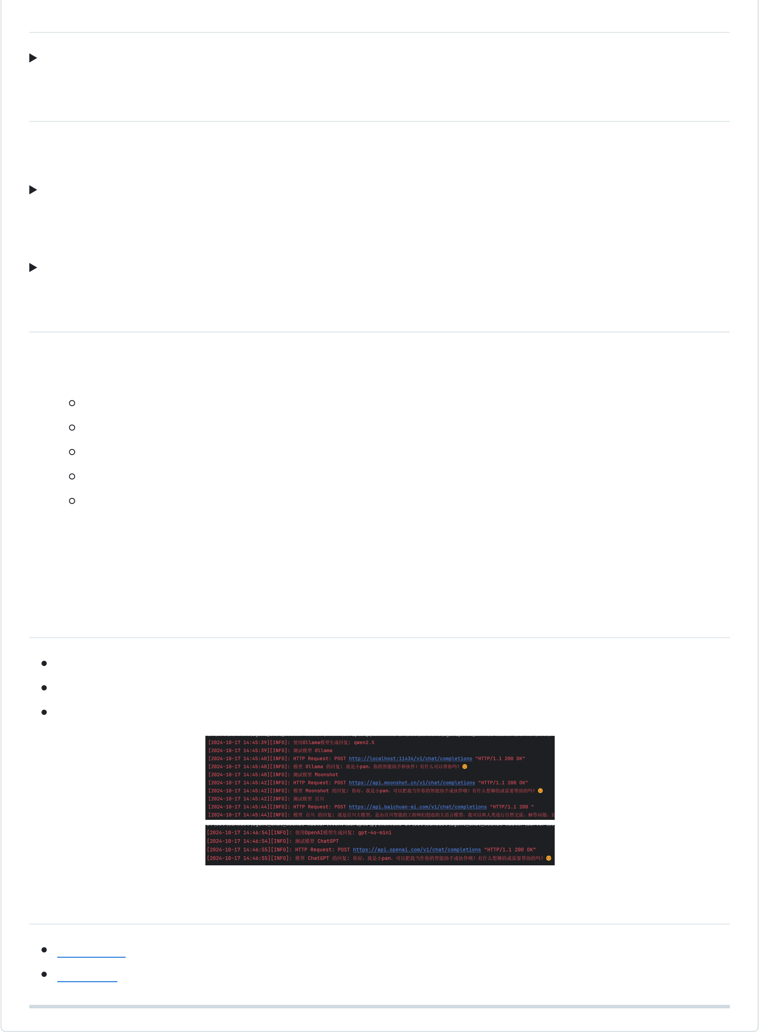

⚙️**配置说明**

配置文件示例 (config/config.py)

🛠**工具开发**

**GPT Agent 工具模板**

展开查看代码模板

**Swarm Agent 工具模板**

展开查看代码模板

📅**开发计划**

1. ✅ RAG 快速检索客服助手  
2. ✅ React 框架支持  
流式输出  
文生图/图生图 (SD-webui API)  
知识库功能  
语音功能  
智能体创建  
3. 🚧 LightRAG v2   
4. 🚧语音集成 (F5-TTS/GPT-SoVITS)   
5. 🚧 Agent 工作流框架

🤖**模型支持**

ChatGPT 系列  
Ollama 全系列  
国内主流模型（百川、MoonShot等）

🔗**相关项目**

[VChat 框架](https://github.com/z2z63/VChat)感谢z2z63作者  
[AIChat_UI](https://github.com/panxingfeng/AIChat_UI)⭐️⭐️

**[Releases](https://github.com/panxingfeng/agent_chat_wechat/releases)**

No releases published

**[Packages](https://github.com/users/panxingfeng/packages?repo_name=agent_chat_wechat)**

No packages published

**Languages**

|  |  |
| --- | --- |
|  | **Python** 100.0% |