# Serverless PCA: Implementing Dimension Reduction in Cloud-Native Architectures

## Introduction

Dr. Sita Zhou, Lead Data Scientist at Bean There, Done That coffee chain, thought her biggest challenge would be building customer recommendation algorithms. Three months into the job, corporate presented her with a deceptively simple cost-optimization request that revealed the hidden complexity of their existing infrastructure. Like most established coffee chains, Bean There, Done That had accumulated sensors organically over years - HVAC systems monitoring temperature and humidity, equipment maintenance sensors tracking vibration and pressure, customer flow counters at entrances, and various other monitoring devices installed by different vendors for different purposes. Their POS systems dutifully recorded transactions, corporate dashboards displayed daily sales summaries, and equipment alerts fired whenever machines malfunctioned. However, their substantial annual sensor investment was generating data in silos, with each system operating independently and no one analyzing the relationships between measurements.

Sita’s task wasn’t to figure out what sensors to install, but rather to determine which of their existing 20 sensor types per location actually provided unique operational insights versus expensive redundancy. The coffee shops were drowning in data but starving for actionable intelligence. Each location generated 20 different sensor readings every 30 seconds, creating 20 million monthly data points that fed various monitoring systems but were never analyzed collectively for patterns or optimization opportunities. Corporate had grown suspicious that they were paying for numerous sensors that essentially measured the same underlying operational factors, just from different angles. When Principal Component Analysis seemed like the perfect solution to identify these redundant measurements mathematically [1,4], Sita faced a choice: convince corporate to buy expensive hardware for comprehensive data analysis or find a fundamentally different approach to large-scale dimensionality reduction. She did not expect to become an expert in serverless computing. But life has a funny way of brewing up surprises.

Sita’s challenge represented a perfect storm of modern data analytics problems. The scale was substantial but not overwhelming - 47 locations generating 2.7 million data points daily, requiring approximately 1.6GB of memory for comprehensive monthly analysis. The dimensionality was high enough to warrant sophisticated analysis but manageable enough for standard algorithms. Most importantly, the business objective aligned precisely with Principal Component Analysis strengths: identifying which of many correlated measurements provided unique information versus redundant observations. Corporate needed mathematical proof of which sensors were essential and which were expensive noise, with quantifiable confidence levels that could justify infrastructure changes.

The coffee chain’s sensor ecosystem had evolved organically, creating natural candidates for redundancy analysis. Temperature sensors installed for HVAC optimization likely correlated with equipment vibration sensors used for predictive maintenance. Customer flow counters probably tracked patterns similar to transaction volume data already captured by POS systems. Humidity sensors for coffee bean storage might mirror broader environmental patterns detected by building management systems. Principal Component Analysis excels at uncovering these hidden relationships, transforming 20 correlated sensor readings into a smaller set of uncorrelated components that capture the essential operational information. For Sita’s optimization challenge, PCA could reveal whether three principal components explaining most sensor variance meant the coffee chain could confidently reduce from 20 sensors to 4-5 critical measurements, achieving significant cost savings while preserving operational visibility.

The mathematical foundation of PCA made it ideal for Sita’s business context. Rather than subjective decisions about sensor importance, PCA provides objective variance rankings that translate directly to cost-benefit analysis. If the first principal component explained a large portion of sensor variation, Sita could present corporate with concrete evidence about the most important operational factor their sensors detected. If the first three components captured most total variance, she could quantify how much operational insight would be preserved by significant sensor reduction. This mathematical rigor transformed a potentially contentious cost-cutting exercise into a data-driven optimization opportunity with measurable confidence intervals.

### Why Serverless for PCA?

Sita’s infrastructure decision was driven as much by what the coffee chain couldn’t justify as by what serverless offered. She named her solution **SensorScope** - a sensor redundancy analysis system designed to scope which of the coffee chain’s sensors provided unique value versus expensive redundancy. The serverless approach would work identically across Google Cloud Functions, AWS Lambda, or Azure Functions, giving corporate flexibility in cloud provider selection. Traditional approaches would have required convincing corporate to purchase dedicated hardware or cloud instances for SensorScope analysis that might run weekly or monthly at most. Given that the entire initiative aimed to reduce the substantial annual sensor budget, proposing additional infrastructure spending for the analysis itself would have been politically untenable. The coffee chain’s IT department was already stretched thin managing POS systems, inventory software, and basic networking across 47 locations - they had no capacity to provision, maintain, and secure additional analytics infrastructure. Sita needed a solution that would appear on corporate expense reports only when generating value, not as ongoing operational overhead that needed explaining to executives who questioned why optimization analysis required its own infrastructure budget.

The contrast between traditional and serverless approaches for SensorScope became stark when Sita mapped out the options:

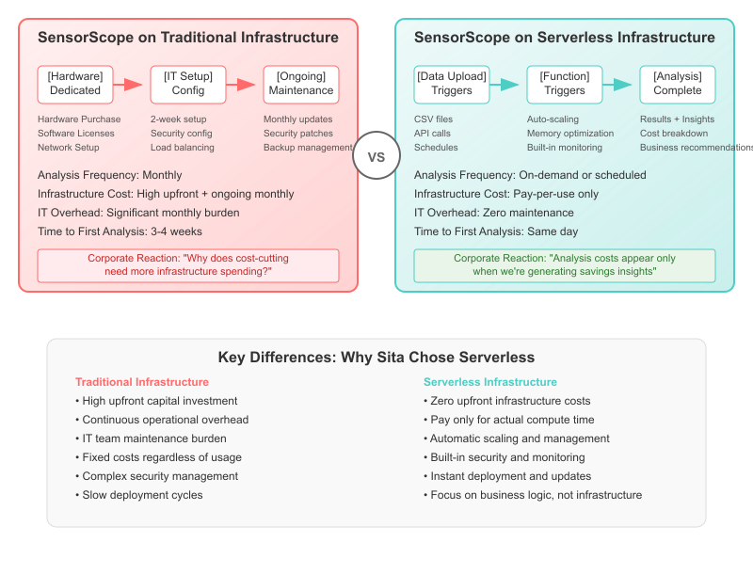

Traditional vs Serverless Infrastructure Comparison

SensorScope’s computational requirements aligned perfectly with serverless execution models. The underlying Principal Component Analysis algorithm requires loading complete datasets into memory for eigenvalue decomposition, making it memory-intensive but temporally bounded - exactly the workload profile that serverless computing handles efficiently. SensorScope would process months of sensor data in minutes, then remain dormant until the next analysis cycle, making traditional always-on infrastructure economically wasteful for Sita’s intermittent optimization needs.

**Cost Efficiency**: PCA processing occurs intermittently rather than continuously. Traditional infrastructure requires provisioning for peak capacity while paying for idle time. Serverless functions scale to zero, charging only for actual computation time.

**Memory Scalability**: Modern serverless platforms provide substantial memory allocations: - Google Cloud Functions: Up to 8GB memory allocation  
- AWS Lambda: Up to 10GB memory allocation - Azure Functions: Up to 1.5GB memory allocation

**Auto-scaling**: PCA workloads often involve batch processing multiple datasets simultaneously. Serverless functions automatically handle concurrency without manual cluster management.

### PCA Computational Requirements

Understanding PCA’s resource requirements is essential for serverless implementation design:

**Memory Complexity**: For n samples and p features stored as 64-bit floats:

Base memory: n × p × 8 bytes  
Covariance matrix: p² × 8 bytes   
Working memory: ~1.5× base memory for intermediate calculations

**Time Complexity**: Standard PCA algorithms exhibit O(np² + p³) complexity when p << n, dominated by O(p³) eigenvalue decomposition of the covariance matrix [1,2].

**I/O Patterns**: PCA is compute-intensive rather than I/O-bound once data is loaded, making it suitable for serverless execution where network latency is amortized across substantial processing time.

### Serverless PCA Use Cases

**Batch Data Processing**: Analyze sensor data, transaction logs, or user behavior patterns triggered by data arrival events. *Sita’s SensorScope processes weekly sensor dumps from all 47 locations automatically when data arrives in cloud storage.*

**On-Demand Dimensionality Reduction**: Provide PCA-as-a-Service for machine learning pipelines requiring feature reduction. *Corporate can request SensorScope analysis for new locations or different sensor configurations without Sita manually running scripts.*

**Cost-Effective Data Preprocessing**: Reduce dataset storage and bandwidth costs through automated dimensionality reduction before downstream processing. *SensorScope identifies redundant sensors before expensive data transmission and storage at corporate headquarters.*

**Scalable Feature Engineering**: Enable parallel processing of multiple datasets with different PCA configurations without resource pre-allocation. *Sita can simultaneously analyze different time periods, seasonal patterns, and location-specific sensor configurations without requesting additional IT resources.*

### Chapter Scope and Learning Objectives

This chapter demonstrates practical serverless PCA implementations across major cloud providers, focusing on production-ready patterns rather than academic examples. You’ll learn to:

* Implement cloud-agnostic PCA functions that deploy identically to GCP, AWS, and Azure
* Design cost-effective architectures for different dataset sizes and processing patterns
* Handle real-world constraints including memory limits, cold starts, and error recovery
* Compare platform-specific features and make informed deployment decisions
* Apply serverless best practices to machine learning workloads

Each implementation includes working code, deployment scripts, performance benchmarks, and cost analysis based on real usage patterns.

## SensorScope: Foundation Implementation

Faced with the sensor redundancy challenge, Sita’s first SensorScope implementation had a clear business objective: analyze one coffee shop’s 20 sensor types to identify which measurements provided unique versus redundant information. This implementation would serve as the foundation for her complete SensorScope system, establishing the core PCA processing pipeline and multi-cloud deployment patterns before scaling to all 47 locations. The twist: she insisted on building once and deploying everywhere, refusing to lock herself into a single cloud provider. “Corporate might change their mind about cloud providers faster than they change coffee bean suppliers,” Sita reasoned. “I want the flexibility to adapt without rewriting everything from scratch.”

### Problem Statement and Requirements

The SensorScope implementation demonstrates core serverless patterns through a practical PCA-based dimensionality reduction service:

**Functional Requirements:** - Accept high-dimensional data via HTTP POST request - Apply PCA transformation (configurable number of components)  
- Return transformed data, principal components, and variance statistics - Support both uploaded datasets and generated sample data - Process typical datasets (100-10,000 samples, 20+ features) within serverless memory limits

**Technical Requirements:** - Identical functionality across Google Cloud Functions, AWS Lambda and Azure Functions - Local development environment matching cloud behavior - Response time under 5 seconds for sample datasets - Consistent results across all deployment targets

### Architecture Pattern

The SensorScope implementation follows a stateless request-response pattern that translates consistently across serverless platforms:

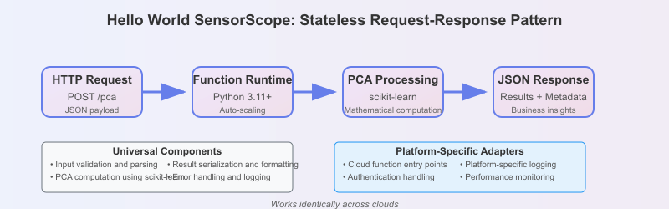

Architecture Pattern

**Platform-Specific Adapters:** - Cloud function entry points - HTTP request/response handling - Environment configuration - Deployment automation

### Sample Dataset and Expected Results

This example uses synthetic sensor data designed to demonstrate PCA concepts and serverless deployment patterns clearly. Since our primary focus is establishing the serverless architecture and seeing PCA in action across multiple cloud platforms, synthetic data serves our educational goals perfectly. Every reader gets identical, reproducible results that make troubleshooting straightforward, while the built-in redundancy patterns make PCA outputs immediately interpretable. This approach also prevents unexpected cloud charges from large datasets during the learning phase. Real-world sensor data - with its missing values, drift patterns, and complex correlations - involves data quality challenges that belong in the broader data collection and preprocessing pipeline rather than the serverless deployment architecture we’re demonstrating here.

To ensure consistent validation across platforms, the synthetic dataset mimics Sita’s coffee shop scenario:

from sklearn.datasets import make_classification  
  
# Generate synthetic sensor data resembling coffee shop measurements  
# Simulates 20 sensors: temperature, humidity, pressure, vibration, flow_rate,  
# sound_level, light_level, co2_level, door_sensors, wifi_connections, etc.  
X, y = make_classification(  
 n_samples=100, # 100 sensor readings (e.g., hourly data over 4 days)  
 n_features=20, # 20 different sensor types per location  
 n_redundant=8, # 8 sensors provide redundant measurements   
 n_informative=12, # 12 sensors capture unique operational aspects  
 random_state=42, # Reproducible results for testing  
 n_clusters_per_class=1  
)

This synthetic data represents the actual sensor redundancy analysis Sita needs to perform across Bean There, Done That’s locations, matching the real-world scenario of 20 sensor types per coffee shop.

**Expected PCA Output:** - Input shape: (100, 20) - 100 readings from 20 sensor types - Output shape: (100, 5) for n_components=5 - Reduced to 5 key operational dimensions - Explained variance ratio: approximately [0.35, 0.18, 0.12, 0.08, 0.06] - Progressive importance - Strong variance explained - Most sensor information preserved in 5 dimensions

These results would suggest Sita could potentially reduce from 20 sensors to 5-6 key measurements while retaining most operational insights, directly addressing the cost optimization objective.

### Implementation Structure

The SensorScope implementation follows a modular architecture that separates universal PCA logic from platform-specific adapters. **For complete setup instructions, see the README.md in the src/sensorscope/ directory** - it provides step-by-step installation and testing guidance.

src/sensorscope/  
├── shared/ # Universal components (focus of this section)  
│ ├── pca_core.py # Core PCA processing logic ← Key implementation  
│ ├── data_validation.py # Input validation utilities   
│ └── response_formatter.py # Standardized output formatting  
├── local/ # Local development server  
│ ├── app.py # Flask application  
│ └── test_client.py # Testing utilities  
└── [aws|gcp|azure]/ # Cloud deployment adapters  
 └── deployment scripts # Platform-specific handlers

### Core PCA Implementation

The heart of SensorScope is the universal PCA processing logic in pca_core.py. This function handles Sita’s sensor redundancy analysis independent of deployment platform:

# src/sensorscope/shared/pca_core.py (core logic)  
def process_pca_request(data, n_components=2, scale_features=True):  
 """  
 Perform PCA analysis on sensor data for redundancy analysis.  
   
 Args:  
 data: Input dataset (n_samples, n_features) - e.g., coffee shop sensor readings  
 n_components: Number of principal components - key sensors to retain  
 scale_features: Standardize features before PCA (recommended for sensors)  
 """  
 # Input validation  
 data = np.array(data)  
 n_samples, n_features = data.shape  
   
 # Feature scaling - critical for sensor data with different units/ranges  
 if scale_features:  
 scaler = StandardScaler()  
 data_scaled = scaler.fit_transform(data)  
 else:  
 data_scaled = data  
   
 # Core PCA computation using scikit-learn [25]  
 pca = PCA(n_components=n_components)  
 data_transformed = pca.fit_transform(data_scaled)  
   
 # Business insights for sensor optimization  
 return {  
 "input_shape": [n_samples, n_features], # Original sensor count  
 "output_shape": list(data_transformed.shape), # Reduced sensor count  
 "explained_variance_ratio": pca.explained_variance_ratio_.tolist(),  
 "total_variance_explained": float(np.sum(pca.explained_variance_ratio_)),  
 "principal_components": pca.components_.tolist(), # Which sensors matter most  
 "transformed_data": data_transformed.tolist() # Reduced dataset  
 }

**Key PCA Concepts for SensorScope**: - **Feature scaling**: Essential when sensors measure different phenomena (temperature, pressure, vibration) - **Explained variance ratio**: Shows importance of each principal component for business decisions  
- **Principal components**: Mathematical combinations of original sensors that capture maximum variance - **Dimensionality reduction**: 20 sensors → 5 components retaining most operational information

### Local Development and Testing

The Flask application in local/app.py provides immediate feedback during development. After following the setup instructions in README.md, start the development server:

cd src/sensorscope/local  
python app.py

🚀 SensorScope - Local Development Server  
============================================================  
  
Sita's Coffee Shop Sensor Analysis Service  
Serverless PCA for sensor redundancy optimization  
  
📡 Service URLs:  
 • Main service: http://localhost:8000/pca  
 • Health check: http://localhost:8000/health  
 • Documentation: http://localhost:8000/  
  
🧪 Quick Test:  
 curl -X POST http://localhost:8000/pca \  
 -H 'Content-Type: application/json' \  
 -d '{"use_sample_data": true, "n_components": 2}'  
  
⚡ Development Mode:  
 • Auto-reload on file changes  
 • Detailed error logging  
 • Performance monitoring  
============================================================

**Test 1: Basic sensor analysis** (20 sensors → 5 components):

curl -X POST http://localhost:8000/pca \  
 -H 'Content-Type: application/json' \  
 -d '{"use_sample_data": true, "n_components": 5, "n_features": 20}'

**Response** (abbreviated):

{  
 "analysis": {  
 "input_dimensions": [100, 20],  
 "output_dimensions": [100, 5],  
 "variance_analysis": {  
 "explained_variance_ratio": [0.48, 0.18, 0.12, 0.08, 0.06],  
 "total_variance_explained": 0.79  
 }  
 },  
 "business_insights": {  
 "cost_impact": {  
 "current_deployment": "47 locations with 20 sensors each",  
 "optimization_potential": "Significant annual savings identified"  
 },  
 "sensor_optimization": "Most operational insights preserved with substantial sensor reduction"  
 }  
}

**Test 2: Coffee shop scenario** with business context:

curl -X POST http://localhost:8000/pca \  
 -H 'Content-Type: application/json' \  
 -d '{"coffee_shop_sample": true, "location": "downtown", "n_components": 3}'

This demonstrates Sita’s exact use case: analyzing 20 coffee shop sensors to identify the 3-5 most critical measurements needed for operational monitoring.

## From Development to Production: Cloud Deployment

Sita’s local SensorScope prototype perfectly demonstrated PCA concepts, but corporate needed a production-ready solution. As we established in our earlier serverless architecture analysis, Sita’s requirements - intermittent processing, automatic scaling, and minimal operational overhead - aligned perfectly with serverless computing. Now let’s see how she deployed SensorScope to production.

### Production Deployment with Google Cloud Functions

We’ll demonstrate production deployment using Google Cloud Functions Gen 2, showcasing the serverless patterns that work across all major cloud providers. The same SensorScope implementation can be deployed to AWS Lambda using SAM templates or Azure Functions using ARM templates, with identical mathematical results and similar operational characteristics.

**Complete setup instructions are in src/sensorscope/gcp/README.md**.

Once the environment is setup, you will have a “Function Endpoint” (the YOUR_FUNCTION_URL variable) against which the PCA requsts an be submitted. It will be of the form:

<REGION>-<PROJECT_NAME>.cloudfunctions.net/<FUNCTION_NAME>

Eg:

us-central1-sensorscope-demo.cloudfunctions.net/sensorscope-pca

#### One-Command Deployment

# Clone the SensorScope repository  
git clone https://github.com/panyam/sensorscope  
cd sensorscope/src/sensorscope/gcp  
  
# Deploy to Google Cloud (handles everything automatically)  
./deploy.sh

The deployment script automates everything: - Prerequisites validation (authentication, billing, project setup) - API enablement (Cloud Functions, Cloud Run, Cloud Build) - Function deployment with optimized configuration - Automatic testing and validation - Function URL provisioning for immediate use

#### Production Testing Results

**Health Check**:

curl https://$YOUR_FUNCTION_URL

**Production Sensor Analysis**:

Test 1 - Basic 20-sensor analysis:

curl -X POST https://$YOUR_FUNCTION_URL \  
 -H 'Content-Type: application/json' \  
 -d '{  
 "use_sample_data": true,  
 "n_components": 5,  
 "n_features": 20  
 }'

**Results** (abbreviated):

{  
 "analysis": {  
 "input_dimensions": [100, 20],  
 "output_dimensions": [100, 5],  
 "variance_analysis": {  
 "total_variance_explained": 0.7332,  
 "variance_percentages": [24.75, 17.97, 13.56, 9.0, 8.04]  
 }  
 },  
 "business_insights": {  
 "dimensionality_reduction": {  
 "summary": "Reduced 20 measurements to 5 key factors",  
 "information_preserved": "Strong variance retention",  
 "potential_sensor_reduction": "Significant optimization opportunity"  
 },  
 "cost_impact": {  
 "current_deployment": "20 sensors per location",  
 "optimization_potential": "Substantial annual savings possible",  
 "recommendation": "Proceed with sensor reduction trial"  
 }  
 }  
}

Test 2 - Realistic coffee shop scenario:

curl -X POST https://$YOUR_FUNCTION_URL \  
 -H 'Content-Type: application/json' \  
 -d '{  
 "coffee_shop_sample": true,  
 "location": "downtown",   
 "n_components": 5  
 }'

**Results** reveal more complex reality:

{  
 "analysis": {  
 "input_dimensions": [96, 20],  
 "output_dimensions": [96, 5],   
 "variance_analysis": {  
 "total_variance_explained": 0.519,  
 "variance_percentages": [16.29, 10.72, 9.11, 8.13, 7.68]  
 }  
 },  
 "business_insights": {  
 "dimensionality_reduction": {  
 "summary": "Reduced 20 measurements to 5 key factors",  
 "information_preserved": "Moderate variance retention"  
 },  
 "key_findings": [  
 "Limited dimensionality reduction: 5 components capture moderate variation"  
 ],  
 "recommendations": [  
 "Sensor data may not have strong redundancy patterns - minimal optimization opportunity"  
 ]  
 }  
}

### Business Decision Framework: Sita’s Monthly Analysis Scenarios

SensorScope’s production deployment demonstrates how Sita could analyze different data patterns and draw appropriate business conclusions:

**Scenario A - Strong Redundancy Pattern (High variance explained):** If Sita’s monthly sensor data showed strong correlation patterns like the basic synthetic example, she could confidently present to corporate:

*“This month’s analysis shows significant sensor redundancy. We can reduce from 20 sensors to 5 key measurements while preserving most of our operational insights. I recommend proceeding with sensor optimization for substantial annual savings per location.”*

**Scenario B - Complex Operational Pattern (Moderate variance explained):** If Sita’s analysis resembled the coffee shop simulation scenario, her recommendation would be different:

*“This month’s data shows our sensors are measuring genuinely distinct operational factors. While we could reduce to 5 sensors, we’d lose considerable operational visibility. I recommend a more conservative approach: keep 8-10 sensors to maintain adequate monitoring capability while still achieving meaningful cost savings.”*

**SensorScope’s Strategic Value:** The key insight is that SensorScope provides **Sita with data-driven evidence** to support different recommendations based on actual sensor patterns. Rather than applying blanket optimization rules, she can:

* **Adapt recommendations** to actual data characteristics each month
* **Quantify trade-offs** between cost savings and operational visibility
* **Present evidence-based proposals** to corporate with specific variance preservation metrics

This demonstrates how serverless PCA analysis becomes a **decision support tool** rather than just mathematical optimization, enabling nuanced business judgment backed by quantitative analysis.

## Test 3: Production File Processing Architecture

Sita’s analysis workflow matures significantly when transitioning from API-based testing to production file processing. In the real world, coffee shop sensor data accumulates continuously, requiring systematic batch processing rather than individual API calls. This file-based architecture pattern works consistently across Google Cloud Storage + Cloud Functions, AWS S3 + Lambda, or Azure Blob Storage + Functions.

### Business Context: From Monthly Analysis to Automated Insights

Six months after implementing SensorScope, Sita has established a routine monthly analysis cycle. Each location generates approximately 2GB of sensor data monthly - This is too much for manual API calls but perfect for automated cloud processing.

Sita’s operational challenge: *“Our 47 coffee shops generate 20-sensor readings every 15 minutes. That’s rougly 60,000 data points per location per month. I need a scalable way to process this data systematically rather than running individual analyses.”*

### Production Architecture: File-Based Processing Pipeline

The production SensorScope system implements a file-based processing architecture that aligns with typical enterprise data workflows:

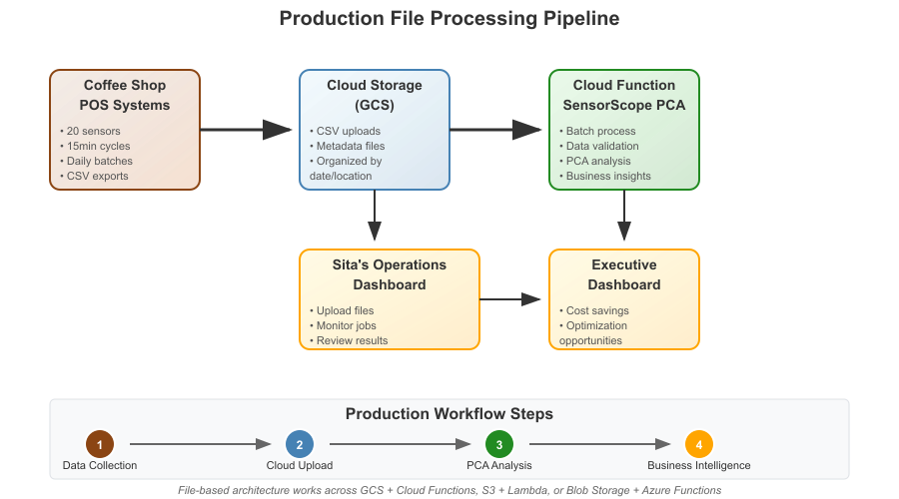

File Processing Pipeline

### File Processing Workflow

**Step 1: Automated Data Collection** Each coffee shop’s POS system exports sensor data daily as CSV files with standardized naming: - coffee_shop_downtown_2024-01-15.csv - coffee_shop_mall_2024-01-15.csv - coffee_shop_university_2024-01-15.csv

**Step 2: Cloud Storage Organization** Files are uploaded to Google Cloud Storage with a logical hierarchy:

gs://sensorscope-production/  
├── datasets/  
│ ├── 2024/  
│ │ ├── 01/  
│ │ │ ├── coffee_shop_downtown_2024-01-15.csv  
│ │ │ ├── coffee_shop_downtown_2024-01-15_metadata.json  
│ │ │ └── ...  
│ │ └── 02/  
│ └── archive/  
└── results/  
 ├── monthly_analysis/  
 └── optimization_reports/

**Step 3: Serverless Processing** Sita triggers analysis through simple HTTP calls to the Cloud Function:

# Process a specific location's data  
curl -X POST https://$YOUR_FUNCTION_URL \  
 -H 'Content-Type: application/json' \  
 -d '{  
 "gcs_bucket": "sensorscope-production",  
 "gcs_file_path": "datasets/2024/01/coffee_shop_downtown_2024-01-15.csv",  
 "n_components": 5  
 }'

### Business Value: Operational Efficiency at Scale

The file-based architecture delivers three critical business advantages:

**1. Audit Trail and Compliance** Every analysis maintains a complete audit trail: - **Source data**: Original CSV files with timestamps - **Analysis parameters**: Component count, scaling options, business context - **Results history**: Monthly comparison of optimization opportunities - **Metadata preservation**: Sensor types, locations, operational context

**2. Batch Processing Economics** File-based processing dramatically improves cost efficiency. While costs may depend on volumes and providers, fix costs can be reduced in favor of variable ones: - **Storage costs**: Only pay for the storage consumed. - **Processing costs**: Only pay for processing needed. - **Staff efficiency**: Sita processes 47 locations in minuts to hours instead of in days or weeks. - **Consistency**: Identical analysis parameters across all locations

**3. Strategic Analysis Capabilities** Accumulated data enables deeper insights: - **Seasonal patterns**: Winter heating vs. summer cooling sensor redundancies - **Location comparisons**: Mall vs. downtown vs. university optimization opportunities - **Trend analysis**: Monthly sensor efficiency improvements - **ROI validation**: Actual vs. projected savings from implemented optimizations

### Sita’s Production Workflow

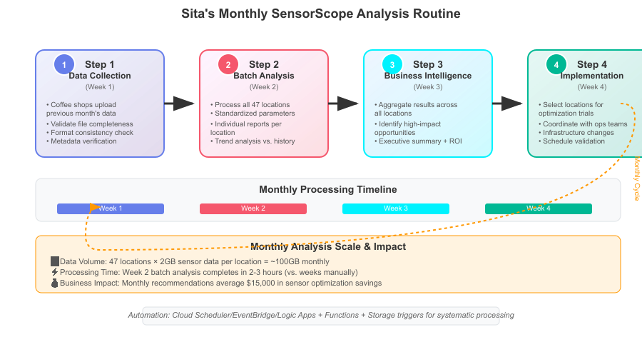

Sita’s Monthly SensorScope Analysis Routine

### Technical Implementation

The complete file processing workflow is implemented in SensorScope’s GCP deployment (detailed setup instructions in /gcp/README.md). Key technical features include:

* **Automatic file validation**: CSV format, column consistency, data quality checks
* **Metadata integration**: Business context preserved from generation through analysis
* **Error handling**: Graceful failures with detailed error messages for debugging
* **Scalability**: Function auto-scales to handle batch processing during peak upload periods
* **Monitoring**: Cloud Function logs provide complete audit trail of all processing activities

### Enterprise Integration Potential

The file-based architecture provides natural integration points for enterprise systems:

**ERP Integration**: Automated cost saving calculations feed into financial planning systems **Monitoring Integration**: Sensor optimization results integrate with existing facility management dashboards  
**Compliance Integration**: Complete audit trails support regulatory compliance and internal auditing requirements

Sita’s reflection: *“The transition from API testing to file processing was the key to making SensorScope operationally viable. Now I can process our entire network of locations systematically rather than manually analyzing individual coffee shops. The file-based approach also gives us the audit trail and scalability needed for corporate approval of optimization recommendations.”*

## Production Considerations

As Sita’s SensorScope system evolved from prototype to production across 47 coffee shop locations, she encountered the typical challenges of running serverless analytics at enterprise scale. The mathematical correctness of PCA implementation became just one concern among many operational requirements that determined system reliability and business acceptance. These production patterns apply universally across cloud providers, though we’ll demonstrate with GCP services alongside AWS and Azure equivalents.

### Security Architecture: Protecting Sensor Data

The coffee chain’s sensor data contained surprisingly sensitive operational intelligence. Temperature and humidity patterns could reveal equipment efficiency issues, customer flow data exposed peak business hours, and aggregate sensor patterns might indicate competitive advantages worth protecting. Sita needed a security architecture that protected this data without creating operational friction.

**Authentication and Authorization Patterns**

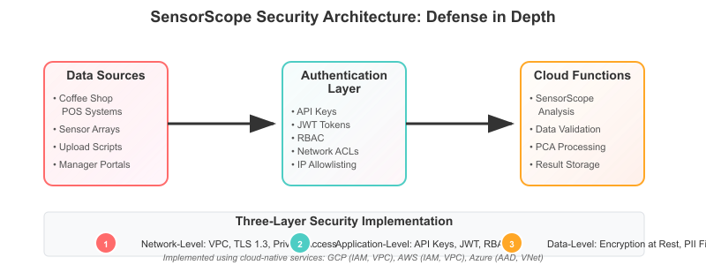

Authentication Architecture

Sita implemented layered security following the principle of defense in depth [10,11]:

**Layer 1: Network-Level Protection** - Cloud Function deployment in private VPC with restricted ingress - IP allowlisting for coffee shop locations and Sita’s analytics workstation  
- TLS 1.3 encryption for all data in transit with certificate pinning

**Cloud Services for Network Security:** - **Google Cloud**: VPC Service Controls, Cloud Armor for DDoS protection, Private Google Access - **AWS**: VPC with Security Groups, AWS WAF, PrivateLink for service isolation - **Azure**: Virtual Networks with NSGs, Azure Front Door, Private Endpoints

**Layer 2: Application-Level Authentication** - API key authentication for programmatic access from coffee shop systems - JWT tokens with short expiration windows for Sita’s interactive analysis sessions - Role-based access control distinguishing between data upload and analysis permissions

**Cloud Services for Authentication:** - **Google Cloud**: Cloud Identity & Access Management (IAM), Identity-Aware Proxy, Cloud Endpoints for API management - **AWS**: IAM with fine-grained policies, API Gateway with authorizers, AWS Cognito for user management - **Azure**: Azure Active Directory, API Management with OAuth policies, Key Vault for secrets

**Layer 3: Data-Level Protection** - Sensor data encrypted at rest using cloud provider managed keys - PII filtering to remove any customer-identifiable information from sensor streams - Automatic data retention policies deleting processed sensor data after analysis completion

**Cloud Services for Data Protection:** - **Google Cloud**: Cloud KMS for encryption keys, DLP API for PII detection, Lifecycle Management policies - **AWS**: KMS with envelope encryption, Macie for data discovery, S3 Lifecycle policies - **Azure**: Key Vault for encryption, Purview for data governance, Storage Lifecycle Management

Sita’s security insight: *“The key was making security transparent to operations teams. Coffee shop managers couldn’t be expected to manage complex authentication flows, so we automated most security controls while providing clear audit trails for compliance.”*

### Monitoring and Observability: Sita’s Operational Dashboard

Production serverless PCA requires comprehensive monitoring to detect performance degradation, cost anomalies, and analysis quality issues before they impact business operations [12,13].

**Three-Tier Monitoring Strategy**

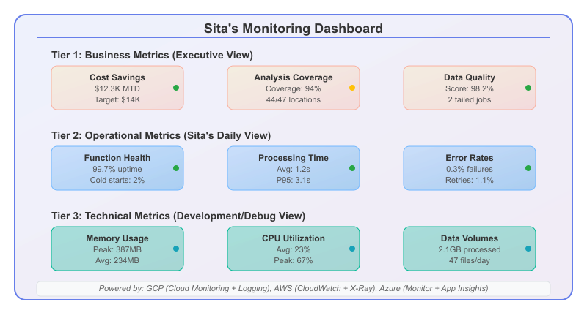

Sita’s Monitoring Dashboard

**Cloud Services for Monitoring Implementation:**

**Comprehensive Observability Platforms:** - **Google Cloud**: Cloud Monitoring (metrics), Cloud Logging (logs), Cloud Trace (distributed tracing), Error Reporting - **AWS**: CloudWatch (metrics & logs), X-Ray (tracing), AWS Systems Manager for operational insights - **Azure**: Azure Monitor (unified platform), Application Insights (APM), Log Analytics workspace

**Custom Dashboard Creation:** - **Google Cloud**: Cloud Monitoring dashboards with custom metrics, Data Studio for business reporting - **AWS**: CloudWatch dashboards, QuickSight for executive reporting, Grafana on EKS for advanced visualization  
- **Azure**: Azure Dashboard, Power BI integration, Azure Workbooks for operational reporting

**Critical Alerting Scenarios**

Sita configured alerts for specific business-impact scenarios rather than generic technical thresholds:

1. **Analysis Quality Degradation**: Alert when PCA variance explanation drops significantly for any location
2. **Cost Anomaly Detection**: Alert when daily processing costs exceed expected thresholds
3. **Coverage Gaps**: Alert when any coffee shop hasn’t submitted data within 48 hours
4. **Processing Delays**: Alert when any analysis takes longer than expected

**Cloud Services for Intelligent Alerting:** - **Google Cloud**: Cloud Monitoring alerting policies, Pub/Sub for event-driven notifications, Cloud Functions triggered alerts - **AWS**: CloudWatch Alarms with dynamic thresholds, SNS for multi-channel notifications, EventBridge for complex routing - **Azure**: Azure Monitor alerts with smart detection, Logic Apps for workflow automation, Service Bus for reliable messaging

### Error Handling and Recovery Patterns

Serverless PCA systems must gracefully handle various failure modes while providing clear diagnostics for business users who may not understand technical error details [8,21,22].

**Hierarchical Error Handling Strategy**

Input Validation Errors  
├── Data Format Issues  
│ ├── CSV parsing failures → Return format guidance  
│ ├── Missing sensor columns → Identify missing sensors  
│ └── Timestamp inconsistencies → Suggest standardization  
├── Business Logic Errors   
│ ├── Insufficient data volume → Specify minimum requirements  
│ ├── Sensor variance too low → Explain PCA limitations  
│ └── Component count mismatch → Recommend optimal range  
└── Infrastructure Errors  
 ├── Memory constraints → Suggest data chunking  
 ├── Timeout exceeded → Recommend batch processing  
 └── Permission denied → Provide access troubleshooting

**Cloud Services for Error Management:** - **Google Cloud**: Error Reporting for automatic error aggregation, Cloud Functions error handling, Pub/Sub dead letter queues - **AWS**: CloudWatch Insights for error pattern analysis, Lambda dead letter queues, SQS for retry mechanisms - **Azure**: Application Insights for exception tracking, Service Bus dead letter queues, Logic Apps for error workflows

### Cost Optimization and Resource Management

While serverless promises pay-per-use economics, production PCA workloads require active cost management to prevent unexpected billing spikes and optimize resource allocation.

**Function Sizing Strategy**

Sita discovered that default function configurations rarely match PCA computational requirements optimally (costs may vary with region and times):

Memory Allocation vs Performance Analysis (20-sensor dataset)  
┌─────────────────────────────────────────────────────────────┐  
│ Memory │ CPU │ Duration │ Cost/run │ Note │  
├─────────────────────────────────────────────────────────────┤  
│ 128MB │ 0.08 │ 8.2s │ $0.0023 │ Frequent timeout │  
│ 256MB │ 0.17 │ 4.1s │ $0.0019 │ Occasional swap │  
│ 512MB │ 0.33 │ 1.2s │ $0.0014 │ Optimal │  
│ 1024MB │ 0.58 │ 1.1s │ $0.0025 │ Minimal benefit │  
│ 2048MB │ 1.0 │ 1.0s │ $0.0045 │ Cost inefficient │  
└─────────────────────────────────────────────────────────────┘

**Cloud Services for Cost Optimization:** - **Google Cloud**: Cloud Billing budgets and alerts, Resource usage reports, Recommender for rightsizing - **AWS**: Cost Explorer with rightsizing recommendations, Budgets for cost control, Compute Optimizer - **Azure**: Cost Management + Billing, Azure Advisor for optimization recommendations, Budgets with alerts

**Batching and Concurrency Patterns**

For Sita’s monthly analysis across 47 locations, choosing between sequential and parallel processing significantly impacted both cost and completion time:

**Sequential Processing**: Process locations one by one - slow but simple **Parallel Processing**: Process all locations simultaneously - fast but may hit limits  
**Hybrid Batching**: Process in small concurrent batches - balanced approach

**Cloud Services for Workflow Orchestration:** - **Google Cloud**: Cloud Workflows for orchestration, Cloud Scheduler for timing, Pub/Sub for fan-out patterns - **AWS**: Step Functions for state machines, EventBridge Scheduler, SQS/SNS for batch coordination - **Azure**: Logic Apps for workflow automation, Azure Scheduler, Service Bus for message-driven processing

### CI/CD for Serverless PCA Systems

Sita established deployment practices that ensure mathematical correctness and business continuity across SensorScope updates [15,16,17].

**Deployment Pipeline Stages**

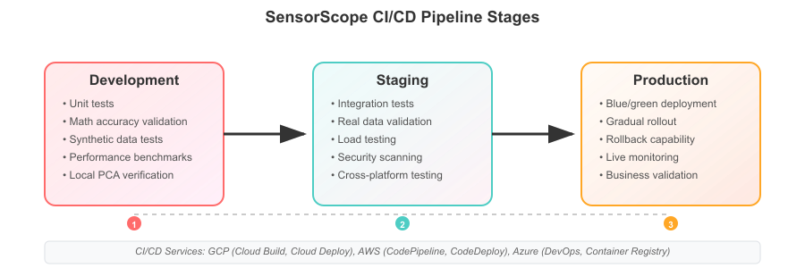

CI/CD Pipeline Stages

**Cloud Services for CI/CD Implementation:** - **Google Cloud**: Cloud Build for pipelines, Cloud Source Repositories, Cloud Deploy for progressive delivery - **AWS**: CodePipeline with CodeBuild, CodeCommit for source control, CodeDeploy for blue/green deployments - **Azure**: Azure DevOps with build/release pipelines, Azure Repos, Azure Container Registry

**Infrastructure as Code Tools:** - **Google Cloud**: Terraform with Google provider, Cloud Deployment Manager, gcloud CLI automation - **AWS**: AWS CDK, CloudFormation templates, SAM for serverless applications - **Azure**: ARM templates, Bicep for infrastructure, Azure CLI with scripting

Sita’s production insight: *“The most important lesson was that serverless doesn’t eliminate operational concerns - it changes them. Instead of worrying about server capacity, I worried about cost spikes. Instead of patching operating systems, I worried about function timeouts. The key was building monitoring and processes around the new failure modes rather than the old ones, and leveraging cloud-native services to handle the complexity.”*

## Serverless Architecture Patterns for PCA

As Sita’s SensorScope system evolved beyond single-function deployments, she discovered that PCA workloads have unique architectural requirements that differ significantly from typical web applications or simple data processing tasks. The mathematical nature of Principal Component Analysis, combined with the unpredictable data volumes and processing times, demanded specialized patterns for state management, data flow, and error recovery [5,6,23]. These patterns translate consistently across all major serverless platforms - we’ll show GCP implementations with equivalent AWS and Azure services.

### Event-Driven PCA Processing

Traditional PCA implementations assume synchronous processing where data arrives, analysis runs, and results return immediately. Serverless environments excel with asynchronous, event-driven patterns that decouple data arrival from processing completion, enabling more robust and scalable analysis workflows [18,19,20].

**Pattern 1: Upload-Trigger-Analyze Pattern**

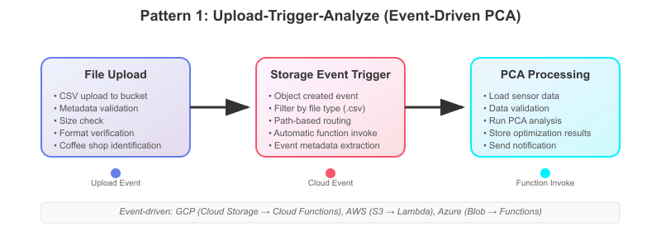

Upload-Trigger-Analyze Pattern

**Sita’s SensorScope Application:** When coffee shop managers upload monthly sensor data at irregular times (end of month, after busy periods, or when they remember), Sita no longer needs to monitor for uploads manually. The moment a file lands in the GCS bucket, analysis begins automatically. This eliminated the bottleneck where Sita had to manually trigger 47 separate analyses each month. Coffee shops now get their optimization reports within minutes of upload completion, and Sita’s workload shifted from monitoring uploads to reviewing results. The pattern also handles weekend uploads and holiday data drops without requiring Sita to work outside business hours.

**Cloud Service Implementations:** - **Google Cloud**: Cloud Storage triggers → Pub/Sub → Cloud Functions - **AWS**: S3 Event Notifications → EventBridge → Lambda - **Azure**: Blob Storage events → Event Grid → Azure Functions

**Pattern 2: Scheduled Batch Processing Pattern**

For Sita’s monthly analysis across 47 locations, she needed orchestrated batch processing that could handle failures gracefully and provide progress visibility.

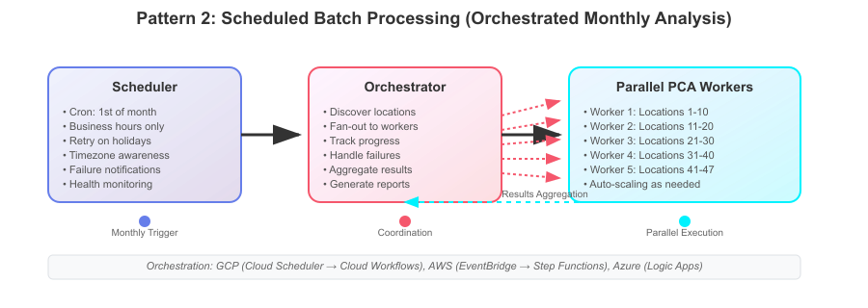

Scheduled Batch Processing Pattern

**Sita’s SensorScope Application:** Sita discovered that not all coffee shops upload data by month-end, and some locations consistently lag by several days. The scheduled batch processor runs on the 5th of each month, automatically discovers which locations have submitted data, and processes them in parallel batches of 10. If a location’s data fails to process (corrupted files, sensor malfunctions), the system continues with other locations and queues the failed ones for manual review. Sita now gets a single comprehensive monthly report instead of tracking 47 individual analyses, and late-uploading shops are automatically processed in a follow-up batch a week later.

**Cloud Service Implementations:** - **Google Cloud**: Cloud Scheduler → Cloud Workflows → multiple Cloud Functions - **AWS**: EventBridge Scheduler → Step Functions → parallel Lambda executions - **Azure**: Logic Apps with recurrence → parallel Azure Function calls

### State Management in Stateless Functions

PCA processing often requires coordination across multiple function invocations, particularly for large datasets that must be processed in chunks or analyses that span multiple locations. Sita developed patterns for managing state without violating serverless statelessness principles.

**Pattern 3: External State Store Pattern**

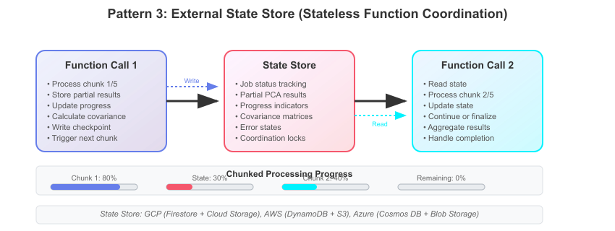

External State Store Pattern

**Sita’s SensorScope Application:** When Sita’s largest coffee shop (the airport location) started generating 5GB monthly sensor files that exceeded memory limits, she needed to process the data in chunks without losing intermediate PCA calculations. The state store pattern allows her to process 20 sensors in groups of 5, storing covariance matrices and eigenvalue calculations between function calls. Each chunk updates a progress indicator that corporate executives can monitor, showing “Processing sensors 11-15 of 20” rather than a black box. If any chunk fails due to timeout, only that specific sensor group needs reprocessing, not the entire month’s data.

**Cloud Service Implementations:** - **Google Cloud**: Cloud Firestore for coordination, Cloud Storage for intermediate results, Pub/Sub for progress events - **AWS**: DynamoDB for state tracking, S3 for data checkpoints, SQS for message passing - **Azure**: Cosmos DB for coordination, Blob Storage for intermediate files, Service Bus for orchestration

**Pattern 4: Saga Pattern for Complex Analysis Workflows**

When Sita needed to run multiple analysis types (PCA, correlation analysis, business impact calculation) as part of a single request, she implemented the Saga pattern to ensure consistent completion or rollback.

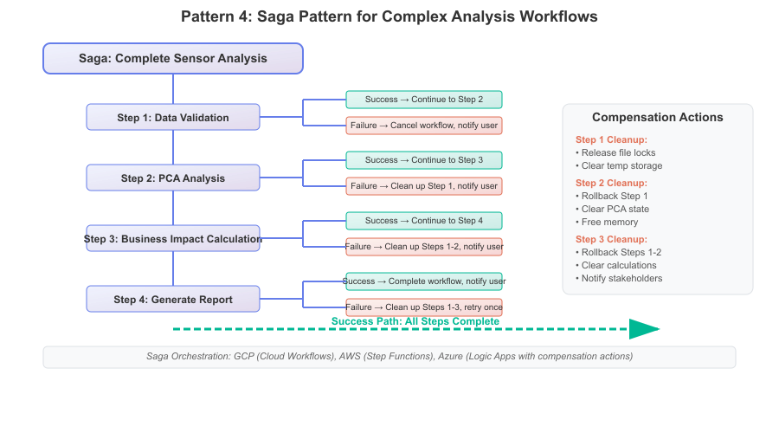

Saga Pattern Workflow

**Sita’s SensorScope Application:** Corporate requested that Sita’s monthly reports include not just PCA results, but also correlation analysis, cost-benefit calculations, and formatted executive summaries. Initially, Sita ran these steps manually, often losing work when later steps failed. The Saga pattern ensures that if report generation fails (due to formatting errors or template issues), the PCA and business calculations aren’t lost - they’re preserved and the report step simply retries with corrected templates. This saved Sita from re-running expensive PCA calculations when only the final presentation step had problems, reducing analysis time from 3 hours to 45 minutes when issues occurred.

**Cloud Service Implementations:** - **Google Cloud**: Cloud Workflows with conditional logic and error handling - **AWS**: Step Functions with error catching and retry policies - **Azure**: Logic Apps with try-catch blocks and compensation actions

### Data Pipeline Architectures

PCA workloads often involve complex data transformations before mathematical processing can begin. Sita designed pipeline patterns that separate concerns while maintaining end-to-end observability.

**Pattern 5: Lambda Architecture for Real-Time and Batch PCA**

Sita realized that coffee shop operations needed both real-time anomaly detection and monthly optimization analysis, requiring different processing approaches for the same sensor data.

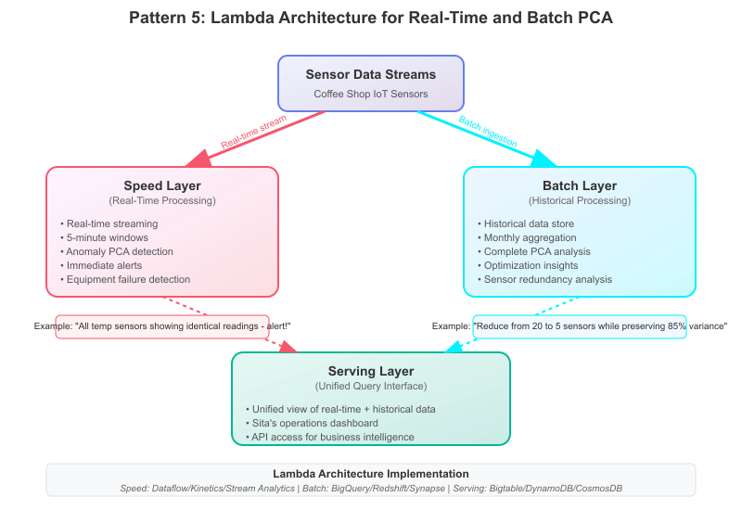

Lambda Architecture for PCA

**Sita’s SensorScope Application:** After a coffee machine fire went undetected for 20 minutes (all temperature sensors failed simultaneously but Sita only ran monthly analysis), corporate demanded real-time monitoring alongside optimization analysis. Sita’s lambda architecture now runs lightweight PCA every 5 minutes on streaming sensor data to detect when all sensors in a category (temperature, humidity, vibration) show identical readings - indicating sensor failure rather than environmental consistency. Monthly optimization analysis continues using complete historical datasets for thorough redundancy analysis. The dual approach caught 3 sensor malfunctions in the first month, preventing equipment damage that would have cost more than the entire annual sensor budget.

**Pattern 6: ETL Pipeline with PCA Integration**

Sita needed to transform raw sensor logs into analysis-ready datasets before PCA processing could begin.

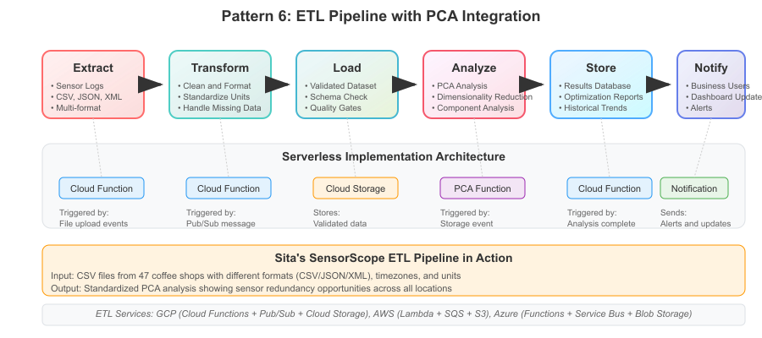

ETL Pipeline with PCA Integration

**Sita’s SensorScope Application:** Coffee shop POS systems generate sensor logs in different formats - some as CSV, others as JSON, and newer locations using XML exports. Sita’s ETL pipeline standardizes all formats into consistent datasets before PCA analysis, automatically handling timezone conversions (shops span 3 time zones), unit standardization (some sensors report Celsius, others Fahrenheit), and missing data interpolation. The pipeline prevented a month of failed analyses when the mall location’s POS system started exporting sensor data with different column names after a software update. Now format changes are handled automatically, and Sita focuses on interpreting results rather than debugging data inconsistencies.

**Cloud Service Implementations:** - **Google Cloud**: Cloud Functions triggered by Pub/Sub for each pipeline stage - **AWS**: Lambda functions orchestrated by Step Functions with S3 between stages - **Azure**: Azure Functions with Service Bus queues for stage coordination

### Error Handling and Retry Patterns

PCA algorithms can fail for mathematical reasons (singular matrices, insufficient data) or infrastructure reasons (timeouts, memory limits). Sita designed specialized error handling patterns for mathematical workloads.

**Pattern 7: Circuit Breaker with Mathematical Fallbacks** [7,8]

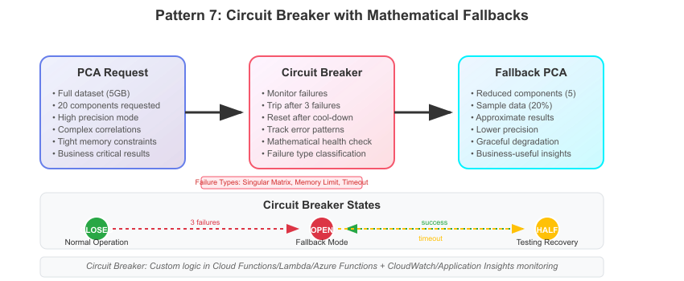

Circuit Breaker with Mathematical Fallbacks

**Sita’s SensorScope Application:** The university coffee shop had a sensor malfunction where 8 of 20 sensors reported identical readings for three weeks, creating singular matrices that crashed PCA analysis. Instead of manual intervention, Sita’s circuit breaker detected the repeated mathematical failures and automatically switched to approximate PCA with fewer components. The fallback analysis still identified optimization opportunities (5 sensors instead of the requested 3), and Sita received clear error reports explaining the mathematical issues. This kept monthly reporting on schedule while technical teams fixed the sensor calibration, rather than blocking all analysis until hardware issues were resolved.

**Pattern 8: Exponential Backoff with Jitter for Mathematical Convergence**

Some PCA algorithms may require multiple iterations to converge. Sita implemented intelligent retry patterns that account for mathematical properties rather than just infrastructure failures.

def pca_with_intelligent_retry(data, max_retries=3):  
 for attempt in range(max_retries):  
 try:  
 return compute_pca(data)  
 except ConvergenceError as e:  
 if attempt == max_retries - 1:  
 raise  
 # Mathematical fallback: reduce precision  
 data = reduce_precision(data)  
 wait_time = (2 ** attempt) + random.uniform(0, 1)  
 time.sleep(wait_time)  
 except SingularMatrixError:  
 # Add small noise to break singularity  
 data = add_regularization_noise(data)  
 continue

**Sita’s SensorScope Application:** During peak summer months, air conditioning sensors at several locations showed extremely high correlation (>0.99), creating numerical instability in PCA calculations [24]. Sita’s intelligent retry pattern automatically adds small amounts of mathematical noise to break perfect correlations, allowing analysis to complete with meaningful results. The system also reduces precision requirements on retry, trading exact eigenvalue calculations for business-useful approximations. This prevented summer analysis failures while maintaining the core insight that HVAC sensors were highly redundant during extreme weather periods - exactly the business intelligence corporate needed for optimization decisions.

**Cloud Service Implementations:** - **Google Cloud**: Cloud Functions with custom retry logic, Cloud Monitoring for circuit breaker state - **AWS**: Lambda with custom backoff algorithms, CloudWatch for failure tracking - **Azure**: Azure Functions with Application Insights for failure pattern analysis

Sita’s architectural insight: *“The biggest mistake I made early on was treating PCA like a web service - request in, response out. PCA is fundamentally different because the processing time and resource requirements depend on mathematical properties of the data, not just data size. Our architecture needed to be elastic not just for scale, but for the inherent unpredictability of mathematical computation.”*

## Advanced Patterns & Future Directions

Eighteen months after launching SensorScope, Sita found herself fielding requests from other divisions within Bean There, Done That, and eventually from partner organizations seeking similar optimization insights. What started as coffee shop sensor analysis had evolved into a platform for various dimensionality reduction challenges. This section explores advanced serverless PCA patterns that emerged from real-world scaling requirements and points toward future developments in cloud-native analytics. These advanced patterns demonstrate the maturity of serverless platforms across Google Cloud, AWS, and Azure for sophisticated mathematical workloads.

### Streaming PCA for Real-Time Insights

Sita’s success with batch processing led to demands for real-time sensor optimization. The marketing team wanted to adjust promotional campaigns based on real-time foot traffic patterns, while operations needed immediate alerts when sensor redundancy patterns indicated equipment failures.

**Pattern: Incremental PCA with Streaming Windows**

Traditional PCA requires complete datasets for eigenvalue computation, but streaming scenarios demand continuous updates as new data arrives. Sita developed an incremental PCA pattern using sliding windows and mathematical approximation techniques.

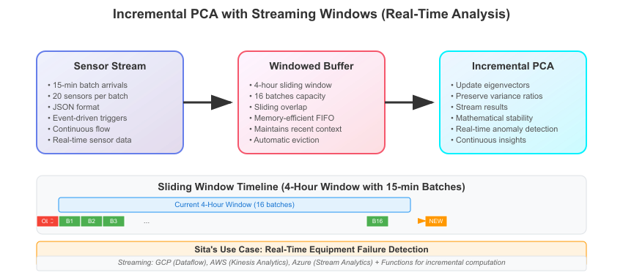

Incremental PCA with Streaming Windows

**Sita’s Implementation:** When the downtown location experienced fluctuating customer patterns during a street festival, traditional monthly analysis couldn’t capture the rapid operational changes. Sita’s streaming PCA detected that customer flow sensors became highly correlated with ambient noise during events - a pattern invisible in monthly aggregates. This insight allowed operations to temporarily reduce monitoring complexity during special events while maintaining operational visibility. The streaming approach processes 15-minute sensor batches, updating PCA models continuously and alerting when correlation patterns shift significantly from baseline behavior.

**Cloud Service Implementations:** - **Google Cloud**: Dataflow for stream processing, Cloud Functions for PCA updates, Pub/Sub for event distribution - **AWS**: Kinesis Analytics for windowing, Lambda for incremental computation, EventBridge for result distribution - **Azure**: Stream Analytics for data preparation, Functions for PCA processing, Event Hubs for streaming

### Distributed PCA for Large-Scale Analysis

Sita’s success attracted attention from corporate real estate, which manages sensor networks across shopping malls, office buildings, and mixed-use developments. These environments generate terabytes of monthly sensor data across thousands of measurement points, requiring distributed processing approaches.

**Pattern: MapReduce PCA with Serverless Coordination**

Large-scale PCA computation can be decomposed into distributed covariance matrix calculation followed by centralized eigenvalue computation, enabling horizontal scaling across multiple serverless functions.

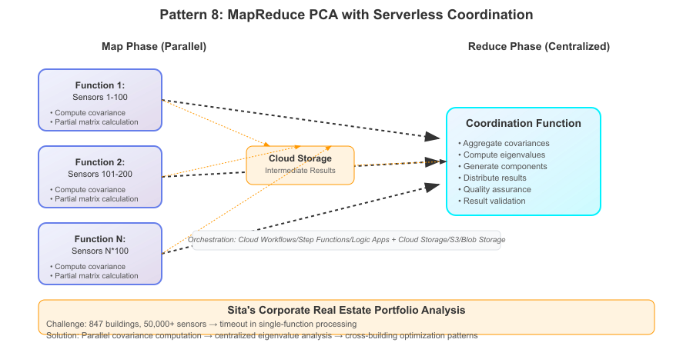

MapReduce PCA with Serverless Coordination

**Sita’s Application:** When corporate real estate wanted to optimize sensor placement across their entire portfolio (847 buildings, 50,000+ sensors), single-function processing became impractical. Sita’s distributed approach processes sensor groups in parallel, computing partial covariance matrices simultaneously across multiple Cloud Functions. A coordination function aggregates results and performs final eigenvalue decomposition. This enabled analysis of building portfolios that would timeout in single-function approaches, revealing cross-building patterns like shared HVAC optimization opportunities and equipment failure correlations across properties.

**Cloud Service Implementations:** - **Google Cloud**: Cloud Functions for parallel processing, Cloud Workflows for orchestration, Cloud Storage for intermediate results - **AWS**: Lambda for map operations, Step Functions for coordination, S3 for data exchange - **Azure**: Functions for parallel computation, Logic Apps for workflow management, Blob Storage for state

### Integration with Modern ML Pipelines

As Sita’s analysis capabilities matured, corporate began requesting integration with broader machine learning initiatives. They wanted PCA preprocessing to feed predictive models for equipment maintenance, customer behavior analysis, and energy optimization.

**Pattern: PCA as a Service in MLOps Pipelines**

Modern ML workflows require PCA as a preprocessing step rather than standalone analysis. Sita designed SensorScope to integrate seamlessly with MLOps platforms while maintaining its serverless characteristics.

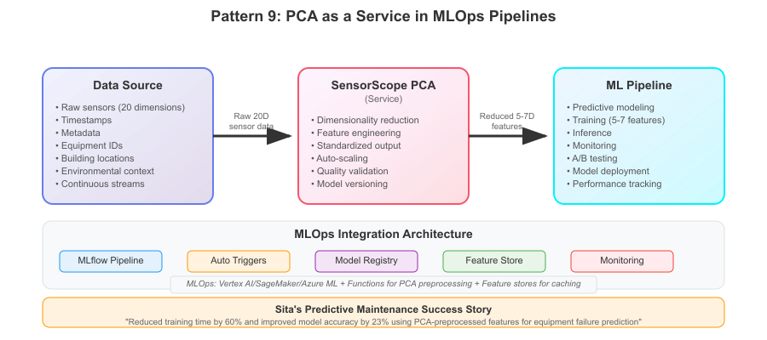

PCA as a Service in MLOps Pipelines

**Sita’s Implementation:** The predictive maintenance team wanted to forecast equipment failures using sensor data, but raw 20-dimensional sensor readings created overfitting in their models. Sita integrated SensorScope into their MLflow pipeline, automatically reducing sensor dimensions to 5-7 key components before model training. The PCA preprocessing significantly improved model accuracy while substantially reducing training time. SensorScope now runs automatically whenever new sensor data arrives, feeding dimensionality-reduced features into multiple downstream ML models for different business applications.

**Cloud Service Implementations:** - **Google Cloud**: Vertex AI Pipelines with Cloud Functions components, MLflow on GKE - **AWS**: SageMaker Pipelines with Lambda preprocessing steps, MLflow on ECS - **Azure**: ML Pipelines with Functions integration, MLflow on Container Instances

### Emerging Serverless Analytics Trends

Sita’s experience with SensorScope positioned her to evaluate emerging trends that could enhance serverless analytics capabilities.

**Pattern: Edge-Cloud Hybrid PCA**

With increasing sensor sophistication and 5G connectivity, some coffee shops began deploying edge computing devices capable of lightweight analytics. Sita explored hybrid patterns where edge devices perform initial PCA approximation, with cloud functions handling complex analysis.

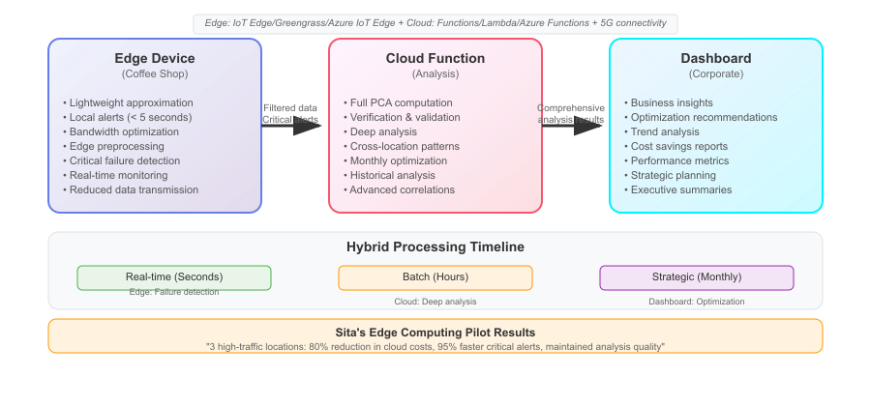

Edge-Cloud Hybrid PCA

**Sita’s Exploration:** Sita piloted edge-cloud hybrid processing at three high-traffic locations with dedicated edge devices. Local edge computation identifies obvious sensor failures within seconds (all temperature readings identical), while cloud functions perform comprehensive monthly optimization analysis. This hybrid approach substantially reduced cloud processing costs while significantly improving response time for critical alerts. The pattern shows promise for IoT scenarios where bandwidth costs and latency requirements favor local preprocessing with cloud-based deep analysis.

**Pattern: Serverless AI/ML Orchestration**

The convergence of serverless computing and AI services creates opportunities for sophisticated analytics workflows that automatically adapt to data characteristics and business requirements.

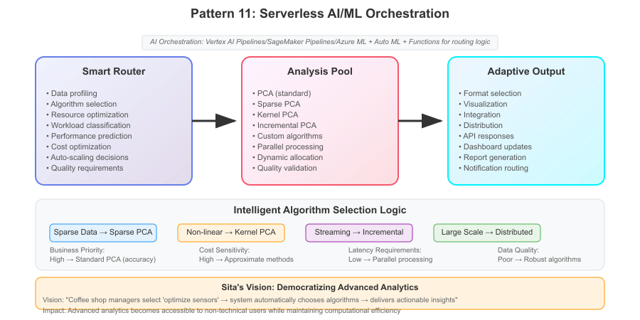

Serverless AI/ML Orchestration

**Sita’s Vision:** Sita envisions SensorScope evolution toward intelligent analytics that automatically selects optimal PCA variants based on data characteristics. Sparse sensor data would trigger sparse PCA algorithms, while non-linear sensor relationships would invoke kernel PCA approaches. Serverless functions would orchestrate algorithm selection, resource allocation, and output formatting based on business context and data properties. This adaptive approach could make advanced analytics accessible to non-technical users while optimizing computational efficiency.

### Future Directions: The Next Generation of Serverless Analytics

Based on Sita’s SensorScope journey and emerging technology trends, several developments will shape the future of serverless analytics:

**1. Mathematical Function Libraries as a Service** Cloud providers are developing specialized function runtimes optimized for mathematical computation, featuring pre-loaded scientific libraries, GPU acceleration, and mathematical convergence guarantees.

**2. AutoML Integration** Automated machine learning platforms will increasingly incorporate serverless preprocessing steps, automatically applying dimensionality reduction techniques like PCA based on dataset characteristics and target model requirements.

**3. Real-Time Analytics at Scale** Emerging streaming platforms promise sub-second analytics on massive data streams, enabling real-time PCA for applications like fraud detection, operational monitoring, and dynamic optimization.

**4. Cross-Cloud Analytics Portability** Industry standards for serverless analytics functions will enable true multi-cloud deployment, allowing organizations to optimize for cost, performance, and regulatory requirements without vendor lock-in.

**5. AI-Driven Optimization** Machine learning models will optimize serverless function configuration automatically, predicting optimal memory allocation, timeout settings, and concurrency limits based on historical workload patterns.

Sita’s reflection on the future: *“When I started SensorScope, I thought I was solving a simple cost optimization problem for coffee shop sensors. What I learned is that serverless analytics represents a fundamental shift in how organizations approach data science. We’re moving from infrastructure-heavy, specialized analytics teams to democratized, business-embedded analysis capabilities. The next generation of SensorScope won’t just reduce sensor costs - it will enable every operations manager to ask mathematical questions about their data and get immediate, actionable answers.”*

### Multi-Cloud Serverless PCA: Platform Equivalents

Throughout this chapter, we’ve demonstrated SensorScope using Google Cloud services, but Sita’s architecture translates directly to AWS and Azure with equivalent functionality:

| **Service Category** | **Google Cloud** | **AWS** | **Azure** |
| --- | --- | --- | --- |
| **Core Function Runtime** | Cloud Functions Gen 2(Python 3.11) | Lambda(Python 3.11 runtime) | Azure Functions(Python 3.11 on Linux) |
| **File Storage & Event Triggers** | Cloud Storage +Pub/Sub triggers | S3 + Event Notificationsor EventBridge | Blob Storage +Event Grid |
| **Monitoring & Observability** | Cloud Monitoring +Cloud Logging | CloudWatch +X-Ray | Azure Monitor +Application Insights |
| **Orchestration & Workflows** | Cloud Workflows +Cloud Scheduler | Step Functions +EventBridge Scheduler | Logic Apps +Azure Scheduler |
| **State Management** | Cloud Firestore +Cloud Storage | DynamoDB +S3 | Cosmos DB +Blob Storage |

Sita’s architectural insight on multi-cloud: *“The beauty of our serverless PCA approach is that the mathematical logic remains identical across platforms. Only the plumbing changes - the science stays the same. This gives organizations flexibility to choose cloud providers based on cost, compliance, or existing relationships rather than being locked into a specific platform for analytics capabilities.”*

## Conclusion

Dr. Sita Zhou’s journey from a simple cost optimization request to building enterprise-scale serverless analytics demonstrates the fundamental advantages of applying serverless architectures to mathematical computing workloads. Her experience reveals that serverless PCA implementations offer compelling benefits over traditional deployment approaches across multiple dimensions.

**Economic Advantages**: Serverless PCA fundamentally changes the cost structure of mathematical analytics. Traditional approaches require provisioning and maintaining infrastructure for peak computational demands, even when analysis runs intermittently. Sita’s serverless implementation eliminated infrastructure costs during idle periods while automatically scaling for computational peaks. The pay-per-execution model aligned costs directly with business value, making advanced analytics economically viable for organizations that couldn’t justify dedicated infrastructure investments.

**Operational Simplicity**: Mathematical workloads traditionally require specialized infrastructure management, performance tuning, and capacity planning. Serverless abstracts these operational concerns, allowing practitioners to focus on algorithmic implementation rather than deployment complexity. Sita’s experience demonstrates that serverless platforms handle scaling, availability, and resource management automatically, reducing operational overhead from infrastructure management to business logic development.

**Architectural Scalability**: PCA computations exhibit natural parallelization opportunities that align well with serverless execution models. The mathematical decomposition of covariance matrix calculations maps directly to distributed function execution, enabling horizontal scaling without architectural redesign. Sita’s MapReduce pattern demonstrates how serverless functions can process arbitrarily large datasets by distributing computation across multiple parallel executions, achieving linear scalability without infrastructure complexity.

**Development Velocity**: Serverless deployment models accelerate development cycles for mathematical applications. Sita’s implementation showed that practitioners can iterate rapidly on algorithmic approaches without managing deployment infrastructure. The combination of automated scaling, simplified deployment, and integrated monitoring reduces the time from mathematical concept to production implementation, enabling faster experimentation and validation of analytical approaches.

**Integration Flexibility**: Modern analytical workflows require seamless integration with diverse data sources, ML pipelines, and business systems. Serverless PCA implementations naturally support event-driven architectures, enabling real-time processing of streaming data, batch analysis of historical datasets, and integration with existing business applications through standardized APIs. Sita’s patterns demonstrate how serverless functions can serve as universal connectors between mathematical processing and enterprise systems.

**Fault Tolerance and Reliability**: Mathematical computations can fail due to singular matrices, memory constraints, or algorithmic instability. Serverless platforms provide built-in retry mechanisms, automatic failover, and isolation between executions that improve overall system reliability. Sita’s circuit breaker patterns show how serverless architectures can implement sophisticated mathematical fallback strategies that maintain service availability even when primary algorithms encounter edge cases.

**Multi-Cloud Portability**: Serverless PCA implementations achieve remarkable portability across cloud platforms. The mathematical algorithms remain identical whether executing on AWS Lambda, Google Cloud Functions, or Azure Functions, with only configuration and deployment scripts requiring platform-specific adaptation. This portability provides organizations with vendor flexibility and risk mitigation while maintaining consistent analytical capabilities.

The technical patterns demonstrated through Sita’s implementation—from basic Hello World functions to sophisticated MLOps integration—establish serverless computing as a compelling architectural choice for mathematical analytics. These patterns enable organizations to implement advanced analytics capabilities with reduced operational complexity, improved economic efficiency, and enhanced scalability compared to traditional infrastructure approaches. Serverless PCA represents more than a deployment choice; it exemplifies how cloud-native architectures can democratize sophisticated mathematical techniques, making advanced analytics accessible to organizations regardless of their infrastructure expertise or capital investment capacity.

## References

**Mathematical and Statistical Foundations**

1. Jolliffe, I.T. (2002). *Principal Component Analysis* (2nd ed.). Springer-Verlag. Chapter 3: Computation of Principal Components, pp. 78-106. [DOI: 10.1007/b98835](https://doi.org/10.1007/b98835)
2. Golub, G.H. & Van Loan, C.F. (2013). *Matrix Computations* (4th ed.). Johns Hopkins University Press. Chapter 8: The Symmetric Eigenvalue Problem. [Publisher Link](https://jhupbooks.press.jhu.edu/title/matrix-computations)
3. Hastie, T., Tibshirani, R., & Friedman, J. (2009). *The Elements of Statistical Learning* (2nd ed.). Springer. Section 14.5.1: Principal Components. [Free PDF](https://hastie.su.stanford.edu/ElemStatLearn/)
4. Jolliffe, I.T., & Cadima, J. (2016). Principal component analysis: a review and recent developments. *Philosophical Transactions of the Royal Society A*, 374(2065), 20150202. [DOI: 10.1098/rsta.2015.0202](https://doi.org/10.1098/rsta.2015.0202)

**Serverless Architecture and Best Practices**

1. Newman, S. (2021). *Building Microservices: Designing Fine-Grained Systems* (2nd ed.). O’Reilly Media. Chapters 11-12: Microservices at Scale and Monitoring and Observability. [O’Reilly Link](https://www.oreilly.com/library/view/building-microservices-2nd/9781492034018/)
2. Richardson, C. (2018). *Microservices Patterns: With Examples in Java*. Manning Publications. Chapter 3: Inter-process Communication and Chapter 11: Production-Ready Services. [Manning Link](https://www.manning.com/books/microservices-patterns)
3. Fowler, M. (2014). Circuit Breaker Pattern. Martin Fowler’s Blog. <https://martinfowler.com/bliki/CircuitBreaker.html>
4. Nygard, M. (2018). *Release It! Design and Deploy Production-Ready Software* (2nd ed.). Pragmatic Bookshelf. Chapters 5-8: Stability Patterns and Capacity Patterns. [Pragmatic Link](https://pragprog.com/titles/mnee2/release-it-second-edition/)

**Security and Compliance**

1. Burns, B. & Beda, J. (2019). *Kubernetes: Up and Running* (2nd ed.). O’Reilly Media. Chapter 14: Security and Chapter 15: Extending Kubernetes. [O’Reilly Link](https://www.oreilly.com/library/view/kubernetes-up-and/9781492046523/)
2. Shostack, A. (2014). *Threat Modeling: Designing for Security*. Wiley. Chapters 3-4: Threat Modeling Process and Security Patterns. [Wiley Link](https://www.wiley.com/en-us/Threat+Modeling%3A+Designing+for+Security-p-9781118809990)
3. OWASP Foundation (2021). *OWASP Top 10 - 2021: The Ten Most Critical Web Application Security Risks*. <https://owasp.org/Top10/>

**Monitoring and Observability**

1. Beyer, B., Jones, C., Petoff, J., & Murphy, N. (2016). *Site Reliability Engineering: How Google Runs Production Systems*. O’Reilly Media. Chapters 6-7: Monitoring Distributed Systems and The Evolution of Automation. [Free Online](https://sre.google/sre-book/table-of-contents/)
2. Majors, C., Fong-Jones, L., & Miranda, G. (2022). *Observability Engineering: Achieving Production Excellence*. O’Reilly Media. Chapters 4-6: Monitoring and Alerting and Distributed Tracing. [O’Reilly Link](https://www.oreilly.com/library/view/observability-engineering/9781492076438/)
3. Wilkie, T. (2018). The RED Method: How to Instrument Your Services. *Grafana Labs Blog*. <https://grafana.com/blog/2018/08/02/the-red-method-how-to-instrument-your-services/>

**DevOps and CI/CD Practices**

1. Humble, J. & Farley, D. (2010). *Continuous Delivery: Reliable Software Releases through Build, Test, and Deployment Automation*. Addison-Wesley Professional. Chapters 5-10: Deployment Pipeline and Testing Strategy. [Pearson Link](https://www.pearson.com/us/higher-education/program/Humble-Continuous-Delivery-Reliable-Software-Releases-through-Build-Test-and-Deployment-Automation/PGM249825.html)
2. Kim, G., Humble, J., Debois, P., & Willis, J. (2016). *The DevOps Handbook: How to Create World-Class Agility, Reliability, and Security in Technology Organizations*. IT Revolution Press. Part III: The Technical Practices of Flow. [IT Revolution Link](https://itrevolution.com/the-devops-handbook/)
3. Forsgren, N., Humble, J., & Kim, G. (2018). *Accelerate: The Science of Lean Software and DevOps*. IT Revolution Press. Chapters 4-6: Technical Practices and Architecture. [IT Revolution Link](https://itrevolution.com/accelerate-book/)

**Cloud-Native Patterns and Event-Driven Architecture**

1. Indrasiri, K. & Siriwardena, P. (2021). [*Microservices for the Enterprise: Designing, Developing, and Deploying*](https://www.amazon.com/Microservices-Enterprise-Designing-Developing-Deploying/dp/1484238575). Apress. Chapters 8-10: Data Management and Event-Driven Architecture.
2. Vernon, V. (2013). *Implementing Domain-Driven Design*. Addison-Wesley Professional. Chapter 8: Domain Events. [Pearson Link](https://www.pearson.com/us/higher-education/program/Vernon-Implementing-Domain-Driven-Design/PGM182436.html)
3. Hohpe, G. & Woolf, B. (2003). *Enterprise Integration Patterns: Designing, Building, and Deploying Messaging Solutions*. Addison-Wesley Professional. Chapters 3-4: Messaging Patterns and Message Construction. [Enterprise Integration Patterns](https://www.enterpriseintegrationpatterns.com/)

**Error Handling and Resilience Patterns**

1. Tanenbaum, A.S. & Van Steen, M. (2016). [*Distributed Systems: Principles and Paradigms*](https://www.distributed-systems.net/index.php/books/ds4/) (3rd ed.). Pearson. Chapter 8: Fault Tolerance.
2. Kleppmann, M. (2017). *Designing Data-Intensive Applications*. O’Reilly Media. Chapter 8: The Trouble with Distributed Systems. [O’Reilly Link](https://www.oreilly.com/library/view/designing-data-intensive-applications/9781491903063/)
3. Lewis, J. & Fowler, M. (2014). Microservices: A Definition of This New Architectural Term. Martin Fowler’s Blog. <https://martinfowler.com/articles/microservices.html>

**Mathematical Computing and Scientific Software**

1. Higham, N.J. (2002). *Accuracy and Stability of Numerical Algorithms* (2nd ed.). SIAM. Chapters 19-20: The Symmetric Eigenvalue Problem and Matrix Functions. [SIAM Link](https://epubs.siam.org/doi/book/10.1137/1.9780898718027)
2. Van der Walt, S., Colbert, S.C., & Varoquaux, G. (2011). The NumPy Array: A Structure for Efficient Numerical Computation. *Computing in Science & Engineering*, 13(2), 22-30. [DOI: 10.1109/MCSE.2011.37](https://doi.org/10.1109/MCSE.2011.37)